Java:

Identifiers: A name in java programmer is called identifier – it can be class name/method name / variable name / label name – which can be used for identification purpose.

Class Test (1)

{  
Public static void main (2) (string [](3) args(4))

{  
int x(5) =10

}

}

Rules for defining java identifiers:

Rule 1 : Allow characters are below:

A to Z

a to z

0 to 9

$

_

Rule 2: Identifiers should not start with digits

Total123 – valid

123total – invalid

Rule 3 : Java identifiers are cases sensitive and also Java is case sensitive programming language

Class Test {  
  
int number =10;

Int Number =10;

Int NUMBER =10;

We can differentiate w.r.t case

}

Rule 4: There is no length limit for java identifiers but it is not recommended to take too lengthy identifiers

Int xxxxxxxxxxxxxxxxxxxxxxxxxxxxxxxxxxxxxxxxxxxxxxxxxxxxxxxxxxxxxxxxxxxxxxxxxxxxxxxxxxxxxxxxxxxxxxxxxxxxxxxxxxxxxxxxxxxxxxxxxxxxxxxxxxxxxxxxxxxxxxxxxxxxxxxxxxxxxxxxxxxxxxxxxxxxxxxxxxxxxxxxxxxxxx=10;

Rule 5 : We can’t use reserved words as identifiers

Int x=10; - valid

Int if =10 – invalid

**Rule** 6: All predefined java class names and interface names we can use as identifiers

Even though it is valid but it is not a good programming practice because it is reduces readability and creates confusion

Class Test {  
  
int String =888; - valid

Int Runnable =9999; - valid

}

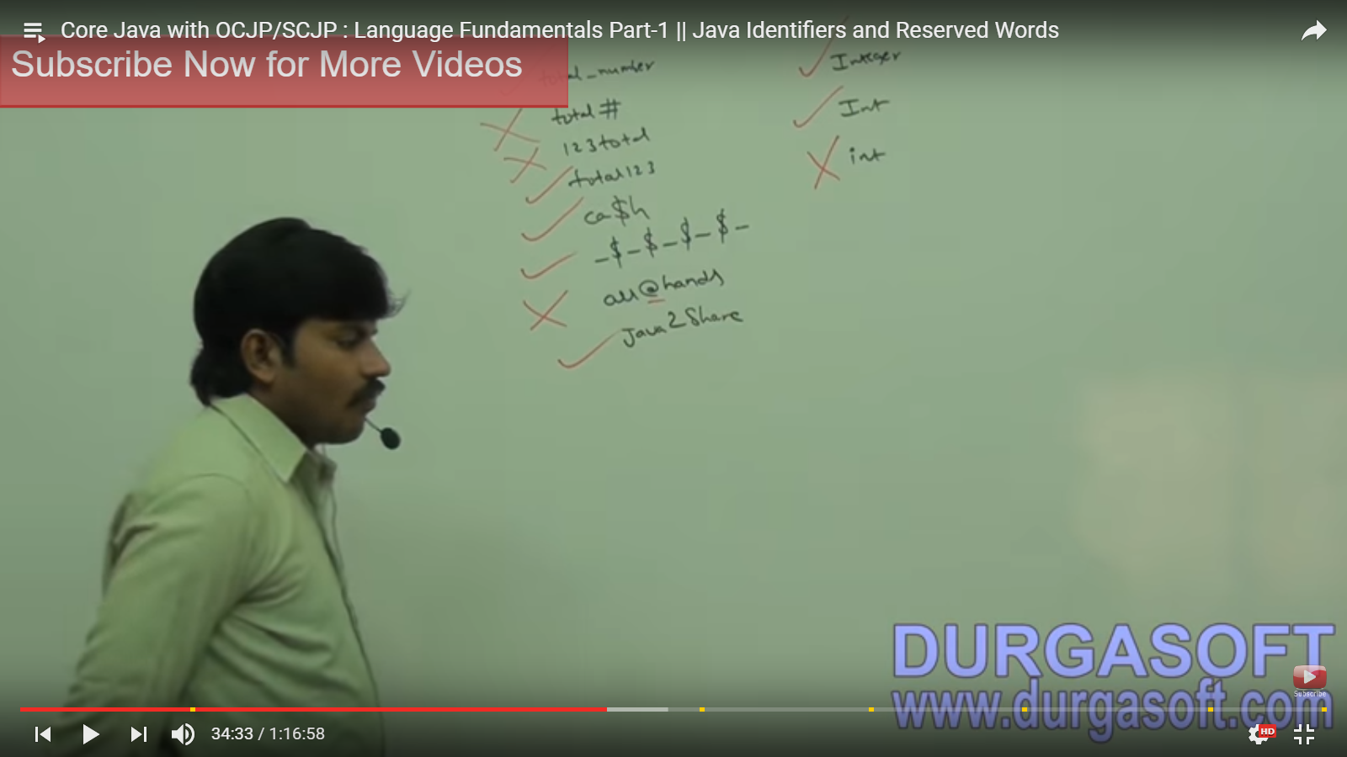

**Reserve words:**

Java contains 53 reserve words to represent some meaning or functionality

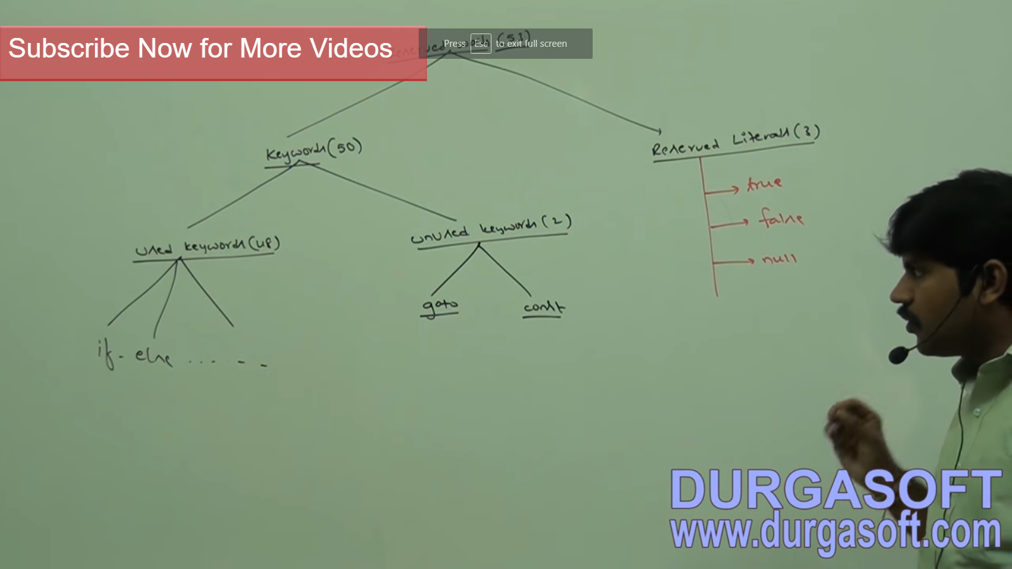

**Keywords for data types:**

Byte

Short

Int

Long

Float

Double

Boolean

Char

Keywords for flow control:

If

Else

Switch

Case

Default

While

Do

For

Break

Continue

Return

Keywords for modifiers :

Public

Private

Protected

Default

Static

Final

Abstract

Synchronized

Native

strictfp (1.2 V)

Transient

Volatile

Keywords for exceptional handling :

Try

Catch

Finally

Throw

Throws

Assert (1.4 v)

Class related keywords:

Class

Interface

Extends

Implements

Package

Import

Object related keywords

New

Instanceof

Super

This

Return type keyword – in java return type is mandatory if method wont return anything then we have to declare that method with void return type but in C language is optional and default return type is Int.

Void

Unused keywords:

Goto – usage of go to create a several problems in old languages hence some people banned this keyword in java

Const – use final instead of const.

If we try to use above keywords we will get compile time error.

Reserved literals:

True – values for Boolean data types

False – values for Boolean data types

Null – default value for object reference

We can use enum to define a group named constants:

Enum( 1.5 v)

Conclusion:

In java all 53 reserved words contains only lower case alphabet symbols

In java we have only new keyword and there is no delete keyword because distraction of useless objects is the responsibility of garbage collector.

The following are new keywords in java :

strictfp

assert

Enum

Some keywords below the way we need to write

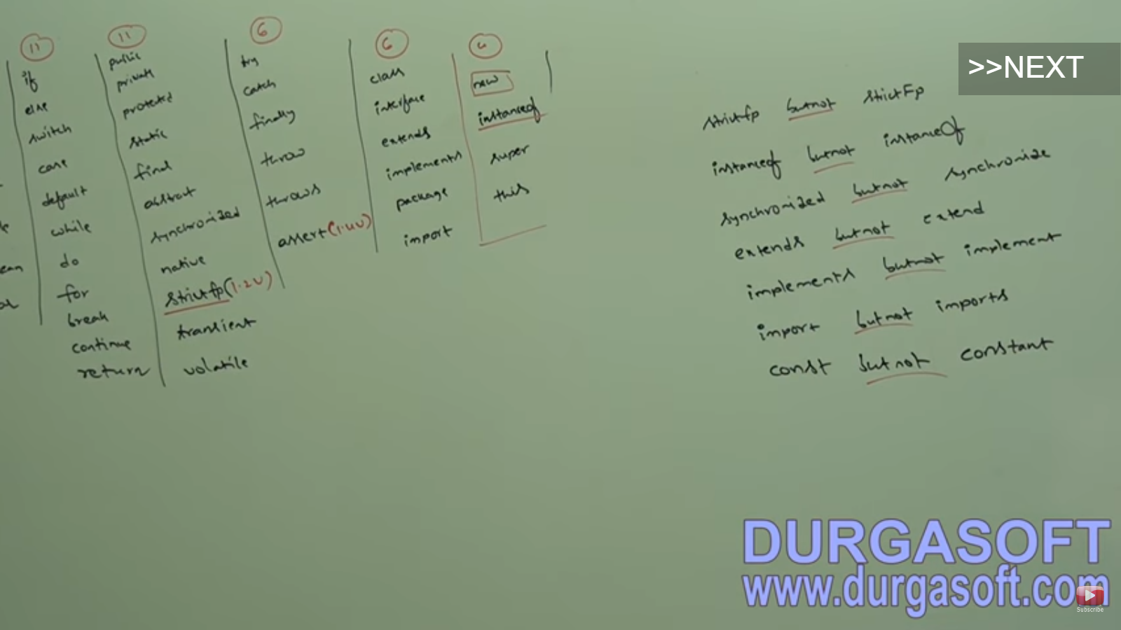

Data types :

In Java every variable and every expression has some type

Each every data type is clearly defined

Every assignment should be checked by compiler by type compatibility

Java is strongly typed language:

Java is not a pure object oriented language because several oops feature are not satisfied by java like (operator over loading, multiple inheritance ...etc) moreover we are depending on primitive data types which are non-objects.

Primitive data types :

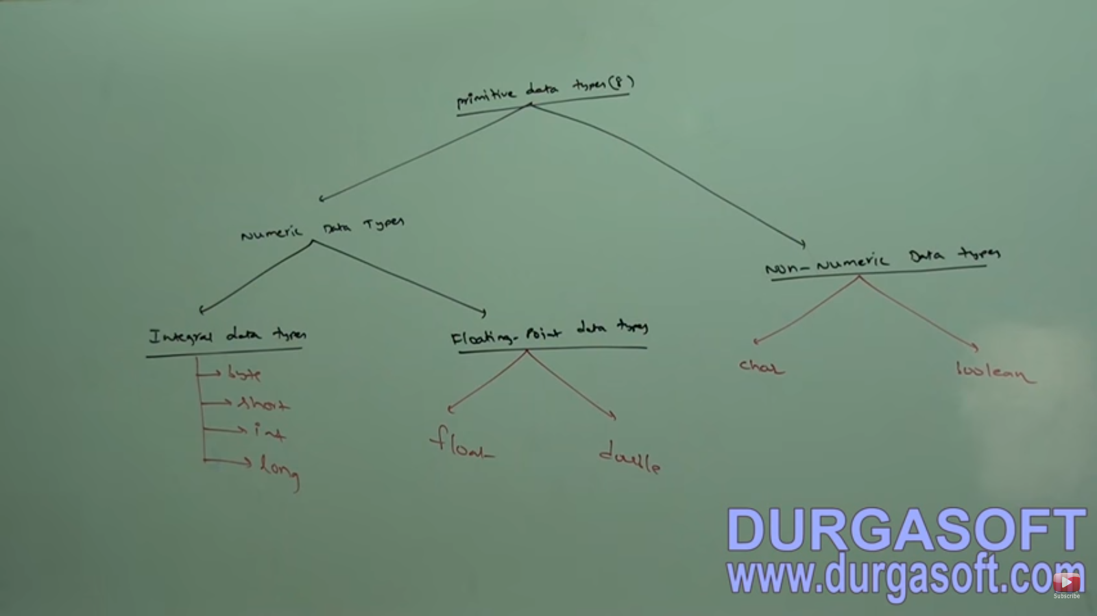

Except Boolean and char remaining data types are consider as signed data types. Because we can represent both positive and negative numbers.

**Byte :**

Size: 1 byte (8 bits)

0 means positive

1 means negative

Positive numbers will be represented directly in memory whereas negative numbers will be represented in two complement form.

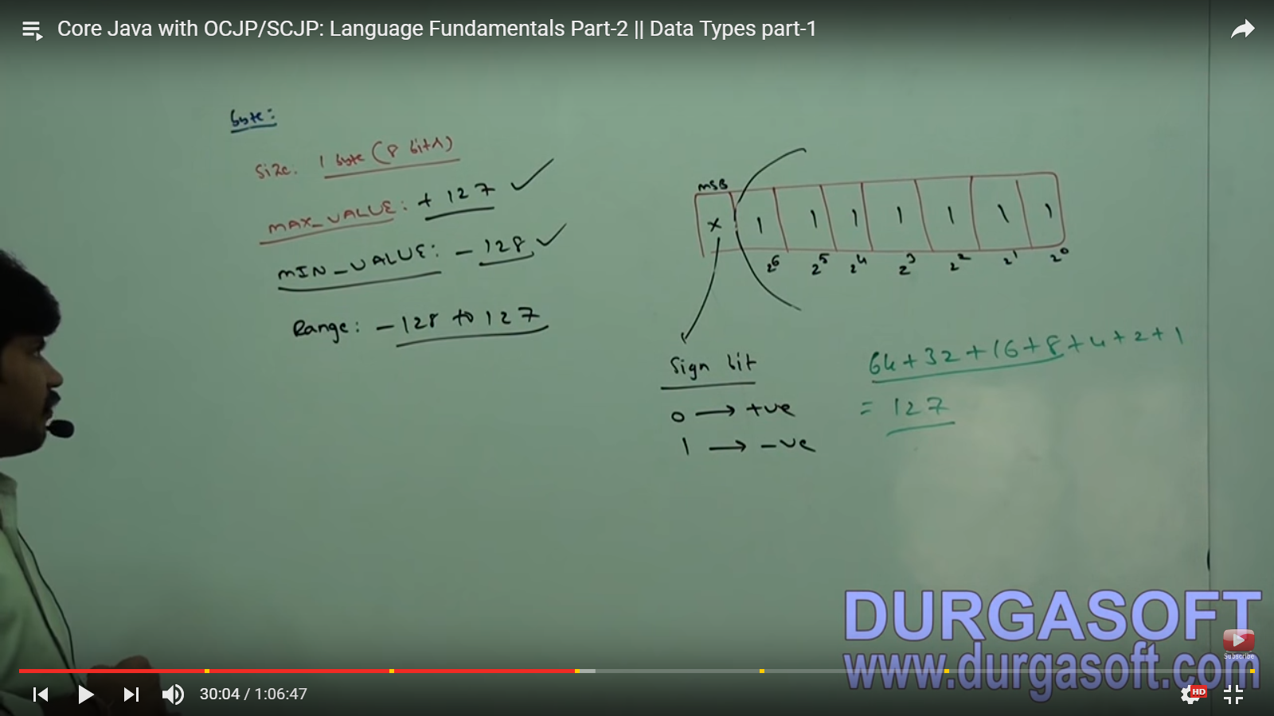

Byte b=10;

Byte b = 127

Byte b=128 –invalid (Error – possible loss of precession found – int required: byte)

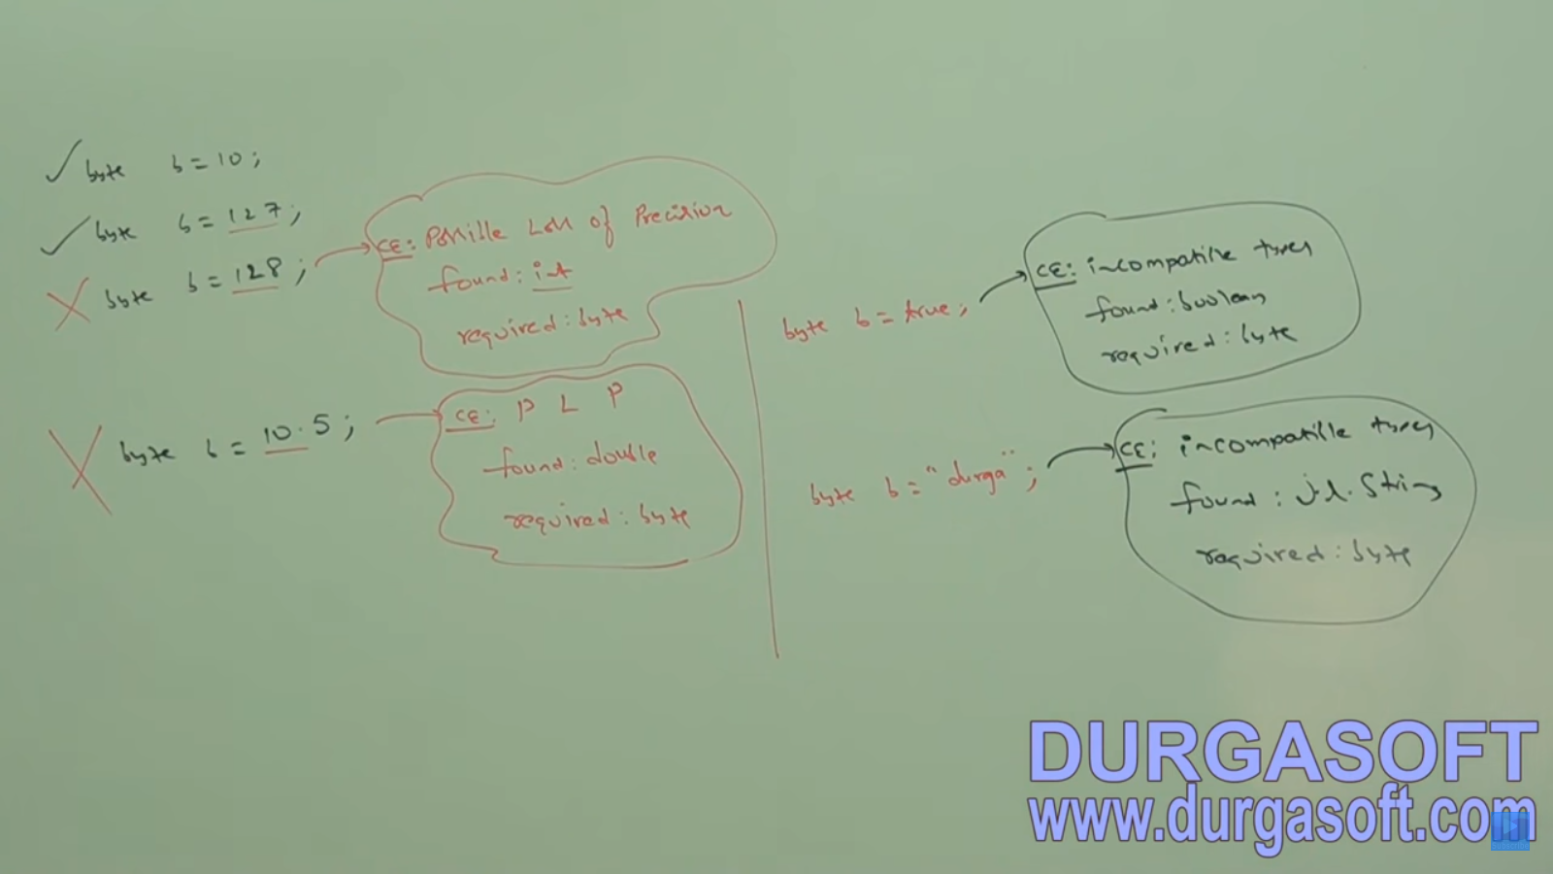

Byte is the best choice if we want handle data in terms of streams either from the file or from the network (file or n/w supported form is byte)

Short data type :

This is very rarely used data type in java

Size : 2 bytes

Range : -2(15) to 2(15) -1

[-32768 to 32767]

