AI Resume Screening System
Using LangChain, LangSmith & Groq (LLaMA 3)
Project | AgenticalAI Internship – Innomatics Research Labs
Author | Ashish Saval | IN226099902_GENAI
Date | April 16, 2026
Stack | Python · LangChain · LangSmith · Groq API · PyPDF

1. Introduction
In today's recruitment process, manually screening resumes is time-consuming and inefficient. Organizations receive hundreds of applications for a single role, making it difficult for recruiters to identify suitable candidates quickly. This project presents an AI-powered Resume Screening System that automates the evaluation process using Large Language Models (LLMs). The system analyzes resumes against a job description and provides a fit score along with an explanation, simulating a real-world recruiter workflow.

2. Problem Statement
The goal is to build an AI tool for recruiters with the following functionality:
- Input: Resume + Job Description
- Process: Skill Extraction → Matching → Scoring
- Output: Fit Score (0–100) + Explanation
The system should:
- Extract skills, tools, and experience
- Compare candidate profile with job requirements
- Assign a score
- Provide explainable reasoning

3. Objectives
- Build a modular LLM-based pipeline using LangChain
- Implement resume and job description parsing
- Develop skill matching and scoring logic
- Generate explainable outputs
- Enable debugging and tracing using LangSmith

4. Tools and Technologies Used
Technology | Purpose
Python | Core programming language
LangChain | Pipeline orchestration
LangSmith | Tracing and debugging
Groq API (LLaMA 3) | LLM model inference
PyPDF | PDF resume parsing

5. System Architecture
The system follows a modular pipeline:
Resume → Extract → JD Extract → Match → Score → Explain
- Extract: Extract skills, tools, and experience from resume
- JD Extract: Extract required skills from job description
- Match: Compare candidate skills with required skills
- Score: Calculate score (0–100)
- Explain: Provide reasoning behind score

6. Implementation Details

Step 1 – Skill Extraction
The extraction chain reads the PDF resume using PyPDF and prompts the LLM to return structured JSON containing skills, tools, and experience in years.

Step 2 – Matching Logic
- Matched skills = intersection of candidate and required skills
- Missing skills = required skills absent from candidate profile

Step 3 – Scoring Logic
Score = (Matched Skills / Total Required Skills) × 100
- +10 if experience ≥ 3 years
- –10 if experience < 1 year

Step 4 – Explanation
The explain chain generates a human-readable breakdown covering matched skills, missing critical skills, and experience impact.

7. Results
Three candidates with different profiles were evaluated against a Data Scientist / AI Engineer job description:
Candidate | Profile Type | Score | Key Observation
Ashish Saval | Strong | 73.68 | 14/20 matched; missing Matplotlib, OpenAI API, HuggingFace, Git, Jupyter
Nitin Satarkar | Average | 10.0 | Only 2/20 skills (Python, SQL); 0.5 yrs experience
Ram Kachare | Weak / Mismatch | 5.0 | 1/20 skill (REST APIs); Java/web developer profile

8. LangSmith Tracing & Screenshots
The following screenshots were captured during development and testing of the pipeline.

8.1 Average Candidate – Nitin Satarkar (Score: 10.0)
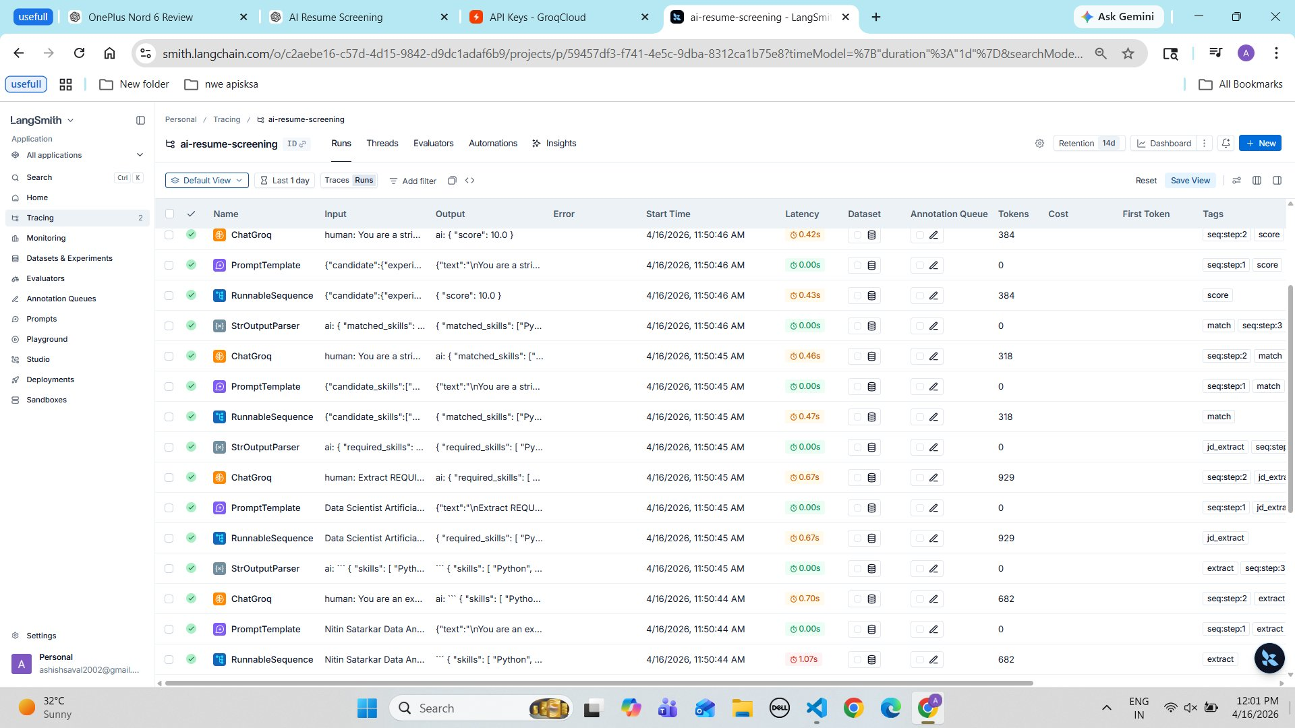
Fig 1 – LangSmith Runs overview showing all pipeline steps for the average candidate
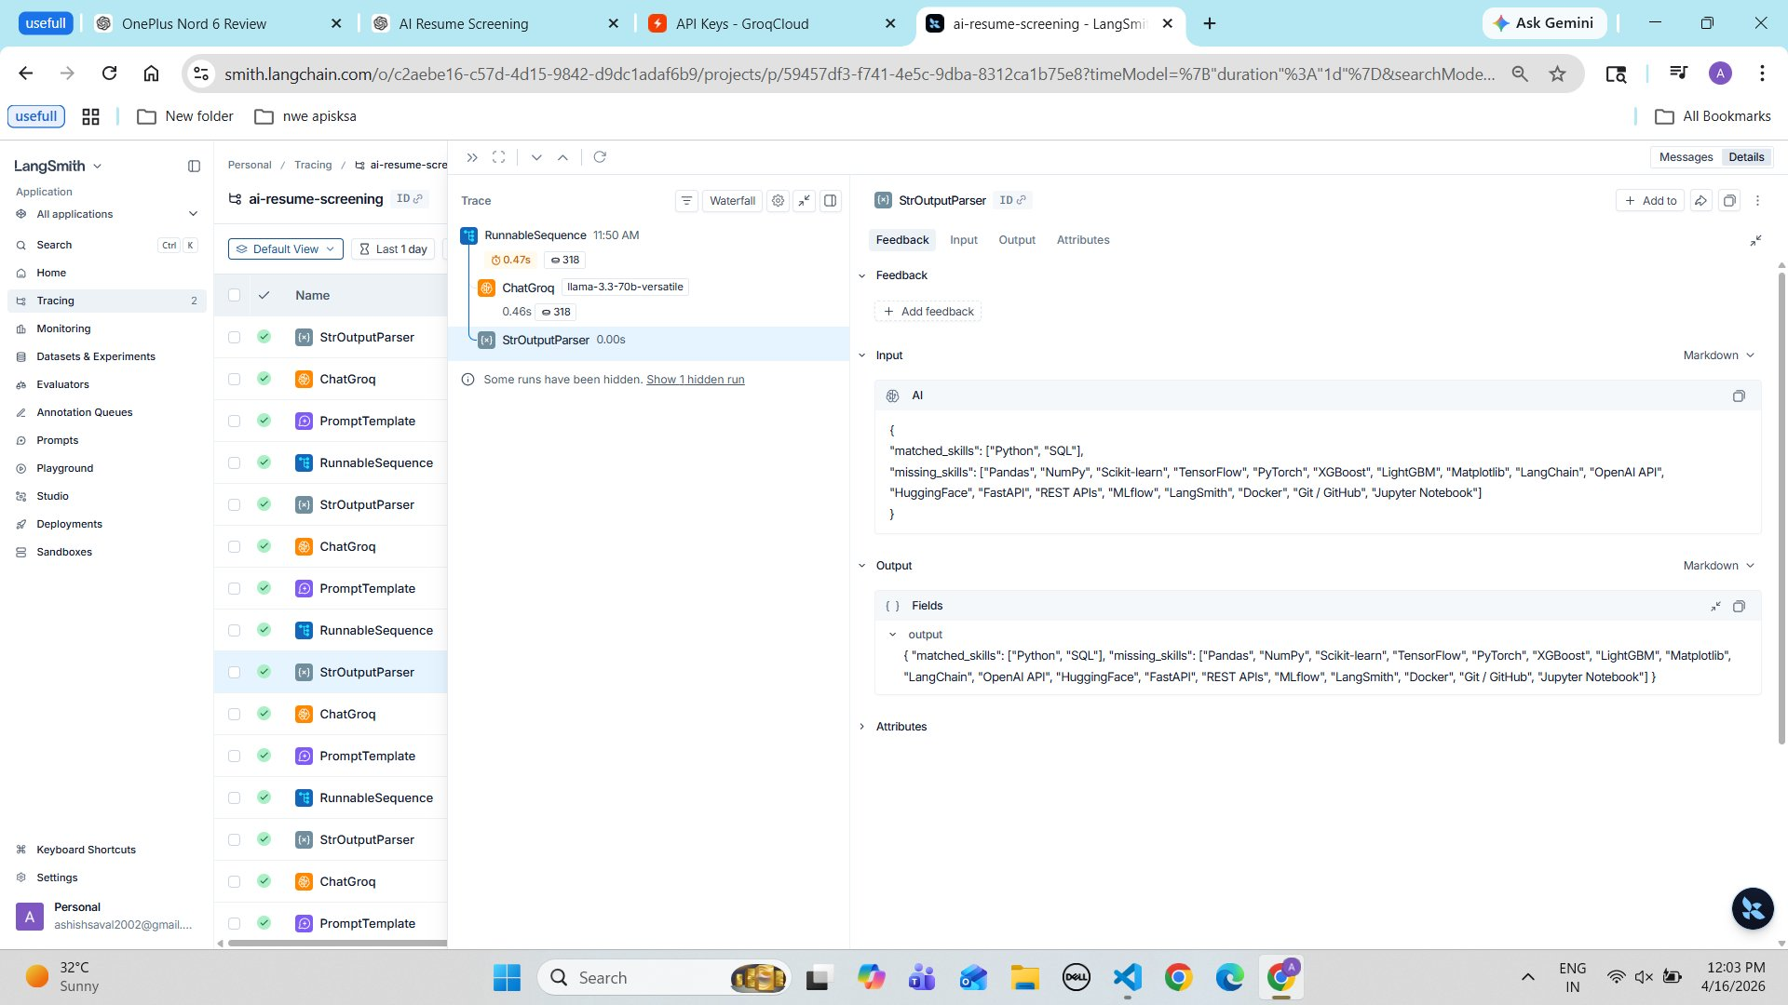
Fig 2 – StrOutputParser trace: matched skills and missing skills JSON output
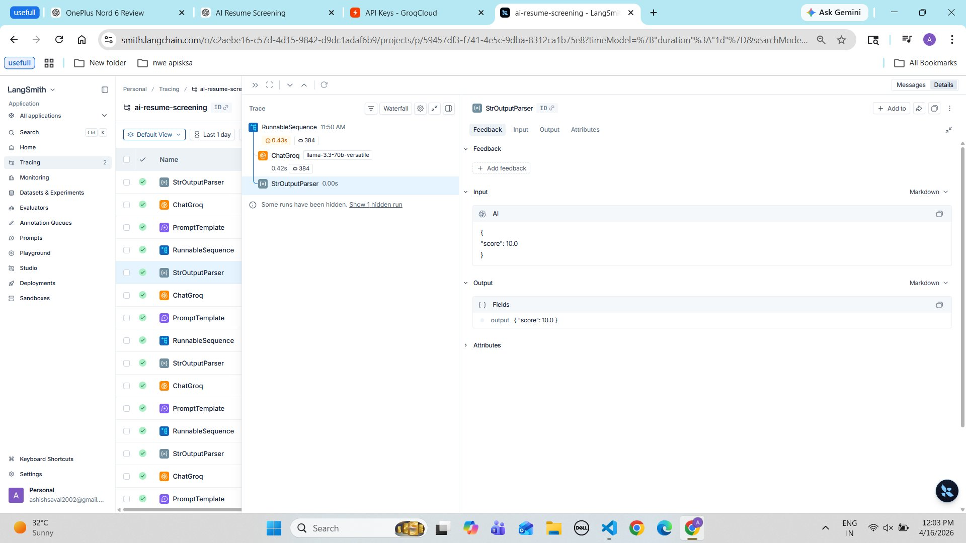
Fig 3 – Score output: { score: 10.0 } after evaluation

8.2 Strong Candidate – Ashish Saval (Score: 73.68)
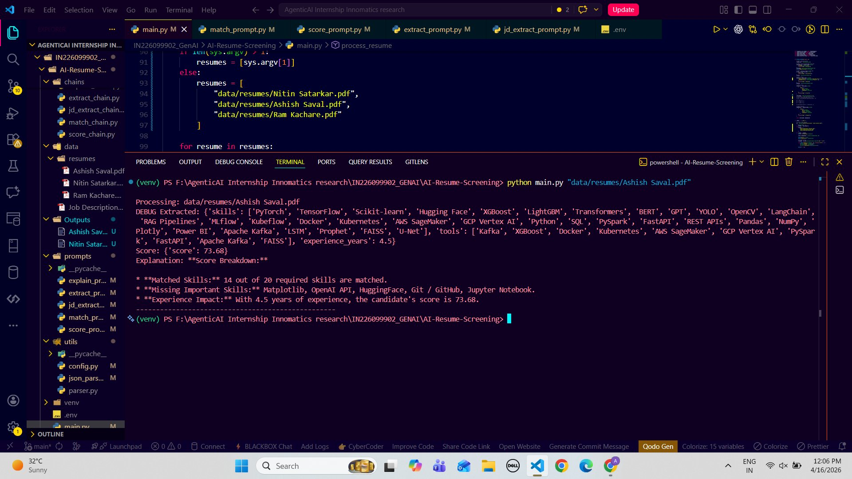
Fig 4 – LangSmith Runs: full trace for strong candidate pipeline execution
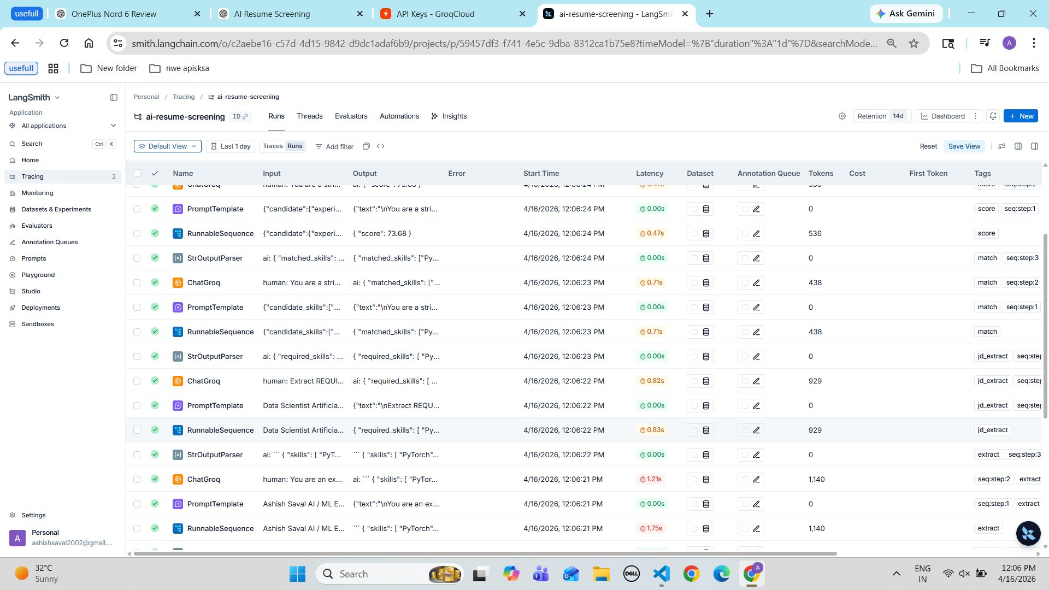
Fig 5 – Detailed match trace showing matched and missing skills
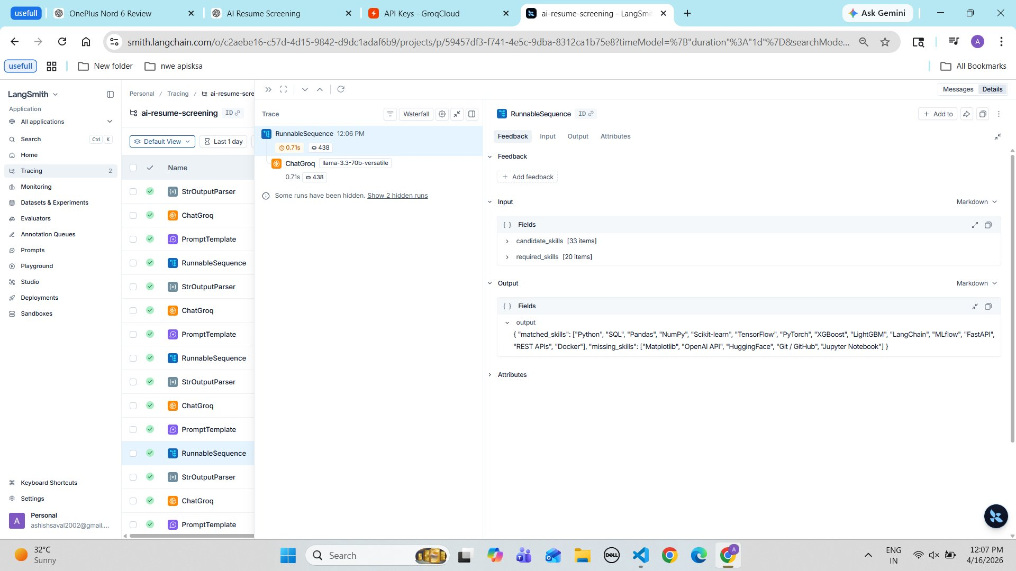
Fig 6 – RunnableSequence: 33 candidate skills vs 20 required skills
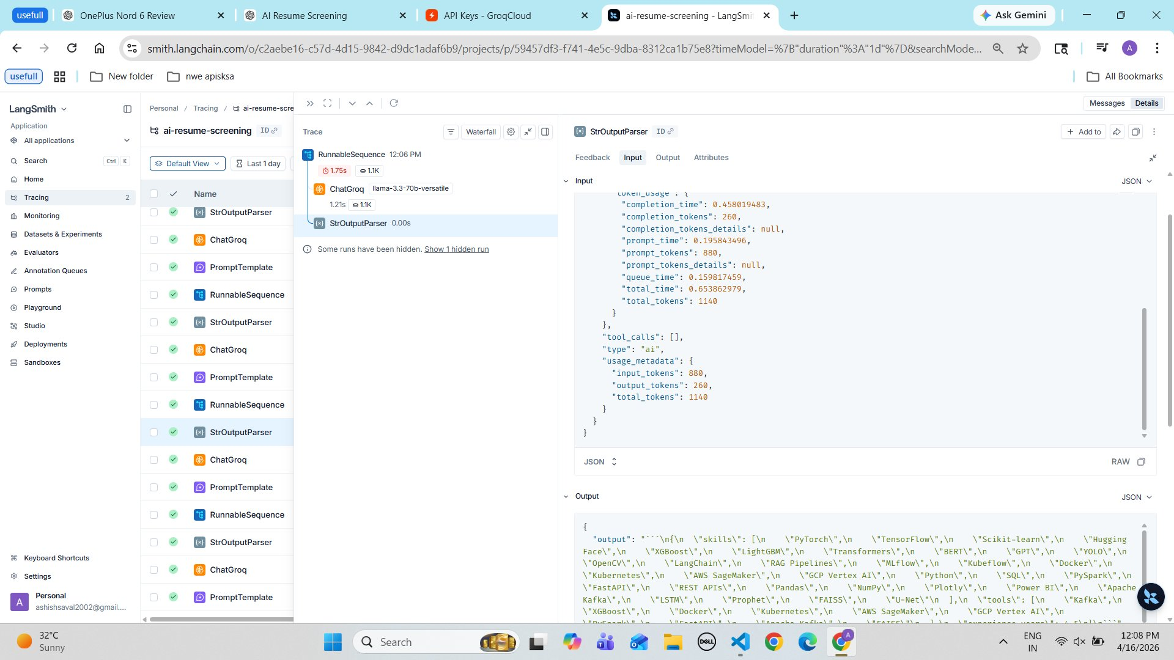
Fig 7 – Raw token usage and input/output JSON from extraction chain

8.3 Weak / Mismatch Candidate – Ram Kachare (Score: 5.0)
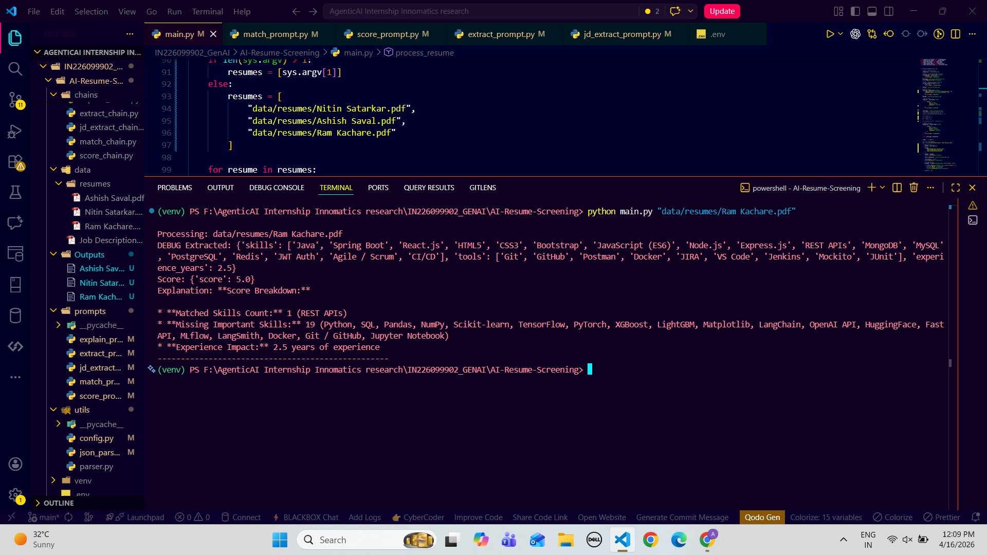
Fig 8 – VS Code terminal: Ram Kachare processing showing web skills extracted
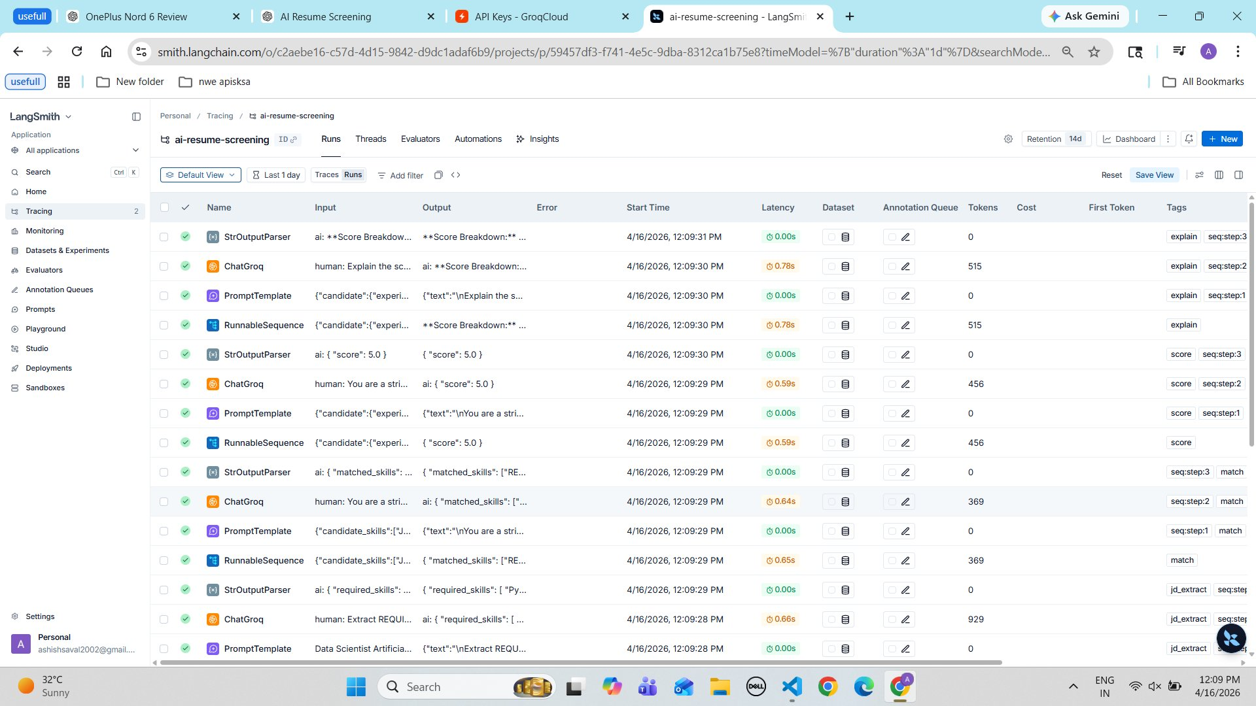
Fig 9 – LangSmith Runs list for weak candidate
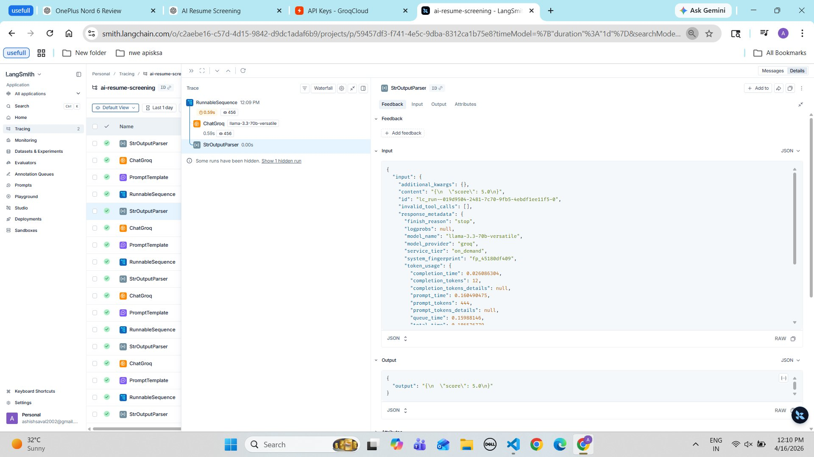
Fig 10 – Score trace output: { score: 5.0 } with token metadata
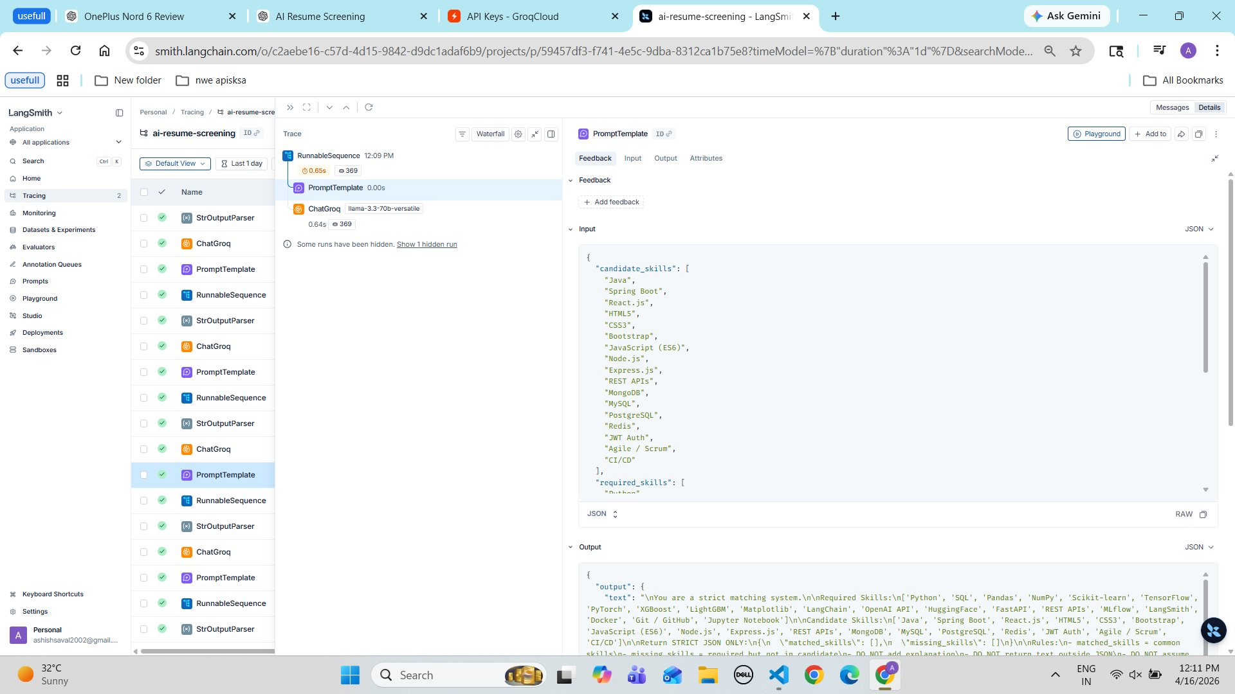
Fig 11 – PromptTemplate showing Java/web skills vs required Python/ML skills

9. LangSmith Tracing
LangSmith was integrated as the primary observability layer for the pipeline:
- Tracking each pipeline step (extract, jd_extract, match, score, explain)
- Debugging errors such as invalid JSON parsing issues
- Monitoring input-output flow across all LLM chains
- Viewing token usage, latency, and model metadata per run

10. Debugging Case
During development, an issue occurred where the model returned invalid JSON output, causing parsing errors in the StrOutputParser step.
- Enforced STRICT JSON output instructions in all prompts
- Used structured prompt templates to avoid model hallucination
- Added JSON validation logic before downstream chain steps
These changes significantly improved system reliability and output consistency.

11. Key Features
- Modular LangChain pipeline design (each step is an independent chain)
- Structured JSON outputs enforced via prompt engineering
- Explainable AI results with score breakdown
- Automated output file generation per candidate
- LangSmith tracing integration for full observability

12. Conclusion
This project demonstrates how LLMs can be used to build real-world AI systems for recruitment. The system successfully automates resume screening with scoring and explanation, providing faster candidate evaluation, transparent decision-making, and a scalable solution for recruiters.

13. Future Enhancements
- Build a UI using Streamlit or React
- Add a weighted scoring system prioritizing critical skills
- Integrate a database for storing and querying results
- Support multiple job roles and dynamic JD templates

14. Learning Outcomes
- Designed and implemented LLM-based agentic pipelines
- Applied prompt engineering techniques for structured output
- Built explainable AI systems with traceable decisions
- Used LangSmith for production-grade debugging and tracing

