**Earlyone app**

**Device- Huawei p20 lite**

**CHECKLIST**

1. [Installation testing](https://www.softwaretestinghelp.com/software-installationuninstallation-testing/)

* Check the presence of the app in play market, install and run the application.
* Check that the installation of the application should take place without significant errors, if the device meets the system requirements.

1. [**Usability testing**](https://www.softwaretestinghelp.com/usability-testing-guide/)

* Checking of menu options, buttons, bookmarks, history, settings, and navigation flow of the application.
* Make sure that the buttons are of the normal size and placed in one area of the screen
* Ensure the icons and pictures look natural in the app environment.
* Verify the color of the buttons that perform the same function is the same.
* The text should be simple, clear and visible to the user. Short sentences and paragraphs are possible to read.
* Define the optimal font size.
* Ensure correct operation of the Zoom-in and Zoom-out system.
* Verify the context menus are not overloaded.
* Verify the user can return or cancel the action if he/she pressed the wrong button.
* Verify the speed of response of the element is high enough.
* Determine languages supported by the application. Ensure the correctness of the translation.
* Check the date formats.

1. **Services testing**

* Testing the services of the application online and offline.

1. [**Performance testing**](https://www.softwaretestinghelp.com/introduction-to-performance-testing-loadrunner-training-tutorial-part-1/)

* Testing the performance of the application by changing the connection from 2G, 3G to WIFI, sharing the documents, battery consumption.
* Check the application stability under conditions of a hard user load.
* Determine the number of users who can simultaneously work with the application.

1. **Security Testing**

* Testing an application to validate if the information system protects data or not.

1. **Interruptions testing**

* Check the behaviour of app while incoming and outgoing calls, SMS, battery discharge/removal, disconnecting and connecting the network/Wi-Fi.

**BUG REPORT**

|  |  |
| --- | --- |
| ID number | #1 |
| Bug Summary | The “close” button issue. Title is not clear |
| Reporter | Syune Avanesyan |
| Submit Date | 27/02/2021 |
| Platform | Huawei P20 lite |
| Operating System | Android |
| Severity | Medium |
| Component/tag | “close” button |
| Screenshot/video | It is attached at the top of the page. |

**Precondition**: The app should be installed in mobile phone.

**Description**: When it is offline we have notification that “Earlyone requires internet connection. Please check your connection” and 2 options “close” and “retry”. After clicking on “close” button the app does not closed.

**Steps to reproduce:**

Step 1: Switch off your connection.

Step2: Open earlyone app.

Step3: After appearing the notification press “close” button.

**Expected result:** The app should be closed.

**Actual result:** It stays still on the app.

**Notes**: This bug is actual for Earlyone v3.0.8 .

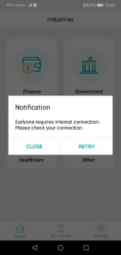 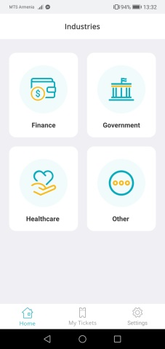

**BUG REPORT**

|  |  |
| --- | --- |
| ID number | #2 |
| Bug Summary | The “Terms and Condition” and “Privacy Policy” sections are only available in English. |
| Reporter | Syuzanna Stepanyan |
| Submit Date | 27/02/2021 |
| Platform | Huawei P20 lite |
| Operating System | Android |
| Severity | High |
| Component/tag | “Terms and Condition” and “Privacy Policy” |
| Screenshot/video | It is attached at the top of the page. |

**Precondition**: The app should be installed in mobile phone.

**Description**:

**Steps to reproduce:**

Step 1: Open earlyone app.

Step2: Open “settings” section.

Step3: Change the language and choose another language beside English, e.g. Armenian.

Step 4: Click on “Terms and condition” and “Privacy policy” sections.

**Expected result:** Terms and condition” and “Privacy policy” sectionsshould be in translated in Armenian.

**Actual result: “**Terms and condition” and “Privacy policy” sections are only in English.

**Notes**: This bug is actual for Earlyone v3.0.8 .

