**Hello Team!** **Consider the below two tables**:

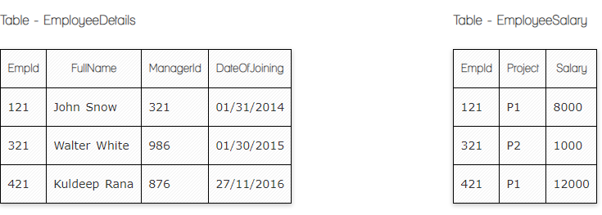

**Ques.1. Write a SQL query to fetch the count of employees working in project 'P1'.**

**Your Answer:**

**SELECT** **COUNT**(*) **FROM** EmployeeSalary **WHERE** Project = 'P1';

**Ques.2. Write a SQL query to fetch employee names having salary greater than or equal to 5000 and less than or equal 10000.**

**Your Answer:**

**SELECT** FullName

**FROM** EmployeeDetails

**WHERE** EmpId **IN**

(**SELECT** EmpId **FROM** EmpolyeeSalary

**WHERE** Salary **BETWEEN** 5000 **AND** 10000);

**Ques.3. Write a SQL query to fetch count of employees sorted by project's count in descending order.**

**Your Answer:**

**SELECT** Project, **count**(EmpId) EmpProjectCount

**FROM** EmployeeSalary

**GROUP** **BY** Project

**ORDER** **BY** EmpProjectCount **DESC**;

**Ques.4. Write a query to fetch employee names and salary records. Return employee details even if the salary record is not present for the employee.**

**Your Answer:**

**SELECT** E.FullName, S.Salary

**FROM** EmployeeDetails E **LEFT** **JOIN** EmployeeSalary S

**ON** E.EmpId = S.EmpId;

**Ques.5. Write a SQL query to create an empty table with ‘Test’ name.**

**Your Answer:**

CREATE TABLE Test (  
    column1 datatype,  
    column2 datatype,  
    column3 datatype,  
   ....  
);

**Ques.6. Write a SQL query to delete an empty table with ‘Test’ name.**

**Your Answer:**

DROP TABLE Test;

**Ques.7. Write a SQL query to fetch all the Employees details from EmployeeDetails table who joined in Year 2016.**

**Your Answer:**

**SELECT** * **FROM** EmployeeDetails

**WHERE** DateOfJoining **BETWEEN** '01/01/2016' **AND** '31-12-2016';

**Ques.8. Write a SQL query to insert new record to the EmployeeDetails table with any data.**

**Your Answer:**

INSERT INTO **EmployeeDetails** (FulName, ManagerId, DateofJoining)  
VALUES (‘value1’, ‘value2’, ‘value3’);

**Ques.9. Write a SQL query to update EmployeeSalery table with setting Salary to 2000 for Project P2.**

**Your Answer:**

UPDATE **EmployeeSalery**  
SET Salary = 2000  
WHERE Project = ‘P2’;



**Ques.10. Write a SQL query to right join both tables and draw the results.**

**Your Answer:**

**Select FullName, Employeesalary .EmpId, Employeesalary.Salary**

**from Employeesalary**

**Right Join EmployeeDetails**

**on EmployeeDetails.EmpId = EmployeeSalary.EmpId**

|  |  |  |
| --- | --- | --- |
| **EmpId** | **Salary** |  |
| **121** | **8000** | **John** |
| **321** | **1000** | **Walter** |
| **420** | **12000** | **Null** |

**Now take these two tables:**

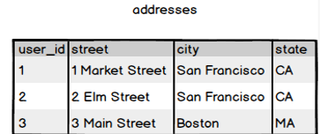

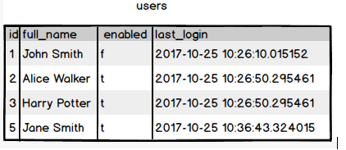

**Ques.11. Write a SQL query to fetch all users full_name from San Francisco.**

**Your Answer:**

SELECT full_name FROM users

INNER JOIN addresses ON addresses.user_id = users.id

WHERE city= 'San Francisco';

**Ques.12. Write a SQL query to fetch all users full_name, last_login who are enabled**

**Your Answer:**

SELECT users.full_name, users.last_login

FROM users

WHERE enabled = 't';

**Ques.13. Write a SQL query to fetch all users full_name who are not from 3 Main street**

**Your Answer:**

SELECT full_name FROM users

INNER JOIN addresses ON addresses.user_id = users.id

WHERE street NOT IN ('3 Main Street');

**Ques.14. Write a SQL query to fetch all users full_name who are from 3 Main street or San Francisco**

**Your Answer:**

SELECT full_name FROM users

INNER JOIN addresses ON addresses.user_id = users.id

WHERE street= '3 Main Street' or city= 'San Francisco';

--(or WHERE street in ('Tumanyan', 'Abovyan'))

**Ques.15. Write a SQL query to fetch user full_name who is equal to user_id from Boston (find user_id value in sub_query)**

**Your Answer:**

--select full_name FROM users

WHERE id in (SELECT user_id from addresses WHERE city= 'Boston' )