Maximum Number of price

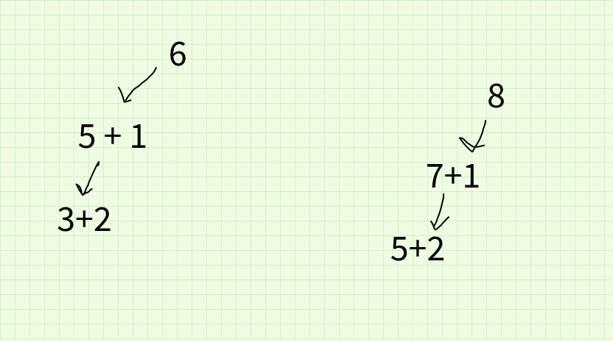
result = [];
getMaxPrise(num, level)
if num <= level
if(result not contains n+level)
result.add(n+level);
return 0;
else
result.add(level)
level => level + 1
return getMaxPrise(num-level, level)

