Steps to load Data using given Excel file:

Step:1

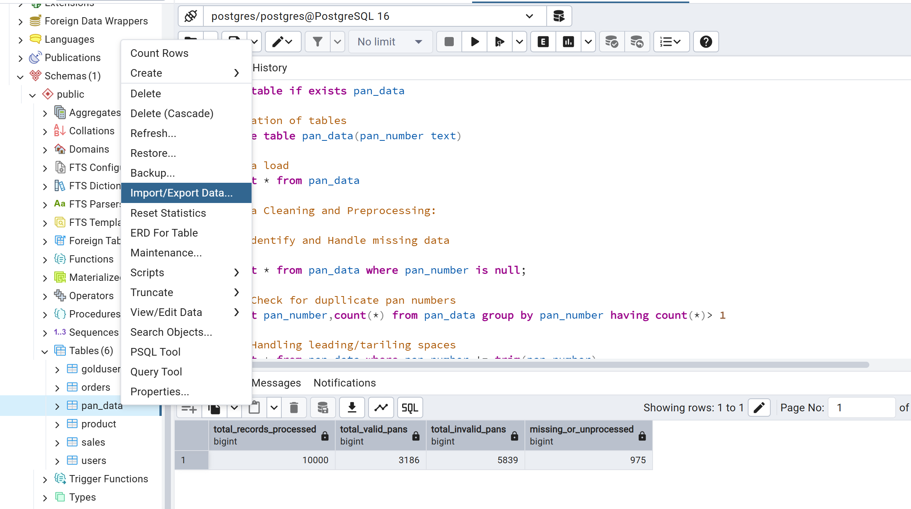

Step:2 Selection of CSV file

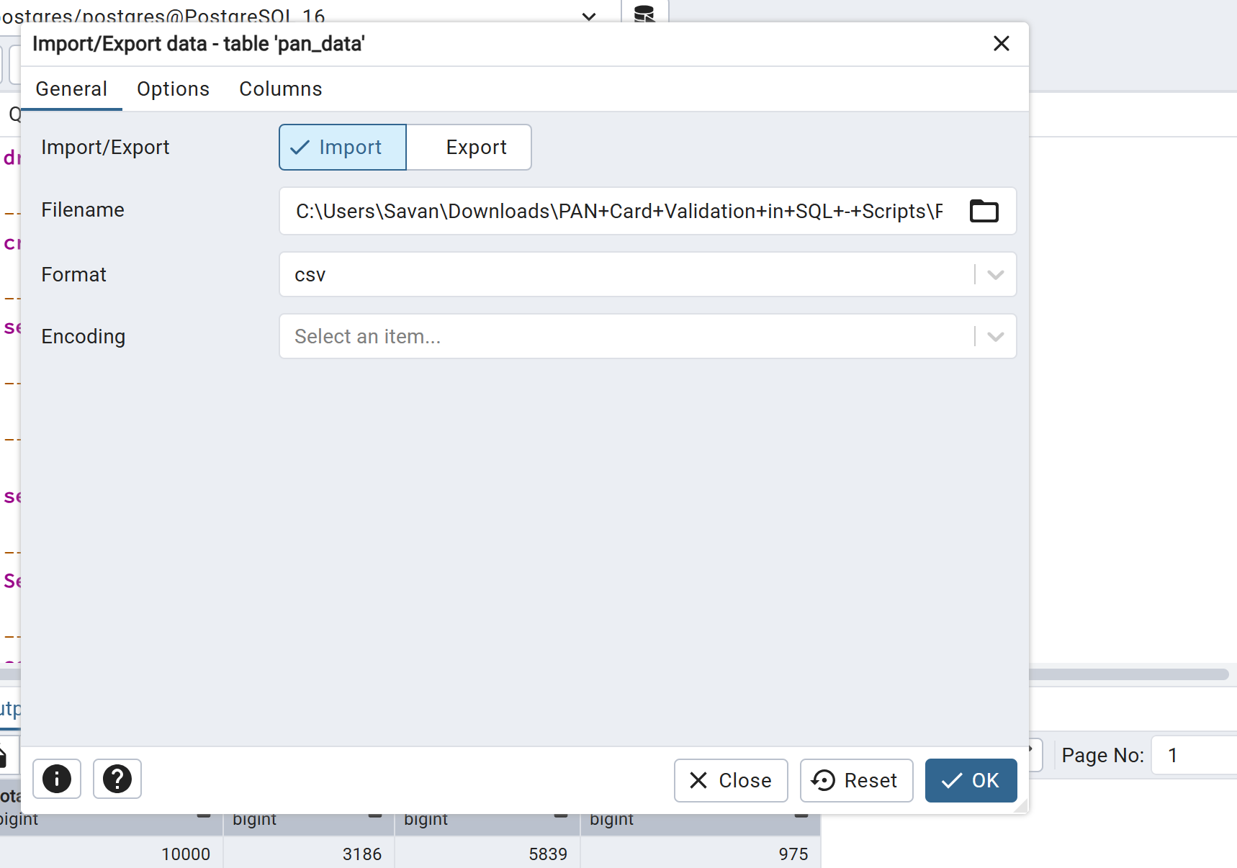

Step:3 Keep this header on otherwise it will make an entry for header too, Click on Ok

