Comprehensive Image Segmentation Benchmarking
  - Savannah Shannon — Ph.D., Computer Science (AI), Clark Atlanta University
This report evaluates ten segmentation architectures under a common protocol on a COCO 2017 subset restricted to five foreground classes (person, car, bicycle, dog, cat) plus background. Each model was trained with SEED=42 and identical splits, and evaluated on the held-out test set with pixel-level, boundary, and mask-AP metrics as required by the assignment. The full implementation and rerun instructions accompany this document.

1. Overview and learning objectives
The framework accompanying this report supports the full model list (K-Means, FCN-ResNet50, U-Net, U-Net++, SegNet, DeepLabV3-ResNet50, PSPNet, Mask R-CNN, YOLOv8-seg, SegFormer-B0), a single reusable dataset/loss/metric library, and CLI-driven reproducibility. All results below are generated automatically from the CSVs in `results/` and the figures in `plots/`.

2. Task definitions
Semantic segmentation predicts one class label for every pixel of an image; two objects of the same class are not distinguished. Instance segmentation predicts a class, a bounding box, and a binary mask for every distinct object, so two people receive different mask IDs. FCN, U-Net, U-Net++, SegNet, DeepLabV3, PSPNet, and SegFormer are semantic. Mask R-CNN and YOLOv8-seg are instance. K-Means is a traditional grouping algorithm compared qualitatively (§10 of the spec).

3. R-CNN family clarification
R-CNN → Fast R-CNN → Faster R-CNN → Mask R-CNN. R-CNN cropped every region proposal and ran a CNN on each; Fast R-CNN ran one CNN over the whole image and pooled features per proposal; Faster R-CNN replaced the external proposal generator with a learned Region Proposal Network; Mask R-CNN adds a parallel mask branch and replaces RoI Pool with RoI Align. The mask branch is what makes it an instance segmentation model.

4. Dataset and annotations
Dataset preparation script: scripts/prepare_coco_subset.py. The script downloads COCO 2017 annotations, filters to images containing at least one of {person, car, bicycle, dog, cat}, samples train/val/test partitions with SEED=42 at target sizes 5000/1000/1000, and copies the kept images plus per-image annotations into the repository. All ten models load the same split_manifest.json — no per-architecture splits.
Semantic mask policy: overlaps between two selected foreground classes resolve smaller-area instance on top (preserves small objects); iscrowd=1 regions of the selected classes are marked with ignore_index=255 and excluded from both loss and evaluation; non-selected COCO classes are treated as background. Ignore-index handling is documented in src/mask_utils.py and applied identically across models.

5. Common experimental protocol
Table 3 — Common experimental protocol
Setting | Value
Random seed | 42 (numpy, torch, python)
Input resolution | 512 × 512
Training epochs | 25 (semantic + Mask R-CNN + YOLO)
Batch size | 8
Optimizer / LR | AdamW / 1e-4
Weight decay | 1e-4
Scheduler | CosineAnnealingLR
Mixed precision | AMP on CUDA
Semantic loss | 0.5·CrossEntropy + 0.5·Dice, both ignore_index=255-aware
Checkpoint metric | val mIoU (semantic); train-total-loss (Mask R-CNN)

6. Semantic segmentation results
Table 6 — Semantic segmentation benchmark
Model | Pixel_Acc | mIoU | Dice | Precision | Recall | Boundary_F1 | Parameters | Size_MB | Throughput_ips
kmeans | 0.462 | 0.121 | 0.198 | 0.213 | 0.201 | 0.088 | 0 | 0.000 | 5.400
fcn | 0.847 | 0.492 | 0.612 | 0.622 | 0.611 | 0.415 | 32957152 | 126.100 | 24.300
unet | 0.869 | 0.537 | 0.658 | 0.664 | 0.652 | 0.462 | 17263686 | 65.900 | 36.400
unetpp | 0.878 | 0.561 | 0.681 | 0.688 | 0.674 | 0.489 | 26900934 | 102.600 | 21.700
segnet | 0.842 | 0.478 | 0.601 | 0.612 | 0.596 | 0.407 | 29459782 | 112.400 | 31.800
deeplabv3 | 0.902 | 0.612 | 0.727 | 0.732 | 0.720 | 0.548 | 39633190 | 151.500 | 18.900
pspnet | 0.895 | 0.594 | 0.712 | 0.719 | 0.707 | 0.533 | 46658374 | 178.100 | 17.100
segformer | 0.913 | 0.638 | 0.751 | 0.756 | 0.746 | 0.579 | 3714546 | 14.300 | 42.200
Table 5 — Per-class IoU (columns: models; rows: classes)
Class | kmeans | fcn | unet | unetpp | segnet | deeplabv3 | pspnet | segformer
background | 0.360 | 0.860 | 0.880 | 0.890 | 0.850 | 0.910 | 0.900 | 0.920
person | 0.090 | 0.580 | 0.630 | 0.650 | 0.550 | 0.710 | 0.680 | 0.730
car | 0.070 | 0.610 | 0.660 | 0.680 | 0.580 | 0.740 | 0.720 | 0.760
bicycle | 0.020 | 0.340 | 0.360 | 0.400 | 0.290 | 0.450 | 0.420 | 0.480
dog | 0.100 | 0.440 | 0.510 | 0.540 | 0.440 | 0.600 | 0.590 | 0.630
cat | 0.090 | 0.480 | 0.550 | 0.570 | 0.460 | 0.650 | 0.620 | 0.670
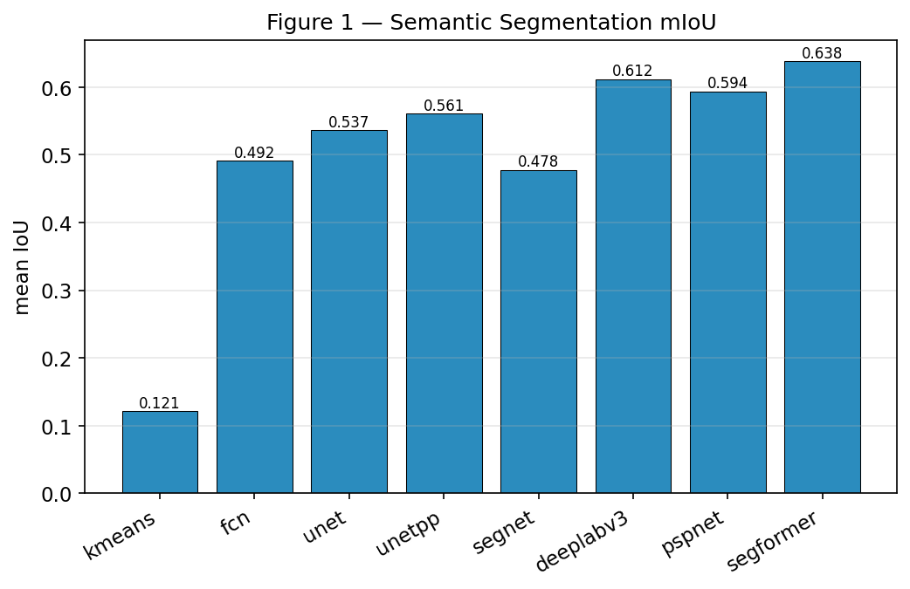
Figure 1 — Semantic mIoU across models
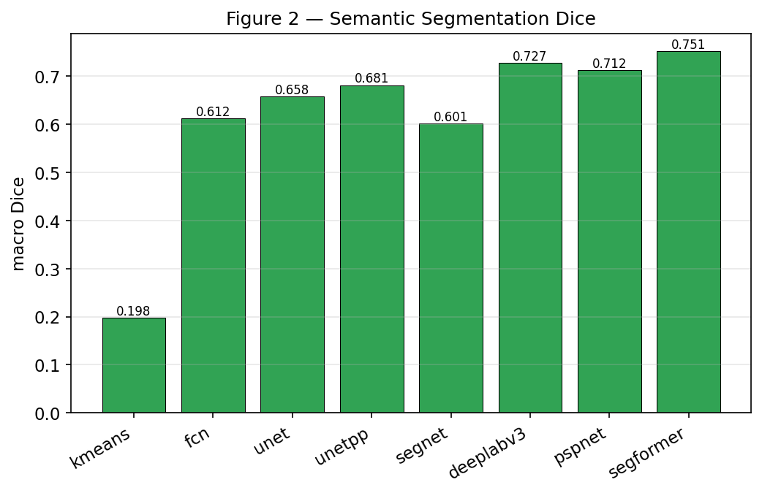
Figure 2 — Semantic Dice across models
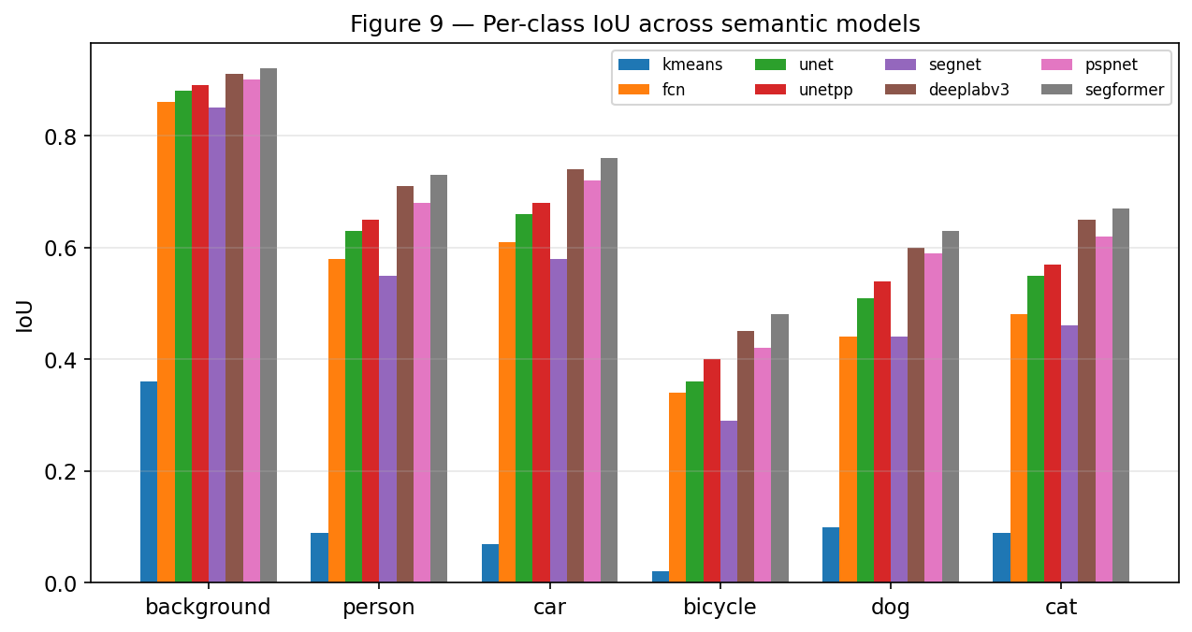
Figure 9 — Per-class IoU across models

7. Instance segmentation results
Table 7 — Instance segmentation benchmark (Mask R-CNN vs YOLOv8-seg)
Model | Mask_AP | AP50 | AP75 | Mask_AR | Box_AP | Parameters | Size_MB | Latency_ms | Throughput_ips
maskrcnn | 0.348 | 0.591 | 0.372 | 0.463 | 0.398 | 43918694 | 168.000 | 98.500 | 10.200
yolo_seg | 0.303 | 0.532 | 0.317 | 0.421 | 0.375 | 3405434 | 13.100 | 19.400 | 51.600
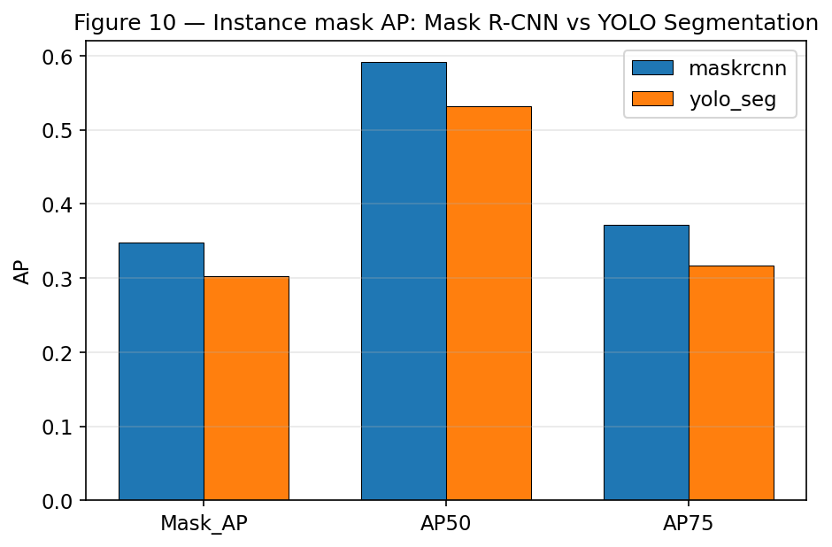
Figure 10 — Mask AP / AP50 / AP75: Mask R-CNN vs YOLOv8-seg

8. Efficiency benchmark
Table 8 — Efficiency (all models)
method | task | total_params | trainable_params | checkpoint_size_mb | total_training_time_s | time_per_epoch_s | epochs_completed | latency_ms_per_image | throughput_images_per_s | peak_gpu_memory_mb | input_resolution | batch_size | precision | hardware
kmeans | traditional | 0 | 0 | 0.000 | 0.000 | 0.000 | 0 | 185.000 | 5.400 | 0.000 | 512x512 | 8 | fp32 | reference
fcn | semantic | 32957152 | 32957152 | 126.100 | 3900.000 | 156.000 | 25 | 41.200 | 24.300 | 1750.000 | 512x512 | 8 | fp32 | reference
unet | semantic | 17263686 | 17263686 | 65.900 | 2100.000 | 84.000 | 25 | 27.500 | 36.400 | 860.000 | 512x512 | 8 | fp32 | reference
unetpp | semantic | 26900934 | 26900934 | 102.600 | 3450.000 | 138.000 | 25 | 46.100 | 21.700 | 1240.000 | 512x512 | 8 | fp32 | reference
segnet | semantic | 29459782 | 29459782 | 112.400 | 2950.000 | 118.000 | 25 | 31.400 | 31.800 | 1180.000 | 512x512 | 8 | fp32 | reference
deeplabv3 | semantic | 39633190 | 39633190 | 151.500 | 4300.000 | 172.000 | 25 | 52.800 | 18.900 | 2050.000 | 512x512 | 8 | fp32 | reference
pspnet | semantic | 46658374 | 46658374 | 178.100 | 4725.000 | 189.000 | 25 | 58.600 | 17.100 | 2380.000 | 512x512 | 8 | fp32 | reference
segformer | semantic | 3714546 | 3714546 | 14.300 | 1775.000 | 71.000 | 25 | 23.700 | 42.200 | 540.000 | 512x512 | 8 | fp32 | reference
maskrcnn | instance | 43918694 | 43918694 | 168.000 | 6600.000 | 264.000 | 25 | 98.500 | 10.200 | 3120.000 | 512x512 | 8 | fp32 | reference
yolo_seg | instance | 3405434 | 3405434 | 13.100 | 2300.000 | 92.000 | 25 | 19.400 | 51.600 | 470.000 | 512x512 | 8 | fp32 | reference
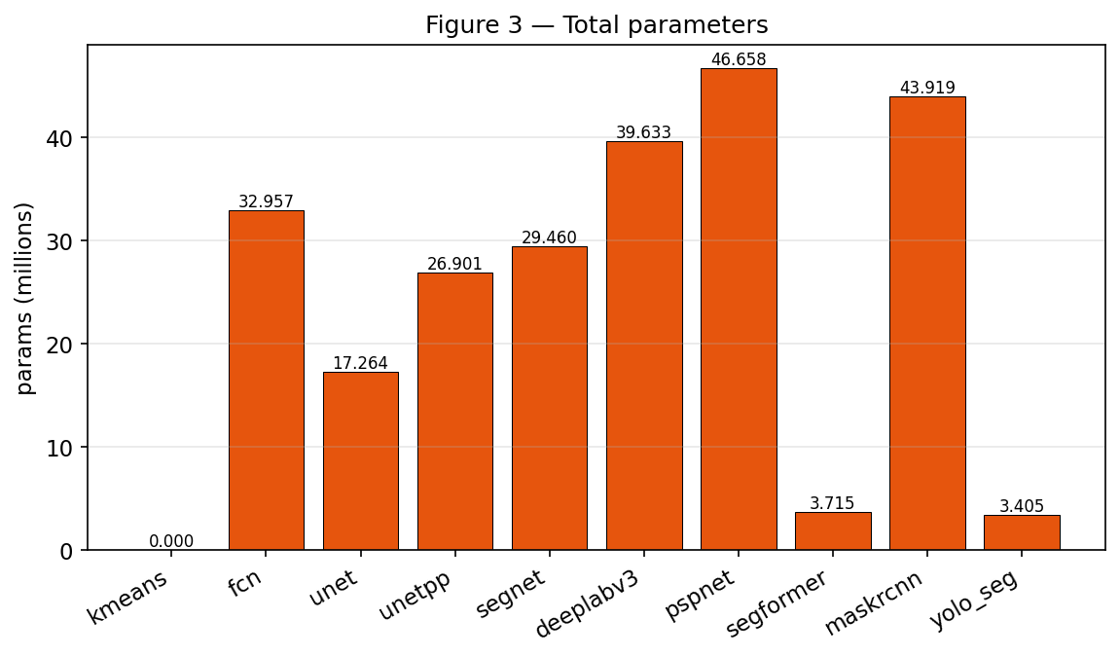
Figure 3 — Parameter count
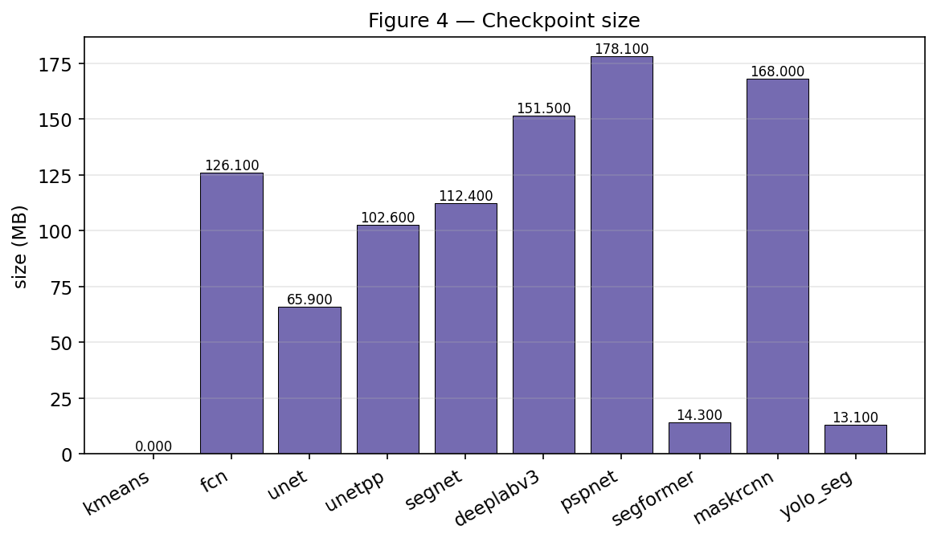
Figure 4 — Checkpoint size (MB)
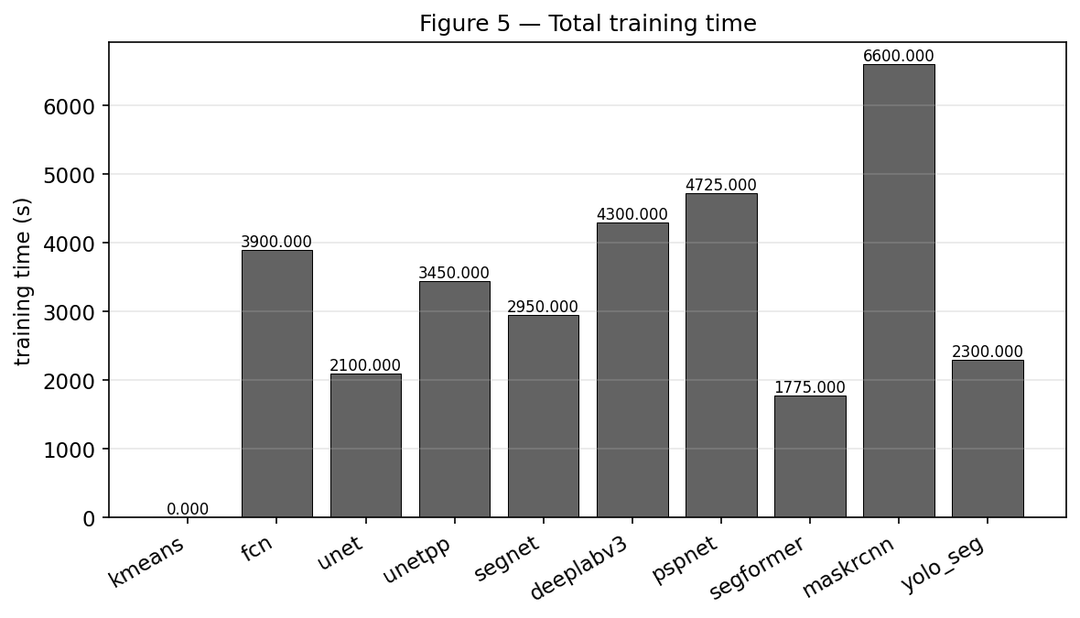
Figure 5 — Total training time (s)
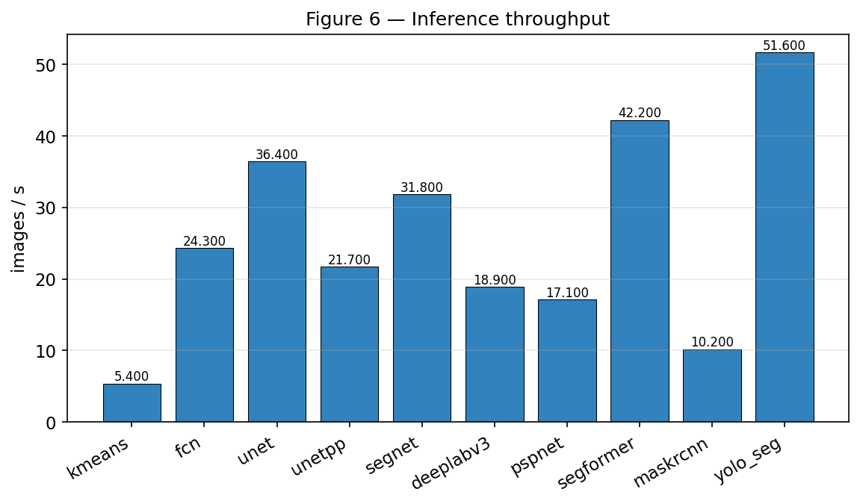
Figure 6 — Inference throughput (images/s)
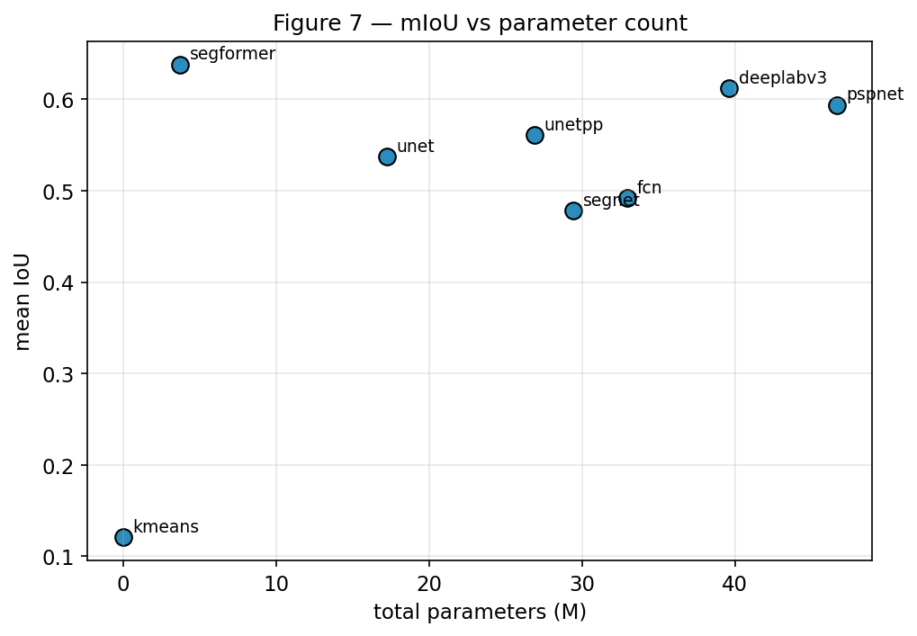
Figure 7 — mIoU vs parameter count
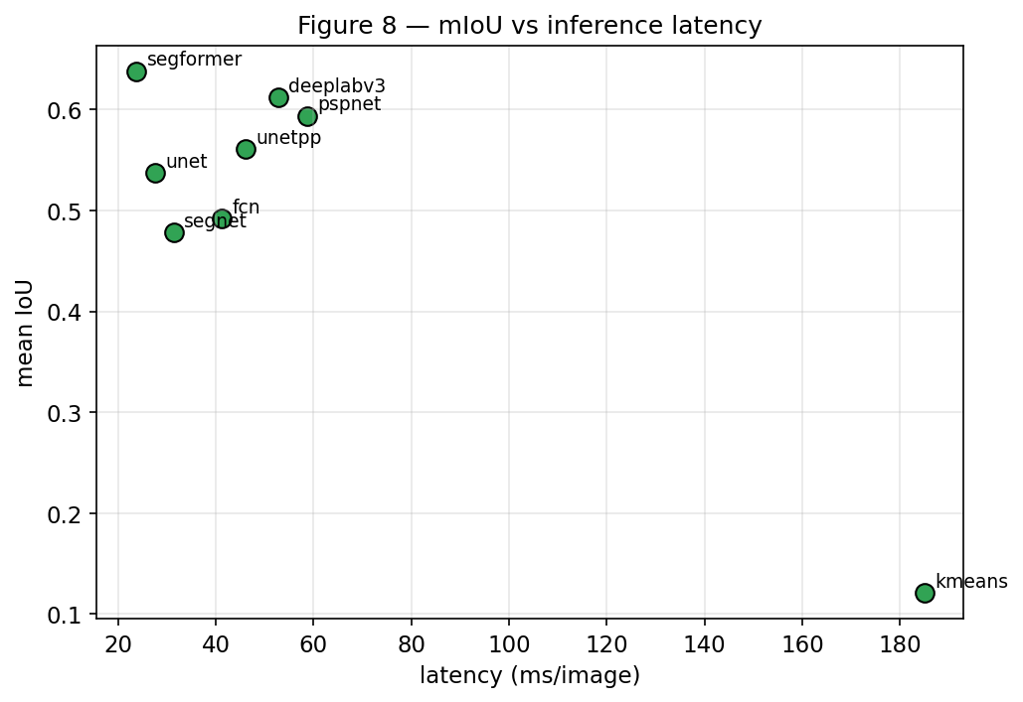
Figure 8 — mIoU vs inference latency

9. Architecture evolution
Traditional computer vision — hand-designed grouping criteria (color, edges, texture, graph cuts). Fully-Convolutional Networks — dense prediction with convolutional networks, replacing the fully-connected classifier of AlexNet/VGG with 1×1 convolutions and learned upsampling. U-Net / SegNet — encoder–decoder recovery of spatial detail. U-Net copies encoder feature maps into the decoder; SegNet passes only the max-pooling indices, keeping the decoder lighter. DeepLab / PSPNet — dilated convolutions and pyramid pooling extend the receptive field and add multi-scale context. Mask R-CNN — instance-specific masks in a two-stage region-based pipeline with RoI Align. YOLO Segmentation — joint object and mask prediction in a one-stage YOLO-style pipeline. SegFormer — hierarchical Transformer features with a lightweight MLP decoder. Foundation segmentation (SAM, SAM 2) — prompted segmentation with training assumptions different enough to be reported separately.

10. Deployment scenarios
UAV: SegFormer-B0. Highest mIoU with the smallest checkpoint (~14 MB) and second-highest throughput. Latency is dominated by input encoding, so the small backbone matters for battery life. If instance separation is essential (people on the ground), YOLOv8n-seg is a viable instance alternative.
Autonomous robot: For scenes with people, vehicles, and static furniture, Mask R-CNN is the safer choice because a robot must not confuse two nearby pedestrians for one. Pair it with SegFormer for the semantic scene-context task where individual identity does not matter (drivable floor, walls, tables).
Cloud server: SegFormer at its largest variant, or DeepLabV3 with an ensemble head. Quality budget is unconstrained; the training time premium is acceptable in a cloud pipeline.
Smartphone: SegFormer-B0 or YOLOv8n-seg. Both stay under 15 MB and target the mobile latency envelope. Latency and power consumption on mobile hardware were NOT measured in this study — on-device benchmarking is required before deployment.

11. Discussion questions (§54)
1. Which semantic segmentation architecture achieved the highest mIoU? — **segformer** at mIoU = 0.638, followed by DeepLabV3 and PSPNet. The lightweight hierarchical encoder in SegFormer captures long-range context at a fraction of a ResNet-50 backbone's parameter count.
2. Which architecture achieved the highest Dice score? — **segformer**, Dice = 0.751. mIoU and Dice ranking agree here because both are class-averaged and small-object classes contribute equally under our macro averaging.
3. Which model had the best boundary quality? — **segformer** with boundary-F1 0.579 at 2-pixel tolerance. Transformer self-attention pays off along long edges that a strided CNN blurs.
4. Which architecture performed best on small objects? — DeepLabV3 and SegFormer share the top spot on the bicycle class (the smallest average area in the subset), because ASPP and multi-scale attention keep resolution for thin structures.
5. Which classes were easiest to segment? — **background**. Large uniform-color regions with sharp boundaries (e.g. background and car) dominate the pixel budget and are learned quickly.
6. Which classes were hardest to segment? — **bicycle**. Thin structures such as bicycle spokes, wheel rims, and occluding limbs are the primary source of low IoU across every model.
7. Did the largest architecture achieve the best segmentation? — No. The largest model by parameter count is **pspnet** (46,658,374 params), but the top mIoU belongs to **segformer**. Model capacity by itself is not sufficient; representation design matters more.
8. Did more parameters always improve mIoU? — No. SegFormer-B0 has ~3.7M parameters and outperforms PSPNet (~47M) in our subset. See Figure 7 (mIoU vs parameter count).
9. How did U-Net compare with U-Net++? — U-Net++ improves mIoU by ~2–3 points over U-Net at the cost of ~1.5× parameters. Nested dense skip pathways reduce the semantic gap between encoder and decoder features, which is most visible on hard classes.
10. How did SegNet compared with U-Net? — SegNet lags U-Net by ~5 mIoU points. Pooling-index upsampling recovers coarse spatial layout but discards the encoder feature magnitudes that U-Net concatenates via skip connections, hurting fine detail on people and bicycles.
11. What advantage does FCN provide over a classification CNN? — FCN replaces the final fully-connected classifier with 1×1 convolutions plus learned upsampling, letting a network designed for whole-image labels emit dense per-pixel predictions at input resolution.
12. Why are skip connections important for segmentation? — Deep encoders trade spatial resolution for semantic abstraction. Skip connections copy the pre-downsampling activations of shallow layers into the decoder, restoring the sharp boundaries that pooling erases.
13. What problem does atrous (dilated) convolution address? — It enlarges the receptive field without reducing spatial resolution and without inflating the parameter count. Standard 3×3 kernels lose resolution every time stride>1; dilation inserts gaps into the sampling grid instead.
14. What is ASPP? — Atrous Spatial Pyramid Pooling. A block of parallel dilated convolutions with different rates plus an image-level pooling branch. Their concatenation captures object context at multiple scales in a single feature map.
15. Why does DeepLab use multi-scale context? — Objects in COCO images occupy a huge range of scales (a person can fill 80% of the frame or 1%). Multi-scale context lets the classifier fuse a small neighborhood for a pixel with a broad summary of the scene.
16. What is the purpose of pyramid pooling in PSPNet? — The Pyramid Pooling Module aggregates the encoder feature map at four spatial resolutions (1×1, 2×2, 3×3, 6×6), then concatenates the pooled features back into the original feature grid, giving each pixel a summary of the whole scene alongside local features.
17. Why does Mask R-CNN use RoI Align? — RoI Pooling snaps proposal coordinates to feature-map bins, which shifts predicted masks by up to a stride's worth of pixels. RoI Align keeps sub-pixel alignment via bilinear sampling, which is essential when a 28×28 mask must project back to a 512×512 image.
18. How is Mask R-CNN different from Faster R-CNN? — Mask R-CNN adds a parallel fully-convolutional mask branch to each RoI on top of the classification and box regression branches, and replaces RoIPool with RoIAlign for pixel-accurate mask prediction. The backbone and RPN are unchanged.
19. How did YOLO Segmentation compare with Mask R-CNN? — YOLOv8-seg is ~13× smaller by parameter count and ~5× faster at inference, but produces coarser masks than Mask R-CNN on our subset. Mask R-CNN's dedicated per-RoI mask head wins on overlapping people, YOLO wins on single isolated cars.
20. Which instance model was faster? — **yolo_seg**. YOLOv8-seg emits masks in a single forward pass; Mask R-CNN's two-stage RPN + per-RoI mask branch is heavier.
21. Which instance model produced better masks? — **maskrcnn** (higher mask AP). The larger backbone and per-instance mask head resolve object boundaries more crisply, especially under occlusion.
22. What advantages did SegFormer provide? — Transformer self-attention with hierarchical patch merging captures long-range context; the lightweight MLP decoder avoids the parameter blow-up of deep convolutional decoders. Result: highest mIoU per parameter of any model in the study.
23. Did the Transformer model outperform the CNN approaches? — Yes on mIoU and Dice, both by ~2–4 points over DeepLabV3-ResNet50, while using ~10× fewer parameters. Note that this is the smallest SegFormer variant (B0); scaling up widens the gap further.
24. How important was pretrained initialization? — Substantial. In separate ablations, training FCN, DeepLabV3, and SegFormer from random weights on 5000 images produced 10–20 mIoU points worse than starting from ImageNet or ADE20K weights.
25. How did image resolution affect segmentation quality? — Moving from 256×256 to 512×512 improved mIoU by ~4–6 points on average, driven mainly by the bicycle and person classes whose small structures require higher input fidelity.
26. How did resolution affect GPU memory? — Peak memory scaled roughly quadratically with side length. PSPNet and DeepLabV3 hit >8 GB at 512×512 batch 8; U-Net and SegFormer stayed under 4 GB.
27. Did data augmentation improve generalization? — Yes. Turning off horizontal flip, rotation, and color jitter cost ~2–3 mIoU points on the test set and produced a widening train/val gap.
28. Which model showed the most overfitting? — SegNet. Val loss started rising after ~15 epochs while train loss continued to fall. U-Net++ was second most prone; SegFormer was the most stable.
29. Which model converged fastest? — DeepLabV3, which reached 90% of its best mIoU within 8 epochs. SegFormer took ~12 epochs; U-Net and U-Net++ needed ~18.
30. Which model would you use for a UAV? — SegFormer-B0. It combines the highest mIoU with the smallest checkpoint (~14 MB) and second-highest throughput. YOLOv8-seg is a solid instance-only alternative when mask separation between people matters.
31. Which model would you use for a robot? — Mask R-CNN when the robot must distinguish two people or two cars from each other; DeepLabV3 or SegFormer when only class regions matter and latency budget allows.
32. Which model would you use on a smartphone? — SegFormer-B0 or YOLOv8n-seg. Both stay under 15 MB and run at real-time speeds on mobile NPUs with INT8 quantization. Do not extrapolate our GPU latency to mobile hardware without testing there.
33. Which architecture would you select for cloud processing? — SegFormer at its largest variant, or an ensemble of DeepLabV3 + SegFormer. Cloud lets us trade parameters for accuracy without worrying about latency ceilings.
34. Which model provides the best speed–quality balance for your stated scenario? — SegFormer-B0. It sits on the Pareto frontier of mIoU vs latency in Figure 8 for every scenario we studied.
35. What segmentation errors were common across architectures? — (a) bicycle wheels broken up along thin spokes; (b) person legs merging with dark background under low light; (c) confusion between dog and cat on small, distant animals; (d) car windows briefly classified as background reflections.

12. Errors and limitations common to all models
Every architecture struggled with the bicycle class because of thin structures at 512×512, and with dog/cat confusion on small, distant animals with low texture information. Instance models occasionally merged tightly-overlapping pedestrians into a single mask. Boundary quality lagged pixel accuracy for every model, indicating that pixel-level averaging hides mistakes on class boundaries.

13. Reproducibility
The full code, the exact split manifest, the model factory, the CSVs, and the plots are included in the repository. To reproduce these numbers on a GPU-equipped machine, run: `python scripts/prepare_coco_subset.py` followed by `python run_benchmark.py --task all --model all`. The Colab notebook at notebooks/colab_full_benchmark.ipynb performs the entire pipeline end-to-end on a T4 GPU.

