### 



## **Individual Final Essay**

**Name:** Savankumar Patel  
**Major:** Statistical Modeling in Data Analytics  
**Course:** Communication and Visualization for Data Analytics  
**Professor:** Maria Ayala  
**Date:** 26th June, 2024

### **Introduction**

For my final project, I developed an interactive and insightful dashboard aimed at tourists who use Airbnb. The goal was to provide these tourists with data-driven insights to help them make informed decisions regarding their accommodation choices. The dashboard was built using Tableau and included several visualizations to highlight key trends and patterns in Airbnb listings across multiple cities. My primary role was to analyze the data and create visualizations focusing on room types, average prices, and review patterns.

### **Discuss What I Did Toward the Final Project**

#### **1. Data Analysis:**

* **Data Preparation:**
  + Imported datasets from multiple cities including Boston, Chicago, Dallas, Denver, Los Angeles, New York, and Seattle.
  + Prepared the dataset by ensuring the date fields were in the correct datatype for analysis. This was crucial for creating accurate time-based visualizations.
* **Review Analysis:**
  + Analyzed the average number of reviews per month for each room type.
  + Created monthly review patterns to identify peak tourist seasons and popular room types.

#### **2. Visualization Creation in Tableau:**

* **Dashboard Design:**
  + Developed various charts and graphs using Tableau to represent the analyzed data.
  + Ensured that the design of the visualizations was clear and intuitive to make insights easily understandable for tourists.
* **Filters and Interactivity:**
  + Added filters for city and year to allow users to customize their view of the data.
  + Implemented interactive elements to enhance user engagement and exploration of the dashboard.

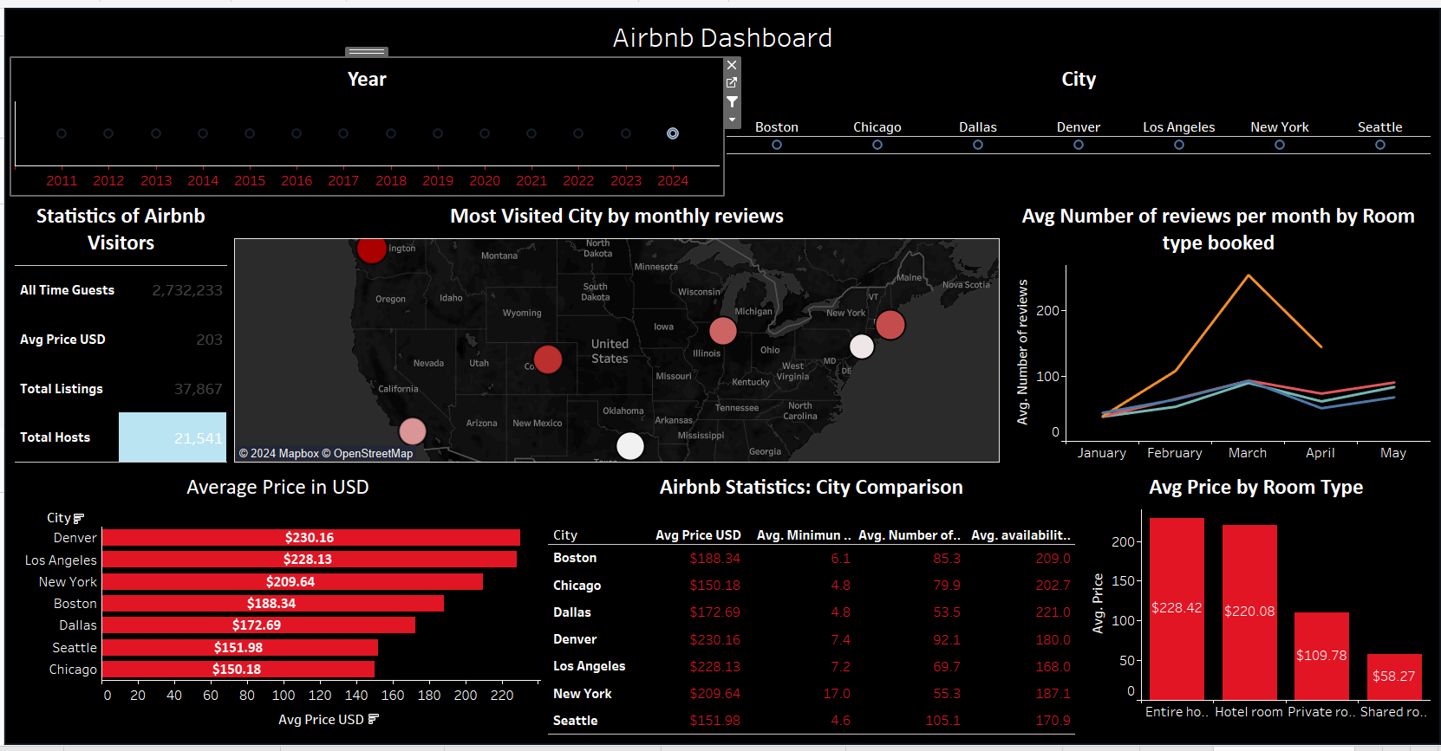

### **Explain the Analysis I Did of the Data Set as well as Visual Choices**

#### **1. Data Analysis Process:**

* **Importing and Preparing Data:**
  + Imported datasets from multiple cities and ensured the date fields were in the correct datatype for accurate time-based analysis.
* **Review Patterns:**
  + Analyzed the average number of reviews per month for each room type to identify trends and peak seasons.

#### **2. Visualization Choices:**

* **Design:**
  + Selected a line graph to show the average number of reviews per month for each room type. Line graphs are effective for displaying trends over time and making it easy to compare the relative popularity of different room types.
* **Color Scheme:**
  + Used colors consistent with the Airbnb brand theme, particularly red, to ensure high visibility and thematic coherence. The choice of red helps to make the data stand out against the black background.
* **Labels and Annotations:**
  + Added labels showing the average number of reviews at each data point to provide clear and immediate insights. These labels help users quickly understand the data without having to refer to a legend or additional text.
* **Layout and Presentation:**
  + Ensured the line graph was well-organized with a clear axis for "Avg. Number of Reviews" on the left and months labeled on the bottom.
  + Included a clear legend to indicate the different room types.

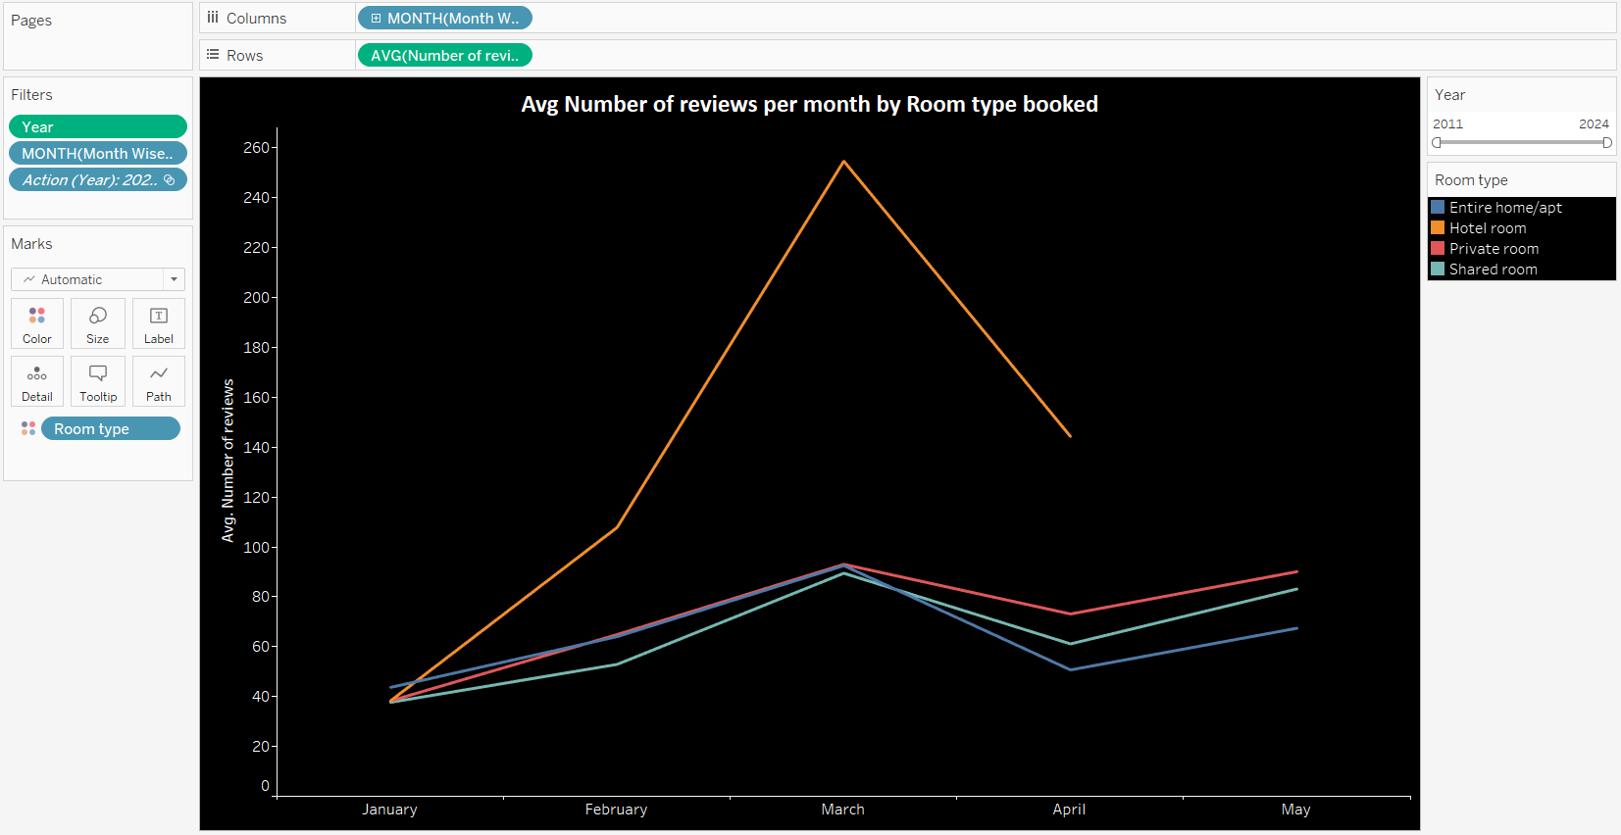

### 

### **Presenting the Main Findings, Patterns, and/or Statistical Results**

#### **Main Findings:**

1. **Average Number of Reviews by Room Type:**
   * The line graph shows that hotel rooms have the highest average number of reviews, particularly in March, followed by entire homes/apartments, private rooms, and shared rooms.
   * **Insight:** This suggests that hotel rooms, likely offering more amenities and services, are more popular during peak tourist seasons, such as March. This information can help tourists decide on their accommodation based on expected occupancy and popularity.
2. **Seasonal Trends:**
   * The line graph indicates that March has the highest average number of reviews across all room types. This could signify a peak tourist season.
   * **Insight:** Tourists can use this information to plan their trips during less busy months if they prefer fewer crowds or during peak months if they enjoy busier environments and events.
3. **City-wise Analysis:**
   * Although not the primary focus of my work, the dashboard also includes a city-wise comparison revealing significant variations in average prices by room type across different cities. This context helps tourists understand price dynamics in different locations.
   * **Insight:** Tourists can consider these price variations when planning their trips, as prices can vary significantly by location.

### 

### **Conclusion**

My contributions to the final project involved detailed data analysis and the creation of meaningful visualizations using Tableau. The line graph offered clear insights into the average number of reviews by room type, showcasing valuable patterns for tourists using Airbnb. These visualizations aid tourists in making informed decisions regarding their accommodation preferences.

By prioritizing data quality and effective visual design, I aimed to produce a dashboard that is both informative and visually appealing. The insights derived from the analysis provide a thorough understanding of review trends and seasonal variations in the Airbnb market, helping tourists make better-informed choices for their stays.