Medical Diagnostic
Support System
━━━━━━━━━━━━━━━━━━━━━━━━━━━━━━━━━━━━━━━━
Using Semantic Networks, Frame-Based Knowledge
Representation & Neo4j Graph Database

Submitted by:D.Savanth
23MIS7317

Project Report
Technologies: Python · Neo4j · NetworkX · Tkinter
Knowledge Base: 46 Diseases · 205 Symptoms

Table of Contents
1. Introduction
2. Problem Statement
3. Core Concepts & Theory
3.1 Frame-Based Knowledge Representation
3.2 Semantic Networks
3.3 Graph Databases (Neo4j)
4. System Architecture
5. Database Schema Design
6. Diagnostic Process
7. Dataset Overview
8. Implementation Details
8.1 Knowledge Base Seeding
8.2 Diagnostic Engine
8.3 Graphical User Interface
8.4 Network Visualization
8.5 Source Code - Key Functions & Algorithms
9. Technologies Used
10. Sample Outputs
11. Conclusion & Future Scope

1. Introduction
The Medical Diagnostic Support System (MDSS) is an intelligent, graph-based application designed to assist in preliminary disease diagnosis. Traditional diagnostic systems often rely on rigid, relational databases that struggle with complex, interconnected medical data. By utilizing Graph Databases and Semantic Networks, this project natively models the non-linear relationships between diseases, symptoms, and treatments.
The system provides medical professionals and patients with a fast, preliminary diagnostic tool that can map patient symptoms to likely conditions, compute confidence scores, display relevant treatments and risk factors, and visually represent the reasoning behind each diagnosis through an interactive semantic network graph.
The current knowledge base contains 46 diseases across 12 body-system categories, with comprehensive symptom mappings, treatment protocols, and risk factor data.

2. Problem Statement
Medical knowledge is inherently highly interconnected. A single disease can have multiple symptoms, and a single symptom (like "Fever") can be common across numerous diseases. Storing this data in traditional SQL tabular formats leads to complex joins, slow performance when analyzing deep connections, and difficulty in representing the semantic meaning of medical relationships.
There is a need for a system that can semantically understand these relationships — treating medical entities as nodes and their relationships as edges — to quickly query and isolate potential diagnoses based on a combination of patient symptoms with computed confidence levels.

3. Core Concepts & Theory

3.1 Frame-Based Knowledge Representation
In artificial intelligence, a "Frame" is a data structure for dividing knowledge into substructures by representing "stereotyped situations." In our system, each Disease acts as a frame with the following components:
- Slots: Properties inherent to the disease (e.g., Description, Prevalence, Severity, Category)
- Fillers: Links to other distinct objects (e.g., Symptoms, Treatments, Risk Factors)
By applying frame-based logic, the system standardizes how varying medical conditions are structurally understood, making it easily expandable and maintainable.
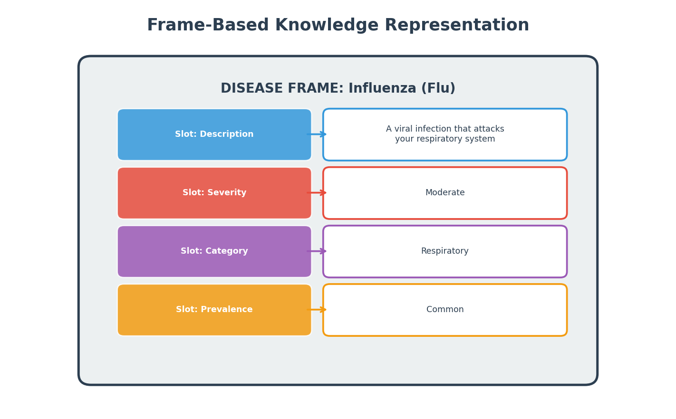
Figure 1: Frame-Based Knowledge Representation for a Disease

3.2 Semantic Networks
A Semantic Network is a knowledge base that represents semantic relations between concepts in a network. In this project:
- Nodes (Vertices): Represent core entities: Disease, Symptom, Treatment, Category, RiskFactor
- Edges (Links): Represent directional relationships: HAS_SYMPTOM, TREATS, BELONGS_TO, HAS_RISK_FACTOR
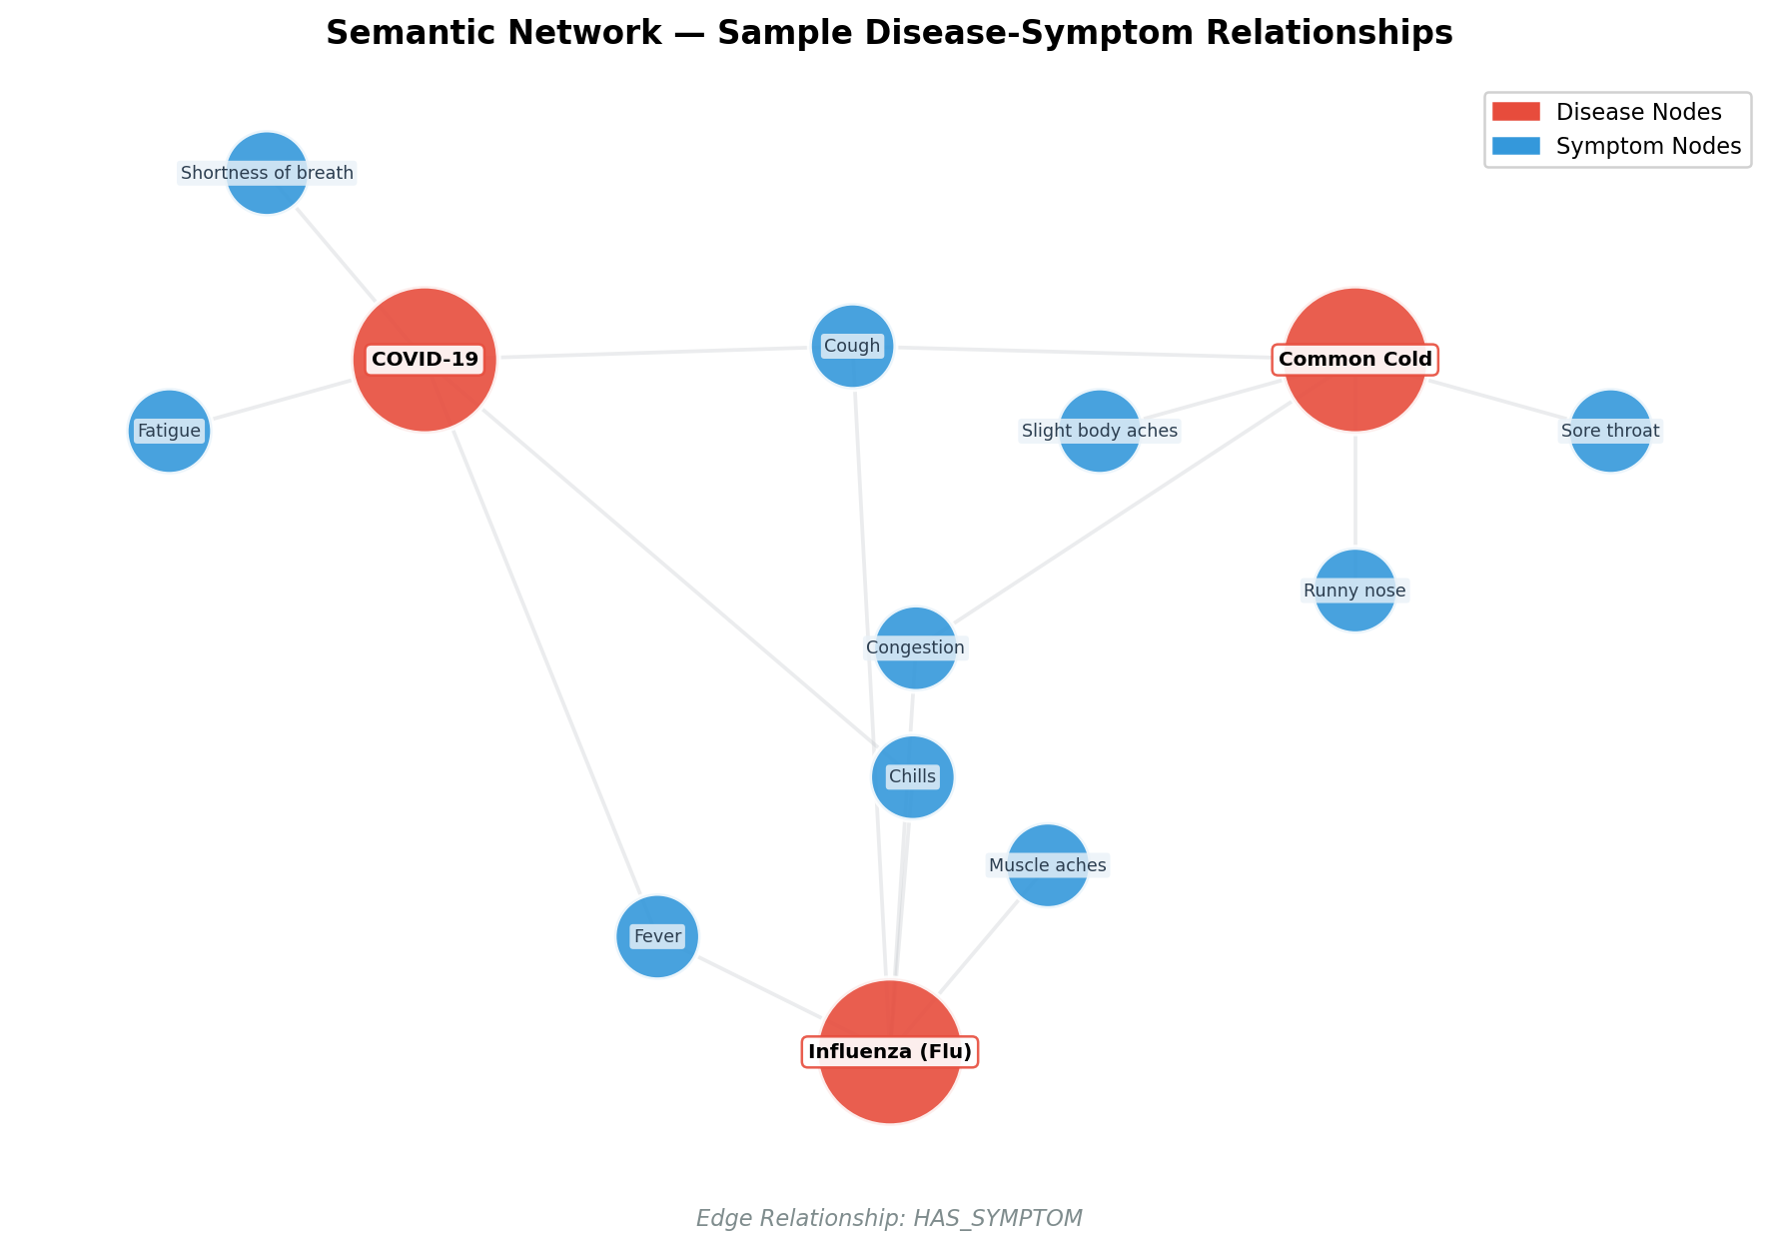
Figure 2: Semantic Network — Sample Disease-Symptom Relationships

3.3 Graph Databases (Neo4j)
To ensure the system is scalable to thousands of medical conditions, Neo4j is used as the data storage layer. Unlike relational databases that use tables, Neo4j is a native graph database. This allows for instantaneous retrieval of connected pathways using Cypher Query Language (CQL), making complex diagnostic pattern-matching highly resource-efficient.
Key advantages of Neo4j over traditional RDBMS for this application:
- Native graph storage eliminates costly JOIN operations
- Constant-time traversal of relationships regardless of dataset size
- Intuitive visual query language (Cypher) maps directly to our semantic network
- Schema-flexible design allows easy addition of new disease categories

4. System Architecture
The application is structured into three continuous processing layers:
- Input Layer: The user submits symptoms through a modern Tkinter GUI application with text entry, quick-add buttons, and category browsing. Symptoms are automatically parsed and standardized.
- Processing Layer: The system executes Cypher queries against the Neo4j graph database. It scans the semantic network for all paths from Symptom nodes to Disease nodes, computing confidence scores as the ratio of matched symptoms to total disease symptoms.
- Output Layer: Results are displayed with confidence percentages, severity indicators, treatments, and risk factors. A clustered semantic network graph is rendered inline showing the diagnosis reasoning.
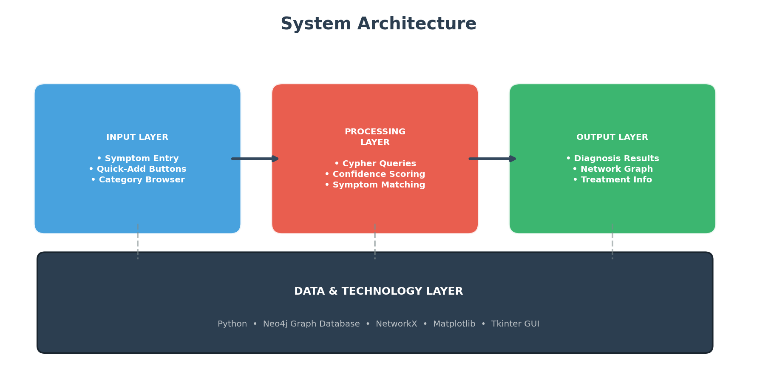
Figure 3: Three-Layer System Architecture

5. Database Schema Design
The Neo4j database schema consists of five node types connected by four relationship types:
Node Type | Properties | Description
Disease | name, description, severity,  category, prevalence | Core medical conditions
Symptom | name | Observable patient symptoms
Treatment | name | Medical treatments and remedies
Category | name | Body system classification
RiskFactor | name | Contributing risk factors

Relationship Types:
Relationship | Direction | Meaning
HAS_SYMPTOM | Disease → Symptom | Disease exhibits this symptom
TREATS | Treatment → Disease | Treatment addresses this disease
BELONGS_TO | Disease → Category | Disease belongs to body system
HAS_RISK_FACTOR | Disease → RiskFactor | Disease has this risk factor

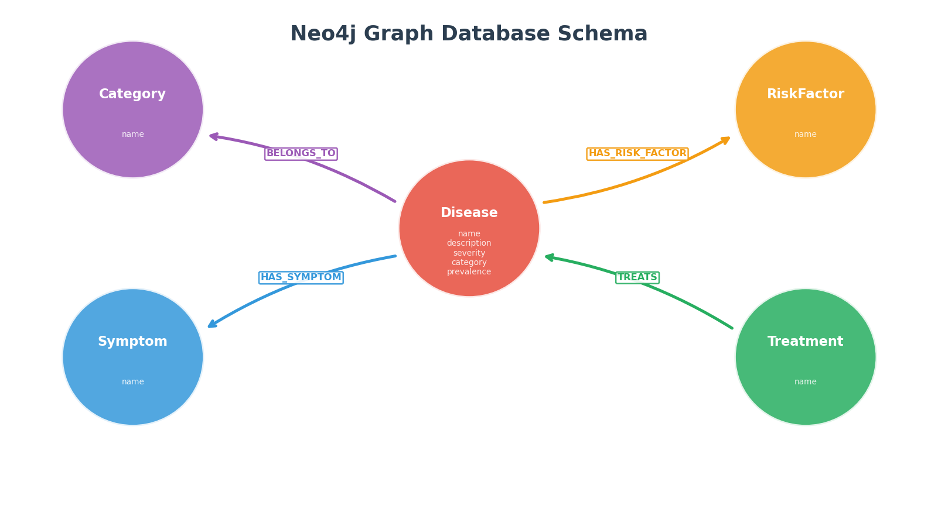
Figure 4: Neo4j Graph Database Schema

6. Diagnostic Process
The diagnostic engine follows a six-step pipeline to convert raw patient symptoms into ranked disease predictions with confidence scores:
Step 1 — Symptom Input: Patient enters symptoms via the GUI text field or quick-add buttons. Multiple symptoms are comma-separated.
Step 2 — Parsing: Symptoms are cleaned, trimmed, and converted to title case to match the standardized database format.
Step 3 — Cypher Query: A Cypher MATCH query is executed against Neo4j, finding all Disease nodes connected to the provided Symptom nodes via HAS_SYMPTOM edges.
Step 4 — Confidence Scoring: For each matched disease, confidence is calculated as: Confidence = (Matched Symptoms / Total Disease Symptoms) × 100%. Results are ranked by confidence descending.
Step 5 — Result Ranking: The top 5 diseases are returned with their confidence percentage, severity level, category, and matched symptom list.
Step 6 — Visualization: A clustered semantic network graph is drawn showing the top 3 diseases with their symptom clusters. Matched symptoms are highlighted.
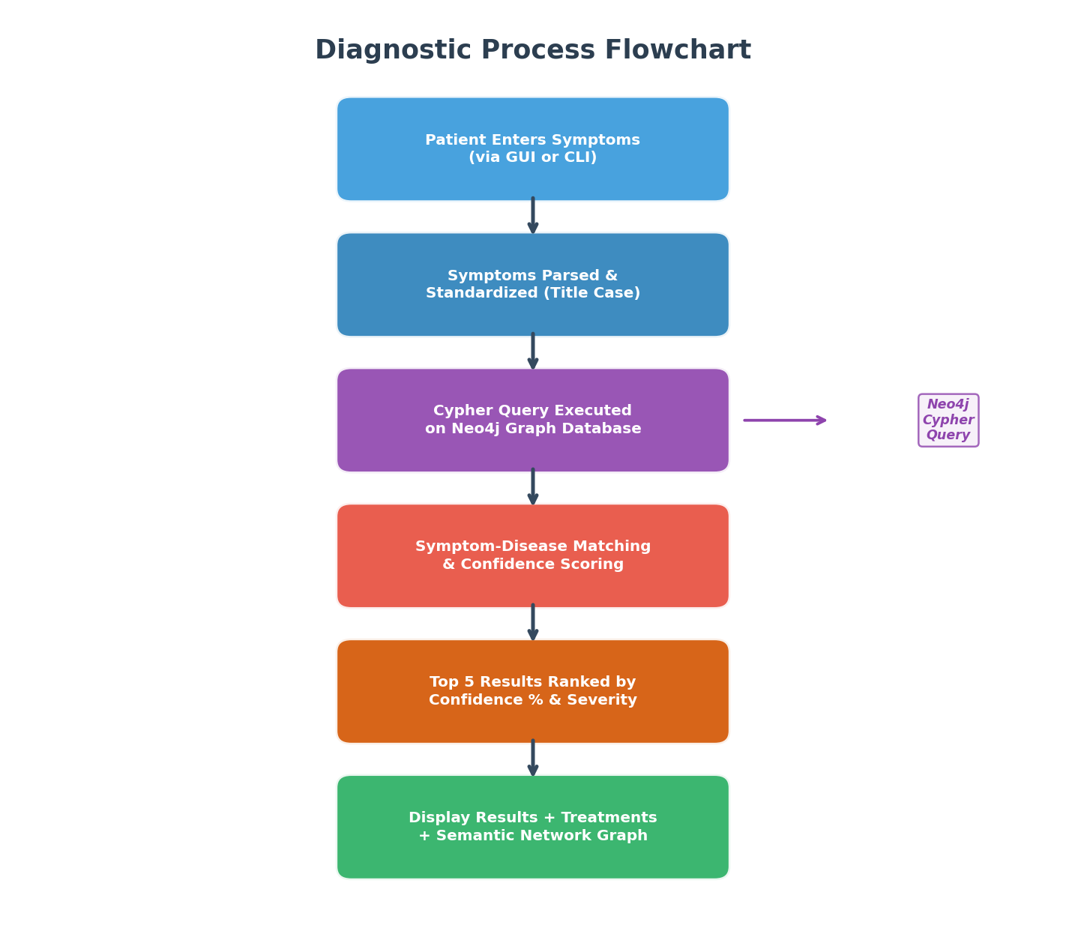
Figure 5: Diagnostic Process Flowchart

Core Diagnostic Cypher Query
MATCH (d:Disease)-[:HAS_SYMPTOM]->(s:Symptom)
WITH d, collect(s.name) AS allSymptoms
WITH d, allSymptoms, size(allSymptoms) AS totalSymptoms
WITH d, allSymptoms, totalSymptoms,
[sym IN allSymptoms WHERE sym IN $patient_symptoms] AS matched
WITH d, matched, totalSymptoms, size(matched) AS matchCount
WHERE matchCount > 0
RETURN d.name AS Disease,
toFloat(matchCount)/toFloat(totalSymptoms)*100 AS Confidence
ORDER BY Confidence DESC LIMIT 5

7. Dataset Overview
The medical knowledge base contains 46 diseases across 12 body-system categories. Each disease is modeled as a frame with slots for description, severity, prevalence, and category, plus fillers linking to symptoms, treatments, and risk factors.
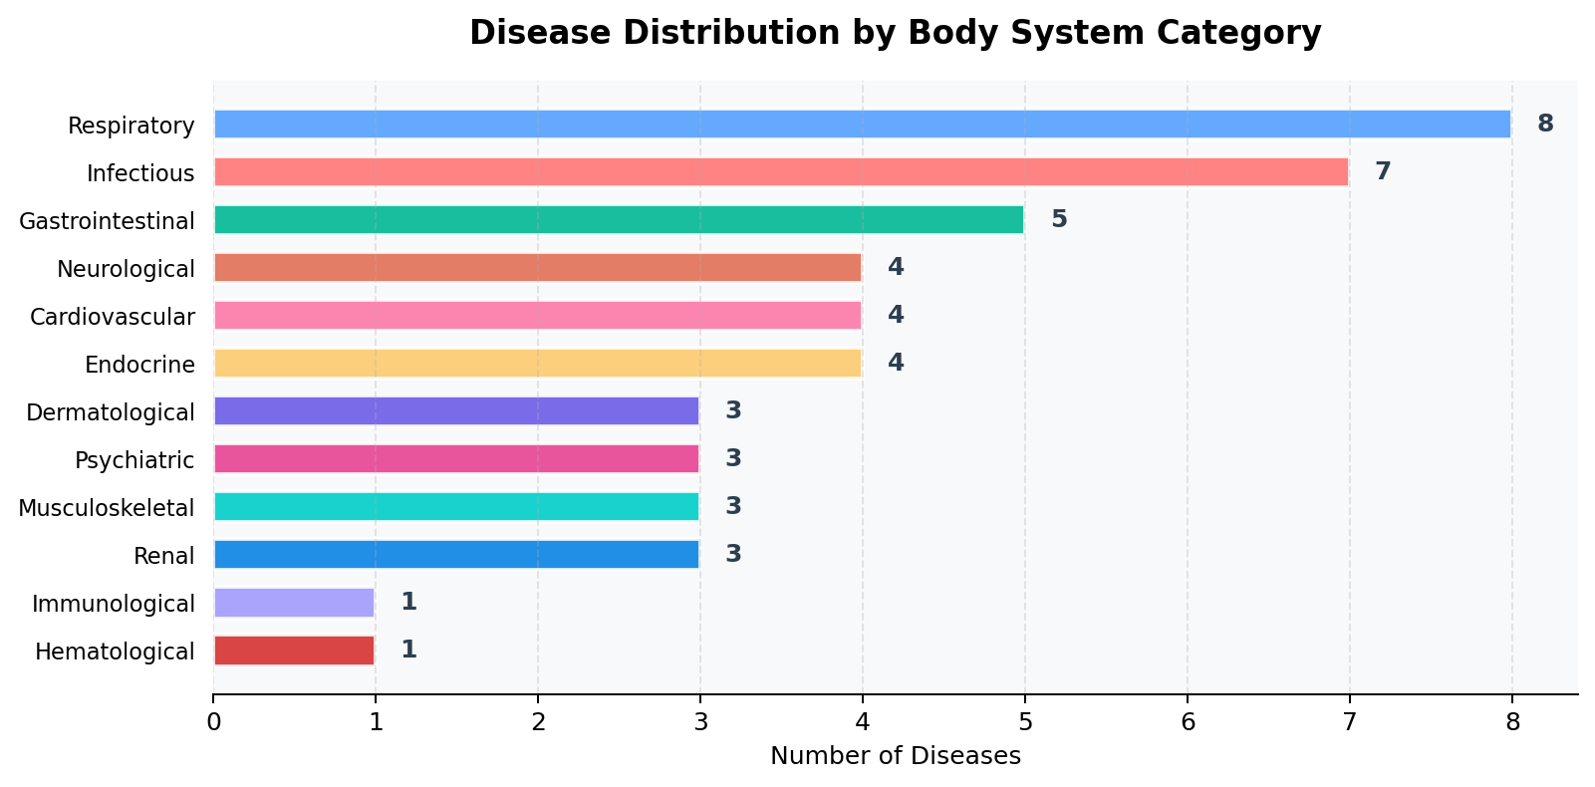
Figure 6: Disease Distribution by Body System Category

Complete Disease List
Cardiovascular
Disease | Severity | Prevalence | Symptoms
Atrial Fibrillation | Moderate to High | Common | Heart palpitations, Shortness of breath, Fatigue, Dizziness, Chest pain, Reduced ability to exercise
Coronary Artery Disease | High | Very Common | Chest pain, Chest pressure, Shortness of breath, Pain in neck or jaw, Pain in shoulder or arm, Fatigue
Heart Failure | High | Common | Shortness of breath, Fatigue, Swollen legs and ankles, Rapid heartbeat, Persistent cough, Wheezing
Hypertension (High Blood Pressure) | Moderate to High | Very Common | Headache, Shortness of breath, Nosebleeds, Flushing, Dizziness, Chest pain
Dermatological
Disease | Severity | Prevalence | Symptoms
Cellulitis | Moderate to High | Common | Red area of skin that tends to expand, Swelling, Tenderness, Pain, Warmth, Fever
Eczema (Atopic Dermatitis) | Mild to Moderate | Very Common | Dry skin, Itching, Red or brownish-gray patches, Small raised bumps, Thickened cracked skin, Raw sensitive skin from scratching
Psoriasis | Moderate | Common | Red patches of skin covered with silvery scales, Dry cracked skin that may bleed, Itching, Burning or soreness, Thickened or ridged nails, Swollen stiff joints
Endocrine
Disease | Severity | Prevalence | Symptoms
Cushing's Syndrome | High | Rare | Weight gain (especially face and abdomen), Purple stretch marks, Thin fragile skin, Slow healing, Acne, Fatigue
Diabetes Type 2 | Moderate to High | Very Common | Increased thirst, Frequent urination, Increased hunger, Unintended weight loss, Fatigue, Blurred vision
Hyperthyroidism | Moderate | Common | Rapid heartbeat, Weight loss, Increased appetite, Tremor, Sweating, Nervousness
Hypothyroidism | Moderate | Common | Fatigue, Weight gain, Cold intolerance, Constipation, Dry skin, Puffy face
Gastrointestinal
Disease | Severity | Prevalence | Symptoms
Gastroenteritis (Stomach Flu) | Moderate | Common | Watery diarrhea, Abdominal cramps, Nausea, Vomiting, Muscle aches, Low-grade fever
Gastroesophageal Reflux Disease (GERD) | Mild to Moderate | Very Common | Heartburn, Chest pain, Difficulty swallowing, Regurgitation of food or sour liquid, Sensation of a lump in your throat, Chronic cough
Hepatitis B | High | Common globally | Abdominal pain, Dark urine, Fever, Joint pain, Loss of appetite, Nausea
Irritable Bowel Syndrome (IBS) | Moderate | Common | Abdominal pain, Bloating, Gas, Diarrhea, Constipation, Mucus in stool
Peptic Ulcer Disease | Moderate | Common | Burning stomach pain, Bloating, Heartburn, Nausea, Intolerance to fatty foods, Feeling of fullness
Hematological
Disease | Severity | Prevalence | Symptoms
Anemia | Moderate | Common | Fatigue, Weakness, Pale skin, Chest pain, Cold hands and feet, Shortness of breath
Immunological
Disease | Severity | Prevalence | Symptoms
Allergic Rhinitis (Allergies) | Mild | Very Common | Sneezing, Runny nose, Itchy eyes, Watery eyes, Congestion
Infectious
Disease | Severity | Prevalence | Symptoms
Chickenpox | Mild to Moderate | Common | Itchy blister-like rash, Fever, Fatigue, Loss of appetite, Headache, General feeling of being unwell
Cholera | Critical | Common in areas with poor sanitation | Profuse watery diarrhea, Vomiting, Rapid dehydration, Muscle cramps, Low blood pressure, Thirst
Dengue Fever | Moderate to High | Common in tropical regions | High fever, Severe headache, Pain behind the eyes, Joint and muscle pain, Fatigue, Nausea
Malaria | High | Common in tropical regions | Fever, Chills, Sweating, Headache, Nausea, Vomiting
Measles | Moderate to High | Uncommon (where vaccinated) | High fever, Cough, Runny nose, Red watery eyes, Skin rash, Koplik spots (white spots inside cheeks)
Strep Throat | Moderate | Common | Throat pain, Difficulty swallowing, Red and swollen tonsils, Swollen lymph nodes, Fever, Headache
Typhoid Fever | High | Common in developing countries | Sustained high fever, Weakness, Abdominal pain, Headache, Diarrhea or constipation, Rose-colored spots on chest
Musculoskeletal
Disease | Severity | Prevalence | Symptoms
Gout | Moderate | Common | Intense joint pain (often big toe), Lingering discomfort, Inflammation and redness, Limited range of motion, Warmth in joint
Osteoarthritis | Moderate | Very Common | Joint pain, Joint stiffness, Tenderness, Loss of flexibility, Grating sensation, Bone spurs
Rheumatoid Arthritis | Moderate to High | Common | Tender swollen joints, Joint stiffness (worse in morning), Fatigue, Fever, Loss of appetite, Firm bumps under skin on arms
Neurological
Disease | Severity | Prevalence | Symptoms
Epilepsy | High | Common | Seizures, Temporary confusion, Staring spells, Uncontrollable jerking movements, Loss of consciousness, Anxiety
Meningitis | Critical | Uncommon | Sudden high fever, Stiff neck, Severe headache, Nausea, Vomiting, Sensitivity to light
Migraine | Moderate to High | Common | Throbbing head pain, Nausea, Vomiting, Sensitivity to light, Sensitivity to sound
Parkinson's Disease | High | Uncommon | Tremor, Slowed movement, Rigid muscles, Impaired posture and balance, Loss of automatic movements, Speech changes
Psychiatric
Disease | Severity | Prevalence | Symptoms
Generalized Anxiety Disorder | Moderate | Common | Excessive worry, Restlessness, Fatigue, Difficulty concentrating, Irritability, Muscle tension
Major Depression | Moderate to High | Very Common | Persistent sadness, Loss of interest, Sleep disturbances, Fatigue, Feelings of worthlessness, Difficulty concentrating
Panic Disorder | Moderate to High | Common | Sudden intense fear, Heart palpitations, Sweating, Trembling, Shortness of breath, Chest pain
Renal
Disease | Severity | Prevalence | Symptoms
Chronic Kidney Disease | High | Common | Nausea, Vomiting, Loss of appetite, Fatigue, Sleep problems, Decreased mental sharpness
Kidney Stones | Moderate to High | Common | Severe pain in side and back, Pain that radiates to lower abdomen and groin, Pain during urination, Pink red or brown urine, Nausea, Vomiting
Urinary Tract Infection (UTI) | Mild to Moderate | Common | Strong, persistent urge to urinate, Burning sensation when urinating, Passing frequent, small amounts of urine, Urine that appears cloudy, Urine that appears red, Strong-smelling urine
Respiratory
Disease | Severity | Prevalence | Symptoms
Asthma | Variable | Common | Shortness of breath, Chest tightness, Wheezing, Coughing attacks
Bronchitis | Moderate | Common | Cough, Production of mucus (sputum), Fatigue, Shortness of breath, Slight fever, Chills
COVID-19 | High | Common | Fever, Chills, Cough, Shortness of breath, Fatigue, Muscle aches
Chronic Obstructive Pulmonary Disease (COPD) | High | Common | Shortness of breath, Wheezing, Chest tightness, Chronic cough, Respiratory infections, Lack of energy
Common Cold | Mild | Very Common | Runny nose, Sore throat, Cough, Congestion, Slight body aches, Mild headache
Influenza (Flu) | Moderate | Common | Fever, Chills, Muscle aches, Cough, Congestion, Runny nose
Pneumonia | High | Common | Chest pain when breathing, Cough with phlegm, Fatigue, Fever, Sweating, Chills
Tuberculosis | High | Common globally | Persistent cough, Chest pain, Coughing up blood, Fatigue, Night sweats, Chills

8. Implementation Details

8.1 Knowledge Base Seeding
The seed_database() method clears existing Neo4j data and builds the complete graph from the Python dictionary-based knowledge base. For each disease frame, it creates:
- A Disease node with name, description, severity, category, and prevalence properties
- A Category node with a BELONGS_TO relationship
- Symptom nodes with HAS_SYMPTOM relationships
- Treatment nodes with TREATS relationships
- RiskFactor nodes with HAS_RISK_FACTOR relationships

8.2 Diagnostic Engine
The diagnostic engine executes an advanced Cypher query that performs symptom matching with confidence scoring in a single database pass. The query uses list comprehension within Cypher to compute the intersection of patient symptoms with each disease's symptom list, then calculates a percentage confidence score.
Results are ordered by confidence descending, then by raw match count as a tiebreaker. The top 5 results are returned to the user interface.

8.3 Graphical User Interface (GUI)
The application features a modern dark-themed Tkinter GUI (gui.py) with the following components:
- Symptom input field with enter-key support and quick-add buttons for common symptoms
- Category browser dropdown for exploring diseases by body system
- Action buttons: List All Diseases, List All Symptoms, Full Network, Reseed Database
- Color-coded results panel showing confidence bars, severity levels, treatments, and risk factors
- Embedded semantic network graph visualization (right panel)
- Status bar showing connection status and disease counts

8.4 Network Visualization
The visualization uses a custom clustered radial layout algorithm. Each disease is placed on a circle, with its symptoms arranged in a ring around it. Shared symptoms (like Fever) are positioned at the midpoint between their connected diseases. This eliminates the messy overlapping common with spring-force layouts.
In diagnostic mode, only the top 3 matched diseases are shown. Matched patient symptoms are highlighted in yellow with bold labels, while unmatched symptoms appear as small gray nodes.

8.5 Source Code - Key Functions & Algorithms
This section presents the core source code functions that power the diagnostic system. Only the main logic and algorithms are shown for clarity.
1. Knowledge Base Frame Structure (medical_dataset.py)
Each disease is stored as a Python dictionary (frame). Slots hold direct properties (description, severity, category, prevalence). Fillers hold relationships to other entities (symptoms, treatments, risk_factors). This structure is directly mapped to Neo4j nodes and edges.
"Influenza (Flu)": {
"description": "A viral infection that attacks your
respiratory system.",
"prevalence": "Common",
"severity": "Moderate",
"category": "Respiratory",
"symptoms": ["Fever", "Chills", "Muscle aches",
"Cough", "Congestion", "Runny nose",
"Headache", "Fatigue"],
"treatments": ["Rest", "Fluid intake",
"Antiviral medication",
"Pain relievers"],
"risk_factors": ["Weakened immune system",
"Age (under 5 or over 65)",
"Chronic illness"]
}
2. Neo4j Database Connection (main.py)
The system connects to Neo4j using the official Python driver. verify_connectivity() ensures the credentials and URI are valid before proceeding.
class MedicalKnowledgeBase:
def __init__(self, uri, user, password):
try:
self.driver = GraphDatabase.driver(
uri, auth=(user, password)
)
self.driver.verify_connectivity()
print("Connected to Neo4j Database.")
except Exception as e:
print(f"Failed to connect: {e}")
self.driver = None
3. Database Seeding Algorithm (main.py)
Algorithm: For each disease frame in the knowledge base, the seeder creates a Disease node with all slot properties, then uses MERGE to create unique Symptom, Treatment, Category, and RiskFactor nodes with their respective relationship edges. MERGE prevents duplicate nodes when multiple diseases share symptoms.
def seed_database(self):
"""Load all frames into Neo4j as nodes
and relationships."""
with self.driver.session() as session:
# Clear old data
session.run("MATCH (n) DETACH DELETE n")
for disease_name, frame in MEDICAL_KNOWLEDGE_BASE.items():
# 1. Create Disease node with properties
session.run('''
CREATE (d:Disease {
name: $name,
description: $description,
severity: $severity,
category: $category
})
''', name=disease_name, ...)
# 2. Create Category node + BELONGS_TO edge
session.run('''
MATCH (d:Disease {name: $d_name})
MERGE (c:Category {name: $c_name})
MERGE (d)-[:BELONGS_TO]->(c)
''', d_name=disease_name, c_name=category)
# 3. Create Symptom nodes + HAS_SYMPTOM edges
for symptom in frame.get("symptoms", []):
session.run('''
MATCH (d:Disease {name: $d_name})
MERGE (s:Symptom {name: $s_name})
MERGE (d)-[:HAS_SYMPTOM]->(s)
''', d_name=disease_name, s_name=symptom)
# 4. Create Treatment + RiskFactor nodes
# (similar MERGE pattern for TREATS and
# HAS_RISK_FACTOR relationships)

4. Diagnostic Engine with Confidence Scoring (main.py)
Algorithm: The Cypher query traverses all Disease->Symptom edges, collects each disease's full symptom list, computes the intersection with the patient's input using list comprehension, then calculates Confidence = (matched / total) * 100. Results are sorted by confidence descending, returning the top 5 matches with severity and category metadata.
def diagnose(self, symptoms):
"""Core diagnostic algorithm using Cypher."""
with self.driver.session() as session:
query = '''
MATCH (d:Disease)-[:HAS_SYMPTOM]->(s:Symptom)
WITH d, collect(s.name) AS allSymptoms
WITH d, allSymptoms,
size(allSymptoms) AS totalSymptoms
WITH d, allSymptoms, totalSymptoms,
[sym IN allSymptoms
WHERE sym IN $patient_symptoms]
AS matchedSymptoms
WITH d, matchedSymptoms, totalSymptoms,
size(matchedSymptoms) AS matchCount
WHERE matchCount > 0
RETURN d.name AS Disease,
matchCount AS MatchingSymptoms,
totalSymptoms AS TotalSymptoms,
matchedSymptoms AS MatchedSymptomList,
d.severity AS Severity,
d.category AS Category,
toFloat(matchCount)
/ toFloat(totalSymptoms)
* 100 AS Confidence
ORDER BY Confidence DESC,
MatchingSymptoms DESC
LIMIT 5
'''
result = session.run(
query, patient_symptoms=symptoms
)
return [record for record in result]
5. Clustered Radial Layout Algorithm (main.py)
Algorithm: Instead of spring-force layout (which causes messy overlapping), this custom algorithm places each disease at an equally-spaced point on a large circle, then arranges each disease's symptoms in a smaller ring around it. When a symptom appears in multiple diseases (e.g., 'Fever'), its position is averaged between clusters, placing it between the diseases that share it. This produces clean, readable cluster diagrams.
def visualize_network(self, top_diseases, symptoms):
"""Custom radial cluster layout for clean graphs."""
# Step 1: Place diseases on a large circle
for i, disease in enumerate(diseases_list):
angle = 2 * pi * i / n_diseases - pi / 2
cx = cluster_radius * cos(angle)
cy = cluster_radius * sin(angle)
pos[disease] = (cx, cy)
# Step 2: Arrange symptoms in a ring
# around each disease
for j, symptom in enumerate(symptoms):
s_angle = 2 * pi * j / len(syms) - pi/2
sx = cx + symptom_radius * cos(s_angle)
sy = cy + symptom_radius * sin(s_angle)
# Step 3: Shared symptoms get averaged
# positions between clusters
if symptom in pos:
old_x, old_y = pos[symptom]
pos[symptom] = (
(old_x + sx) / 2,
(old_y + sy) / 2
)
else:
pos[symptom] = (sx, sy)
# Step 4: Draw with color-coded nodes
# - Red: Diagnosed diseases
# - Yellow: Patient's matched symptoms
# - Gray: Unmatched symptoms
6. GUI Diagnosis Handler (gui.py)
The GUI handler orchestrates the full diagnostic flow: parsing comma-separated input, running the Neo4j query, rendering color-coded results with visual confidence bars, fetching treatments and risk factors for the top diagnosis, and triggering the embedded graph visualization for the top 3 matches.
def _run_diagnosis(self):
"""Handle diagnosis button click in GUI."""
# 1. Parse user input
raw = self.symptom_entry.get().strip()
patient_symptoms = [
s.strip().title() for s in raw.split(',')
if s.strip()
]
# 2. Run diagnostic query
matches = self.db.diagnose(patient_symptoms)
# 3. Display results with confidence bars
for i, m in enumerate(matches, 1):
conf = m['Confidence']
bar_len = 20
filled = int(conf / 100 * bar_len)
bar = '#' * filled + '-' * (bar_len - filled)
self._write_result(
f"{i}. {m['Disease']}\n"
f" Confidence: [{bar}] {conf:.1f}%\n"
f" Severity: {m['Severity']}\n"
)
# 4. Show treatments for top result
top = matches[0]['Disease']
treatments = self.db.get_treatments(top)
risk_factors = self.db.get_risk_factors(top)
# 5. Draw semantic network graph
top_diseases = [m['Disease'] for m in matches[:3]]
self._draw_diagnosis_graph(
top_diseases, patient_symptoms
)

9. Technologies Used
Technology | Version | Purpose
Python | 3.13 | Core programming language for application logic
Neo4j | 5.x | Graph database for semantic network storage and querying
Cypher | - | Graph query language for diagnostic pattern matching
NetworkX | 3.x | Python library for graph creation, manipulation, and visualization
Matplotlib | 3.x | Comprehensive library for creating network visualizations
Tkinter | Built-in | GUI framework for the desktop application interface

10. Sample Diagnostic Scenario
Consider a patient presenting with the symptoms: "Fever, Cough, Headache, Fatigue"
Expected Output (Top 3 Matches):
Rank | Disease | Confidence | Matched | Severity
1 | Influenza (Flu) | 50.0% | Fever, Cough, Headache, Fatigue | Moderate
2 | COVID-19 | 40.0% | Fever, Cough, Headache, Fatigue | High
3 | Malaria | 50.0% | Fever, Headache, Fatigue, Muscle aches | High

11. Conclusion & Future Scope

Conclusion
The Medical Diagnostic Support System successfully demonstrates how graph-based modeling substantially improves the efficiency, clarity, and query speed of medical diagnosis software compared to traditional relational databases. The combination of Frame-based knowledge representation with Semantic Networks provides a structured, expandable, and semantically rich foundation for medical AI applications.
The system achieves its goals of providing fast preliminary diagnoses with confidence scoring, intuitive visual explanations through semantic network graphs, and a modern graphical interface suitable for both medical professionals and educational purposes.

Future Scope
- Probabilistic Weights: Integrate weighted edges to represent symptom-disease probability (e.g., Fever is a 90% indicator of Malaria but only 30% for GERD).
- Machine Learning Integration: Train a model on real-world patient data to improve diagnostic accuracy beyond simple symptom counting.
- Electronic Health Records: Connect to EHR systems to provide personalized diagnoses based on patient history, age, and pre-existing conditions.
- Web Application: Expand the GUI to a full web application using Flask/Django or React for broader accessibility.
- Natural Language Processing: Allow patients to describe symptoms in natural language rather than selecting from predefined lists.
- Multi-language Support: Add support for symptom input and result display in multiple languages for wider global reach.

