**Power BI Assignment 3**

1. List and explain different PowerBi products?

**Reference:** <https://www.scnsoft.com/services/business-intelligence/microsoft/power-bi>

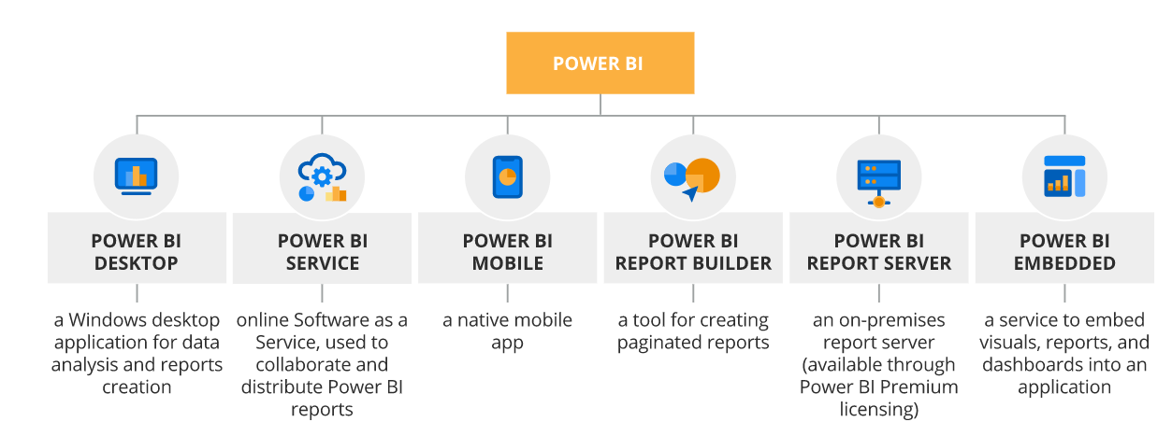

1. What limitations of Excel, Microsoft solved by PowerBi?

**Solution:** Main differences between Excel and Power BI

* Excel is used to organize data, transform it and perform mathematical operations and calculations. On the other hand, Power BI was conceived as a business intelligence and data visualization tool for businesses.
* Excel has limitations in the amount of data it can work with. In contrast, Power BI can handle much larger amounts of data.
* Power BI can connect to a large number of data sources, while Excel's connectivity capacity is limited. Also, unlike Excel, Power BI can be easily used from mobile devices.
* Power BI has faster processing than Excel.
* Power BI dashboards are more visually appealing, interactive and customizable than those in Excel.
* Power BI is a more powerful tool than Excel in terms of comparison between tables, reports or data files.
* Power BI is more user friendly and easy to use than Excel.

1. Explain Power Query?

**Solution:** Power Query is a data transformation and data preparation engine. Power Query comes with a graphical interface for getting data from sources and a Power Query Editor for applying transformations. Because the engine is available in many products and services, the destination where the data will be stored depends on where Power Query was used. Using Power Query, you can perform the extract, transform, and load (ETL) processing of data.

1. Explain Power Map?

**Solution:** Power Map is a 3D Geo-Spatial data visualization tool. Power BI has special buckets to help make the map data unambiguous. Just drag the field that contains your latitude data into the Visualizations > Latitude area. And do the same for your longitude data. When you do this, you also need to fill the Location field when creating your visualizations.

1. How PowerBi eliminated the need to host SharePoint Server on premises?

**Solution:** Power BI reports can be embedded in a SharePoint Online Modern Page using the SharePoint Online web part for Power BI. There is no equivalent web part for SharePoint on-premises but it is possible to use the Power BI API with some custom code to create a SharePoint App and make Power BI content visible in a page. There is also a third-party SharePoint add-in called Power BI Tiles available in the Office Store that uses the API in the background and avoids the need for custom code.

**Reference:** My Github - <https://bit.ly/34pw2QW>

1. Explain the updates done in Power Bi Service (power BI 2.0) as compared to older version?

**Solution:** <https://www.youtube.com/watch?v=iyAmYqTRCLY&t=1098s>

* Sparklines preview
* Azure data explorer
* TIBCO Data visualisation
* New Visual in App source
* PowerBi Channel