**Power BI Assignment 4**

1. Make a simple dashboard and show columns, bar charts, line charts, and area charts.

**Solution: My GitHub Link** - <https://github.com/savanvachhani17/PowerBI/blob/main/SKyData.pbix>

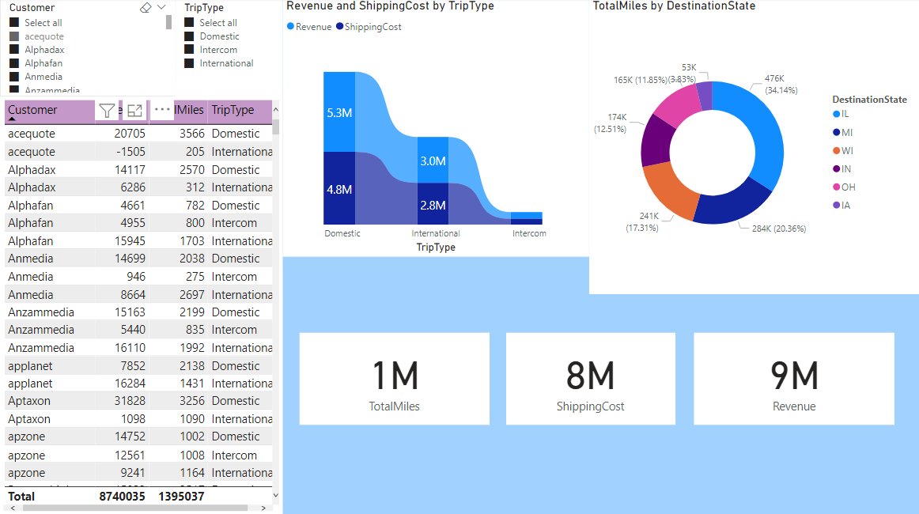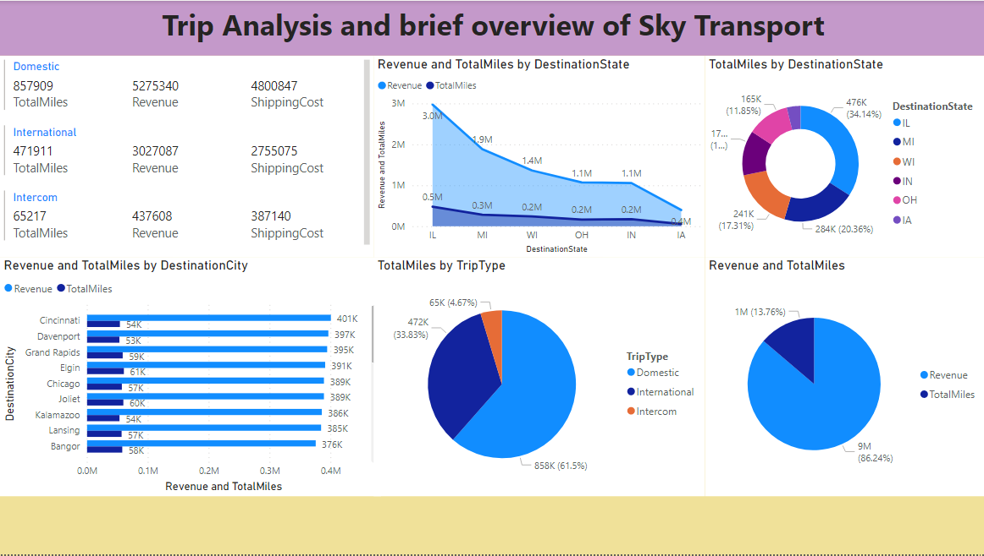

1. Make a simple dashboard and show combination chart, Scatter chart, Shape chart, and Tree map chart.

**Solution: My GitHub Link** - <https://github.com/savanvachhani17/PowerBI/tree/main/Project_Product>

1. Make a dashboard and show 2 maps visualization i.e. basic map and filler maps.

**Solution: My GitHub Link** - <https://github.com/savanvachhani17/PowerBI/blob/main/Initial%20file.pbix>

1. Create a report which has:

Bar chart

Card visualizations

Combo chart visualizations

Matrix visualizations

Column chart visualizations

guide: Sales data can be used

**Solution:** I have attached my GitHub link here so please check the project it has all the charts, cards, matrix, columns, and sales visualization.

**GitHub Link:** <https://github.com/savanvachhani17/PowerBI/tree/main/Project_Spend_Analysis>

1. Make a report to analyse product sales using tree map visualization.

**Solution:** <https://www.youtube.com/watch?v=50vqQrid1mQ>

**GitHub Link:** <https://github.com/savanvachhani17/PowerBI/blob/main/Films.pbix>

1. Make a dashboard on sales data (Minimum 4 tiles).

**Solution:** I have attached my GitHub link here so please check the project it has all data related to sales.

**GitHub Link:** <https://github.com/savanvachhani17/PowerBI/tree/main/Project_Spend_Analysis>