Exp 1: 8 BIT ADDITION

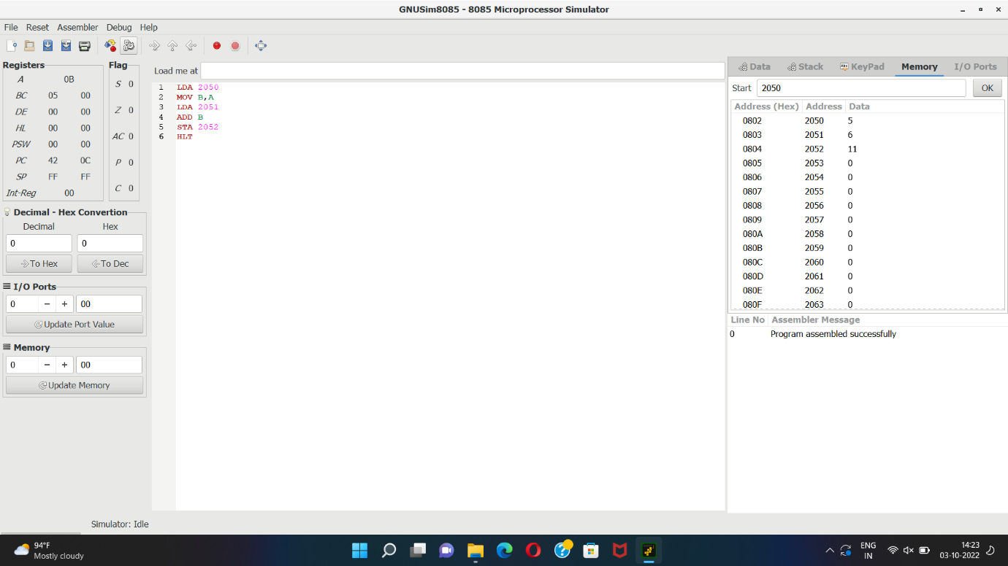

Exp 2: 16 BIT ADDITION

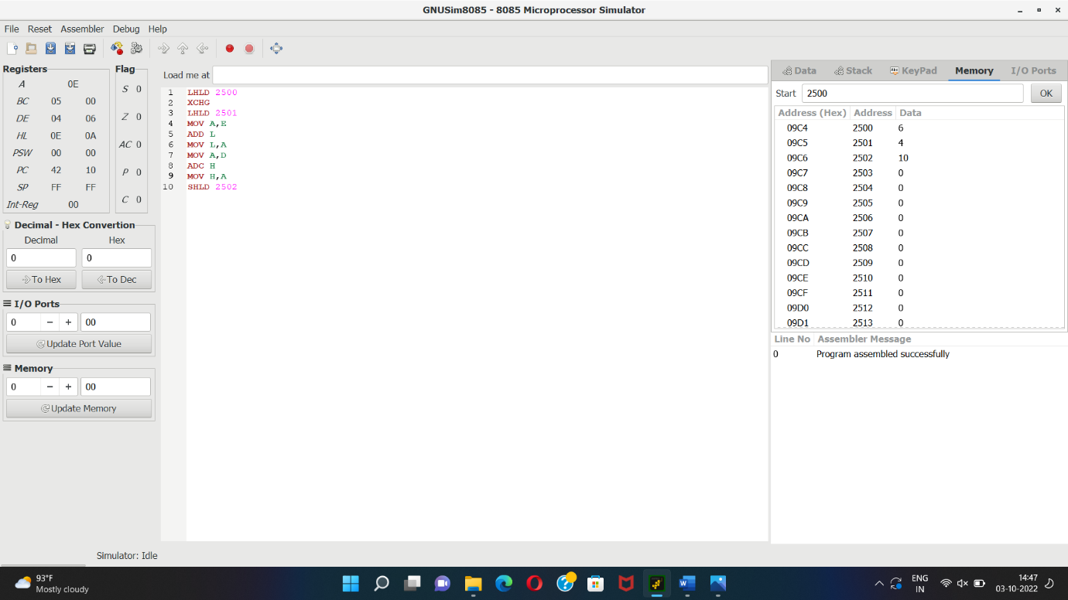

Exp 3: 8 BIT SUBSTRACTION

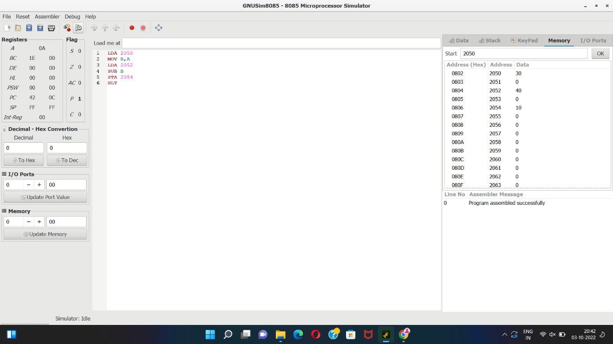

Exp 4: 16 BIT SUBSTRACTION

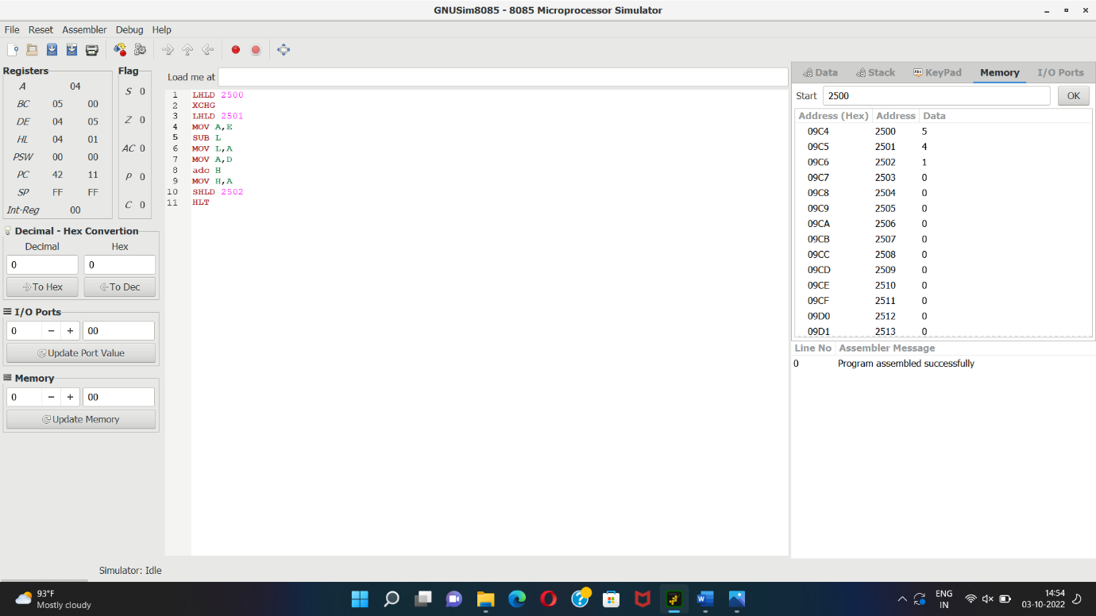

Exp 5: 8 BIT MULTIPLICATION

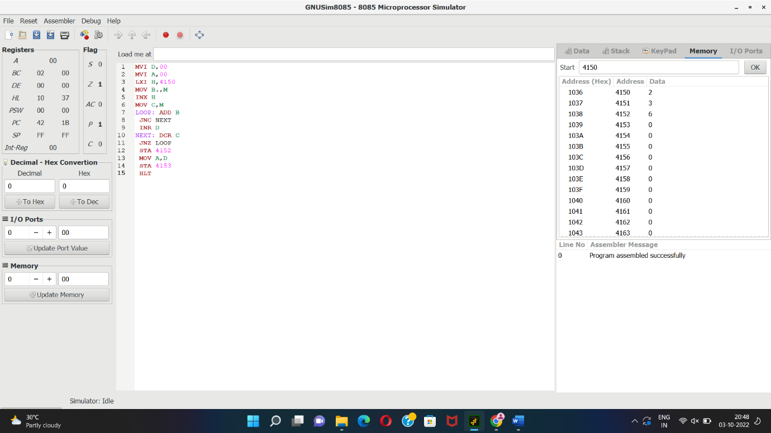

Exp 6: 8 BIT DIVISION

