Installation
EX1
In vscode or cmd/powershell run:
python -m pip install flask
python -m pip install flask-cors

EX2
SSH Key Generation
Yes. The commands are the same on any Linux/macOS system and also work on Windows 10/11 if OpenSSH is installed.
And no, the email is just a label/comment. It is not used for authentication.
So these are all valid:
ssh-keygen -t ed25519 -C "savari@gmail.com"
or
ssh-keygen -t ed25519 -C "college-pc"
or
ssh-keygen -t ed25519 -C "my-ovh-key"
or even
ssh-keygen -t ed25519
The SSH key will work the same regardless of what you put after -C.
Commands to remember for your exam
1. Generate the SSH key
ssh-keygen -t ed25519
Press Enter for:
- File location
- Passphrase
- Confirm passphrase

2. Display the public key
Linux/macOS:
cat ~/.ssh/id_ed25519.pub
Windows Command Prompt (CMD):
type "%USERPROFILE%\.ssh\id_ed25519.pub"
Windows PowerShell:
Get-Content $env:USERPROFILE\.ssh\id_ed25519.pub
Copy the entire output and paste it into OVHcloud.

If ed25519 is not supported (rare)
Use RSA instead:
ssh-keygen -t rsa -b 4096
Then view it with:
Linux/macOS:
cat ~/.ssh/id_rsa.pub
Windows CMD:
type "%USERPROFILE%\.ssh\id_rsa.pub"
These commands are the standard ones you'll typically use in labs, exams, and on cloud platforms like OVHcloud, AWS, Azure, and Google Cloud.
EX5
Download VM Workstation player 17 : https://www.techspot.com/downloads/1969-vmware-player.html

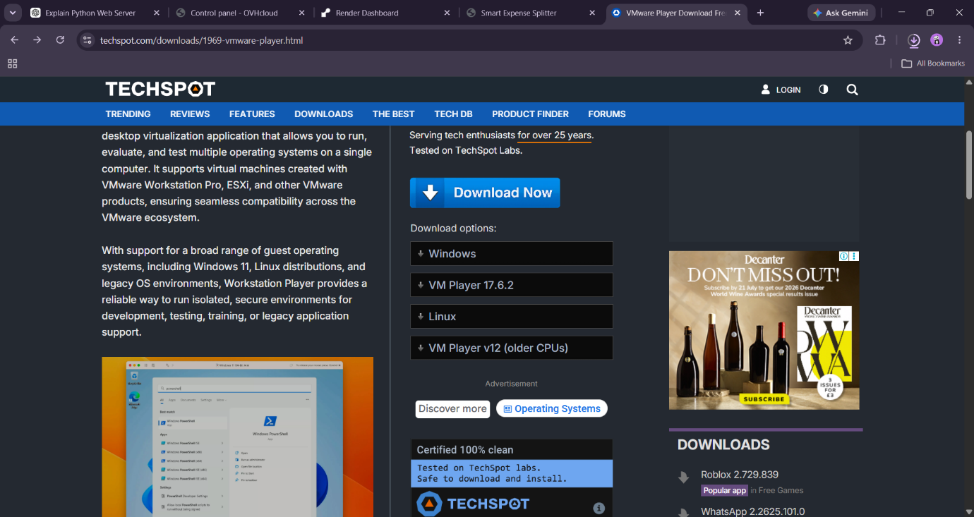

EX 8
C:\Users\Savari Sandeep Karpe>docker run -it ubuntu
root@1a046767e354:/# ls
bin boot dev etc home lib lib64 media mnt opt proc root run sbin srv sys tmp usr var
root@1a046767e354:/# pwd
/
root@1a046767e354:/# mkdir test
root@1a046767e354:/# ls
bin boot dev etc home lib lib64 media mnt opt proc root run sbin srv sys test tmp usr var
root@1a046767e354:/# cd test
root@1a046767e354:/test# pws
bash: pws: command not found
root@1a046767e354:/test# pwd
/test
root@1a046767e354:/test# touch file1.txt
root@1a046767e354:/test# ls
file1.txt
root@1a046767e354:/test# echo "hello">file1.txt
root@1a046767e354:/test# cat file1.txt
hello
root@1a046767e354:/test# rm file1.txt
root@1a046767e354:/test# ls
root@1a046767e354:/test# rm -r test
rm: cannot remove 'test': No such file or directory
root@1a046767e354:/test# cd..
bash: cd..: command not found
root@1a046767e354:/test# ..
bash: ..: command not found
root@1a046767e354:/test# cd ..
root@1a046767e354:/# rm -r test
root@1a046767e354:/# ls
bin dev home lib64 mnt proc run srv tmp var
boot etc lib media opt root sbin sys usr
root@1a046767e354:/#

