

Git is the free and open-source distributed version control system that's responsible for everything GitHub related that happens locally on your computer.

What is the Advantage of Git:
- > In Git Everything is a Workspace (Distributed version control system)
-> Every Workspace will have a copy of the repo
-> Central Workspace (Store and share the changes)
-> Local / user Workspace (Modify / Edit, Store & share)
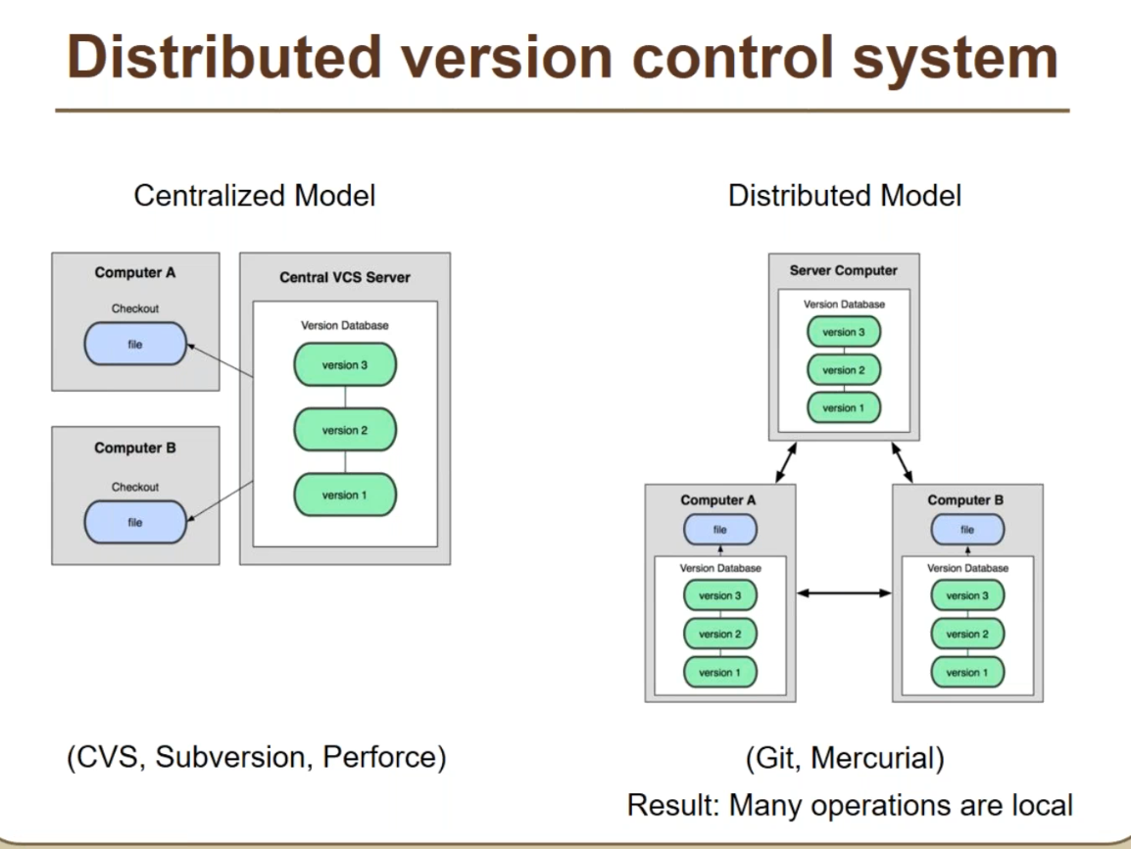
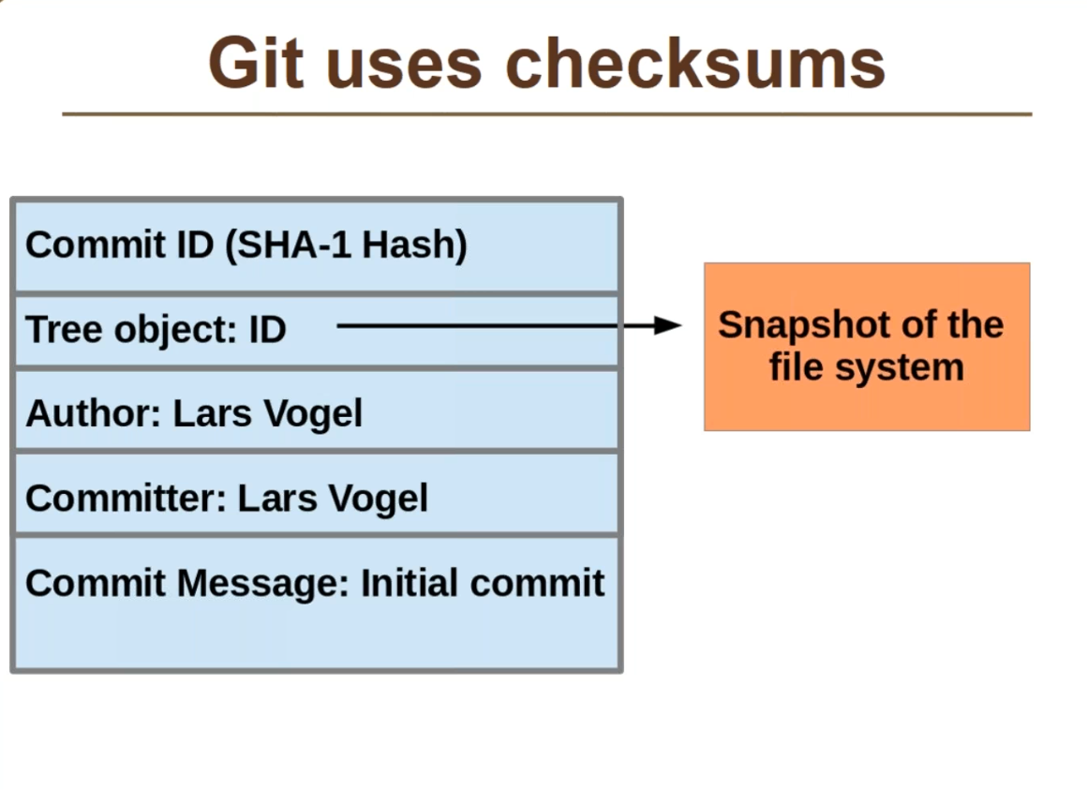
SAMPLE OUTPUT:
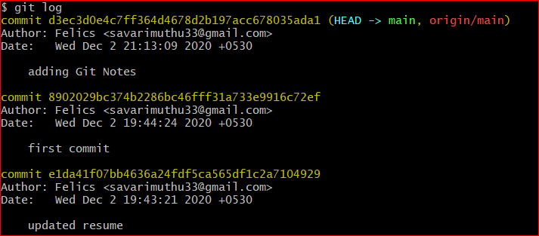
Workspace Contain Below:
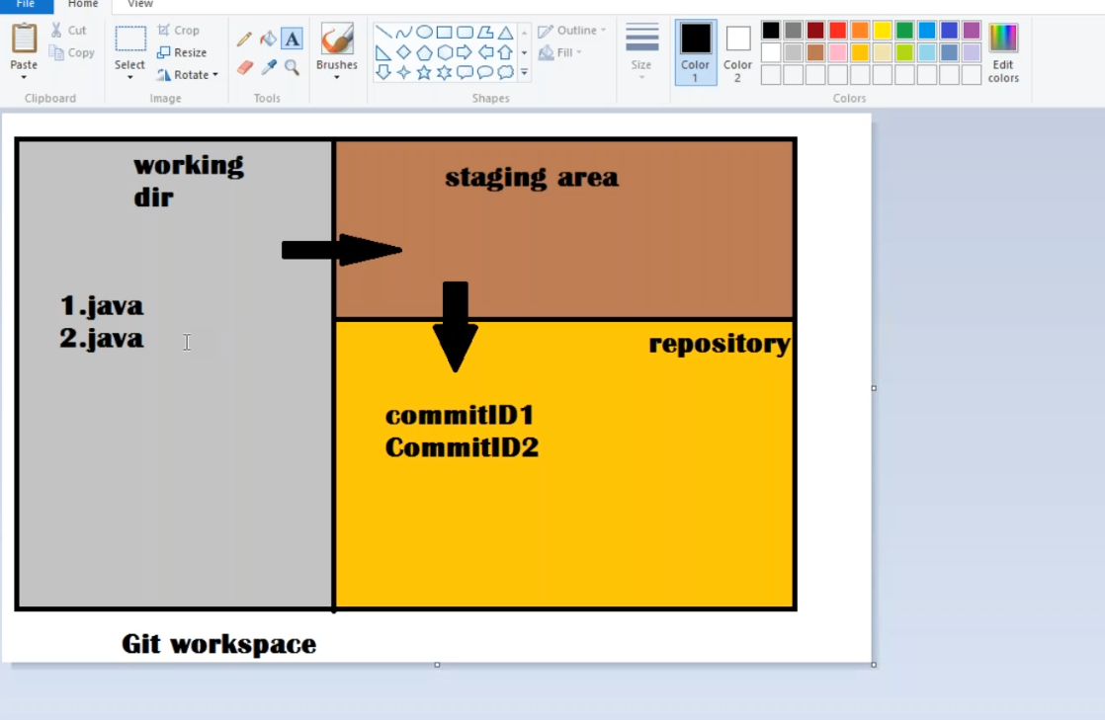
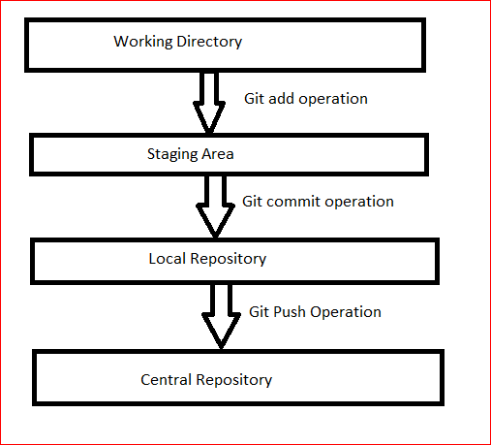
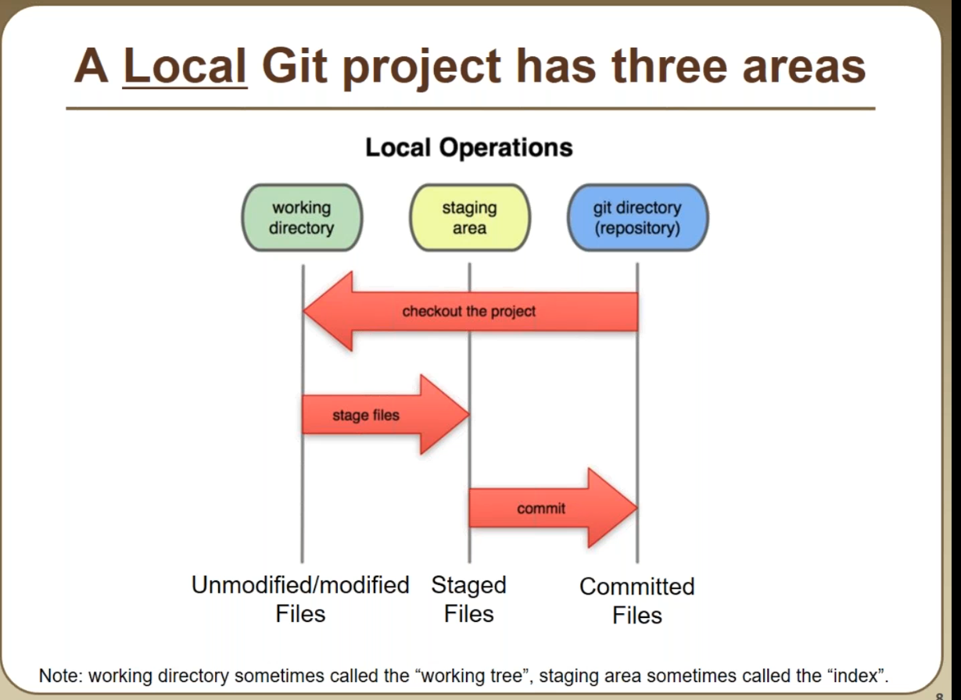

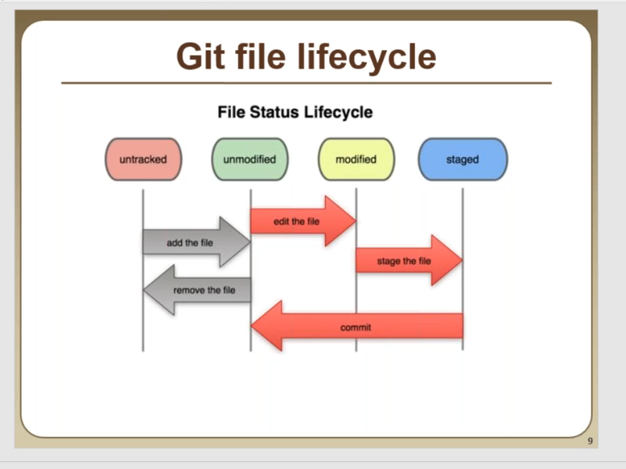

INITIAL SETUP
Configuring user information used across all local repositories

git config --global user.name “[firstname lastname]”

set a name that is identifiable for credit when review version history

git config --global user.email “[valid-email]”

set an email address that will be associated with each history marker

git config --global color.ui auto

set automatic command line coloring for Git for easy reviewing

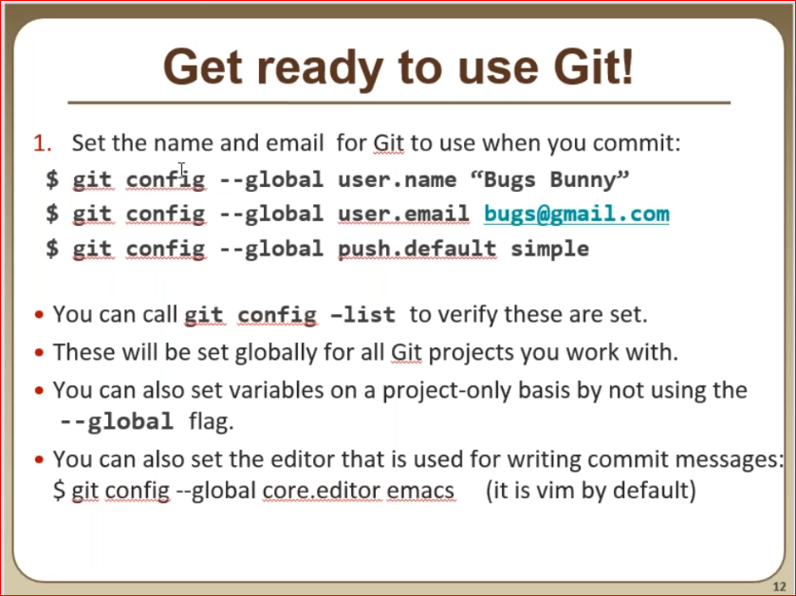

SETUP & INIT
Create repositories:

When starting out with a new repository, you only need to do it once; either locally, then push to GitHub, or by cloning an existing repository.

$ git init
Turn an existing directory into a git repository
$ git clone [url]
Clone (download) a repository that already exists on GitHub, including all of the files, branches, and commits

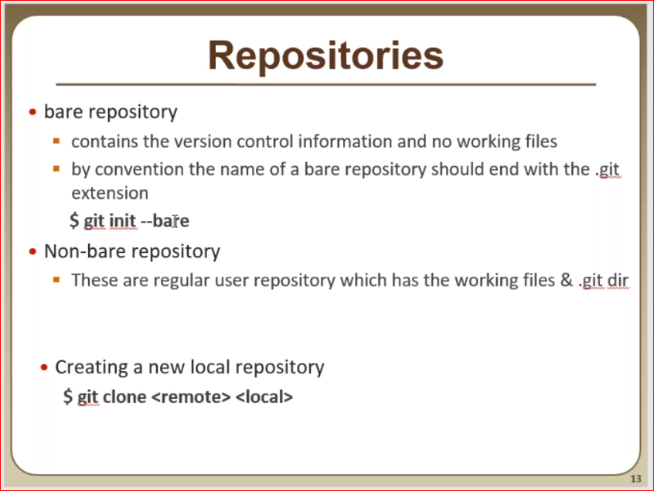
Commands:
$ git init --bare
$ git clone <central.git> <localworkspace>
$ git add .
$ git commit -m "commit_msg"
$ git status
$ git log
$ git push
Whenever we do change something in our repository and do git push, it will always compare the Central repository and if it found any new commit ID in the central repository it will not allow us to do git push,we have to update our local repository to get that update by "git pull" and then we have to do "git push"
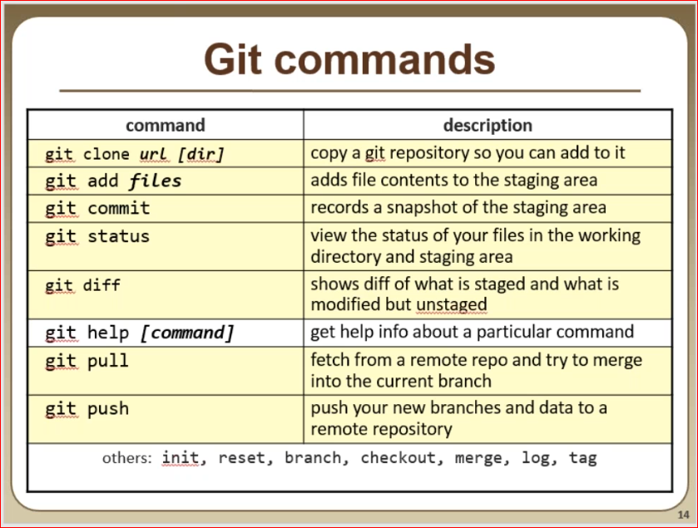
$ ls
Centralrepo.git/ workspace1/ workspace2/

$ git clone Centralrepo.git/ Workspace3
Cloning into 'Workspace3'...
done.

$ cd workspace3

$ ls -lrth
total 2.0K
-rw-r--r-- 1 Muthu 197121 20 Dec 3 13:41 uptime.sh
-rw-r--r-- 1 Muthu 197121 30 Dec 3 13:41 multipath.sh
-rw-r--r-- 1 Muthu 197121 0 Dec 3 13:41 Esxi_checkouts.sh
-rw-r--r-- 1 Muthu 197121 0 Dec 3 13:41 checkouts.sh

$ touch testfile.java

Muthu@DESKTOP-42AP44R MINGW64 /d/Git/workspace3 (master)
$ git status
On branch master
Your branch is up to date with 'origin/master'.

Untracked files:
(use "git add <file>..." to include in what will be committed)
testfile.java

nothing added to commit but untracked files present (use "git add" to track)

$ git add .

$ git status
On branch master
Your branch is up to date with 'origin/master'.

Changes to be committed:
(use "git restore --staged <file>..." to unstage)
new file: testfile.java

$ git commit -m "creating testfile"
[master f807d28] creating testfile
1 file changed, 0 insertions(+), 0 deletions(-)
create mode 100644 testfile.java
$ git log --oneline
f807d28 (HEAD -> master) creating testfile
f4b4afa (origin/master, origin/HEAD) Merge branch 'linux'
038806a (origin/linux) added uptime_script
76d70f8 Merge branch 'linux'
IGNORING PATTERNS
Preventing unintentional staging or committing of files

git config --global core.excludesfile [file]

system wide ignore pattern for all local repositories
logs/
*.notes
pattern*/

Save a file with desired patterns as .gitignore with either direct string
matches or wildcard globs.

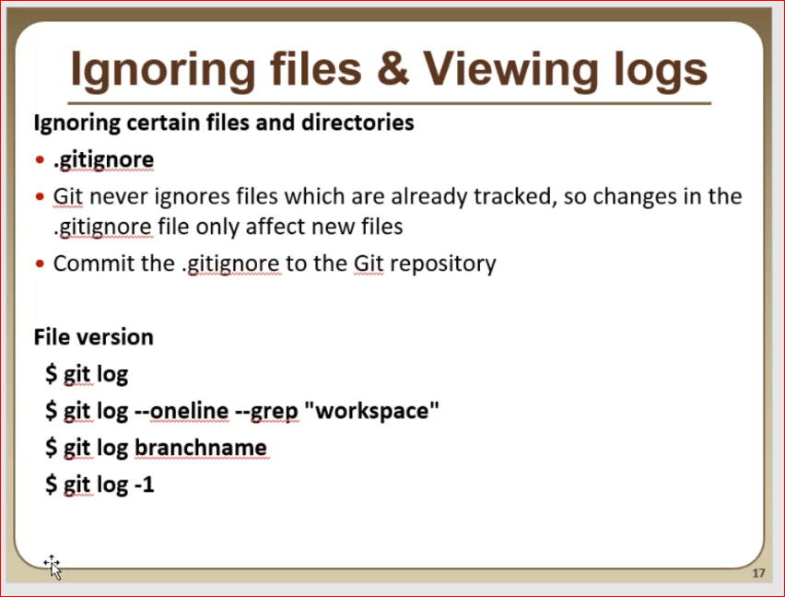
Work Notes :

Muthu@DESKTOP-42AP44R MINGW64 /d/Git/workspace3 (master)

$ ls -la
total 10

drwxr-xr-x 1 Muthu 197121 0 Dec 3 14:00 ./
drwxr-xr-x 1 Muthu 197121 0 Dec 3 13:41 ../
drwxr-xr-x 1 Muthu 197121 0 Dec 3 14:01 .git/
-rw-r--r-- 1 Muthu 197121 14 Dec 3 13:52 .gitignore
-rw-r--r-- 1 Muthu 197121 0 Dec 3 13:41 checkouts.sh
-rw-r--r-- 1 Muthu 197121 0 Dec 3 13:43 testfile.java
-rw-r--r-- 1 Muthu 197121 20 Dec 3 13:41 uptime.sh

Muthu@DESKTOP-42AP44R MINGW64 /d/Git/workspace3 (master)

$ cat .gitignore
*.class
*.log

Muthu@DESKTOP-42AP44R MINGW64 /d/Git/workspace3 (master)

$ touch uptime.class messages.log

Muthu@DESKTOP-42AP44R MINGW64 /d/Git/workspace3 (master)

$ git status

On branch master
Your branch is ahead of 'origin/master' by 2 commits.
(use "git push" to publish your local commits)

nothing to commit, working tree clean

As you can see what ever file you are adding under the file .gitignore
Git is not going to consider or track those files, as soon as we do git status
First it will check any .gitignore file is there , if it is there git going to ignore / untrack those file if it matches

Use case:

When we do compilation it going ti create some class file or log which you don’t want to track or save it in github , for those case .gitignore will be useful

BRANCH & MERGE
Isolating work in branches, changing context, and integrating changes

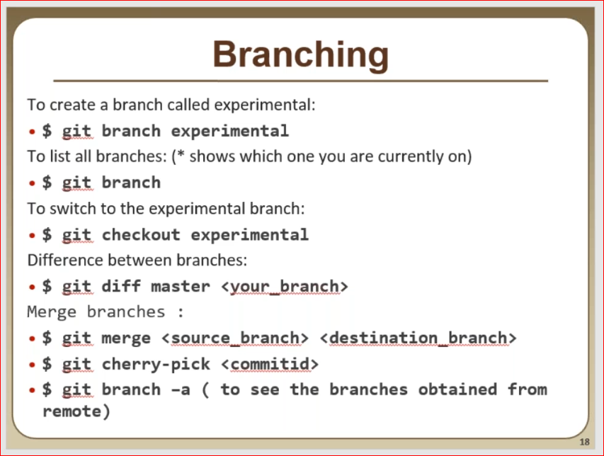
Work Log :
Muthu@DESKTOP-42AP44R MINGW64 /d/Git/workspace3 (master)
$ git branch
* master

$ ls -lrth
total 1.0K
-rw-r--r-- 1 Muthu 197121 20 Dec 3 13:41 uptime.sh
-rw-r--r-- 1 Muthu 197121 0 Dec 3 13:41 checkouts.sh

Creating New Branch
$ git branch linux

$ git branch
linux
* master

$ git checkout linux
Switched to branch 'linux'

$ ls -lrth
total 1.0K
-rw-r--r-- 1 Muthu 197121 20 Dec 3 13:41 uptime.sh
-rw-r--r-- 1 Muthu 197121 0 Dec 3 13:41 checkouts.sh

$ touch 1.java 2.java
$ git add .
$ git commit -m "created 1.java from linux branch"

[linux 5ec6a8b] created 1.java from linux branch
2 files changed, 0 insertions(+), 0 deletions(-)
create mode 100644 1.java
create mode 100644 2.java

$ git push
fatal: The current branch linux has no upstream branch.
To push the current branch and set the remote as upstream, use

git push --set-upstream origin linux

Muthu@DESKTOP-42AP44R MINGW64 /d/Git/workspace3 (master)
$ git checkout master
Switched to branch 'master'
Your branch is ahead of 'origin/master' by 2 commits.
(use "git push" to publish your local commits)
$ ls -lrth
total 1.0K
-rw-r--r-- 1 Muthu 197121 20 Dec 3 13:41 uptime.sh
-rw-r--r-- 1 Muthu 197121 0 Dec 3 13:41 checkouts.sh

Merging Branch
$ git merge linux master
Updating ef5adcf..5ec6a8b
Fast-forward
1.java | 0
2.java | 0
2 files changed, 0 insertions(+), 0 deletions(-)
create mode 100644 1.java
create mode 100644 2.java
$ ls -lrth
total 1.0K
-rw-r--r-- 1 Muthu 197121 20 Dec 3 13:41 uptime.sh
-rw-r--r-- 1 Muthu 197121 0 Dec 3 13:41 checkouts.sh
-rw-r--r-- 1 Muthu 197121 0 Dec 3 15:33 2.java
-rw-r--r-- 1 Muthu 197121 0 Dec 3 15:33 1.java

Muthu@DESKTOP-42AP44R MINGW64 /d/Git/workspace3 (master)
$ git push
Enumerating objects: 8, done.
Counting objects: 100% (8/8), done.
Delta compression using up to 8 threads
Compressing objects: 100% (6/6), done.
Writing objects: 100% (7/7), 754 bytes | 251.00 KiB/s, done.
Total 7 (delta 2), reused 0 (delta 0)
To D:/Git/Centralrepo.git/
f4b4afa..5ec6a8b master -> master
Muthu@DESKTOP-42AP44R MINGW64 /d/Git/workspace3 (master)
$ git cherry-pick d3a1691
$ git branch -d [branch-name] Deletes the specified branch
Stashing is a kind of temporary backup of modified files

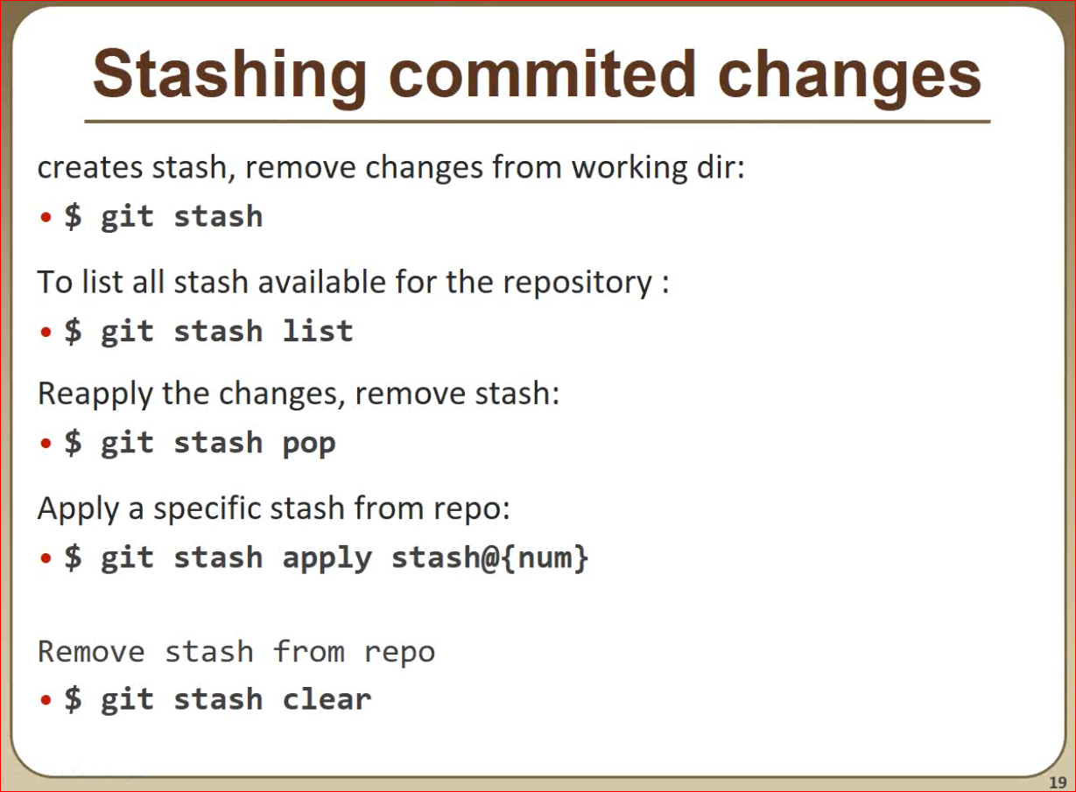
Work Log :
Muthu@DESKTOP-42AP44R MINGW64 /d/Git/workspace3 (master)
$ cat > 1.java
Idea 1
Idea 2

Muthu@DESKTOP-42AP44R MINGW64 /d/Git/workspace3 (master)
$ git status
On branch master
Your branch is ahead of 'origin/master' by 2 commits.
(use "git push" to publish your local commits)

Changes not staged for commit:
(use "git add <file>..." to update what will be committed)
(use "git restore <file>..." to discard changes in working directory)
modified: 1.java

no changes added to commit (use "git add" and/or "git commit -a")

Muthu@DESKTOP-42AP44R MINGW64 /d/Git/workspace3 (master)
$ git stash
warning: LF will be replaced by CRLF in 1.java.
The file will have its original line endings in your working directory
Saved working directory and index state WIP on master: 13e5138 modified 5.java

Muthu@DESKTOP-42AP44R MINGW64 /d/Git/workspace3 (master)
$ cat 1.java

Muthu@DESKTOP-42AP44R MINGW64 /d/Git/workspace3 (master)
$ cat > 1.java
Idea 3
Idea 4

Muthu@DESKTOP-42AP44R MINGW64 /d/Git/workspace3 (master)
$ cat 1.java
Idea 3
Idea 4

Muthu@DESKTOP-42AP44R MINGW64 /d/Git/workspace3 (master)
$ git stash
warning: LF will be replaced by CRLF in 1.java.
The file will have its original line endings in your working directory
Saved working directory and index state WIP on master: 13e5138 modified 5.java

Muthu@DESKTOP-42AP44R MINGW64 /d/Git/workspace3 (master)
$ git stash list
stash@{0}: WIP on master: 13e5138 modified 1.java
stash@{1}: WIP on master: 13e5138 modified 1.java

Muthu@DESKTOP-42AP44R MINGW64 /d/Git/workspace3 (master)
$ cat 1.java

Muthu@DESKTOP-42AP44R MINGW64 /d/Git/workspace3 (master)
$ git stash apply stash@{1}
On branch master
Your branch is ahead of 'origin/master' by 2 commits.
(use "git push" to publish your local commits)

Changes not staged for commit:
(use "git add <file>..." to update what will be committed)
(use "git restore <file>..." to discard changes in working directory)
modified: 1.java

no changes added to commit (use "git add" and/or "git commit -a")

Muthu@DESKTOP-42AP44R MINGW64 /d/Git/workspace3 (master)
$ cat 1.java
Idea 1
Idea 2

