Git : (Distributed Model)

1.In Git Everything is a Workspace ( Distributed version control system )

2.Every Workspace will have a copy of the repo

-> Central Workspace (Store and share the changes)

-> Local / user Workspace (Modify / Edit , Store & share )

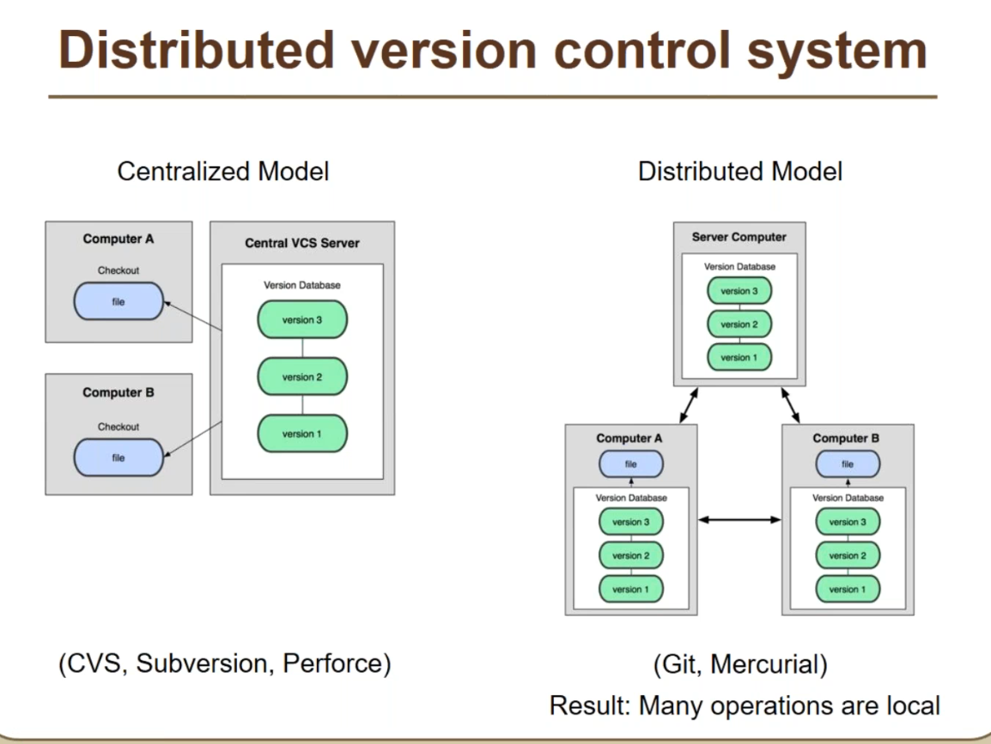

Commit ID is a 40 character uniq ID

It have below

Who modified , what , when

Git Gfgjfhjk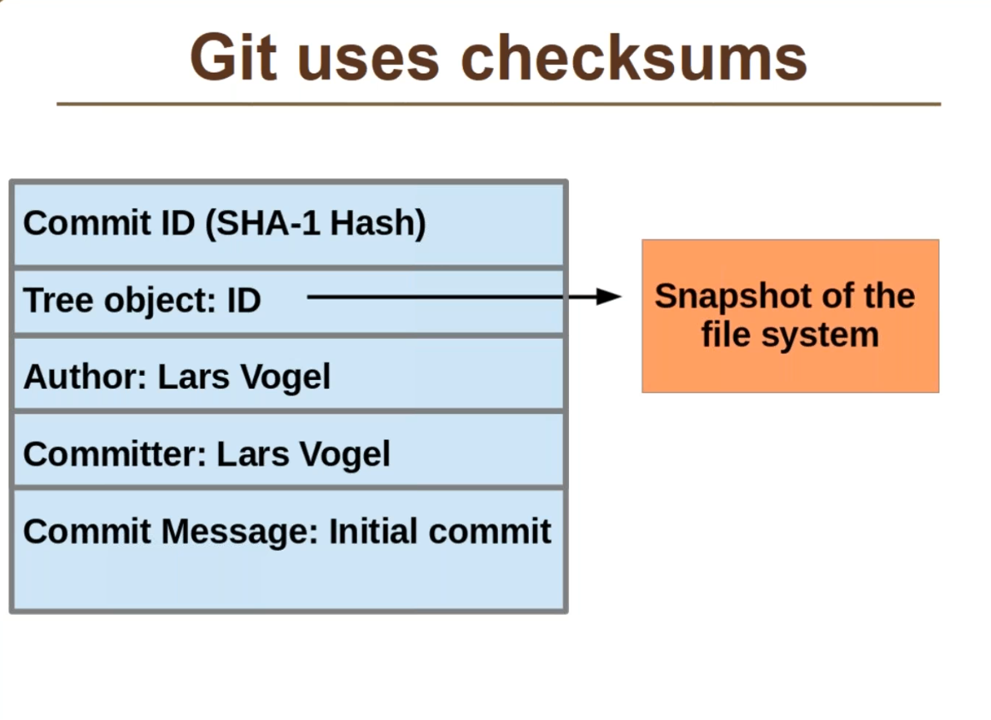

Git workspace have

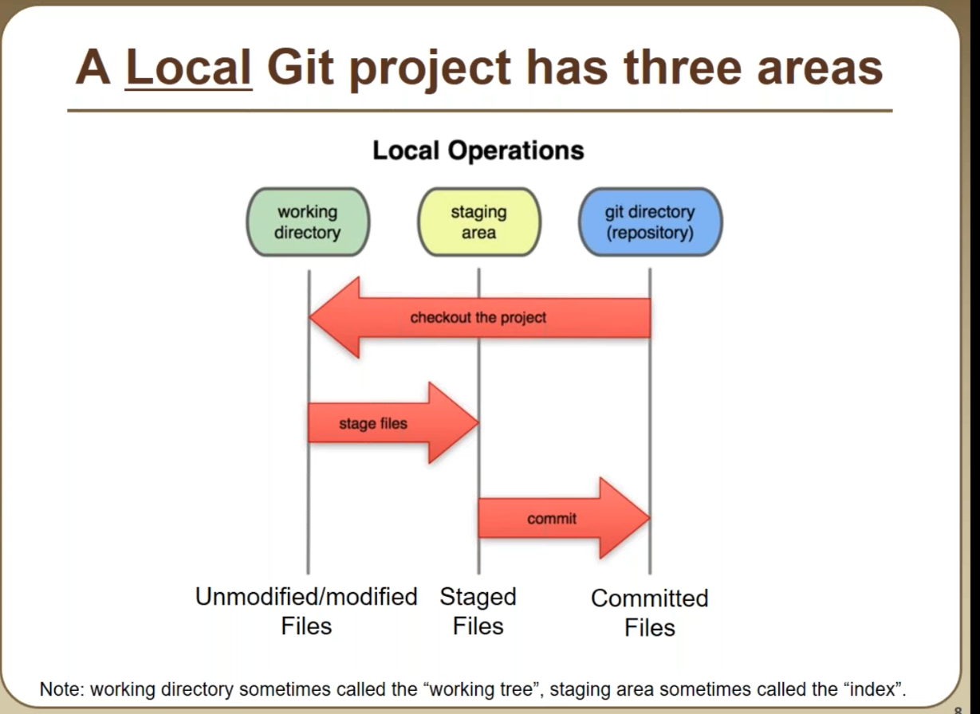

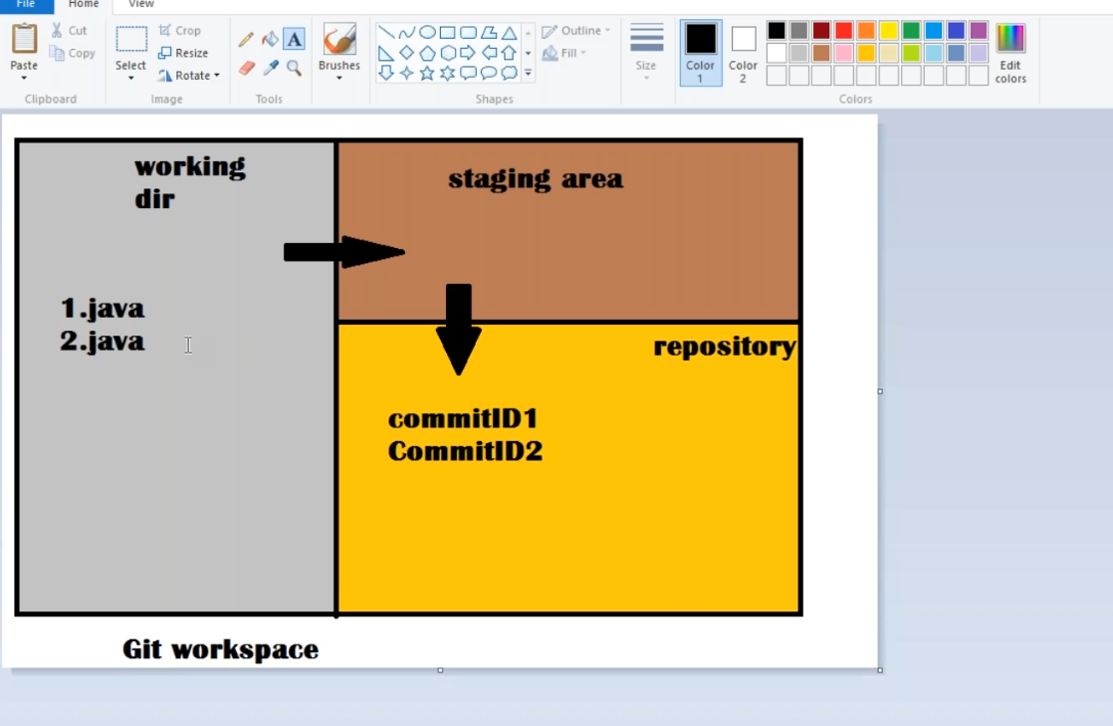

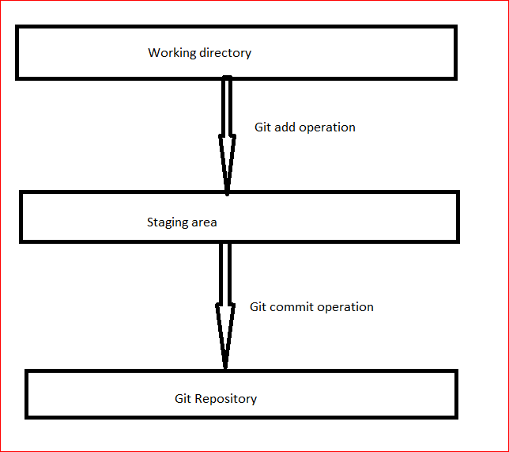

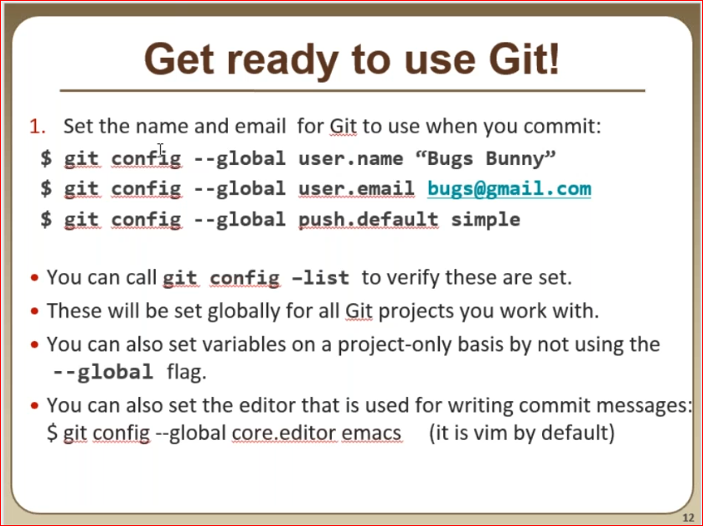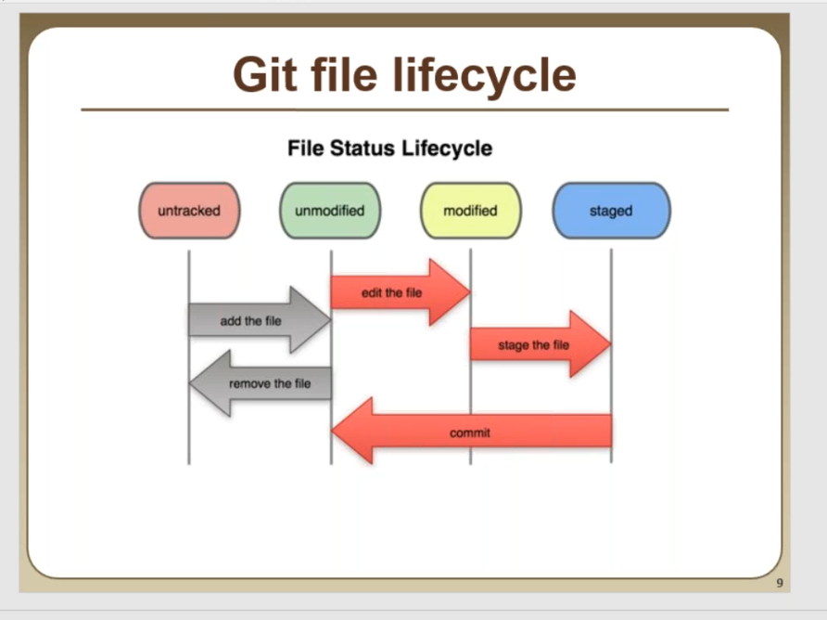

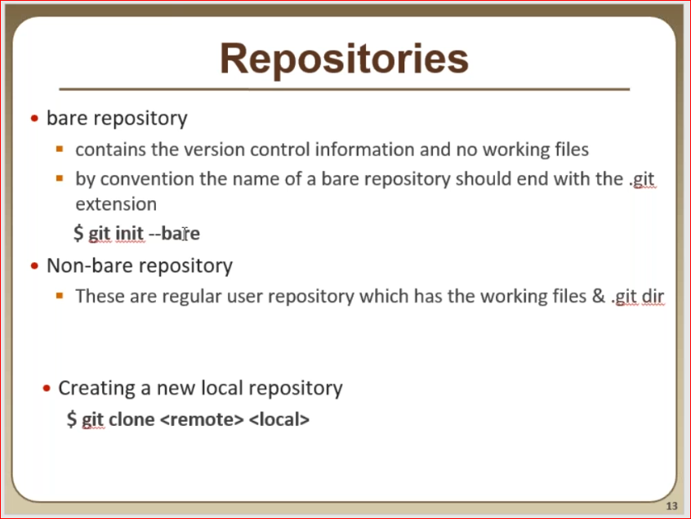

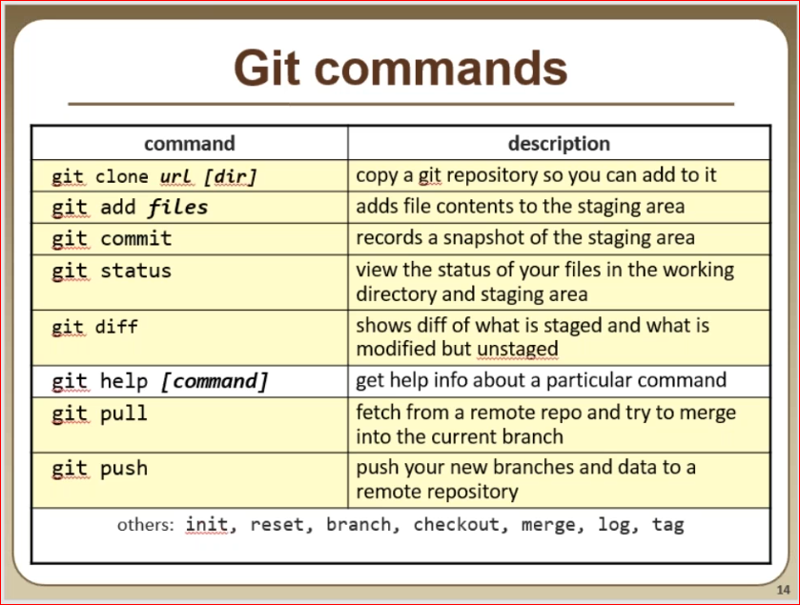

Commands:

$ git init --bare

$ git clone central.git localworkspace

$ git add .

$ git commit -m "commit_msg"

$ git status

$ git log

$ git push

Whenever we do change something in our repository and do git push , it will always compare the Central repository and if it found any new commit ID in the central repository it will not allow us to do git push ,

we have to update our local repository to get that update by "git pull" and then we have to do "git push"

