SPRİNG BOOT PROMETHEUS AND GRAFANA

[Prometheus](https://github.com/prometheus) is an open-source monitoring system. İt is monitoring many app actuators.

PromQL, a [flexible query language](https://prometheus.io/docs/prometheus/latest/querying/basics/) to leverage this dimensionality

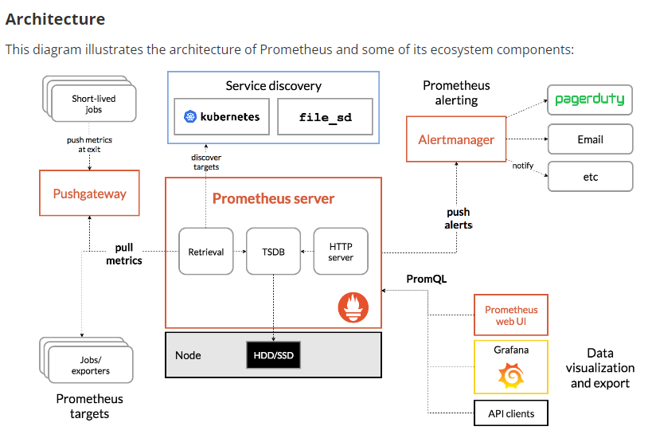

<https://docs.spring.io/spring-boot/docs/current/reference/html/actuator.html#actuator.metrics>

<http://localhost:8085/actuator/prometheus>

<https://grafana.com/grafana/dashboards/?search=spring>

<http://localhost:9090/targets>

<http://localhost:3000/d/wY3BdEVVk/spring-boot-statistics?orgId=1>

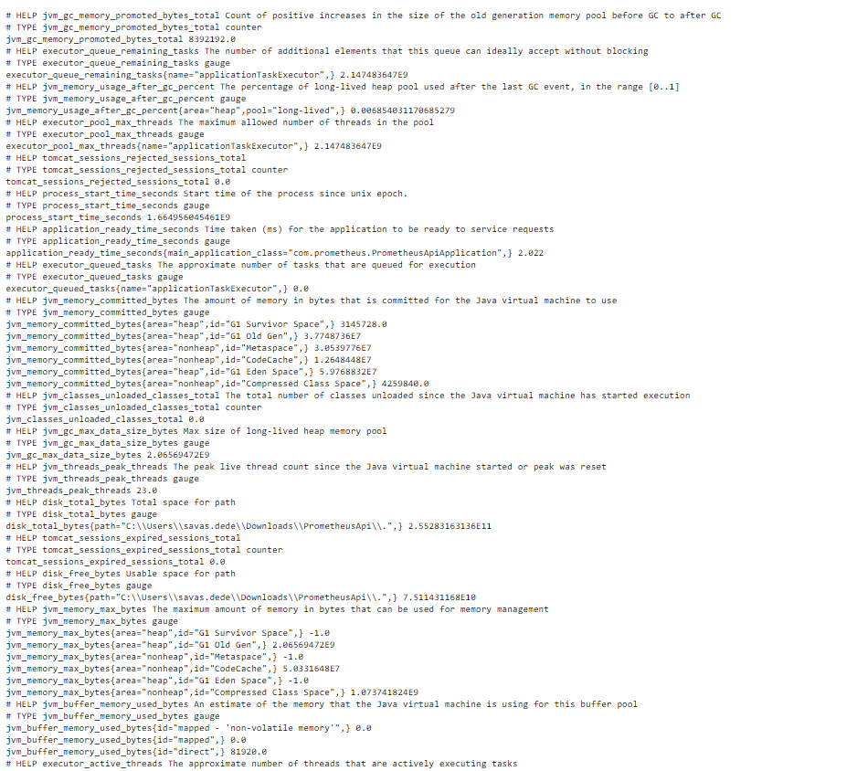

Docker compose setting to Prometheus and up on 9090 ports. The application built Prometheus.yml for docker.

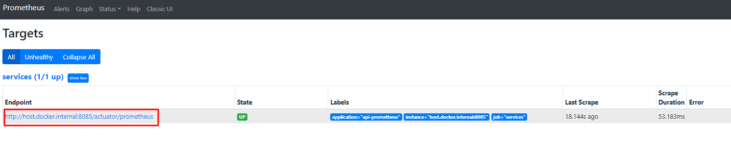

* Grafana setting docker compose and up.
* <http://localhost:3000/>
* Setting, datasource and add Prometheus

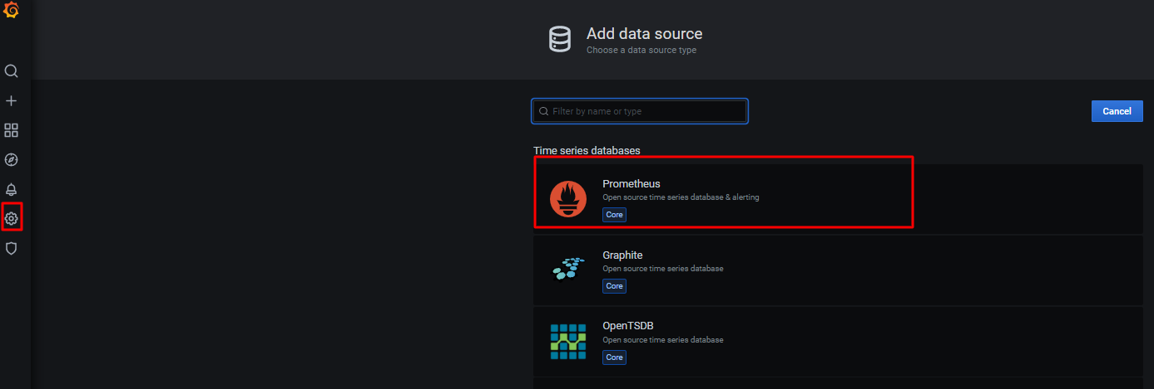

Open Grafana.com and search JVM Micrometer or Spring System Monitor.

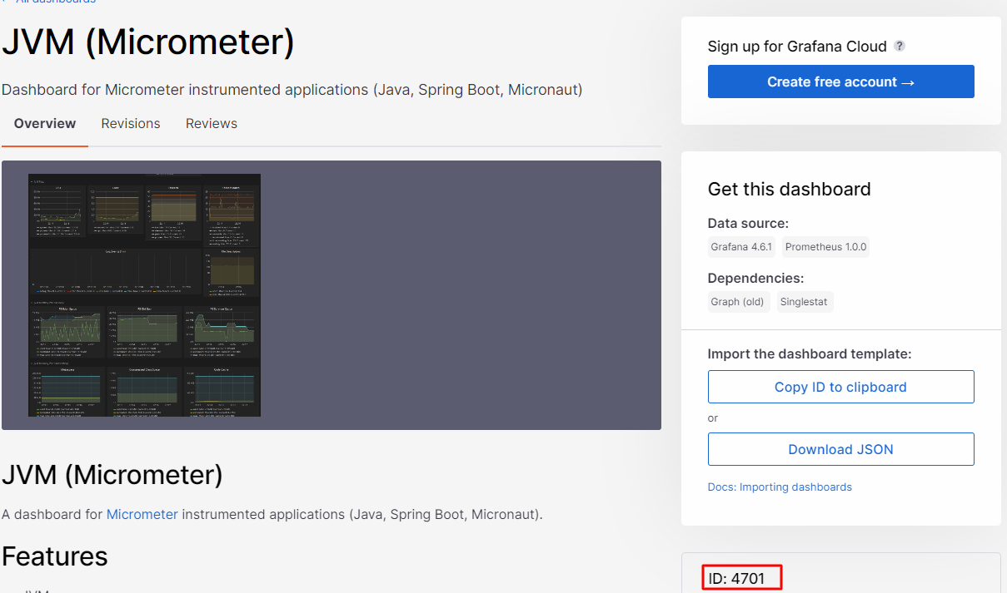

The id:4701

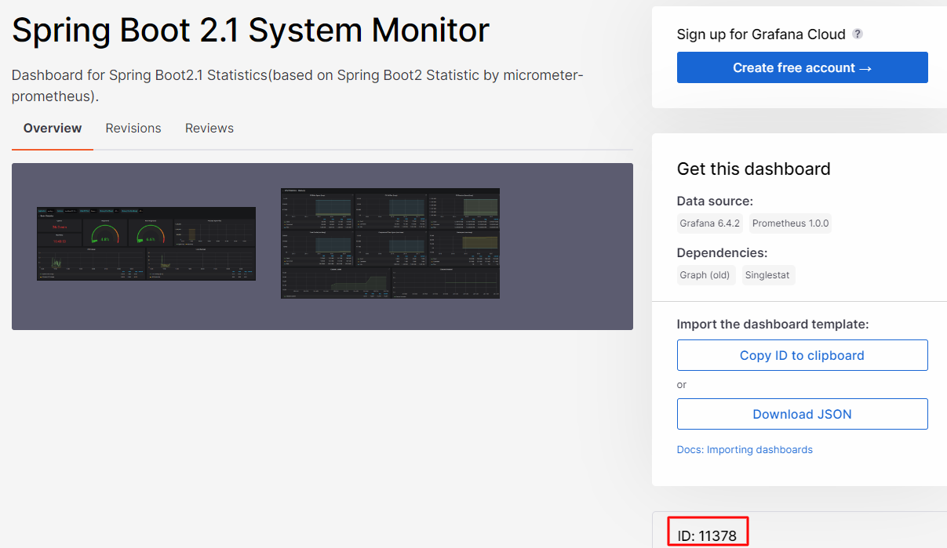

Find the ids and create import on Grafana.

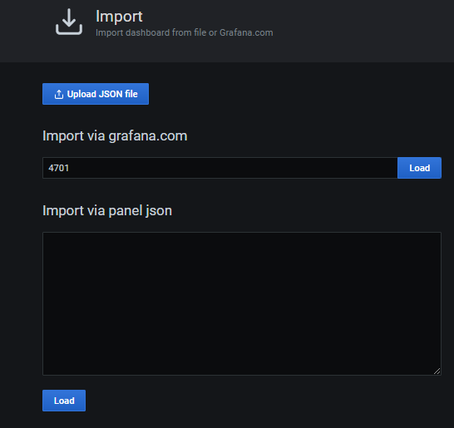

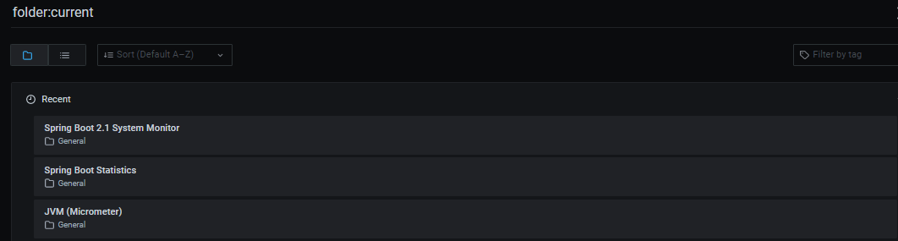

Monitoring app on micrometer or other.

MİCROMETER

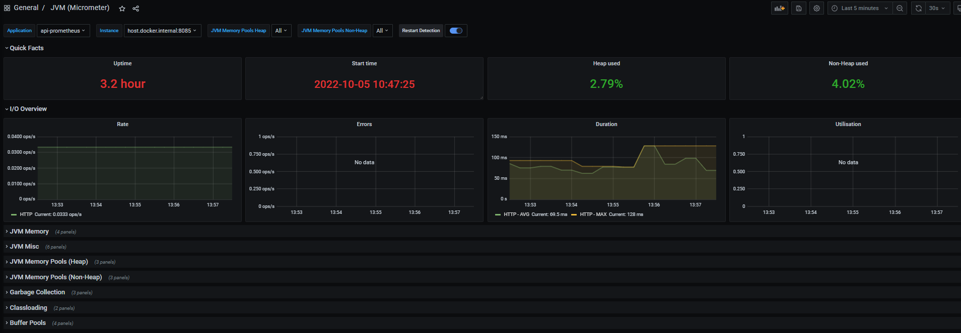

SYSTEM MONİTORİNG

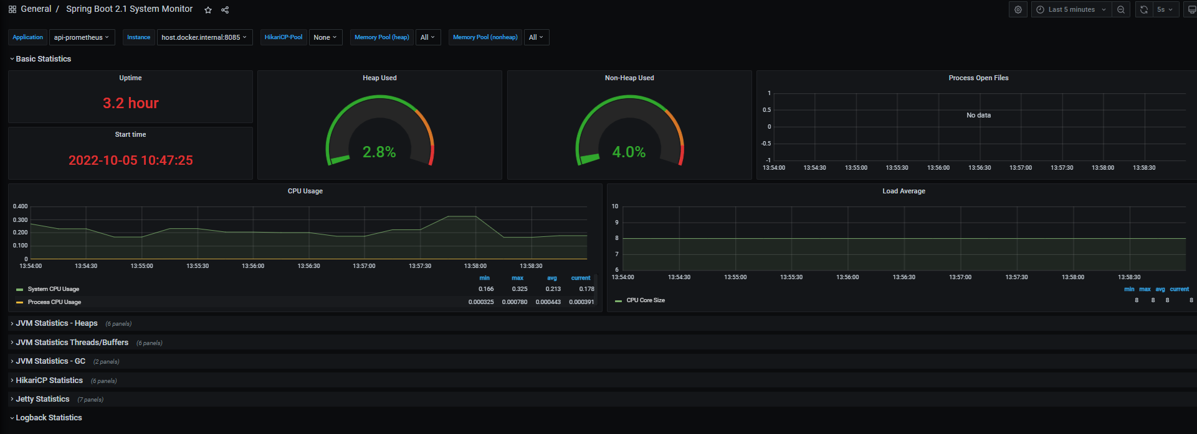

SPRİNG BOOT İSTATİCS

