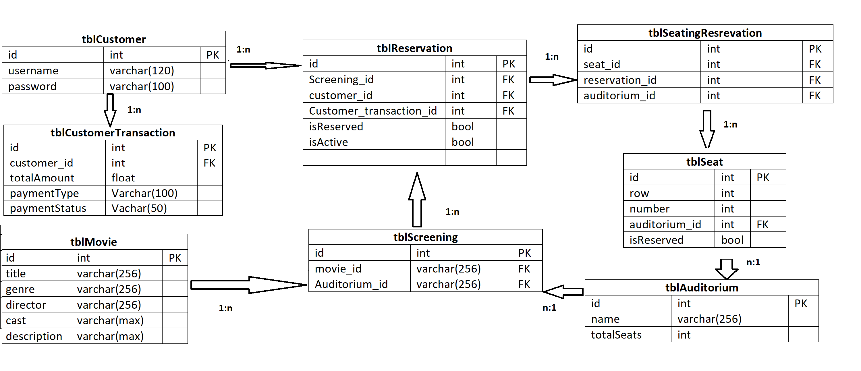

Attached above is the high level relational db design for Movie Tickets Booking System.

Let’s assume a customer is trying to book a ticket for a movie.

The customer logins in and his/her information is stored in tblCustomer. Customer then tries to reserve a movie ticket. For that customer pulls the information from tblScreening. Screening table has foreign key reference to tblMovie which will have title/genre/cast etc about a movie. TblScreening will also hold information on which auditorium the movie will be played. Once movie is selected the tblReservation will then reference tblSeatingReservation to show all the available seats.