RifConverter 8.2

What is it?
RifConverter 8.2 is a Windows application that batch converts RIF files into TIF and PSD files.

Before you use Rifconverter you must read and accept the accompanying license.

Important Changes since the last Version
RIFConverter has been simplified to increase its reliability. On some cases this has meant that it supports fewer features. For example, support for exporting PNG and JPG was dropped. Also, now RIFConverter does not let the user control whether alpha is saved or which colorspace is used. Instead RIFConverter does not save alpha for TIFs and always saves alpha for PSDs and all exports are done in RGB instead of CMYK.

RIFConverter’s UI now docks to the left side of your desktop instead of behaving like a normal window. This will make it easier to see what Painter is doing when RIFConverter is running.

Requirements
Operating System | Windows XP English version  This program is NOT supported on any other OS or non-English versions of Windows XP.
Painter Version | Painter 8 (English Version) with the latest updates.  RIFCONV does not work for Painter 8 written in other languages.
.NET Framework 1.1 | The application is requires the .NET Framework to Run.

Installation

Install the .NET Framework if needed
You can get it here: http://msdn.microsoft.com/netframework/downloads/framework1_1/

Install RIFConverter
Run the setup.exe

Running the Program

Step 1: Before You begin
Backup your RIF files
Identify where folder with the RIF files is
Create an empty folder where the output files will be written
RIFConverter will not delete files or tell Painter to overwrite existing files.

Step 1: Start RIFCONV from the Start Menu

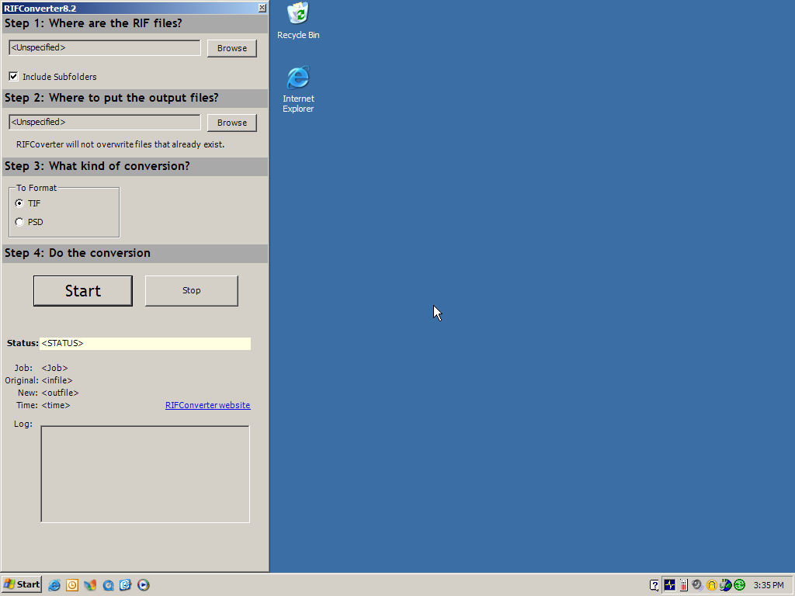

Step 2: Start Painter 8
Launch Painter 8 from the start menu.

Your screen should look like this

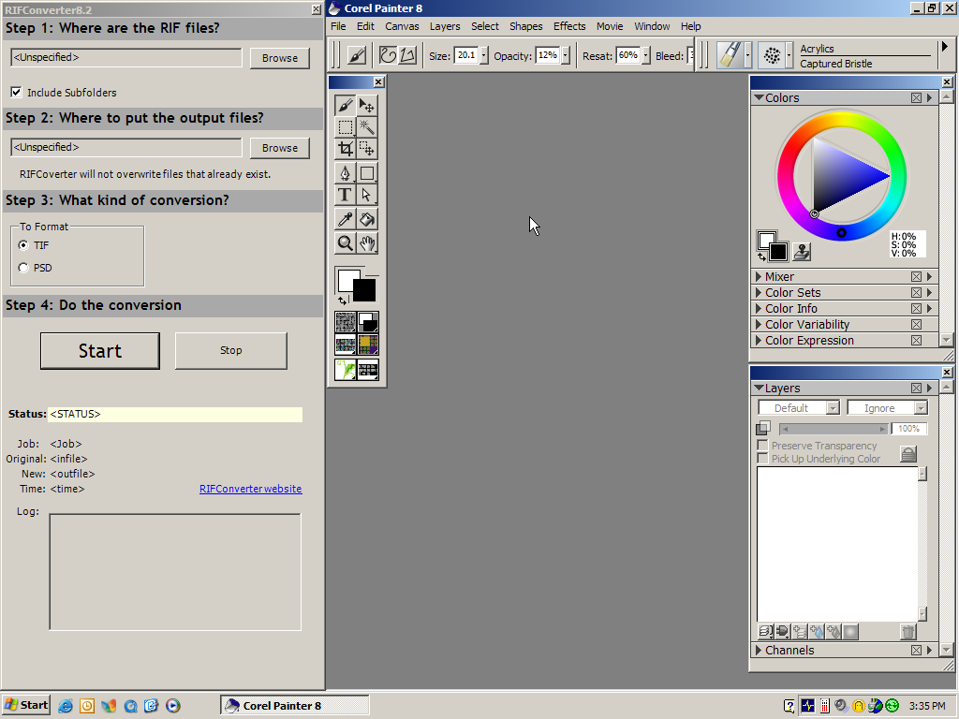

Make sure that no documents are open in painter
Make sure that no dialogs are open in painter

Step 3: Choose the file locations
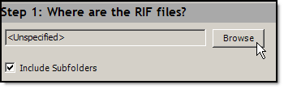

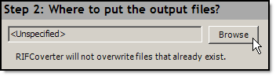

Both of these buttons will bring up this dialog.
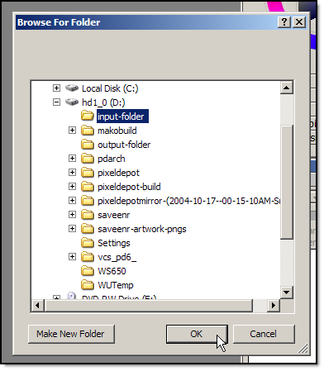

Step 4: Select the output formats
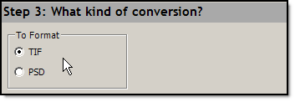

Step 5: Click START
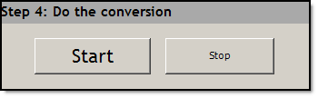

Step 6: Watch the processing
While running leave the machine alone
You will see
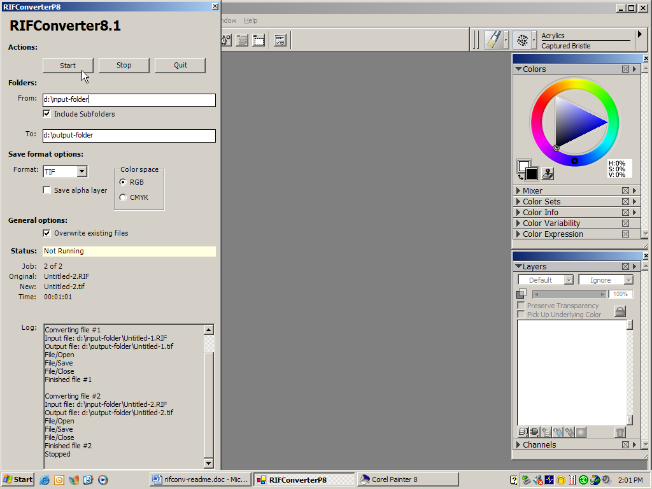

Step 7: Check the files in the output folder
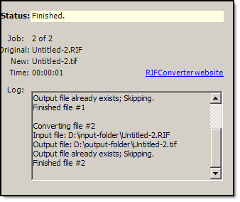

Appendix

What is the right way to batch convert RIFs?
RifConverter is not the right way. RifConverter is a tool created out of necessity and desperation. The number of limitations and non-robustness of the script attest to this fact. However, it does get the job done and is, as far as I am aware, the only tool available for this purpose.

The right way is for Corel to add a batch conversion wizard to Painter.

Change Log

10/26/2004 | Fixed PSD support
04/21/2002 | Use windows messages instead of SendKeysEx in some cases
04/21/2002 | Changed output format to TIF instead of JPG
04/20/2002 | Made shell object a member for RifConverter
04/20/2002 | Wrapped calls to sleep.time into SleepEx
04/20/2002 | Added exception handling for keyboard interrupt
03/06/2000 | Initial Version

