VECTORS
"Worth seeing, yes; but not worth going to see"
Samuel Johnson
(said of the Giant's Causeway)

- In order to describe motion in more than one dimension it is convenient to introduce the concept of Vectors, which take into account both the magnitude and direction of certain quantities.
- A vector quantity must be specified by both a magnitude and direction.
Examples are, velocity, force, displacement and acceleration .
Contrast with scalar quantities which require only a magnitude.
Examples of scalars are, mass, speed, time and distance.
N.B. The magnitude of an object's velocity is its speed.
Displacement is distance in a particular direction.
- Representation
  - Underline A
  - Bold A
  - Arrow on top
  - Graphical
- Addition and subtraction
  - Subtraction is the addition of a "negative" vector. "Negative" vector is opposite in direction with same magnitude as the original vector.
  - Graphical
  - Resolution. "Reverse" of addition. Any vector can be "resolved" into two (or more) components along perpendicular axes (x,y,z).
  - Vector addition (subtraction) via components
    - Resolve each vector into its x,y (z) components
    - Add (subtract) x and y components separately
    - Add x and y components to give resultant vector
- Specific representation of A
  - Magnitude: |A| = (A_{x}² + A_{y}² )^{1/2}
  - Direction: tan (theta) = A_{y} /A_{x}
Since tan (theta) = tan (theta+180), sketching the vector will help define its direction exactly.

- Multiplication of vectors
There are three forms of multiplication in common use
  - Multiplication by a scalar
If k is a scalar and r is a vector,
a = kr is a vector whose magnitude is given by |k||r| with direction either r or -r depending on the sign of k.
  - Scalar or dot product
r and s are two arbitary vectors,
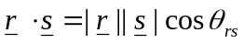 is the scalar product, where 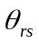 is the angle between r and s.
In terms of components, 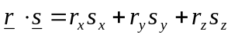
Alternatively, the dot product can be thought of as the product of |r| and the component of s along r, 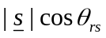

  - Vector or cross product
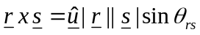
Where the unit vector u is at right angles to both r and s with a sense determined by the right hand rule. Using the unit vector notation for r and s the cross product can be evaluated directly or via the determinant method.

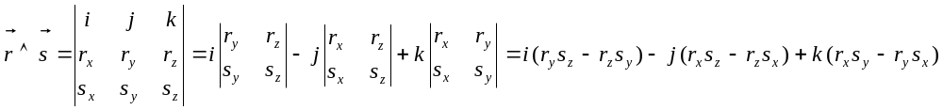

“An Englishman, even if he is alone, forms an orderly queue of one”

George Mikes – How to be an Alien (1946)

Dr. C. L. Davis
Physics Department
University of Louisville
email: c.l.davis@louisville.edu

