Website Admin / User Guide
This guide explains how to manage the content on the Save Life Agro website without needing to write any code.

1. Accessing the Admin Panel
Navigate to your website and click on the Admin link, or go directly to https://www.savelifeagro.com/admin.
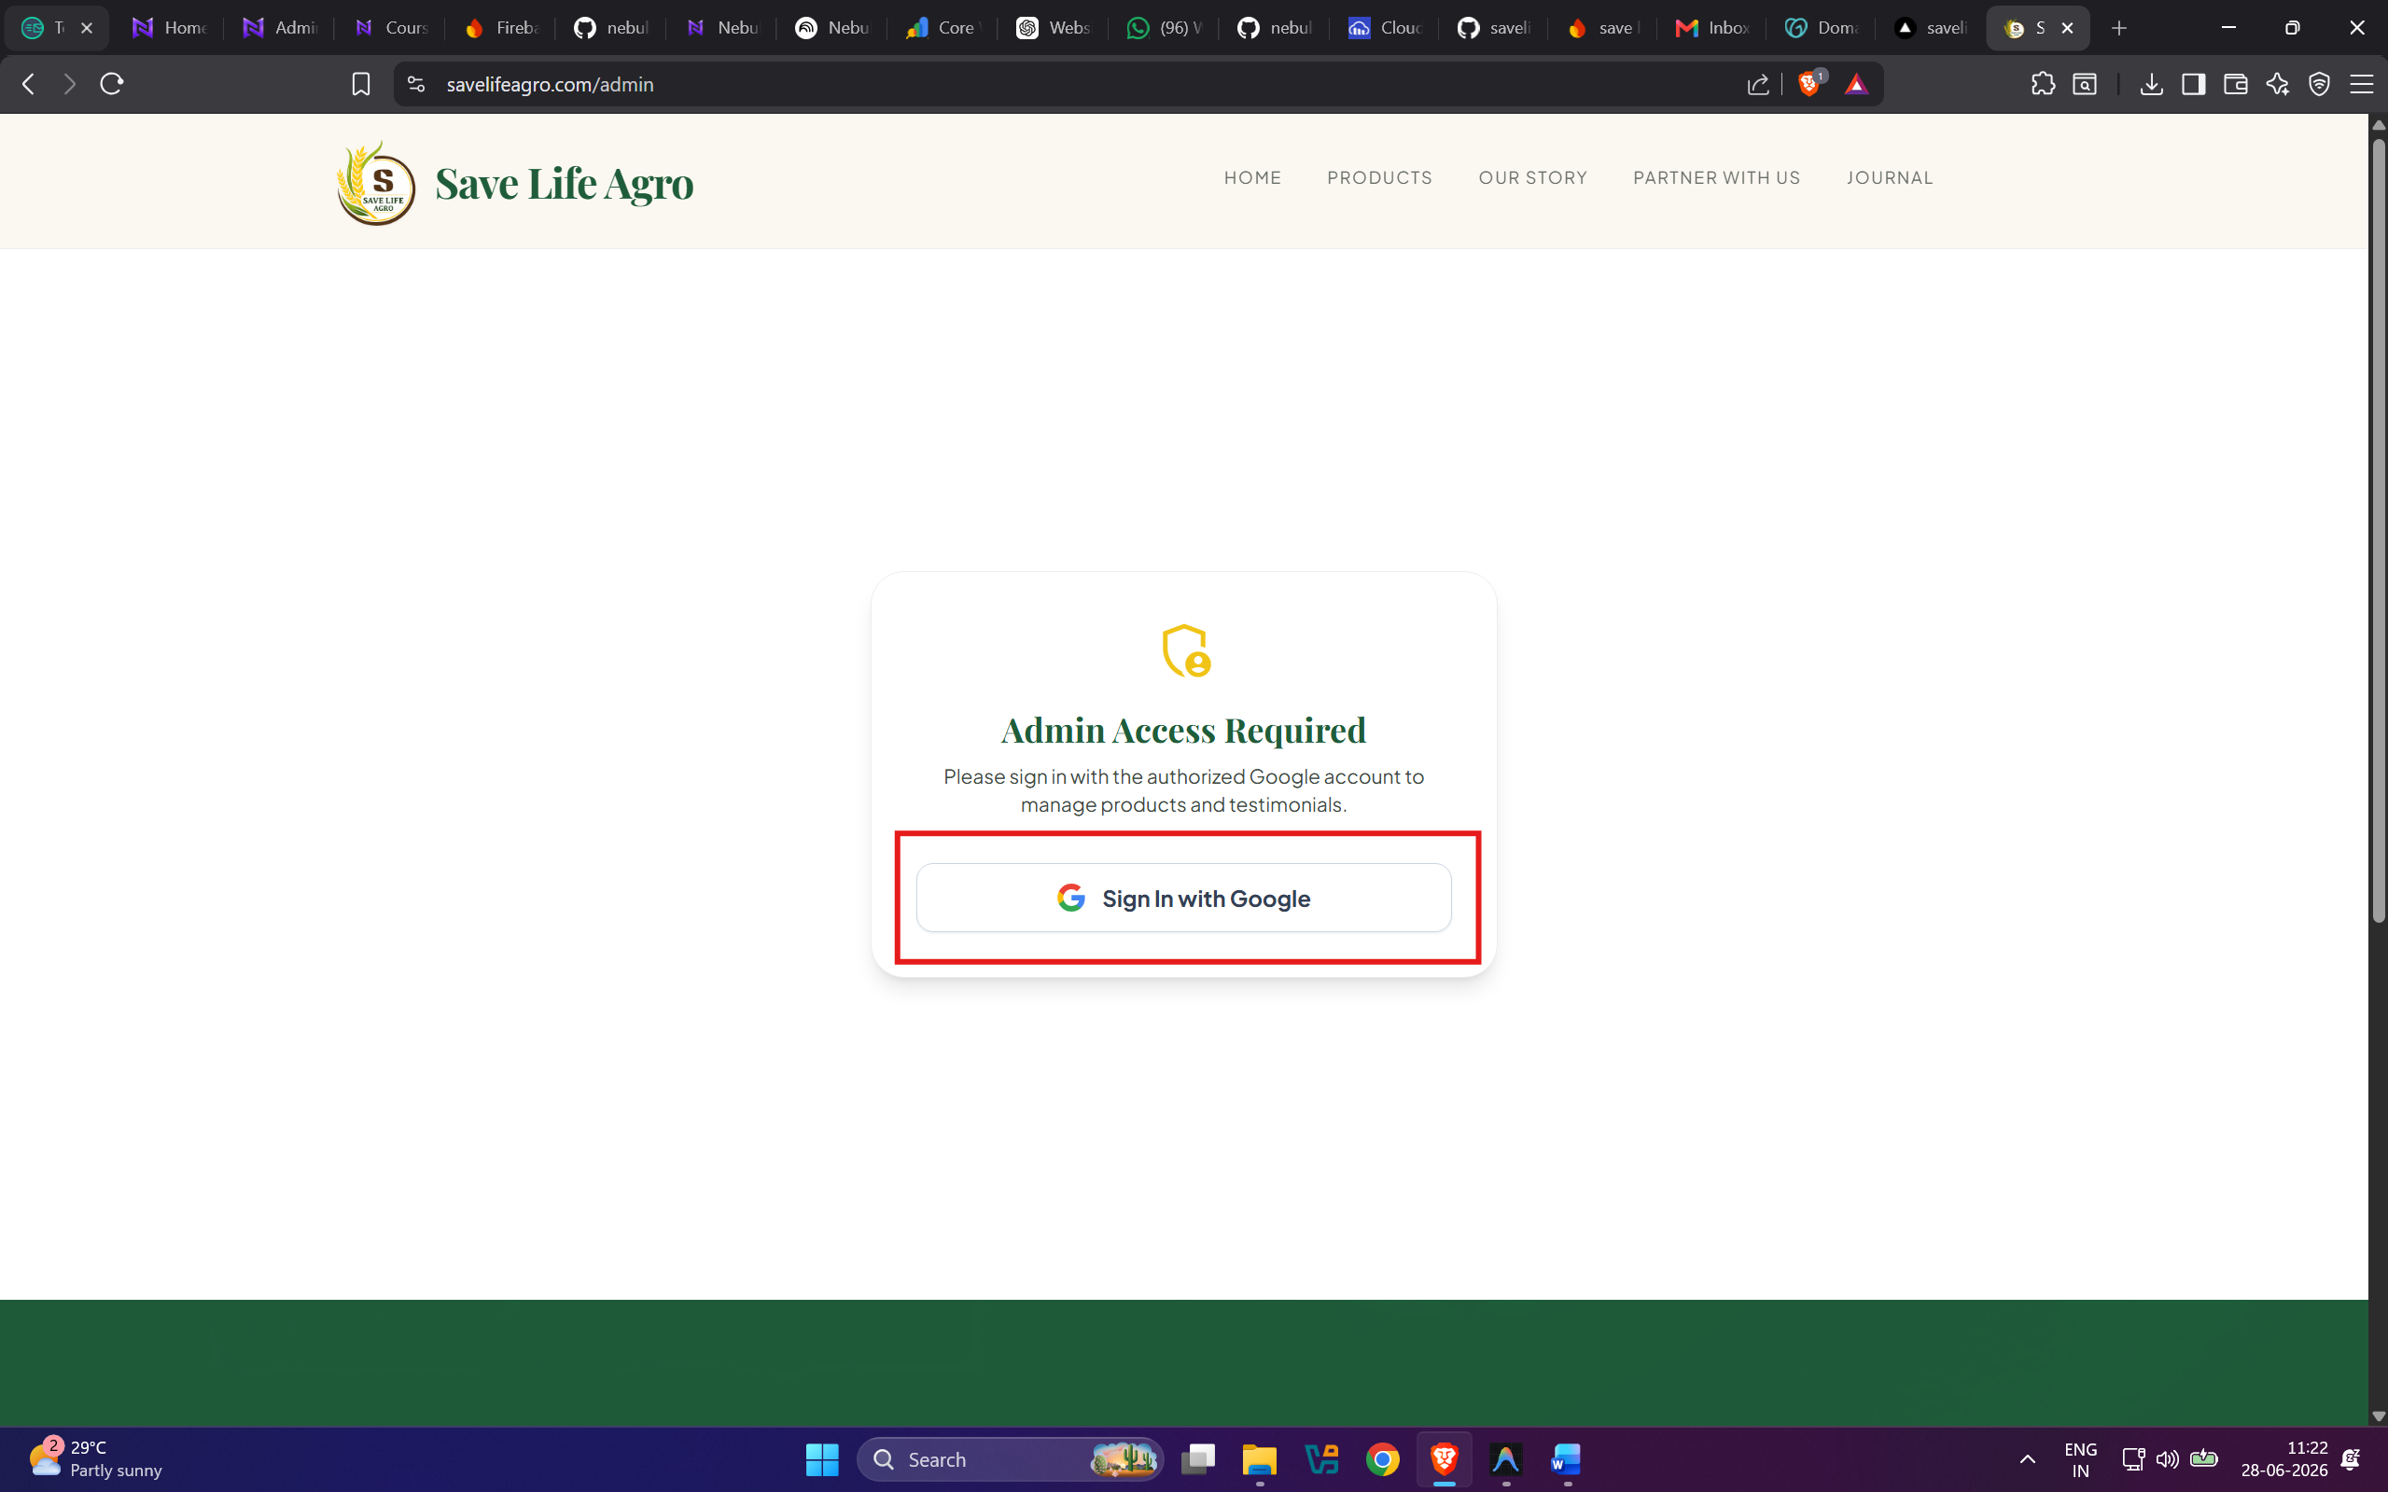

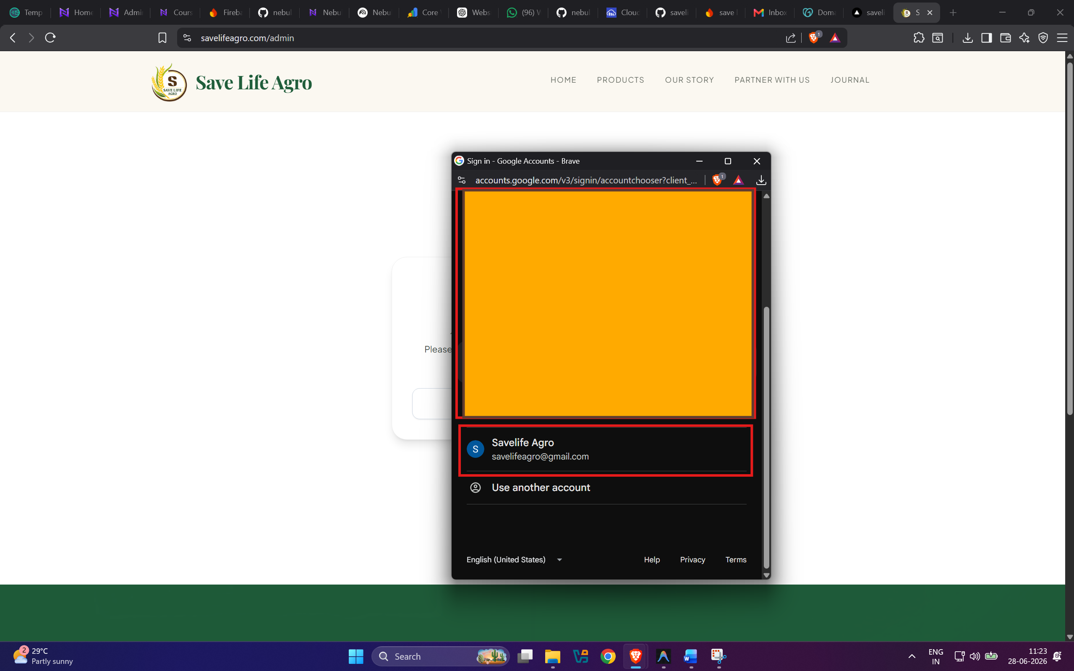

2. Dashboard Overview
The Admin Dashboard is divided into three main tabs:
- Products: Manage your fertilizers and growth promoters.
- Journal: Manage blog posts, scientific essays, and success stories.
- Testimonials: Manage reviews from farmers.

3. Managing Products

Adding a New Product
- Click the Add New Product button.
- Fill in the fields: Name, Category, Description, Image URL, and Ingredients.
- Pricing & Sizes: You can add multiple sizes (e.g., 1L, 5L) and their respective prices.
- Show on Home Screen: Toggle the switch to feature this product on the main home page carousel.
- Click Save Product.
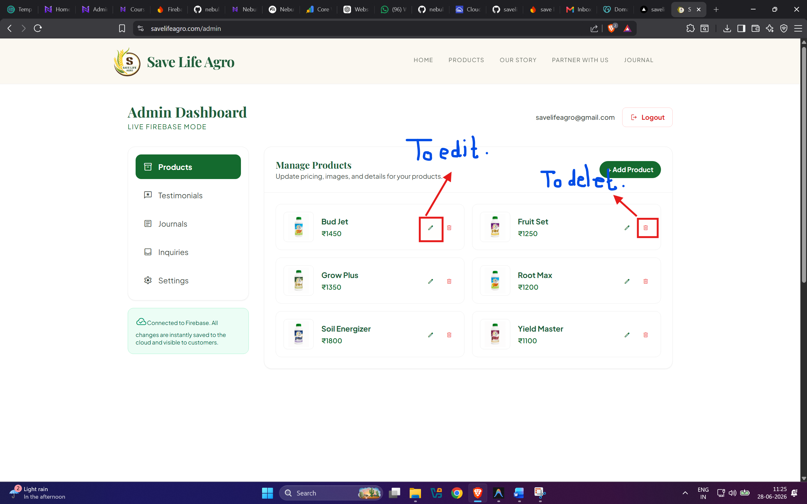

Editing/Deleting a Product
Find the product in the list below the form. Click the Edit (Pencil) icon to modify it, or the Delete (Trash) icon to remove it permanently.

4. Managing the Journal (Blog)
- Switch to the Journal Manager tab.
- Provide a Title, Category, Excerpt, Content (Full article), and Image URL.
- Click Save Entry. It will immediately appear on the Journal page.

5. Image Guidelines
Your website is currently configured to use Cloudinary for image management. For best results when adding new products or journal entries:
- Upload your image to your Cloudinary media library.
- Copy the direct image URL from Cloudinary.
- Paste that link into the Image URL field in the Admin Panel.
Recommended Sizes:
- Products: Square (1:1) with a transparent or white background.
- Journal Covers: Landscape (16:9), high resolution.

