1. Task Success Rate = 100%

a. Task Success Rate=(Total Number of Tasks / Number of Successful Tasks)×100 = 36/36 * 100 = 100

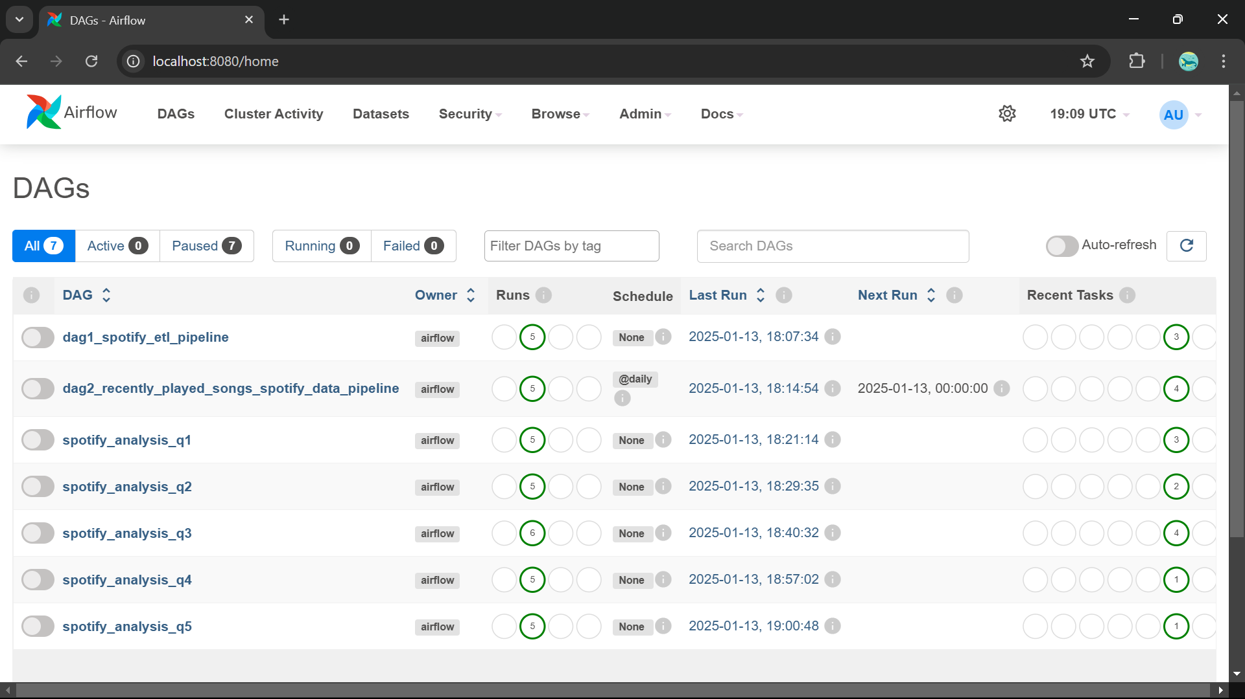

b. SQL Query to get task success rate for specific DAG:

SELECT

dag_id,

COUNT(CASE WHEN state = 'success' THEN 1 END) AS successful_tasks,

COUNT(*) AS total_tasks,

(COUNT(CASE WHEN state = 'success' THEN 1 END) * 100.0 / COUNT(*)) AS task_success_rate

FROM

task_instance

WHERE

dag_id = 'your_dag_id' -- specify your DAG ID here

GROUP BY

dag_id;

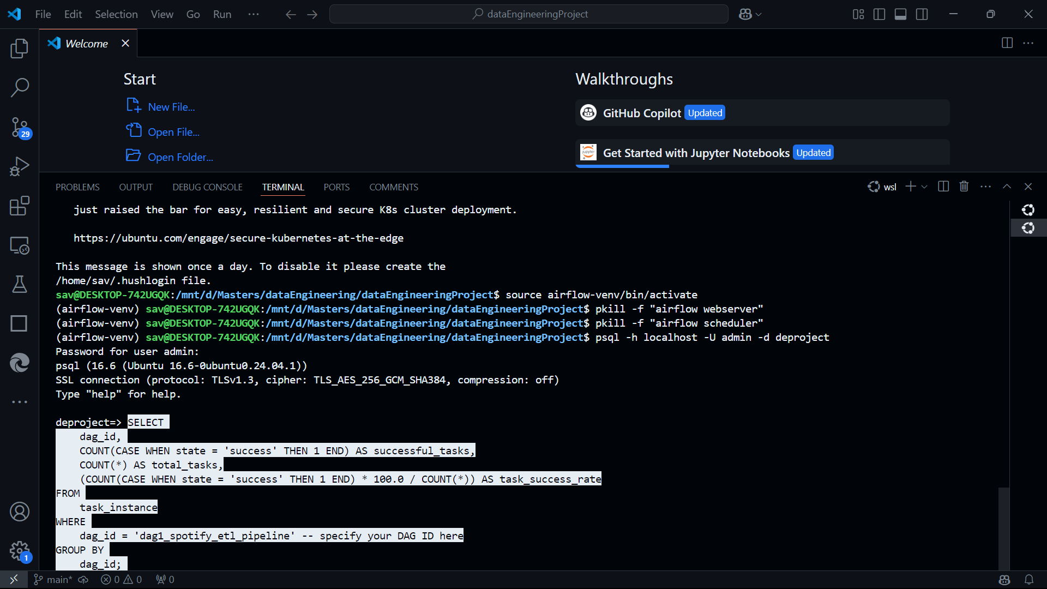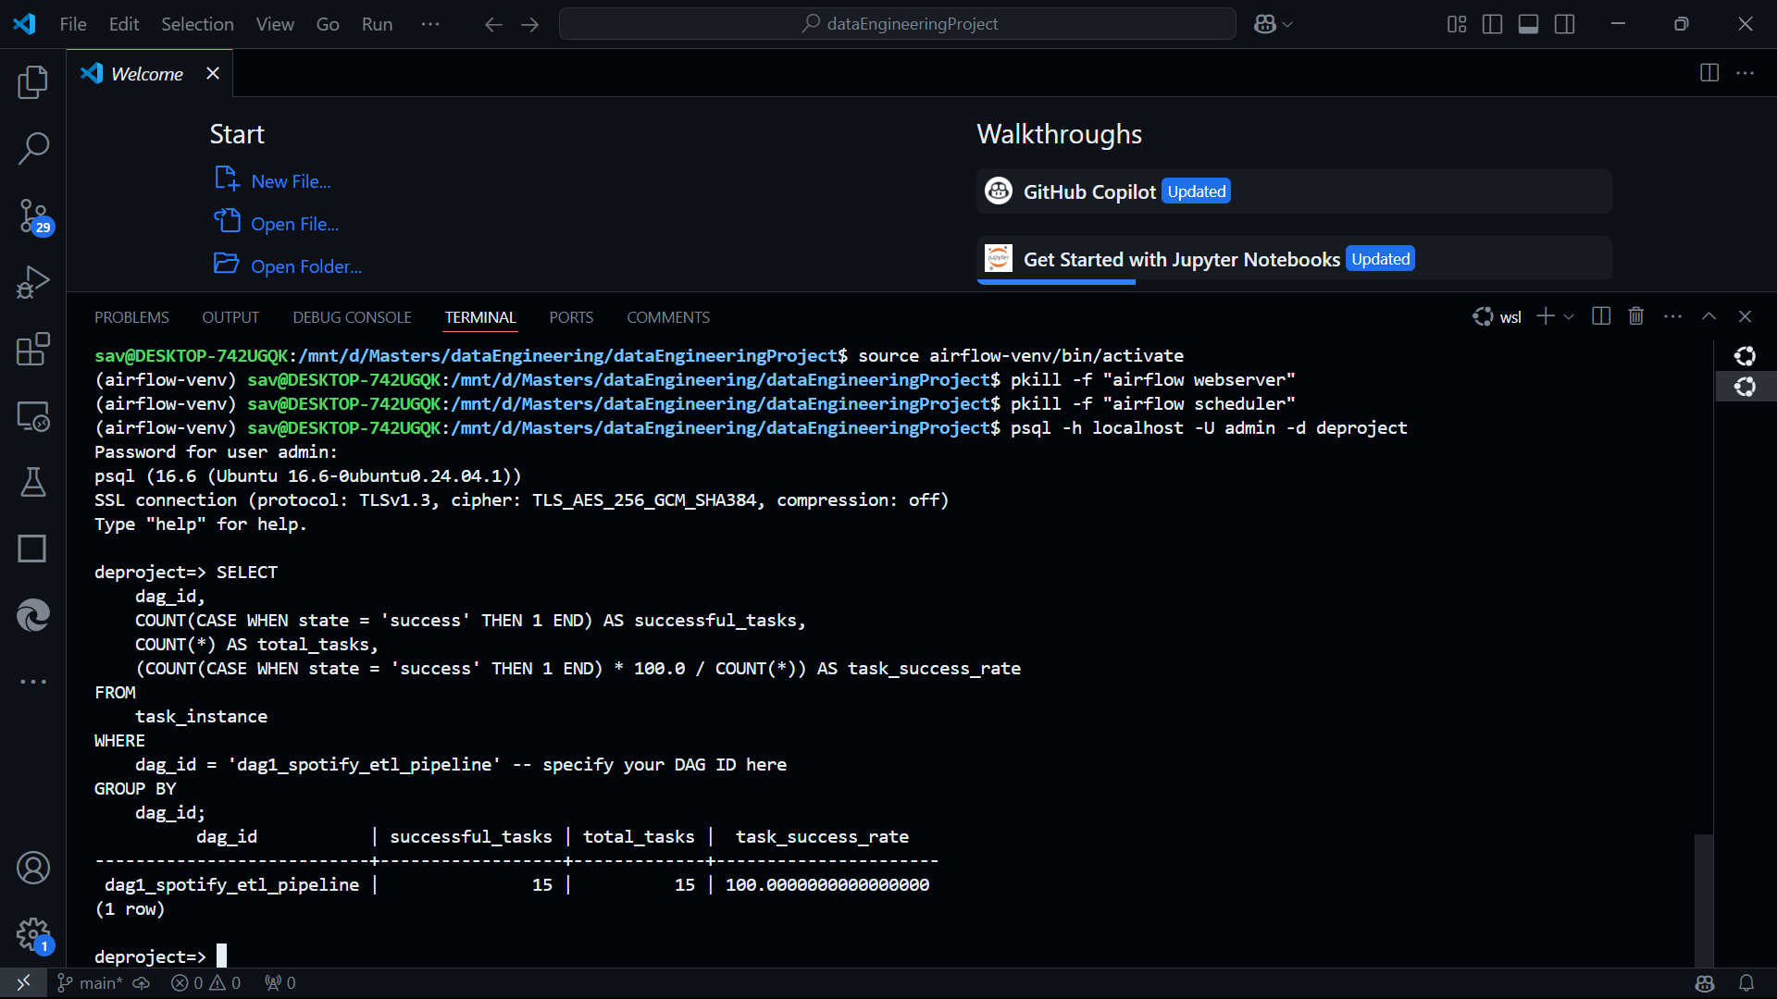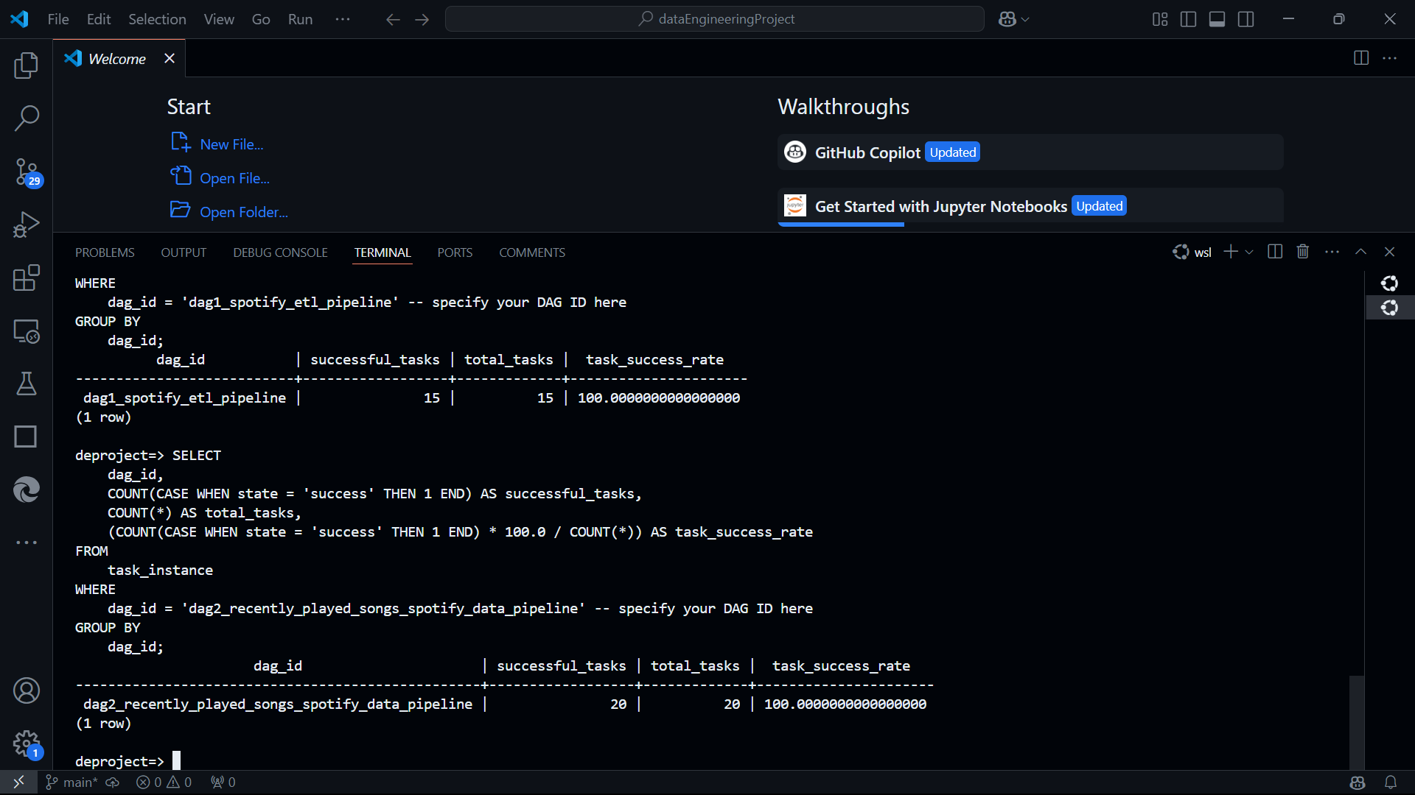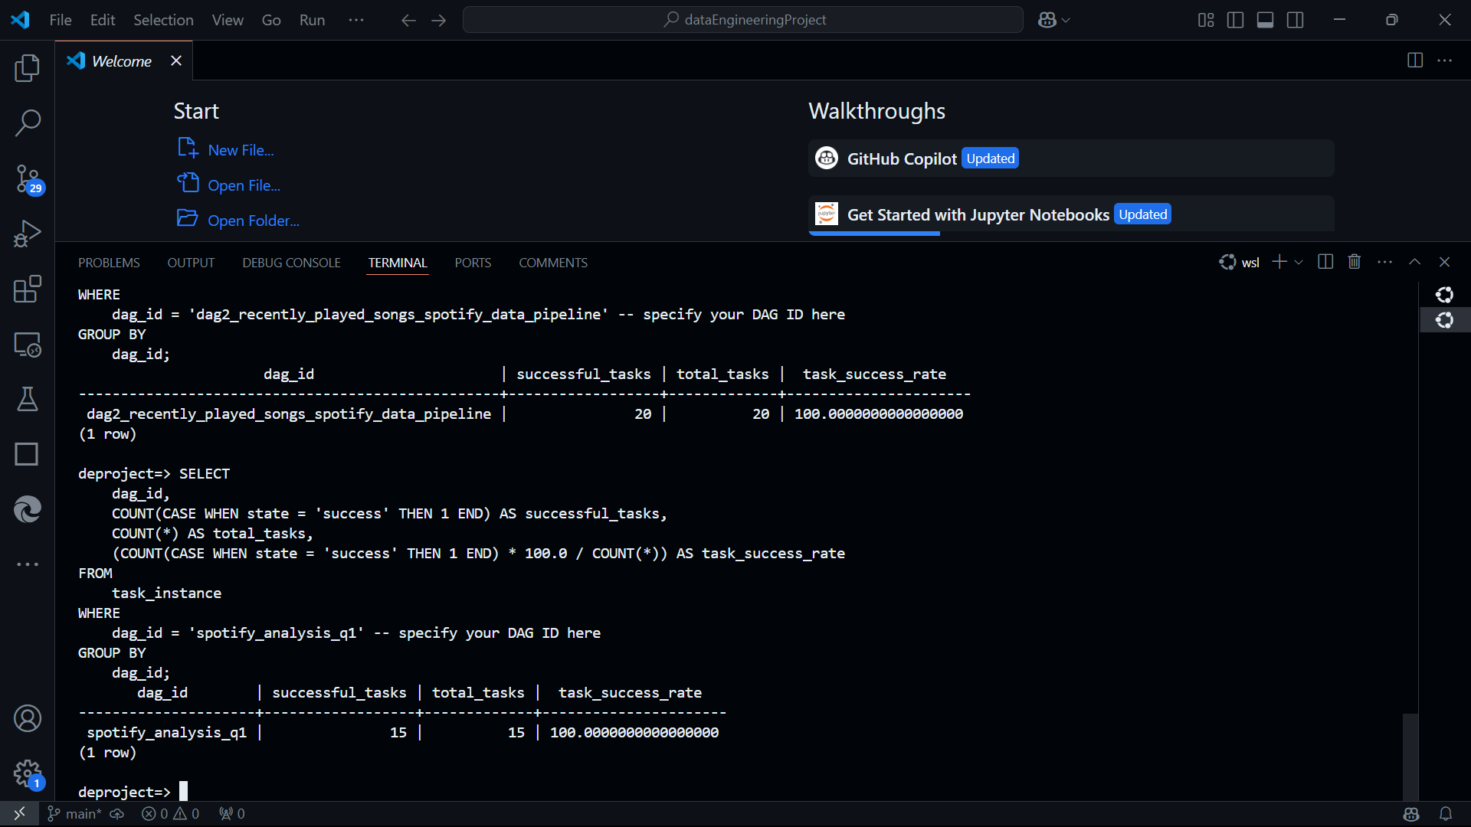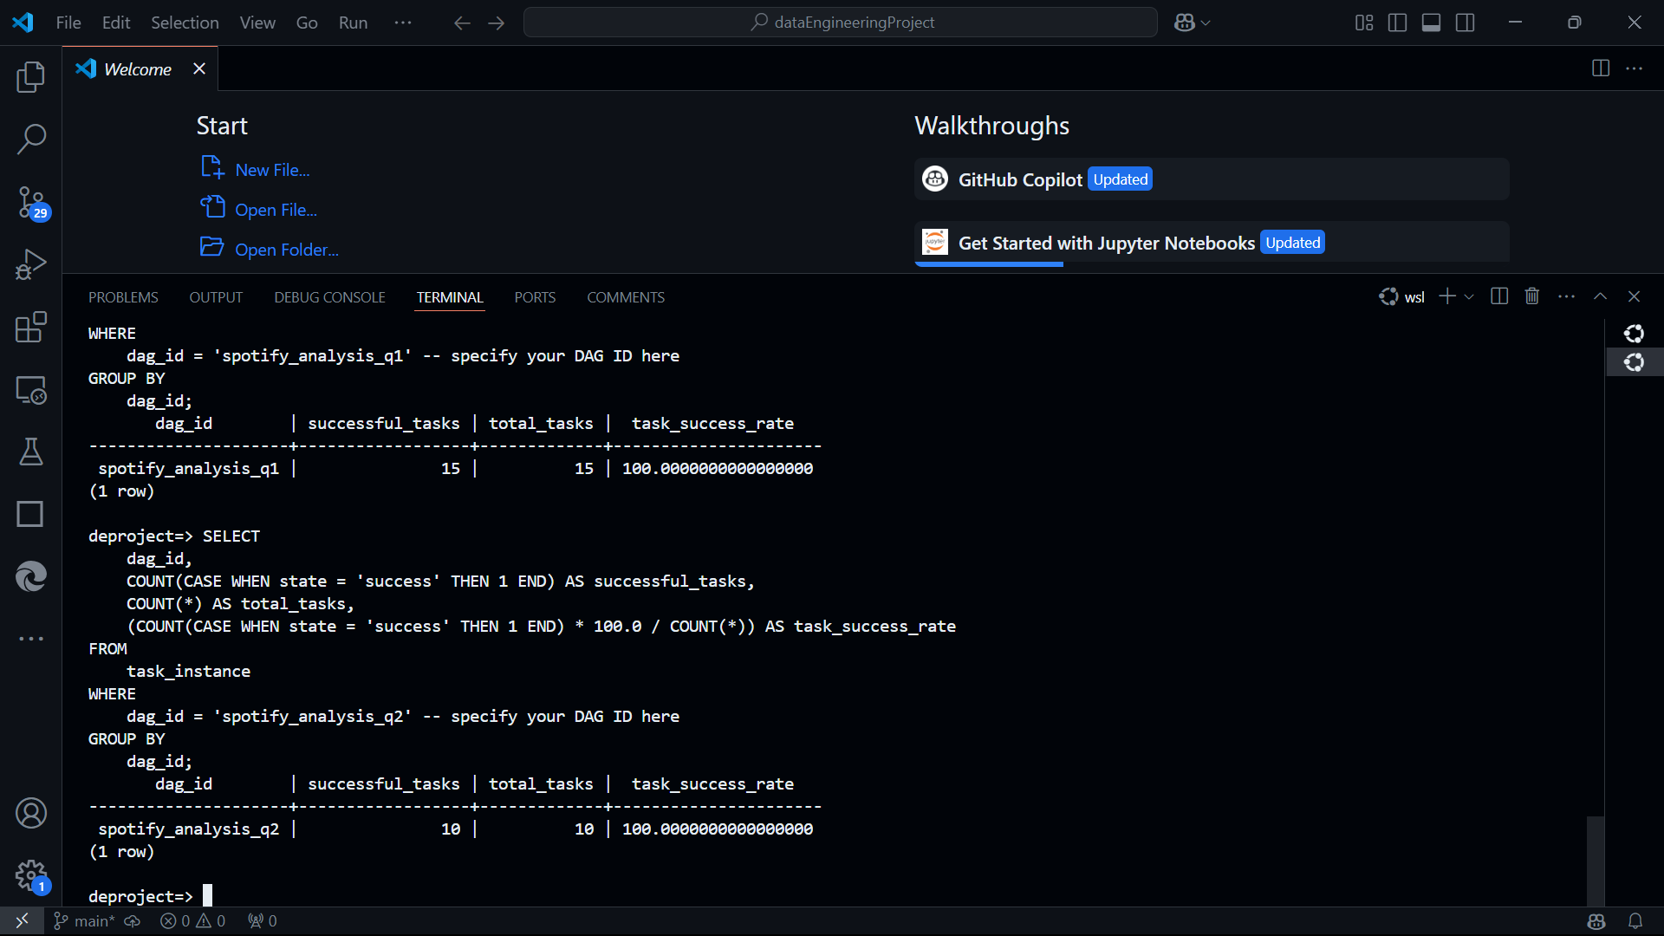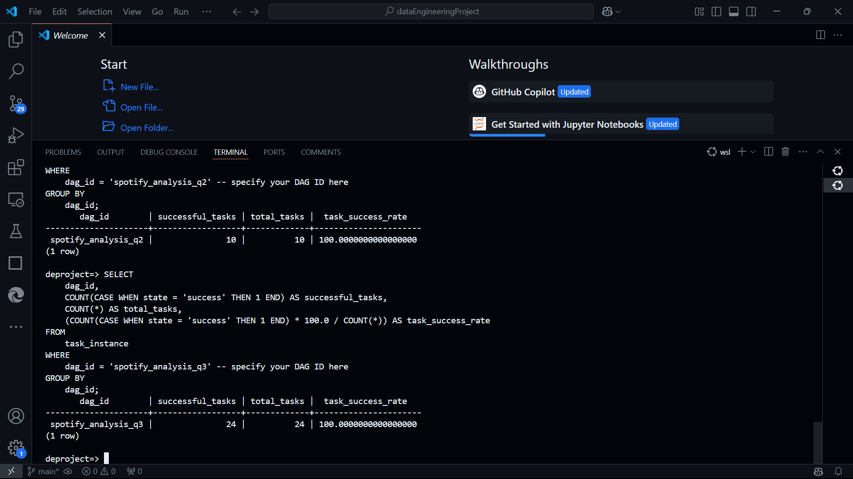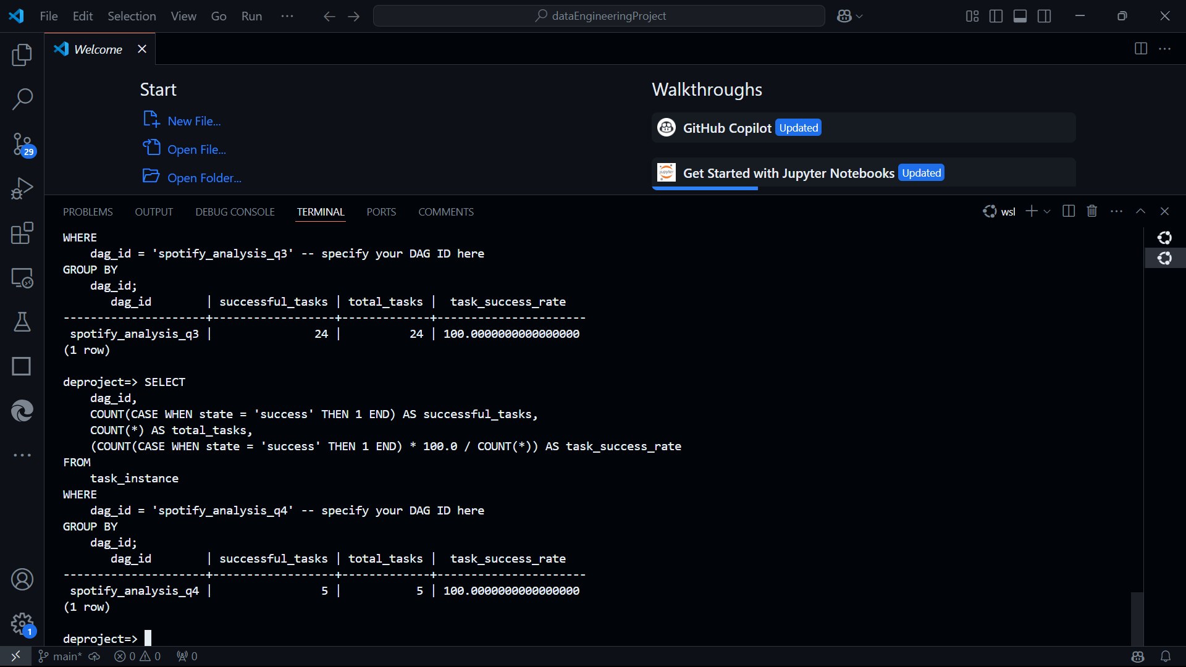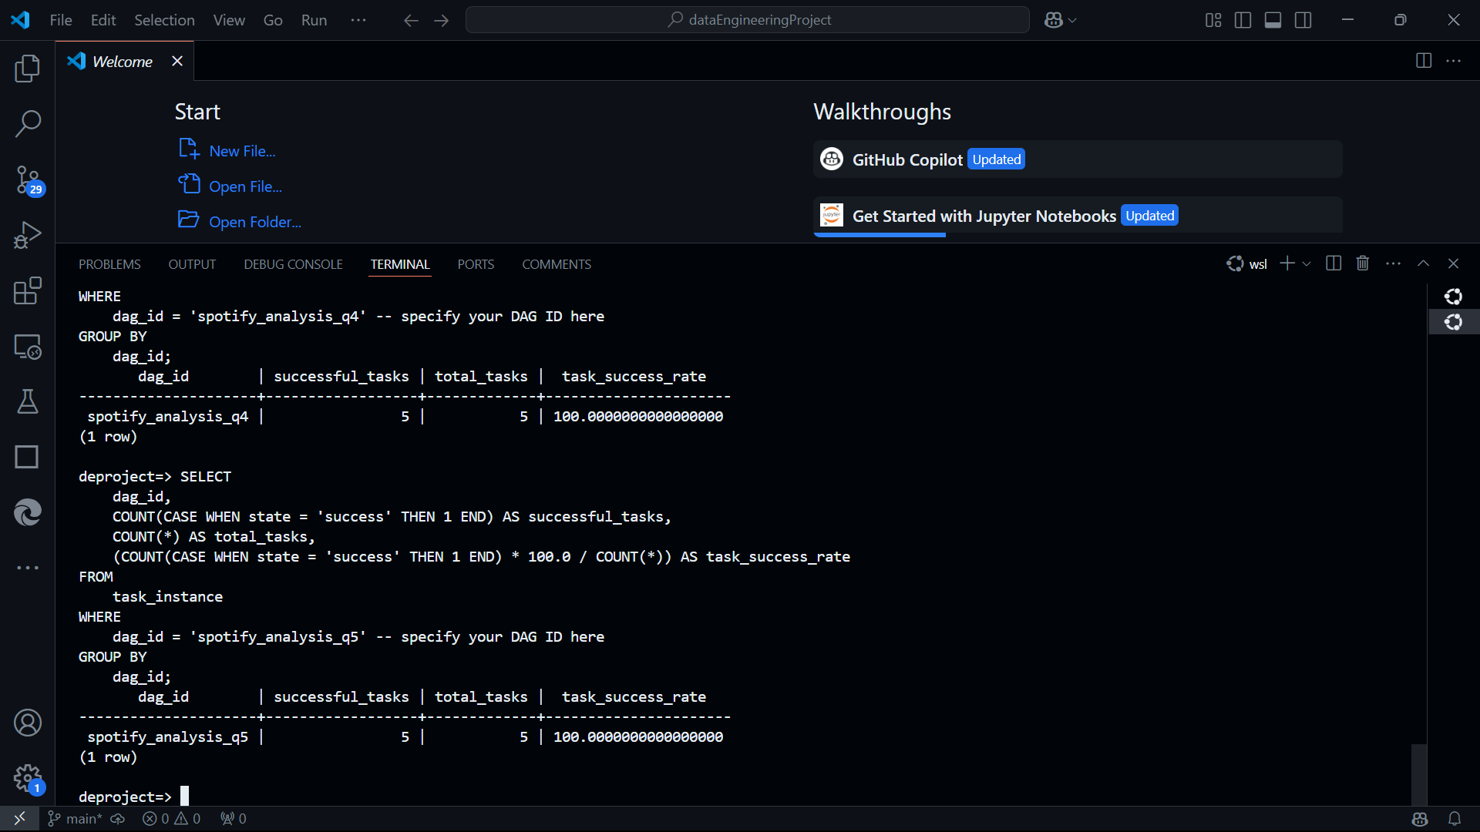

c. SQL Query to get task success rate for all DAGS

SELECT

dag_id,

COUNT(CASE WHEN state = 'success' THEN 1 END) AS successful_tasks,

COUNT(*) AS total_tasks,

(COUNT(CASE WHEN state = 'success' THEN 1 END) * 100.0 / COUNT(*)) AS task_success_rate

FROM

task_instance

GROUP BY

dag_id;

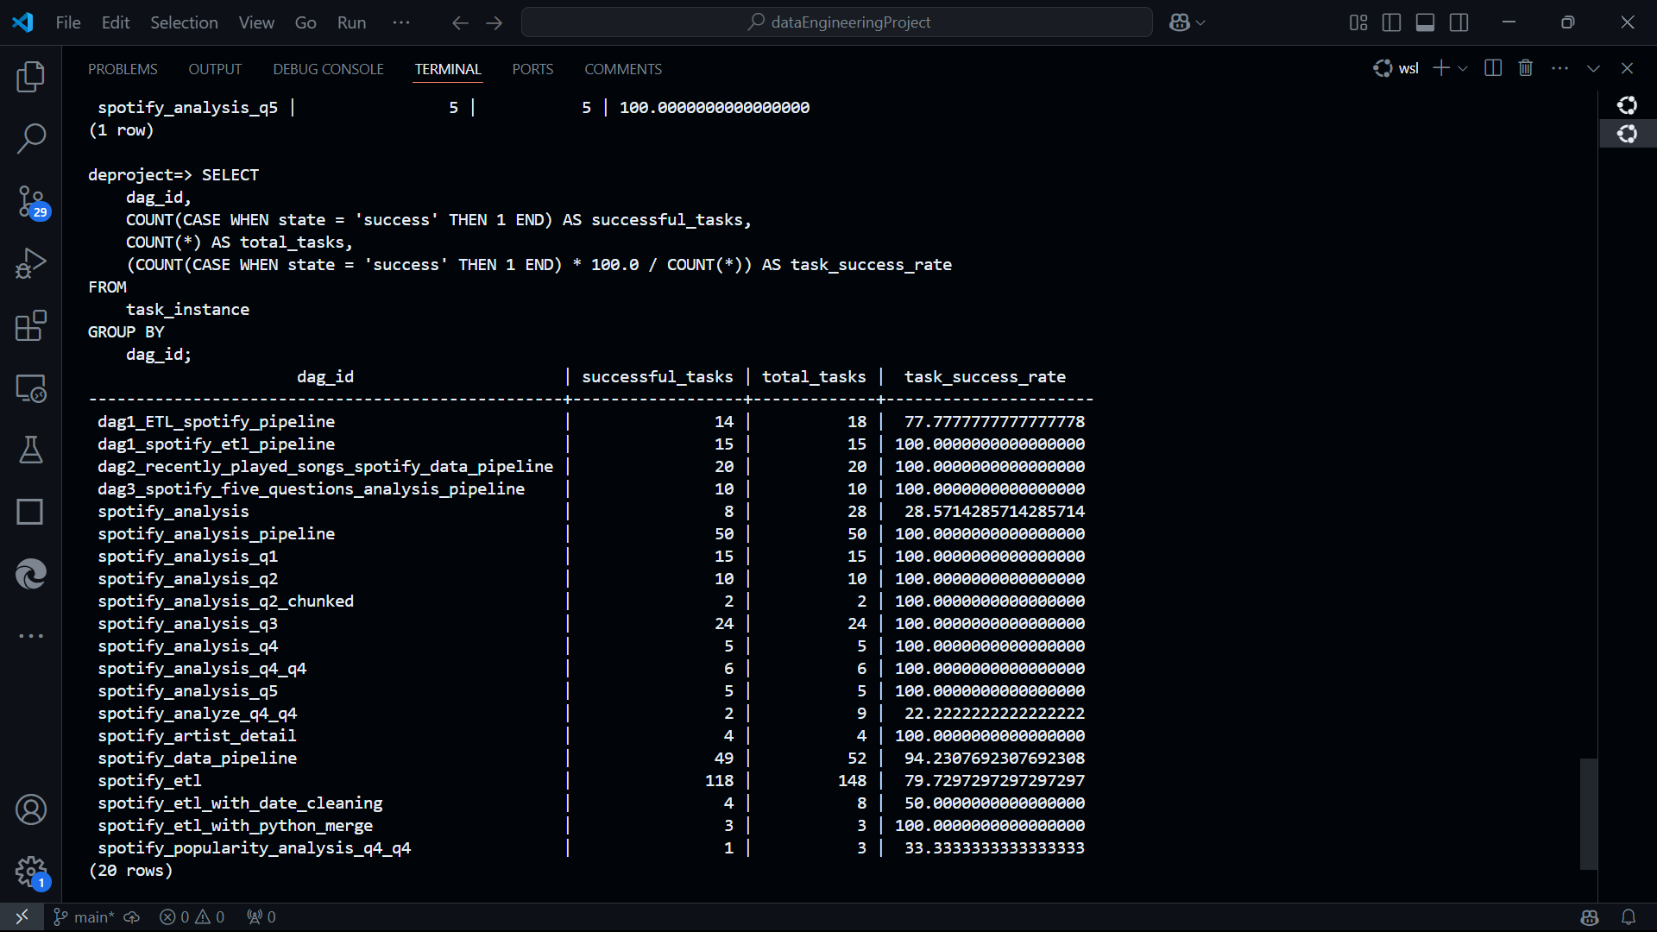

2. DAG Run Success Rate

a. SELECT dag_id, state, COUNT(*) FROM dag_run GROUP BY dag_id, state;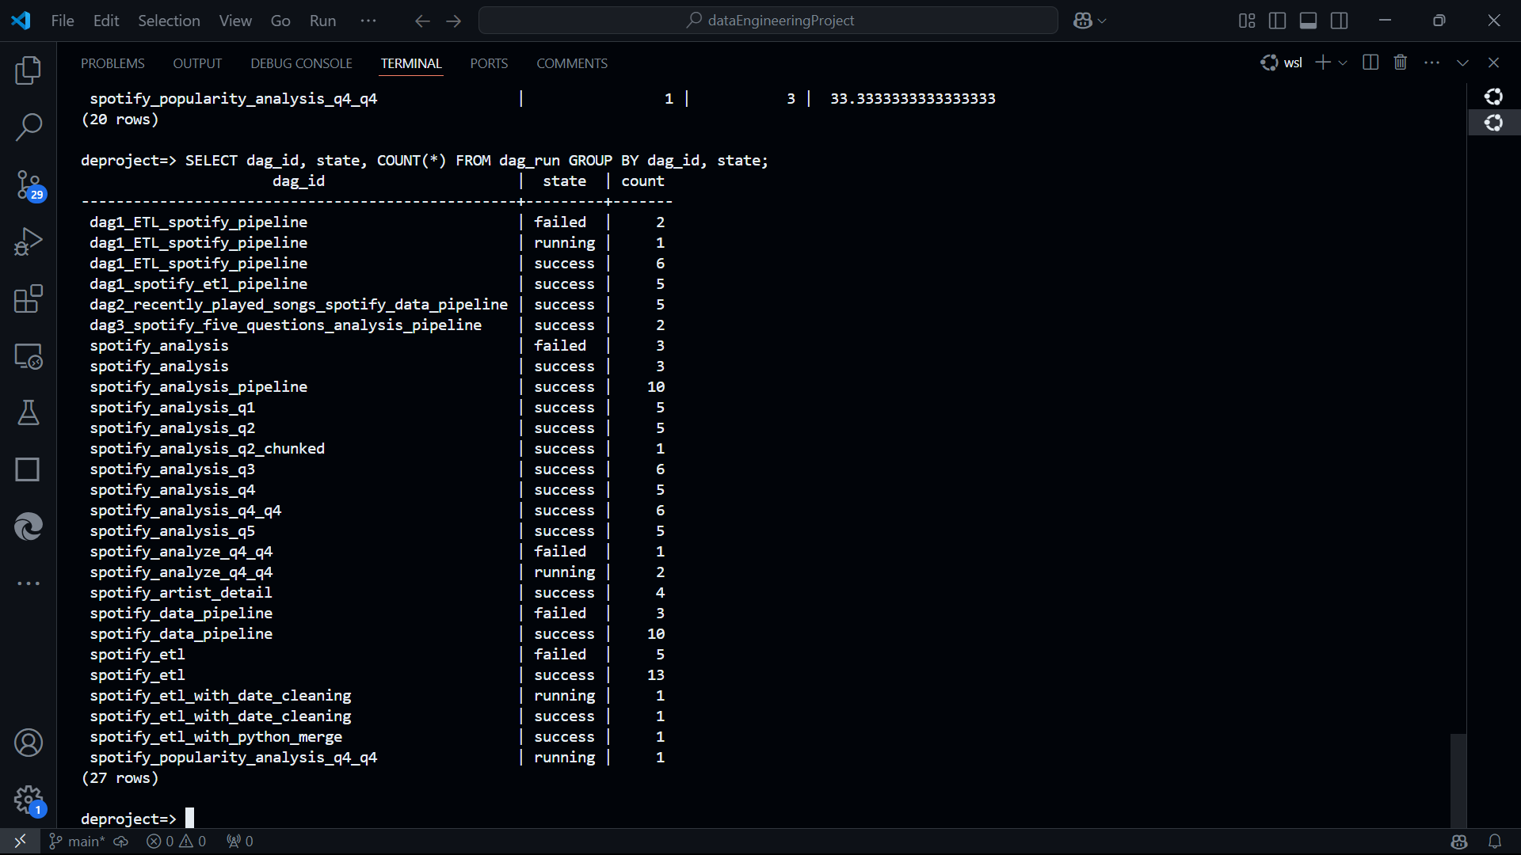

b. SQL query

SELECT

dag_id,

COUNT(CASE WHEN state = 'success' THEN 1 END) AS successful_runs,

COUNT(*) AS total_runs,

(COUNT(CASE WHEN state = 'success' THEN 1 END) * 100.0 / COUNT(*)) AS dag_run_success_rate

FROM

dag_run

GROUP BY

    dag_id;

