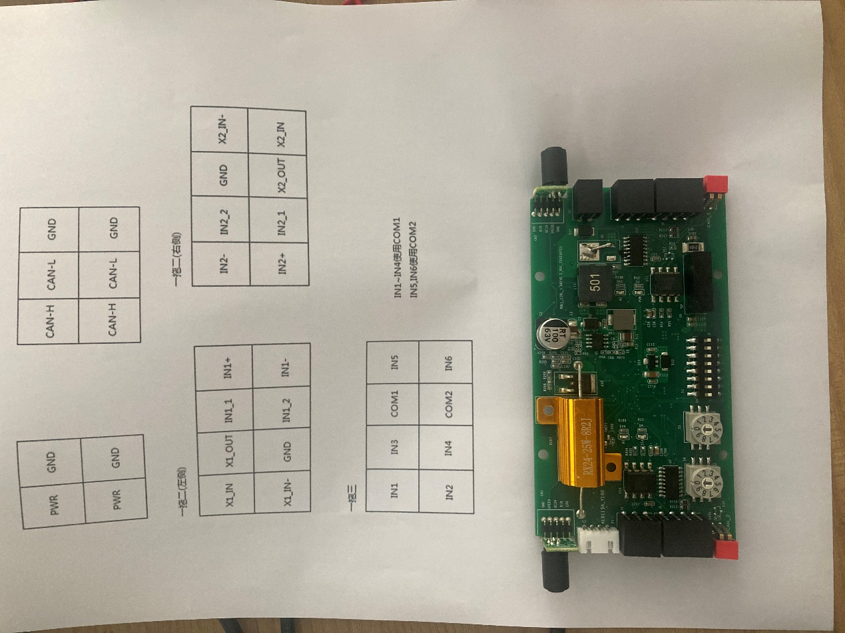

一拖二

右侧

**J3 电源引脚**

|  |  |
| --- | --- |
| **PIN脚** | **PIN脚定义** |
| PWR |  |
| GND |  |

**J4 can1引脚**

|  |  |
| --- | --- |
| **PIN脚** | **PIN脚定义** |
| H |  |
| L |  |
| G |  |

**J2 输入输出引脚**

|  |  |
| --- | --- |
| **PIN脚** | **PIN脚定义** |
| IN2- |  |
| IN2+ |  |
| IN2_2 |  |
| IN2_1 |  |
| P_GND |  |
| X2_OUT1 |  |
| X2_IN- |  |
| X2_IN1 |  |

左侧

**J5 can1引脚**

|  |  |
| --- | --- |
| **PIN脚** | **PIN脚定义** |
| H |  |
| L |  |
| G |  |

**J1 输入输出引脚**

|  |  |
| --- | --- |
| **PIN脚** | **PIN脚定义** |
| X1_IN1 |  |
| X1_IN- |  |
| X1_OUT1 |  |
| PGND |  |
| IN1_1 |  |
| IN1-2 |  |
| IN+ |  |
| IN- |  |

一拖三

右侧

**J3 电源引脚**

|  |  |
| --- | --- |
| **PIN脚** | **PIN脚定义** |
| PWR |  |
| GND |  |

**J4 can1引脚**

|  |  |
| --- | --- |
| **PIN脚** | **PIN脚定义** |
| H |  |
| L |  |
| G |  |

**J5 can1引脚**

|  |  |
| --- | --- |
| **PIN脚** | **PIN脚定义** |
| H |  |
| L |  |
| G |  |

左侧

**J1 输入输出引脚**

|  |  |
| --- | --- |
| **PIN脚** | **PIN脚定义** |
| IN1 |  |
| IN2 |  |
| IN3 |  |
| IN4 |  |
| INCOM1 |  |
| INCOM2 |  |
| IN5 |  |
| IN6 |  |