**PYTHON LAB**

**ASSIGNMENT 1**

NAME: SAVI CHANDWADKAR

MIS NO: 112315169

BRANCH: CSE

GROUP: G4

1. Write a Python program to get the Python version you are using.

Code:

import sys

print(sys.version)

Output:

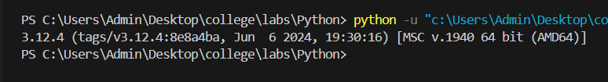

2. Write a Python program to list all the keywords in Python.

Code:

import keyword

print("The list of all keywords is: ")

print(keyword.kwlist)

Output:

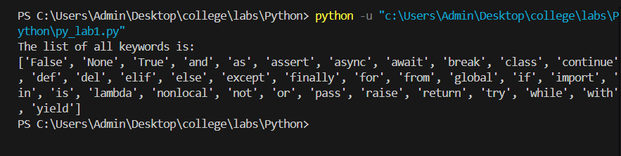

3. Create a program that asks the user to enter their name and age. Print out a message addressed to them that tells them the year they will turn 100 years old.

Code:

name = input("Enter your name: ")

age = int(input("Enter your age: "))

year = 2124 - age

print("You will turn 100 years old in", year)

Output:

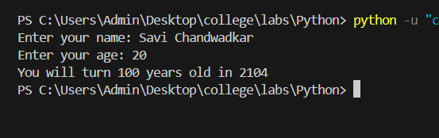

4. Write a Python program which accepts the radius of a circle from the user and compute the area.

Code:

import math

radius = float(input("Enter the radius of the circle: "))

area = math.pi*radius*radius

print("The area of the circle is", area)

Output:

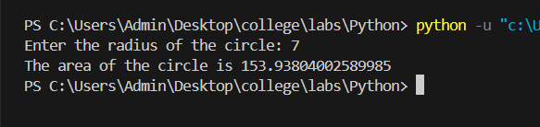

5. Ask the user for a number. Depending on whether the number is even or odd, print out an appropriate message to the user.

Code:

num = int(input("Enter a number: "))

if(num%2==0):

    print("The given number is even.")

else:

    print("The given number is odd.")

Output:

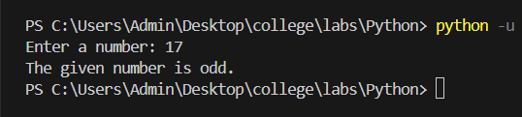

6. Check whether 0.1+0.2 = 0.3 holds true in Python? If not, find ways to make it true.

Code:

print(0.1 + 0.2 == 0.3)

Output:

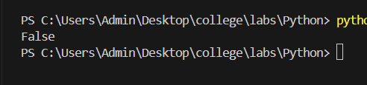

Code:

from decimal import *

getcontext().prec = 6

print(Decimal("0.1") + Decimal("0.2") == Decimal("0.3"))

Output:

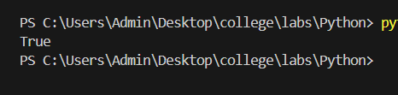

7. Write a Python program to get a single string from two given strings, separated by a space and swap the first two characters of each string.

Code:

def char_mix_up(x, y):

    new_x = y[:2] + x[2:]

    new_y = x[:2] + y[2:]

    return new_x + ' ' + new_y

print(char_mix_up("IIIT", "Pune"))

Output:

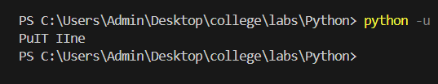

8. Ask the user for a string containing lowercase letters, uppercase letters, digits or underscores or combination of all. Write a python program to check whether the string is a valid identifier.

Code:

def check(string):

    if(string.isidentifier()):

        print("The string is a valid identifier")

    else:

        print("The string is not a valid identifier")

str = input("Enter a string: ")

check(str)

Output:

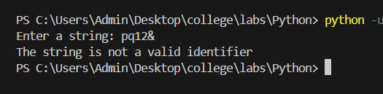

9. Write a Python program to change a given string to a new string where the first and last chars have been exchanged.

Code:

def exchange(str):

    new_str = str[-1] + str[1:-1] + str[0]

    return new_str

a = input("Enter a string: ")

print("New string is", exchange(a))

Output:

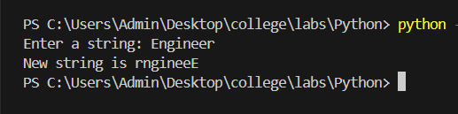

10. Write a Python script that takes input from the user and displays that input back in upper and lower cases.

Code:

a = input("Enter a string: ")

print("Lower case string:", a.lower())

print("Upper case string:", a.upper())

Output:

