**PYTHON LAB**

**ASSIGNMENT 2**

NAME: SAVI CHANDWADKAR

MIS NO: 112315169

BRANCH: CSE

GROUP: G4

1. Write a program for checking whether the given number is even or not.

Code:

x = int(input("Enter a number: "))

if(x%2==0):

    print("The given number is even.")

else:

    print("The given number is odd.")

Output:

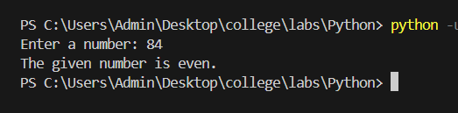

2. Using for loop, write a program that prints out the decimal equivalents of 1/2, 1/3, 1/4……1/10.

Code:

x = 1

for y in range(2,11):

    print(f"{x}/{y} =", x/y)

Output:

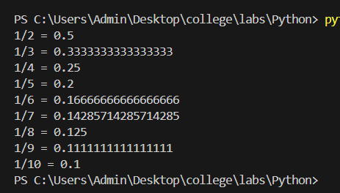

3. Write a program using a while loop that asks the user for a number, and prints a countdown from that number to zero.

Code:

a = int(input("Enter a number: "))

while a>=0:

    print(a)

    a-=1

Output:

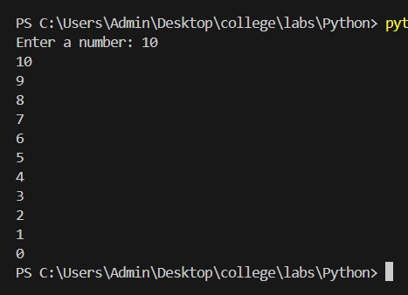

4. Write a python script to print the current date in the following format “Mon August 12 02:26:23 IST 2024”.

Code:

import datetime

current_time = datetime.datetime.now()

print("The current date and time is: ", current_time)

Output:



5. Write a python program to find the largest of three numbers.

Code:

a, b, c = input("Enter 3 values: ").split()

print("The largest number is: ")

if(a>b and a>c):

    print(a)

elif(b>a and b>c):

    print(b)

else:

    print(c)

Output:

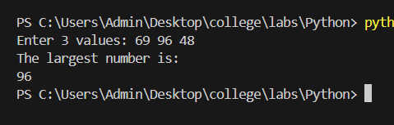

6. Write a python program to convert temperatures to and from Celsius, Farenheit.

Code:

t = input("Enter temperature in Celcius(c) or Farenheit(f): ")

if(t=='c'):

    C = float(input("Enter the temperature: "))

    F = (C * 1.8) + 32

    print("%.2f Celcius is equivalent to %.2f Farenheit. "%(C,F))

else:

    F = float(input("Enter the temperature: "))

    C = (F-32)/1.8

    print("%.2f Farenheit is equivalent to %.2f Celcius. "%(F,C))

Output:

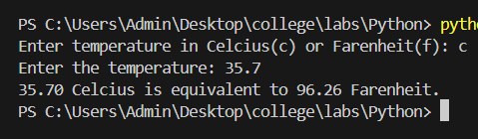

7. Write a python script that prints prime numbers less than 20.

Code:

def isPrime(n):

    if(n==1 or n==0):

        return False

    for i in range(2,n):

        if(n%i==0):

            return False

    return True

for a in range(2, 21):

    if(isPrime(a)):

        print(a, end = " ")

Output:



8. Write a program that accepts the length of three sides of a triangle as inputs. The program output should indicate whether or not the triangle is a right angle.

Code:

def check(a, b, c):

    t = [a, b, c]

    t.sort()

    if(t[2]**2 == t[1]**2 + t[0]**2):

        print("This is a right angled triangle")

    else:

        print("This is not a right angled triangle")

print("Enter the lengths of the triangle")

a = int(input("a = "))

b = int(input("b = "))

c = int(input("c = "))

check(a, b, c)

Output:

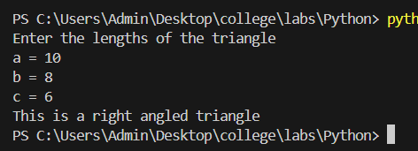

9. Write a python program to find the best of two test average marks out of three test marks accepted from the user.

Code:

def avg(a, b, c):

    x = [a, b, c]

    x.sort()

    return (x[1]+x[2])/2

print("Enter the test scores:")

a = float(input("Enter marks for test 1: "))

b = float(input("Enter marks for test 2: "))

c = float(input("Enter marks for test 3: "))

print("Average of best of two test marks is ", avg(a,b,c))

Output:

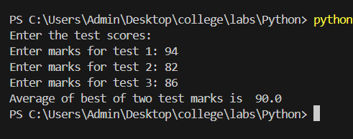

10. Develop a python program to check whether a given number is palindrome or not and also count the occurrences of each digit in the input number.

Code:

x = int(input("Enter a number: "))

str_x = str(x)

if(str_x == str_x[::-1]):

    print("Palindrome")

else:

    print("Not palindrome")

for i in range(10):

    if str_x.count(str(i)) > 0:

        print(str(i), "appears", str_x.count(str(i)), "times")

Output:

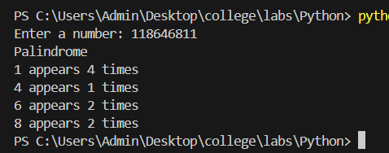

11. Write a python program that accepts a sentence and find the number of words, digits, uppercase letters and lowercase letters.

Code:

s = input("Enter a sentence: ")

w, d, u, l = 0, 0, 0, 0

l_w = s.split()

w = len(l_w)

for c in s:

    if c.isdigit():

        d = d + 1

    elif c.isupper():

        u = u + 1

    elif c.islower():

        l = l + 1

print ("No of Words: ", w)

print ("No of Digits: ", d)

print ("No of Uppercase letters: ", u)

print ("No of Lowercase letters: ", l)

Output:

