Population pharmacokinetics and exposure-response of the anti-tuberculosis drug BTZ-043
Simon E KOELE^{1*}, Norbert HEINRICH^{2,3,4}, Veronique R DE JAGER⁵, Julia DREISBACH^{2,3}, Patrick PJ PHILLIPS⁶, Petra GROSS-DEMEL^{2,3}, Rodney DAWSON⁷, Kim NARUNSKYy⁷, Leticia M WILDNER⁸, Timothy D MCHUGH⁸, Lindsey HM TE BRAKE¹, Andreas H DIACON⁵, Rob E AARNOUTSE¹, Michael HOELSCHER^{2,3,4,9}, Elin M SVENSSON^{1,10}
¹ Department of Pharmacy, Radboud Institute for Medical Innovation, Radboud university medical center, Nijmegen, the Netherlands
² Institute of Infectious Diseases and Tropical Medicine, LMU University Hospital, LMU, Munich, Germany
³ German Center for Infection Research (DZIF), Munich Partner Site, Munich, Germany
⁴ Fraunhofer Institute for Translational Medicine and Pharmacology ITMP, Immunology, Infection and Pandemic Research, Munich, Germany
⁵ TASK, Cape Town, South Africa
⁶ UCSF Center for Tuberculosis, University of California San Francisco, San Francisco, United States
⁷ University of Cape Town Lung Institute, Cape Town, South Africa
⁸ UCL Centre for Clinical Microbiology, University College London, London, UK
⁹ Unit Global Health, Helmholtz Zentrum München, German Research Center for Environmental Health (HMGU), Neuherberg, Germany
¹⁰ Department of Pharmacy, Uppsala University, Uppsala, Sweden
Overview of content:
Figure S1: VPC of BTZ-043 stratified on food-type Page 2
Figure S2: VPC of M1 stratified on food-type Page 2
Figure S3: VPC of M2 stratified on food-type Page 3
Figure S4: VPC on log-scale Page 3
Figure S5: VPC stage 2 per dose Page 4
Pharmacokinetic model code Page 5
Pharmacodynamic model code Page 9
Bioanalysis methods Page 12

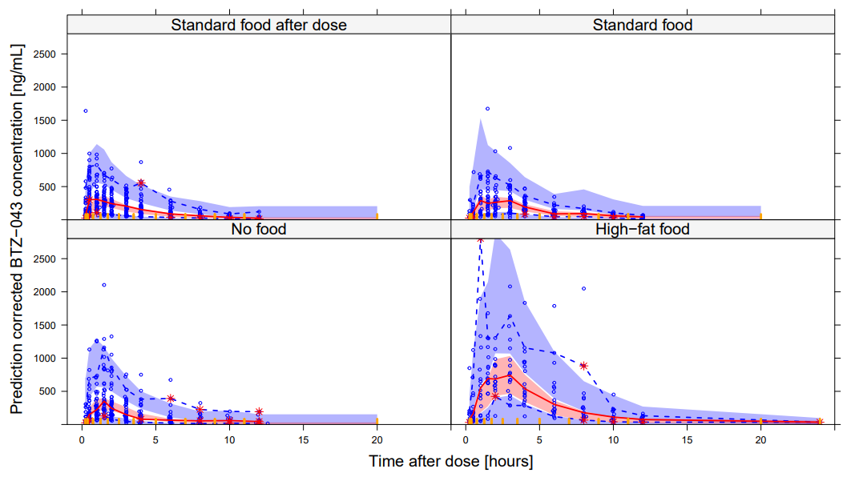
Figure S1: Prediction corrected VPC showing the observed 2.5th, 50th, and 97.5th percentiles (lines) and the 95% confidence intervals for the same percentiles from the PK model. From top left to bottom right: Predicted BTZ-043 concentrations for standard food after dose, standard food, no food, and high-fat food.

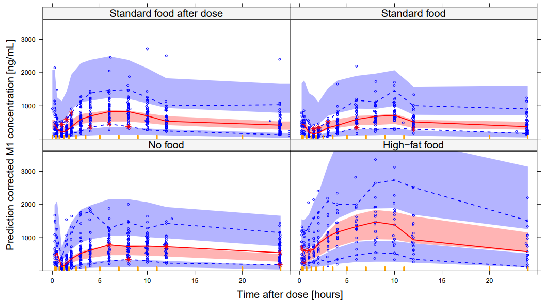
Figure S2: Prediction corrected VPC showing the observed 2.5th, 50th, and 97.5th percentiles (lines) and the 95% confidence intervals for the same percentiles from the PK model. From top left to bottom right: Predicted M1 concentrations for standard food after dose, standard food, no food, and high-fat food.

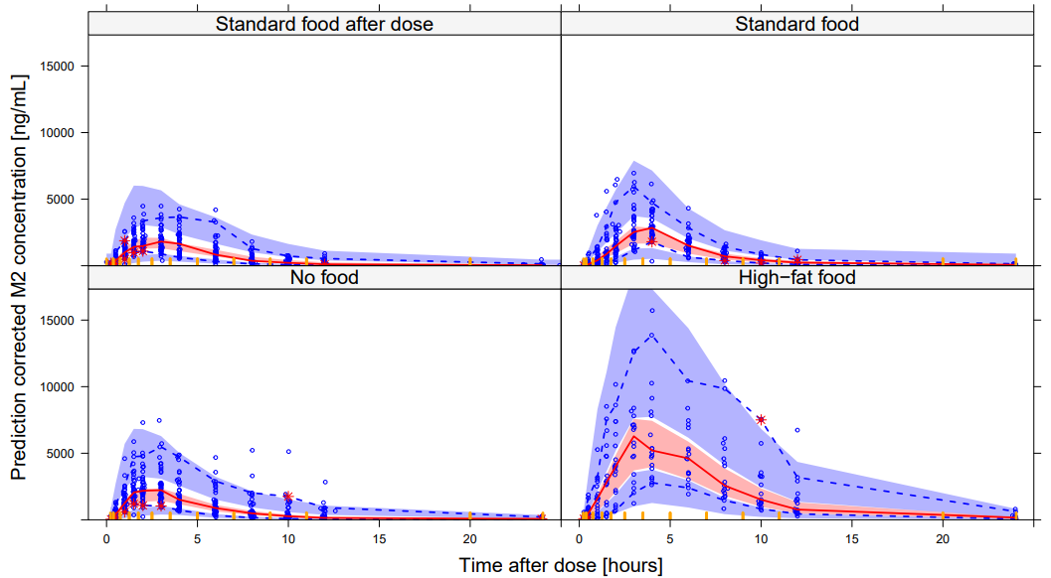
Figure S3: Prediction corrected VPC showing the observed 2.5th, 50th, and 97.5th percentiles (lines) and the 95% confidence intervals for the same percentiles from the PK model. From top left to bottom right: Predicted M2 concentrations for standard food after dose, standard food, no food, and high-fat food.
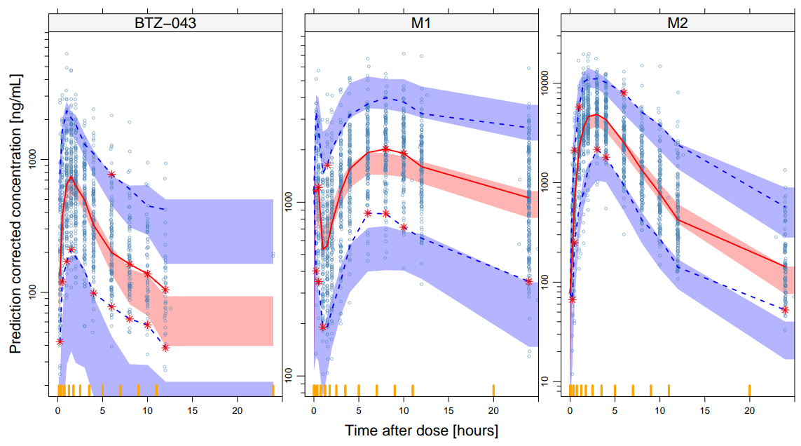
Figure S4: Prediction corrected VPC showing the observed 2.5th, 50th, and 97.5th percentiles (lines) and corresponding 95% confidence intervals from the final PK model on log-scale. From left to right: Predicted BTZ-043, M1, and M2 concentrations over time after dose.

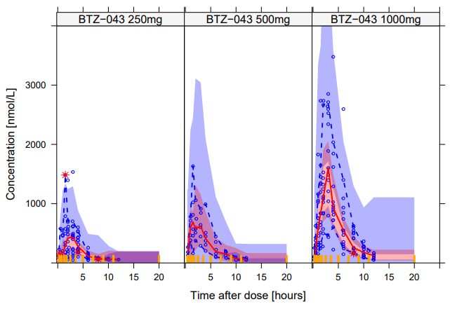
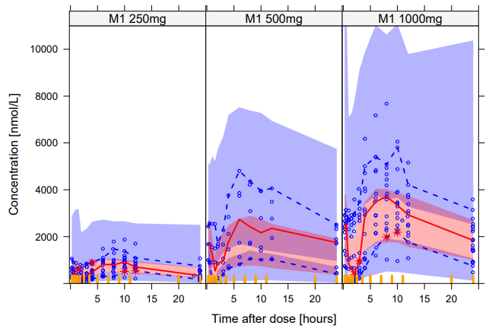
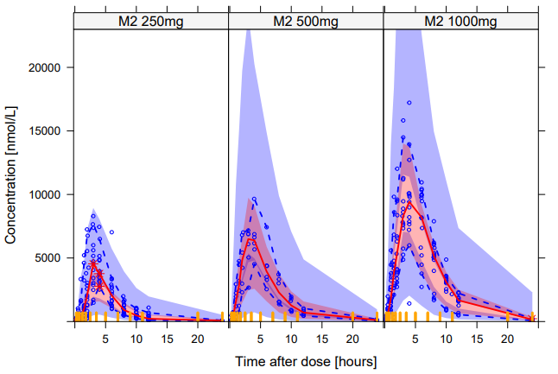
Figure S5: Uncorrected VPCs showing the observed 2.5th, 50th, and 97.5th percentiles (lines) and corresponding 95% confidence intervals from the final PK model for participants in Stage 2 receiving BTZ-043 30 minutes after the start of intake of a standard breakfast stratified per dose. From top to bottom: Predicted BTZ-043, M1, and M2 concentrations over time after dose. From left to right: 250mg, 500mg, and 1000mg of BTZ-043.

Pharmacokinetic model code:
$PROBLEM PK BTZ043
$INPUT ID DOSE DAY TIME CMT EVID AMT FLAG DV DOSEX FOOD RACE WT
$DATA ….csv IGNORE=@

$SUBROUTINE ADVAN13 TOL=6
$MODEL NCOMP=9 COMP=(DEPOT) COMP=(DEPOT2) COMP=(BTZ043)
COMP=(TRANS1) COMP=(TRANS2) COMP=(M1) COMP=(M2) COMP=(M2peripheral) COMP=(BTZ043peripheral)

;Data dictionary
;ID = Participant ID
;DOSE = Dose [mg]
;DAY = Day after start of treatment [day]
;TIME = Time after start of treatment [h]
;CMT = Compartment number
;EVID = Event ID
;AMT = Drug amount [mg]
;FLAG = Compound identifier [1=BTZ-043, 2=M1, 3=M2]
;DV = Observed concentration [nM/L]
;DOSEX = Identifier second dose for parallel absorption [0=no, 1=yes]
;FOOD = Type of food administered together with BTZ-043 [0=no food, 1= High fat food, 2=standard food after dose, 3= standard food before dose]
;RACE = Race [1=Cape-colored, 0=other]
;WT = Weight [kg]

$PK

;-----------------------Allometric scaling--------------------------
AlloCL=(WT/70)**0.75
AlloV=(WT/70)**1

;--------------------------Food effects----------------------------
FOOD1 = 0 ; High fat food
IF(FOOD.EQ.1) FOOD1=1

FOOD2 = 0 ; Dose prior to food
IF(FOOD.EQ.2) FOOD2=1

FOOD3= 0 ; Standard food before dose
IF(FOOD.EQ.3) FOOD3=1
WITHFOOD=0
IF(FOOD.EQ.3.OR.FOOD.EQ.1)WITHFOOD=1

;-----------------------Structural parameters----------------------
TVCL = THETA(1)
TVV = THETA(2)
TVKA = THETA(3)
TVMTT = THETA(4)
MTTeff = 1
IF(WITHFOOD.EQ.0)MTTeff = THETA(5)
TVF1 = 1
IF(WITHFOOD.EQ.1)TVF1 = THETA(6)
ALAG2 = THETA(7)
FDose = 1
IF(DOSE.GT.1250)FDose = THETA(8)
F_highfat = 1
IF(FOOD.EQ.1)F_highfat = THETA(9)
F_nofood = 1
IF(FOOD.EQ.0)F_nofood = THETA(10)
F_latefood = 1
IF(FOOD.EQ.2)F_latefood = THETA(11)
errM0 = THETA(12)
TVCLM1 = THETA(13)
TVVM1 = THETA(14)
errM1 = THETA(15)
TVCLM2 = THETA(16)
TVVM2 = THETA(17)
errM2 = THETA(18)
TVQM2 = THETA(19)
TVVpM2 = THETA(20)
CLM2time = THETA(21)
CLeffRace = 1
IF(RACE.EQ.1)CLeffRace = THETA(22)
FM1FOOD = 1
IF(WITHFOOD.EQ.0)FM1FOOD = THETA(23)
TVQM0 = THETA(24)
TVVpM0 = THETA(25)

;---------------------------OCCASION definition---------------------
OCC1 = 0
OCC2 = 0
OCC3 = 0
IF(DAY.EQ.1) OCC1 = 1
IF(DAY.EQ.12.AND.STAGE.EQ.1) OCC2 = 1
IF(DAY.EQ.14) OCC3 = 1

;--------------------------IIV/IOV definition----------------------
IIVCL = ETA(1)
IIVV = ETA(2)
IOVF = ETA(3)*OCC1 + ETA(4)*OCC2 + ETA(5)*OCC3
IOVMTT = ETA(6)*OCC1 + ETA(8)*OCC2 + ETA(10)*OCC3
IOVKA = ETA(7)*OCC1 + ETA(9)*OCC2 + ETA(11)*OCC3
IIVF = ETA(12)
IIVCLM1 = ETA(13)
IIVVM1 = ETA(14)
IIVCLM2 = ETA(15)
IIVVM2 = ETA(16)

;-----------------------------PK parameters-------------------------
;M0
KA = TVKA* EXP(IOVKA)
KTR = 1/(TVMTT*EXP(IOVMTT)*MTTeff)
CL = TVCL * EXP(IIVCL) *AlloCL * CLeffRace
V = TVV * EXP(IIVV) *AlloV
QM0 = TVQM0 *AlloCL
VpM0 = TVVpM0 *AlloV

;M1
CLM1 = TVCLM1/FM1FOOD *EXP(IIVCLM1)*AlloCL
VM1 = TVVM1/FM1FOOD *EXP(IIVVM1) *AlloV

;M2
CLM2timeEff=1
IF(DAY.GT.10)CLM2timeEff=1*CLM2time

CLM2 = TVCLM2 *EXP(IIVCLM2)*AlloCL *CLM2timeEff
VM2 = TVVM2 *EXP(IIVVM2) *AlloV
QM2 = TVQM2 *AlloCL
VpM2 = TVVpM2 *AlloV

;---------------------------Bioavailability-------------------------
F1 = TVF1 *1000000/431.39 *EXP(IOVF) *EXP(IIVF) *F_highfat *F_nofood *F_latefood *FDose ; DV in nmol/L. AMT in mg. Mw = 431.39 g/mol. To get dose in nmol = 10^6/431.39
F2 = (1- TVF1) *1000000/431.39 *EXP(IOVF) *EXP(IIVF) *F_highfat *F_nofood *F_latefood *FDose

$DES
DADT(1) = -KTR*A(1)
DADT(2) = -KA*A(2)
DADT(3) = KA*A(5) + KA*A(2) - CL/V*A(3) - QM0/V*A(3)+ QM0/VpM0*A(9)
DADT(4) = KTR*A(1) - KTR*A(4)
DADT(5) = KTR*A(4) - KA*A(5)
DADT(6) = CL/V*A(3) - CLM1/VM1*A(6)
DADT(7) = CL/V*A(3) - CLM2/VM2*A(7)- QM2/VM2*A(7) + QM2/VpM2*A(8)
DADT(8) = QM2/VM2*A(7) - QM2/VpM2*A(8)
DADT(9) = QM0/V*A(3) -QM0/VpM0*A(9)

$ERROR

IF(FLAG.EQ.1)IPRED = A(3)/V
IF(FLAG.EQ.2)IPRED = A(6)/VM1
IF(FLAG.EQ.3)IPRED = A(7)/VM2

W=1

IF(IPRED.NE.0.AND.FLAG.EQ.1) W = SQRT(errM0**2*IPRED**2)
IF(IPRED.NE.0.AND.FLAG.EQ.2) W = SQRT(errM1**2*IPRED**2)
IF(IPRED.NE.0.AND.FLAG.EQ.3) W = SQRT(errM2**2*IPRED**2)

IRES = DV-IPRED
IWRES = IRES/W

Y=IPRED + ERR(1)*W

$THETA
(0, 404) ; 1 CL
(0, 764) ; 2 V
(0, 1.69) ; 3 Ka
(0, 0.34) ; 4 MTT
(0, 0.36) ; 5 late food MTT
(0, 0.644,0.9999) ; 6 F1 w food
(0, 1.83) ; 7 lagtime abs 2
(0, 0.71) ; 8 Fhighdose
(0, 1.41) ; 9 F highfat
(0, 0.458) ; 10 F nofood
(0, 0.727) ; 11 F late food
(0, 0.477) ; 12 prop err M0
(0, 36) ; 13 CLM1
(0, 894) ; 14 VM1
(0, 0.329) ; 15 prop err M1
(0, 45.8) ; 16 CLM2
(0, 19) ; 17 VM2
(0, 0.285) ; 18 prop err M2
(0, 64.2) ; 19 QM2
(0, 26.8) ; 20 VpM2
(0, 0.734) ; 21 CLM2timeEff
(0, 0.762) ; 22 CLeffRace
(0, 1.39) ; 23 FM1food
(0, 68) ; 24 QM0
(0, 382) ; 25 VpM0

$OMEGA
0.0715 ; 1 IIV CL
0.172 ; 2 IIV V
$OMEGA BLOCK(1)
0.0543 ; 3 IOV F
$OMEGA BLOCK(1) SAME
$OMEGA BLOCK(1) SAME
$OMEGA BLOCK(2)
0.621 ; 6 IIV MTT
0.345 0.972 ; 7 IOV KA
$OMEGA BLOCK(2) SAME
$OMEGA BLOCK(2) SAME
$OMEGA
0.0681 ; 12 IIV F
0.174 ; 13 IIV CLM1
0.212 ; 14 IIV VM1
0.0878 ; 15 IIV CLM2
0.77 ; 16 IIV VM2

$SIGMA 1 FIX

$ESTIMATION METHOD=1 INTER MAXEVAL=9999 NOABORT SIGL=6 NSIG=2 PRINT=1
$COVARIANCE UNCONDITIONAL PRINT=E

Pharmacodynamic model code:
$PROB BTZ-043 pharmacodynamic model CFU and TTP observations
$INPUT ID TIME DV FLAG BLQ EVID MDV REP L2 EXMET
$DATA ….csv IGNORE =@

;Data dictionary
;ID =Subject ID
;TIME =Time after start of treatment (h)
;DV =Bacterial load (log10(CFU*ml-1),log10(TTP))
;FLAG =Biomarker (1=CFU, 2=TTP)
;BLQ =Below limit of quantification (1=yes, 2=no)
;EVID =Event ID
;MDV =Missing dependent variable
;REP =CFU or TTP replicate (1 or 2)
;L2 =L2 data item
;EXMET =Exposure metric

$PRED

;----------------------------- PD model-----------------------------
INTERCEPTCFU = THETA(1) *EXP(ETA(1))
INTERCEPTTTP = THETA(2) *EXP(ETA(2))
BETA1BTZCFU = (EXMET * THETA(3))/(THETA(8)+(EXMET))
BETA2BTZCFU = THETA(4) *EXP(ETA(4))
BETA1BTZTTP = (EXMET * THETA(5))/(THETA(8)+(EXMET))
BETA2BTZTTP = THETA(6) *EXP(ETA(5))
NODE = THETA(7)

IF(FLAG.EQ.1)THEN
BETA1=BETA1BTZCFU
BETA2=BETA2BTZCFU
ELSE
BETA1=BETA1BTZTTP
BETA2=BETA2BTZTTP
ENDIF

CFU1= INTERCEPTCFU - BETA1*TIME
CFUatNODE= INTERCEPTCFU - BETA1*NODE
CFU2= CFUatNODE - BETA2*(TIME-NODE)

TTP1= INTERCEPTTTP + BETA1*TIME
TTPatNODE= INTERCEPTTTP + BETA1*NODE
TTP2= TTPatNODE + BETA2*(TIME-NODE)

CFU = CFU1
IF (TIME.GT.NODE) CFU= CFU2

TTP = TTP1
IF (TIME.GT.NODE) TTP= TTP2

IF(FLAG.EQ.1) IPRED = CFU
IF(FLAG.EQ.2) IPRED = TTP

;----------- PROBABILITY OF BACTERIAL PRESENCE ---------------------
;Change of negative culture result during first three days on treatment
IF (FLAG.EQ.1) PBAC = 0.009 ;CFU
IF (FLAG.EQ.2) PBAC = 0 ;TTP

;Error model
IF (FLAG.EQ.1.AND.REP.EQ.1) ADDERR = EPS(1)
IF (FLAG.EQ.2.AND.REP.EQ.1) ADDERR = EPS(3)
IF (FLAG.EQ.1.AND.REP.EQ.2) ADDERR = EPS(2)
IF (FLAG.EQ.2.AND.REP.EQ.2) ADDERR = EPS(4)

;----------------------------M3 code--------------------------------
IF (FLAG.EQ.1) SD = SQRT(SIGMA(1,1))
IF (FLAG.EQ.2) SD = SQRT(SIGMA(3,3))
LLOQ=1 ;LLOQ for CFU
ULOQ=LOG10(25*24) ;ULOQ for TTP
DUMLLOQ=(LLOQ-IPRED)/SD
DUMULOQ=(IPRED-ULOQ)/SD

IF (FLAG.EQ.1) CUMD=PHI(DUMLLOQ)
IF (FLAG.EQ.2) CUMD=PHI(DUMULOQ)

IF (BLQ.EQ.2) THEN
F_FLAG=0
Y=IPRED + ADDERR
IRES = DV - IPRED
ENDIF

IF (BLQ.EQ.1) THEN
F_FLAG=1
Y=CUMD+PBAC-(CUMD*PBAC)
MDVRES = 1
ENDIF

$THETA
(0, 6.2) ;1 INTERCEPTCFUP1
(0, 1.99) ;2 INTERCEPTTTPP1
(0, 0.027) ;3 B1CFU
(0, 0.00254) ;4 B2CFU
(0, 0.0039) ;5 B1TTP
(0, 0.0004) ;6 B2TTP
(0, 48) FIX ;7 NODE
(0, 16900) ; 8 EXRES

$OMEGA BLOCK(3)
0.0229 ;1 INTECEPTCFU
-0.0053 0.0026 ;2 INTECEPTTTP
-0.0211 -0.0066 0.217 ;3 SLOPE1TTP

$OMEGA BLOCK(2)
0.455;4 SLOPE2CFU
0.247 0.221;5 SLOPE2TTP

$SIGMA BLOCK(4)
0.299 ; ADD error CFU1
0.278 0.322 ; ADD error CFU2
-0.018 -0.0194 0.0043 ; ADD error TTP1
-0.0175 -0.0189 0.0033 0.0035 ; ADD error TTP2

$ESTIMATION METHOD=1 INTERACTION LAPLACIAN NUMERICAL SLOW MAXEVAL=9999 NSIG=2 PRINT=1
$COV UNCONDITIONAL

Bioanalytical methods BTZ-043
Quantitative analysis of BTZ-043, M1, and M2 was performed using two separate methods. Method 1 quantified the BTZ-043_{total} (BTZ-043+ M2, converted to BTZ-043), and method 2 quantified the BTZ-043 and M1. M2 concentrations were subsequently determined by subtracting the BTZ-043 measured with method 2 from the BTZ-043_{total} from method 1. Chromatographic parameters and equipment were identical for both methods, only the sample work-up was different. The methods were validated according to the European Medicine Agency’s “Guideline on bioanalytical method validation”.
Both methods were performed using a Triple Quad 5500 Liquid Chromatography with tandem mass spectrometry (LC-MS-MS) consisting of a LC-pump, auto-sampler and column oven. Chromatic separation was carried out using a HSS T3 (50 mm x 2.1 mm, 1,8 um) column (Waters, Etten-Leur, The Netherlands). The autosampler temperature was kept at 4 degrees Celsius. The mobile phase consisted of a gradient with 0.1% formic acid in water and acetonitrile with a flow rate of 0.600 mL/min. The mass spectrometer was used in the positive ion electrospray ionization mode using multiple-reaction monitoring. The Analyst 1.6.2. system was used as controlling software (MDS Sciex, Framingham, USA).

Sample work-up Method 1 (BTZ-043_{total}):
Samples were worked up in a 96-wells format. 10.0 µL of each sample was added to a 1000 µL 96-deepwell plate. 20.0 µL AL-IS (analyte-labeled internal standard), 10.0 µL formic acid (50%) and 10.0 µL hemolytic plasma (0.5%) were added to facilitate back- conversion of all M2 to BTZ-043 in order to form BTZ-043_{total}. Samples were centrifuged for 1 min at 1500rpm and shaken on a Mix Mate for 5 min at 1500rpm. Precipitation was performed with 800uL acetonitrile. The 96-deepwell plates were sealed, shaken on a Mix Mate for 1 min at 1500rpm and centrifuged for 5 min at 4500rpm. 5.00 µL was injected into the LC-MS system.

The within run accuracy of eight quality control samples measured in six-fold was 98.6% to 101.2% for BTZ-043_{total} and the precision was 0.7% to 5.6%.
The overall intra-run accuracy of five different concentrations measured in six-fold was determined to be 99.1% to 103.0% and the precision was 1.3% to 7.4%.
The inter-run accuracy determined using six sets of QC samples (5 concentrations each) in three different runs was determined to be 99.4% to 102.3%. The precision was 1.8% to 6.2%. The lower limit of quantification was determined at 20.0 ng/mL.
To check if all M2 was back converted to BTZ-043, validation samples containing only the reference compound M2 were prepared. During extraction all the M2 should be converted into BTZ-043. After extraction the BTZ-043 concentrations were determined as described above. The measurements showed that the whole amount of M2 was converted into BTZ-043 (bias -4.5% to -7.3%).

Sample work-up for Method 2 (BTZ-043 and M1):
At the clinical site, 5 µL of an ascorbic acid solution (250mg/mL) were added to 250 µL of plasma to avoid back-conversion of M2 to BTZ-043.
At the analytical laboratory, samples were worked up in a 96-wells format. 10.0 µL of each sample was added to a 1000 µL 96-deepwell plate. 20.0 µL AL-IS and 10.0 µL 250ng/mL ascorbic acid solution was added. Precipitation was performed with 800uL methanol. The 96-deepwell plates were sealed, shaken on a Mix Mate for 1 min at 1500rpm and centrifuged for 5 min at 4500rpm. 5.00 µL was injected into the LC-MS system.
In summary, the within run accuracy of eight quality control samples measured in seven-fold was 96.8% to 101.4% for BTZ-043 and 96.0% to 102.4% for M1. The precision was 1.4% to 4.7% for BTZ-043 and 1.5% to 5.9% for M1.
The overall intra-run accuracy of five different concentrations measured in six-fold was determined to be -98.1% to 104.0% for BTZ-043 and -97.1% to 103.7% for M1. The precision was 1.8% to 6.3% for BTZ-043 and 1.5% to 6.7% for M1.
The inter-run accuracy determined using six sets of QC samples (5 concentrations each) in three different runs was determined to be 97.6% to 100.5% for BTZ-043 and 97.7% to 106.6% for M1. The precision was 2.4% to 10.1% for BTZ-043 and 4.5% to 7.3% for M1. The lower limit of quantification was determined at 20.0 ng/mL for both analytes.

