Clinical Pharmacokinetics

Characterizing Absorption Properties of Dispersible Pretomanid Tablets Using Population Pharmacokinetic Modelling

Authors
Yuanxi Zou (1), Jerry Nedelman (2), Antonio Lombardi (2), Frances Pappas (2), Mats O. Karlsson (1), Elin M. Svensson (1, 3)
- Department of Pharmacy, Uppsala University, Uppsala, Sweden
- TB Alliance, New York, New York, USA
- Department of Pharmacy, Radboud university medical center, Nijmegen, The Netherlands
ORCID:
Yuanxi Zou: 0000-0003-0547-390X
Elin M. Svensson: 0000-0002-0093-6445

Corresponding author

Elin M. Svensson, elin.svensson@farmaci.uu.se

Supplementary Materials

Bioavailability
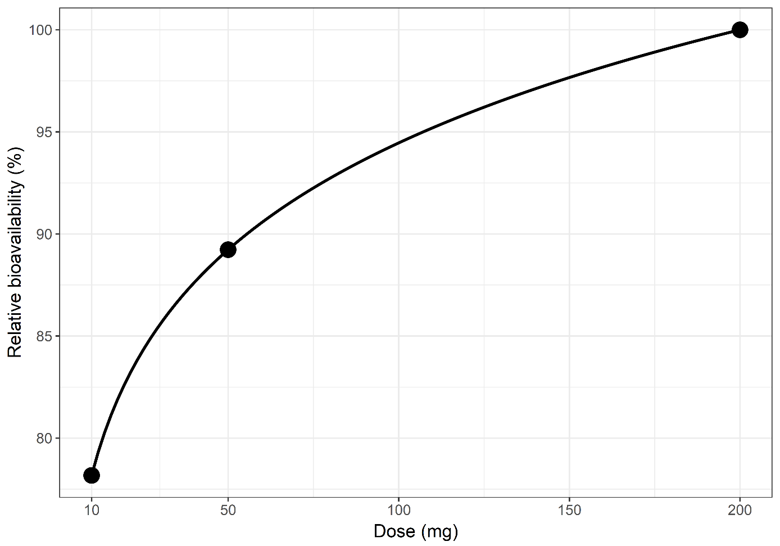
S.Figure A1. Function describing the relationship between the bioavailability relative to 200 mg and dose in the range 10 to 200 mg.
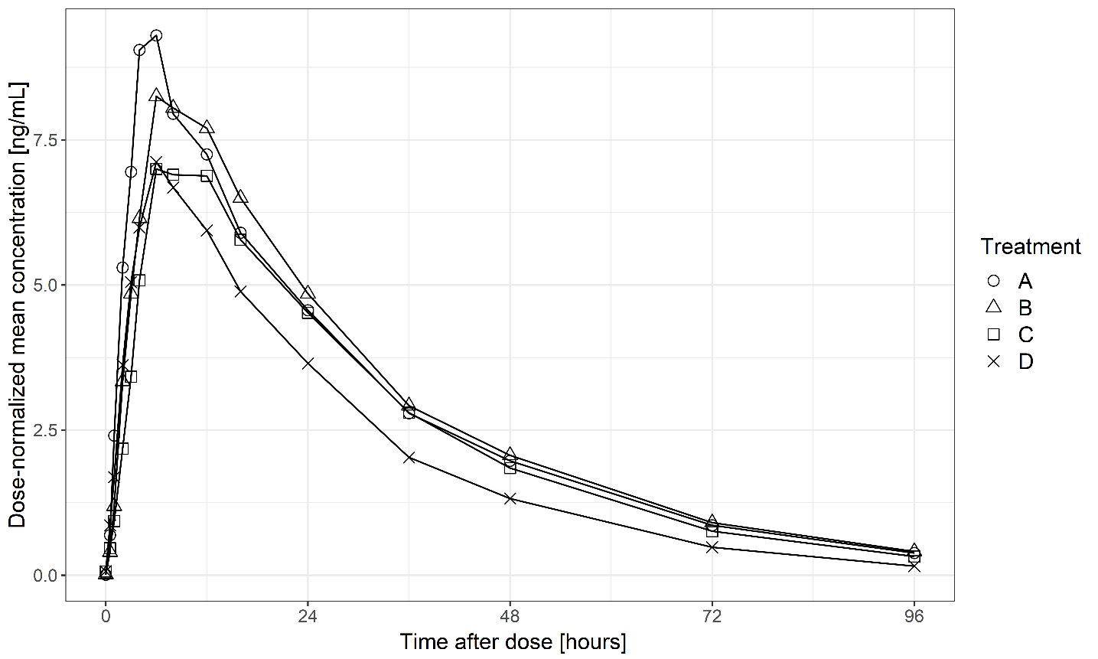
S.Figure A2. Mean plasma concentrations normalized by the corresponding dose versus time after dose per dose and formulation of pretomanid at fed condition. Treatment A, 200 mg marketed formulation; B, 200 mg dispersible tablet formulation; C, 50 mg dispersible tablet formulation; D, 10 mg dispersible tablet formulation.

VPC in normal scale and focused on absorption
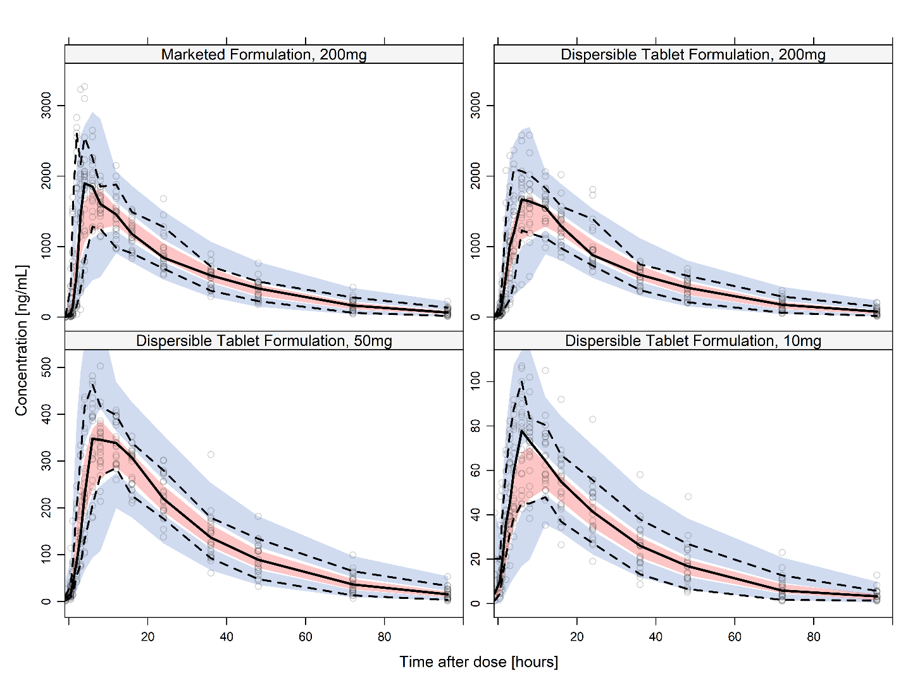
S.Figure B1. Visual predictive checks of the final model on the CL-011 study data (fed condition only) by formulations and doses, showing the concentrations in normal scale versus time after dose to 96 hours. The open circles represent the observed samples. The solid and dashed black lines represent the 50th and 10th/90th percentiles of the observations in the data set. The red and blue-colored areas represent the 95% model-predicted confidence intervals for the corresponding percentiles.

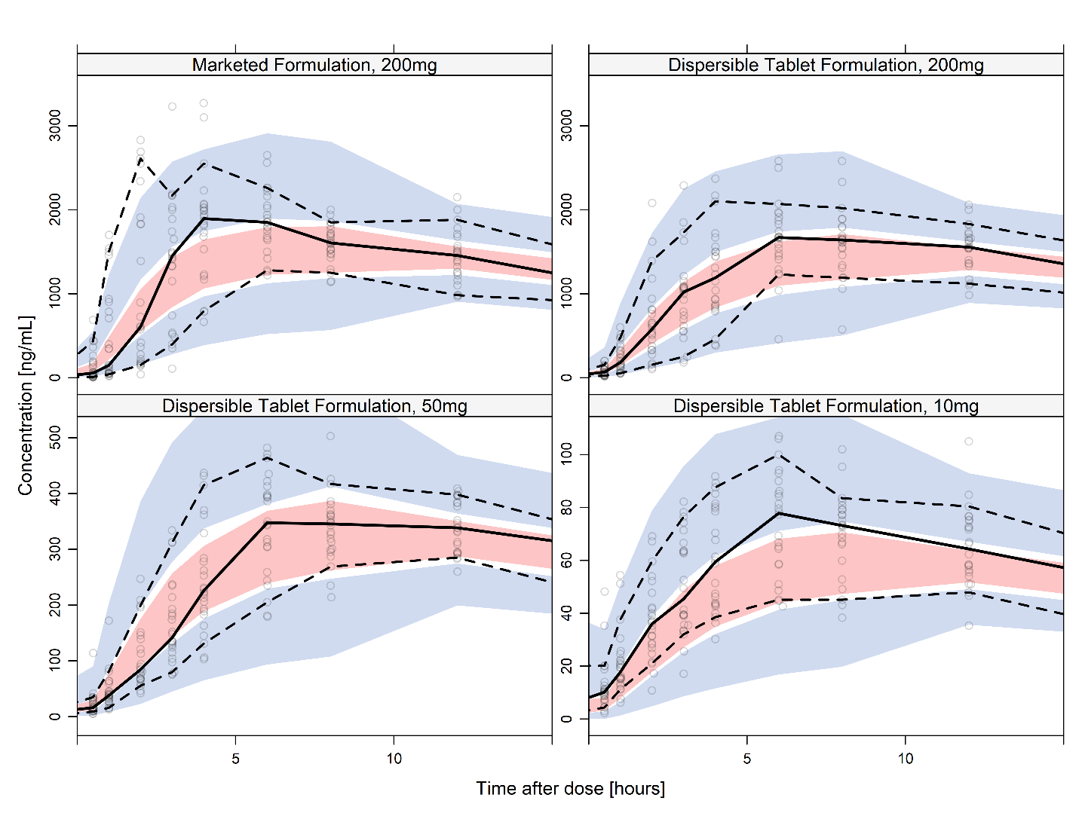
S.Figure B2. Visual predictive checks of the final model on the CL-011 study data (fed condition only) by formulations and doses, showing the concentrations in normal scale versus time after dose to 15 hours. See Figure B1 for detailed figure description.

NONMEM control stream
$SIZES LIM1=6000000 LIM4=200000 LIM15=200000 LIM16=6000000 PD=55 ; prevents disk usage
$PROBLEM PA-824
$INPUT ID DOSE TIME TAD DV AMT BQL CMT EVID MDV WT DTF OCC1 OCC2 OCC3 OCC4
$DATA data.csv IGNORE=C IGNORE(BQL.EQ.1)
$SUBROUTINE ADVAN7 TRANS1
$MODEL
COMP(TRANS1,DEFDOSE) ; 1
COMP(CENTRAL,DEFOBS) ; 2
COMP(ABS) ; 3

;---PK------------------------------------------
$PK

MF = 1 – DTF ; DTF index: 0/1

TVLCL = LOG(THETA(1)) + 0.75*LOG(WT/55)
TVLV2 = LOG(THETA(2)) + 1*LOG(WT/55)
TVLKA = LOG(THETA(3)) + LOG(THETA(5))*MF
TVMTT = LOG(THETA(4))
TVLF1 = LOG(DOSE/200) * THETA(6)

IOVKA = OCC1*ETA(4) + OCC2*ETA(7) + OCC3*ETA(10) + OCC4*ETA(13)
IOVMTT = OCC1*ETA(5) + OCC2*ETA(8) + OCC3*ETA(11) + OCC4*ETA(14)
IOVF1 = OCC1*ETA(3) + OCC2*ETA(6) + OCC3*ETA(9) + OCC4*ETA(12)

CL = EXP( TVLCL + ETA(1) )
V = EXP( TVLV2 + ETA(2) )
KA = EXP( TVLKA + IOVKA)
MTT = EXP( TVMTT + IOVMTT)
F1 = EXP( TVLF1 + IOVF1)

KTR = 1/MTT
KE = CL/V

S2 = V
K13 = KTR
K32 = KA
K20 = KE

$ERROR (ONLY OBSERVATIONS)
IPRED = A(2)/V
ERRT=1
IF(TAD.LT.10) ERRT=THETA(7)
W = SQRT(IPRED**2 *SIGMA(1,1)**2 + SIGMA(2,2)**2)*ERRT

IWRES = (DV-IPRED)/W

Y = IPRED + ERRT*( EPS(1) *IPRED + EPS(2) )

$THETA
(0,2.81) ; 1 CL
(0,68) ; 2 V
(0,0.396) ; 3 KA
(0,1.13) ; 4 MTT
(0,1.65) ; 5 KA~MF
0.0822 ; 6 F1~DOSE
(0,3.46) ; 7 ERRT

$OMEGA BLOCK(2)
0.0622 ; 1 CL
0.0111 ; CL-V2
0.00751 ; 2 V2

$OMEGA BLOCK(3)
0.00561 ; IOV.F1
0 ; IOV.F1.KA
0.284 ; IOV.KA
0 ; IOV.F1.MTT
0 ; IOV.KA.MTT
0.77 ; IOV.MATT
$OMEGA BLOCK(3) SAME
$OMEGA BLOCK(3) SAME
$OMEGA BLOCK(3) SAME

$SIGMA 0.0079 ; PropErr
0.161 ; AddErr
$ESTIMATION METHOD=COND INTERACTION PRINT=1 MAXEVAL=99999 NSIG=3
SIGL=9 NOABORT MSFO=1066.MSF
$COVARIANCE PRINT=E UNCONDITIONAL MATRIX=S

Mean plasma concentration profiles of pretoamanid and other results of standard statistical analysis

S.Figure D1. Mean plasma concentration-time profiles for pretomanid for Panel 1 (Fed) on linear and semi-logarithmic scales.
Panel 1: Fed: Treatment A: 1x200 mg tablet (immediate-release formulation, Reference): Treatment B: 4x50 mg tablets (dispersible pediatric tablet formulation; Test); Treatment C: 1x50 mg tablet (dispersible pediatric tablet
formulation; Test); Treatment D: 1x10mg tablet (dispersible pediatric tablet formulation; Test)

S.Figure D2. Mean plasma concentration-time profiles for pretomanid for Panel 2 (Fasted) on linear and semi-logarithmic scales.
Panel 2: Fasted: Treatment A: 1x200 mg tablet (immediate-release formulation, Reference): Treatment B: 4x50 mg tablets (dispersible pediatric tablet formulation; Test); Treatment C: 1x50 mg tablet (dispersible pediatric tablet
formulation; Test); Treatment D: 1x10mg tablet (dispersible pediatric tablet formulation; Test)

S.Table D1. Statistical analysis of the natural log-transformed systemic exposure of pretomanid comparing test treatment of dispersible tablet formulation (treatment B) to the reference 200 mg marketed (immediate release ) tablet (treatment A) (panel 1, fed condition)
Dependent  Variable | LSMean ª  Test | LSMean ª  Ref | GeoMean ^{b}  Test | GeoMean ^{b}  Ref | Diff ^{c} | SE ^{d} | Ratio (%)^{e}  (Test/Ref) | 90% CI ^{f}  Lower | 90% CI ^{f}  Upper | p-value ^{g} | Power | ANOVA  CV%
C_{max} | 7.50 | 7.66 | 1820 | 2120 | -0.153 | 0.0322 | 85.85 | 81.21 | 90.75 | 0.0001 | 1.0000 | 11.19
AUC_{0-t} | 10.9 | 10.9 | 54200 | 53900 | 0.00600 | 0.0138 | 100.60 | 98.23 | 103.03 | 0.6686 | 1.0000 | 4.79
AUC_{0-inf} | 10.9 | 10.9 | 56700 | 56100 | 0.0102 | 0.0138 | 101.03 | 98.65 | 103.47 | 0.4683 | 1.0000 | 4.79

Panel 1: Fed
Treatment A: 1x200 mg tablet (immediate-release formulation, Reference): Treatment B: 4x50 mg tablets (dispersible pediatric tablet formulation; Test)
a = Least Squares Mean based on natural log-transformed data
b = Geometric Mean based on Least Squares Mean
c = Difference = LS Mean (Test) - LS Mean (Ref)
d = SE = Standard error of the difference
e = Ratio(%) = Geometric Mean (Test)/Geometric Mean (Ref)
f = 90% Confidence Interval
g = p-value for the difference between treatments; Significant difference defined a priori as p < 0.05

S.Table D2. Statistical analysis of the natural log-transformed systemic exposure of pretomanid comparing test treatment of dispersible tablet (treatment B) to the reference 200 mg immediate release tablet (treatment A) (panel 2, fasted condition)
Dependent  Variable | LSMean ª  Test | LSMean ª  Ref | GeoMean ^{b}  Test | GeoMean ^{b}  Ref | Diff ^{c} | SE ^{d} | Ratio (%)^{e}  (Test/Ref) | 90% CI ^{f}  Lower | 90% CI ^{f}  Upper | p-value^{g} | Power | ANOVA  CV%
C_{max} | 6.95 | 7.03 | 1050 | 1130 | -0.0727 | 0.0683 | 92.99 | 82.65 | 104.62 | 0.3001 | 0.9305 | 24.01
AUC_{0-t} | 10.3 | 10.4 | 28800 | 32100 | -0.109 | 0.0577 | 89.70 | 81.20 | 99.10 | 0.0745 | 0.9776 | 20.20
AUC_{0-inf} | 10.3 | 10.4 | 30200 | 33700 | -0.110 | 0.0580 | 89.63 | 81.10 | 99.05 | 0.0734 | 0.9769 | 20.28

Panel 2: Fasted
Treatment A: 1x200 mg tablet (immediate-release formulation, Reference): Treatment B: 4x50 mg tablets (dispersible pediatric tablet formulation; Test)
a = Least Squares Mean based on natural log-transformed data
b = Geometric Mean based on Least Squares Mean
c = Difference = LS Mean (Test) - LS Mean (Ref)
d = SE = Standard error of the difference
e = Ratio(%) = Geometric Mean (Test)/Geometric Mean (Ref)
f = 90% Confidence Interval
g = p-value for the difference between treatments; Significant difference defined a priori as p < 0.05

S.Table D3. Assessment of dose effect on relative bioavailability of dispersible tablets (treatments B, C, and D) (panel 1, fed)
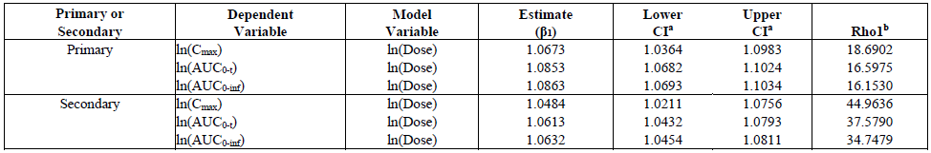
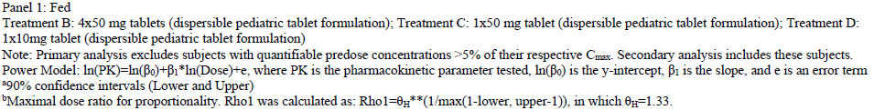

S.Table D4. Assessment of dose effect on relative bioavailability of dispersible tablets (treatments B, C, and D) (panel 2, fasted)
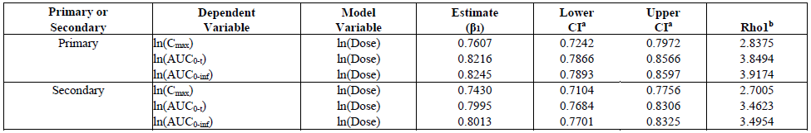
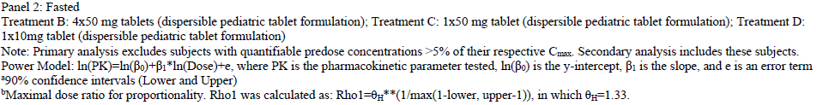

S.Table D5. Statistical analysis of the natural log-transformed systemic exposure of pretomanid among treatments comparing food effects panel 1 vs. panel 2

Primary or  Secondary | Treatment | Dependent  Variable | LSMean ª  Test | LSMean ª  Ref | GeoMean ^{b}  Test | GeoMean ^{b}  Ref | Diff ^{c} | SE ^{d} | Ratio (%)^{e}  (Test/Ref) | 90% CI ^{f}  Lower | 90% CI ^{f}  Upper | p-value^{g} | Power | ANOVA  CV%
Primary | A | C_{max} | 7.66 | 7.03 | 2120 | 1130 | 0.629 | 0.0734 | 187.65 | 165.90 | 212.25 | <0.0001 | 0.9101 | 25.84
 |  | AUC_{0-t} | 10.9 | 10.4 | 53900 | 32100 | 0.519 | 0.0618 | 167.96 | 151.40 | 186.33 | <0.0001 | 0.9702 | 21.66
 |  | AUC_{0-inf} | 10.9 | 10.4 | 56100 | 33700 | 0.509 | 0.0654 | 166.38 | 149.07 | 185.69 | <0.0001 | 0.9550 | 22.96
Primary | B | C_{max} | 7.50 | 6.95 | 1820 | 1050 | 0.549 | 0.0730 | 173.24 | 153.26 | 195.82 | <0.0001 | 0.9126 | 25.70
 |  | AUC_{0-t} | 10.9 | 10.3 | 54200 | 28800 | 0.633 | 0.0767 | 188.36 | 165.60 | 214.26 | <0.0001 | 0.8874 | 27.06
 |  | AUC_{0-inf} | 10.9 | 10.3 | 56700 | 30200 | 0.629 | 0.0819 | 187.54 | 163.44 | 215.20 | <0.0001 | 0.8492 | 28.97
Primary | C | C_{max} | 5.95 | 6.02 | 384 | 412 | -0.0699 | 0.0682 | 93.25 | 83.16 | 104.56 | 0.3107 | 0.9409 | 23.42
 |  | AUC_{0-t} | 9.39 | 9.26 | 12000 | 10500 | 0.132 | 0.0802 | 114.09 | 99.70 | 130.55 | 0.1076 | 0.8615 | 27.72
 |  | AUC_{0-inf} | 9.42 | 9.30 | 12400 | 10900 | 0.127 | 0.0847 | 113.58 | 98.52 | 130.95 | 0.1398 | 0.8276 | 29.32
Secondary | C | C_{max} | 5.94 | 6.03 | 380 | 417 | -0.0918 | 0.0671 | 91.23 | 81.52 | 102.10 | 0.1779 | 0.9470 | 23.55
 |  | AUC_{0-t} | 9.39 | 9.28 | 11900 | 10700 | 0.111 | 0.0793 | 111.70 | 97.78 | 127.60 | 0.1697 | 0.8690 | 27.99
 |  | AUC_{0-inf} | 9.43 | 9.32 | 12400 | 11200 | 0.105 | 0.0846 | 111.05 | 96.34 | 128.00 | 0.2219 | 0.8285 | 29.96
Primary | D | C_{max} | 4.32 | 4.69 | 75.3 | 109 | -0.366 | 0.0667 | 69.38 | 61.96 | 77.68 | <0.0001 | 0.9457 | 19.61
 |  | AUC_{0-t} | 7.59 | 7.79 | 1970 | 2410 | -0.202 | 0.0788 | 81.74 | 71.53 | 93.42 | 0.0155 | 0.8681 | 23.25
 |  | AUC_{0-inf} | 7.61 | 7.82 | 2030 | 2490 | -0.204 | 0.0813 | 81.57 | 71.07 | 93.61 | 0.0175 | 0.8493 | 24.00
Secondary | D | C_{max} | 4.36 | 4.73 | 78.1 | 114 | -0.376 | 0.0667 | 68.68 | 61.40 | 76.81 | <0.0001 | 0.9488 | 23.42
 |  | AUC_{0-t} | 7.72 | 7.88 | 2250 | 2640 | -0.159 | 0.0873 | 85.32 | 73.69 | 98.79 | 0.0756 | 0.8077 | 30.94
 |  | AUC_{0-inf} | 7.76 | 7.92 | 2340 | 2760 | -0.164 | 0.0932 | 84.91 | 72.61 | 99.30 | 0.0860 | 0.7610 | 33.15

Panel 1: Fed (Test); Panel 2: Fasted (Reference)
Treatment A: 1x200 mg tablet (immediate-release formulation): Treatment B: 4x50 mg tablets (dispersible pediatric tablet formulation); Treatment C: 1x50 mg tablet (dispersible pediatric tablet formulation); Treatment D: 1x10mg tablet (dispersible pediatric tablet formulation)
Note: Primary analysis excludes subjects with quantifiable predose concentrations >5% of their respective Cmax. Secondary analysis includes these subjects.
a = Least Squares Mean based on natural log-transformed data
b = Geometric Mean based on Least Squares Mean
c = Difference = LS Mean (Test) - LS Mean (Ref)
d = SE = Standard error of the difference
e = Ratio(%) = Geometric Mean (Test)/Geometric Mean (Ref)
f = 90% Confidence Interval
g = p-value for the difference between treatments; Significant difference defined a priori as p < 0.05

