Title: Rifapentine Population Pharmacokinetics and Dosing Recommendations for Drug-Susceptible Tuberculosis
Target Journal: American Journal of Respiratory and Critical Care Medicine
Word Count (Max 3500 words): 3473 words
Authors (please help suggest authors and order):
Vincent K. Chang*^{,1,2}, Marjorie Zamora Imperial^{1,2}, Nan Zhang^{1,2}, Patrick PJ Phillips^{2,3}, Payam Nahid^{2,3}, Marc Weiner⁴, Ekaterina V. Kurbatova⁵, William Whitworth⁵, Kia Bryant⁵, Wendy Carr⁵, Melissa L. Engle⁴, Susan E. Dorman⁶, Susan Swindells⁷, Richard E. Chaisson⁸, Nguyen Viet Nhung^{9,10}, Pheona Nsubuga¹¹, Kelly E. Dooley¹², Andreas Diacon¹³, Radojka M. Savic^{1,2}, and the AIDS Clinical Trial Group and Tuberculosis Trials Consortium
Corresponding Author: vincent.chang@ucsf.edu (rada.savic@ucsf.edu for publication)

Affiliations
¹ Department of Bioengineering and Therapeutic Sciences, University of California, San Francisco, San Francisco, California, United States of America
² UCSF Center for Tuberculosis, University of California, San Francisco, San Francisco, California, United States of America
³ Division of Pulmonary and Critical Care Medicine, University of California, San Francisco, San Francisco, California, United States of America
⁴ University of Texas Health Science Center at San Antonio and the South Texas Veterans Health Care System, San Antonio, Texas, United States of America
⁵ Centers for Disease Control and Prevention, Atlanta, Georgia, United States of America
⁶ Medical University of South Carolina, Charleston, South Carolina, United States of America
⁷ University of Nebraska Medical Center, Omaha, Nebraska, United States of America
⁸ Johns Hopkins University School of Medicine, Baltimore, Maryland, United States of America
⁹ Vietnam National Tuberculosis Program–University of California, San Francisco Research Collaboration Unit, Hanoi, Vietnam
¹⁰ National Lung Hospital, Hanoi, Vietnam
¹¹ Uganda–Case Western Reserve University Research Collaboration, Kampala, Uganda
¹² Division of Infectious Diseases, Vanderbilt University, Nashville, Tennessee, United States of America
¹³ TASK, Cape Town, Western Cape, South Africa
*Corresponding Author

Author Contributions: All authors contributed to the intellectual content of the manuscript and approved the manuscript version submitted for publication. Data was acquired by __________. V.K.C., M.Z.I., N.Z., and R.M.S made substantial contributions to data analysis, and study concept and design.
Grants: Supported by the NIH/National Institute of Allergy and Infectious Diseases grant 5R01Al126788-04 to R.M.S.
Descriptor Number: 11.06
This article has an online data supplement, which is accessible from this issue's table of content online at www.atsjournals.org

At a Glance Commentary
Scientific Knowledge on the Subject: Rifapentine is a principal component of the recent World Health Organization and US Centers for Disease Control and Prevention recommended novel 4-month rifapentine-moxifloxacin based regimen. High rifapentine exposures were crucial in driving treatment success in the landmark phase 3 trial, but rifapentine pharmacokinetics within that trial have yet to be described and therefore optimal dosing for the novel regimen remains unknown.
What this Study Adds to the Field: In this largest-to-date single cohort rifapentine population pharmacokinetics analysis, we describe the population pharmacokinetics of rifapentine and identify risk factors for under-exposure. We did not identify any strong evidence of associations between higher rifapentine exposure and safety outcomes. Finally, We predictdemonstratemodeling and simulations demonstrated that increasing the dose from 1200 to 1500 mg in the rifapentine-moxifloxacin regimen would increase proportion of patients achieving the target exposure which may benefit treatment outcomes without increased safety concerns.
Abstract
Rationale:
Study 31/A5349 (NCT02410772) was a phase 3 randomized controlled trial that demonstrated noninferiority of a 4-month isoniazid, rifapentine, pyrazinamide plus moxifloxacin regimen compared to the 6-month standard treatment for drug-susceptible tuberculosis (TB). Prior pharmacokinetic-pharmacodynamic analysis of Study 31/A5349 trial data demonstrated the importance of rifapentine exposure as a driver of treatment response, but clarity on the optimal dosing approach is lacking.
Objective:
To characterize subpopulations at risk for rifapentine underexposure, identify safety outcomes associated with rifapentine exposure, and perform simulations to determine optimal dosing strategies across subpopulations.
Methods
Rifapentine steady state pharmacokinetic data were available for 1580 participants administered 1200 mg rifapentine with food. Data were analyzed using nonlinear mixed-effects modeling and covariate analysis was performed to identify risk factors for low exposure.
Measurements and Main Results
Rifapentine PK was significantly modulated by race, sex, and HIV status (unadjusted P<0.001). Overall, Black or mixed race participants had 8.3% lower exposure than Asians, males had 13% lower exposure than females, and participants living with HIV had 8.9% lower exposure than those without HIV. Higher rifapentine steady state area under the concentration-time curve from 0-24 hours (AUC_{0-24h,ss}) was not significantly associated with increased incidence of any grade 3 or higher adverse events. Dosing simulations suggest increasing the flat-dose to 1500 mg or 1800 mg, which may increase proportion of patients who reach target exposures without safety concerns.
Conclusions
Higher doses would prevent underexposure across all subpopulations and may improve treatment outcomes, especially for male or Black people, or people living with HIV at risk for low exposure.
Keywords: tuberculosis; rifapentine; rifamycins; population pharmacokinetics
Word Count (250 max): 248
INTRODUCTION
Since their first use in clinical trials in the 1970s, rifamycins have remained a cornerstone in treatments for drug-susceptible tuberculosis¹. Rifapentine is a cyclopentyl derivative of rifampicin, the rifamycin in the current 6-month standard of care regimen, and was approved by the U.S. FDA in 1998 for the treatment of tubcerulosis using intermittent dosing². As focus has shifted from intermittent dosing to shortening the duration of treatment, rifapentine’s higher potency and longer half-life makes the drug an attractive option for replacing rifampicin in short course treatments. Subsequent animal studies demonstrated that daily rifapentine in a combination regimen had potent antimycobacterial activity able to achieve cure without relapse after three months of treatment in the relapsing mouse model.³ Phase 1 and 2 clinical trials confirmed safety and tolerability of rifapentine at daily doses up to 20 mg/kg (up to 1500 mg total dose) and demonstrated a strong exposure-response relationship with time to stable culture conversion, the primary most commonly used primary outcome in phase II clinical trialson-treatment surrogate biomarker.^{4,5}

In the phase 2b dose ranging study Study 29/29x^{4,6} where 405 participants received rifapentine, Savic et.al. previously described rifapentine population pharmacokinetics (PK) with a first order absorption, one compartment model with first order metabolite clearance.⁵ Male sex, HIV co-infection, older age, absence of food, and dose limiting bioavailability were all found to be covariates on either bioavailability or clearance decreasing rifapentine exposure. Higher rifapentine steady state individual participant area under the concentration-time curve from 0-24 hours (AUC_{0-24h,ss}) was associate with shorter found to shorten time to stable liquid culture conversion with maximum achievable effect observed at an exposure of 350 µg∙h/mL. Additionally, 73% of phase 2b participants achieved this target by taking a 1200 mg dose while consuming food. Therefore, S31/A5349 selected to administer aA flat 1200 mg dose with food was therefore selected for the subsequent phase III trial. Rifamycins are well known to have highly variable pharmacokinetics^{7–9}. The Study 29/29x model found high between subject variability in clearance, metabolite clearance, and bioavailability resulting in up to 5-fold AUC_{0-24h} range with the same dose and meal, underscoring the need to accurately characterize rifapentine pharmacokinetics in a larger population.

As a continuation of the clinical development of rifapentine regimens, The Tuberculosis Trials Consortium recently completed Study 31/ACTG A5349 (S31/A5349), an international, multicenter, randomized, open-label, phase 3, noninferiority trial, which successfully demonstrated noninferiority of a short course 4-month regimen of once-daily rifapentine, isoniazid, pyrazinamide, and moxifloxacin (rifapentine-moxifloxacin regimen) when compared to the 6-month standard of care regimen of once-daily rifampicin, isoniazid, pyrazinamide, and ethambutol (control regimen).^{10,11} S31/A5349 also tested 4-month rifapentine, isoniazid, pyrazinamide, and ethambutol (rifapentine regimen), but this regimen failed to demonstrate noninferioritywas not found to have non-inferior efficacy to the control. Notably, S31/A5349 is the first phase III anti-tuberculosis agent trial that had near study-wide PK sampling for all drugs in nearly all 2516 participants. It offers the first opportunity to build robust population PK models and link exposure to long-term clinical outcomes. We have previously reported in a pharmacokinetic-pharmacodynamic (PKPD) analysis of S31/A5349 that rifapentine exposure is the single most important predictor for Tuberculosis-related unfavorable outcomes [Add REF, in press/submitted]. From this that analysis, we determined the target exposure of rifapentine to be 570 µg∙h/mL, defined to correspond to 5% TB-related unfavorable outcomes achieve 95% cure in participants receiving the rifapentine-moxifloxacin regimen.

In this work, using the largest PK dataset including the participants receiving the rifapentine-moxifloxacin or the rifapentine regimen from S31/A5349, we characterized rifapentine PK using a nonlinear mixed effects population approach to (1) quantify the patient characteristics and clinical factors that explain variability in rifapentine exposure, (2) identify subpopulations at risk for low rifapentine exposure, (3) characterize PK-safety relationships, and (4) perform simulations to determine optimal dosing strategies across subpopulations.

METHODS (500 words max) Current: 531
Study Design
Study 31/A5349 participants were ≥12 years of age and had newly diagnosed pulmonary TB that was confirmed on culture to be susceptible to isoniazid, rifampicin, and fluoroquinolones. Participants were administered 1200 mg rifapentine within 1 hour after ingesting food in the two 4-month experimental regimens. Additional details on the study design and full eligibility are available in the original study protocol publication.¹¹

Pharmacokinetic Sample Collection and Assays
Pharmacokinetic samples were taken between the 2 week and 8 week visit windows, after enzyme induction reached steady state. Intensive sampling was performed on a small number of participants (n = 53), with samples were taken at 0.5, 3, 5, 9, 12, and 24 hours in 2-3 separate occasions. The remaining participants were sampled sparsely with time points at 0.5, 5, and 24 hours in 1-2 occasions. Plasma concentrations of rifapentine and its main metabolite, 25-desacetyl-rifapentine, were determined using validated high-performance liquid chromatography assays.

Modeling Software and Methods
Pharmacokinetic data were randomly split into an analysis cohort for model development and validation cohort for model validation, where one-third of the data was conserved for the validation cohort and covariates (clinical site and HIV) were balanced between cohorts. Data were analyzed using nonlinear mixed-effects modeling with NONMEM version 7.41 (ICON Development Solutions). Population PK model building followed standard procedures by first characterizing the base structural model and estimating typical PK parameters using a first-order conditional estimation method with interaction.¹²

Covariates such as age, sex, race, weight, etc. were evaluated for potential inclusion as covariates on PK parameters. Covariate effects were selected through a stepwise procedure with forward selection (P<0.05) and backward elimination (P<0.01). Final inclusion of covariates was based on statistical significance, scientific plausibility, and clinical relevance.¹³

Model development was guided by assessment of goodness of fit plots, condition number, and the likelihood ratio test. Simulation based diagnostics (e.g., visual predictive checks [VPCs] and bootstraps) were used for model development and validation.

Safety Outcomes and Analysis
The primary safety outcome in the trial was any grade 3 or higher adverse events during the on-treatment period, defined as the time during which trial medications were received and up to 14 days after the last dose.^{10,11} Additional analyses were performed for: (i) treatment related grade 3 or higher adverse events, (ii) serious adverse events, (iii) premature discontinuation of the assigned treatment for any reason other than microbiological ineligibility, (iv) death, (v) 3x and 5x upper limit of normal bilirubin, alanine transaminase, and aspartate transaminase levels, (vi) Hy’s law criteria¹⁴, (vii) grade 3 or above neutropenia.^{15,16} Rifapentine AUC_{0-24h,ss} and maximal plasma concentration (C_{max}) were analyzed with independent logistic regression models for each safety outcomes with significance level ɑ=0.05. Unadjusted and adjusted (for regimen, age, sex, African/non-African site, HIV and diabetes status, risk factors for tuberculosis-related unfavorable outcomes¹⁷) analyses were performed.

Dosing Simulations
Dosing simulations were performed withusing the final model to (1) assess the impact of clinically relevant patient factors on rifapentine exposure, and (2) propose pragmatic dosing strategies for rifapentine that maximizes the proportion of patients achieving target exposure (570 µg∙h/mL) and minimizes safety concerns. Since bioavailability of rifapentine is dose dependent, simulations were performed using the following equation [EQ1] to calculate bioavailability relative to the 1200 mg dose.¹⁸
$$[EQ1] F=\frac{1-0.000167⋅DOSE}{1-0.000167⋅1200}$$

RESULTS
Study Design and Dataset
PK data were available from The S31/A5349 rifapentine PK data were received from the US Centers for Disease Control and consisted of XXXX1580 participants. Of all participants, 27 were intensively sampled, and 759 were sparsely sampled from the rifapentine regimen, and 26 participants were intensively sampled and 768 were sparsely sampled from the rifapentine-moxfiloxacin regimen. In total, 472 intensive samples and 4556 sparse samples were collected and measured for both parent drug rifapentine and metabolite 25-desacetyl-rifapentine concentrations (Figure 1). Twenty-four samples were reported as below the limit of quantification (0.25 µg/mL) and were fixed to 0.125 µg/mL. Patient demographics and clinical factors were similar across the two investigational arms and across the model development and validation datasets (Table 1 and Supplemental Table 1).

Pharmacokinetic Model
The one-compartment disposition model with linear metabolite clearance and transit compartment absorption best described the observed data. The rifapentine steady state apparent clearance was estimated to be 2.24 L/h and the apparent volume of distribution to be 47.4 L in the typical reference patient (male, Black, and HIV-). Two transit compartments best described the absorption phase with a mean transit time (MTT) of 3.68 hours. Metabolite clearance (CL_{m}) was estimated as 2.15 L/h. Between subject variability was estimated for the following PK parameters: bioavailability (19.7%), apparent clearance (32.3%), mean transit time (32.8%), and metabolite clearance (47.5%). Correlations were found between CL-F=41.2%, F-CL_{m}=39.2%, and CL-CL_{m}=58.1%. The distribution of between subject variability on CL_{m} was not normal and required a Box Cox transformation to improve model fit. (Table 2)

Impact of Covariates on Pharmacokinetics
The between subject variability described earlier can be explained by demographic and clinical covariates. We found that rifapentine bioavailability was strongly influenced by race and sex (P < 0.001). Participants of Asian race had a 9.2% increase in bioavailability relative to Black or Mixed race, and females had a 15.1% increase in bioavailability relative to males. Food, dose, and time dependent enzyme induction are well documented effects on rifapentine bioavailability¹⁸, however since all participants in S31/A5349 were given the same 1200 mg dose with food with samples collected between 2-8 weeks (after induction has reached steady state) these effects could not be estimated. (Figure 2)

Body weight was statistically significant on apparent clearance (P<0.001), however apparent clearance only changed by 2.6% for every 10 kg change in body weight, a clinically insignificant effect size that explained little of the variability in clearance and did not appreciably change individual clearances (Supplemental Figure 3A). Additionally, individual clearance and body weight had a weak relationship, R²=0.0088 (Supplemental Figure 3B). Ultimately, the effect was removed from the final model for parsimony.

The raw PK profiles stratified by HIV status can be seen in Supplemental Figure 4A, along with model calculated AUCs stratified by HIV status in Supplemental Figure 4B where participants with HIV had a median decrease of 14.6% in AUC_{0-24h} relative to participants without HIV. HIV-coinfection significantly increased apparent clearance by 10% relative to clearance in participants without HIV(P<0.01).

In total, the three covariates, HIV status, sex, and race explained 25% of the variance in bioavailability and 15% of the variance in apparent clearance.

Model Evaluation and Validation
The model described the data well (Supplemental Figure 2A). Furthermore, we show that model-predicted concentrations matched the observed data of the validation cohort, which was not used in model development (Supplemental Figure 2B). After model validation, data from both cohorts were pooled, and parameters were re-estimated for the final model (Supplemental Table 1). Model performance of the final PK model for rifapentine and its metabolite are shown in Figure 3.

The final rifapentine PK structural model is shown in Supplemental Figure 1, and final bootstrap parameter estimates and confidence intervals in Table 2.

Pharmacokinetic-Safety Analysis
Higher rifapentine AUC_{0-24h,ss} or C_{max} were associated in univariable analysis with a decreased risk for death (Odds Ratio, 0.50 for every 100 µg∙h/mL increase in AUC_{0-24h,ss}; 95% CI, 0.27 – 0.87 | OR, 0.31 for every 10 µg/mL increase in C_{max}; 95% CI, 0.09 – 0.91). Overall mortality, however, was low, 7/1681 in the safety population. In analyses adjusted for regimen, age, sex, African vs. non-African site, HIV status and diabetes status, higher rifapentine C_{max} was significantly associated with decreased risk of adverse events resulting in discontinuation of assigned treatment (OR, 0.70 for every 10 µg/mL increase in C_{max}; 95% CI, 0.51 - 0.94) and increased risk of Hy’s law criteria (OR, 1.81 for every 10 µg/mL increase in C_{max}; 95% CI, 1.00 - 3.13). Other safety outcomes were not significantly associated with rifapentine exposure (Figure 4 and Supplemental Table 3). Participants missing PK sampling in the safety population were more likely to have any grade 3 or higher adverse events, 27/93 (29.0%, p=0.00084), compared to participants with PK sampling, 251/1580 (15.8%). Participants without PK sampling had a higher proportion of premature discontinuations of the assigned regimen in the microbiologically eligible population, 53/67 (79%, p<0.00001), compared to participants with PK sampling, 38/1508 (2.5%). A sensitivity analysis exploring how high missing exposures would have to be to observe a statistically significant exposure-safety relationship can be found in the supplement.

Dosing Simulations
Rifapentine exposure is the single most important predictor for tuberculosis-related unfavorable outcomes (Figure 5). In our PKPD analysis [Add REF], we reported a rifapentine exposure target of 570 µg∙h/mL would achieve <5% tuberculosis-related unfavorable outcomes in the S31/A5349 participant population. Unfortunately, a 1200 mg flat dose only resulted in 47.3% (748/1580) of S31/A5239 participants achieving rifapentine exposures above the 570 µg∙h/mL target. Importantly, some subpopulations had lower proportions: 45.7% of Black participants, 40.2% of male participants, and 30.2% of participants with HIV achieved the 570 µg∙h/mL exposure target. Participants with combinations of these risk factors were at higher risk for low rifapentine exposure; of male participants with HIV, only 16.2% achieved the target exposure. Simulations in the S31/A5349 participant population of two dosing strategies were compared to the flat 1200 mg dose (1) flat 1500 mg dose, (2) flat 1800 mg dose (Figure 6). Simulations demonstrated that although participants achieve higher exposures, the range of exposures does not shift much because of dose-limiting bioavailability. Specifically, 70.7% and 80.8% of participants would achieve the target exposure with 1500 and 1800 mg rifapentine (Figure 7).

DISCUSSION
The study described here represents the largest single-trial analysis of rifapentine population PK to date. Considering the recent WHO and CDC guidelines which recommended the new 4-month 2HPZM/2HPM regimen as a possible alternative to the 6-month 2HRZE/4HR regimen for the treatment of DS-TB^{19–21} and our S31/A5349 PKPD analysis which identified rifapentine exposure as the single most important predictor for treatment success, further optimizing of the dosing of rifapentine could lead to even higher cure rates and potentially shorter regimens than the currently endorsed rifapentine and moxifloxacin 4 month regimen. Rifapentine’s highly variable PK in this study with AUC_{0-24h,ss} varying from 117 to 1444 µg∙h/mL amongst 1580 participants all receiving a flat 1200 mg daily dose by directly observed therapy underscores the challenges in implementing this novel regimen in pragmatic settings in low and middle income countries where TB has high prevalence. Although the heterogeneity in exposure is partly due to biochemical properties of rifapentine such as activation of pregnane X²² receptor, induction of metabolizing enzymes^{23,24}, and high binding affinity to plasma proteins¹⁵ which are outside the scope of our analysis, we have accounted for 25% of the variance in bioavailability and 15% in apparent clearance by thoroughly characterizing the between subject variability of bioavailability and apparent clearance, and their relationships with three simple clinical characteristics and demographic covariates: HIV status, sex, and race. Our results in the largest-to-date analysis of rifapentine pharmacokinetics establish several findings that may help guide rifapentine dosing strategies: 1) the PK, efficacy, and safety data do not support weight-based dosing for rifapentine; 2) male, Black/Mixed race, and participants living with HIV are at higher risk for low exposure, especially intersections of these populations; 3) the data doesn’t provide evidence of an exposure-toxicity relationship, and 4) our simulations suggest increasing the flat-dose to 1500 mg or 1800 mg, which will increase the proportion of patients who reach target exposures, especially in patients who are at high risk of low rifapentine exposures (male, Black/Mixed race, and/or participants living with HIV).

Currently, rifapentine is primarily used for the treatment of latent TB and current guidelines recommend weight-based dosing for rifapentine¹⁵, which was not supported in our largest-to-date analysis. In four previously described rifapentine population pharmacokinetic models, weight also did not influence rifapentine PK.^{5,18,25,26} Furthermore, Savic et. al. supported flat dosing, which was implemented in this trial⁵, because body weight did not significantly modulate clearance in the preceding phase II dose ranging trial. Hibma and Radtke et. al. identified a small weight effect of <10% change in apparent clearance for every 10kg change in body weight but concluded this effect to be clinically insignificant¹⁸. Contrarily, Langdon et. al. identified a larger 24% increase in apparent clearance for every 10 kg increase in body weight although they dosed by weight and did not adjust for dose limiting bioavailability which would have likely decrease the estimated effect size²⁷. In this study, with the largest cohort to date, a small weight effect compared to all other studies was observed (2% change in apparent clearance for every 10 kg change in body weight). Such a small change in apparent clearance along with little evidence of dose-limiting toxicity does not justify weight banded dosing.

The covariates selected in this Study 31/A5349 analysis, race, sex, and HIV status, were reported previously by Savic et. al for the Phase II trial Study 29/29x⁵. However, Savic previously found sex to be a covariate on apparent clearance and HIV status on F. Our analysis here, found sex on bioavailability and HIV status on clearance to best describe the observed data. In 2008 when Study 29/29x was initiated, prevailing WHO guidelines²⁸ for treating patients with TB and HIV recommended that the priority was to treat TB first and defer antiretroviral therapy (ART) until after the initial phase of TB treatment unless CD4 count <200/mm³. In 2010, these guidelines^{29,30} were updated to recommend initiating ART as soon as possible. Therefore, participants with HIV in S29/29x were not on ART while 116/133 (87%) S31/A5349 HIV seropositive participants were on efavirenz-based ART prior to PK sampling and therefore were potential subject to drug-drug interactions. This could explain why HIV status was found to significantly modulate clearance instead of bioavailability in this study. We note that rifapentine exposure in participants taking antiretrovirals other than efavirenz may differ from what we observed.

Our findings with race on F were consistent with previous findings where Black or mixed race have lower F relative to White or Asian race. Savic and other authors have also previously reported that rifapentine administered with a high fat meal increases F by 20.5%. Given that race, geographic site, and type of meal are all confounded with each other, it is challenging to clearly disentangle the contributions of each. S31/A5349 pharmacogenomic data were collected but were not yet available for this studyand analyses are ongoing for future publication. Pharmacogenomic analysis may bring clarity to the exact contributions of race in modulating rifapentine pharmacokinetics. Previous pharmacogenomic analysis with rifampicin has identified rs4149032 polymorphism of SLCO1B1 which explained an additional 21% of the between-subject variability in apparent clearance.^{31,32} The model reported here may will be updated in the future to incorporate pending pharmacogenomic analysesdata.

Increasing rifapentine exposure was associated with a decreased risk for death (odds ratio XX, 95% CI (xx, XX)), however, only 7 deaths were reported in the rifapentine containing arms thus limiting drawing strong conclusions. Adjusting for regimen, age, sex, African vs. non-African site, HIV status and diabetes status, higher rifapentine C_{max} was significantly associated with decreased risk of adverse events resulting in discontinuation of assigned treatment and increased risk of Hy’s law criteria. However, there were only 18 participants meeting Hy’s law criteria and rifapentine exposures were not univariably associated with this safety outcome, so no strong clear conclusions can be made here either. Other safety outcomes were not associated with rifapentine exposure. InterestinglyOf note, participants with missing PK sampling were more likely to have any grade 3 or higher adverse events and premature discontinuation of the assigned regimen. It is possible that participants missing PK sampling had higher exposures and therefore are masking an exposure-safety relationship. However, it is unlikely, as participants missing PK samples would need high exposures, >95th and >73rd percentiles, to observe a statistically significant relationship with any grade 3 or higher adverse events and premature discontinuation of assigned regimen respectively; a more likely explanation is that some. In combination with dosing simulations, the toxicity concerns of higher rifapentine doses are ameliorated as we found no strong evidence of association between adverse events and treatment discontinuation occurred prior to PK sampling thereby increasing the number with missing PK datahigh rifapentine exposure and the exposures observed in the higher doses are capped by dose-limiting bioavailability.

Through its high between subject variability (31.6% in apparent clearance, 32.8% in MTT, and 47.3% in apparent metabolite clearance) and dose-limiting bioavailability, rifapentine underexposure is a risk to all subpopulations. Furthermore, we have shown that only 47.3% of 1580 S31/A5349 participants reached the 570 µg∙h/mL target exposure with the 1200 mg dose, with lower proportions in subpopulations at risk for low exposure (Black/Mixed race, male, and HIV+). The proportion of participants achieving target exposure drastically improves in all populations with a 1500 or 1800 mg dose, and these higher doses are particularly crucial for male participants with HIV who are at higher risk for TB-related unfavorable outcomes because of low rifapentine exposure (rifapentine regimen: 10/45 [22.2%], rifapentine-moxifloxacin: 2/34 [5.9%]), compared to all other participants (rifapentine regimen: 65/739 [8.8%], rifapentine-moxifloxacin: 43/757 [5.7%]).

The strengths of this study included the atypically large study size, diverse racial makeup, breadth of covariates collected, and the remarkable consistency in study implementation across 13 countries and 34 sites. However, there was a major limitation in the analysis. High between subject variability is a well-known issue with rifamycin dosing, and although the study was conducted vigorously and robustly there remains substantial unexplained variability. The three covariates, HIV status, sex, and race only explain 25% of the between subjected variability in bioavailability and 15% in apparent clearance. Pending pharmacogenomic analyses may explain additional variability.

In conclusion, we have modeled characterized rifapentine PK in the largest rifapentine PK dataset to date. We have previously shown that rifapentine exposure is the single most significant predictor for treatment failure and bacteriological relapse in participants receiving the novel 4-month rifapentine-moxifloxacin regimen. Whereas the 4 month regimen was successful, further optimized dosing may lead to additional advances in cure rates, especially in selected populations, or further treatment shortening broadly. Our work suggests increasing the flat-dose to 1500 mg or 1800 mg, which will increase the proportion of patients who reach target exposures, especially in patients who are at high risk of low rifapentine exposures (male, Black/Mixed race, and/or participants living with HIV). At these higher doses, toxicity concerns are minimized because we did not identify any strong evidence of increased safety outcomes with increased rifapentine exposure in the trial.

Conflicts of Interest: All authors report no conflict of interest with respect to this work.

Funding: Funding support for this trial was provided by the U.S. Centers for Disease Control and Prevention, National Center for HIV/AIDS, Viral Hepatitis, STD, and TB Prevention, Division of Tuberculosis Elimination; and by the National Institute of Allergy and Infectious Diseases of the National Institutes of Health under Award Numbers UM1 AI068634, UM1 AI068636 and UM1 AI106701.
Sanofi (Paris, France, and Bridgewater, New Jersey, USA) donated rifapentine and all other study drugs, supported shipping of study drugs to all sites, and provided funding support for pharmacokinetic testing and preparation of the final Clinical Study in this collaborative study.

Acknowledgments
We are grateful to the study participants who contributed their time to this trial and site and local TB program staff who assisted in the clinical management of study participants. Support from Lara Hosey, clinical trials specialist, Richard Hafner, DAIDS medical officer, Kristine Coughlin, data manager, Akbar Shahkolahi, international program specialist, and Christopher Lane, laboratory technologist is also appreciated. We thank Phil LoBue, Carla Winston and Jonathan Mermin for continued support of the TBTC within the CDC; Westat, Inc and PPD, Inc for on-site monitoring.

Consortium Identifiers: Tuberculosis Trials Consortium Study 31. AIDS Clinical Trials Group A5349

Disclaimer
The contents of this report are solely the responsibility of the authors and do not necessarily represent the official views of the Centers for Disease Control and Prevention (CDC), the National Institute of Allergy and Infectious Diseases, or the U.S. Department of Health and Human Services.

Declaration of conflicting interests
The authorship team members have declared any potential conflicts of interest with respect to the research, authorship, and/or publication of this article. Sanofi commercial interests did not influence the study design; the collection, analysis, or interpretation of data; the preparation of this manuscript; or the decision to submit this manuscript for publication. A Sanofi technical expert served on the protocol team.

Ethical Approval
The trial was approved by the U.S. CDC Institutional Review Board (IRB). Each participating institution provided for the review and approval of this protocol and its informed consent documents by a local IRB or ethics committee or relied formally on the U.S. CDC IRB approval

FDA IND Number: 46,954.
IND Sponsor: U.S. Centers for Disease Control and Prevention.
ClinicalTrials.gov Identifier: NCT02410772.

REFERENCES
1. Aristoff, P. A., Garcia, G. A., Kirchhoff, P. D. & Hollis Showalter, H. D. Rifamycins – Obstacles and opportunities. Tuberculosis 90, 94–118 (2010).
2. Roehr B. FDA approves rifapentine for the treatment of pulmonary tuberculosis.... Food and Drug Administration. J Int Assoc Physicians AIDS Care. 1998 Aug;4(8):19-25. PMID: 11365728.
3. Rosenthal, I. M., Zhang, M., Almeida, D., Grosset, J. H. & Nuermberger, E. L. Isoniazid or Moxifloxacin in Rifapentine-based Regimens for Experimental Tuberculosis? Am. J. Respir. Crit. Care Med. 178, 989–993 (2008).
4. Dorman, S. E. et al. Daily Rifapentine for Treatment of Pulmonary Tuberculosis. A Randomized, Dose-Ranging Trial. Am. J. Respir. Crit. Care Med. 191, 333–343 (2015).
5. Savic, R. et al. Defining the optimal dose of rifapentine for pulmonary tuberculosis: Exposure-response relations from two phase II clinical trials. Clin. Pharmacol. Ther. 102, 321–331 (2017).
6. Dorman, S. E. et al. Substitution of Rifapentine for Rifampin During Intensive Phase Treatment of Pulmonary Tuberculosis: Study 29 of the Tuberculosis Trials Consortium. J. Infect. Dis. 206, 1030–1040 (2012).
7. Burman, W. The Rifamycins: Renewed Interest in an Old Drug Class. 8.
8. Effects of Tuberculosis, Race, and Human Gene SLCO1B1 Polymorphisms on Rifampin Concentrations. https://journals.asm.org/doi/epub/10.1128/AAC.00353-10 doi:10.1128/AAC.00353-10.
9. Pharmacokinetics of Rifapentine at 600, 900, and 1,200 mg during Once-Weekly Tuberculosis Therapy. https://www.atsjournals.org/doi/epdf/10.1164/rccm.200311-1612OC doi:10.1164/rccm.200311-1612OC.
10. Dorman, S. E. et al. Four-Month Rifapentine Regimens with or without Moxifloxacin for Tuberculosis. N. Engl. J. Med. 384, 1705–1718 (2021).
11. Dorman, S. E. et al. High-dose rifapentine with or without moxifloxacin for shortening treatment of pulmonary tuberculosis: Study protocol for TBTC study 31/ACTG A5349 phase 3 clinical trial. Contemp. Clin. Trials 90, 105938 (2020).
12. Byon, W. et al. Establishing Best Practices and Guidance in Population Modeling: An Experience With an Internal Population Pharmacokinetic Analysis Guidance. CPT Pharmacomet. Syst. Pharmacol. 2, 51 (2013).
13. Mould, D. & Upton, R. Basic Concepts in Population Modeling, Simulation, and Model-Based Drug Development-Part 2: Introduction to Pharmacokinetic Modeling Methods. CPT Pharmacomet. Syst. Pharmacol. 2, 38 (2013).
14. Reuben, A. Hy’s law. Hepatology 39, 574–578 (2004).
15. Rifapentine (Priftin) [package insert]. Kansas City, KA: Hoechst Mar- ion Roussel, 1998.
16. Munsiff, S. S., Kambili, C. & Ahuja, S. D. Rifapentine for the Treatment of Pulmonary Tuberculosis. Clin. Infect. Dis. 43, 1468–1475 (2006).
17. Imperial, M. Z. et al. A patient-level pooled analysis of treatment-shortening regimens for drug-susceptible pulmonary tuberculosis. Nat. Med. 24, 1708–1715 (2018).
18. Hibma, J. E. et al. Rifapentine Population Pharmacokinetics and Dosing Recommendations for Latent Tuberculosis Infection. Am. J. Respir. Crit. Care Med. 202, 866–877 (2020).
19. World Health Organization. Treatment of drug-susceptible tuberculosis: rapid communication. (World Health Organization, 2021).
20. Carr, W. et al. Interim Guidance: 4-Month Rifapentine-Moxifloxacin Regimen for the Treatment of Drug-Susceptible Pulmonary Tuberculosis — United States, 2022. MMWR Morb. Mortal. Wkly. Rep. 71, 285–289 (2022).
21. WHO consolidated guidelines on tuberculosis. Module 4: treatment - drug-susceptible tuberculosis treatment. Geneva: World Health Organization; 2022. Licence: CC BY-NC-SA 3.0 IGO.
22. Shehu, A. I., Li, G., Xie, W. & Ma, X. The pregnane X receptor in tuberculosis therapeutics. Expert Opin. Drug Metab. Toxicol. 12, 21–30 (2016).
23. Williamson, B., Dooley, K. E., Zhang, Y., Back, D. J. & Owen, A. Induction of Influx and Efflux Transporters and Cytochrome P450 3A4 in Primary Human Hepatocytes by Rifampin, Rifabutin, and Rifapentine. Antimicrob. Agents Chemother. 57, 6366–6369 (2013).
24. Induction and autoinduction properties of rifamycin derivatives: a review of animal and human studies. https://ehp.niehs.nih.gov/doi/epdf/10.1289/ehp.94102s9101 doi:10.1289/ehp.94102s9101.
25. Savic, R. M. et al. Population Pharmacokinetics of Rifapentine and Desacetyl Rifapentine in Healthy Volunteers: Nonlinearities in Clearance and Bioavailability. Antimicrob. Agents Chemother. 58, 3035–3042 (2014).
26. Zvada, S. P. et al. Effects of Four Different Meal Types on the Population Pharmacokinetics of Single-Dose Rifapentine in Healthy Male Volunteers. Antimicrob. Agents Chemother. 54, 3390–3394 (2010).
27. Langdon, G. et al. Population Pharmacokinetics of Rifapentine and Its Primary Desacetyl Metabolite in South African Tuberculosis Patients. Antimicrob. Agents Chemother. 49, 4429–4436 (2005).
28. TB/VIH manuel clinique. (2005).
29. World Health Organization. Antiretroviral Threapy for HIV Infection in Adults and Adolescents: Recommendations for a public health approach. (WHO, 2010).
30. Schutz, C., Meintjes, G., Almajid, F., Wilkinson, R. J. & Pozniak, A. Clinical management of tuberculosis and HIV-1 co-infection. Eur. Respir. J. 36, 1460–1481 (2010).
31. Swaminathan, S. & Ramachandran, G. Role of pharmacogenomics in the treatment of tuberculosis: a review. Pharmacogenomics Pers. Med. 89 (2012) doi:10.2147/PGPM.S15454.
32. Chigutsa, E. et al. The SLCO1B1 rs4149032 Polymorphism Is Highly Prevalent in South Africans and Is Associated with Reduced Rifampin Concentrations: Dosing Implications. Antimicrob. Agents Chemother. 55, 4122–4127 (2011).
33. R Core Team (2013). R: A language and environment for statistical computing. R Foundation for Statistical Computing, Vienna, Austria. URL http://www.R-project.org/.
34. Jonsson, E. Niclas, and Mats O. Karlsson. ‘Xpose—an S-PLUS based population pharmacokinetic/pharmacodynamic model building aid for NONMEM.’ Computer methods and programs in biomedicine 58.1 (1998): 51-64.
35. Keizer, R. J. ‘R library to create visual predictive checks. The vpc package.’ (2019).
36. Lindbom, Lars, Jakob Ribbing, and E. Niclas Jonsson. ‘Perl-speaks-NONMEM (PsN)—a Perl module for NONMEM related programming.’ Computer methods and programs in biomedicine 75.2 (2004): 85-94.

 | Arm 2  2HPZE/2HP | Arm 3  2HPZM/2HPM | Total
PHARMACOKINETIC SAMPLING *
Total Participants | N=786 | N=794 | N=1580
Intensive Sampling Participants | N=27 (486 samples) | N=26 (458 samples) | N=53 (944 samples)
Sparse Sampling Participants | N=759 (4528 samples) | N=768 (4584 samples) | N=1527 (9112 samples)
Below Limit of Quantification | 10 samples | 14 samples | 24 samples
DEMOGRAPHIC FACTORS
Age [years] | 31 (18 – 59) | 31 (17 – 60) | 31 (17-60)
Male Sex | 558 (71.0) | 567 (71.4) | 1125 (71)
Height [cm] | 167 (151 – 182) | 167 (151 – 183) | 167 (151 – 182)
Weight [kg] | 53 (41 – 75) | 53 (41 – 77) | 53 (41 -76)
BMI [kg/m2] | 19.00 (14.87 – 27.61) | 18.99 (15.21 – 28.83) | 19.00 (15.05 – 28.02)
Race
Black | 564 (72) | 558 (70) | 1122 (71)
Mixed/Multi-racial | 126 (16) | 134 (17) | 260 (16)
Asian | 88 (11) | 90 (11) | 178 (11)
White | 8 (1) | 12 (2) | 20 (1)
CLINICAL FACTORS
African Clinical Site | 585 (74) | 584 (74) | 1169 (74)
Baseline Chest X-Ray Cavity | 571 (73) | 574 (72) | 1145 (73)
Baseline Aggregate Cavity Size ▼
No cavities | 209 (27) | 212 (27) | 421 (27)
Cavities < 4cm | 246 (31) | 274 (35) | 520 (33)
Cavities ≥ 4cm | 326 (42) | 301 (38) | 627 (40)
Baseline Chest X-Ray Disease Extent ▼
Lesions < 1/4 thoracic area | 138 (18) | 150 (19) | 288 (18)
Lesions 1/4 to < 1/2 thoracic area | 339 (43) | 368 (47) | 707 (45)
Lesions ≥ 1/2 thoracic area | 304 (39) | 269 (34) | 573 (37)
Baseline Smear Grade ▼
Negative | 39 (5) | 24 (3) | 63 (4)
Scanty | 131 (17) | 154 (19) | 285 (18)
Grade 1 | 177 (23) | 170 (21) | 347 (22)
Grade 2 | 219 (28) | 224 (29) | 443 (28)
Grade 3 | 211 (27) | 215 (27) | 426 (27)
Positive WHO scale not used | 8 (1) | 6 (1) | 14 (1)
Karnofsky Score | 90 (70 – 100) | 90 (70 – 100) | 90 (70 – 100)
HIV | 67 (8) | 66 (8) | 133 (8)
Diabetes | 13 (2) | 30 (4) | 43 (3)
SAFETY OUTCOMES
Number of Patients (Safety Population) | 835 | 846 | 1681
Grade 3 or higher adverse event | 119 (14.3) | 159 (18.8) | 278 (16.5)
Treatment-related grade 3 or higher adverse event | 64 (7.7) | 109 (12.9) | 173 (10.3)
Any serious adverse event | 39 (4.7) | 37 (4.4) | 76 (4.5)
Death | 4 (0.5) | 3 (0.4) | 7 (0.4)
Any adverse event resulting in discontinuation of assigned treatment | 11 (1.3) | 16 (1.9) | 27 (1.6)
Any grade 3 or higher adverse event within 28 weeks after randomization | 138 (16.5) | 194 (22.9) | 332 (19.8)
ALT or AST level ≥5×ULN | 13 (1.6) | 16 (1.9) | 29 (1.7)
ALT or AST level ≥10×ULN | 5 (0.6) | 4 (0.5) | 9 (0.5)
Serum total bilirubin level ≥3×ULN | 20 (2.4) | 28 (3.3) | 48 (2.9)
Hy’s law criteria of ALT or AST level ≥3×ULN plus serum total bilirubin level ≥2×ULN | 8 (1.0) | 10 (1.2) | 18 (1.1)
Premature discontinuation of assigned regimen for any reason in the microbiologically eligible population | 37/784 (4.7) | 55/791 (7.0) | 92/1575 (5.8)
Neutropenia | 42 (5.0) | 77 (9.1) | 119 (7.1)
Table 1. Summary of Pharmacokinetic, Demographic, Clinical, and Safety data. (*) rifapentine and 25-desacetyl rifapentine were measured in each sample. †12 participants are missing aggregate cavity size and disease extent, 3 participants are missing baseline smear grade. N (%) given for categorical variables and median (95th percentiles) given for continuous variables.
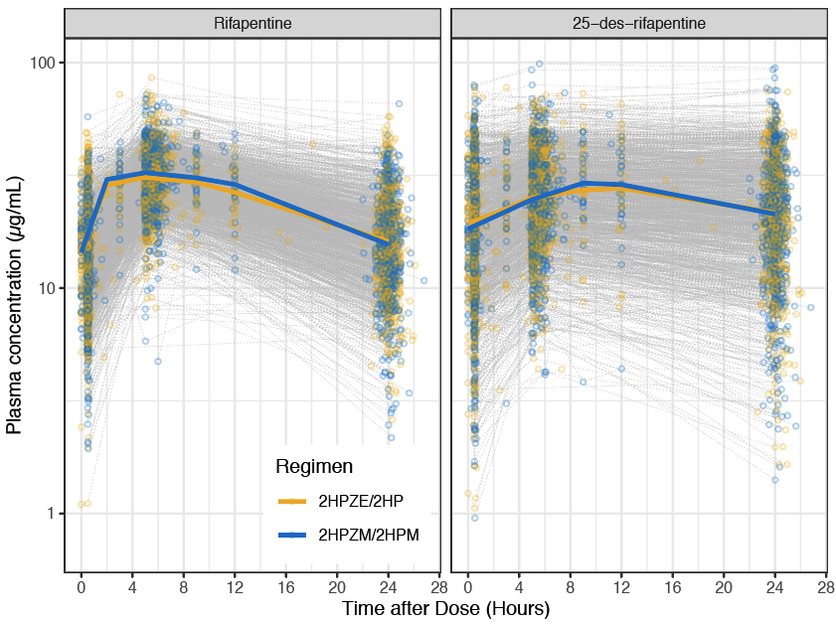
Figure 1. Observed rifapentine and 25-desacetyl rifapentine pharmacokinetic data were similar between 2HPZE/2HP and 2HPZM/2HPM regimens. Circles represent individual samples and solid lines represent medians. Data is stratified by regimen (yellow for 2HPZE/2HP regimen and blue for 2HPZM/2HPM regimen), parent drug (left) and metabolite (right).
Table 2. Bootstrap of Final Model. (*) parameters are fixed.
 | Final Full Model
Parameters (units) | Median | 95% Confidence Interval | Relative Standard Error (%)
CL/F (L/h) | 2.24 | 2.19 – 2.29 | 1.17
V/F (L) | 47.4 | 45.0 – 50.1 | 2.66
Mean transit time (h) | 3.68 | 3.40 – 3.95 | 3.52
CL_{m}/F_{m} (L/h) | 2.15 | 2.08 – 2.21 | 1.50
CL_{m} box cox transformation shape parameter | 0.294 | 0.190 – 0.393 | 17.4
V_{m}/F_{m} (L) | 11.3 | 10.4 – 12.1 | 4.04
F | 1* | – | –
F_{m} | 1* | – | –
N transit compartments | 2* | – | –
Covariates (reference)
Asian race effect on bioavailability  (fraction relative to Black reference) | 1.091 | 1.051 – 1.151 | 27.8
Female effect on bioavailability  (fraction relative to male reference) | 1.155 | 1.118 – 1.196 | 11.8
HIV infection effect on clearance  (fraction relative to HIV-uninfected reference) | 1.098 | 1.049 – 1.14 | 22.8
Between Subject Variability (units)
Between-subject variability in CL (%CV) | 32.3 | 28.4 – 35.4 | 11.0
Between-subject variability in MTT (%CV) | 32.8 | 23.0 – 38.3 | 21.3
Between-subject variability in CL_{m} (%CV) | 47.5 | 45.2 – 49.5 | 4.92
Between-subject variability in F (%CV) | 20.9 | 16.3 – 25.3 | 20.4
Correlation CL-F | 0.412 | 0.33 – 0.47 | 32.1
Correlation CL-CL_{m} | 0.581 | 0.55 – 0.61 | 8.84
Correlation F-CL_{m} | 0.392 | 0.30 – 0.46 | 36.9
Residual Error (units)
Proportional error, parent (%) | 15.5 | 14.0 – 17.1 | 4.84
Additive error, parent (µg/mL) | 0.25* | – | –
Proportional error, metabolite (%) | 14.6 | 13.7 – 16.1 | 3.91
Additive error, metabolite (µg/mL) | 0.25* | – | –

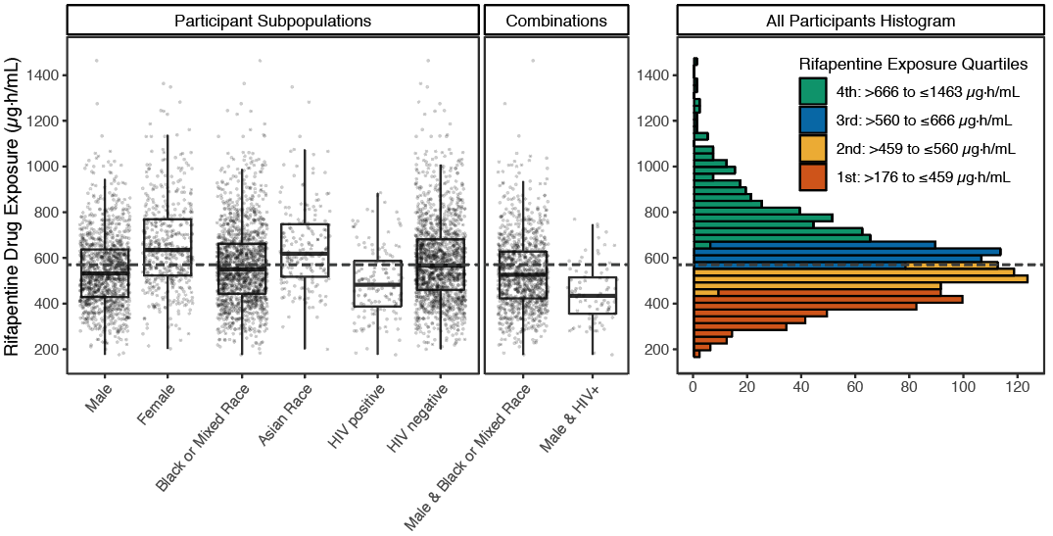
Figure 2. Box plots of rifapentine exposures stratified by significant covariates, sex, race, and HIV status, demonstrate participants living with HIV at highest risk for low exposure. Dotted line represents the 570 µg∙h/mL exposure target. Histogram on the left shows the distribution of rifapentine exposures across all participants colored by quartiles.

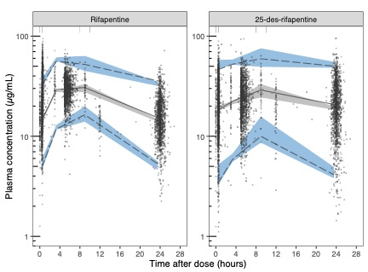
Figure 3. Prediction corrected visual predictive check of total cohort shows reasonable model fit. Points show observed concentration, solid black line show median of the observed data, dashed black lines show the 5th and 95th percentile of the observed data, shaded areas show 95% confidence interval of the 5th, median, and 95th percentile of model predicted simulations.

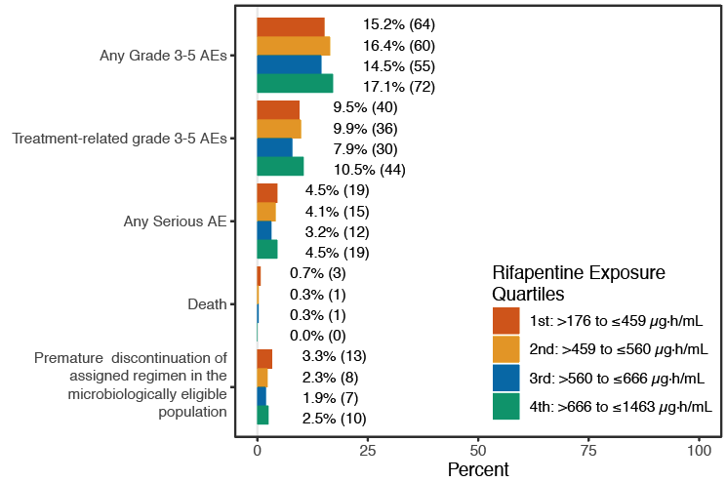
Figure 4. Rifapentine exposures were not associated with safety outcomes. Bars shows percentage of participants with safety outcomes by quartiles of rifapentine exposure. Tolerability was defined as premature discontinuation of the assigned regimen for any reason other than microbiological ineligibility. Participants without pharmacokinetic sampling were excluded from this figure. Percentages are calculated from the safety population for all safety outcomes except tolerability, which was calculated from the microbiologically eligible population.

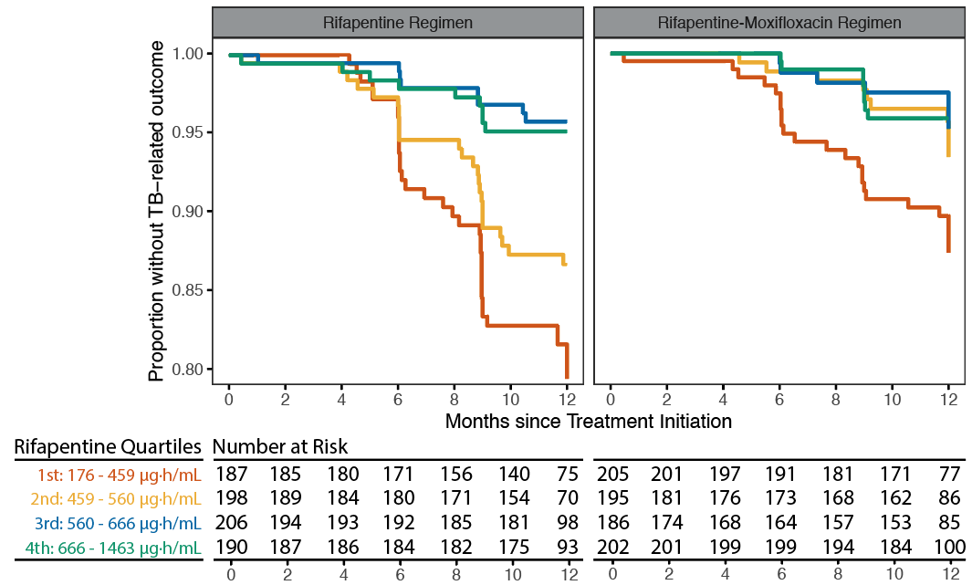
Figure 5. Kaplan Meier estimates of Tuberculosis-related Unfavorable Outcomes Stratified by Rifapentine Exposure Quartiles Shows Participants with Low Rifapentine Exposure are at Higher Risk of Tuberculosis-related Unfavorable Outcomes. Participants in the microbiologically eligible population were stratified by regimen and quartiles of rifapentine exposure. A clear exposure response relationship can be seen in both rifapentine and rifapentine-moxifloxacin regimens.

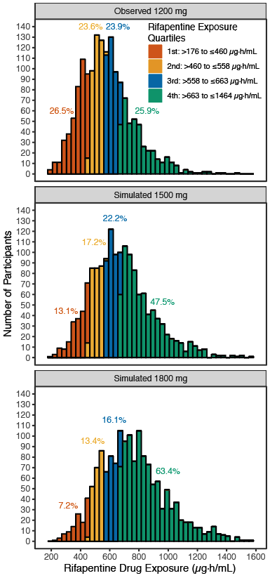
Figure 6. Participants achieve higher AUC_{0-24h,ss} with simulated 1500 and 1800 mg dose, but dose-limiting bioavailability puts a ceiling on the increase. Rifapentine exposure quartile bins in the legend were calculated from the observed 1200 mg data, the colored percentages on the plot represent the percentage of participants receiving the labeled dose that would lie within the quartile bins in the legend. Participants are shifted from lower to higher quartiles, but the range does not appreciably change.
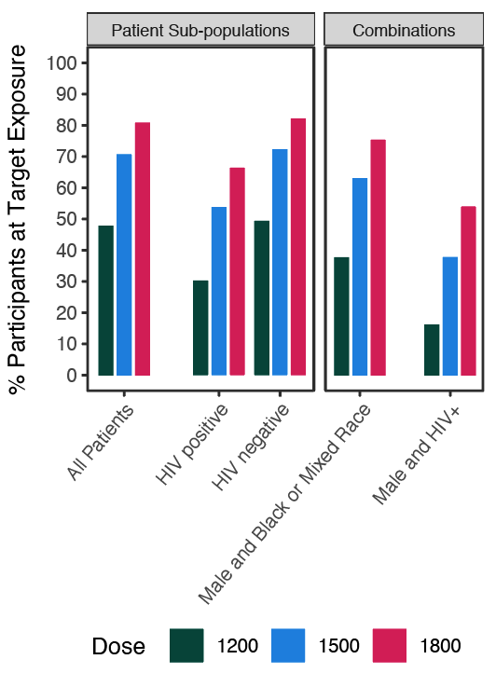
Figure 7. HIV seropositive, male and black or mixed race, and male and HIV seropositive, were at highest risk for low drug exposure with the flat 1200 mg dose. Bar graphs represent the percentage of the subpopulation achieving the 570 µg∙h/mL target exposure at 1200, 1500, and 1800 mg doses. In the left panels, participants are stratified by single risk factors and in the right panels, stratified by combinations of risk factors.

Supplemental Methods
R software (version 3.5.2)³³ was used for all data management, analyses, and graphical visualization. The xpose (version 0.4.4)³⁴ and vpc (version 1.0.1)³⁵ packages were used for visual diagnostics. Nonparametric bootstrap and covariate modeling were performed with Perl-speaks-NONMEM (version 4.7.0)³⁶.

For the 93 participants missing PK sampling in the safety population and 67 participants missing PK sampling in the microbiologically eligible population receiving rifapentine, their AUC_{0-24,ss} and C_{max} were imputed as 50th to 95th percentile values. Then logistic regressions were performed on all participants to determine how high AUC_{0-24,ss} and C_{max} needs to be for the participants missing PK sampling to observe statistically significant exposure-safety relationships. This post-hoc analysis was performed on any grade 3 or higher adverse events in the safety population and premature discontinuation of assigned regimen due to any reason in the microbiologically eligible population, the two safety outcomes more likely to occur in participants missing PK sampling.

Supplemental Results
For any grade 3 or higher adverse events in the safety population, even if all 93 participants with missing PK had the 95th percentile AUC_{0-24,ss} (901 µg∙h/mL), higher rifapentine AUC_{0-24,ss} were not associated with higher incidence of any grade 3 or higher adverse events. For premature discontinuation of assigned regimen due to any reason in the microbiologically eligible population, a statistically significant relationship (P<0.05) is observed if all 67 participants with missing PK had 73rd percentile AUC_{0-24,ss} (656 µg∙h/mL).
Supplemental Table 1. Summary of Pharmacokinetic, Demographic, Clinical, and Safety data. Training and validation data split had similar characteristics. *samples were measured for both rifapentine and 25-desacetyl rifapentine, sample numbers reflect both measurements. †12 participants are missing aggregate cavity size and disease extent, 3 participants are missing baseline smear grade. N (%) given for categorical measures and median (95th percentiles) given for continuous measures.
 | Training Dataset | Validation Dataset | Validation Dataset 2 | Total
PHARMACOKINETIC SAMPLING*
Total Patients | N=1053 | N=462 | N=65 | N=1580
Intensive Sampling Patients | N=35 (624 samples) | N=18 (324 samples) | N=0 (0 samples) | N=53 (944 samples)
Sparse Sampling Patients | N=1018 (6094 samples) | N=444 (2670 samples) | N=65 (390 samples) | N=1527 (9112 samples)
Below Limit of Quantification | 16 samples | 8 samples | 0 samples | 24 samples
Arm 2: 2HPZE/2HP | N=532 (50) | N=220 (48) | N=34 (52) | N=786 (50)
Arm 3: 2HPZM/2HPM | N=521 (50) | N=242 (52) | N=31 (48) | N=794 (50)
DEMOGRAPHIC FACTORS
Age [years] | 30 (17 – 60) | 31 (18 – 59) | 35 (19 – 56) | 31 (17-60)
Male Sex | 758 (72.0) | 321 (69) | 46 (71) | 1125 (71)
Height [cm] | 167 (151 – 182) | 167 (150 – 183) | 167 (152 – 189) | 167 (151 – 182)
Weight [kg] | 53 (41 - 76) | 54 (41 – 75.4) | 54 (42 – 85.4) | 53 (41 -76)
BMI [kg/m2] | 18.92 (14.87 – 27.73) | 19.08 (15.58 – 27.58) | 19.05 (15.53 – 31.46) | 19.00 (15.05 – 28.02)
Race
Black | 758 (72) | 328 (71) | 36 (55) | 1122 (71)
Mixed/Multi-racial | 160 (15) | 73 (16) | 27 (42) | 260 (16)
Asian | 122 (12) | 56 (12) | 0 (0) | 178 (11)
White | 13 (1) | 5 (1) | 2 (3) | 20 (1)
CLINICAL FACTORS
African Clinical Site | 770 (73) | 336 (73) | 63 (97) | 1169 (74)
Baseline Chest X-Ray Cavity | 772 (73) | 325 (70) | 47 (73) | 1145 (73)
Baseline Chest X-Ray Class ▼
No cavities | 269 (26) | 135 (29) | 17 (27) | 421 (27)
Cavities < 4cm | 351 (34) | 143 (31) | 26 (41) | 520 (33)
Cavities ≥ 4cm | 424 (41) | 182 (40) | 21 (33) | 627 (40)
Baseline Chest X-Ray Extent ▼
Lesions < 1/4 thoracic area | 182 (17) | 90 (20) | 16 (25) | 288 (18)
Lesions 1/4 to < 1/2 thoracic area | 479 (46) | 207 (45) | 21 (33) | 707 (45)
Lesions ≥ 1/2 thoracic area | 383 (36) | 165 (35) | 27 (42) | 573 (37)
Baseline Smear Grade ▼
Negative | 39 (4) | 18 (4) | 6 (9) | 63 (4)
Scanty | 185 18) | 86 (19) | 14 (22) | 285 (18)
Grade 1 | 222 (21) | 113 (25) | 12 (18) | 347 (22)
Grade 2 | 287 (27) | 140 (30) | 16 (25) | 443 (28)
Grade 3 | 306 (29) | 103 (22) | 17 (26) | 426 (27)
Positive WHO scale not used | 13 (1) | 1 (0) |  | 14 (1)
Karnofsky Score | 90 (70 - 100) | 90 (70 - 100) | 90 (70 - 100) | 90 (70 – 100)
HIV | 80 (8) | 46 (10) | 7 (11) | 133 (8)
Diabetes | 25 (2) | 14 (3) | 4 (6) | 43 (3)

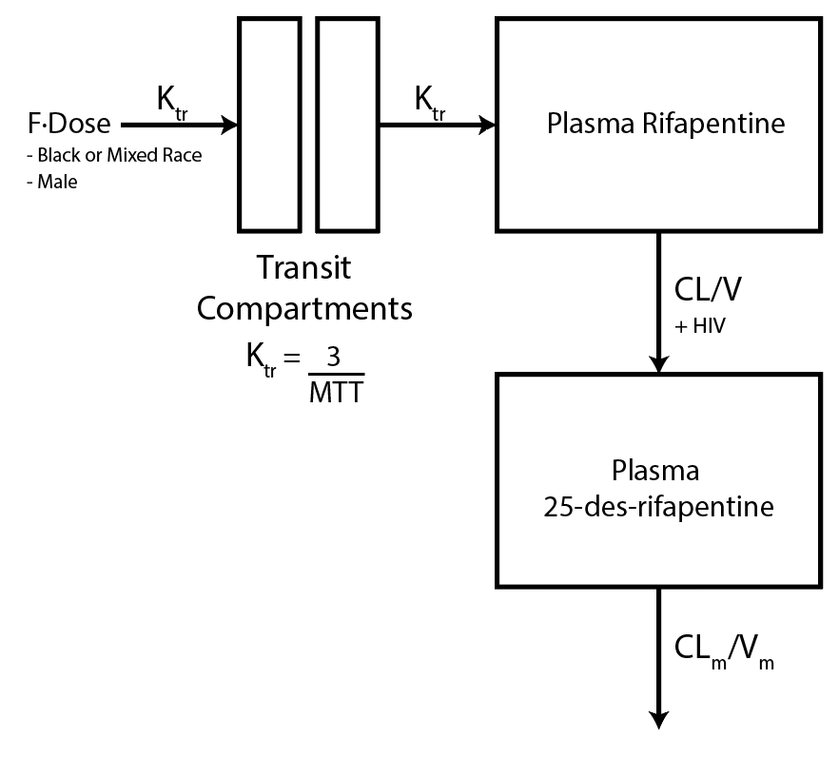
Supplemental Figure 1. Rifapentine Structural Pharmacokinetic Model. Pharmacokinetic data were well described with a one compartment model with linear metabolite clearance and two transit compartment delayed absorption. Male sex and Black/Mixed race participants had lower bioavailability, while HIV seropositive participants had higher apparent clearance.
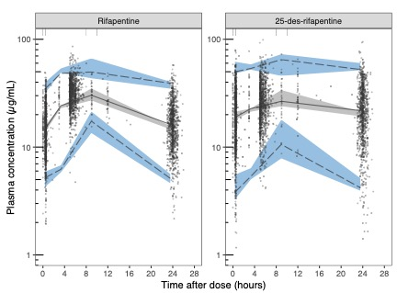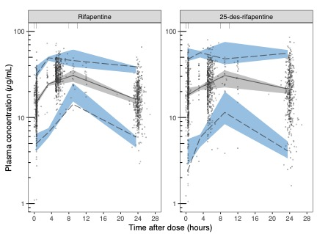
B
A
Supplemental Figure 2. Prediction Corrected Visual Predictive Checks of (A) Training and (B) Validation Cohorts. Points show observed concentration, solid black line show median of the observed data, dashed black lines show the 5th and 95th percentile of the observed data, shaded areas show 95% confidence interval of the 5th, median, and 95th percentile of model predicted simulations.

 | Training Model |  | Final Full Model
Parameters (units) | Estimate (%RSE) | Between-subject Variability  %CV (%RSE) | Estimate (%RSE) | Between-subject Variability  %CV (%RSE)
CL/F (L/h) | 2.22 (1) | 27.8 (7) | 2.25 (1) | 32.4 (4)
V/F (L) | 42.9 (3) | -- | 47.3 (2) | --
MTT (h) | 4.04 (4) | 35.5 (7) | 3.66 (3) | 33.8 (9)
CL_{m}/F_{m} (L/h) | 2.09 (1) | 46.8 (4) | 2.14 (2) | 50.1 (3)
CL_{m} Box Cox transformation Shape parameter | 0.392 (19) | -- | 0.354 (19) | --
V_{m}/F_{m} (L) | 10 (3) | -- | 11.3 (3) | --
F | 1* | 2.9 (70) | 1* | 19.9 (8)
F_{m} | 1* | -- | 1* | --
N Transit Compartments | 2* | -- | 2* | --
Covariates (reference)
Asian race effect on bioavailability  (fraction relative to Black reference) | 1.099 (49) | -- | 1.092 (28) | --
Female effect on bioavailability  (fraction relative to male reference) | 1.159 (18) | -- | 1.151 (15) | --
HIV infection effect on clearance  (relative to HIV-uninfected reference) | 1.091 (29) | -- | 1.10 (21) | --
Variability (units)
Correlation CL-F | -- | -0.99 (32) | -- | 0.382 (14)
Correlation CL-CLm | -- | 0.707 (7) | -- | 0.741 (5)
Correlation F-CLm | -- | -0.707 (32) | -- | 0.20 (20)
Residual Error (units)
Proportional Error, parent (%) | 16.8 (4) | -- | 15.9 (4) | --
Additive Error, parent (ug/mL) | 0.25* | -- | 0.25* | --
Proportional Error, metabolite (%) | 15.5 (5) | -- | 14.9 (4) | --
Additive Error, metabolite (ug/mL) | 0.25* | -- | 0.25* | --
Supplemental Table 2. Training and Final Model Parameters. Parameters with (*) were fixed.

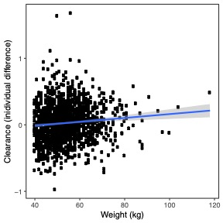
Supplemental Figure 3. Body weight does not significantly modulate rifapentine clearance. (A) Model derived individual clearance accounting for weight (y-axis) and not accounting for weight (x-axis). There is little change in clearance for individual participants. (B) Weak relationship between individual differences in clearance and weight, R²=0.0088.
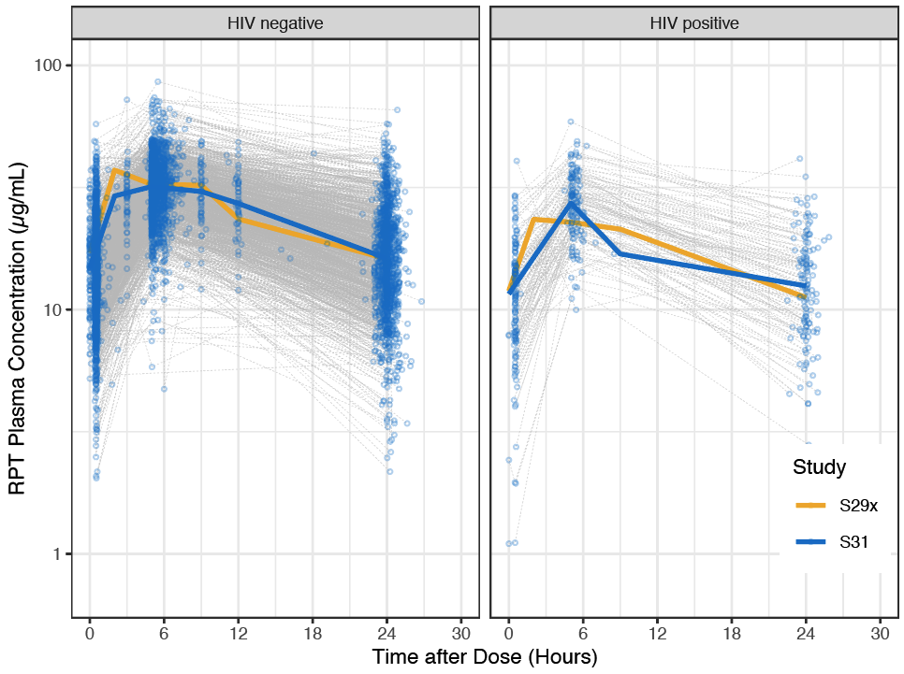
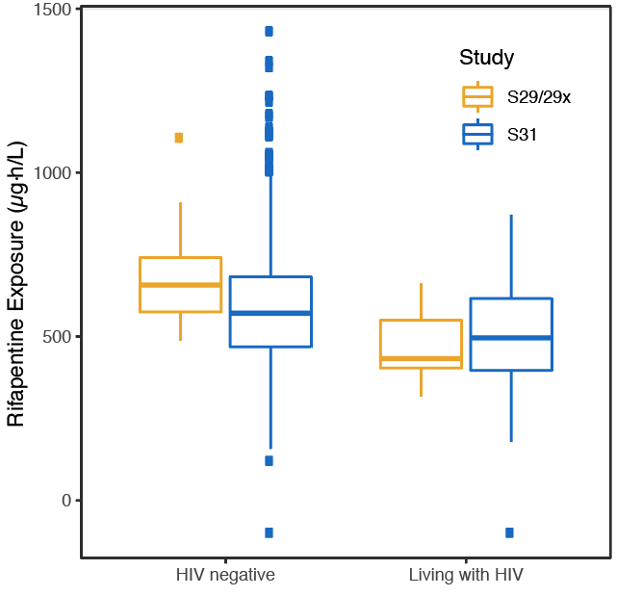
Supplemental Figure 4. HIV seropositive participants have lower exposure. (A) Raw rifapentine pharmacokinetic profiles stratified by HIV status in S31/A5349 and S29/29x. S29/29x found the effect on bioavailability, in S31/A5349 we found the effect on apparent clearance, potentially due to S31/A5349 participants taking efavirenz based ART, which is also a potent CYP inducer. (B) Regardless of the effect on bioavailability or clearance, the exposures of HIV seropositive participants are comparable between the two studies.

Safety Outcome | Unadjusted  Odds Ratio | Unadjusted  95% CI | Unadjusted  p-value | Adjusted  Odds Ratio | Adjusted  95% CI | Adjusted  p-value
Rifapentine AUC_{0-24h} (for every 100 µg∙h/mL)
Grade 3 or higher adverse event | 1.02 | 0.95 - 1.10 | 0.55 | 1.02 | 0.94 - 1.10 | 0.70
Treatment-related grade 3 or higher adverse event | 1.00 | 0.92 - 1.10 | 0.93 | 1.00 | 0.91 - 1.10 | 0.94
Any serious adverse event | 0.94 | 0.81 - 1.07 | 0.35 | 0.93 | 0.80 - 1.08 | 0.38
Any grade 3 or higher adverse event within 28 weeks after randomization | 1.02 | 0.96 - 1.10 | 0.51 | 1.02 | 0.95 - 1.10 | 0.54
Any adverse event resulting in discontinuation of assigned treatment | 0.96 | 0.85 - 1.09 | 0.56 | 0.93 | 0.81 - 1.06 | 0.27
Premature discontinuation of assigned regimen for any reason in the microbiologically eligible population | 0.97 | 0.77 - 1.20 | 0.81 | 0.95 | 0.73 - 1.21 | 0.69
ALT or AST level ≥5×ULN | 1.07 | 0.86 - 1.29 | 0.53 | 0.98 | 0.78 - 1.22 | 0.87
ALT or AST level ≥10×ULN | 0.95 | 0.63 - 1.36 | 0.81 | 0.89 | 0.56 - 1.32 | 0.60
Serum total bilirubin level ≥3×ULN | 1.05 | 0.89 - 1.23 | 0.52 | 1.08 | 0.89 - 1.29 | 0.41
Hy’s law criteria of ALT or AST level ≥3×ULN plus serum total bilirubin level ≥2×ULN | 1.19 | 0.92 - 1.48 | 0.16 | 1.23 | 0.93 - 1.59 | 0.13
Neutropenia | 1.07 | 0.96 - 1.19 | 0.20 | 1.15 | 1.02 - 1.30 | 0.018
Death | 0.51 | 0.27 - 0.88 | 0.023 | 0.59 | 0.30 - 1.04 | 0.093
Rifapentine C_{max} (for every 10 µg/mL)
Grade 3 or higher adverse event | 1.04 | 0.88 - 1.21 | 0.67 | 1.01 | 0.85 - 1.19 | 0.95
Treatment-related grade 3 or higher adverse event | 1.00 | 0.82 - 1.21 | 1.00 | 0.98 | 0.79 - 1.21 | 0.86
Any serious adverse event | 0.84 | 0.62 - 1.12 | 0.24 | 0.84 | 0.60 - 1.15 | 0.28
Any grade 3 or higher adverse event within 28 weeks after randomization | 1.02 | 0.88 - 1.19 | 0.76 | 1.00 | 0.85 - 1.18 | 0.98
Any adverse event resulting in discontinuation of assigned treatment | 0.79 | 0.59 - 1.04 | 0.096 | 0.70 | 0.51 - 0.94 | 0.02
Premature discontinuation of assigned regimen for any reason in the microbiologically eligible population | 0.79 | 0.47 - 1.28 | 0.35 | 0.72 | 0.40 - 1.24 | 0.25
ALT or AST level ≥5×ULN | 1.13 | 0.72 - 1.73 | 0.57 | 0.94 | 0.57 - 1.49 | 0.79
ALT or AST level ≥10×ULN | 0.87 | 0.35 - 1.89 | 0.74 | 0.74 | 0.28 - 1.76 | 0.53
Serum total bilirubin level ≥3×ULN | 1.18 | 0.83 - 1.64 | 0.34 | 1.31 | 0.88 - 1.92 | 0.18
Hy’s law criteria of ALT or AST level ≥3×ULN plus serum total bilirubin level ≥2×ULN | 1.61 | 0.95 - 2.58 | 0.059 | 1.81 | 1.00 - 3.13 | 0.041
Neutropenia | 1.16 | 0.92 - 1.45 | 0.21 | 1.31 | 1.00 - 1.70 | 0.045
Death | 0.31 | 0.09 - 0.91 | 0.043 | 0.45 | 0.13 - 1.39 | 0.19
Supplemental Table 3. Odds Ratios of Safety Outcomes for increase in Rifapentine Exposure. Odds ratios are adjusted for treatment group and are reported for every 100 µg∙h/mL increase in rifapentine AUC_{0-24h} and every 10 µg/mL increase in rifapentine C_{max}. Adjusted odds ratios, 95% confidence intervals, and p-values were adjusted for regimen, African or non-African site, diabetes status, HIV status, sex and age. Safety outcomes significantly associated with rifapentine AUC_{0-24h} or C_{max} in unadjusted or adjusted analyses are bolded.

