PHARMACY MANAGEMENT SYSTEM

Group Name: Code Warriors

Submitted By:
Amandeep Sharma
KrupaliKumari Patel
Gursharan kaur
Sukhwinder kaur
Bansari Parekh
Rajanbir Singh
Prabhjit Singh
Savieo Sebastian
HariKrishna Sabu
Amal Vijay

Table of Contents

1.Introduction
1.1 Product overview……………………………………………………………..3
1.2 Scope……………………….....……………………………………………….3
2. Requirements
2.1 Software……………………………………………………………………….3
2.2 Hardware………………………………………………………………………3
3. Architecture……………………………………………………………………………3
4. Technology
4.1 Web Application……………………………………………………………….4
4.2 Mobile…………………………………………………………………………5
5 Diagrams
5.1 Use Case……………………………………………………………………….5
5.2 Class Diagram…………………………………………………………………8
5.3 Sequence Diagram……………………………………………………………..9
6 Mock Up
6.1 Web App…………………………………………………………..………….10
6.2 Mobile App………………………………………………………….……….23
7 Database
7.1 Type…………………………………………………………………………..26
7.2 Schema……………………………………………………………………….26
8 References ………………………………………………………………………….27

1. INTRODUCTION

1.1 Product Overview

Pharmacy Management System is a web/mobile application to manage an online pharmacy store. The application helps pharmacists to sell drugs, consult the available stocks of drugs, add new products and send orders to suppliers. The application must also make it possible to determine the money collected by the pharmacy over a given period. Apart from this, the application will also allow staff to manage who is the pharmacist or the person who sold the drug and an alert mechanism for the management of best-selling products will be implemented.

1.2 Scope

The Pharmacy Management System will be accessible from both web and mobile interface.

2. REQUIREMENT

2.1 Software

- Windows10/above OS
-32/64 bit OS
-Android 4.0(Iscreamsandwich)/above(Mobile)

2.2 Hardware

-Intel Core i5 Processor
-16 GB RAM
-1Ghz and above(Mobile)
-2 GB(Mobile)

3 ARCHITECTURE

The architecture of pharmacy management system includes mainly 3 parts as listed below
-Web Front End
-Mobile Application
-A Rest API

From the Web/Mobile, a request is generated and send to the Rest API to do a specific task. Once the proxy server in Rest API receives the request it call the respective micro service. Following are the micro services in the API
-User Management System
-Product Management System
-Sales Management System
-Purchase Management System
-Supplier Management System

This micro services communicate with the database and once the task is completed, the appropriate response will be send back to the proxy server and from there response is send back and rendered in Web/Mobile UI.

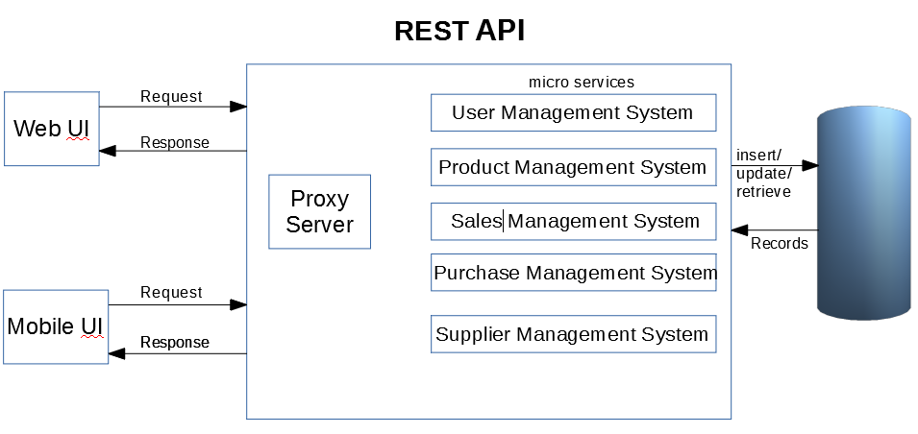

4. TECHNOLOGY

4.1 Web Application

For developing Front-end
-HTML
-Css
-Materialize/Bootstrap
-JavaScript
-React

For developing Back-end REST API
-Spring Boot
-JPA
-Hibernate

4.2 Mobile

For developing mobile app, following technologies are used
-Kotlin
-Retrofit2
-Dagger2

5 DIAGRAMS

5.1 Use Case
A use case diagram is a graphical interpretation of the system in which we describe the relationships among all the elements of a system. Mainly, it is used in an analysis process to identify, clarify, and organize system requirements.
In this diagram, we are representing the four major users of this system. Admin is the one who has all the privileges to handle this system such as add users, manage users, manage medicines, manage orders, make the payments to the supplier and so on. Whereas, Stock Manager manages the stock for the pharmacy. He deals with the Supplier. Whenever we are shortage with the quantity for any product, he will send the purchase order to the Supplier.
On the other hand, Pharmacist has only access to the products. The pharmacist tackles with the customer side. He can place an order for the customer, generate reports for the sales and prepare invoices for the client.

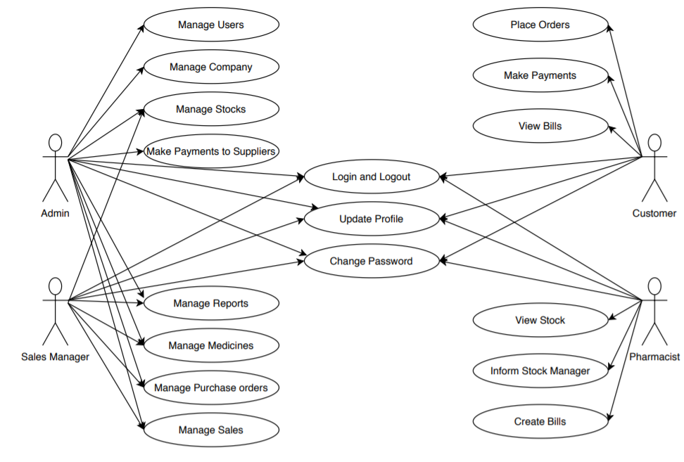

5.1.1 Use Case Diagram for Pharmacist

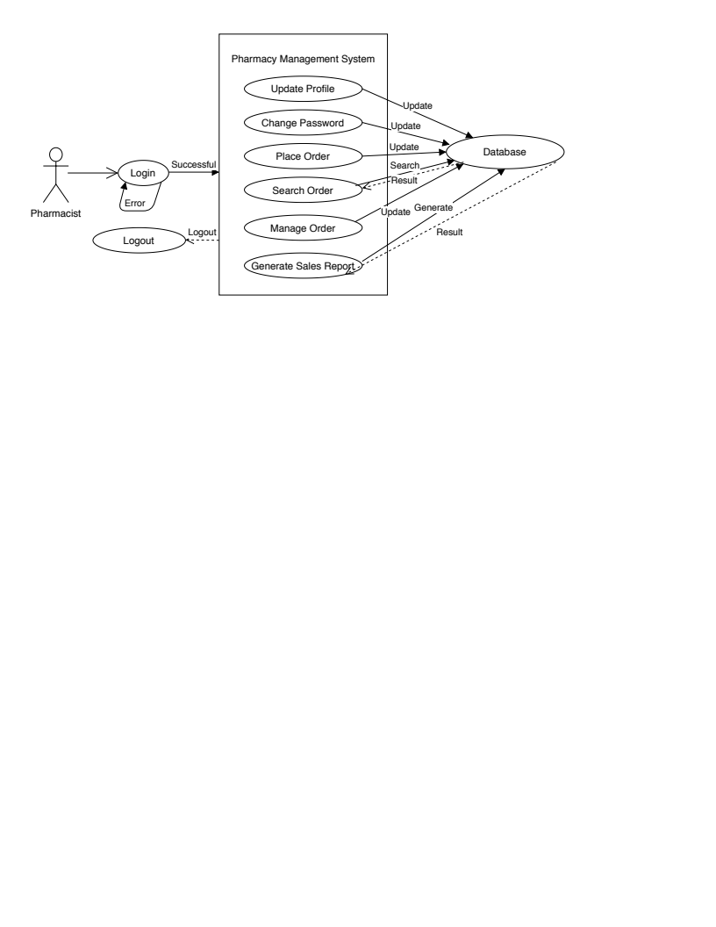

5.1.2 Use Case Diagram for Admin

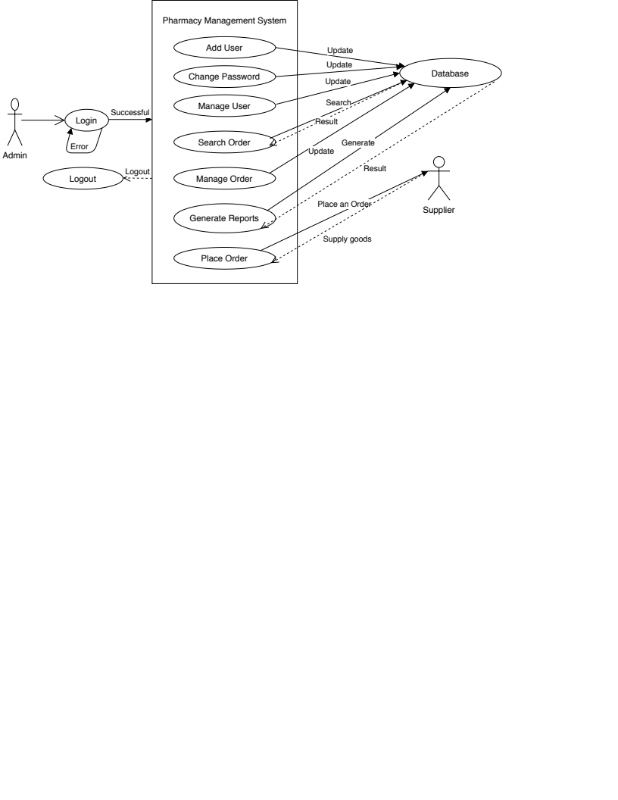

5.1.3 Use Case Diagram for Stock Manager

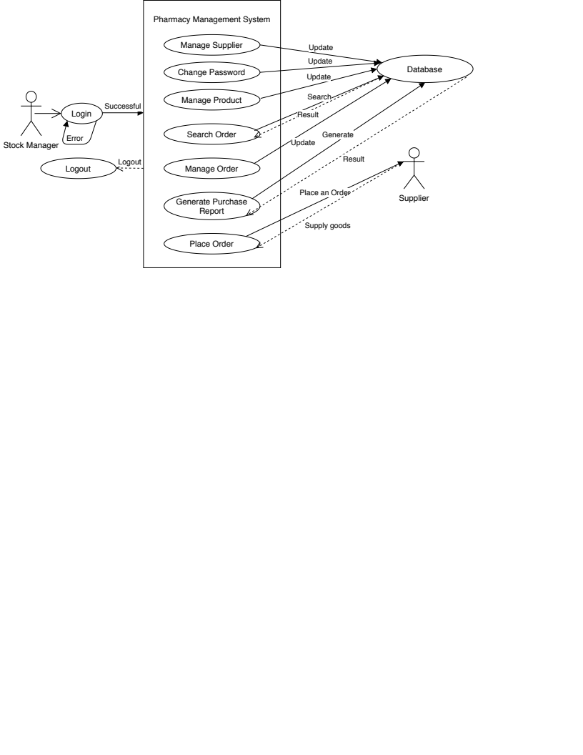

5.2 Class Diagram
UML Class Diagrams defines the interaction between the classes and interfaces, that is represents their relationships like associations, composition, aggregation and constraints which shows the structure of the system.
The Class represented in the box which have their attributes with the data type. The middle rectangle without the attribute represent as the interface. The dark arrow shows the composition that is special type of aggregation which defines the strong relationship between two classes. The another simple arrow represent the aggregation which defines the special type of association assembled the another class object and make the complex one.

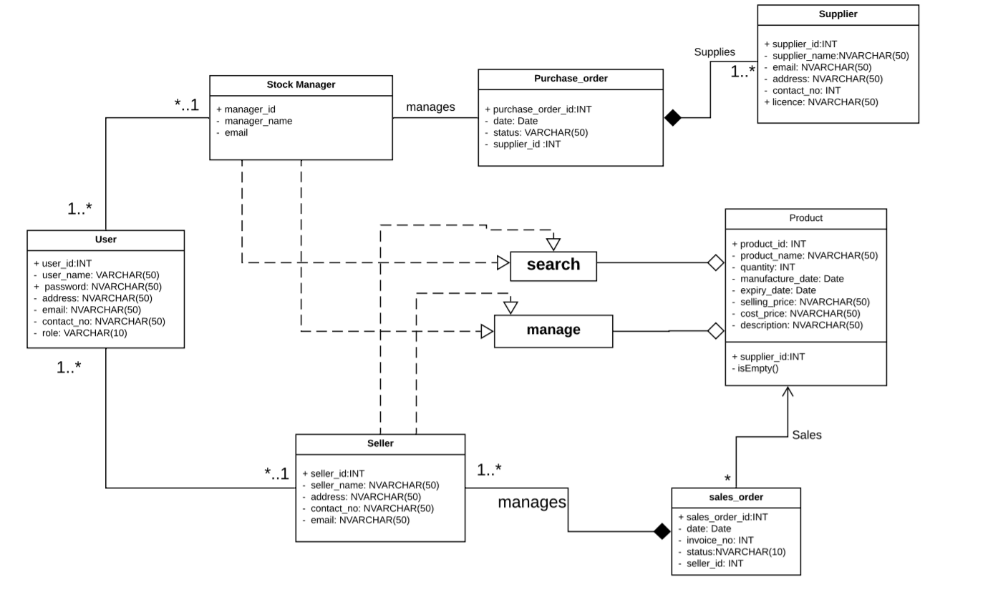

5.3 Sequence Diagram
The sequence diagram is a UML diagram use to document a system's requirements and to flush out a system's design. The reason the sequence diagram shows the interaction logic between the objects in the system in the time order that the interactions take place.
This system diagram is about the pharmacy management sysytem. It has four lifelines Customer, Pharmacist, Stock manager and supplier. Simple the store management which describes the how this whole process take place.

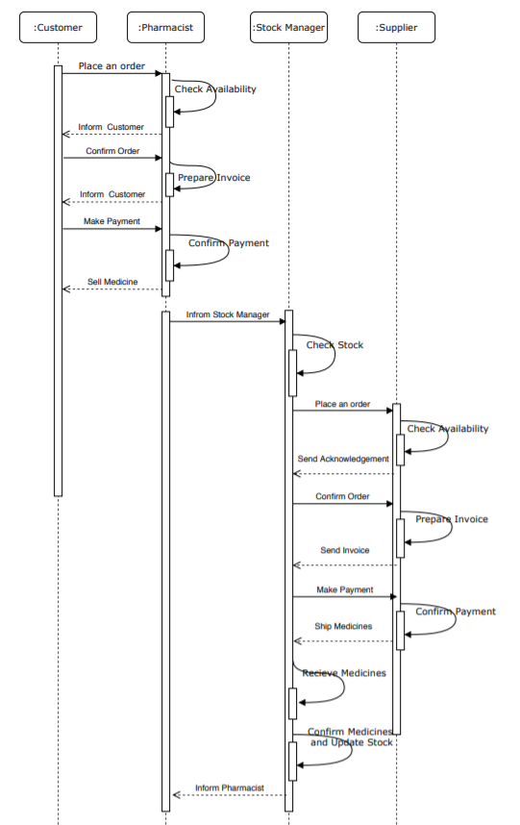

6 MOCK UP
A mock up is a visual way of representing a website. Depending on the level of details, a mock up can have only some or all visual properties of a final solution.

6.1 Web App

Login Page

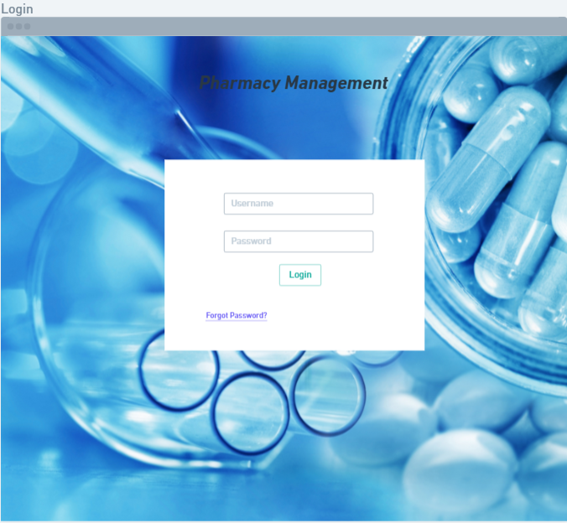
Login page is the entry page of the website. Pharmacist, Stock Manager and Admin are able to login. The login form contains a field for the username and another for the password. Both fields will be validated and if the person is the valid one page will redirect to the Dashboard Page. Otherwise, will not be able to proceed the login form.

Dashboard

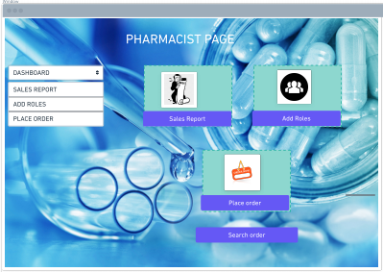

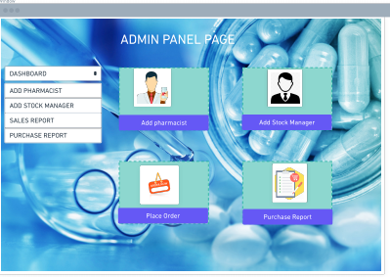

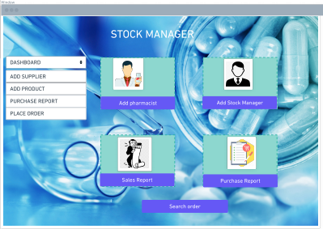
Dashboard have different panels like Pharmacist Panel, Stock Manager, Supplier Panel, Admin panel, Expenses, Sales Details, Order Details and Purchase Details. On which feature you will click that page will redirect to that page and display about the particular feature.

Order detail Page

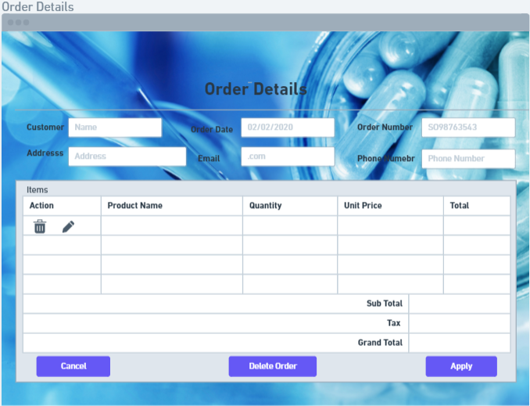
In this page, Pharmacist and admin will get to know about the order which is customers taking. In this form, we have details about the customers and medicines by using some fields like customer names, Order Number, product name, etc.
if Admin and Pharmacist want to apply some actions on the customer's order they will edit the data and will delete the order. with click on the Apply will going to next page. with Exit will going back to previous page.

Purchase Order Page

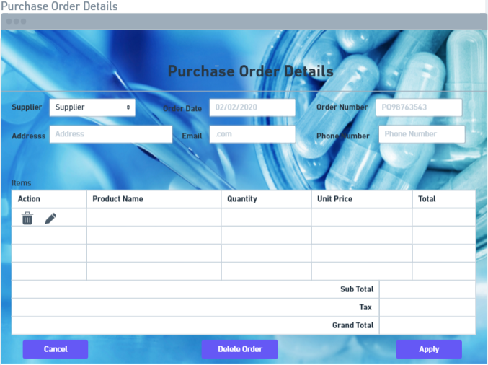
In this page, Stock Manager and admin will get to know about the order which is Supplier taking. In this form, we have details about the Supplier and Products by using some fields like supplier Names, Order Number, product name, etc. if Admin Stock Manager want to apply some actions on the Supplier order they will edit the data and will delete the order. with click on the Apply will going to next page. with Exit will going back to previous page.

Add User

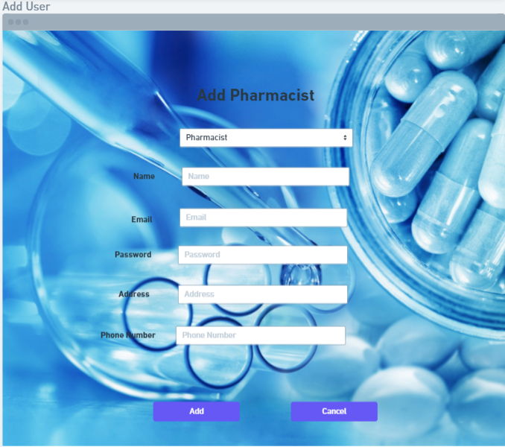
Admin has only access to any pharmacist by using their name, e-mail, password, address and phone number. At bottom we have two buttons ADD and CANCEL for Admin to cancel and add new users.

Add Stock Manager/Admin

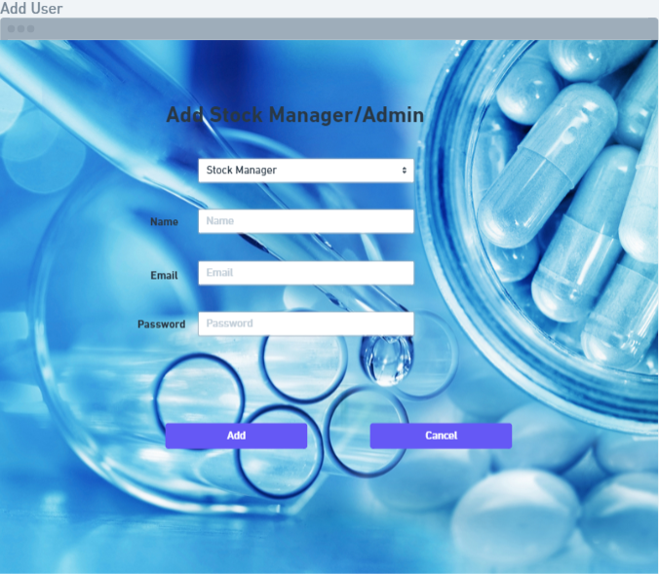

Admin has the access to add the Stock Manager and Admin wants to add a new admin he will add. At bottom we have two buttons ADD and CANCEL for Admin to cancel and add new users.

Generate Report

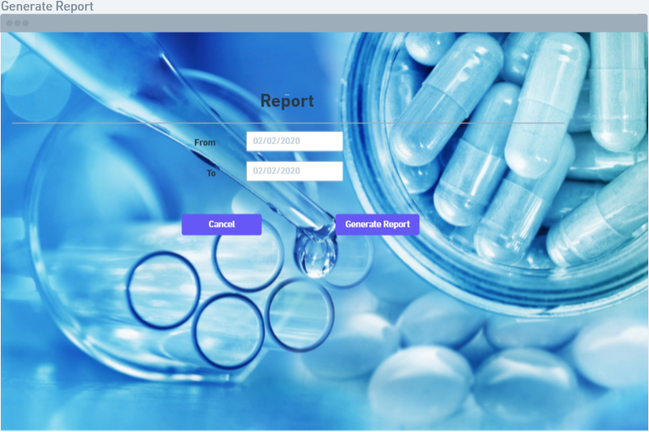
In this, we have two input fields for dates in which we can select and input any dates accordingly for the requirement of report generation. by selecting FROM DATES and TO DATES it will generate the report for that dates.

Add/Update Product
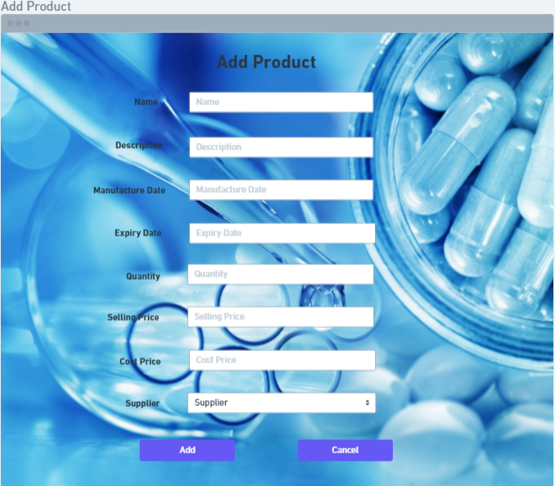

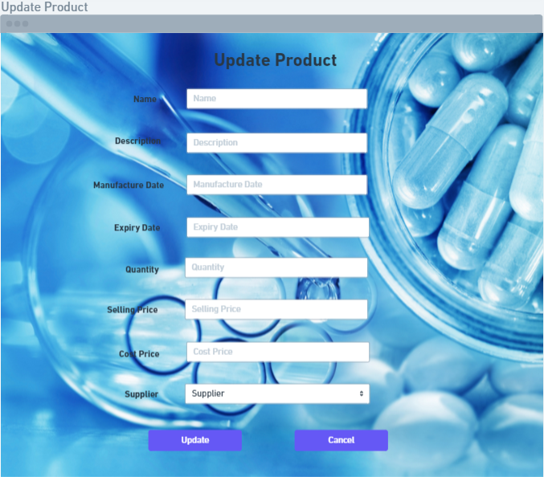

Add Product page has input fields like name, description, manufacture date, expiry date, quantity, selling price, cost price and supplier through which we can add description details regarding any product's packing date up to expiration period. so user can add new product with its appropriate descriptions.
Same for the Update Product Page user can update product information.

Pharmacist Profile

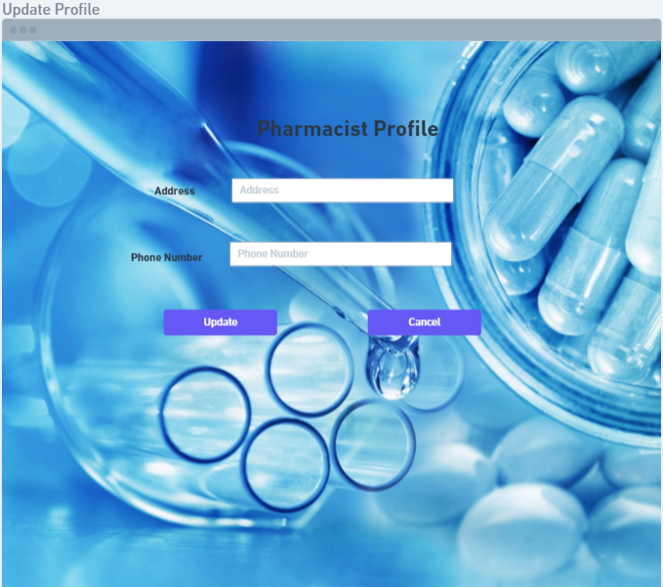
In this page Admin and pharmacist both can make changes for the profile.

Change Password
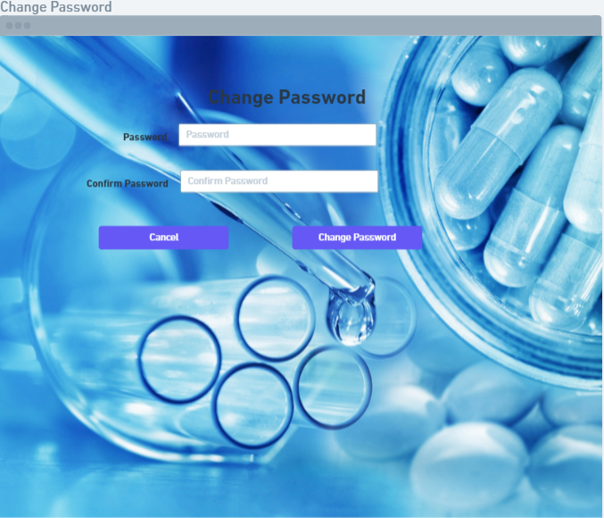

In this page user can change password for their own purpose of usage.

Add Role
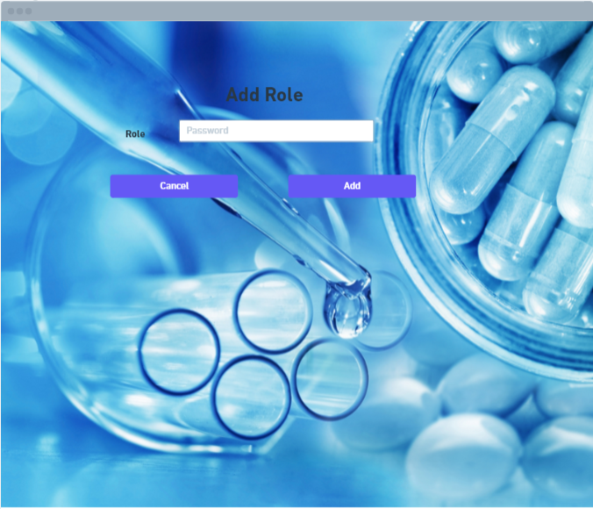

User can add the new role in system.
Search Panel for User, Supplier, Product and Role
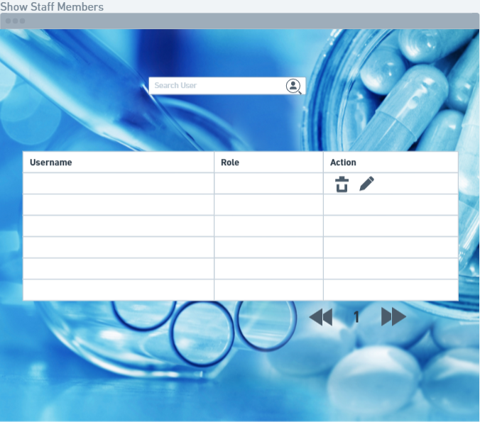

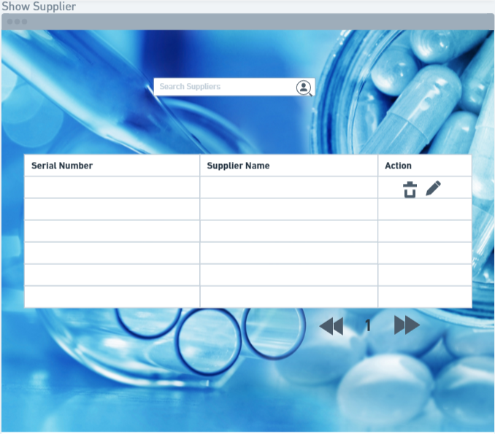

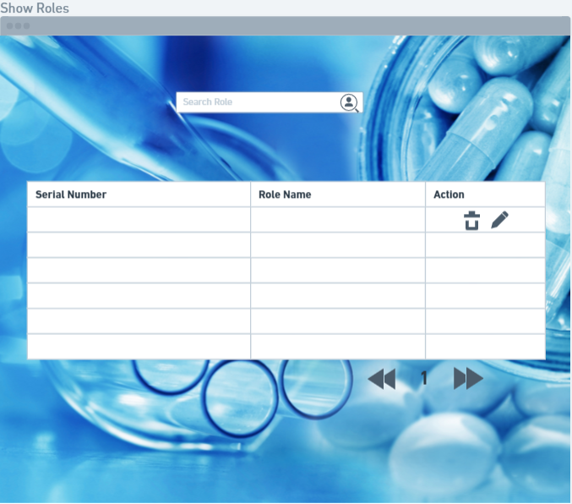

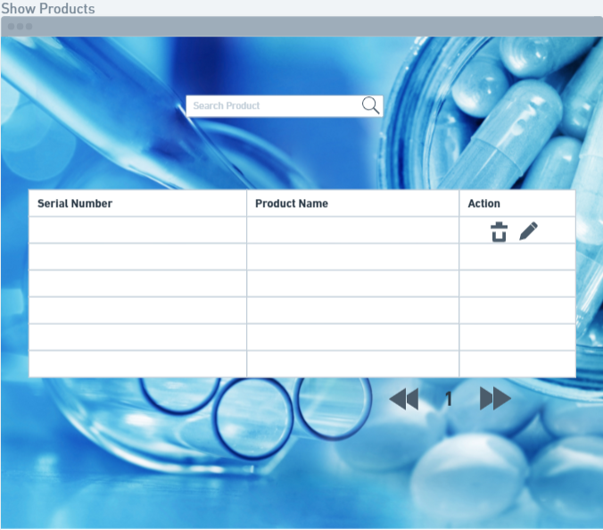

This each page describes the search action for particular user, supplier, role and the products so that it will gives the filter for that search. This each page has their different feature.

6.2 Mobile App

Pharmacist Mobile application
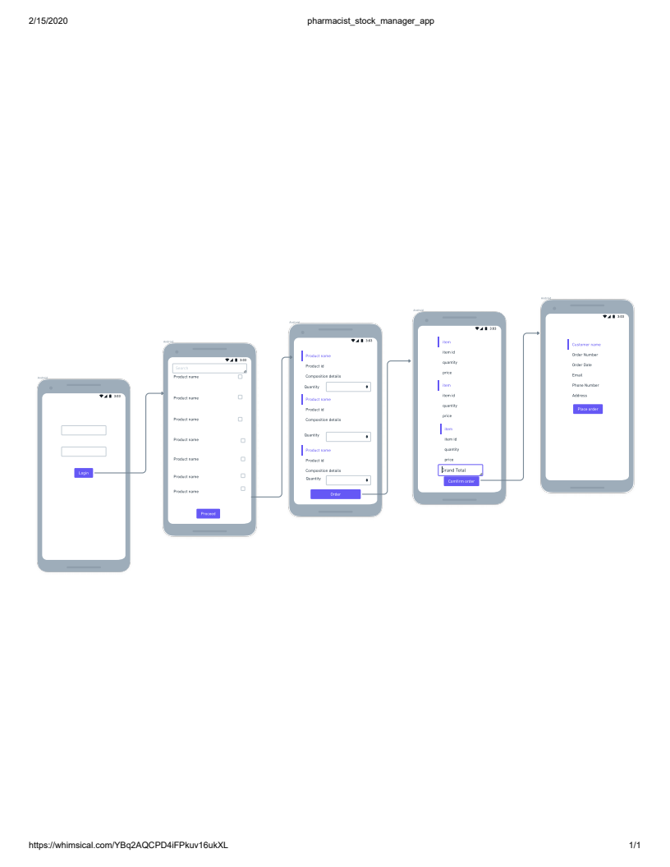

Stock Manager Mobile Application

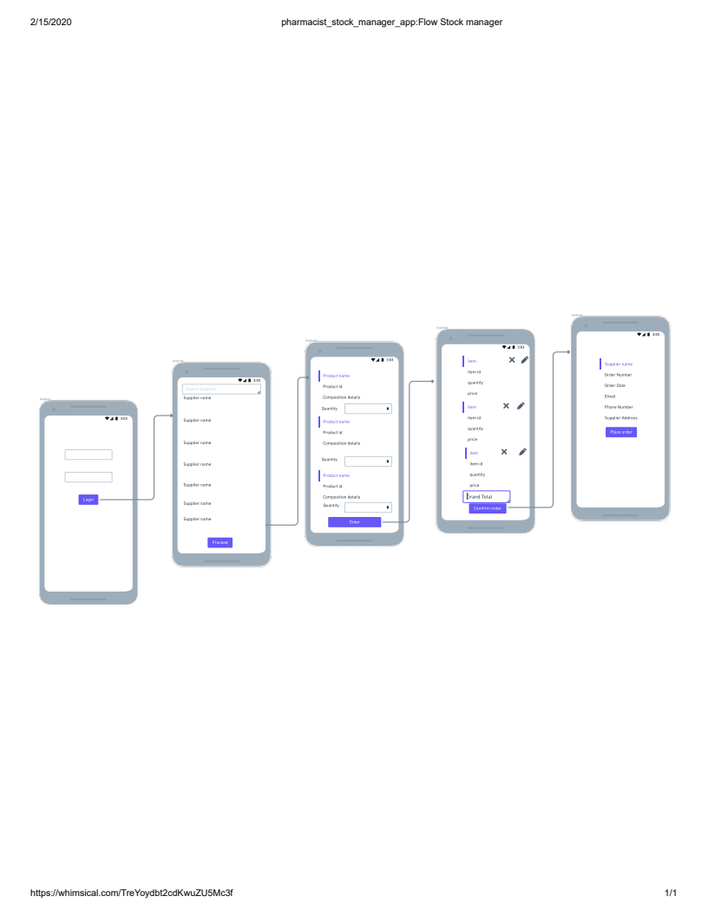

Login page:
User login in application in login page with their assigned username and password,
From these credentials application sends an API call and from the response application decides whether it is pharmacist or stock manager.

Home page-Pharmacist:-
This page has a search bar in which user can search products for pharmacist .
Pharmacist selects products in checklist and click confirm which takes the app to next page Order detail page.

Home page-Stock_Manager:-
This page has a search bar in which user can search supplier in case of stock manager. API call response provides the supplier name. Then he can select Supplier from the list, This select takes him to order detail page

Order Detail page-Pharmacist:
Display the products details from API call response. It also has the functionality to edit or remove a particular product order. The Order button takes us to Order summary page.

Order Detail page-Stock_Manager:-
Display the products from the particular supplier which we have limited/no stock. It also has the functionality to edit or remove a particular product order. The Order button takes us to Order summary page.

Order Summary page-Pharmacist/Stock Manager:
Product details with unit price and grand total is displayed

Customer Detail collection page : Pharmacist:
Get the customer details in the form. Place order button click will trigger an API call in which All final data of a particular order will be send to server.

Supplier Detail confirmation page- Stock Manager:
Confirms the supplier details. Place order button click will trigger an API call in which All final data of a particular order will be send to server.

7 DATABASE

7.1 Type

In the Pharmacy Management System the database used is MySql.

7.2 Schema

Database Name: db_pharmacy

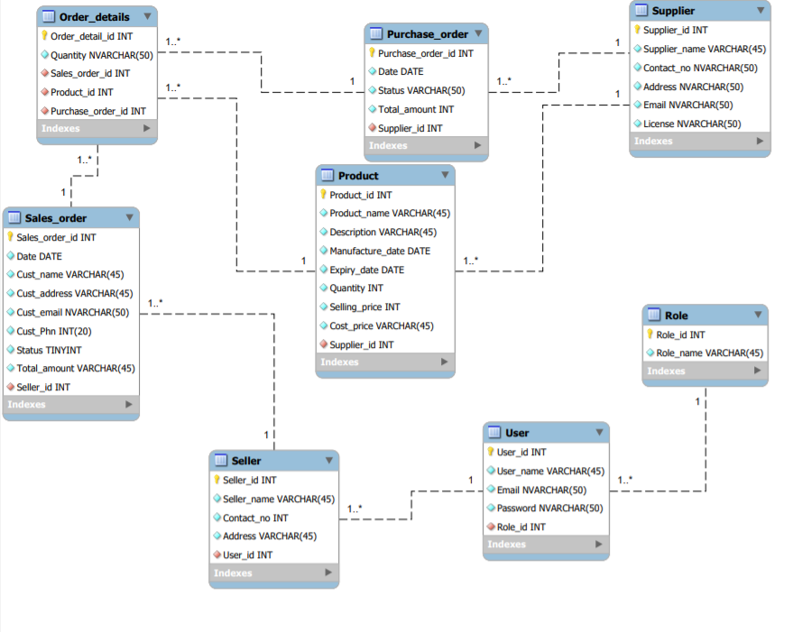

8 REFERENCES

https://www.draw.io/#G1yDBhsuIBL2_VYCp2HJo8uVeVEvlV1pk_

https://www.lucidchart.com/documents#/templates?folder_id=

https://whimsical.com/XfkoroFfP5SSXWgFpshs54

https://www.uml-diagrams.org/class-diagrams-overview.html

