

DATA STRUCTURES AND ALGORITHMS
23CSE203
LAB MANUAL

Submitted By
NAME | SABAREESH V
ROLL NO. | AV.SC.U4CSE25046
YEAR/SEM/SECTION | 2nd/3rd/CSE-A
Credits | 5

Submitted to | Dr. Raj Kumar Batchu
Designation | Asst. Professor (Sl. Grade)
Department | School of Computing

WEEK – 1
Aim:
Code:
def launch_rocket(count):
if count >= 1:
print(count)
launch_rocket(count - 1)

launch_rocket(10)
print('🚀🚀🚀')

Output:
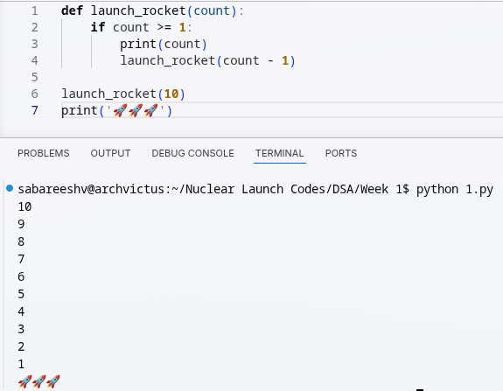

Explanation:
- Counts down from 10 to 1 using recursion.
- Each call prints the current number, then calls itself with one less.
- Stops when the count reaches 0.
- Prints the rocket emojis after the countdown completes.

Aim:
Code:
def power(p,n):
if n==0:
return 1
else:
return p*power(p,n-1)
print(power(4,5))

Output:
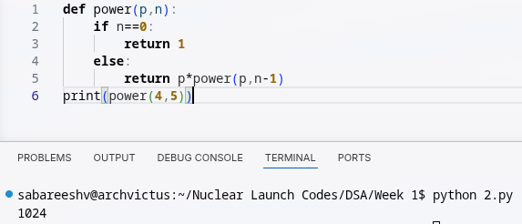
Explanation:
- Calculates p raised to the power n using recursion.
- Multiplies p by the result of power(p, n-1) until n reaches 0.
- Returns 1 at n == 0.

Aim:
Code:
def search(emp):
i=int(input('Enter employee ID: '))
for n in range(len(emp)):
if emp[n]==i:
print('employee found at index:',n)
break
else:
print('no such id exist')
emp=[101,102,103,104,105,106,107,108,109]
search(emp)

Output:
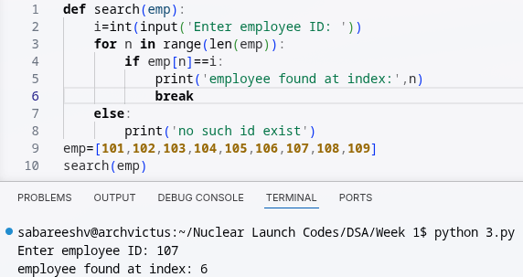

Explanation:
- Searches for an employee ID in a list of employee IDs.
- Takes the ID as input and checks each list element for a match.
- Prints the index if the employee is found.
- Prints a message if no matching ID exists.

Aim:
Code:
def fib(n):
if n <= 1:
return n
return fib(n - 1) + fib(n - 2)

n = 20
print("Fibonacci series: ")
for i in range(n):
print(fib(i), end=" ")
print("")

Output:
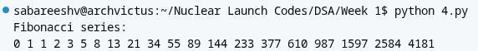
Explanation:
- Generates the first 20 Fibonacci numbers using recursion.
- Each number is calculated by adding the previous two numbers.
- Prints the sequence from the 0th to the 19th Fibonacci number.

Aim:
Code:
def fact(n):
if n==0:
return 1
else:
return n*fact(n-1)
print(fact(5))

Output:
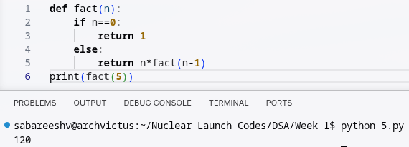
Explanation:
- Calculates the factorial of a number using recursion.
- Multiplies n by the factorial of n-1 until n reaches 0.
- Prints the factorial of 5, which is 120.

WEEK – 2
Aim:
Code:
def linearsearch(arr, key):
for i in range(0, len(arr)):
if arr[i] == key:
return i
return -1
arr = [1, 2, 3, 4, 5, 6, 7, 8, 9, 10]
print(linearsearch(arr, 9))

Output:
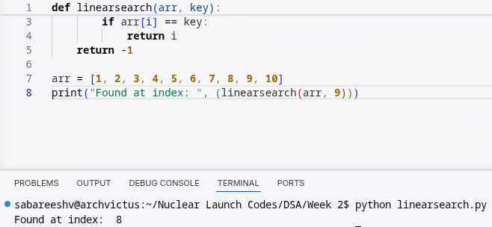
Explanation:
- Searches for a given value in a list using linear search.
- Checks each element one by one until the value is found.
- Returns its index, or -1 if the value is not present.

Aim:
Code:
def binsearch(arr, key):
low = 0
high = len(arr)-1
while low <= high:
mid = low + (high - low) // 2
if key == arr[mid]:
return mid
elif key > arr[mid]:
low = mid + 1
else:
high = mid - 1
return - 1

arr = [10, 9, 8, 7, 6, 5, 4, 3, 2, 1]

arr.sort()
print(binsearch(arr, 2))

Output:
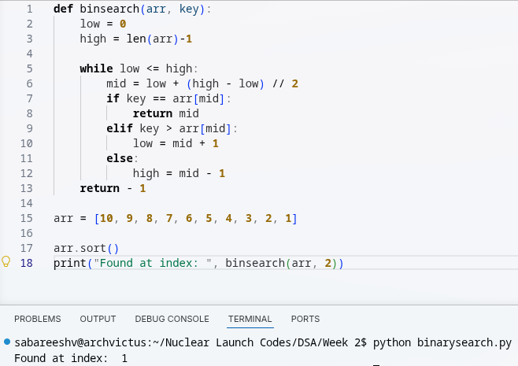

Explanation:
- Performs a binary search on a sorted list to find a target value.
- Repeatedly checks the middle element and narrows the search range.
- Returns the target's position, or `-1` if it is not found.

WEEK – 3
Aim:
Code:
def bubbleSort(arr):
n = len(arr)
for i in range(n):
swap = False

for j in range(0, n-i-1):

if arr[j] > arr[j+1]:
arr[j], arr[j+1] = arr[j+1], arr[j]
swap = True
if (swap == False):
break
return arr

arr = [10, 9, 8, 7, 6, 5, 4, 3, 2, 1]
print(bubbleSort(arr))

Output:
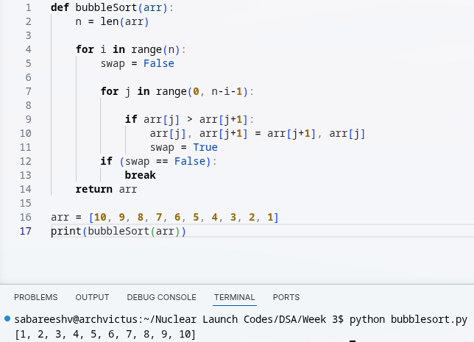

Explanation:
- Sorts a list in ascending order using bubble sort.
- Repeatedly compares adjacent elements and swaps them when they are out of order.
- Stops early if a complete pass makes no swaps.

Aim:
Code:
def insertionsort(arr):
for i in range(1, len(arr)):
key = arr[i]
j = i - 1
while j >= 0 and key < arr[j]:
arr[j + 1] = arr[j]
j -= 1
arr[j+1] = key
return arr

arr = [10, 9, 8, 7, 6, 5, 4, 3, 2, 1]
print(insertionsort(arr))

Output:
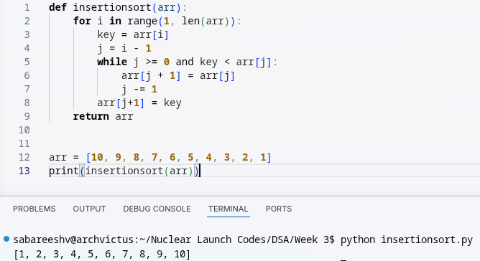

Explanation:
- Sorts a list in ascending order using insertion sort.
- Takes each element and inserts it into its correct position among the previous elements.
- Shifts larger elements to make space for the selected element.

Aim:
Code:
# Define a function to implement the merge sort algorithm
def mergesort(arr):
# Base case: if the array has 1 or 0 elements, it is already sorted
if len(arr) <= 1:
return arr
# Find the middle index of the array to split it into two halves
mid = len(arr) // 2
# Split the array into left and right halves
left = arr[:mid]
right = arr[mid:]

# Recursively sort the left and right halves
left = mergesort(left)
right = mergesort(right)

# Merge the sorted left and right halves back into the original array
i = j = k = 0 # Initialize indices for left, right, and original arrays
while i < len(left) and j < len(right):
# Compare elements from left and right, and place the smaller one in the original array
if left[i] <= right[j]:
arr[k] = left[i]
i += 1
else:
arr[k] = right[j]
j += 1
k += 1 # Move to the next position in the original array

# If there are remaining elements in the left half, append them to the original array
while i < len(left):
arr[k] = left[i]
i += 1
k += 1
# If there are remaining elements in the right half, append them to the original array
while j < len(right):
arr[k] = right[j]
j += 1
k += 1
# Return the sorted array
return arr

# Test the merge sort function with the example array
arr = [10, 9, 8, 7, 6, 5, 4, 3, 2, 1]
print(mergesort(arr))

Output:
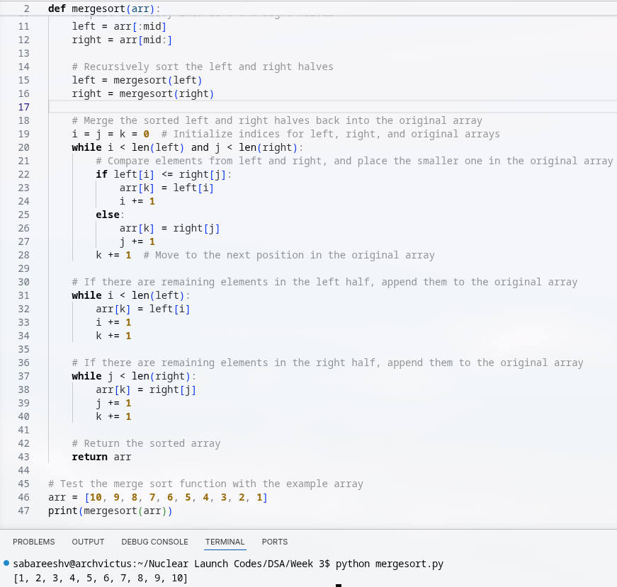

Explanation:
- Sorts a list using the merge sort algorithm.
- Recursively splits the list into smaller halves until single elements remain.
- Merges the smaller sorted parts back together in ascending order.
- Continues merging until the entire list is sorted.

Aim:
Code:
def quickSort(arr, low, high):
if low >= high:
return

pivot = arr[high]
i = low

for j in range(low, high):
if arr[j] <= pivot:
arr[i], arr[j] = arr[j], arr[i]
i += 1

arr[i], arr[high] = arr[high], arr[i]

quickSort(arr, low, i - 1)
quickSort(arr, i + 1, high)

return arr

arr = [10, 9, 8, 7, 6, 5, 4, 3, 2, 1]
print(quickSort(arr, 0, len(arr) - 1))

Output:
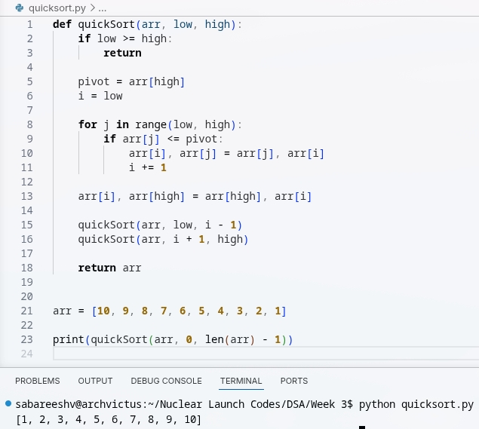

Explanation:
- Sorts a list using the quick sort algorithm.
- Selects a pivot and rearranges elements around it.
- Recursively sorts the elements on both sides of the pivot.

Aim:
Code:
def selectionsort(arr):
for i in range(0, len(arr)):
min_idx = i
for j in range(i + 1, len(arr)):
if arr[j] < arr[min_idx]:
min_idx = j
arr[min_idx], arr[i] = arr[i], arr[min_idx]
return arr

arr = [10, 9, 8, 7, 6, 5, 4, 3, 2, 1]
print(selectionsort(arr))

Output:
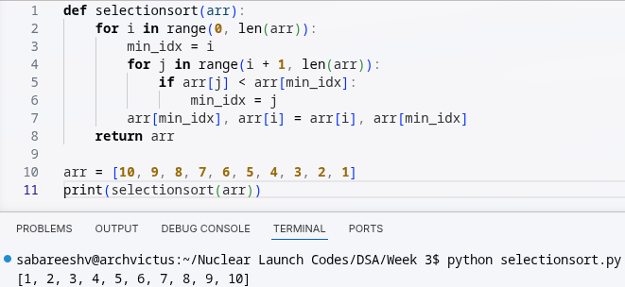
Explanation:
- Sorts a list in ascending order using selection sort.
- Finds the smallest element in the unsorted portion.
- Swaps it with the first element of that portion.

WEEK – 4
Aim: To implement the Linked List ADT in Python
Code:
node.py:
class Node:
def __init__(self, data):
self.data = data
self.next = None

linkedlist.py
from node import Node

class linkedlist:
def __init__(self):
self.head = None

deletion.py
from linkedlist import linkedlist
from node import Node

def deleteFromBeginning(self):
if self.head is not None:
self.head = self.head.next
else:
return

def deleteFromEnd(self):
if self.head is None:
return
elif self.head.next is None:
self.head = None
return
else:
temp = self.head
while temp.next.next is not None:
temp = temp.next
temp.next = None

def deleteAtIndex(self, index):
if self.head is None:
return

if index == 0:
self.head = self.head.next
return

temp = self.head

for i in range(index - 1):
if temp.next is None:
return
temp = temp.next

if temp.next is None:
return

temp.next = temp.next.next

linkedlist.deleteFromBeginning = deleteFromBeginning
linkedlist.deleteFromEnd = deleteFromEnd
linkedlist.deleteAtIndex = deleteAtIndex

insertion.py
from node import Node
from linkedlist import linkedlist
from traversal import count

def insertAtBeginning(self, data):
new = Node(data)
new.next = self.head
self.head = new

def insertAtEnd(self, data):
if self.head is None:
new = Node(data)
self.head = new
return
temp = self.head
while temp.next is not None:
temp = temp.next
new = Node(data)
temp.next = new
new.next = None

def insertAtIndex(self, index, data):
if index == 0:
self.insertAtBeginning(data)
return
elif index < 0 or index > self.count():
print("Invalid Index entered")
return
else:
new = Node(data)
temp = self.head
for i in range(0, index - 1):
temp = temp.next
new.next = temp.next
temp.next = new

linkedlist.insertAtBeginning = insertAtBeginning
linkedlist.insertAtEnd = insertAtEnd
linkedlist.insertAtIndex = insertAtIndex

traversal.py
from linkedlist import linkedlist

def displayElements(self):
temp = self.head

while temp:
print(temp.data, end=" --> ")
temp = temp.next

print("None")

def count(self):
temp = self.head
i = 0

while temp:
i += 1
temp = temp.next
return i

linkedlist.displayElements = display
linkedlist.count = count

main.py
from linkedlist import linkedlist

import insertion
import traversal
import deletion

print("----------------------------------- \n1) Create a linked list \n2) Insert at beginning \n3) Insert at end \n4) Insert at a specific index \n5) Delete by value \n6) Delete first node \n7) Delete last node \n8) Count number of nodes \n9) Display \n10) Exit")
choice = int(input("Enter your choice: "))

if choice == 1:
l1 = linkedlist()
l1.display

elif choice == 2:
data = int(input("Enter value to enter: "))
l1.insertAtBeginning(data)
l1.display()

elif choice == 3:
data = int(input("Enter value to enter: "))
l1.insertAtEnd(data)
l1.display()

elif choice == 4:
data = int(input("Enter value to enter: "))
value = int(input("Enter index to enter: "))
l1.insertAtIndex(value, data)
l1.display()

elif choice == 5:
value = int(input("Enter index to enter: "))
l1.deleteFromIndex(value)
l1.display()

elif choice == 6:
l1.deleteFromBeginning()
l1.display()

Output:
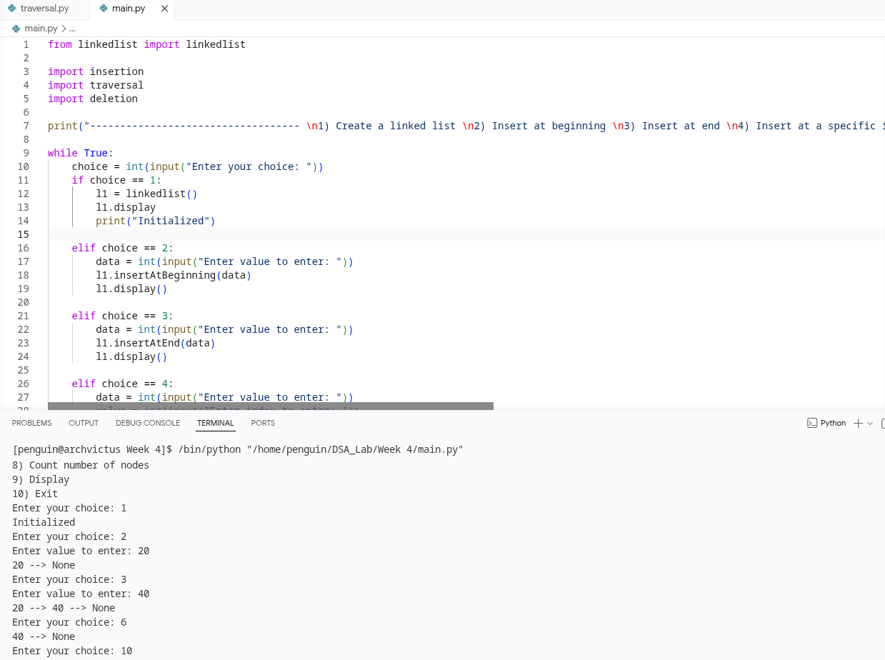

Explanation:
- Implements a singly linked list using separate Node and LinkedList classes.
- Supports inserting nodes at the beginning, end, or a specific index.
- Supports deleting nodes from the beginning, end, or a specific index.
- Traverses the list to display its elements and count the nodes.
- Uses a menu-driven program to let the user perform linked-list operations.

WEEK – 5
Aim: To implement the Stack ADT using Arrays in Python

Code:
class Stack:
def __init__(self, size):
self.size = size
self.stack = [None] * size
self.top = -1

def push(self, data):
if self.top < self.size - 1:
self.top += 1
self.stack[self.top] = data
print(data, "added to stack")
else:
print("Stack Overflow Err -- Stack is full")

def pop(self):
if self.top == -1:
print("Stack Underflow Err -- Stack is empty")
else:
store = self.stack[self.top]
self.stack[self.top] = None
self.top -= 1
print(store, "removed from stack")
return store

def peek(self):
if self.top == -1:
print("Stack is empty")
else:
print("Top element: ", self.stack[self.top])
return self.stack[self.top]

def display(self):
if self.top == -1:
print("Stack is empty")
else:
for i in range(self.top, -1, -1):
print(self.stack[i], end=" ")
print("")
return

print("---------------------------------------------------------------------")
stack_size = int(input("Initialize stack length: "))
print("Creating stack of length", stack_size)
s1 = Stack(stack_size)

print("1 -- Add to stack \n2 -- Remove from stack \n3 -- View top \n4 -- Display full stack \n5 -- Exit")

while True:
choice = int(input("Enter a choice: "))
if choice == 1:
data = int(input("Enter the number: "))
s1.push(data)
elif choice == 2:
s1.pop()
elif choice == 3:
s1.peek()
elif choice == 4:
s1.display()
elif choice == 5:
break
else:
print("Select a valid choice.")

Output:
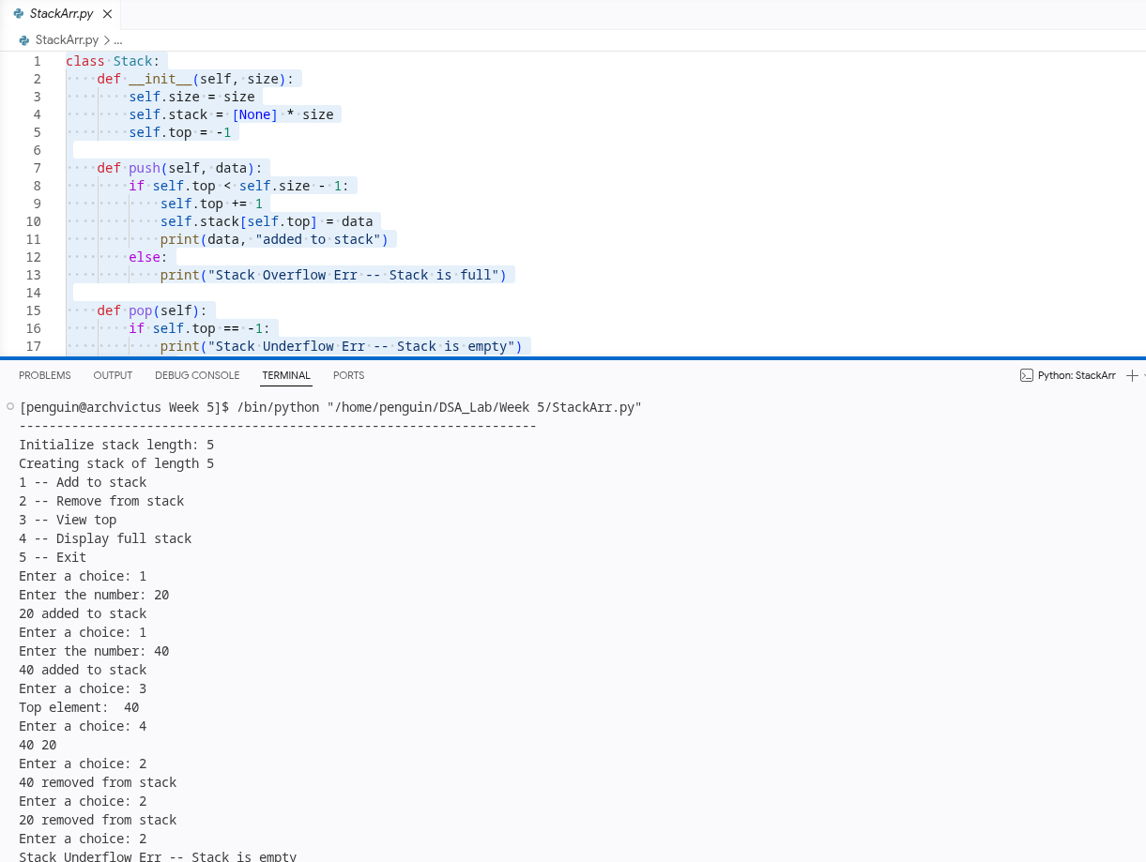
Explanation:
- Implements a stack using a fixed-size array and the LIFO principle.
- Supports adding, removing, viewing the top, and displaying stack elements.
- Handles stack overflow when full and underflow when empty.
- Uses a menu-driven loop to perform stack operations.

Aim: To implement the Stack ADT using Linked List in Python

Code:
class Node:
def __init__(self, data):
self.data = data
self.next = None

class Stack:
def __init__(self):
self.top = None

def push(self, data):
new_node = Node(data)
new_node.next = self.top
self.top = new_node
print(data, "added to stack")

def pop(self):
if self.top is None:
print("Stack Underflow Err -- Stack is empty")
else:
store = self.top.data
self.top = self.top.next
print(store, "removed from stack")
return store

def peek(self):
if self.top is None:
print("Stack is empty")
else:
print("Top element:", self.top.data)
return self.top.data

def display(self):
if self.top is None:
print("Stack is empty")
else:
current = self.top
while current is not None:
print(current.data, end=" ")
current = current.next
print()

print("---------------------------------------------------------------------")
print("Creating stack using linked list")
s1 = Stack()

print("1 -- Add to stack\n2 -- Remove from stack\n3 -- View top\n4 -- Display full stack\n5 -- Exit")

while True:
choice = int(input("Enter a choice: "))

if choice == 1:
data = int(input("Enter the number: "))
s1.push(data)

elif choice == 2:
s1.pop()

elif choice == 3:
s1.peek()

elif choice == 4:
s1.display()

elif choice == 5:
break

else:
print("Select a valid choice.")

Output:
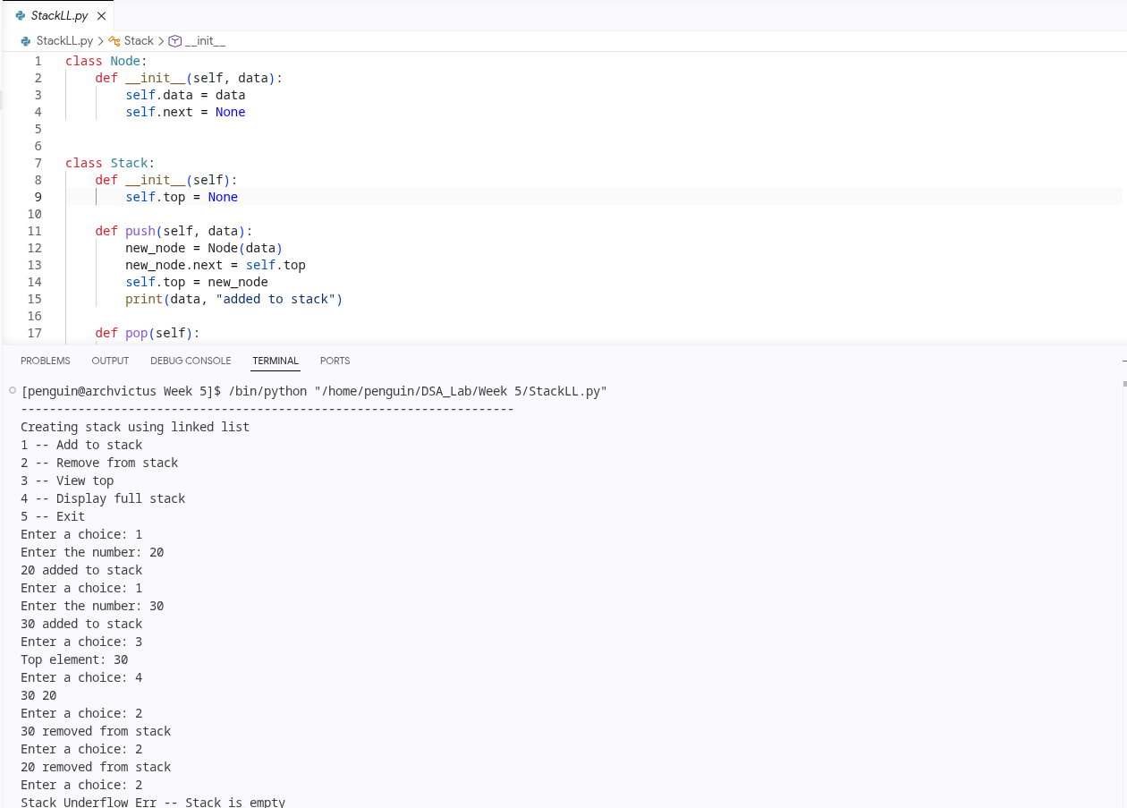
Explanation:
- Implements a stack using a linked list.
- Adds and removes nodes from the top, following the LIFO principle.
- Supports viewing the top element and displaying the stack contents.
- The stack grows dynamically without a predefined size limit.

WEEK – 6
Aim: Implement Queue ADT Using Arrays
Code:
class Queue:
def __init__(self, size):
self.size = size
self.queue = [None] * size
self.top = -1
self.rear = -1

def enqueue(self, data):
if self.rear < self.size - 1:
if self.rear == -1:
self.top = 0
self.rear = 0
self.queue[self.rear] = data
print(data, "Added to queue")
return
self.rear += 1
self.queue[self.rear] = data
print(data, "Added to queue")
else:
print("Queue overflow err - Queue is full")
return

def dequeue(self):
if self.rear == -1:
print("Underflow err -- Queue is empty")
else:
data = self.queue[self.top]
self.queue[self.top] = None
self.top += 1

def display(self):
if self.top == -1:
print("Queue is empty")
else:
for i in range(self.top, self.rear+1):
print(self.queue[i], end = " ")

q1 = Queue(5)
q1.enqueue(5)
q1.enqueue(10)
q1.enqueue(10)
q1.enqueue(10)
q1.dequeue()
q1.dequeue()
q1.display()

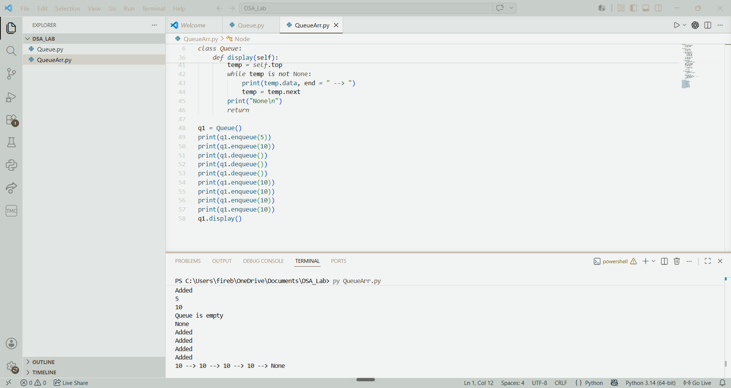

Explanation:
- Implements a queue using a fixed-size list.
- Adds elements at the rear and removes elements from the front, following the FIFO principle.
- Supports displaying the queue contents and handles queue overflow and underflow conditions.
- Uses top and rear pointers to track the front and rear positions of the queue.

Aim: Implement Queue ADT Using Linked Lists
Code:
class Node:
def __init__(self, data):
self.data = data
self.next = None

class Queue:
def __init__(self):
self.top = None
self.rear = None

def enqueue(self, data):
new = Node(data)
if self.rear == None:
self.top = new
self.rear = new
return("Added")

self.rear.next = new
self.rear = new
return("Added")

def dequeue(self):
if self.top == None:
print("Queue is empty")
return
store = self.top.data
temp = self.top.next
self.top.next = None
self.top = temp

if self.top == None:
self.rear = None

return store

def display(self):
if self.top == None:
print("Queue is empty")
return

temp = self.top
while temp is not None:
print(temp.data, end = " --> ")
temp = temp.next
print("None\n")
return

q1 = Queue()
print(q1.enqueue(5))
print(q1.enqueue(10))
print(q1.dequeue())
print(q1.dequeue())
print(q1.dequeue())
print(q1.enqueue(10))
print(q1.enqueue(10))
print(q1.enqueue(10))
print(q1.enqueue(10))
q1.display()

Output:
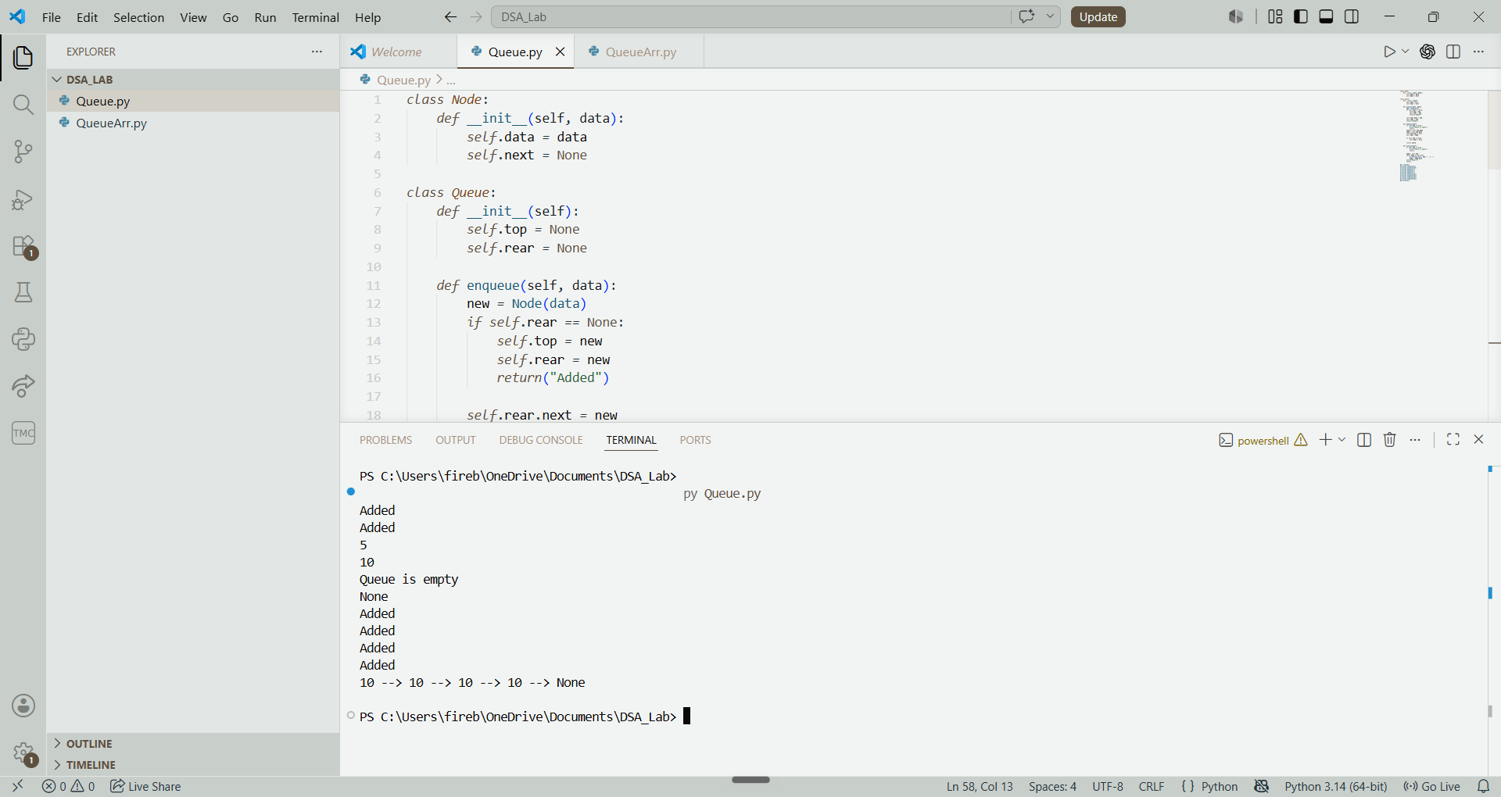

Explanation:
- Implements a queue using a linked list.
- Adds elements at the rear and removes elements from the front, following the FIFO principle.
- Supports displaying the queue contents and handles attempts to remove elements from an empty queue.
- Uses top and rear pointers to track the front and rear nodes of the queue.
- Grows dynamically without a predefined size limit.

Aim: To implement Circular Queue ADT Using Arrays
Code:
class CircularQueue:
def __init__(self, size):
self.size = size
self.queue = [None] * size
self.top = -1
self.rear = -1

def enqueue(self, data):
if (self.rear + 1) % self.size == self.top:
print("Queue overflow err - Queue is full")
return

if self.top == -1:
self.top = 0
self.rear = 0
else:
self.rear = (self.rear + 1) % self.size

self.queue[self.rear] = data
print(data, "Added to queue")

def dequeue(self):
if self.top == -1:
print("Underflow err -- Queue is empty")
return None

temp = self.queue[self.top]

if self.top == self.rear:
self.top = -1
self.rear = -1
else:
self.top = (self.top + 1) % self.size
return temp

def display(self):
if self.top == -1:
print("Queue is empty")
return

i = self.top
while True:
print(self.queue[i], end=" ")
if i == self.rear:
break
i = (i + 1) % self.size
print()
q1 = CircularQueue(5)
q1.enqueue(5)
q1.enqueue(10)
q1.enqueue(10)
q1.enqueue(10)
q1.enqueue(10)
q1.enqueue(10)
q1.dequeue()
q1.enqueue(8)
q1.display()

Output:
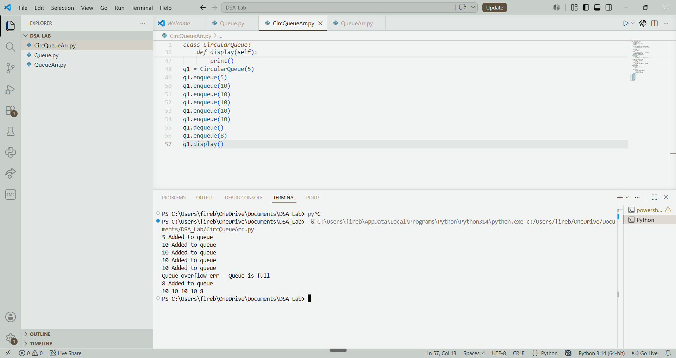

Explanation:

- Implements a circular queue using a fixed-size list.
- Adds elements at the rear and removes elements from the front, following the FIFO principle.
- Reuses empty spaces by wrapping the top and rear pointers to the beginning of the list.
- Supports displaying queue contents and handles overflow and underflow conditions.
- Efficiently utilises available space by connecting the end of the queue back to the beginning.

Aim: To Implement Circular Queue ADT Using Linked Lists
Code:
class Node:
def __init__(self, data):
self.data = data
self.next = None

class CircularQueue:
def __init__(self, size):
self.size = size
self.current_size = 0
self.front = None
self.rear = None

def enqueue(self, data):
if self.current_size == self.size:
print("Queue overflow err - Queue is full")
return

new_node = Node(data)

if self.front is None:
self.front = new_node
self.rear = new_node
self.rear.next = self.front
else:
self.rear.next = new_node
self.rear = new_node
self.rear.next = self.front

self.current_size += 1
print(data, "Added to queue")

def dequeue(self):
if self.front is None:
print("Underflow err -- Queue is empty")
return None

temp_data = self.front.data

if self.front == self.rear:
self.front = None
self.rear = None
else:
self.front = self.front.next
self.rear.next = self.front

self.current_size -= 1
return temp_data

def display(self):
if self.front is None:
print("Queue is empty")
return

temp = self.front
while True:
print(temp.data, end=" ")
temp = temp.next
if temp == self.front:
break
print()

q1 = CircularQueue(5)
q1.enqueue(5)
q1.enqueue(10)
q1.enqueue(10)
q1.enqueue(10)
q1.enqueue(10)
q1.enqueue(10)
q1.dequeue()
q1.enqueue(8)
q1.display()

Output:
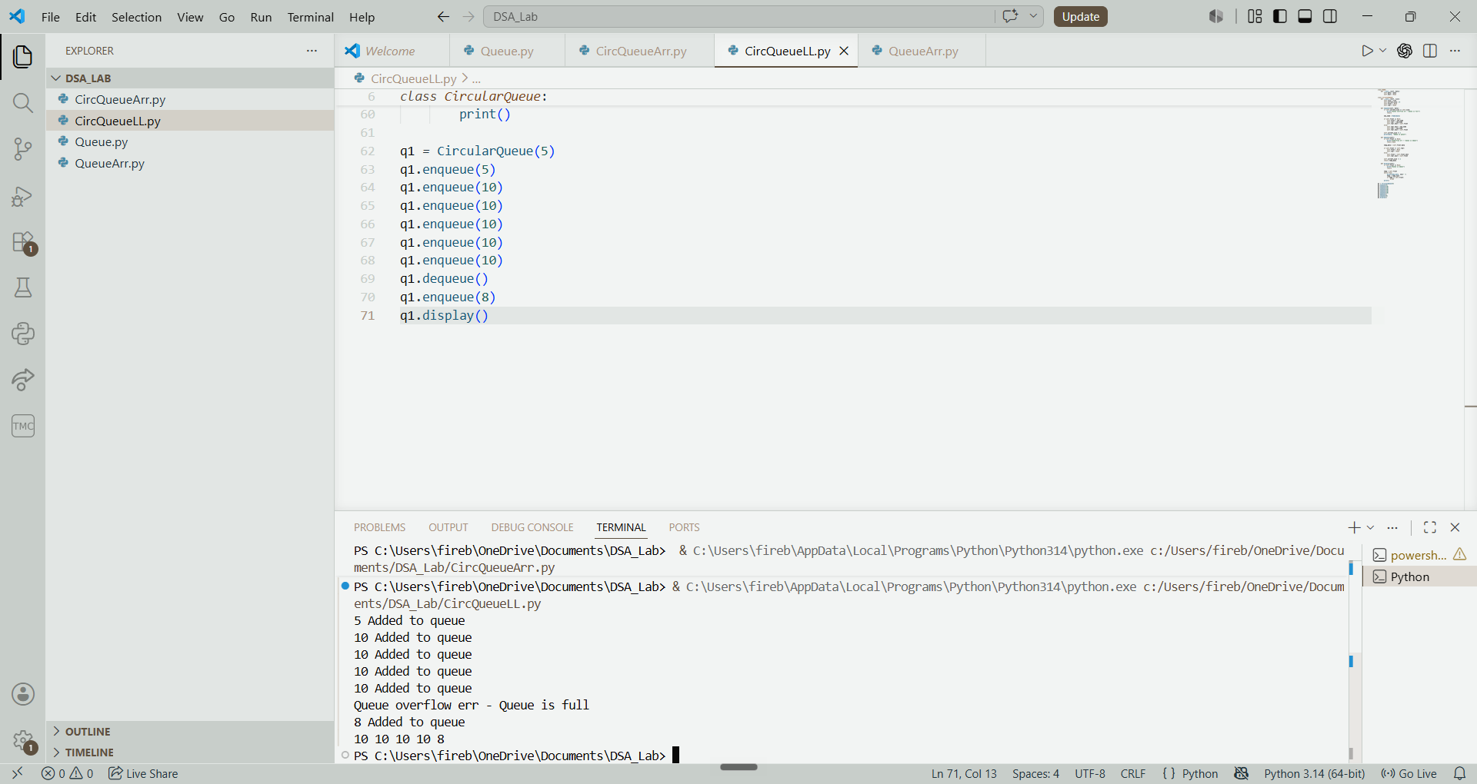

Explanation:
- Implements a circular queue using a linked list.
- Adds elements at the rear and removes elements from the front, following the FIFO principle.
- Connects the last node to the first node to maintain the circular structure.
- Tracks the current number of elements and handles queue overflow and underflow conditions.
- Supports displaying queue contents and efficiently manages elements within a predefined size limit.

WEEK – 7
Aim: To implement Binary Tree Using Arrays
Code:
class BinaryTree:
def __init__(self):
self.tree = [None] * 20

def insert(self, value):
for i in range(len(self.tree)):
if self.tree[i] == None:
if i == 0 or self.tree[(i - 1) // 2] != None:
self.tree[i] = value
print(value, "Added to tree")
return

print("Tree is full")

def insert_left(self, value, parentIndex):
if parentIndex < 0 or parentIndex >= len(self.tree) or self.tree[parentIndex] == None:
print("Invalid parent")
return

left_index = 2 * parentIndex + 1

if left_index >= len(self.tree):
self.tree.extend([None] * (left_index - len(self.tree) + 1))

self.tree[left_index] = value
print(value, "Added to left")

def insert_right(self, value, parentIndex):
if parentIndex < 0 or parentIndex >= len(self.tree) or self.tree[parentIndex] == None:
print("Invalid parent")
return

right_index = 2 * parentIndex + 2

if right_index >= len(self.tree):
self.tree.extend([None] * (right_index - len(self.tree) + 1))

self.tree[right_index] = value
print(value, "Added to right")

def remove_index(self, index):
if index < 0 or index >= len(self.tree) or self.tree[index] == None:
print("Invalid index")
return

self.tree[index] = None
print("Node removed")

def traverse_inorder(self, index=0):
if index < len(self.tree) and self.tree[index] != None:
self.traverse_inorder(2 * index + 1)
print(self.tree[index], end=" ")
self.traverse_inorder(2 * index + 2)

def traverse_preorder(self, index=0):
if index < len(self.tree) and self.tree[index] != None:
print(self.tree[index], end=" ")
self.traverse_preorder(2 * index + 1)
self.traverse_preorder(2 * index + 2)

def traverse_postorder(self, index=0):
if index < len(self.tree) and self.tree[index] != None:
self.traverse_postorder(2 * index + 1)
self.traverse_postorder(2 * index + 2)
print(self.tree[index], end=" ")

b = BinaryTree()

b.insert(10)
b.insert_left(20, 0)
b.insert_right(30, 0)
b.insert_left(40, 1)
b.insert_right(50, 1)

print("Inorder Traversal:")
b.traverse_inorder()
print()

print("Preorder Traversal:")
b.traverse_preorder()
print()

print("Postorder Traversal:")
b.traverse_postorder()
print()

b.remove_index(4)

print("After removing:")
b.traverse_inorder()
print()
Output:
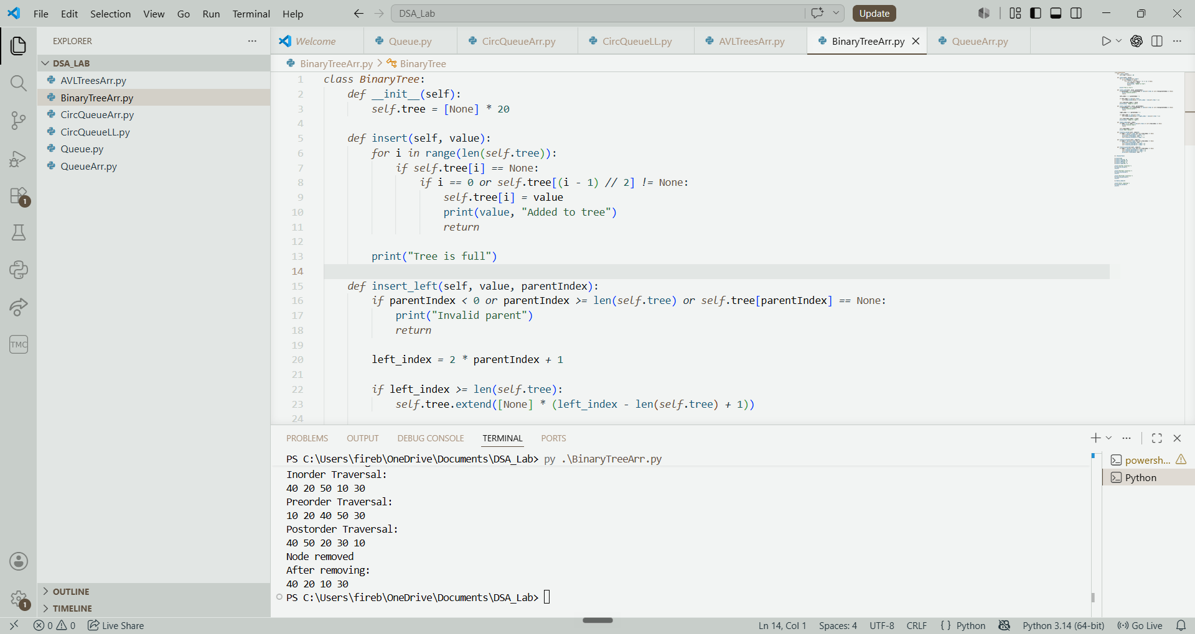

Explanation:
- Implements a Binary Tree using an array to store node values.
- Supports inserting root, left child and right child nodes using array indices.
- Allows removing nodes using their respective array positions.
- Supports inorder, preorder and postorder tree traversals.
- Uses parent and child index calculations to maintain the binary tree structure.
- Expands the array dynamically when additional space is required.

Aim: To implement Binary Tree Using Linked Lists
Code:
class Node:
def __init__(self, value):
self.value = value
self.left = None
self.right = None

class BinaryTree:
def __init__(self):
self.root = None

def insert_root(self, value):
if self.root is None:
self.root = Node(value)
print(value, "Added as root")
else:
print("Root already exists")

def find_node(self, value):
if self.root is None:
return None

queue = [self.root]

while queue:
current = queue.pop(0)

if current.value == value:
return current

if current.left is not None:
queue.append(current.left)

if current.right is not None:
queue.append(current.right)

return None

def insert_left(self, value, parentValue):
parent = self.find_node(parentValue)

if parent is None:
print("Invalid parent")
return

if parent.left is not None:
print("Left child already exists")
return

parent.left = Node(value)
print(value, "Added to left")

def insert_right(self, value, parentValue):
parent = self.find_node(parentValue)

if parent is None:
print("Invalid parent")
return

if parent.right is not None:
print("Right child already exists")
return

parent.right = Node(value)
print(value, "Added to right")

def remove(self, value):
if self.root is None:
print("Tree is empty")
return

if self.root.value == value:
self.root = None
print("Node removed")
return

queue = [(self.root, None)]

while queue:
current, parent = queue.pop(0)

if current.value == value:
if parent.left == current:
parent.left = None
else:
parent.right = None

print("Node removed")
return

if current.left is not None:
queue.append((current.left, current))

if current.right is not None:
queue.append((current.right, current))

print("Value not found")

def traverse_inorder(self, node):
if node is not None:
self.traverse_inorder(node.left)
print(node.value, end=" ")
self.traverse_inorder(node.right)

def traverse_preorder(self, node):
if node is not None:
print(node.value, end=" ")
self.traverse_preorder(node.left)
self.traverse_preorder(node.right)

def traverse_postorder(self, node):
if node is not None:
self.traverse_postorder(node.left)
self.traverse_postorder(node.right)
print(node.value, end=" ")

b = BinaryTree()

b.insert_root(10)
b.insert_left(20, 10)
b.insert_right(30, 10)
b.insert_left(40, 20)
b.insert_right(50, 20)

print("Inorder Traversal:")
b.traverse_inorder(b.root)
print()

print("Preorder Traversal:")
b.traverse_preorder(b.root)
print()

print("Postorder Traversal:")
b.traverse_postorder(b.root)
print()

b.remove(20)

print("After removing:")
b.traverse_inorder(b.root)
print()

Output:
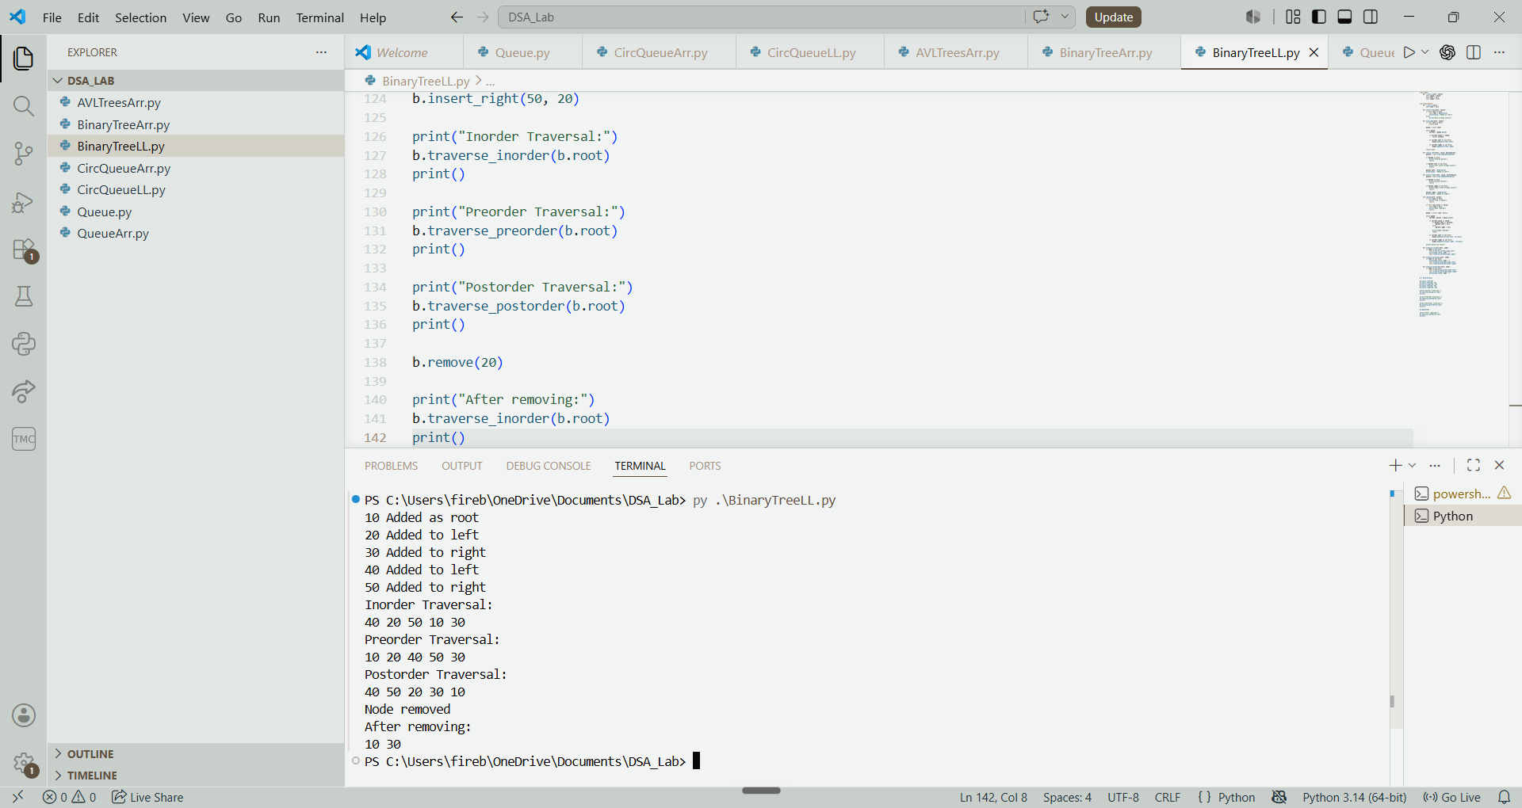

Explanation:
- Implements a Binary Tree using a linked list with dynamically created nodes.
- Supports inserting a root node, left child and right child.
- Uses level-order searching to locate parent nodes.
- Supports removing nodes from the tree.
- Performs inorder, preorder and postorder traversals.
- Uses pointers to connect parent nodes with their left and right children.

WEEK – 8
Aim: To Implement Binary Search Trees
Code:
class Node:
def __init__(self, value):
self.value = value
self.left = None
self.right = None

class BinarySearchTree:
def __init__(self):
self.root = None

def insert(self, data):
new = Node(data)

if self.root is None:
self.root = new
print(data, "Added to tree")
return

temp = self.root

while True:
if data == temp.value:
print("Duplicate value")
return

if data < temp.value:
if temp.left is None:
temp.left = new
print(data, "Added to tree")
return
temp = temp.left

else:
if temp.right is None:
temp.right = new
print(data, "Added to tree")
return
temp = temp.right

def search(self, data):
temp = self.root

while temp is not None:
if temp.value == data:
return True

if data < temp.value:
temp = temp.left
else:
temp = temp.right

return False

def delete_node(self, root, data):
if root is None:
return None

if data < root.value:
root.left = self.delete_node(root.left, data)

elif data > root.value:
root.right = self.delete_node(root.right, data)

else:
if root.left is None:
return root.right

if root.right is None:
return root.left

temp = root.right

while temp.left is not None:
temp = temp.left

root.value = temp.value
root.right = self.delete_node(root.right, temp.value)

return root

def delete(self, data):
if self.search(data) == False:
print("Value not found")
return

self.root = self.delete_node(self.root, data)
print(data, "Removed from tree")

def display_inorder(self, node):
if node is not None:
self.display_inorder(node.left)
print(node.value, end=" ")
self.display_inorder(node.right)

def display(self):
if self.root is None:
print("Tree is empty")
return

self.display_inorder(self.root)
print()

b = BinarySearchTree()

b.insert(50)
b.insert(30)
b.insert(70)
b.insert(20)
b.insert(40)
b.insert(60)
b.insert(80)

print("Inorder Traversal:")
b.display()

print("Search 40:", b.search(40))

b.delete(30)

print("After deleting:")
b.display()

Output:
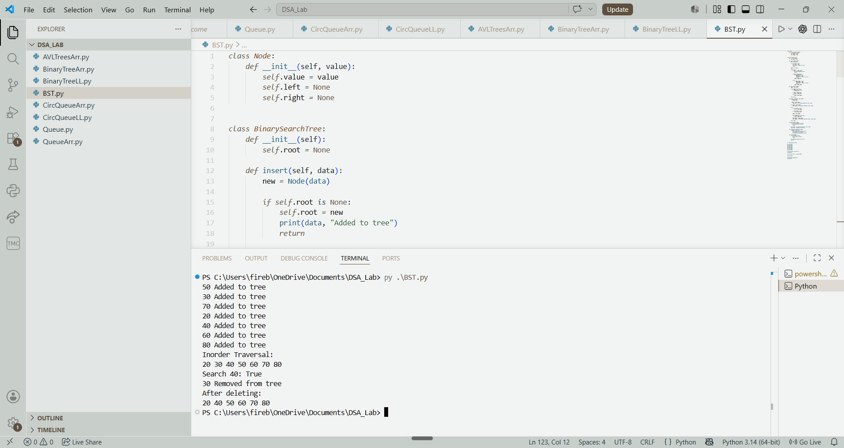

Explanation:
- Implements a Binary Search Tree (BST) using a linked list.
- Inserts elements according to BST rules, with smaller values on the left and larger values on the right.
- Supports searching for a specific element in the tree.
- Allows deleting nodes with zero, one or two children.
- Maintains the BST structure after insertion and deletion.
- Displays the tree elements using inorder traversal.

WEEK – 9
Aim: To Implement AVL Trees Using Arrays
Code:
class AVLTree:
def __init__(self, size):
self.size = size
self.data = [None] * size
self.left = [-1] * size
self.right = [-1] * size
self.height = [0] * size
self.root = -1
self.count = 0

def get_height(self, index):
if index == -1:
return 0
return self.height[index]

def get_balance(self, index):
if index == -1:
return 0
return self.get_height(self.left[index]) - self.get_height(self.right[index])

def rotate_right(self, y):
x = self.left[y]
temp = self.right[x]

self.right[x] = y
self.left[y] = temp

self.height[y] = 1 + max(self.get_height(self.left[y]), self.get_height(self.right[y]))
self.height[x] = 1 + max(self.get_height(self.left[x]), self.get_height(self.right[x]))

return x

def rotate_left(self, x):
y = self.right[x]
temp = self.left[y]

self.left[y] = x
self.right[x] = temp

self.height[x] = 1 + max(self.get_height(self.left[x]), self.get_height(self.right[x]))
self.height[y] = 1 + max(self.get_height(self.left[y]), self.get_height(self.right[y]))

return y

def insert_node(self, index, data):
if index == -1:
if self.count == self.size:
print("Tree overflow err - Tree is full")
return -1

index = self.count
self.data[index] = data
self.left[index] = -1
self.right[index] = -1
self.height[index] = 1
self.count += 1
return index

if data < self.data[index]:
self.left[index] = self.insert_node(self.left[index], data)
elif data > self.data[index]:
self.right[index] = self.insert_node(self.right[index], data)
else:
print("Duplicate values are not allowed")
return index

self.height[index] = 1 + max(
self.get_height(self.left[index]),
self.get_height(self.right[index])
)

balance = self.get_balance(index)

if balance > 1 and data < self.data[self.left[index]]:
return self.rotate_right(index)

if balance < -1 and data > self.data[self.right[index]]:
return self.rotate_left(index)

if balance > 1 and data > self.data[self.left[index]]:
self.left[index] = self.rotate_left(self.left[index])
return self.rotate_right(index)

if balance < -1 and data < self.data[self.right[index]]:
self.right[index] = self.rotate_right(self.right[index])
return self.rotate_left(index)

return index

def insert(self, data):
self.root = self.insert_node(self.root, data)

def display(self, index=None):
if index is None:
index = self.root

if index == -1:
print("Tree is empty")
return

print(self.data[index], end=" ")

if self.left[index] != -1:
self.display(self.left[index])

if self.right[index] != -1:
self.display(self.right[index])

tree = AVLTree(10)

tree.insert(30)
tree.insert(20)
tree.insert(40)
tree.insert(10)
tree.insert(25)

print("AVL Tree elements:")
tree.display()
Output:
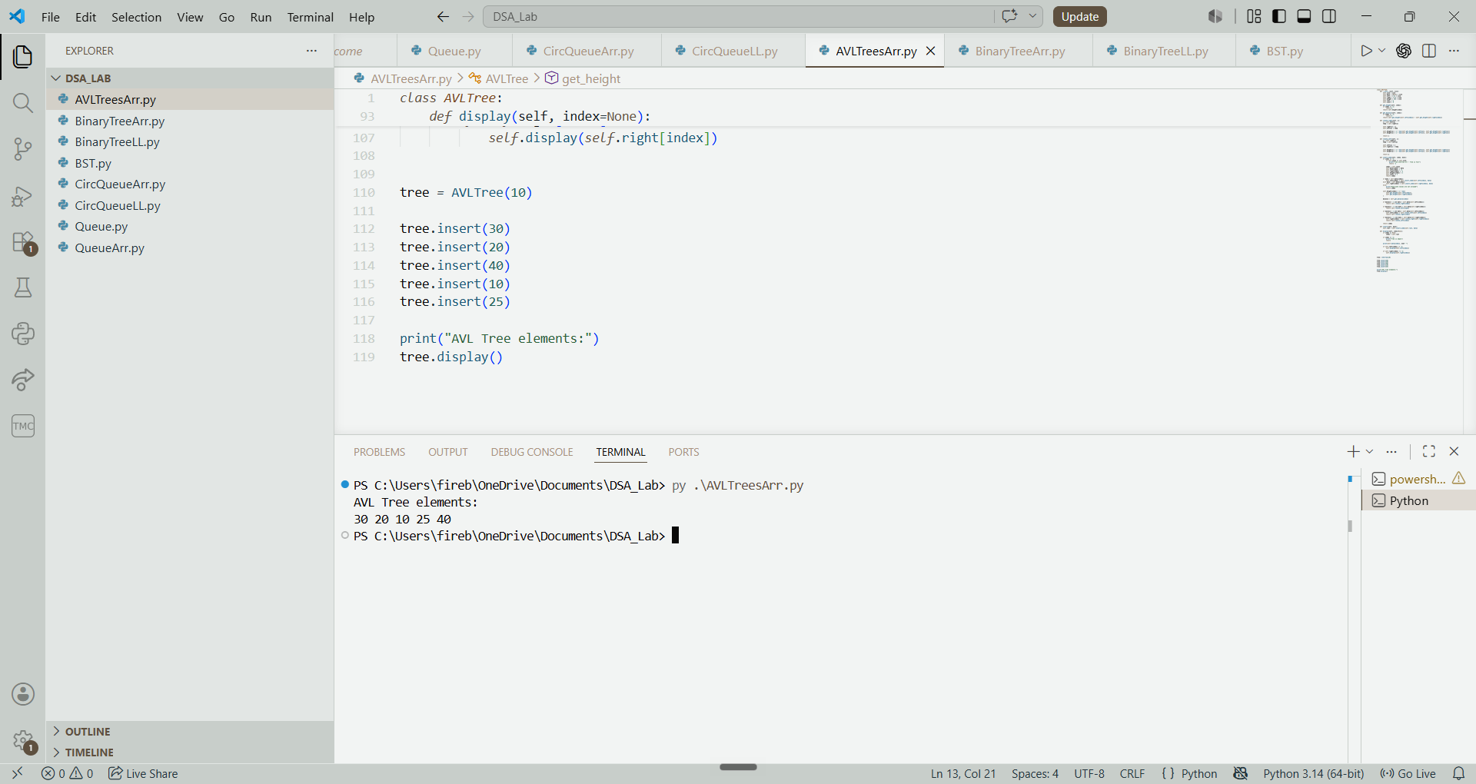

Explanation:
- Implements an AVL Tree using arrays to store node values, left and right child positions, and heights.
- Inserts elements according to Binary Search Tree rules.
- Calculates balance factors to check whether the tree is balanced.
- Performs LL, RR, LR and RL rotations to maintain tree balance.
- Supports searching for elements in the tree.
- Displays the tree elements using preorder traversal.
- Maintains a balanced tree after every insertion.

