

DATA STRUCTURES AND ALGORITHMS
23CSE203
LAB MANUAL

Submitted By
NAME | SABAREESH V
ROLL NO. | AV.SC.U4CSE25046
YEAR/SEM/SECTION | 2nd/3rd/CSE-A
Credits | 5

Submitted to | Dr. Raj Kumar Batchu
Designation | Asst. Professor (Sl. Grade)
Department | School of Computing

WEEK – 1
Aim:
Code:
def launch_rocket(count):
if count >= 1:
print(count)
launch_rocket(count - 1)

launch_rocket(10)
print('🚀🚀🚀')

Output:
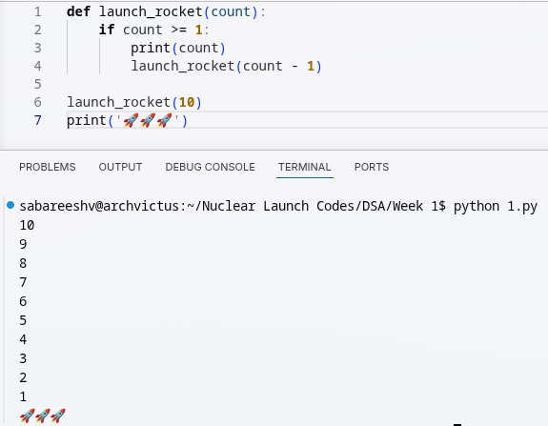

Explanation:
- Counts down from 10 to 1 using recursion.
- Each call prints the current number, then calls itself with one less.
- Stops when the count reaches 0.
- Prints the rocket emojis after the countdown completes.

Aim:
Code:
def power(p,n):
if n==0:
return 1
else:
return p*power(p,n-1)
print(power(4,5))

Output:
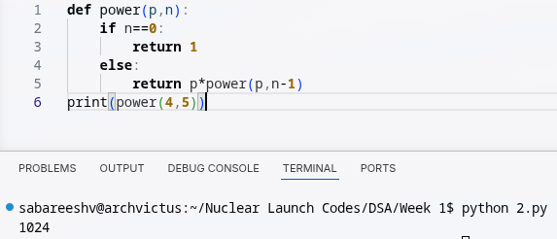
Explanation:
- Calculates p raised to the power n using recursion.
- Multiplies p by the result of power(p, n-1) until n reaches 0.
- Returns 1 at n == 0.

Aim:
Code:
def search(emp):
i=int(input('Enter employee ID: '))
for n in range(len(emp)):
if emp[n]==i:
print('employee found at index:',n)
break
else:
print('no such id exist')
emp=[101,102,103,104,105,106,107,108,109]
search(emp)

Output:
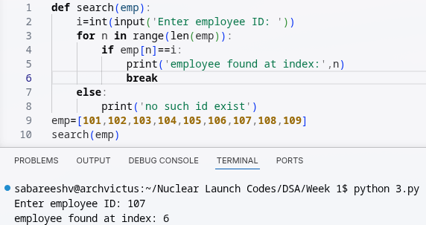

Explanation:
- Searches for an employee ID in a list of employee IDs.
- Takes the ID as input and checks each list element for a match.
- Prints the index if the employee is found.
- Prints a message if no matching ID exists.

Aim:
Code:
def fib(n):
if n <= 1:
return n
return fib(n - 1) + fib(n - 2)

n = 20
print("Fibonacci series: ")
for i in range(n):
print(fib(i), end=" ")
print("")

Output:
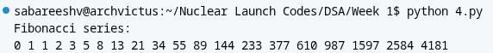
Explanation:
- Generates the first 20 Fibonacci numbers using recursion.
- Each number is calculated by adding the previous two numbers.
- Prints the sequence from the 0th to the 19th Fibonacci number.

Aim:
Code:
def fact(n):
if n==0:
return 1
else:
return n*fact(n-1)
print(fact(5))

Output:
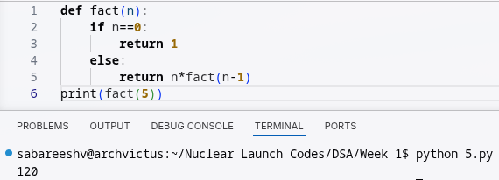
Explanation:
- Calculates the factorial of a number using recursion.
- Multiplies n by the factorial of n-1 until n reaches 0.
- Prints the factorial of 5, which is 120.

WEEK – 2
Aim:
Code:
def linearsearch(arr, key):
for i in range(0, len(arr)):
if arr[i] == key:
return i
return -1
arr = [1, 2, 3, 4, 5, 6, 7, 8, 9, 10]
print(linearsearch(arr, 9))

Output:
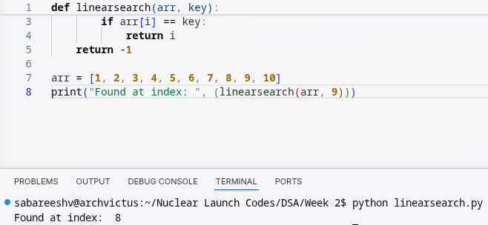
Explanation:
- Searches for a given value in a list using linear search.
- Checks each element one by one until the value is found.
- Returns its index, or -1 if the value is not present.

Aim:
Code:
def binsearch(arr, key):
low = 0
high = len(arr)-1
while low <= high:
mid = low + (high - low) // 2
if key == arr[mid]:
return mid
elif key > arr[mid]:
low = mid + 1
else:
high = mid - 1
return - 1

arr = [10, 9, 8, 7, 6, 5, 4, 3, 2, 1]

arr.sort()
print(binsearch(arr, 2))

Output:
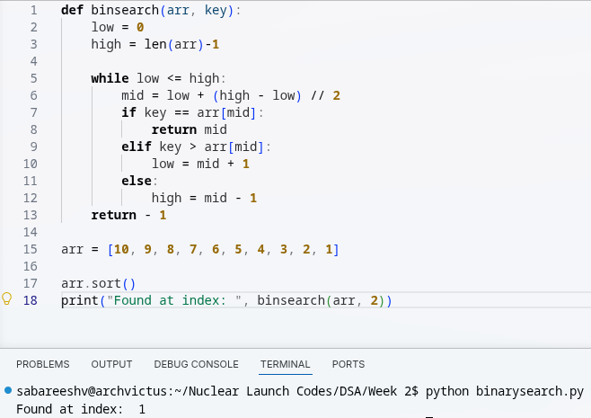

Explanation:
- Performs a binary search on a sorted list to find a target value.
- Repeatedly checks the middle element and narrows the search range.
- Returns the target's position, or `-1` if it is not found.

WEEK – 3
Aim:
Code:
def bubbleSort(arr):
n = len(arr)
for i in range(n):
swap = False

for j in range(0, n-i-1):

if arr[j] > arr[j+1]:
arr[j], arr[j+1] = arr[j+1], arr[j]
swap = True
if (swap == False):
break
return arr

arr = [10, 9, 8, 7, 6, 5, 4, 3, 2, 1]
print(bubbleSort(arr))

Output:
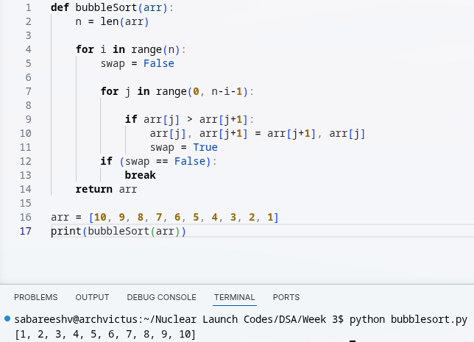
Explanation:
- Sorts a list in ascending order using bubble sort.
- Repeatedly compares adjacent elements and swaps them when they are out of order.
- Stops early if a complete pass makes no swaps.

Aim:
Code:
def insertionsort(arr):
for i in range(1, len(arr)):
key = arr[i]
j = i - 1
while j >= 0 and key < arr[j]:
arr[j + 1] = arr[j]
j -= 1
arr[j+1] = key
return arr

arr = [10, 9, 8, 7, 6, 5, 4, 3, 2, 1]
print(insertionsort(arr))

Output:
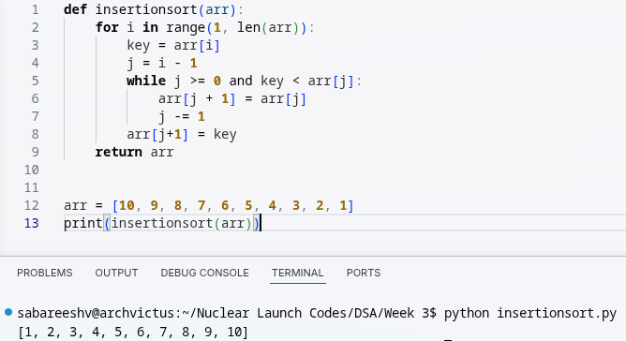

Explanation:
- Sorts a list in ascending order using insertion sort.
- Takes each element and inserts it into its correct position among the previous elements.
- Shifts larger elements to make space for the selected element.

Aim:
Code:
# Define a function to implement the merge sort algorithm
def mergesort(arr):
# Base case: if the array has 1 or 0 elements, it is already sorted
if len(arr) <= 1:
return arr
# Find the middle index of the array to split it into two halves
mid = len(arr) // 2
# Split the array into left and right halves
left = arr[:mid]
right = arr[mid:]

# Recursively sort the left and right halves
left = mergesort(left)
right = mergesort(right)

# Merge the sorted left and right halves back into the original array
i = j = k = 0 # Initialize indices for left, right, and original arrays
while i < len(left) and j < len(right):
# Compare elements from left and right, and place the smaller one in the original array
if left[i] <= right[j]:
arr[k] = left[i]
i += 1
else:
arr[k] = right[j]
j += 1
k += 1 # Move to the next position in the original array

# If there are remaining elements in the left half, append them to the original array
while i < len(left):
arr[k] = left[i]
i += 1
k += 1
# If there are remaining elements in the right half, append them to the original array
while j < len(right):
arr[k] = right[j]
j += 1
k += 1
# Return the sorted array
return arr

# Test the merge sort function with the example array
arr = [10, 9, 8, 7, 6, 5, 4, 3, 2, 1]
print(mergesort(arr))

Output:
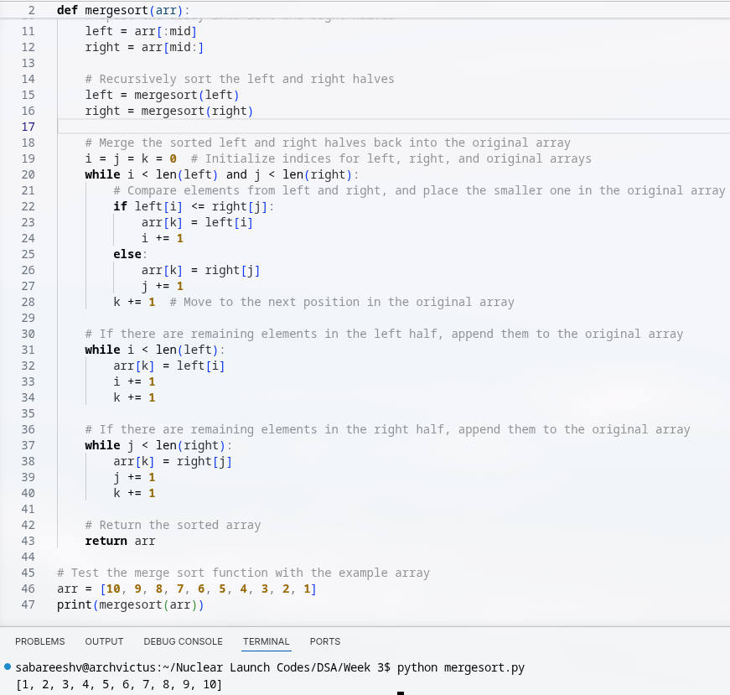
Explanation:
- Sorts a list using the merge sort algorithm.
- Recursively splits the list into smaller halves until single elements remain.
- Merges the smaller sorted parts back together in ascending order.
- Continues merging until the entire list is sorted.

Aim:
Code:
def quickSort(arr, low, high):
if low >= high:
return

pivot = arr[high]
i = low

for j in range(low, high):
if arr[j] <= pivot:
arr[i], arr[j] = arr[j], arr[i]
i += 1

arr[i], arr[high] = arr[high], arr[i]

quickSort(arr, low, i - 1)
quickSort(arr, i + 1, high)

return arr

arr = [10, 9, 8, 7, 6, 5, 4, 3, 2, 1]
print(quickSort(arr, 0, len(arr) - 1))

Output:
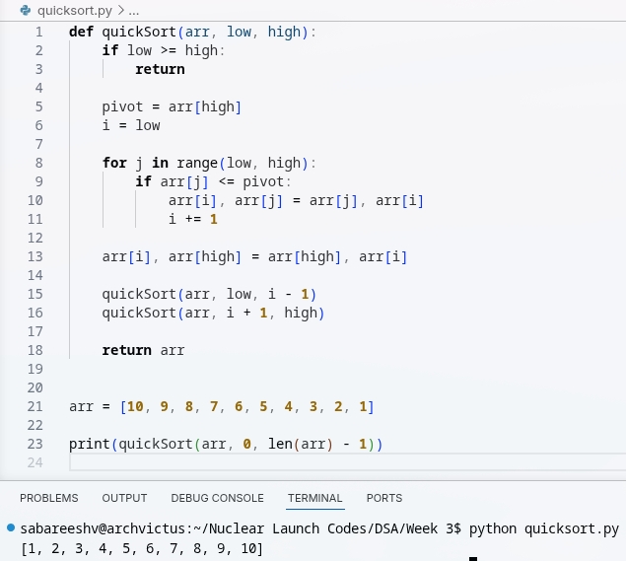

Explanation:
- Sorts a list using the quick sort algorithm.
- Selects a pivot and rearranges elements around it.
- Recursively sorts the elements on both sides of the pivot.

Aim:
Code:
def selectionsort(arr):
for i in range(0, len(arr)):
min_idx = i
for j in range(i + 1, len(arr)):
if arr[j] < arr[min_idx]:
min_idx = j
arr[min_idx], arr[i] = arr[i], arr[min_idx]
return arr

arr = [10, 9, 8, 7, 6, 5, 4, 3, 2, 1]
print(selectionsort(arr))

Output:
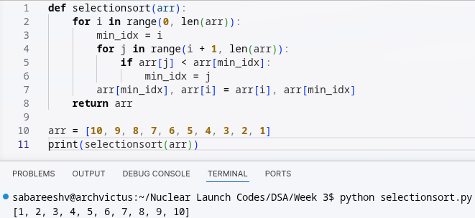
Explanation:
- Sorts a list in ascending order using selection sort.
- Finds the smallest element in the unsorted portion.
- Swaps it with the first element of that portion.

WEEK – 4
Aim: To implement the Linked List ADT in Python
Code:
node.py:
class Node:
def __init__(self, data):
self.data = data
self.next = None

linkedlist.py
from node import Node

class linkedlist:
def __init__(self):
self.head = None

deletion.py
from linkedlist import linkedlist
from node import Node

def deleteFromBeginning(self):
if self.head is not None:
self.head = self.head.next
else:
return

def deleteFromEnd(self):
if self.head is None:
return
elif self.head.next is None:
self.head = None
return
else:
temp = self.head
while temp.next.next is not None:
temp = temp.next
temp.next = None

def deleteAtIndex(self, index):
if self.head is None:
return

if index == 0:
self.head = self.head.next
return

temp = self.head

for i in range(index - 1):
if temp.next is None:
return
temp = temp.next

if temp.next is None:
return

temp.next = temp.next.next

linkedlist.deleteFromBeginning = deleteFromBeginning
linkedlist.deleteFromEnd = deleteFromEnd
linkedlist.deleteAtIndex = deleteAtIndex

insertion.py
from node import Node
from linkedlist import linkedlist
from traversal import count

def insertAtBeginning(self, data):
new = Node(data)
new.next = self.head
self.head = new

def insertAtEnd(self, data):
if self.head is None:
new = Node(data)
self.head = new
return
temp = self.head
while temp.next is not None:
temp = temp.next
new = Node(data)
temp.next = new
new.next = None

def insertAtIndex(self, index, data):
if index == 0:
self.insertAtBeginning(data)
return
elif index < 0 or index > self.count():
print("Invalid Index entered")
return
else:
new = Node(data)
temp = self.head
for i in range(0, index - 1):
temp = temp.next
new.next = temp.next
temp.next = new

linkedlist.insertAtBeginning = insertAtBeginning
linkedlist.insertAtEnd = insertAtEnd
linkedlist.insertAtIndex = insertAtIndex

traversal.py
from linkedlist import linkedlist

def displayElements(self):
temp = self.head

while temp:
print(temp.data, end=" --> ")
temp = temp.next

print("None")

def count(self):
temp = self.head
i = 0

while temp:
i += 1
temp = temp.next
return i

linkedlist.displayElements = display
linkedlist.count = count

main.py
from linkedlist import linkedlist

import insertion
import traversal
import deletion

print("----------------------------------- \n1) Create a linked list \n2) Insert at beginning \n3) Insert at end \n4) Insert at a specific index \n5) Delete by value \n6) Delete first node \n7) Delete last node \n8) Count number of nodes \n9) Display \n10) Exit")
choice = int(input("Enter your choice: "))

if choice == 1:
l1 = linkedlist()
l1.display

elif choice == 2:
data = int(input("Enter value to enter: "))
l1.insertAtBeginning(data)
l1.display()

elif choice == 3:
data = int(input("Enter value to enter: "))
l1.insertAtEnd(data)
l1.display()

elif choice == 4:
data = int(input("Enter value to enter: "))
value = int(input("Enter index to enter: "))
l1.insertAtIndex(value, data)
l1.display()

elif choice == 5:
value = int(input("Enter index to enter: "))
l1.deleteFromIndex(value)
l1.display()

elif choice == 6:
l1.deleteFromBeginning()
l1.display()

Output:
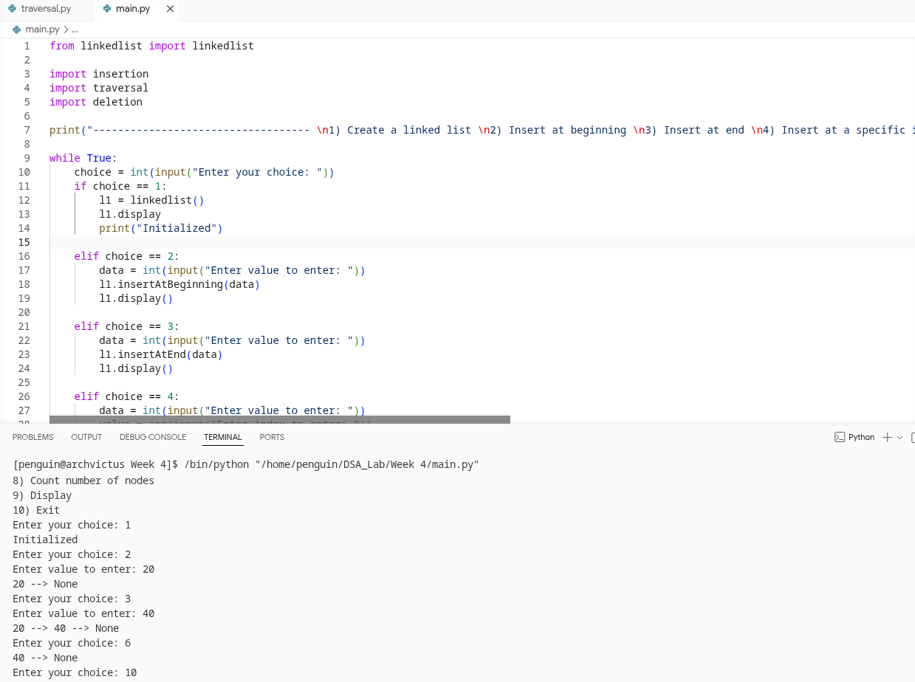

Explanation:
- Implements a singly linked list using separate Node and LinkedList classes.
- Supports inserting nodes at the beginning, end, or a specific index.
- Supports deleting nodes from the beginning, end, or a specific index.
- Traverses the list to display its elements and count the nodes.
- Uses a menu-driven program to let the user perform linked-list operations.

WEEK – 5
Aim: To implement the Stack ADT using Arrays in Python

Code:
class Stack:
def __init__(self, size):
self.size = size
self.stack = [None] * size
self.top = -1

def push(self, data):
if self.top < self.size - 1:
self.top += 1
self.stack[self.top] = data
print(data, "added to stack")
else:
print("Stack Overflow Err -- Stack is full")

def pop(self):
if self.top == -1:
print("Stack Underflow Err -- Stack is empty")
else:
store = self.stack[self.top]
self.stack[self.top] = None
self.top -= 1
print(store, "removed from stack")
return store

def peek(self):
if self.top == -1:
print("Stack is empty")
else:
print("Top element: ", self.stack[self.top])
return self.stack[self.top]

def display(self):
if self.top == -1:
print("Stack is empty")
else:
for i in range(self.top, -1, -1):
print(self.stack[i], end=" ")
print("")
return

print("---------------------------------------------------------------------")
stack_size = int(input("Initialize stack length: "))
print("Creating stack of length", stack_size)
s1 = Stack(stack_size)

print("1 -- Add to stack \n2 -- Remove from stack \n3 -- View top \n4 -- Display full stack \n5 -- Exit")

while True:
choice = int(input("Enter a choice: "))
if choice == 1:
data = int(input("Enter the number: "))
s1.push(data)
elif choice == 2:
s1.pop()
elif choice == 3:
s1.peek()
elif choice == 4:
s1.display()
elif choice == 5:
break
else:
print("Select a valid choice.")

Output:
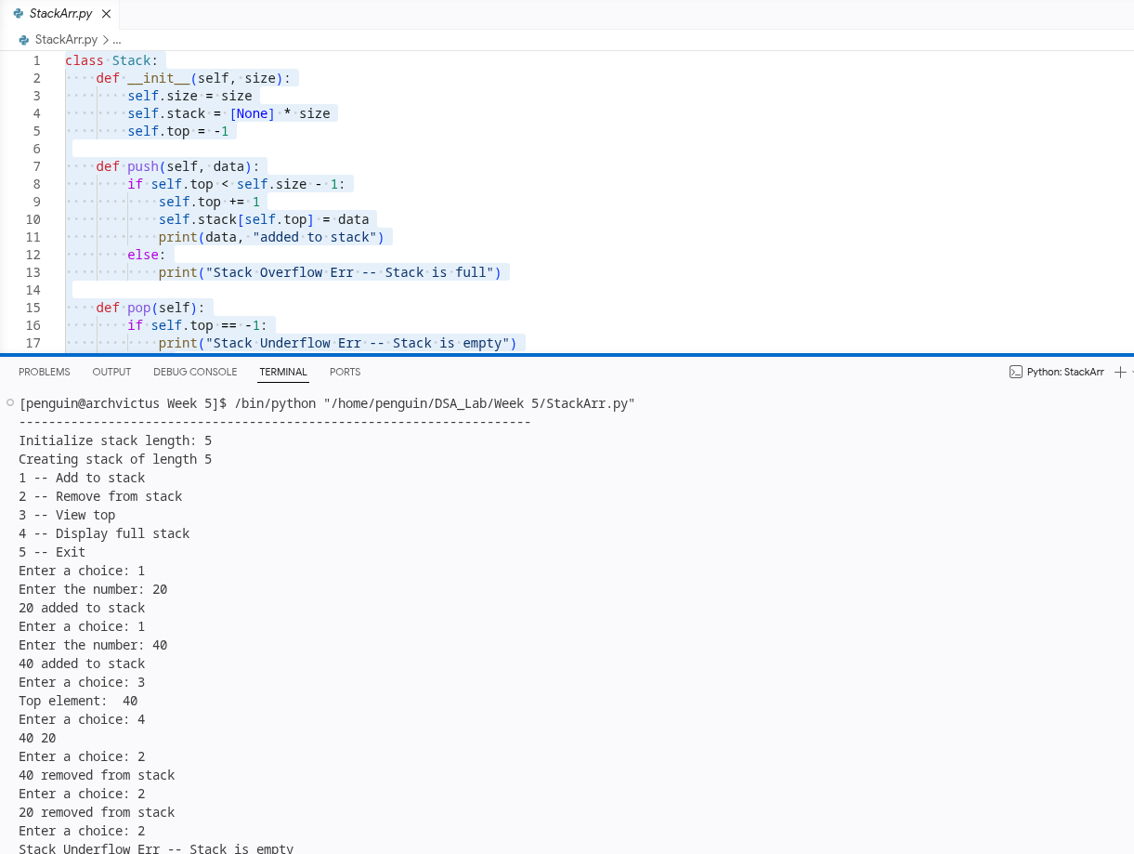
Explanation:
- Implements a stack using a fixed-size array and the LIFO principle.
- Supports adding, removing, viewing the top, and displaying stack elements.
- Handles stack overflow when full and underflow when empty.
- Uses a menu-driven loop to perform stack operations.

Aim: To implement the Stack ADT using Linked List in Python

Code:
class Node:
def __init__(self, data):
self.data = data
self.next = None

class Stack:
def __init__(self):
self.top = None

def push(self, data):
new_node = Node(data)
new_node.next = self.top
self.top = new_node
print(data, "added to stack")

def pop(self):
if self.top is None:
print("Stack Underflow Err -- Stack is empty")
else:
store = self.top.data
self.top = self.top.next
print(store, "removed from stack")
return store

def peek(self):
if self.top is None:
print("Stack is empty")
else:
print("Top element:", self.top.data)
return self.top.data

def display(self):
if self.top is None:
print("Stack is empty")
else:
current = self.top
while current is not None:
print(current.data, end=" ")
current = current.next
print()

print("---------------------------------------------------------------------")
print("Creating stack using linked list")
s1 = Stack()

print("1 -- Add to stack\n2 -- Remove from stack\n3 -- View top\n4 -- Display full stack\n5 -- Exit")

while True:
choice = int(input("Enter a choice: "))

if choice == 1:
data = int(input("Enter the number: "))
s1.push(data)

elif choice == 2:
s1.pop()

elif choice == 3:
s1.peek()

elif choice == 4:
s1.display()

elif choice == 5:
break

else:
print("Select a valid choice.")

Output:
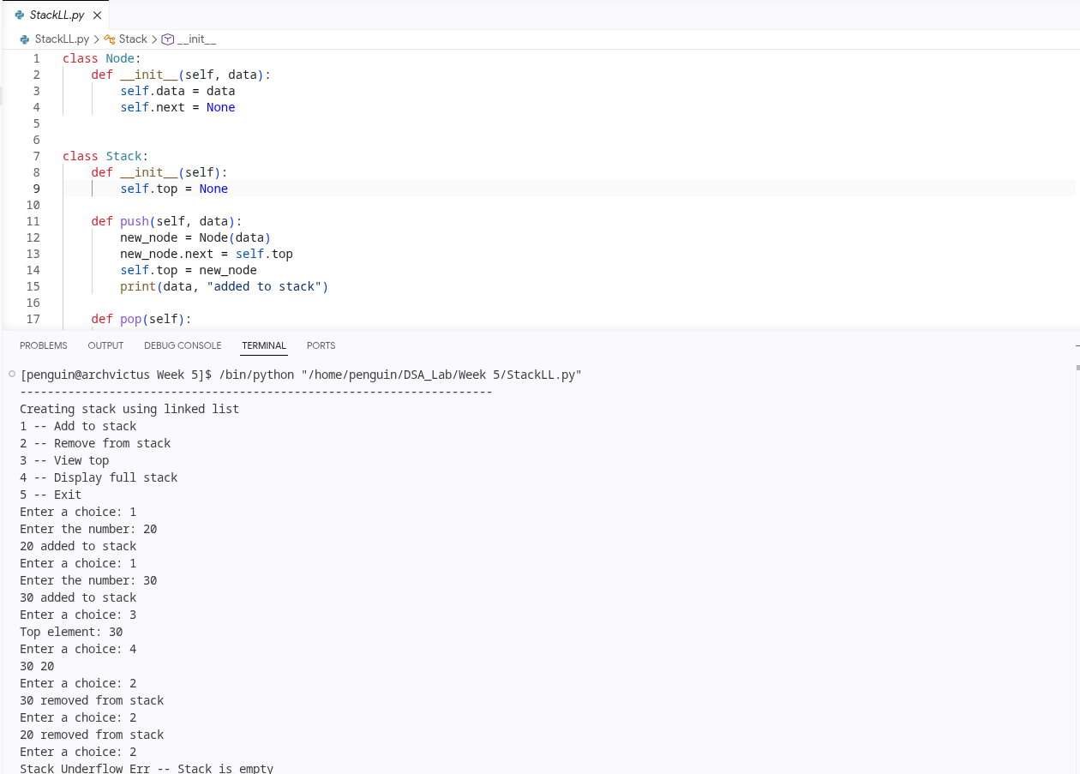
Explanation:
- Implements a stack using a linked list.
- Adds and removes nodes from the top, following the LIFO principle.
- Supports viewing the top element and displaying the stack contents.
- The stack grows dynamically without a predefined size limit.

