

DATA STRUCTURES AND ALGORITHMS
23CSE203
LAB MANUAL

Submitted By
NAME | SABAREESH V
ROLL NO. | AV.SC.U4CSE25046
YEAR/SEM/SECTION | 2nd/3rd/CSE-A
Credits | 5

Submitted to | Dr. Raj Kumar Batchu`
Designation | Asst. Professor (Sl. Grade)
Department | School of Computing

WEEK – 1
Aim:
Code:
def launch_rocket(count):
if count >= 1:
print(count)
launch_rocket(count - 1)

launch_rocket(10)
print('🚀🚀🚀')

Output:
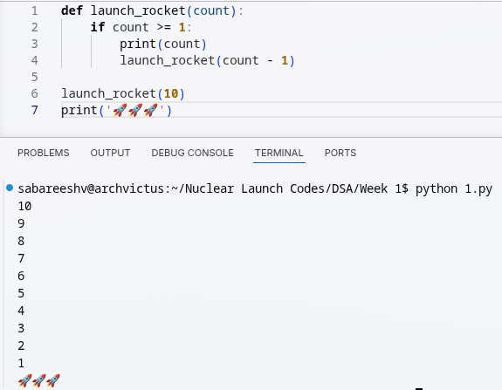

Aim:
Code:
def power(p,n):
if n==0:
return 1
else:
return p*power(p,n-1)
print(power(4,5))

Output:
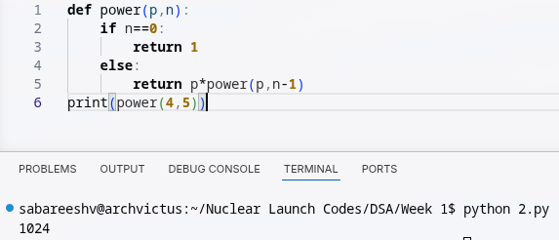

Aim:
Code:
def search(emp):
i=int(input('Enter employee ID: '))
for n in range(len(emp)):
if emp[n]==i:
print('employee found at index:',n)
break
else:
print('no such id exist')
emp=[101,102,103,104,105,106,107,108,109]
search(emp)

Output:
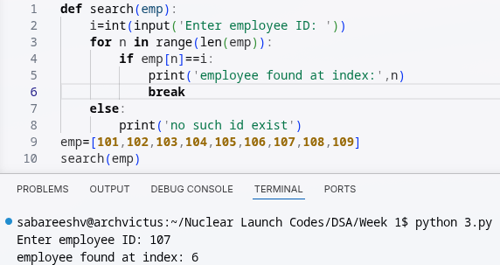

Aim:
Code:
def fib(n):
if n <= 1:
return n
return fib(n - 1) + fib(n - 2)

n = 20
print("Fibonacci series: ")
for i in range(n):
print(fib(i), end=" ")
print("")

Output:
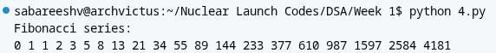

Aim:
Code:
def fact(n):
if n==0:
return 1
else:
return n*fact(n-1)
print(fact(5))

Output:
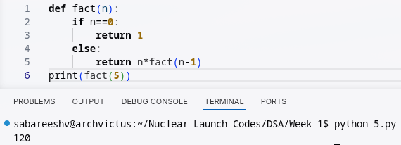

WEEK – 2
Aim:
Code:
def linearsearch(arr, key):
for i in range(0, len(arr)):
if arr[i] == key:
return i
return -1
arr = [1, 2, 3, 4, 5, 6, 7, 8, 9, 10]
print(linearsearch(arr, 9))

Output:
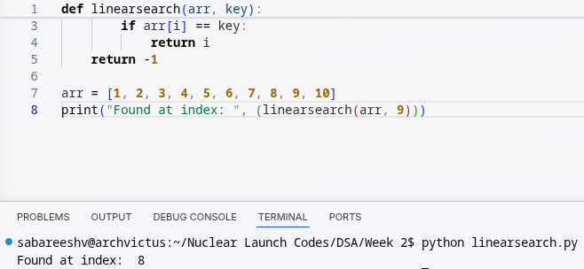

Aim:
Code:
def binsearch(arr, key):
low = 0
high = len(arr)-1
while low <= high:
mid = low + (high - low) // 2
if key == arr[mid]:
return mid
elif key > arr[mid]:
low = mid + 1
else:
high = mid - 1
return - 1

arr = [10, 9, 8, 7, 6, 5, 4, 3, 2, 1]

arr.sort()
print(binsearch(arr, 2))

Output:
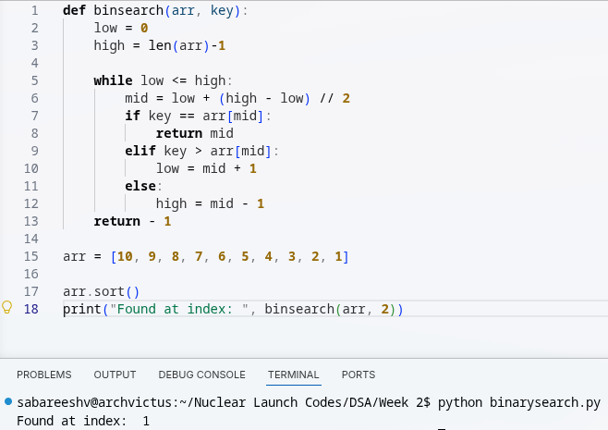
WEEK – 3
Aim:
Code:
def bubbleSort(arr):
n = len(arr)
for i in range(n):
swap = False

for j in range(0, n-i-1):

if arr[j] > arr[j+1]:
arr[j], arr[j+1] = arr[j+1], arr[j]
swap = True
if (swap == False):
break
return arr

arr = [10, 9, 8, 7, 6, 5, 4, 3, 2, 1]
print(bubbleSort(arr))

Output:
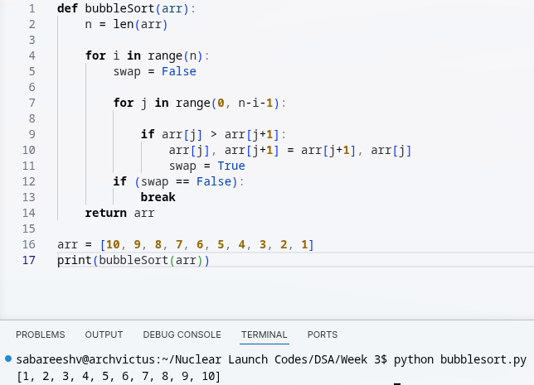
Aim:
Code:
def insertionsort(arr):
for i in range(1, len(arr)):
key = arr[i]
j = i - 1
while j >= 0 and key < arr[j]:
arr[j + 1] = arr[j]
j -= 1
arr[j+1] = key
return arr

arr = [10, 9, 8, 7, 6, 5, 4, 3, 2, 1]
print(insertionsort(arr))

Output:
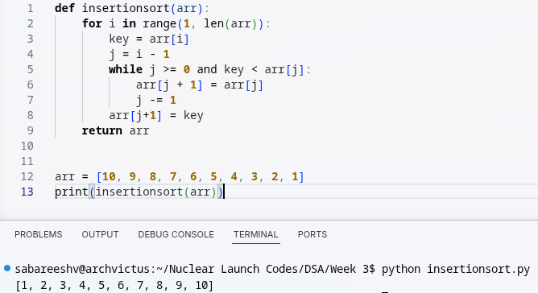

Aim:
Code:
# Define a function to implement the merge sort algorithm
def mergesort(arr):
# Base case: if the array has 1 or 0 elements, it is already sorted
if len(arr) <= 1:
return arr
# Find the middle index of the array to split it into two halves
mid = len(arr) // 2
# Split the array into left and right halves
left = arr[:mid]
right = arr[mid:]

# Recursively sort the left and right halves
left = mergesort(left)
right = mergesort(right)

# Merge the sorted left and right halves back into the original array
i = j = k = 0 # Initialize indices for left, right, and original arrays
while i < len(left) and j < len(right):
# Compare elements from left and right, and place the smaller one in the original array
if left[i] <= right[j]:
arr[k] = left[i]
i += 1
else:
arr[k] = right[j]
j += 1
k += 1 # Move to the next position in the original array

# If there are remaining elements in the left half, append them to the original array
while i < len(left):
arr[k] = left[i]
i += 1
k += 1
# If there are remaining elements in the right half, append them to the original array
while j < len(right):
arr[k] = right[j]
j += 1
k += 1
# Return the sorted array
return arr

# Test the merge sort function with the example array
arr = [10, 9, 8, 7, 6, 5, 4, 3, 2, 1]
print(mergesort(arr))

Output:
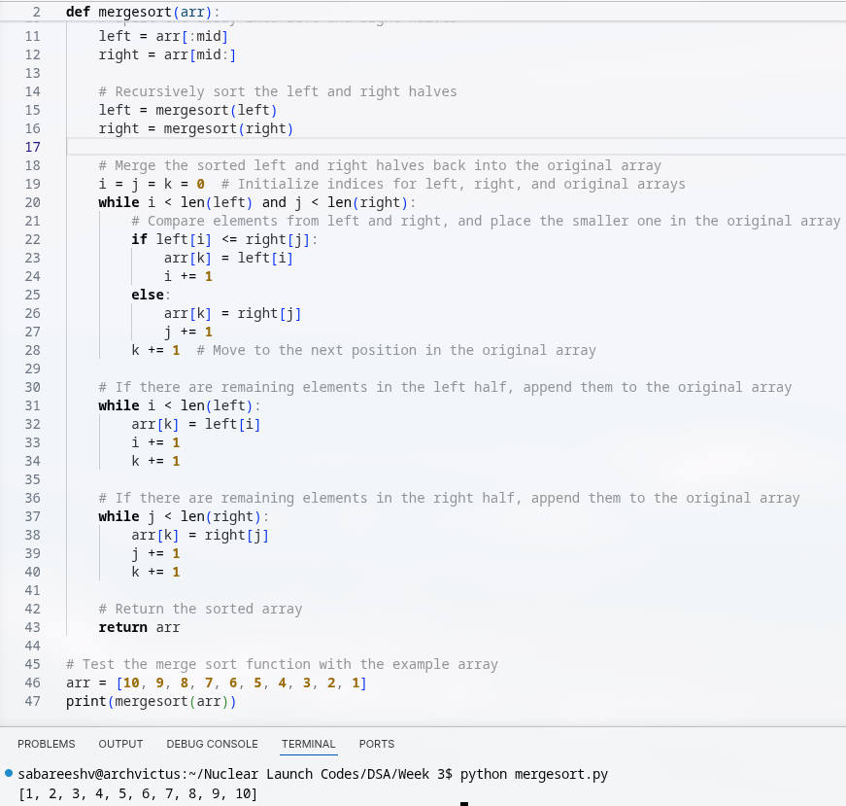

Aim:
Code:
def quickSort(arr, low, high):
if low >= high:
return

pivot = arr[high]
i = low

for j in range(low, high):
if arr[j] <= pivot:
arr[i], arr[j] = arr[j], arr[i]
i += 1

arr[i], arr[high] = arr[high], arr[i]

quickSort(arr, low, i - 1)
quickSort(arr, i + 1, high)

return arr

arr = [10, 9, 8, 7, 6, 5, 4, 3, 2, 1]
print(quickSort(arr, 0, len(arr) - 1))

Output:
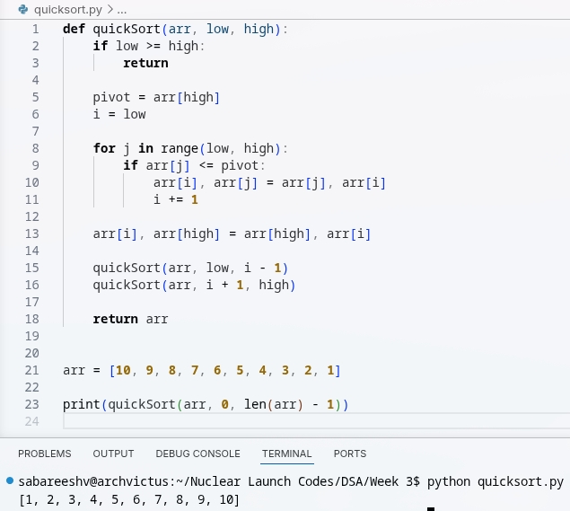

Aim:
Code:
def selectionsort(arr):
for i in range(0, len(arr)):
min_idx = i
for j in range(i + 1, len(arr)):
if arr[j] < arr[min_idx]:
min_idx = j
arr[min_idx], arr[i] = arr[i], arr[min_idx]
return arr

arr = [10, 9, 8, 7, 6, 5, 4, 3, 2, 1]
print(selectionsort(arr))

Output:
