McKinsey’s Pre-Interview Process: What Happens Before You Get the Interview Call
The process of getting an interview at McKinsey & Company begins much earlier than the actual interview. The company uses a methodical pre-interview screening procedure to find applicants with a track record of excellence, strong problem-solving skills, and leadership potential.
Before you ever meet an interviewer, this is what goes on behind the scenes.

How to Apply for a Career at McKinsey & Company
At McKinsey & Company, recruitment is designed to identify individuals who demonstrate leadership, problem-solving ability, and a strong drive to create impact. Candidates can apply through multiple structured pathways depending on their background and experience level.

1. Direct Application Through the Official Careers Portal
The most reliable and transparent method is to apply through the official McKinsey Careers website.
Candidates can:
- Search for open roles by location and function
- Submit their resume and supporting documents
- Track application progress
This method ensures your application is reviewed through the firm’s standardized evaluation process.

2. Campus Recruitment Programs
McKinsey actively hires from leading undergraduate colleges, MBA programs, and advanced degree institutions.
Students can apply through:
- On-campus placement drives
- Pre-placement talks and networking sessions
- Internship-to-full-time conversion programs
Common entry-level roles include Business Analyst (Undergraduate) and Associate (MBA/Advanced Degree).

3. Internship Programs
Internships are a primary entry route for students. Programs such as:
- Summer Business Analyst Internship
- Associate Internship
High-performing interns often receive pre-placement offers (PPOs).

4. Employee Referral Program
Candidates may apply through a referral from a current McKinsey employee.
A referral:
- Strengthens visibility of your application
- Reflects cultural alignment
- Does not guarantee selection but enhances screening chances

5. Applying Via LinkedIn
- McKinsey occasionally posts job openings on LinkedIn, making it a useful platform for job searching.
- Candidates can apply directly to these roles using LinkedIn’s application process, often submitting their profile and resume with just a few clicks.
- By following McKinsey’s official LinkedIn page, candidates stay updated on new job postings, company news, and recruitment events.
- LinkedIn enables candidates to research McKinsey’s work culture, recent projects, and employee experiences.
- Candidates may connect with current McKinsey employees or recruiters to learn more about the firm and express interest in open positions.

6. Applying through Special Programs
- McKinsey offers special programs like Insight Programs and Diversity Fellowships for specific groups of candidates.
- These programs often provide workshops, mentorship, and networking opportunities.
- Candidates who participate may receive extra support and sometimes fast-track interview opportunities.
- Details and application deadlines are available on McKinsey’s careers website and through university career centers

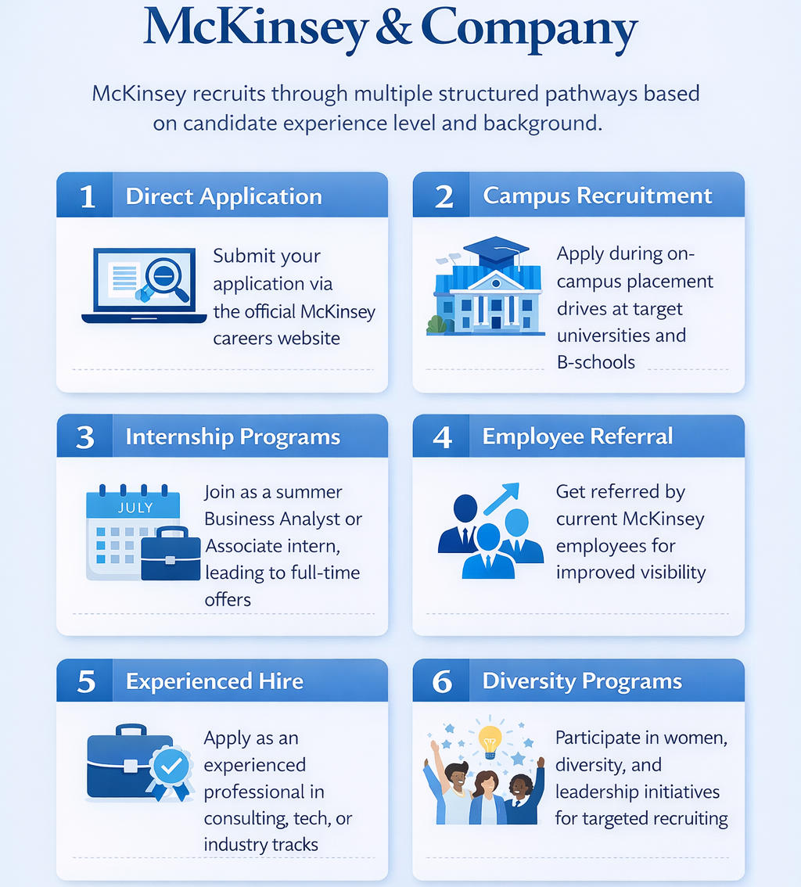

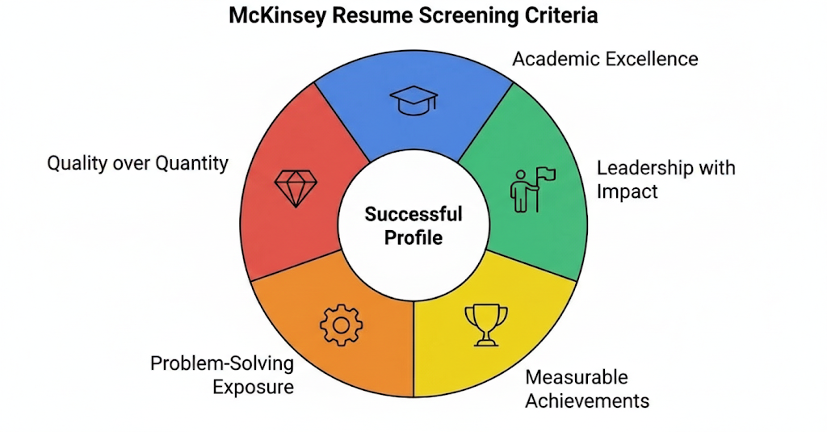

1. Resume Screening & How Shortlisting Works
This is the first and most challenging filter in the McKinsey recruitment process. Before any assessment or interview, your resume is screened to check if you possess the essential qualities of a prospective consultant.
McKinsey usually seeks:

Academic Excellence
Excellent academic records, particularly in analytical or quantitative fields. This indicates your ability to work hard and possess strong intellect.

Leadership with Impact
McKinsey values ownership and initiative, not just involvement. Simply being part of a team is not enough — they look for candidates who took responsibility, influenced outcomes, and drove results.

Measurable Achievements
Achievements are more important than responsibilities.
Do not write:
“Part of organizing committee”
Instead, write about the impact you have made:
“Managed logistics for a 1,000+ attendee college fest and reduced event costs by 20% through vendor negotiations.”

Problem-Solving Exposure
Experience in strategy, analytics, research, consulting projects, or situations where you have tackled complex problems.

Quality over Quantity
It is not about what you have done, but about what you have done best

2. Online Problem-Solving Assessment
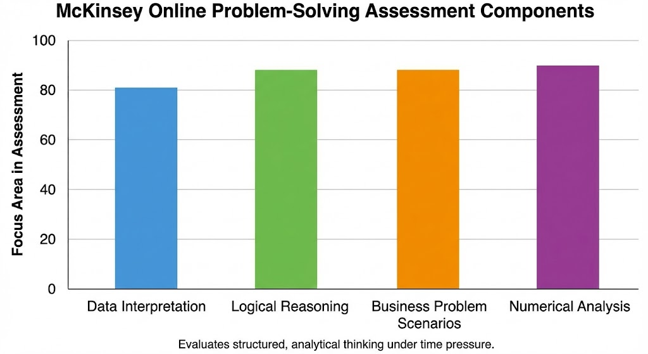
Shortlisted candidates typically take a digital test that evaluates their thinking skills. It may include:
- Data interpretation
- Logical reasoning
- Business problem scenarios
- Numerical analysis
In some cases, McKinsey uses game-based assessments to judge decision-making, strategy, and thinking in uncertain situations. The goal is to see if you can think in a structured, analytical way when under time pressure.

3. Early Fit Signals
Even before interviews, recruiters notice:
- Clear and professional communication
- Well-structured applications
- Strong stories hinted through leadership and achievements
These later form the base for behavioral interviews.

4. Role of Referrals
A referral can help ensure your resume is reviewed carefully, but it cannot compensate for a weak profile. Performance and achievements remain the deciding factors.

SOURCES:
https://www.mckinsey.com/careers/interviewing/id-id?
https://strategycase.com/mckinsey-personal-experience-interview-the-only-post-you-need-to-read/
https://www.myconsultingoffer.org/case-study-interview-prep/mckinsey-pei/
https://www.mckinsey.com/careers/interviewing
https://www.drillinsight.com/news/mckinseys-latest-hiring-guide-2025-application-process-tips-and-success-strategies/
https://www.linkedin.com/pulse/how-pass-mckinsey-job-interview-hiring-assessment-bl6ec/
https://www.mckinsey.com/careers/
https://www.casebasix.com/pages/mckinsey-internship

Mastering the McKinsey Interview
Landing an interview with McKinsey & Company is a significant milestone, but the process is famously rigorous and designed to test candidates to their limits. To help navigate this journey, a comprehensive guide has been compiled that aligns with the firm’s specific requirements and evaluation criteria.

The McKinsey Interview Timeline
The entire process generally spans five to eight weeks. While timelines may vary by role, the standard progression typically involves:
- Resume screening
- Solve (an assessment tool)
- Recruiter screening(s)
- First-round interviews (typically three to four weeks from the start)
- Second-round interviews (typically two to four weeks after the first round)
- Job offer

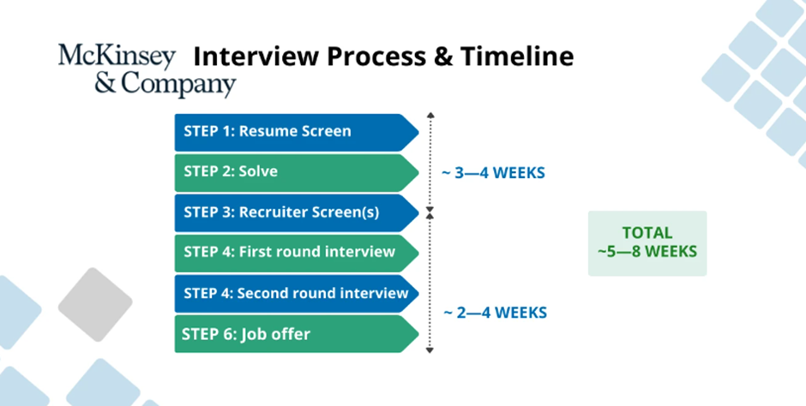

Breaking Down the Interview Rounds
McKinsey uses a multi-layered approach to evaluate candidates both as individuals and as potential colleagues.

First Round
Candidates typically participate in two 45-60 minute sessions led by Associates or Engagement Managers. Each session includes one interviewer-led case interview and one Personal Experience Interview (PEI). The primary focus is on logical structuring, mathematical accuracy, and clarity of communication.

Second Round
Principals or Partners led the second round interview and involved more ambiguous cases with less guidance. Interviewers probe deeper into leadership behaviors and apply rigorous pushback to test candidates’ thought processes.

Final Round (If Applicable)
These interviews are often shorter or less structured and are conducted by Senior Partners. The emphasis shifts toward strategic thinking, communication skills, and cultural fit.

The Personal Experience Interview (PEI)
The PEI is considered just as important as the case interview. McKinsey’s PEI questions revolve around four key themes. While official sources reference four themes without naming them, they are commonly known as Personal Impact, Entrepreneurial Drive, Inclusive Leadership, and Courageous Change. Candidates are advised to prepare two to three stories for each theme.

Connection
Delivering the right answer to clients requires respectful debate supported by trust-based relationships.
Sample question: Explain a challenging situation encountered while working with someone who held an opposing opinion.

Drive
Overcoming obstacles and achieving challenging goals requires resilience, creativity, and sound judgment.
Sample question: Describe a time when significant effort was required to achieve excellence under particularly tough circumstances.

Leadership
Harnessing the power of diverse thinking requires leadership grounded in understanding, empowerment, and motivation.
Sample question: Share an example of working effectively with people from different backgrounds despite challenges.

Growth
Professional growth requires constant learning and openness to feedback and change.
Sample question: Revisit a time when you had to learn quickly to tackle a challenging situation.

Problem-Solving (Case Interviews)
The second type of interview encountered in the first round is the problem-solving interview, more commonly known as the case interview.
The core competencies evaluated include:
- Structured problem solving: The ability to break down problems into MECE components and drive the case forward
- Numerical intuition: Comfort with approximations, ratios, and sanity checks
- Business intuition: The ability to understand and analyze business models
- Communication skills: The ability to communicate in a clear, top-down manner
- Coachability: Responsiveness when the interviewer redirects the case

Examples of McKinsey Problem-Solving Case Interviews

Example 1: Profitability Case
Case Prompt:
A global consumer goods company has seen its profits decline over the past two years, despite stable revenues. The CEO has asked McKinsey to identify the root cause and recommend solutions.
Candidate Approach (McKinsey Style):
The candidate begins with a clear hypothesis that profits are declining due to either increasing costs or decreasing margins. The problem is structured into two MECE branches: revenues and costs.
- Revenue Analysis:
  - Price per unit
  - Sales volume
  - Product mix
- Cost Analysis:
  - Fixed costs (manufacturing, overheads)
  - Variable costs (raw materials, logistics)
Key Analysis:
Data reveals that raw material costs have increased significantly due to supplier concentration, while pricing has remained unchanged due to competitive pressure.
Recommendation:
The candidate recommends renegotiating supplier contracts, exploring alternative suppliers, and selectively increasing prices on premium products while maintaining volume on core offerings.

Example 2: Market Entry Case
Case Prompt:
A European electric vehicle manufacturer is considering entering the Indian market. The client wants to know whether this is an attractive opportunity.
Candidate Approach:
The candidate frames the analysis around three MECE areas: market attractiveness, competitive landscape, and capability fit.
- Market Attractiveness:
  - Market size and growth
  - Customer demand and regulation
- Competition:
  - Existing players
  - Pricing and differentiation
- Capabilities:
  - Brand strength
  - Manufacturing and supply chain readiness
Key Analysis:
The market is growing rapidly due to government incentives, but price sensitivity is high, and local competitors have cost advantages.
Recommendation:
The candidate suggests a phased entry strategy, beginning with premium models in metropolitan areas and forming partnerships with local manufacturers to reduce costs.

Example 3: Pricing Case
Case Prompt:
A software as a service (SaaS) company wants to introduce a new pricing model for its enterprise customers.
Candidate Approach:
The candidate proposes evaluating pricing through three lenses: cost-based, value-based, and competition-based pricing.
Key Analysis:
Value-based pricing analysis shows that customers derive significant cost savings from automation, suggesting room for higher prices than current offerings.
Recommendation:
The candidate recommends tiered pricing based on usage and value delivered, along with pilot testing the model with select enterprise clients.

Example 4: Market Sizing Case
Case Prompt:
Estimate the annual market size for ride-hailing services in a major metropolitan city.
Candidate Approach:
The candidate clearly states assumptions and structures the problem logically:
- Population of the city
- Percentage of people using ride-hailing services
- Average rides per user per year
- Average fare per ride
Key Analysis:
Using reasonable assumptions, the candidate calculates the total number of rides per year and multiplies it by the average fare.
Conclusion:
The candidate presents a final estimate and performs a sanity check to ensure the number is reasonable.

Example 5: Operations Case
Case Prompt:
A manufacturing plant is facing frequent production delays. The client wants to improve operational efficiency.
Candidate Approach:
The candidate structures the problem into people, process, and technology.
- People: Skill gaps, staffing levels
- Process: Bottlenecks, scheduling
- Technology: Equipment downtime, automation
Key Analysis:
The analysis shows that unplanned equipment downtime is the main driver of delays.
Recommendation:
The candidate recommends implementing preventive maintenance, investing in predictive analytics, and retraining staff.

McKinsey’s Style
- Interview led with focused questions
- Hypothesis-driven thinking
- Clear MECE structures
- Strong mental math and logic
- Concise, top-down recommendations
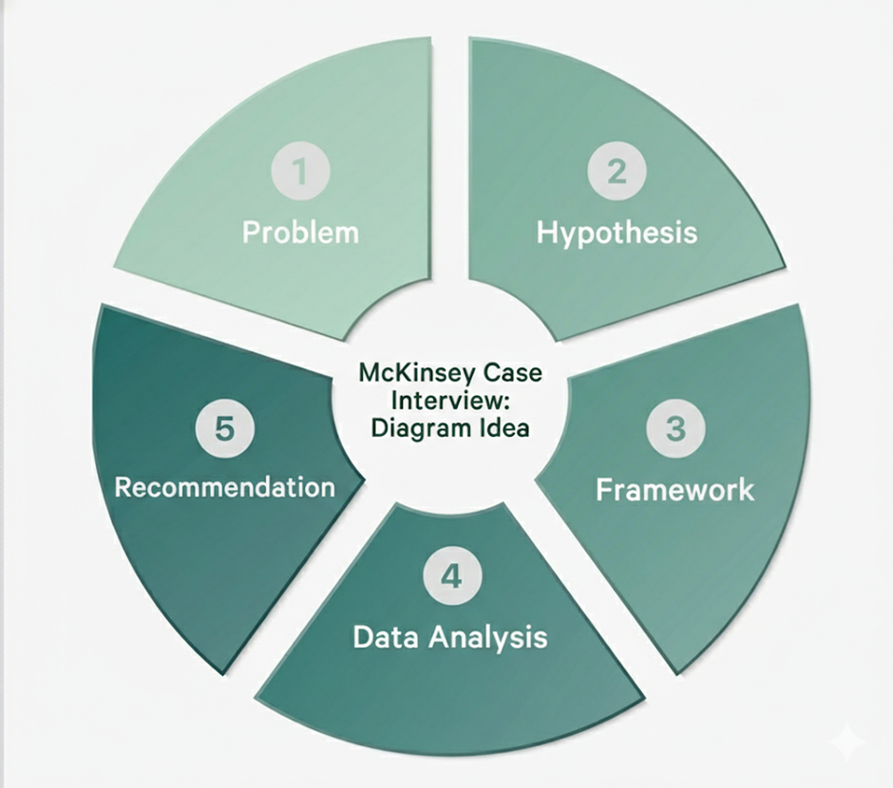

Second-Round Case Preparation
The format of second-round interviews is similar to the first round, with the primary difference being that interviews are conducted by Partners and Senior Partners. As a result, candidates may encounter more spontaneous and less structured questions.
The most effective way to prepare for these spontaneous questions is to broaden overall case interview knowledge and practice a wide range of case types, including:
- Profitability cases
- Market entry cases
- Merger and acquisition cases
- Pricing cases
- Market sizing cases
- Operations cases

Additional Interviews at McKinsey
Depending on the role, candidates may encounter additional interview stages.

Expertise Interview
Experienced hires or candidates applying for technical roles may undergo an expertise interview. This interview may include coding challenges, problem-solving tasks, or other role-specific exercises designed to assess the required level of proficiency.

Experience Day
Certain internal roles may involve an Experience Day, conducted either virtually or at a McKinsey Global Services office. Depending on the role, this may include role simulations, group exercises (such as group case interviews), or multiple interviews, along with opportunities to learn more about the firm and the position.

What McKinsey Is Looking For
McKinsey evaluates candidates across three primary dimensions:
- Problem-Solving Skills: The ability to deconstruct complex problems and test hypotheses using logic and mathematics
- Leadership and Personal Impact: Demonstrated initiative, influence, and the ability to lead through ambiguity
- Entrepreneurial Drive and Communication: Energy, ownership, composure under pressure, and clear communication

Cracking the Case: The McKinsey Style
McKinsey case interviews differ from those used by other consulting firms. While some firms employ candidate-led and flexible cases, McKinsey cases are interviewer-led, fast-paced, and high-pressure, with a strong emphasis on mental math and concise, structured thinking.
To succeed, candidates must master the following principles:
- MECE Logic: All answers must be Mutually Exclusive and Collectively Exhaustive. Candidates are expected to structure their thinking aloud using clear issue trees.
- Hypothesis-Driven Thinking: Rather than attempting to analyze everything, candidates should begin with a testable hypothesis and determine where to focus first.
- Case Flow: A successful case follows a structured cycle—Problem → Hypothesis → Framework → Data Analysis → Recommendation.
- Adaptability: Standard frameworks such as the 4Ps or Porter’s Five Forces should be tailored to the specific client context rather than applied mechanically.

Mindset and Final Preparation
Presence and composure are as important as analytical and mathematical skills. Interviewers may intentionally challenge assumptions or introduce mid-case curveballs to observe how candidates respond under pressure. These moments should be treated as opportunities to demonstrate collaboration and problem-solving ability.
In the final 48 hours before the interview, candidates are advised to:
- Avoid cramming and focus instead on confidence and polish
- Practice only one or two cases
- Review PEI stories until they sound natural
- Prioritize sleep to remain sharp and focused

Sources:
- iGotAnOffer - McKinsey Interview Process
- McKinsey & Company - Careers: Interviewing
- JoinLeland -Navigating the McKinsey Interview Process

POST INTERVIEW:-What Happens After the McKinsey Final Round Interview?

Once you’ve completed your final round interviews at McKinsey, the waiting period begins. This stage can feel uncertain, but understanding what happens behind the scenes can help you manage expectations. The post-interview process includes evaluating candidate performance, making final hiring decisions, and providing feedback. Here’s what to expect.

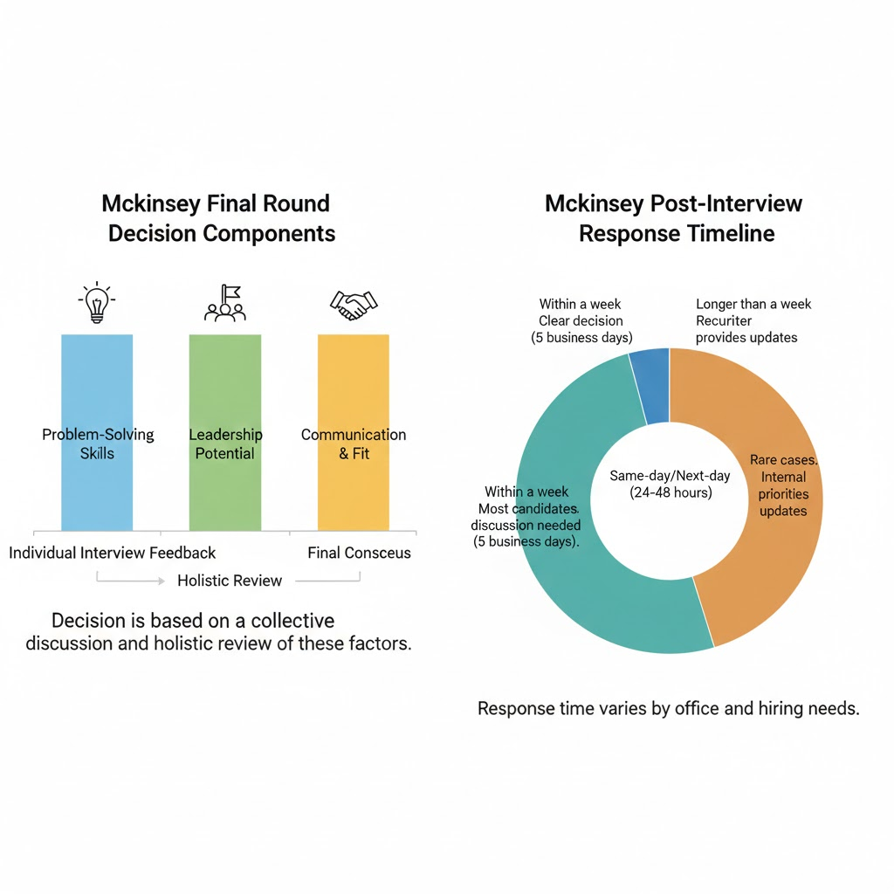

How McKinsey Makes Final Hiring Decisions :-
After your final interviews, McKinsey follows a structured decision-making process. Unlike earlier rounds, where candidates are evaluated on individual interviews, the final decision is based on a collective discussion among all your interviewers.

•Interviewers submit independent feedback on your case performance, PEI, and overall fit.
•A hiring committee reviews all assessments to determine whether you meet McKinsey’s standards for problem-solving, leadership, and communication.
•Final decisions are based on consensus. If there is strong agreement among interviewers, an offer is extended quickly. If opinions are mixed, further discussions may take place before a final decision is made.

A candidate with strong problem-solving skills but weaker leadership stories may be compared against others with different strengths. This holistic evaluation ensures that offers go to those who best align with McKinsey’s expectations.

How Long Until You Hear Back?
The response time varies depending on office location and hiring needs, but most candidates receive an update within a few days to a week.

Same-day or next-day response :-. If the decision is clear, offers or rejections can be communicated within 24 to 48 hours

Within a week:- If additional discussions are needed, it may take up to five business days to finalize decisions.

Longer than a week:- In rare cases, decisions take longer due to internal hiring priorities. If this happens, recruiters usually provide updates on your status.

If you haven’t received a response after a week, it’s acceptable to follow up with your recruiter for clarification.

Career Trajectory at McKinsey & Company
At McKinsey & Company, career progression is structured and performance-driven, with growth determined by impact, leadership, and problem-solving ability. The journey typically begins with the Business Analyst role, the entry point for undergraduate students. Business Analysts conduct research, analyze data, build financial models, and support senior team members in tackling complex client problems. This foundational experience, lasting about 0–3 years, helps develop strong analytical and communication skills and comes with a salary range of ₹15–27 lakhs per year. After gaining experience, many consultants advance to the Associate position, where responsibilities expand to include structuring analyses, leading workstreams, presenting findings to clients, and mentoring Business Analysts. Associates, who can expect a salary between ₹25–45 lakhs per year, usually spend 2–5 years in this role.
For those who continue to grow, the next step is Engagement Manager, a position that involves leading consulting teams, managing client relationships, overseeing analysis quality, and ensuring that strategic recommendations are implemented effectively. Engagement Managers, with a typical tenure of 5–8 years, earn between ₹60 lakhs and more than ₹1 crore per year. The career path then leads to Associate Partner, where professionals contribute to business development and client acquisition while managing larger strategic accounts and mentoring multiple teams. Associate Partners often spend 8–12 years in this role and earn between ₹1 crore and ₹1.5 crore or more per year. The highest level is Partner, where the main focus is on major client relationships, firm strategy, and revenue growth. Partners lead large-scale transformations and influence industry decisions, with compensation starting above ₹1.5 crore per year and tenure extending well beyond 10 years.
Throughout this journey, McKinsey’s promotion system ensures that advancement is based on results and demonstrated leadership, rather than just years of service. Each step brings increased responsibility, greater influence, and significant growth in compensation, offering a rewarding and challenging career path for high performers.

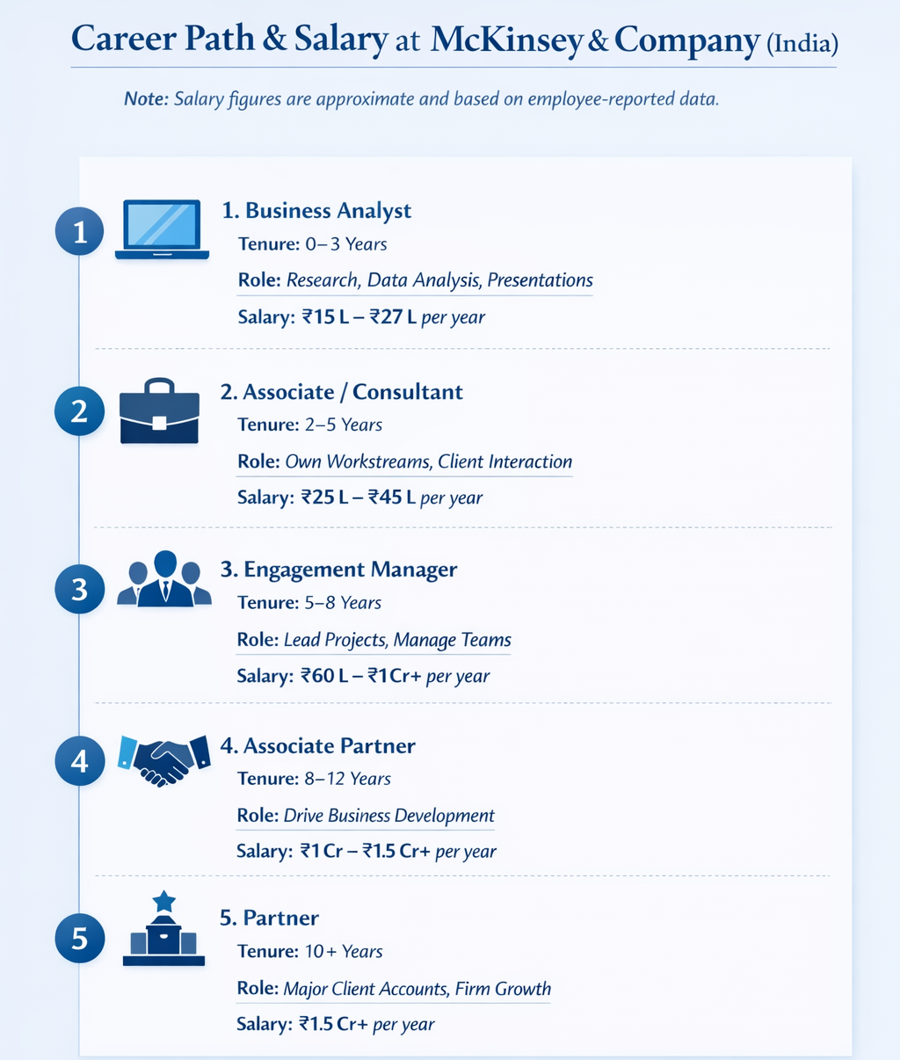

Receiving an Offer: What to Expect
If you receive an offer, McKinsey will typically provide:

•A verbal offer from your recruiter, followed by a formal written offer.
•Details on compensation, benefits, and your expected start date.
•Opportunities to connect with current consultants to help you transition into the firm.

You’ll usually have a few weeks to make your decision, and McKinsey encourages candidates to ask questions before accepting. Some offices may also invite you to informal networking events or Q&A sessions before you finalize your decision.

If You Don’t Receive an Offer
If you are not selected, McKinsey typically provides brief but constructive feedback on your performance.

•Your recruiter will explain the decision and highlight areas for improvement.
•Feedback will focus on key skills, such as structuring, problem-solving, or leadership.
•You may be eligible to reapply. Many candidates successfully re-interview after gaining more experience.

McKinsey often encourages strong candidates to reapply after strengthening their skills. If you receive this feedback, take the time to improve before making another attempt. Many successful consultants were not selected on their first try.

Key Takeaways: What to Expect After Your Final Round
•McKinsey’s final decision is made collectively, considering all interview feedback holistically.
•Most candidates receive a response within a few days to a week, but timelines vary.
•If you receive an offer, McKinsey provides guidance on next steps and helps you transition into the firm.
•If you don’t receive an offer, feedback can help you improve for a future reapplication.

Understanding the post-interview process helps you manage expectations and plan your next steps accordingly.
Sources:-
https://managementconsulted.com/
https://www.myconsultingoffer.org/
https://caseinterview.com/
https://www.ambitionbox.com/salaries/mckinsey-and-company-salaries

