# Normality Testing

# Actually, normality testing used for checking the variable data is normally distributed or not. Actually this normality testing is necessary part. Because after completing this only we can determine which method (pearson or spearman) we can use for completing the correlational analysis. To do this normality testing Anderson darling, Lilliefors, and shapiro-wiki tests are used.

# **Statistical Hypothetical Testing: Normality tests for Sample : Dataset : economic status**

Significant level = 0.05 (5%)

Confidence level = 0.95 (95%)

Variable = GDP

(*) Whether or not GDP is normally distributed?

H­0: GDP is normally distributed

H­1: GDP is not normally distributed

ad.test(GDP)

Anderson-Darling normality test

data: GDP

A = 0.25343, p-value = 0.7268

Decision: p-value= 0.7268 > α=0.05 => Accept H0 at 5% significant level

lillie.test(GDP)

Lilliefors (Kolmogorov-Smirnov) normality test

data: GDP

D = 0.051776, p-value = 0.7333

Decision: p-value= 0.7333 > α=0.05 => Accept H0 at 5% significant level

shapiro.test(GDP)

Shapiro-Wilk normality test

data: GDP

W = 0.98988, p-value = 0.6552

Decision: p-value= 0.6552 > α=0.05 => Accept H0 at 5% significant level

Conclusion - According to the Anderson-Darling test (p = 0.7268), Lilliefors test (p = 0.7333), and Shapiro-Wiki test (p = 0.6552), at 5 % significant level “GDP” data is normality distributed.

**Summary statistics about GDP**

summary(GDP) Min. 1st Qu. Median Mean 3rd Qu. Max.

23803 43991 48730 48962 54060 68523

**Montercarlo graph for GDP**

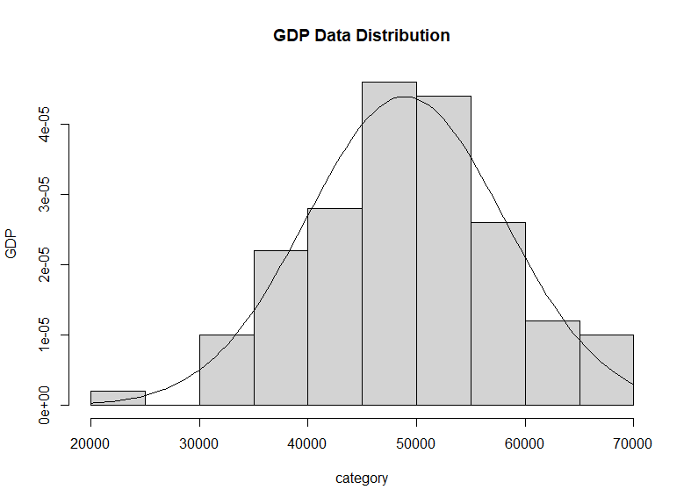

Figure 1 - GDP data distribution

**Interpretation of Montercarlo graph**

According to the above plot bell curve GDP is normally distributed at 5% significant level.

**Quintile comparison plot**

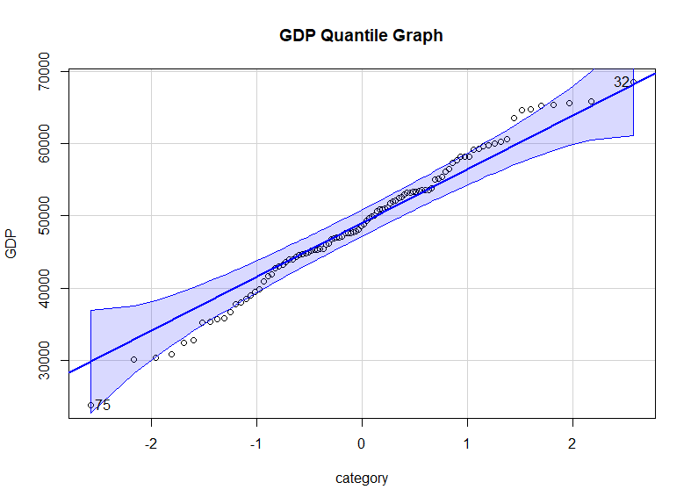

Figure 2 - Quintile comparison plot for GDP

**Interpretation of quintile comparison plot**

Based on above quintile plot, it clearly describes lot of data points are overlapped the absolute line and available within this envelop. So then, GDP values can be considered as normally distributed at 5 % significant level.

# **Statistical Hypothetical Testing: Normality tests for Sample : Dataset : economic status**

Significant level = 0.05 (5%)

Confidence level = 0.95 (95%)

Variable = Unemployment_Rate

(*) Whether or not Unemployment_Rate is normally distributed?

H­0: Unemployment_Rate is normally distributed

H­1: Unemployment_Rate is not normally distributed

ad.test(Unemployment_Rate)

Anderson-Darling normality test

data: Unemployment_Rate

A = 0.62141, p-value = 0.1029

Decision: p-value= 0.1029 > α=0.05 => Accept H0 at 5% significant level

lillie.test(Unemployment_Rate)

Lilliefors (Kolmogorov-Smirnov) normality test

data: Unemployment_Rate

D = 0.072104, p-value = 0.2269

Decision: p-value= 0.2269 > α=0.05 => Accept H0 at 5% significant level

shapiro.test(Unemployment_Rate)

Shapiro-Wilk normality test

data: Unemployment_Rate

W = 0.97753, p-value = 0.08526

Decision: p-value= 0.08526 > α=0.05 => Accept H0 at 5% significant level

Conclusion - According to the Anderson-Darling test (p = 0.1029), Lilliefors test (p = 0.2269), and Shapiro-Wiki test (p = 0.08526), at 5 % significant level “Unemployment_Rate” data is normality distributed.

summary(Unemployment_Rate) Min. 1st Qu. Median Mean 3rd Qu. Max.

1.162 3.389 5.168 5.045 6.076 10.440

**Montercarlo graph for Unemployment_Rate**

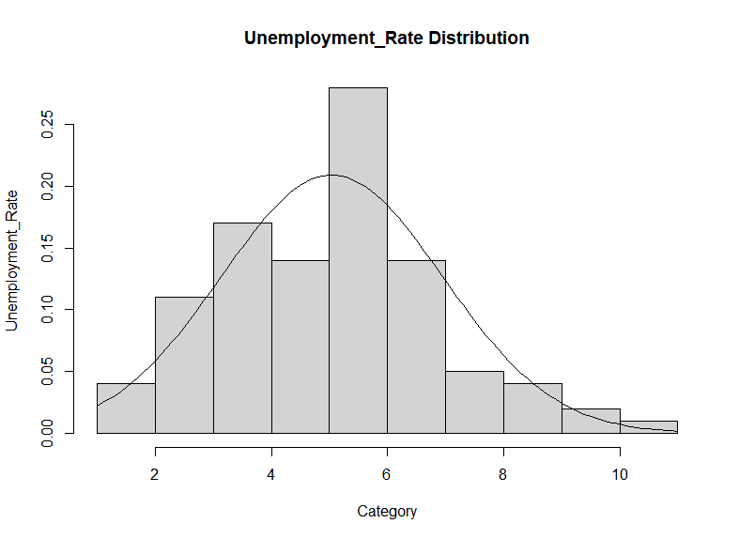

Figure 3 - Unemployment_Rata data distribution

**Interpretation of Montercarlo**

According to the above plot bell curve Unemployment_Rate is normally distributed at 5% significant level.

**Quintile comparison plot**

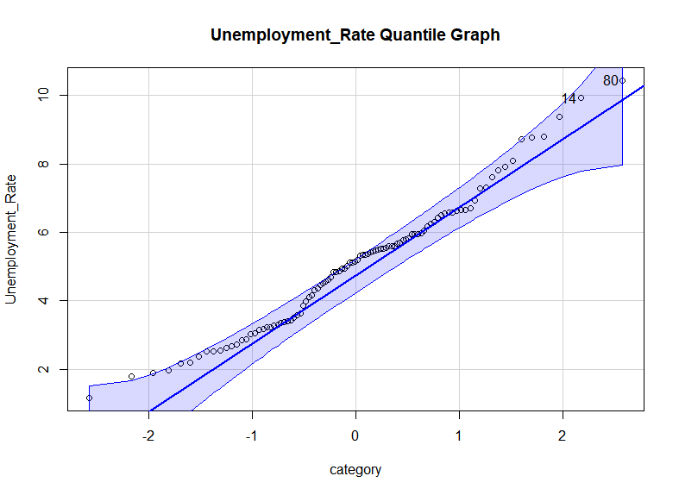

Figure 4 - Quintile comparison plot for Unemployment_Rate

According to the above quintile plot, it clearly describes some data points are overlapped the absolute line. And also huge amount of data points available within this envelop. So then, Unemployment_Rate values can be considered as normally distributed at 5 % significant level.

# **Statistical Hypothetical Testing: Normality tests for Sample : Dataset : economic status**

Significant level = 0.05 (5%)

Confidence level = 0.95 (95%)

Variable = Interest_Rate

(*) Whether or not Unemployment_Rate is normally distributed?

H­0: Interest_Rate is normally distributed

H­1: Interest_Rate is not normally distributed

d.test(Interest_Rate)

Anderson-Darling normality test

data: Interest_Rate

A = 0.33355, p-value = 0.5059

Decision: p-value= 0.5059 > α=0.05 => Accept H0 at 5% significant level

lillie.test(Interest_Rate)

Lilliefors (Kolmogorov-Smirnov) normality test

data: Interest_Rate

D = 0.055555, p-value = 0.6289

Decision: p-value= 0.6289 > α=0.05 => Accept H0 at 5% significant level

shapiro.test(Interest_Rate)

Shapiro-Wilk normality test

data: Interest_Rate

W = 0.98568, p-value = 0.3551

Decision: p-value= 0.3551 > α=0.05 => Accept H0 at 5% significant level

Conclusion - According to the Anderson-Darling test (p = 0.5059), Lilliefors test (p = 0.6269), and Shapiro-Wiki test (p = 0.3551), at 5 % significant level “Interest_Rate” data is normality distributed.

summary(Interest_Rate) Min. 1st Qu. Median Mean 3rd Qu. Max.

-0.2413 2.3446 3.0977 3.0649 3.7044 6.8527

**Montercarlo graph**

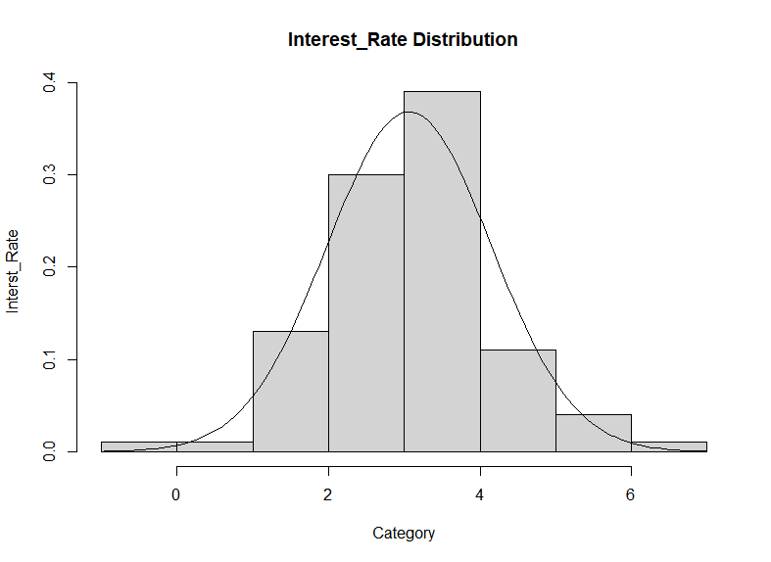

Figure 5 - Interest_Rate data distribution

**Interpretation of Montercarlo**

According to the above plot bell curve Interest_Rate is normally distributed at 5% significant level.

**Quintile comparison plot**

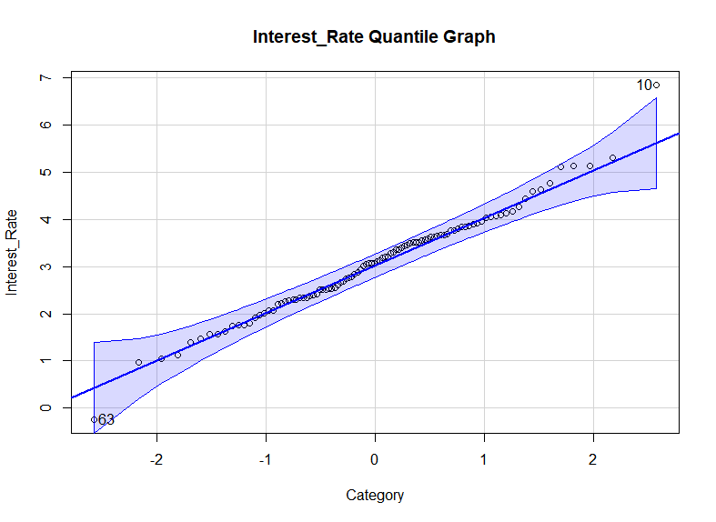

Figure 6 Quintile graph for Interest_Rate

According to the above quintile plot, it clearly describes huge number of data points are overlapped the absolute line. And also huge amount of data points available within this envelop. So then, Interest_Rate values can be considered as normally distributed at 5 % significant level.