Supermarket Sales Analysis
Data Analytics & AI Internship Project — Business Intelligence Report
Prepared: September 2026 | Dataset: 500 transactions, Jan–Jul 2026

Executive Summary
This report analyzes 500 supermarket sales transactions to uncover customer purchasing behavior, product performance, branch profitability, and payment preferences, and to translate those findings into actionable business recommendations.
Total Sales  Rs. 2,44,411.08 | Total Transactions  500 | Average Rating  3.99 / 5 | Top Branch  C - Mumbai

1. Problem Statement & Objectives
Analyze historical retail store and supermarket transaction data to uncover customer purchasing behavior, product performance, branch profitability, and payment preferences, and use the findings to support inventory, branch strategy, and service-quality decisions.

2. Data Overview & Cleaning
The dataset contains 500 transaction records with 13 features: Invoice ID, Date, Branch, City, Customer Type, Gender, Product, Category, Quantity, Unit Price, Payment Method, Rating, and Sales.
- Missing values: none found across any column.
- Duplicate rows / duplicate Invoice IDs: none found.
- Data types: verified and corrected (dates parsed, quantities as integers, prices/ratings/sales as floats).
- Feature validation: Sales was cross-checked against Quantity × Unit Price for all 500 rows — zero discrepancies.

3. Key Findings

3.1 Product Performance
Cheese is the highest-selling product by revenue, generating Rs. 27,906.30 despite a moderate unit price, driven by strong basket sizes. High-value Dairy and Personal Care items dominate the top 10.
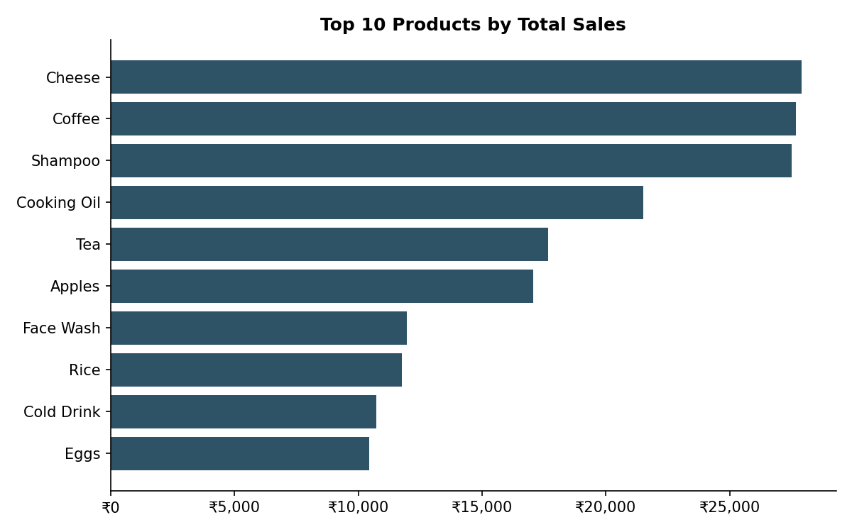

3.2 Branch Profitability
Branch C (Mumbai) is the strongest performer with Rs. 72,469.45 in total sales, roughly 13% ahead of Branch B (Delhi). Branch A (Jaipur) generates the least revenue of the four branches.
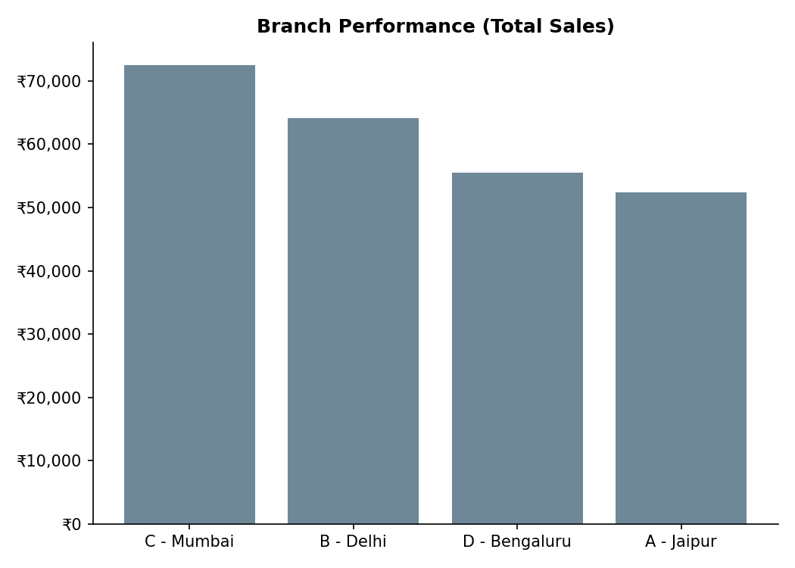

3.3 Category Performance
Beverages is the top-selling category at Rs. 56,108.24, followed closely by Personal Care and Dairy. Bakery and Vegetables trail, largely reflecting their lower per-unit prices.
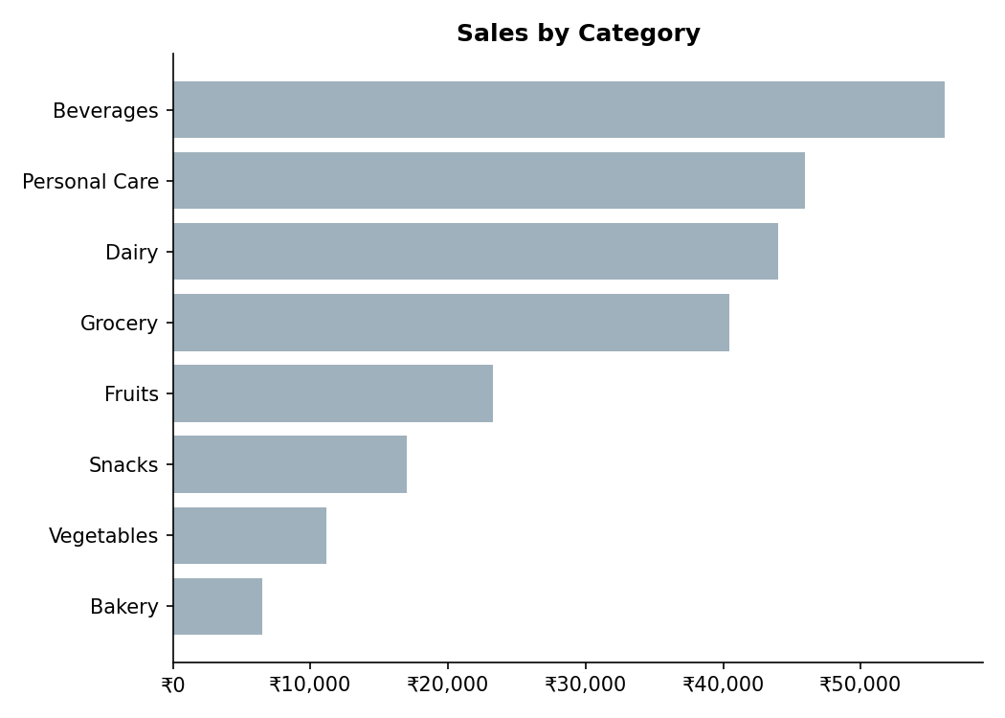

3.4 Payment Preferences
UPI is the most-used payment method (127 of 500 transactions, 25.4%), narrowly ahead of Net Banking (126), Card (125), and Cash (122). Digital payment methods combined (UPI + Net Banking + Card) account for over three-quarters of all transactions.
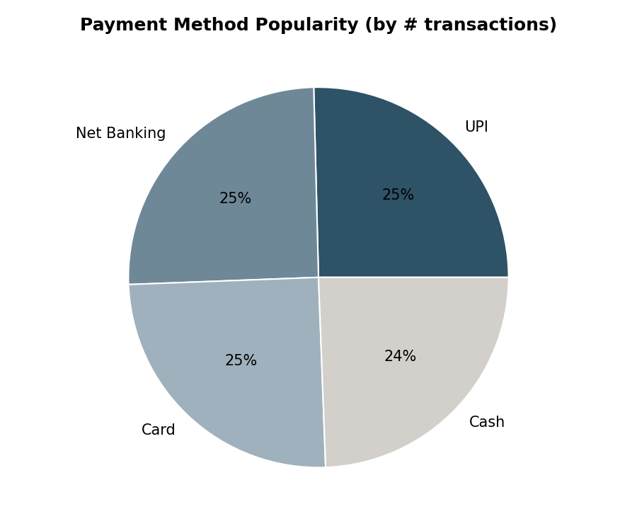

3.5 Member vs. Normal Customer Spend
Contrary to a common assumption, Members do not spend more per transaction than Normal customers. Normal customers average Rs. 497.07 per basket vs. Rs. 483.14 for Members. However, Members transact far more often (296 vs. 204 transactions), so they still generate 41% more total revenue overall — the Member advantage is in loyalty and frequency, not basket size.
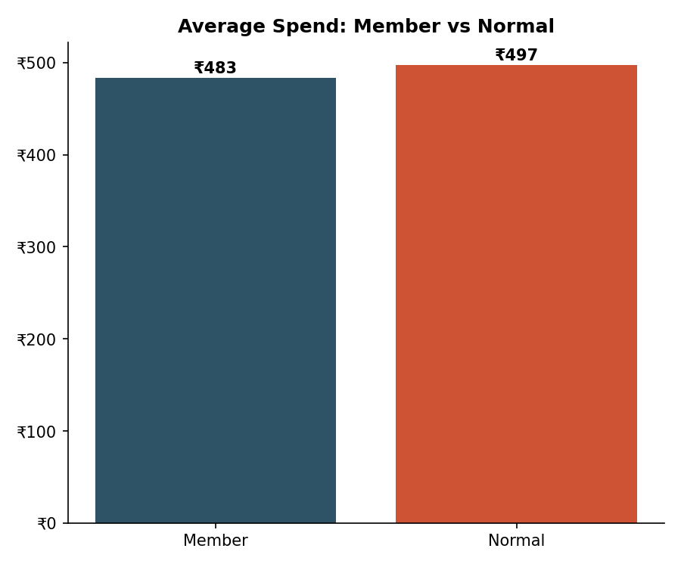

3.6 Customer Satisfaction
The average customer rating across all transactions is 3.99 out of 5 — a respectable score with clear room to grow toward a stronger 4.5+ benchmark. Branch D (Bengaluru) posts the highest average rating (4.09) despite not leading on sales, while Branch A (Jaipur) has both the lowest sales and the lowest rating (3.84), pointing to a possible service-quality gap.
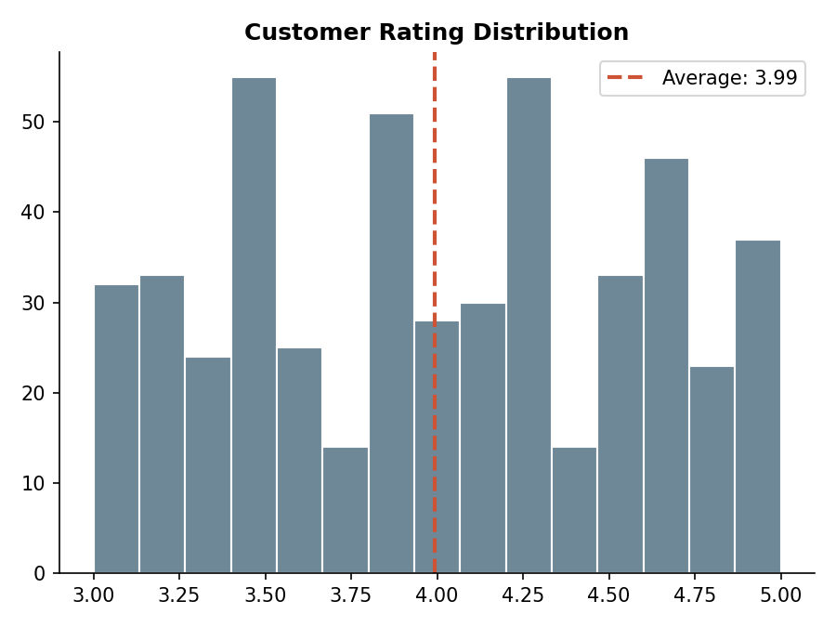

3.7 Monthly Sales Trend
Sales peak in April (Rs. 52,569.77) and dip through February before recovering. The apparent July drop reflects incomplete data (only the first day of the month is captured), not an actual decline.
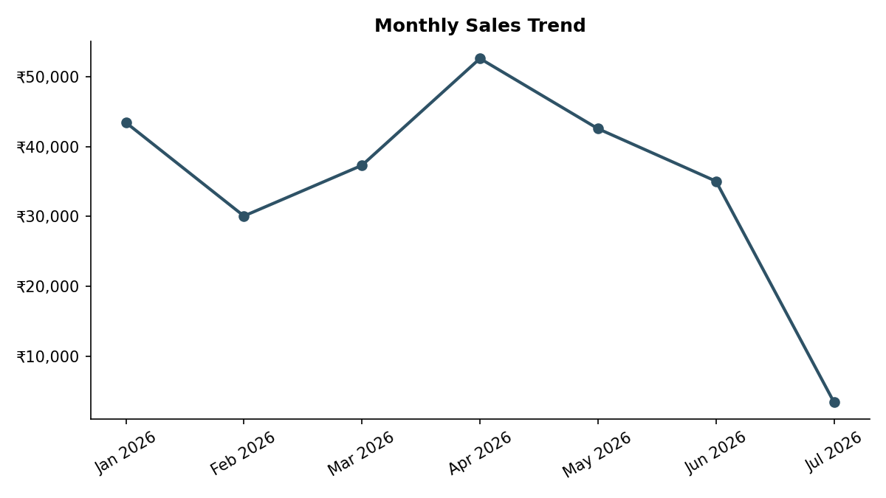

4. Extended Analysis

4.1 Sales by Gender
Sales are almost evenly split by gender (Female Rs. 1,23,954.12 vs. Male Rs. 1,20,456.96) — gender is not a meaningful driver of revenue, so marketing spend need not be gender-segmented.
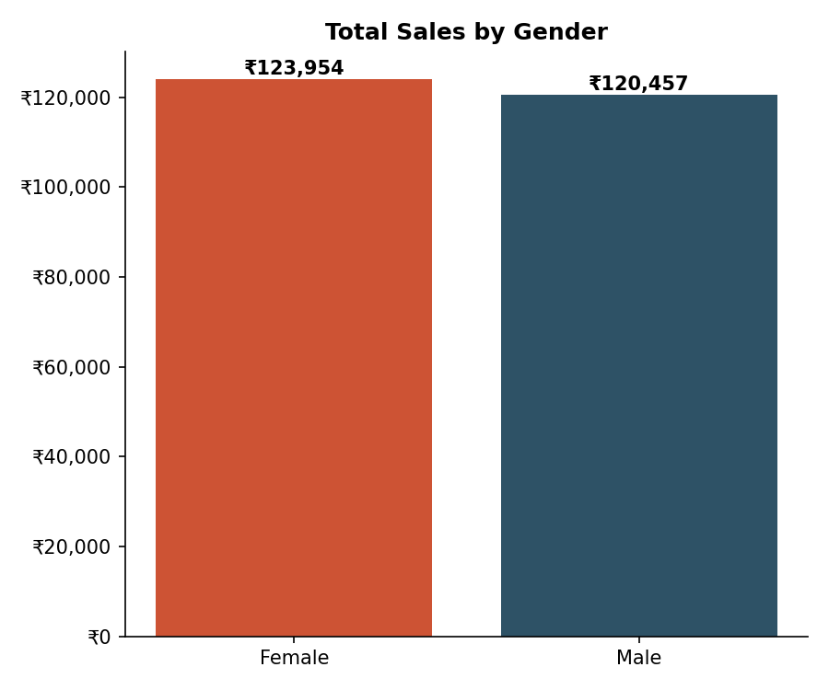

4.2 Sales by Day of Week
Monday is the strongest sales day (Rs. 42,602.44), likely a start-of-week stock-up pattern, while Thursday is the weakest (Rs. 28,576.26). This can inform staffing levels and weekday-specific promotions.
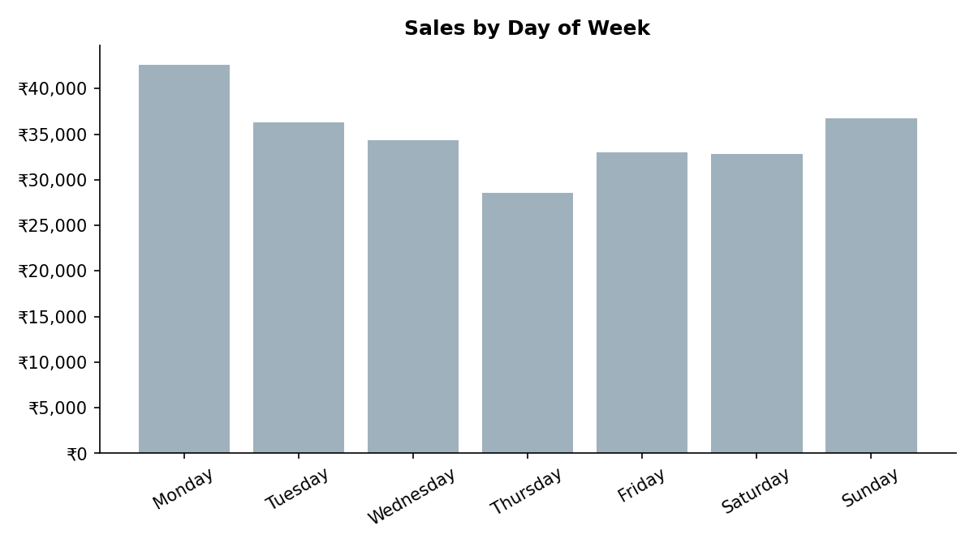

4.3 Correlation Analysis
Sales correlates most strongly with Unit Price (0.72) and Quantity (0.57), which is expected since Sales is derived from both. Rating shows almost no correlation with Sales (-0.05) — satisfaction and revenue are driven by different factors and should be tracked as independent KPIs, not assumed to move together.
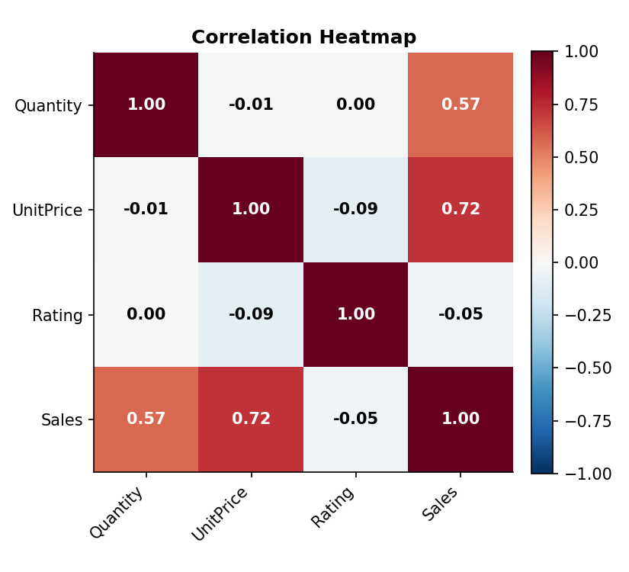

4.4 Branch × Category Breakdown
Branch C (Mumbai) leads specifically in Dairy and Personal Care, while Branch D (Bengaluru) and Branch B (Delhi) lead in Beverages. Branch A (Jaipur) has no standout category at all — its underperformance is broad rather than concentrated in one area, reinforcing the case for a full operational review rather than a single category fix.
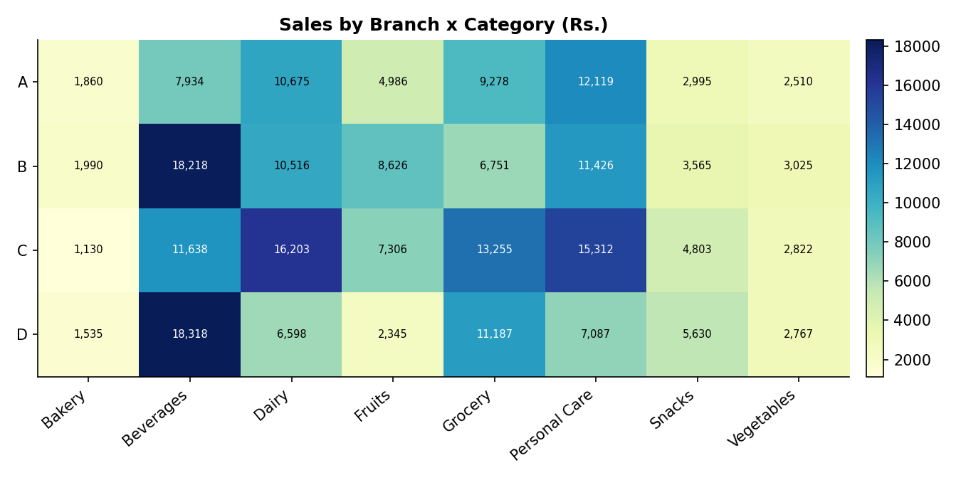

4.5 Unit Price vs. Sales by Category
Personal Care and Dairy occupy the higher unit-price band and cluster toward higher per-transaction sales, while Vegetables, Bakery, and Snacks sit in the low-price, low-ticket cluster. Basket value is driven more by product pricing tier than by category popularity alone.
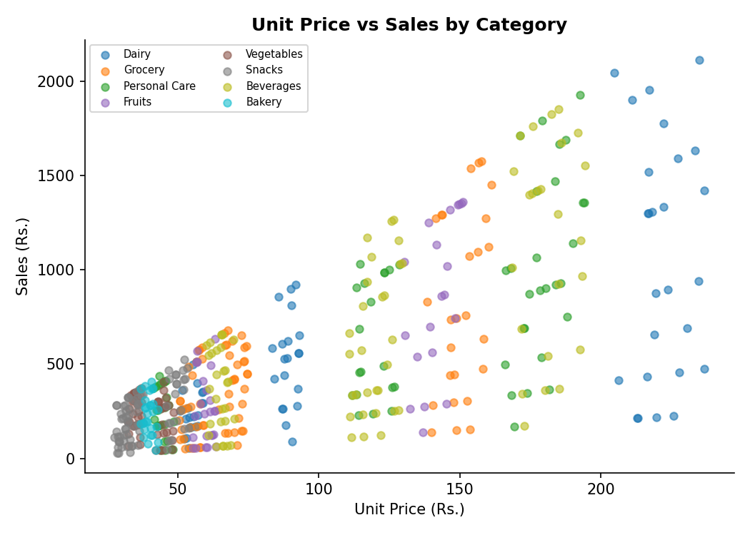

5. Business Recommendations
- Optimize inventory around high performers — prioritize stock of Cheese, other Dairy items, and Beverages (the top category), especially ahead of the April sales peak, to avoid stockouts.
- Study and replicate Branch C's (Mumbai) success — examine its product mix, staffing model, and local promotions, and apply the learnings to Branch A (Jaipur), the weakest performer on both sales and rating.
- Strengthen the digital payment experience — since UPI, Net Banking, and Card already account for ~76% of transactions, invest in uptime, speed, and cashback partnerships to keep this channel frictionless.
- Grow purchase frequency among Normal customers and basket size among Members — Members already visit more often; incentivize larger baskets per visit (bundles, cross-category coupons) to combine loyalty with higher spend.
- Investigate the service gap at Branch A — its combination of lowest sales and lowest rating (3.84) merits a manager-level review, potentially via mystery-shopper audits or targeted staff retraining.
- Launch a rating-uplift initiative — with the fleet average at 3.99, targeted investment in checkout speed, staff training, or store layout could push ratings past 4.5, which is likely correlated with repeat visits and higher lifetime value.

6. Conclusion
The supermarket's sales are driven by a concentrated set of high-value products and one standout branch, while payment behavior is already skewing strongly digital. The clearest opportunities lie in replicating Branch C's model at underperforming locations, deepening engagement with existing Members, and closing the service-quality gap that appears to be constraining Branch A. Acting on these six recommendations should improve both revenue concentration risk and overall customer satisfaction.

