

OPTICAL CARE MANAGEMENT SYSTEM WITH APPOINTMENT SCHEDULING

SAFIO ABDIKADIR HASAN
003290

SAFIO ABDIKADIR HASAN
EAUGRW003290

A THESIS SUBMITTED TO THE FACULTY OF INFORMATION TECHNOLOGY IN PARTIAL FULFILLMENT OF THE REQUIREMENTS FOR THE AWARD OF
BACHELORS DEGREE IN COMPUTER SCIENCE OF
EAST AFRICA UNIVERSITY

OCT, 2026

DECLARATION
I, SAFIO ABDIKADIR HASAN, hereby declare that this graduation thesis project entitled "OPTICAL CARE MANAGEMENT SYSTEM WITH APPOINTMENT SCHEDULING" is my own original work, carried out under the supervision and guidance of the faculty at East Africa University. This work has not been submitted previously in part or in full for any other degree, diploma, or academic qualification at this or any other university or institution of higher learning.
All sources of information, software engineering frameworks, design methodologies, and literature cited in this document have been duly acknowledged in accordance with academic integrity and the APA 6th Edition referencing standards.
Student Name: SAFIO ABDIKADIR HASAN
Registration Number: 003290 / EAUGRW003290
Signature: __________________________________________
Date: __________________________________________

APPROVAL SHEET
This is to certify that the thesis project entitled "OPTICAL CARE MANAGEMENT SYSTEM WITH APPOINTMENT SCHEDULING" submitted by SAFIO ABDIKADIR HASAN (Reg. No: 003290 / EAUGRW003290) in partial fulfillment of the requirements for the award of the Degree of Bachelor of Science in Computer Science from the Faculty of Information Technology / Technology and Engineering at East Africa University, Garowe Campus, has been examined and approved by the thesis committee and academic supervisor.
Supervisor: Engr. Abdirizak Jirde
Signature: ________________________________________________
Date: ________________________________________________
Head of Department:
Signature: ________________________________________________
Date: ________________________________________________
Dean, Faculty of Technology & Engineering:
Signature: ________________________________________________
Date: ________________________________________________

DEDICATION
This work is primarily dedicated to Almighty Allah, the Most Gracious and the Most Merciful, who granted me life, sound health, strength, and intellectual capability to bring this graduation thesis and software project to successful completion.
I lovingly dedicate this achievement to my beloved parents, whose unconditional love, continuous prayers, sacrifices, and tireless moral and financial support have been the cornerstone of my entire academic journey.
I also dedicate this work to my brothers, sisters, friends, and colleagues for their constant encouragement, patience, and companionship throughout my years of undergraduate study.

ACKNOWLEDGEMENTS
All praise and gratitude are due to Almighty Allah for His infinite blessings, divine guidance, and strength that sustained me through all stages of designing, developing, and documenting this Optical Care Management System.
I wish to express my deepest and most sincere appreciation to the administration, faculty, and academic staff of East Africa University (Garowe Campus), particularly the lecturers in the Department of Computer Science, whose exceptional instruction and academic mentorship provided the foundational knowledge required to complete this work.
My profound gratitude goes to my thesis supervisor, Engr. Abdirizak Jirde, for the invaluable guidance, constructive critique, and professional insights provided throughout the formulation, design, implementation, and documentation phases of this project.
Finally, special thanks are extended to the eye clinic practitioners, healthcare professionals, and fellow students who shared their time, insights, and operational feedback during the requirements gathering and evaluation stages of this research.

TABLE OF CONTENTS
DECLARATION i
APPROVAL SHEET ii
DEDICATION iii
ACKNOWLEDGEMENTS iv
TABLE OF CONTENTS v
LIST OF TABLES vii
LIST OF FIGURES viii
LIST OF ABBREVIATIONS ix
ABSTRACT x
CHAPTER ONE: INTRODUCTION 1
Background of the Study 1
Statement of the Problem 2
Objectives of the Study 2
General Objective 2
Specific Objectives 2
Research Questions 3
Scope of the Study 3
Significance of the Study 3
Organization of the Thesis 4
CHAPTER TWO: LITERATURE REVIEW 6
Introduction 6
Review of Related Studies 6
Analysis of Existing Systems 7
Identification of Research Gap 8
Chapter Summary 9
CHAPTER THREE: RESEARCH METHODOLOGY 10
Introduction 10
Research Design 10
Data Collection and Requirement Analysis 11
Software Development Life Cycle (Agile SDLC) 12
Development Tools and Technologies 14
System Architecture Overview 16
Hardware and Software Requirements 15
CHAPTER FOUR: SYSTEM DESIGN AND ARCHITECTURE 18
Introduction 18
Use Case Diagram & Actor Descriptions 19
Layered System Architecture 22
Entity Relationship Diagram (ERD) 23
Data Flow Diagrams (Context Level 0 and Level 1) 25
System Workflow Diagrams 27
Authentication and Role Routing Workflow 27
Patient Workflow 29
Administrator Workflow 30
Database Design & Specifications 31
Database Summary 31
Table Specifications 32
Foreign Key Relationship Summary 37
CHAPTER FIVE: RESULTS AND DISCUSSION 38
Introduction 38
User Interface Screenshots & Module Implementation 38
Core Implementation Artifacts & Source Code 61
ApplicationDbContext (Entity Framework Core 9) 61
Configuration (appsettings.json) 62
Program Configuration & Middleware (Program.cs) 62
Role Seeding and Security 64
System Testing and Verification 65
Discussion of Results & Findings 65
Project Completion Confirmation and Summary 66
CHAPTER SIX: CONCLUSION AND RECOMMENDATIONS 68
Introduction 68
Summary of Findings 68
Conclusion 68
Recommendations for Future Work 69
Final Remarks 70
REFERENCES 71
APPENDIX A: SYSTEM SCREENSHOTS 72
APPENDIX B: SYSTEM DESIGN DIAGRAMS 73
APPENDIX C: SYSTEM ARCHITECTURE AND MODULE DIAGRAMS 74

LIST OF TABLES
Table 2.1: Comparison Between Proposed System and Existing Solutions 7
Table 2.2: Existing System Limitations and Proposed Solutions 8
Table 3.1: Minimum Hardware Requirements 14
Table 3.2: Minimum Software Requirements 15
Table 4.1: Summary of Database Tables 31
Table 4.2: UserAccounts Table Specification 32
Table 4.3: Patients Table Specification 32
Table 4.4: Doctors Table Specification 33
Table 4.5: Appointments Table Specification 33
Table 4.6: ExaminationRecords Table Specification 34
Table 4.7: Prescriptions Table Specification 34
Table 4.8: Frames Table Specification 35
Table 4.9: FrameBookings Table Specification 35
Table 4.10: InventoryItems Table Specification 36
Table 4.11: Foreign Key Relationship Summary 37

LIST OF FIGURES
Figure 4.1: Use Case Diagram of Optical Care Management System 20
Figure 4.2: Layered System Architecture Diagram 22
Figure 4.3: Entity Relationship Diagram (ERD) 24
Figure 4.4: Context Diagram (DFD Level 0) 25
Figure 4.5: Data Flow Diagram (DFD Level 1) 26
Figure 4.6: Authentication and Role Routing Workflow 28
Figure 4.7: Patient Workflow Diagram 29
Figure 4.8: Administrator Workflow Diagram 30
Figure 5.1: Clinic Home Page & Navigation Bar 40
Figure 5.2: Secure User Authentication and Login Page 40
Figure 5.3: Main Administrator Dashboard & Summary Cards 41
Figure 5.4: Patient Management & Records Dashboard 42
Figure 5.5: Doctors & Medical Staff Management Interface 43
Figure 5.6: Appointments & Patient Booking Management Interface 44
Figure 5.7: Doctor Prescriptions & Medications Management 45
Figure 5.8: Optical Inventory & Stock Management Interface 46
Figure 5.9: Patient Frame Bookings Tracking Screen 47
Figure 5.10: System Reports & Operations Analytics Interface 48
Figure 5.11: Clinical Eye Examinations Management 49
Figure 5.12: Patient Portal Dashboard 50
Figure 5.13: Patient Prescriptions & Medications View 51
Figure 5.14: Patient Eye Examination Results View 51
Figure 5.15: Patient Profile & Account Information Management 52
Figure 5.16: Eyeglass Frames Catalog Showcase 53
Figure 5.17: Eyeglass Frame Search & Filtering Interface 54
Figure 5.18: Book Eyeglass Frame Modal / Form 55
Figure 5.19: Patient Active Frame Bookings Screen 57
Figure 5.20: Patient Appointment Booking Interface 57
Figure 5.21: Optometrist / Doctor Personal Dashboard 58
Figure 5.22: Doctor Appointments Schedule View 59
Figure 5.23: Doctor Eye Examination Records Form 59
Figure 5.24: Doctor Prescription & Medication Issuance 60
Figure 5.25: Doctor Assigned Patients Directory 61

LIST OF ABBREVIATIONS
2FA Two-Factor Authentication
AI Artificial Intelligence
API Application Programming Interface
ASP.NET Active Server Pages .NET
C# C Sharp (Object-Oriented Programming Language)
CSS Cascading Style Sheets
DFD Data Flow Diagram
EAU East Africa University
EF Core Entity Framework Core
EMR Electronic Medical Records
ERD Entity Relationship Diagram
FK Foreign Key
HTML HyperText Markup Language
IDE Integrated Development Environment
IST Information Science and Technology
MVC Model-View-Controller
ORM Object-Relational Mapping
PK Primary Key
QR Quick Response (Code)
RBAC Role-Based Access Control
RDBMS Relational Database Management System
SDLC Software Development Life Cycle
SQL Structured Query Language
SSMS SQL Server Management Studio
UAT User Acceptance Testing
UI User Interface
UML Unified Modeling Language
UX User Experience
WHO World Health Organization

ABSTRACT
In contemporary healthcare delivery, optical clinics play an indispensable role in diagnosing visual impairments, prescribing corrective lenses, and providing essential eyecare services. However, many optical healthcare facilities continue to rely on manual, paper-based workflows or fragmented, generic record systems. These conventional practices frequently lead to extended patient waiting times, disorganized appointment queues, misplaced clinical history records, inefficient eyeglass frame inventory tracking, and cumbersome administrative reporting. To address these operational challenges, this thesis project presents the design, development, and implementation of the Smart Optical Care Management System with Appointment Scheduling, an integrated web-based healthcare software application tailored specifically to the operational demands of optical clinics. The system was engineered utilizing modern enterprise technologies, including the ASP.NET Core 9 Model-View-Controller (MVC) framework, C#, Entity Framework Core 9 Code-First Object-Relational Mapping (ORM), Microsoft SQL Server, Bootstrap 5, and JavaScript. Following the Agile Software Development Life Cycle (SDLC) methodology, iterative sprints were conducted to gather user requirements, model structural and behavioral processes, construct relational database schemas, and build modular user interfaces. The system incorporates Role-Based Access Control (RBAC) across three primary user roles: System Administrators, Optometrists/Doctors, and Patients. Key functional modules include online patient self-registration, real-time appointment scheduling, comprehensive clinical eye examination recording, prescription and medication issuance, an interactive eyeglass frame catalog with reserve-and-booking capabilities, automated optical inventory stock management, and analytical reporting with tabular data export features. Comprehensive system verification—encompassing functional testing, integration testing, and user acceptance testing (UAT)—demonstrated that the system successfully automates core clinic operations, eliminates paper record redundancy, streamlines patient throughput, and guarantees secure data persistence. The findings confirm that specialized digital solutions like the Optical Care Management System dramatically enhance service efficiency, clinical accountability, and patient satisfaction in modern optical healthcare facilities.

Keywords: Optical Care Management, Appointment Scheduling, Electronic Medical Records (EMR), ASP.NET Core MVC, Entity Framework Core, SQL Server, Eye Clinic System.

CHAPTER ONE
INTRODUCTION
Background of the Study
The Smart Optical Care System with Appointment Scheduling is a computer system that helps manage eye care services. This system puts records and appointment scheduling together in one place so eye clinics can give people good care. More and more people need eye care so clinics need new systems to handle information and run the clinic every day.
As observed by Cayirli and Veral (2006), poorly organized appointment scheduling in ambulatory and outpatient healthcare facilities inevitably results in extended patient waiting times, scheduling conflicts, and provider idle time. In optical settings, Evans, Acton, Hiscott, and Gartner (2023) demonstrated that automated, multi-criteria patient scheduling significantly mitigates appointment bottlenecks and improves overall clinic resource utilization. A lot of eye clinics still use ways to manage patient records and schedule appointments. They keep information in paper files and make appointments using books, phone calls or by visiting the clinic. These methods have been used for a time but they can cause problems like lost records trouble finding information, appointment mistakes and long wait times. These problems can make the clinic less efficient. Make patients unhappy.
The Smart Optical Care System with Appointment Scheduling helps with these problems by doing office work automatically. The system lets healthcare workers store records on computers manage appointments track prescriptions and make reports easily. Patients can also book appointments online without going to the clinic, which makes it easier for them to get care.
Scheduling appointments is a part of the system. Managing appointments well helps reduce crowds shorten wait times and improve communication between patients and healthcare workers. With scheduling eye clinics can organize their daily work better and make sure patients get care on time.
The Smart Optical Care System with Appointment Scheduling is a way to improve eye care services. By putting patient records and appointment scheduling the system can make the clinic run more smoothly make patients happier and help give people good eye care. The Smart Optical Care System with Appointment Scheduling is very important for eye clinics because it helps them give care to patients. The Smart Optical Care System with Appointment Scheduling makes it easier for patients, to book appointments. Get the care they need..
Problem Statement
Efficient management of patient records and appointment scheduling is essential for the effective operation of any healthcare facility. However, many optical clinics continue to rely on manual methods such as paper-based record keeping, telephone reservations, and walk-in appointment scheduling. These traditional approaches are often inefficient, time-consuming, and vulnerable to human error.
Manual appointment scheduling can create difficulties for both patients and clinic staff. Patients may experience delays when booking appointments, especially during busy clinic hours. In some cases, appointments may be missed, duplicated, or incorrectly recorded, leading to confusion and inconvenience. Long waiting times and poor scheduling practices can negatively affect patient satisfaction and reduce the quality of services provided.
Managing patient records manually also presents significant challenges. Paper-based records can be misplaced, damaged, or difficult to retrieve when needed. This may delay diagnosis and treatment, affect decision-making, and reduce the efficiency of healthcare service delivery. In addition, clinic administrators often spend considerable time organizing records, managing appointments, and preparing reports.
The absence of an integrated digital platform limits the ability of optical clinics to provide efficient and organized services. Patients increasingly expect convenient online services that allow them to book appointments and access healthcare information easily. Without modern technological solutions, optical clinics may struggle to meet these expectations and remain competitive in a rapidly evolving healthcare environment.
Therefore, there is a need for a Smart Optical Care System with Appointment Scheduling that can automate appointment management, improve record keeping, enhance communication, and increase the overall efficiency of optical healthcare services.
Objectives of the Study
General Objective
To design and implement a Smart Optical Care System with Appointment Scheduling that improves patient management and enhances the efficiency of optical healthcare service delivery.
Specific Objectives
The specific objectives of the study are:
To examine the existing methods used for managing patient records and scheduling appointments in optical clinics.
To design and develop a user-friendly Smart Optical Care System for managing optical healthcare services.
To enable patients to schedule appointments electronically through the system.
To provide secure storage and management of patient records and appointment information.
To evaluate the effectiveness, usability, and performance of the developed system.
Scope of the Study
This study focuses on the design and development of a Smart Optical Care System with Appointment Scheduling intended to improve patient management and appointment scheduling processes within optical clinics. The system is designed to serve patients, optical healthcare professionals, and clinic administrators.
The proposed system will include several important features such as patient registration, online appointment scheduling, appointment management, patient record management, prescription tracking, report generation, and schedule monitoring. Patients will be able to create accounts, schedule appointments, and access relevant information regarding their healthcare services. Optical healthcare professionals and administrators will be responsible for managing appointments, updating patient information, maintaining records, and monitoring clinic activities.
The study covers the analysis, design, development, testing, and evaluation of the proposed system. However, it is limited to the operations of a single optical clinic and does not include advanced functionalities such as online payment processing, inventory management, telemedicine services, or integration with external healthcare systems. These features may be considered in future improvements of the system.
Significance of the Study
Benefits to Patients
The proposed system will provide patients with a convenient and efficient method of scheduling appointments. Patients will be able to access services more easily, reduce waiting times, and receive improved healthcare experiences. The availability of organized patient records will also contribute to better continuity of care.
Benefits to Optical Healthcare Professionals
The system will enable healthcare professionals to access patient information quickly and manage appointments more effectively. This will improve workflow efficiency, support informed decision-making, and contribute to better patient outcomes.
Benefits to Clinic Administrators
The proposed system will assist administrators in managing appointments, maintaining records, generating reports, and reducing paperwork. Automation of these tasks will improve productivity and enhance overall clinic performance.
Academic Significance
This study will contribute to the existing body of knowledge related to healthcare information systems, appointment scheduling technologies, and digital healthcare solutions. It may serve as a useful reference for students, researchers, and developers interested in healthcare system development.
Benefits to Healthcare Institutions
Healthcare institutions can benefit from adopting modern information systems that improve service quality, operational efficiency, and patient satisfaction. The study demonstrates how technology can be used to address common challenges in healthcare administration and service delivery.
Organization of the Thesis
This thesis is organized into six comprehensive chapters. Chapter One presents the introduction, problem statement, research objectives, research questions, scope, and significance of the study. Chapter Two provides a detailed literature review and comparative analysis of existing healthcare management systems. Chapter Three outlines the research methodology, data collection techniques, and Agile software development lifecycle. Chapter Four details the system design, layered architectural framework, relational database models, and operational workflows. Chapter Five presents the system implementation results, core module walkthroughs, security configurations, and verification testing findings. Finally, Chapter Six concludes the research, summarizes major achievements, and provides actionable recommendations for future enhancements.

CHAPTER TWO
LITERATURE REVIEW
Review of Related Studies
Enterprise management information systems play a transformative role in contemporary healthcare institutions by providing reliable digital infrastructure for operational efficiency, transaction processing, and strategic clinical decision-making (Laudon & Laudon, 2022). In the specialized domain of optometry and ophthalmology, Azameti, Koi-Akrofi, Agbodo, and Amegadzie (2022) conducted a comprehensive investigation into model-driven optical clinic management systems, emphasizing that customized software architectures are critical for managing patient eye examination records, digital prescriptions, and retail eyewear stock without data redundancy.
Research on appointment scheduling systems demonstrates that automated web-based scheduling is vital for managing outpatient visits and improving patient throughput (Cayirli & Veral, 2006). Kuiper, de Mast, and Mandjes (2021) investigated outpatient scheduling across diverse clinical practices and determined that unmanaged appointment variance and rigid scheduling policies are the root causes of clinic congestion and prolonged patient waiting times. Furthermore, Chogo and Musinga (2012) designed and implemented an interactive patient appointment booking information system, demonstrating that digital self-service booking significantly reduces administrative burdens at reception desks and minimizes appointment overlap. Similarly, Kyambille and Kalegele (2016) demonstrated that integrating accessible web and mobile platforms into clinic appointment scheduling substantially cuts down missed consultations and enhances patient compliance.
These systems help doctors and nurses manage records, schedule appointments and keep medical information on computers.
This helps to reduce paperwork minimize mistakes and improve the way services are delivered.
Many studies have shown that appointment scheduling systems are really useful for managing visits.
These systems let patients book appointments online which reduces waiting times and improves communication between patients and healthcare providers.
Online appointment scheduling makes patients happier because services become more accessible and convenient.
Research on patient management systems shows that electronic medical record systems are great for storing, retrieving and keeping information secure.
These systems help healthcare institutions keep records, which supports good decision-making.
In eye clinics digital systems can help manage eye examination records, prescriptions and patient histories.
Web-based healthcare systems are becoming popular because they let patients access healthcare services remotely.
Patients can look up information and schedule appointments without having to physically visit the clinic.
These systems improve efficiency and reduce the administrative workload.
However many eye clinics still use methods to manage appointments and patient records.
These traditional approaches can cause delays, data loss, scheduling conflicts and reduced service quality.
Therefore there is a need for a Smart Optical Care System, with Appointment Scheduling to improve eye healthcare service delivery.
Analysis of Existing Systems
Table 2.1: Comparison of Existing Systems and Proposed System
Table 2.1: Comparison Between Proposed System and Existing Solutions
Proposed Smart Optical Care System | Optical Clinic Management System | Eye Care Appointment System | Eye Care Appointment System
This project is developed as a web-based optical care system with appointment scheduling. | This project is developed as a web-based clinic management system. | This project is developed as an online eye care appointment system. | This project is developed as a healthcare management system.
The system allows patients  to register, book appointments, and access eye care services online. | The system manages patient records and clinic operations. | The system allows patients to schedule appointments online. | The system manages patient and hospital information.
The system stores eye examination records, prescriptions, and patient information digitally. | The system stores patient information and prescription records. | The system mainly focuses on appointment booking services. | The system stores medical records and healthcare data.
The system provides automated notifications and appointment reminders. | Notification services are limited. | The system provides appointment confirmations. | Notification services are limited.
Uses: Waterfall Methodology | Uses: Waterfall Methodology | Uses: Agile Methodology | Uses: Agile Methodology
Comparative Analysis
The table above looks at the Smart Optical Care System and how it compares to other systems that already exist. The Optical Clinic Management System is about keeping track of patient records and how the clinic runs. The Eye Care Appointment System is good for scheduling appointments. It does not do a great job of managing optical healthcare records. The Hospital Management System can handle a lot of healthcare tasks. It is not made specifically for clinics that deal with eyes. The Smart Optical Care System is special because it combines things like scheduling appointments, managing patient records keeping track of eye exams handling prescriptions and sending out notifications all in one place, which makes it very useful for people who need optical healthcare services. The Smart Optical Care System is really good, for healthcare because it has all these features in one place.
Identification of Research Gap
Table 2.2: Existing System Limitations and Proposed System Solutions
Existing System Limitation | Explanation | Proposed System Solution
Lack of Optical-Specific Systems | Most existing systems are general hospital or clinic systems not focused on optical care. | The proposed system is specifically designed for optical clinics.
No Integrated Appointment Scheduling | Some systems do not support online appointment booking. | The proposed system provides full online appointment scheduling.
No Automated Notifications | Patients are not reminded about appointments in many systems. | The proposed system includes SMS/notification reminders.
Manual Record Management | Some clinics still use paper-based records. | The proposed system stores all patient records digitally.
Limited Prescription Management | Existing systems do not properly manage eye prescriptions. | The proposed system includes full prescription management.
Lack of Centralized System | Data is scattered in different systems or files. | The proposed system provides a centralized database.
Comparative Analysis
The table above shows us where the problems are in the systems we have now for optical and healthcare. A lot of these systems do not have services for optical care and they do not have things, like scheduling appointments, managing prescriptions and sending out reminders. So the Smart Optical Care System we are talking about tries to fix these problems by giving clinics a simple and easy to use system. This system is designed for optical clinics and it helps them to
work better. The Smart Optical Care System is a place where clinics can do all these things and it is designed to be easy for people to use.

CHAPTER THREE
RESEARCH METHODOLOGY
Introduction
According to Pressman and Maxim (2020), disciplined software engineering lifecycle models are essential for delivering reliable, maintainable systems that satisfy stakeholder requirements through continuous iteration and feedback. Sommerville (2016) similarly emphasizes that iterative software development and structured verification cycles—encompassing unit testing, system integration, and user acceptance testing—are indispensable for guaranteeing software quality and clinical accountability. Furthermore, structured systems analysis requires rigorous requirement elicitation, process modeling using Data Flow Diagrams (DFDs), and architectural layering to decouple presentation, business logic, and data storage (Dennis, Wixom, & Roth, 2020). In this chapter I will introduce the framework and system design process used to develop the Smart Optical Care System with Appointment Scheduling.
This chapter covers the research design, data collection and requirements analysis.
It also explains the development process, including the Agile SDLC and the tools and technologies used.
The system architecture is also discussed in detail.
The goal of this chapter is to outline the process and technology used to design and develop an efficient optical care management system.
This system aims to link clinics and patients through a centralized database environment.
The proposed Smart Optical Care System is designed to improve management.
It also enhances doctor scheduling and optical prescription management.
The system allows for appointment tracking and information sharing among staff.
All of this is done through an centralized database environment, which is a key part of the Smart Optical Care System.
The Smart Optical Care System will help patients and optical clinics.
It will make it easier for patients to schedule appointments and for clinics to manage their operations.
Research Design
The study used the Design and Development Research Methodology.
This approach was picked because the goal is to create a software system.
The system should solve problems in administration.
It should also handle appointment overlapping and medical record management.
The Design and Development Research Methodology provides a steps.
These steps include:
- Identifying system requirements
- Designing and developing software elements
- Testing the systems performance
- Deploying the system
The Design and Development Research Methodology was used to develop the software system.
This software system is for administration, patient appointment overlapping and medical record management.
The research design was chosen for its approach, to system development.
It offers a way to ensure the software meets the needs.
The Design and Development Research Methodology helps to identify and test system requirements.
Data Collection and Requirement Analysis
We collected a lot of information. Looked at what the system needs to work properly. To do this we watched how the clinic runs, studied how patients are taken care of and checked out the way of booking appointments. What we found was that there are some issues with the systems used for managing eye care.
For example it is hard to get the information when you need it and sometimes the doctors schedules conflict with each other. There are also problems with keeping information safe and managing prescriptions, for glasses.
So we think the new system should be able to help with things like signing up patients, scheduling appointments managing the staff at the clinic keeping track of prescriptions for glasses monitoring everything from a main dashboard and sharing information with the right people in a secure way. The new system should be able to do all these things for optical care management.
Development Framework
The Smart Optical Care System is built using the tools for making websites. These tools include ASP.NET Core MVC, C# SQL Server, HTML, CSS, Bootstrap and JavaScript. We chose these tools because they are flexible, secure and easy to maintain.
The Smart Optical Care System uses ASP.NET Core MVC, which's a good way to make applications. This way the parts of the application that do the work and the parts that users see are separate.
The Smart Optical Care System also uses SQL Server to store appointment information. SQL Server is a choice because it keeps this information safe and organized. The Smart Optical Care System is made to be flexible and secure which is important for storing information.
The Smart Optical Care. Its tools, like ASP.NET Core MVC and SQL Server work well together to make a good system.
Agile SDLC Phases for the System
The Smart Optical Care System was made using the Agile Software Development Life Cycle. We chose Agile because it helps us make the system better all the time. With Agile we can keep making the booking and optical care system better by trying new things and making changes. This way the Smart Optical Care System gets improved over time.
Requirement Gathering
The requirement gathering stage was, about figuring out what the optical institution needed.
We looked at what functions they needed.
These functions included:
- Patient registration
- Doctor appointment scheduling
- Logging prescriptions
- Managing clinic staff
- Viewing dashboards
- Generating reports
All this information helped us design the system.
The requirements we gathered were used to create the proposed system design.
Design the Requirements
When we finished gathering all the requirements we used them to create designs. While we were working on the design we made plans, for the system architecture, database design, user interface design and how people would move through the system. We made sure to think about security how easy the system is to use and how well it can handle a lot of work. The system can handle scheduling appointments in real time and keep patient information private. We wanted the optical scheduling system to work well and protect confidentiality.
Coding
When I was working on the coding part I had to make sure that the system could do a lot of things. I used ASP.NET Core MVC and C# to make this happen.
I made parts of the application and connected them to the database.
The coding part was really important because I had to make sure that the system was secure.
Some of the things I worked on during this time include making sure that users could log in safely managing information, booking appointments keeping track of optical prescriptions and monitoring what was going on with the clinical dashboard.
I did a lot of work on the information management and the appointment slot booking engine.
The clinical dashboard monitoring and the optical prescription recording were also very important.
I used ASP.NET Core MVC and C# to make all of these things work together.
The system had to be able to do all of these things so I spent a lot of time on the coding part.
I worked on the user authentication and the patient information management.
I also worked on the appointment slot booking engine and the optical prescription recording.
The clinical dashboard monitoring was very important so I made sure that it was working correctly.
I used C# and ASP.NET Core MVC to make the system work the way it was supposed to.
Testing
The system was tested to make sure everything worked the way it was supposed to. We did these tests to check how well the system performed if the data was correct if bookings were reliable and if the system was secure. The tests made sure that data could be stored looked at updated and taken care of without any problems, with the system. We tested the system to ensure that the data validation was accurate and the cryptographic security was good. The system testing also checked the booking reliability to make sure it worked properly.
Deployment
On completion of the testing process the application was deployed into the environment it was meant for.
The deployment process was quite involved.
It included setting up the server that would host the web application configuring the database to connect and getting the system ready to be used.
This step was crucial because it allowed patients, clinic staff and optometrists to use the system.
They could access the system functionalities through the platform that was set up for them.
The system was now ready for use, by authorized users.
Maintenance
The people who take care of the Smart Optical Care System do maintenance work after it is set up. They do this to make sure the Smart Optical Care System keeps working. This maintenance work includes things like fixing problems with the software doing updates on the system from time to time making the database work better and making the Smart Optical Care System more secure. Doing maintenance work, on the Smart Optical Care System helps it last longer and work over time for the Smart Optical Care System.
Tools and Technologies Used
The people who take care of the Smart Optical Care System do maintenance work after it is set up. They do this to make sure the Smart Optical Care System keeps working. This maintenance work includes things like fixing problems with the software doing updates on the system from time to time making the database work better and making the Smart Optical Care System more secure. Doing maintenance work, on the Smart Optical Care System helps it last longer and work over time for the Smart Optical Care System.
Table 3.1 Tools and Technologies Used
Technology | Category | Purpose
ASP.NET Core MVC | Framework | Backend application development and business logic implementation
C# | Programming Language | Development of server-side functionalities and scheduling algorithms
SQL Server | Database Management System | Secure storage and relational management of patient records and slots
HTML5 | Markup Language | Structuring web pages and client-side optical portal interfaces
CSS3 | Styling Language | Designing and formatting user dashboards and clinic interfaces
Bootstrap | Frontend Framework | Creating responsive cross-platform layouts for mobile and web views
JavaScript | Scripting Language | Implementing real-time interactive functionalities and client validations
Visual Studio 2022 | Development Environment | Integrated environment for coding debugging and project management
GitHub | Version Control System | Source code management precise tracking and remote collaboration
Table 3.2: Software Configuration
Software Component |  |  | Specification
Operating System |  |  | Windows 10 Pro (64-bit)
Development Framework |  |  | ASP.NET Core MVC
Programming Language |  |  | C#
Front-End Technologies |  |  | HTML5 / CSS3 / Bootstrap / JavaScript
Database Management System |  |  | SQL Server
ORM Framework |  |  | Entity Framework Core
Development Environment |  |  | Visual Studio 2022
Version Control |  |  | Git & GitHub
Browser |  |  | Google Chrome / Mozilla Firefox / Microsoft Edge
Development Environment | Visual Studio 2022
Version Control | Git & GitHub
Browser | "Google Chrome | Mozilla Firefox |  | Microsoft Edge"
Table 3.3: Hardware Configuration
Hardware Component | Specification
Processor | Intel® Core™ i7-7600U CPU @ 2.80GHz ~ 2.90 GHz
Memory (RAM) | 16 GB RAM
Operating System Architecture | 64-bit Architecture
DirectX Version | DirectX 12
Display Device | Integrated Display (Laptop Screen)
Keyboard | Standard Laptop Keyboard
Pointing Device | Touchpad / External Mouse
Network Connectivity | Wi-Fi / Ethernet / Internet / Intranet Support
System Architecture and Framework
The Smart Optical Care System is made up of an internet based system. This system lets people who use it talk to each other. Use the things the application offers. It also lets them look at the database. The system is built to make sure it works well and that people can look at optical records safely. The application was implemented using the ASP.NET Core 9 MVC framework, adhering to enterprise architectural standards established by Microsoft Corporation (2024a). Data persistence and object-relational mapping were facilitated via Entity Framework Core 9 (Microsoft Corporation, 2024b), enabling type-safe database queries and automated schema migrations. The relational database schema was deployed on Microsoft SQL Server (Microsoft Corporation, 2024c), providing robust ACID compliance, referential integrity, and secure storage for patient records.
The Smart Optical Care System architecture is shown below:
Presentation Tier (Frontend)
The Presentation Layer is the part of the system that people actually use. This is where patients, administrators and doctors interact with the system. It shows them the information they need and lets them put in their information.
The front part of the system is made using HTML, CSS, Bootstrap and JavaScript so it looks good and works well on devices. The main things you can do on the system are the Login Page, Portal Dashboard, Patient Profile Management, Doctor Appointment Scheduling, Prescription Records and Dynamic Search. The Presentation Layer is what makes all these things work for the patients, administrators and doctors.
Application Tier (Backend)
The Application Tier is where the business logic of the application is. It is like a man between the part that users see and the database. The backend of the application is built using ASP.NET Core MVC and C#. The Application Tier takes care of things like making sure users are who they say they are booking appointments, managing records figuring out time slots and creating reports, about what is going on. The Application Tier does all these things to support the application.
Data Tier (Database)
The Data Tier is responsible for keeping all the data that the system uses. It stores the data in a place and makes it easy to get to when you need it. The system uses a SQL Server database to store things, like biometric details, clinical optometrist slots, optical center logs and reservation history. It also keeps track of what the usersre doing in the system, which is called user activity audit trails. The Data Tier is very important because it keeps all of this data safe and organized.
The Data Tier is used for storing biometric details and clinical optometrist slots. It is also used for storing center logs and reservation history. The Data Tier stores user activity audit trails that happen in the system. This means the Data Tier is always keeping track of what's going on in the system. The Data Tier is a part of the system because it stores all of the data in one place.
References

CHAPTER FOUR
SYSTEM DESIGN AND ARCHITECTURE
Introduction
This chapter presents the architectural and detailed technical design of the Optical Care Management System with Appointment Scheduling. Building on the software requirements and Agile methodology established in the preceding chapters, this chapter translates functional and non-functional requirements into concrete structural and behavioral design artifacts. The design begins with the Use Case Diagram defining system actors and interactions, followed by the N-Tier System Architecture, the Entity Relationship Diagram (ERD), Level 0 and Level 1 Data Flow Diagrams (DFDs), and detailed System Workflow Diagrams. Finally, the chapter details the comprehensive database design, specifying all normalized tables, attributes, primary keys, and foreign key constraints implemented in Microsoft SQL Server using Entity Framework Core 9.

Use Case Diagram
The use case diagram identifies the two actors who interact with the Optical Care Management System and the principal functions each actor can perform. A Patient is any user who registers and signs in to manage their own appointments, frame reservations and clinical records. An Administrator is a member of clinic staff who manages patient, doctor, appointment, frame booking, clinical and inventory records, and who generates reports.
Login is shared by both actors, since every session begins with the same authentication check regardless of role. Generate Reports includes two further use cases, Export to Excel and Print Report, representing the two output formats the administrator may choose once a report is generated.
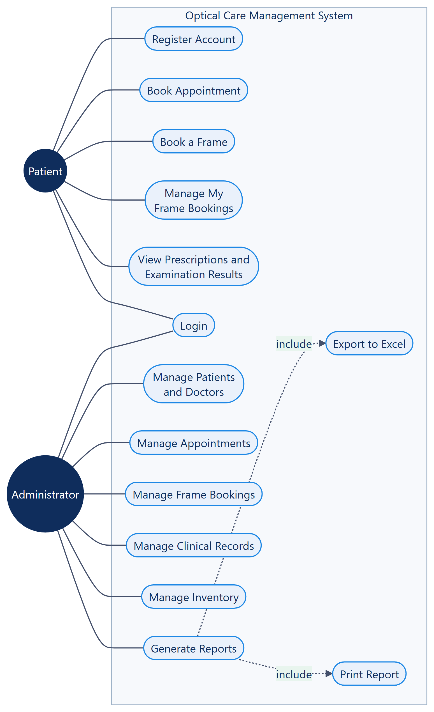
Figure 4.1: Use Case Diagram of the Optical Care Management System

System Architecture Diagram
The Optical Care Management System is implemented as a five-tier layered architecture. Each layer communicates only with the layer directly beneath it, which keeps presentation concerns separate from business rules and from data persistence. This separation makes the system easier to test, maintain and extend.
The Client Tier is the user's web browser. The Presentation Layer is an ASP.NET Core 9 MVC application whose middleware pipeline authenticates each request before routing it to the appropriate controller, which then renders a Razor view. The Business Logic Layer enforces authentication, role-based authorisation and model validation, and hosts application services such as Excel report generation. The Data Access Layer uses Entity Framework Core 9 to translate object operations into SQL, and the Database Tier stores all persistent data in Microsoft SQL Server.
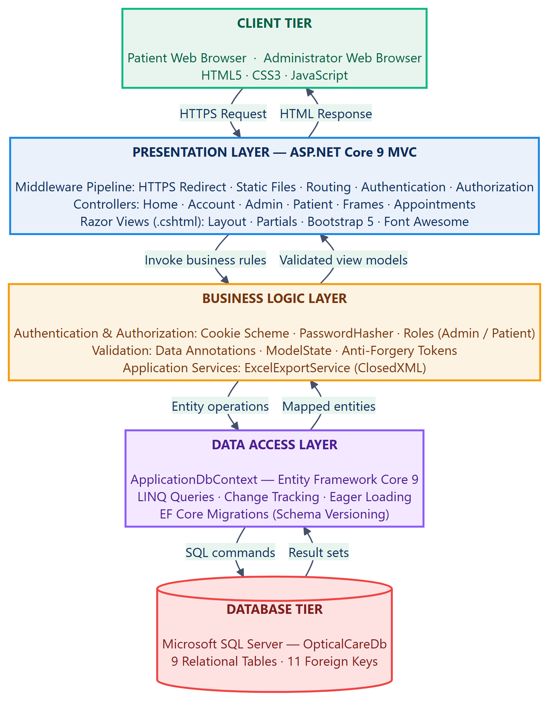
Figure 4.2: Layered System Architecture Diagram

Entity Relationship Diagram (ERD)
The entity relationship diagram below models the nine entities that make up the system database, together with their attributes and the relationships between them. Primary keys are marked PK and foreign keys are marked FK. Attributes that permit a null value are annotated NULL. For readability the diagram shows base data types only; exact column lengths and precision are given in Section 6.
UserAccounts is the authentication entity and is optionally linked to either a Patient or a Doctor profile, allowing both groups to sign in through a single credential store. Patients and Doctors are the two principal participants in the clinical entities: Appointments, ExaminationRecords and Prescriptions. A Prescription is additionally tied to the ExaminationRecord from which it was derived, preserving full clinical traceability. FrameBookings links a Patient to a Frame from the product catalogue, while InventoryItems is an independent entity used for stock control.

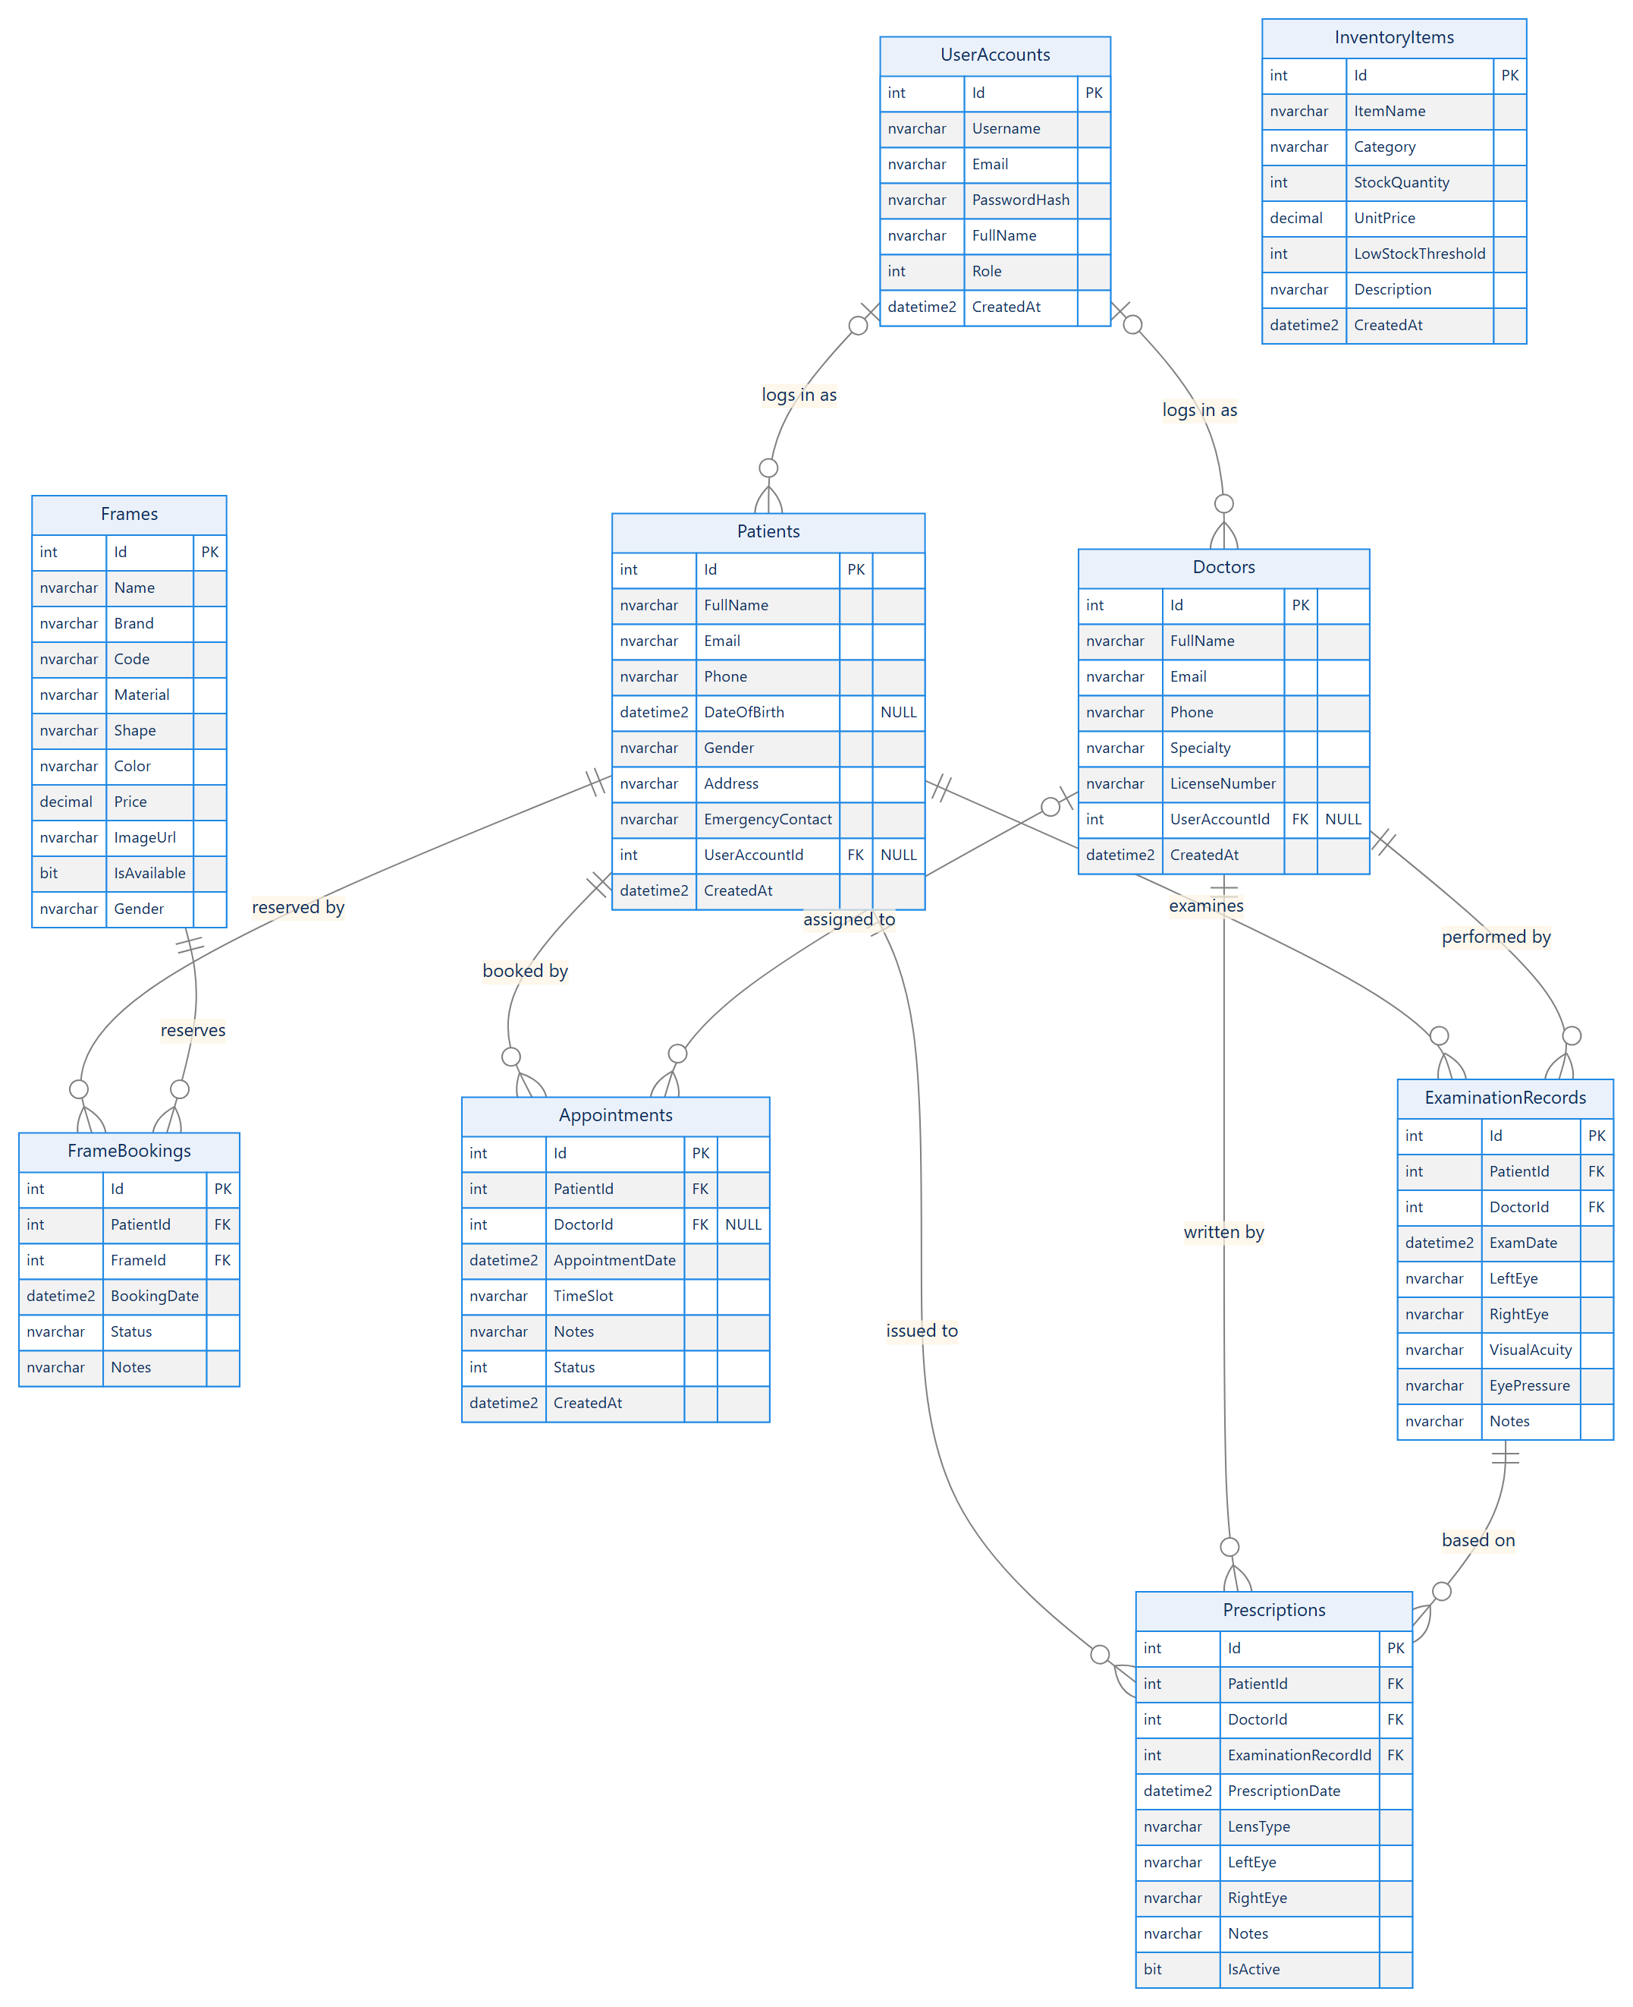
Figure 3: Entity relationship diagram showing all nine entities and eleven relationships

Data Flow Diagrams
The data flow diagrams describe how information moves through the system. The context diagram establishes the system boundary and the two external entities that interact with it, while the level 1 diagram decomposes the system into its six major processes and shows the data stores each process reads from and writes to.

Context Diagram (Level 0)
The context diagram represents the entire system as a single process. Two external entities interact with it: the Patient, who registers, books appointments and reserves frames; and the Administrator, who manages clinical records, approves bookings and generates reports.
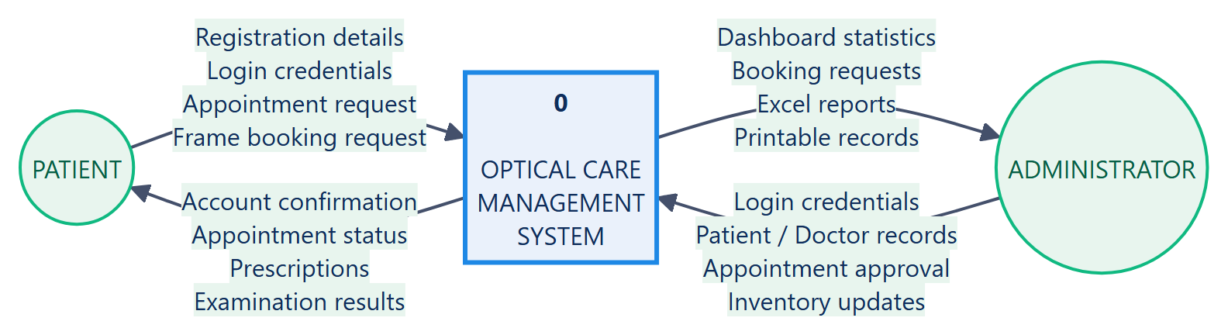
Figure 4.4: Context Diagram (DFD Level 0)

Data Flow Diagram (Level 1)
The level 1 diagram expands the single process of the context diagram into six sub-processes: Manage Authentication, Manage Appointments, Manage Clinical Records, Manage Frames and Bookings, Manage Inventory, and Generate Reports and Exports. Six data stores correspond to the underlying database tables. Arrows show the direction in which data travels between external entities, processes and stores.
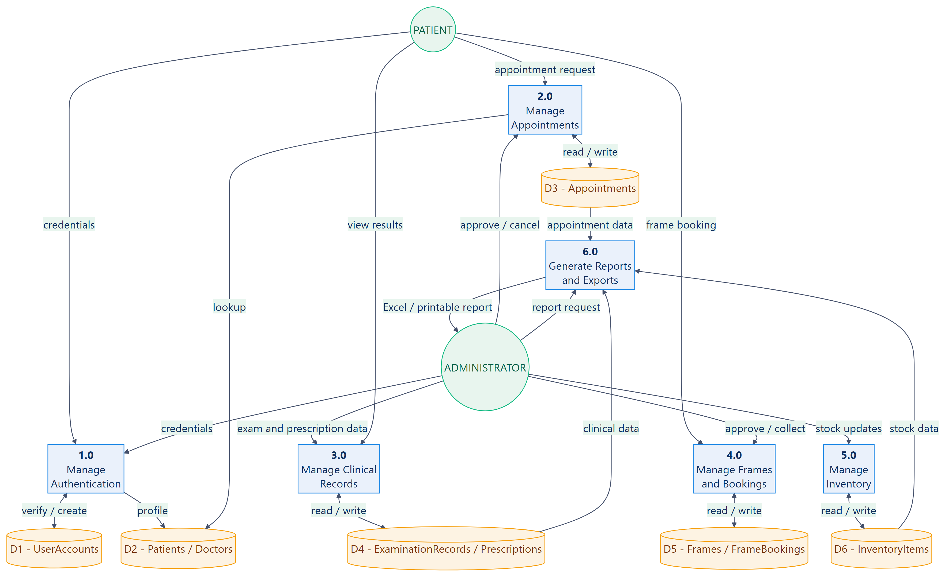
Figure 4.5: Data Flow Diagram (DFD Level 1)

System Workflow Diagrams
The workflow diagram traces the sequence of activities a user performs from the moment the system is opened. A visitor either registers a new account, which is always created with the Patient role, or signs in with existing credentials. Once the credentials are verified the system branches according to the user's role.
A patient may book an appointment by choosing a date, time slot and preferred doctor, browse and reserve a frame from the catalogue, or view their prescriptions and examination results. Both appointments and frame bookings are created with a Pending status and await confirmation. An administrator reviews those pending requests and either approves or cancels them, manages the clinical and inventory records, and generates reports that can be printed or exported to Excel. A frame booking that is approved may subsequently be marked as Collected, at which point the frame is automatically flagged unavailable in the catalogue.
Because the complete workflow spans both user roles, it is presented in three parts for clarity: the authentication and role-routing sequence common to all users (Figure 6), the patient workflow (Figure 7) and the administrator workflow (Figure 8).

Authentication and Role Routing
Every session begins with authentication. A visitor who is not yet registered creates an account, which the system always assigns the Patient role; administrator accounts are granted separately. Credentials are verified against the hashed password stored in UserAccounts, and the user is then routed to the dashboard that corresponds to their role.
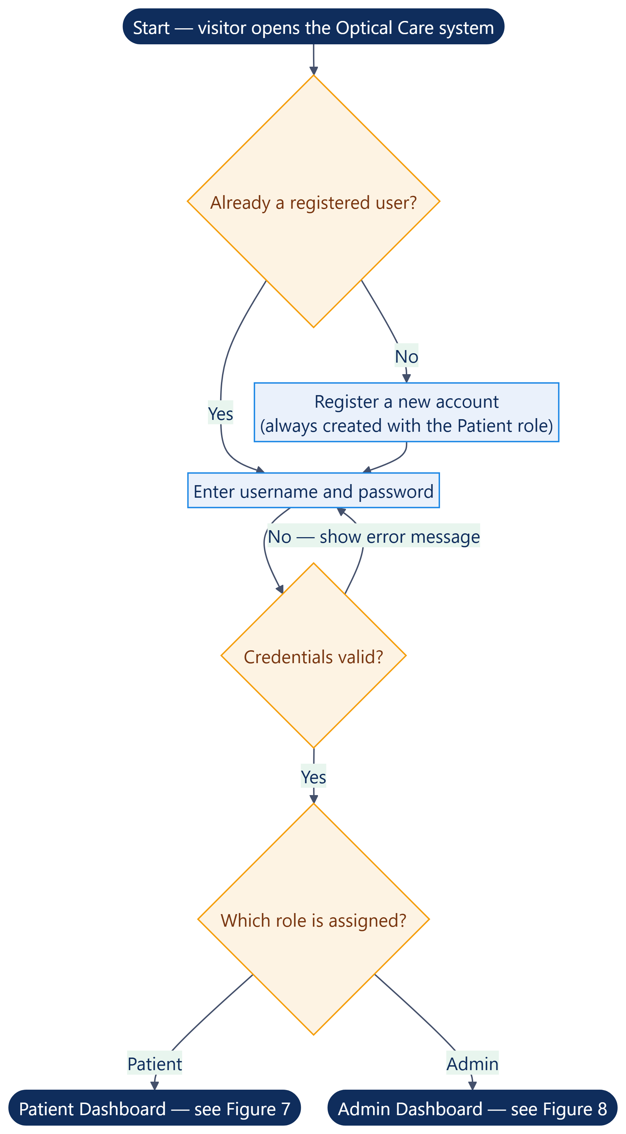
Figure 4.6: Authentication and Role Routing Workflow

Patient Workflow
From the patient dashboard a patient may book an appointment by choosing a date, time slot and preferred doctor; browse the frame catalogue and reserve a frame; view their prescriptions and examination results; or manage and cancel their own pending frame bookings. Both appointments and frame bookings are created with a Pending status and await confirmation by the clinic.
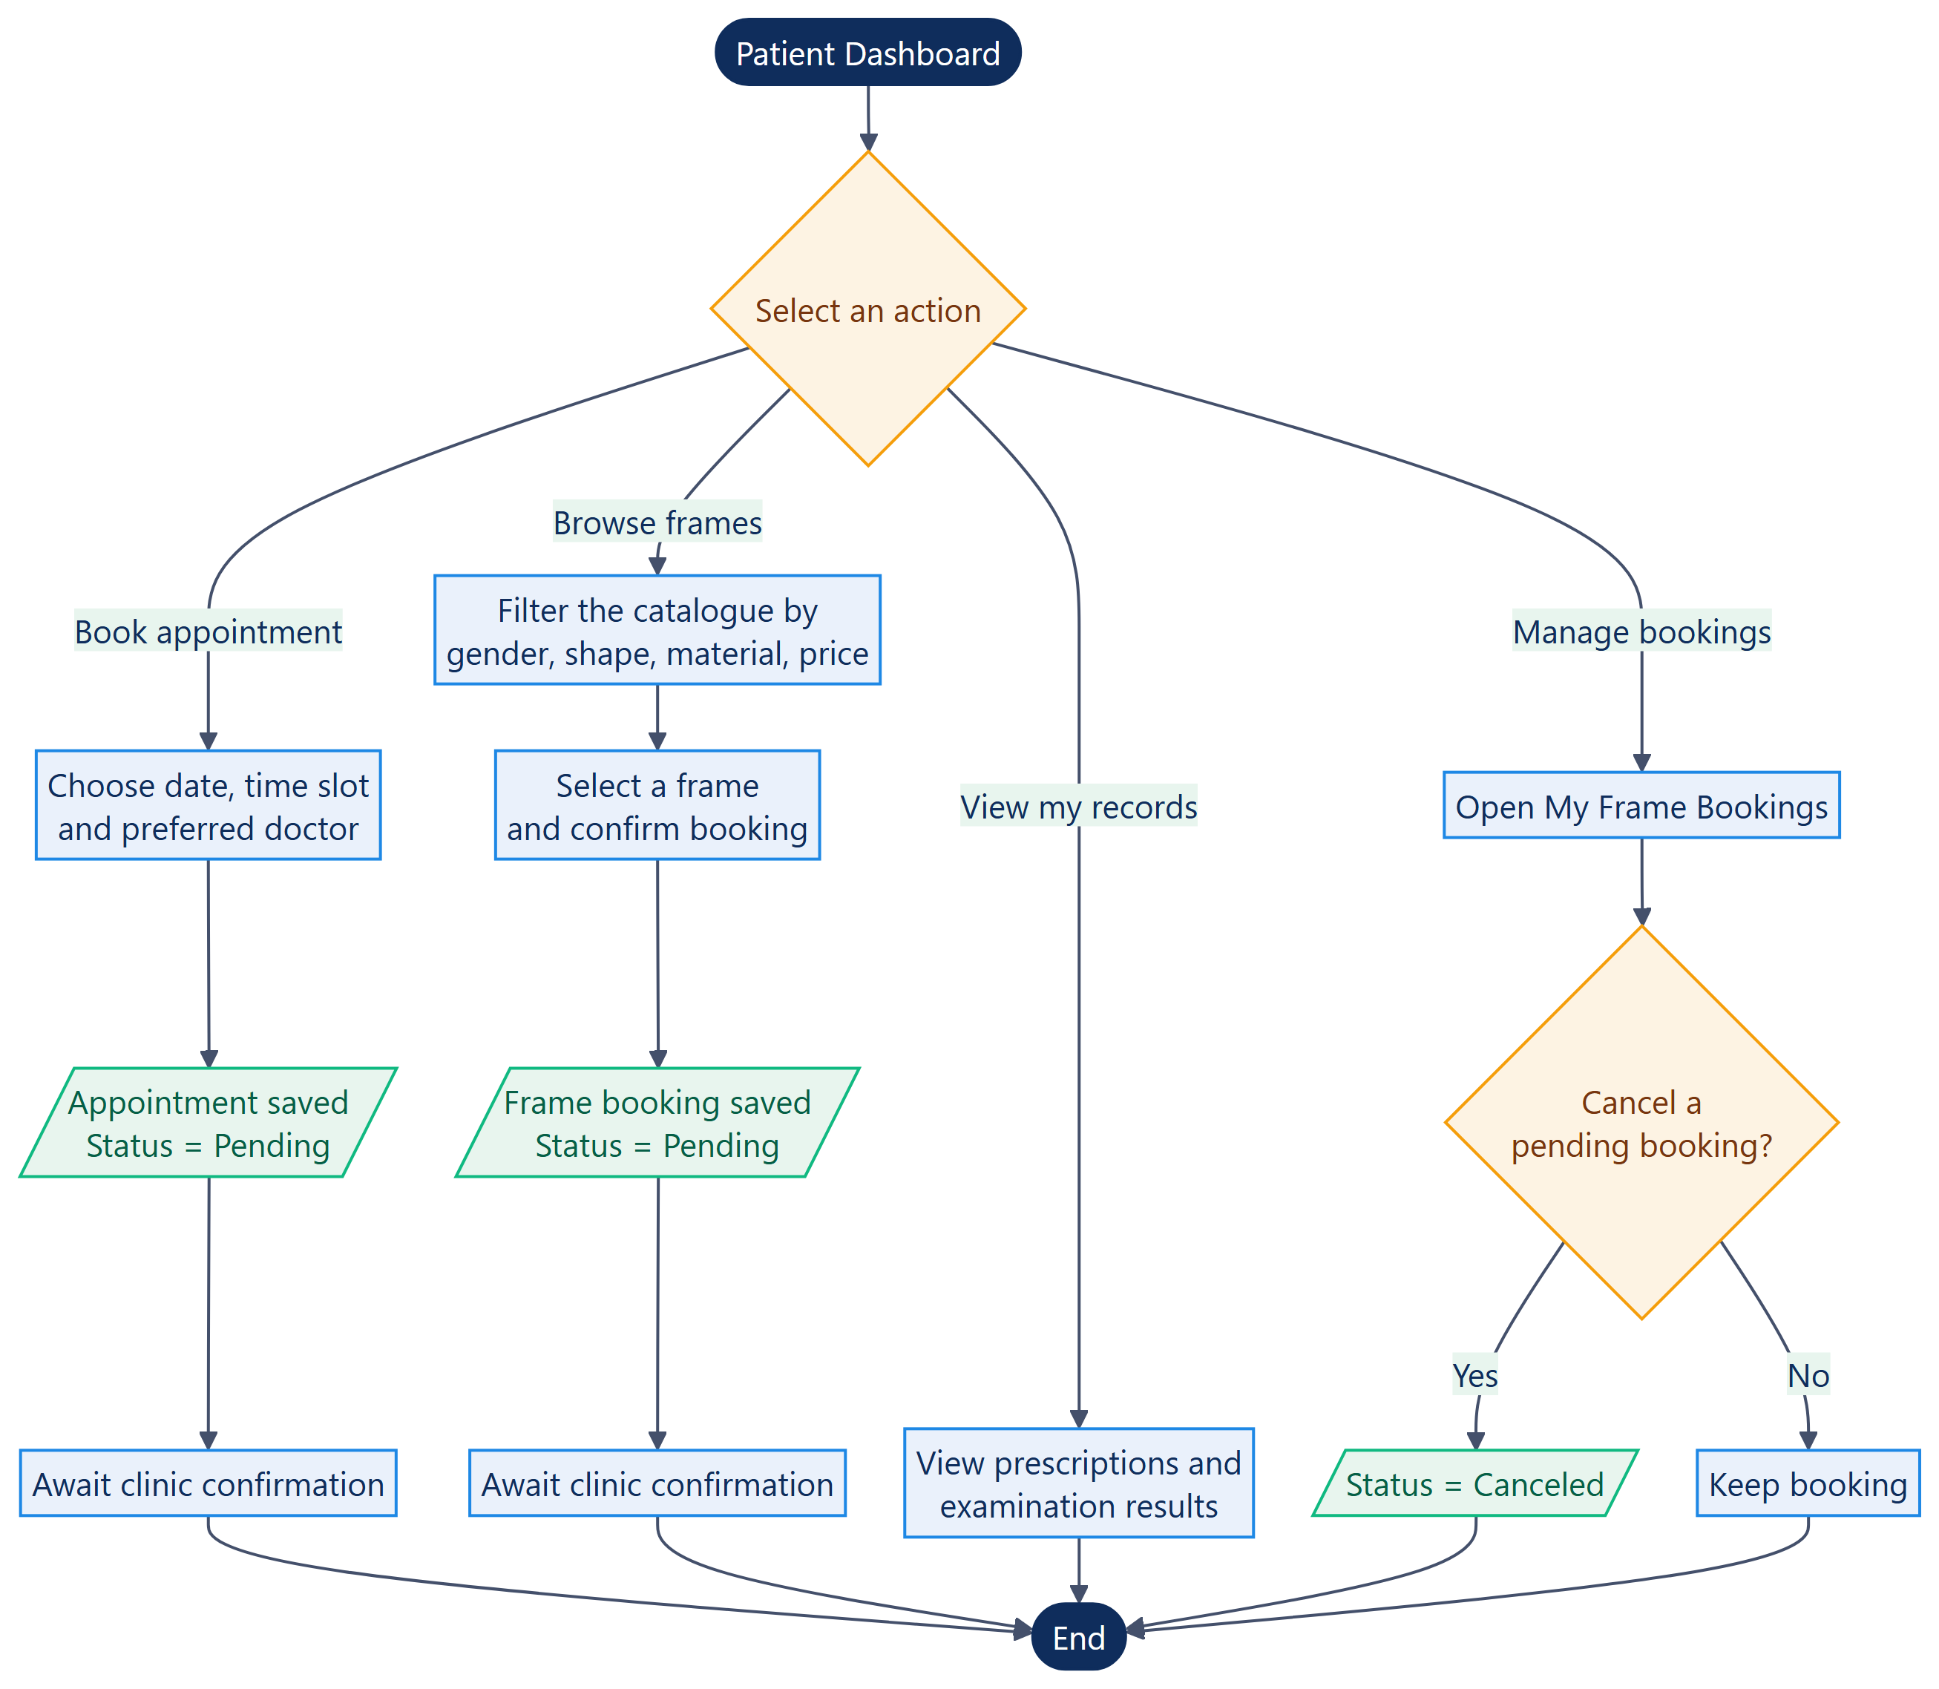
Figure 4.7: Patient Workflow Diagram

Administrator Workflow
The administrator reviews the pending requests raised by patients and either approves or cancels them. An approved frame booking may subsequently be marked as Collected, at which point the system automatically flags that frame as unavailable in the catalogue. The administrator also maintains the patient, doctor, examination, prescription and inventory records, and generates reports that may either be printed or exported to Excel.
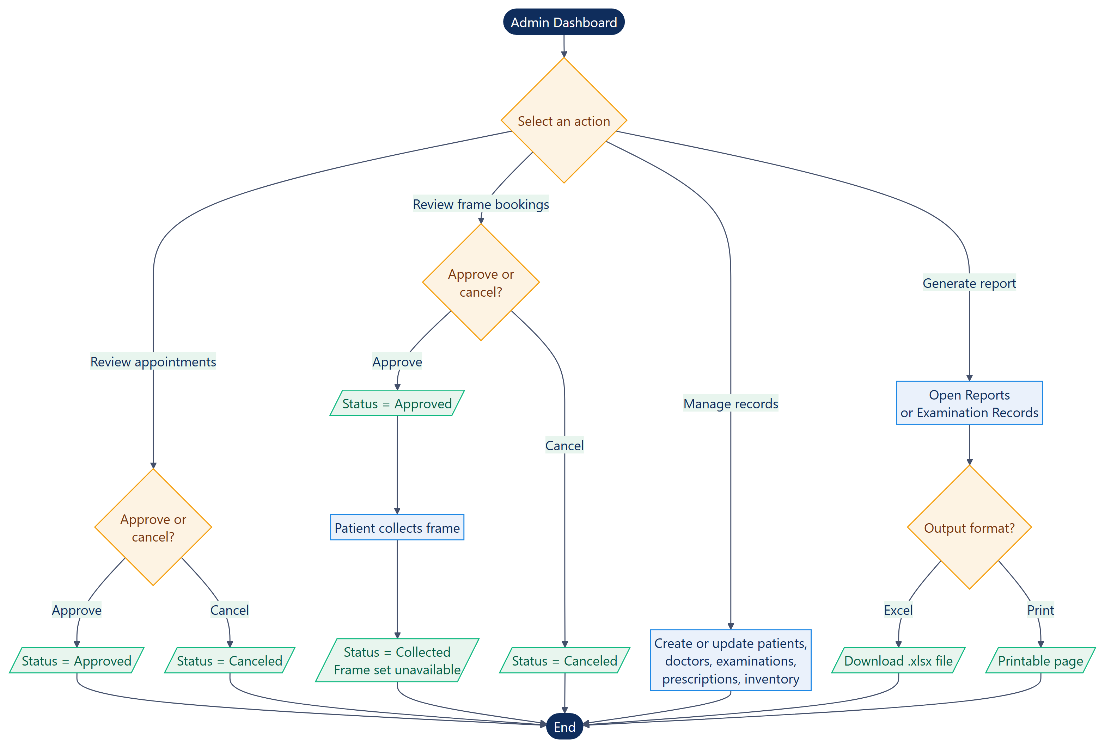
Figure 4.8: Administrator Workflow Diagram

Database Design

Database Summary
The system persists data in a Microsoft SQL Server database named OpticalCareDb. The schema is generated and versioned through Entity Framework Core migrations. It comprises nine application tables joined by eleven foreign key constraints. Every table uses a single auto-incrementing integer surrogate primary key named Id.
# | Table Name | Columns | Purpose
1 | UserAccounts | 7 | Stores login credentials and the role of every system user.
2 | Patients | 10 | Holds the demographic and contact record of each patient.
3 | Doctors | 8 | Holds the professional profile of each optometrist, including specialty and licence number, and may be linked to a UserAccount.
4 | Appointments | 8 | Records consultation bookings made by patients or created by an administrator.
5 | ExaminationRecords | 9 | Stores the clinical findings of an eye examination, including readings for each eye, visual acuity and intra-ocular pressure.
6 | Prescriptions | 10 | Stores the corrective lens prescription issued after an examination.
7 | Frames | 11 | Catalogue of eyeglass frames offered by the clinic, including physical attributes, price, product image and availability status.
8 | FrameBookings | 6 | Records a patient's reservation of a frame and tracks it through the Pending, Approved, Collected and Canceled states.
9 | InventoryItems | 8 | Tracks consumable and saleable stock such as lenses, accessories and solutions, together with the threshold at which an item counts as low stock.
Table 4.1: Summary of Database Tables

Table Specifications
The following tables document every column in the database, giving its data type, whether it accepts null values, its key constraint and its purpose. The data types shown are the actual SQL Server types created by the Entity Framework Core migrations.

UserAccounts Table Specification
Stores login credentials and the role of every system user. Passwords are never stored in plain text; only a hashed value produced by ASP.NET Core Identity's PasswordHasher is persisted.
Column Name | Data Type | Null | Key | Description
Id | int | No | PK | Surrogate primary key, auto-incremented.
Username | nvarchar(100) | No |  | Unique login name entered at sign-in.
Email | nvarchar(MAX) | No |  | Email address; may also be used to sign in.
PasswordHash | nvarchar(MAX) | No |  | Hashed password (PBKDF2). Never stores plain text.
FullName | nvarchar(MAX) | No |  | Display name shown in the interface.
Role | int | No |  | Enum stored as integer: 0 = Admin, 1 = Patient.
CreatedAt | datetime2 | No |  | Timestamp the account was created (UTC).
Table 4.2: UserAccounts Table Specification

Patients Table Specification
Holds the demographic and contact record of each patient. A patient row may be linked to a UserAccount so the patient can sign in and manage their own bookings.
Column Name | Data Type | Null | Key | Description
Id | int | No | PK | Surrogate primary key, auto-incremented.
FullName | nvarchar(MAX) | No |  | Full legal name of the patient.
Email | nvarchar(MAX) | No |  | Contact email address.
Phone | nvarchar(MAX) | No |  | Contact telephone number.
DateOfBirth | datetime2 | Yes |  | Date of birth; optional.
Gender | nvarchar(MAX) | No |  | Gender of the patient.
Address | nvarchar(MAX) | No |  | Residential address.
EmergencyContact | nvarchar(MAX) | No |  | Name and number of next of kin.
UserAccountId | int | Yes | FK | FK to UserAccounts. Null when the record was created by an administrator and has no login.
CreatedAt | datetime2 | No |  | Timestamp the record was registered (UTC).
Table 4.3: Patients Table Specification

Doctors Table Specification
Holds the professional profile of each optometrist, including specialty and licence number, and may be linked to a UserAccount.
Column Name | Data Type | Null | Key | Description
Id | int | No | PK | Surrogate primary key, auto-incremented.
FullName | nvarchar(MAX) | No |  | Full name of the doctor.
Email | nvarchar(MAX) | No |  | Professional contact email.
Phone | nvarchar(MAX) | No |  | Professional contact number.
Specialty | nvarchar(MAX) | No |  | Area of specialisation, e.g. Optometrist.
LicenseNumber | nvarchar(MAX) | No |  | Practising licence identifier.
UserAccountId | int | Yes | FK | FK to UserAccounts. Null when the doctor has no system login.
CreatedAt | datetime2 | No |  | Timestamp the profile was created (UTC).
Table 4.4: Doctors Table Specification

Appointments Table Specification
Records consultation bookings made by patients or created by an administrator. The doctor may initially be unassigned and allocated later by the clinic.
Column Name | Data Type | Null | Key | Description
Id | int | No | PK | Surrogate primary key, auto-incremented.
PatientId | int | No | FK | FK to Patients. The patient the appointment belongs to.
DoctorId | int | Yes | FK | FK to Doctors. Null until a doctor is assigned by the clinic.
AppointmentDate | datetime2 | No |  | Calendar date requested for the consultation.
TimeSlot | nvarchar(MAX) | No |  | Selected time band, e.g. 10:00 AM - 11:00 AM.
Notes | nvarchar(MAX) | No |  | Symptoms or request supplied by the patient.
Status | int | No |  | Enum stored as integer: 0 = Pending, 1 = Approved, 2 = Canceled.
CreatedAt | datetime2 | No |  | Timestamp the booking was submitted (UTC).
Table 4.5: Appointments Table Specification

ExaminationRecords Table Specification
Stores the clinical findings of an eye examination, including readings for each eye, visual acuity and intra-ocular pressure.
Column Name | Data Type | Null | Key | Description
Id | int | No | PK | Surrogate primary key, auto-incremented.
PatientId | int | No | FK | FK to Patients. Subject of the examination.
DoctorId | int | No | FK | FK to Doctors. Clinician who performed the examination.
ExamDate | datetime2 | No |  | Date the examination was carried out.
LeftEye | nvarchar(MAX) | No |  | Measured reading for the left eye.
RightEye | nvarchar(MAX) | No |  | Measured reading for the right eye.
VisualAcuity | nvarchar(MAX) | No |  | Visual acuity result, e.g. 6/6.
EyePressure | nvarchar(MAX) | No |  | Intra-ocular pressure reading.
Notes | nvarchar(MAX) | No |  | Additional clinical observations.
Table 4.6: ExaminationRecords Table Specification

Prescriptions Table Specification
Stores the corrective lens prescription issued after an examination. Each prescription is traceable to the examination record it was derived from.
Column Name | Data Type | Null | Key | Description
Id | int | No | PK | Surrogate primary key, auto-incremented.
PatientId | int | No | FK | FK to Patients. Recipient of the prescription.
DoctorId | int | No | FK | FK to Doctors. Prescribing clinician.
ExaminationRecordId | int | No | FK | FK to ExaminationRecords. Examination the prescription derives from.
PrescriptionDate | datetime2 | No |  | Date the prescription was issued.
LensType | nvarchar(MAX) | No |  | Type of corrective lens prescribed.
LeftEye | nvarchar(MAX) | No |  | Prescribed power for the left eye.
RightEye | nvarchar(MAX) | No |  | Prescribed power for the right eye.
Notes | nvarchar(MAX) | No |  | Dispensing or wearing instructions.
IsActive | bit | No |  | Indicates whether the prescription is still current.
Table 4.7: Prescriptions Table Specification

Frames Table Specification
Catalogue of eyeglass frames offered by the clinic, including physical attributes, price, product image and availability status.
Column Name | Data Type | Null | Key | Description
Id | int | No | PK | Surrogate primary key, auto-incremented.
Name | nvarchar(MAX) | No |  | Display name of the frame model.
Brand | nvarchar(MAX) | No |  | Manufacturer or brand name.
Code | nvarchar(MAX) | No |  | Internal product/catalogue code.
Material | nvarchar(MAX) | No |  | Construction material, e.g. Titanium, Acetate.
Shape | nvarchar(MAX) | No |  | Frame shape: Round, Square, Rectangle or Cat Eye.
Color | nvarchar(MAX) | No |  | Colour finish of the frame.
Price | decimal(18,2) | No |  | Retail selling price.
ImageUrl | nvarchar(MAX) | No |  | File name of the product image under wwwroot/images/frames.
IsAvailable | bit | No |  | False once the frame is sold or reserved for collection.
Gender | nvarchar(MAX) | No |  | Target gender: Men, Women or Unisex.
Table 4.8: Frames Table Specification

FrameBookings Table Specification
Records a patient's reservation of a frame and tracks it through the Pending, Approved, Collected and Canceled states.
Column Name | Data Type | Null | Key | Description
Id | int | No | PK | Surrogate primary key, auto-incremented.
PatientId | int | No | FK | FK to Patients. Patient who reserved the frame.
FrameId | int | No | FK | FK to Frames. Frame being reserved.
BookingDate | datetime2 | No |  | Date and time the reservation was made.
Status | nvarchar(MAX) | No |  | Workflow state: Pending, Approved, Collected or Canceled.
Notes | nvarchar(MAX) | No |  | Optional note supplied by the patient.
Table 4.9: FrameBookings Table Specification

InventoryItems Table Specification
Tracks consumable and saleable stock such as lenses, accessories and solutions, together with the threshold at which an item counts as low stock.
Column Name | Data Type | Null | Key | Description
Id | int | No | PK | Surrogate primary key, auto-incremented.
ItemName | nvarchar(MAX) | No |  | Name of the stock item.
Category | nvarchar(MAX) | No |  | Grouping such as Frames, Lenses or Accessories.
StockQuantity | int | No |  | Units currently held in stock.
UnitPrice | decimal(18,2) | No |  | Cost or selling price per unit.
LowStockThreshold | int | No |  | Level at or below which the item is flagged low.
Description | nvarchar(MAX) | No |  | Free-text description of the item.
CreatedAt | datetime2 | No |  | Timestamp the item was added (UTC).
Table 4.10: InventoryItems Table Specification

Relationship Summary
The table below lists every foreign key constraint enforced by the database, together with the cardinality of the relationship it represents. All constraints use NO ACTION on delete, meaning a parent row cannot be removed while dependent rows still reference it. This preserves referential integrity across the clinical records.
# | Child Table (FK) | Parent Table (PK) | Cardinality | Relationship
1 | FrameBookings.PatientId | Patients.Id | 1 : N | A patient may reserve many frames
2 | FrameBookings.FrameId | Frames.Id | 1 : N | A frame may appear in many bookings
3 | Doctors.UserAccountId | UserAccounts.Id | 1 : 0..1 | A user account may own one doctor profile
4 | Patients.UserAccountId | UserAccounts.Id | 1 : 0..1 | A user account may own one patient profile
5 | Appointments.PatientId | Patients.Id | 1 : N | A patient may have many appointments
6 | Appointments.DoctorId | Doctors.Id | 0..1 : N | A doctor may handle many appointments
7 | ExaminationRecords.PatientId | Patients.Id | 1 : N | A patient may have many examinations
8 | ExaminationRecords.DoctorId | Doctors.Id | 1 : N | A doctor may perform many examinations
9 | Prescriptions.PatientId | Patients.Id | 1 : N | A patient may hold many prescriptions
10 | Prescriptions.DoctorId | Doctors.Id | 1 : N | A doctor may issue many prescriptions
11 | Prescriptions.ExaminationRecordId | ExaminationRecords.Id | 1 : N | An examination may yield many prescriptions
Table 4.11: Foreign Key Relationship Summary

CHAPTER FIVE
RESULTS AND DISCUSSION

RESULTS AND DISCUSSION
Introduction
This chapter shows how the Optical Care Management System with Appointment Scheduling was built and tested. It describes the steps taken to put the system into use. Provides visual examples through screenshots. Each screenshot highlights a feature of the system, such, as user login, dashboard views, managing patients handling doctor information, scheduling appointments storing eye exam records managing prescriptions, tracking frames controlling inventory and generating reports. The chapter also confirms that the system works as expected and meets all the goals and needs that were defined during the planning and design stages.
User Interface Screenshots and Module Implementation
Home page
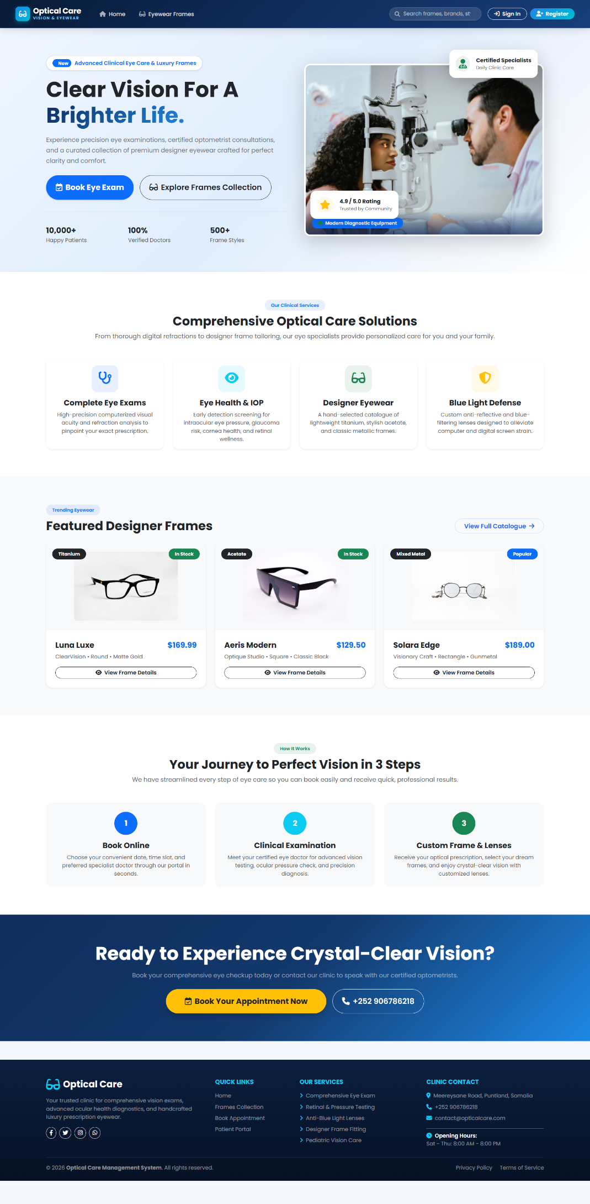
Figure 5.1: Clinic Home Page & Navigation Bar

LOGIN PAGE
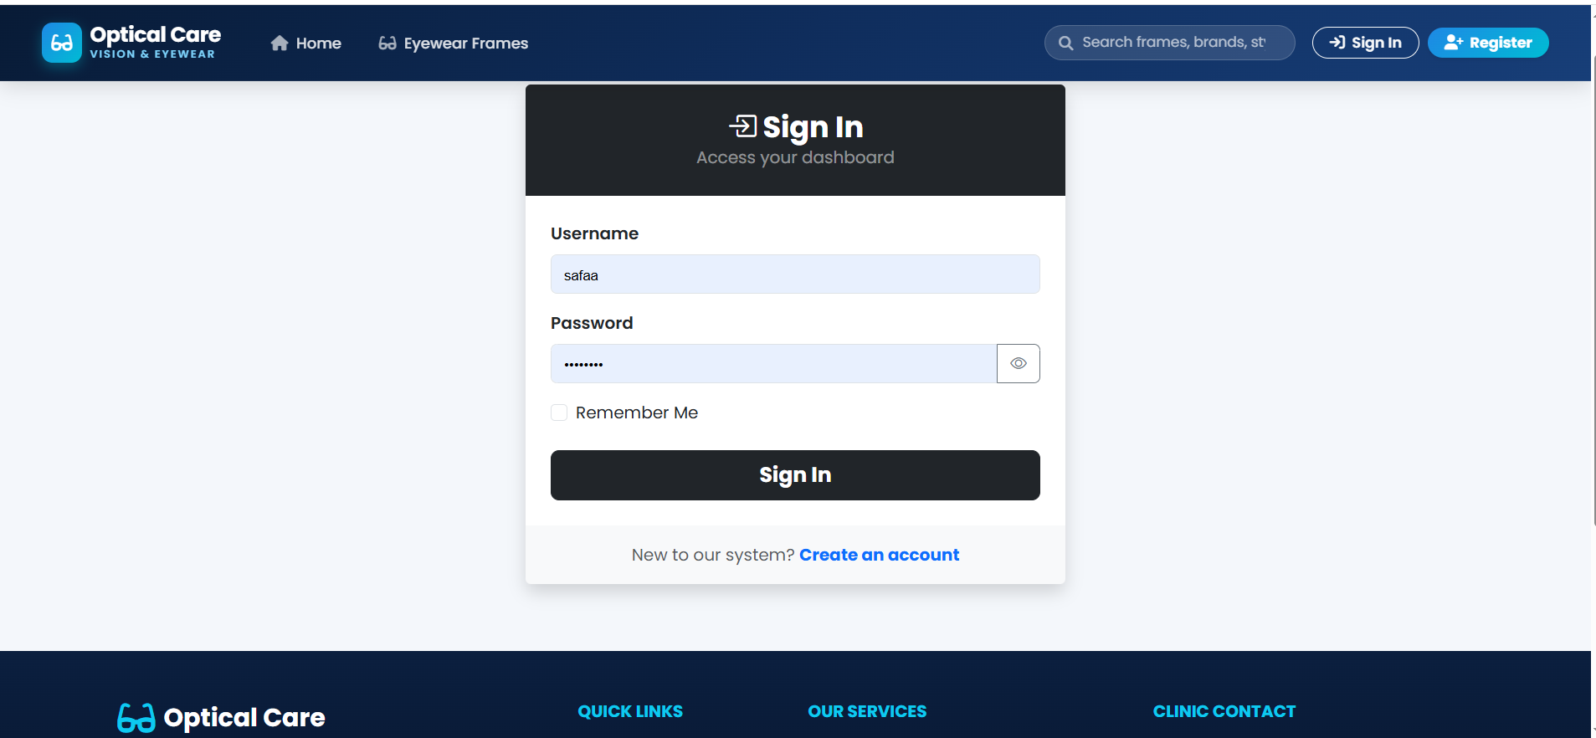
Figure 2 login page
Admin Dashboard

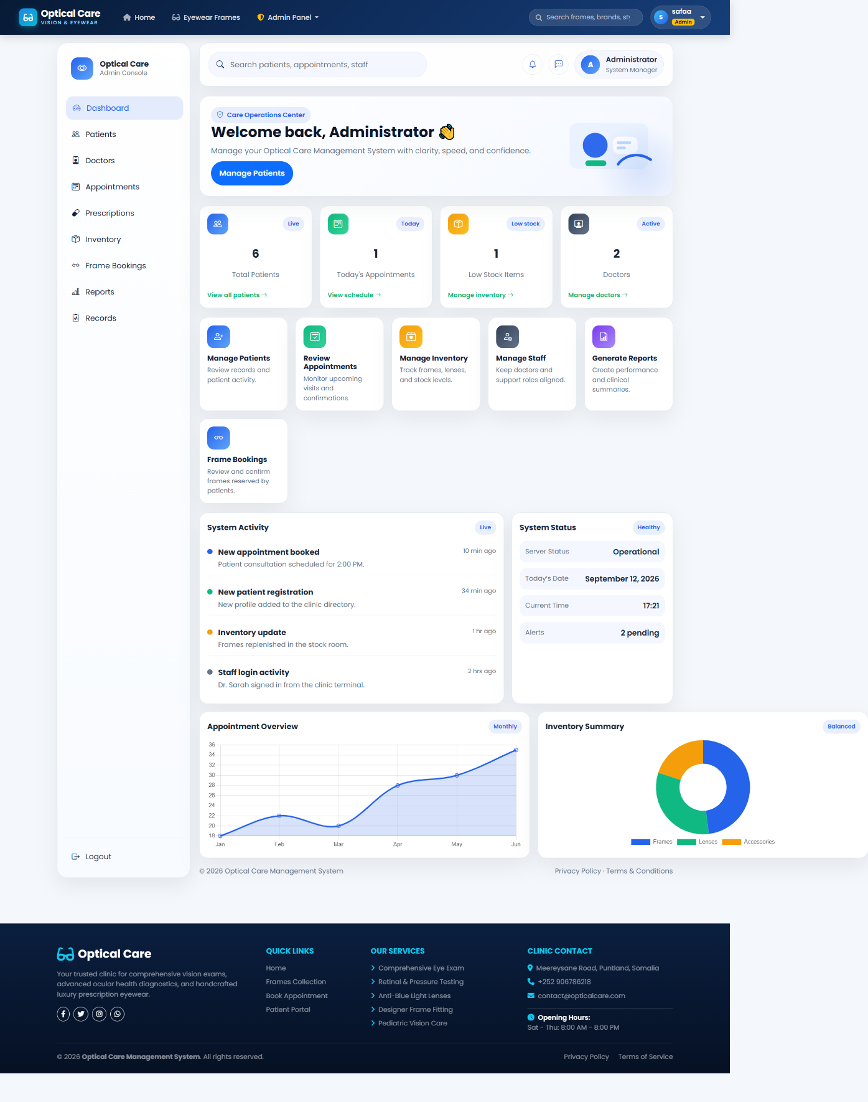
Figure 5.3: Main Administrator Dashboard & Summary Cards
Patient Management Dashboard
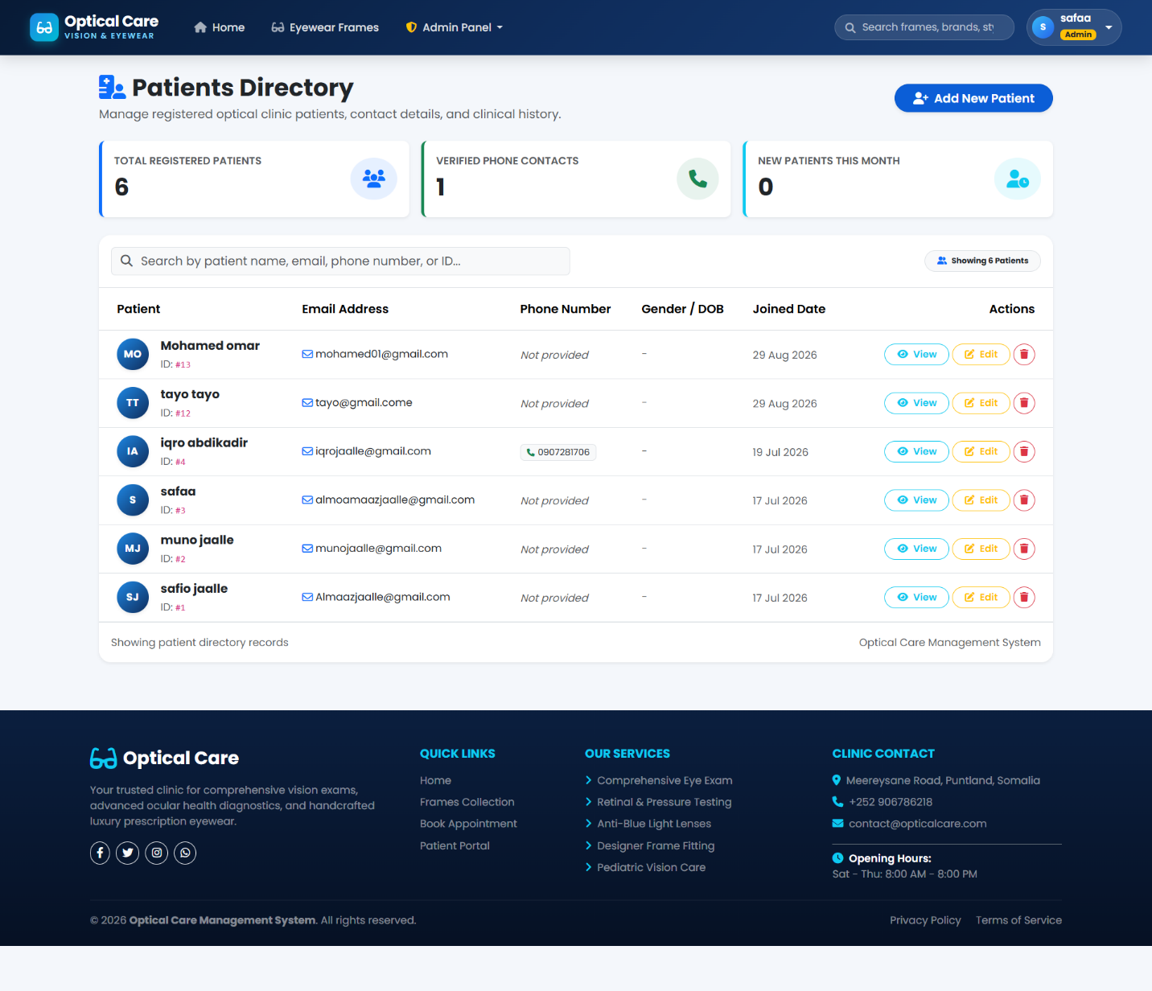
Figure 5.4: Patient Management & Records Dashboard

Doctors& medical staff dashboard
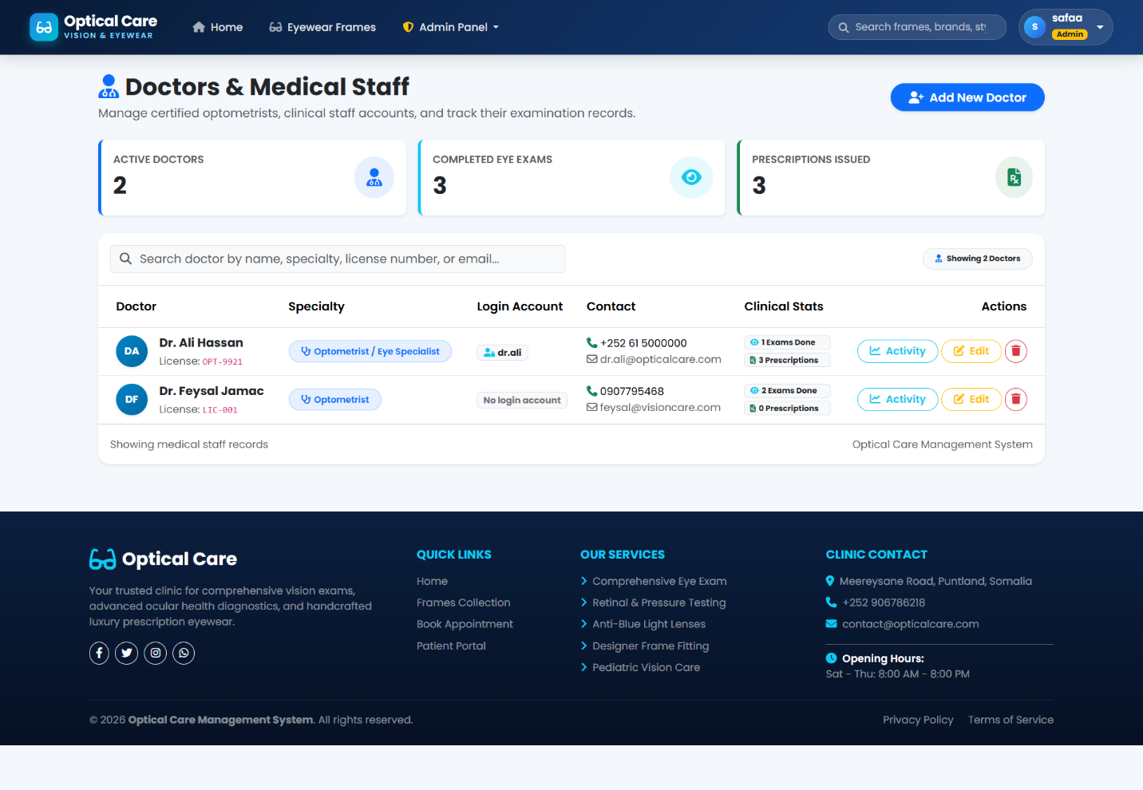
Figure 5.5: Doctors & Medical Staff Management Interface

Appointments & patients Booking
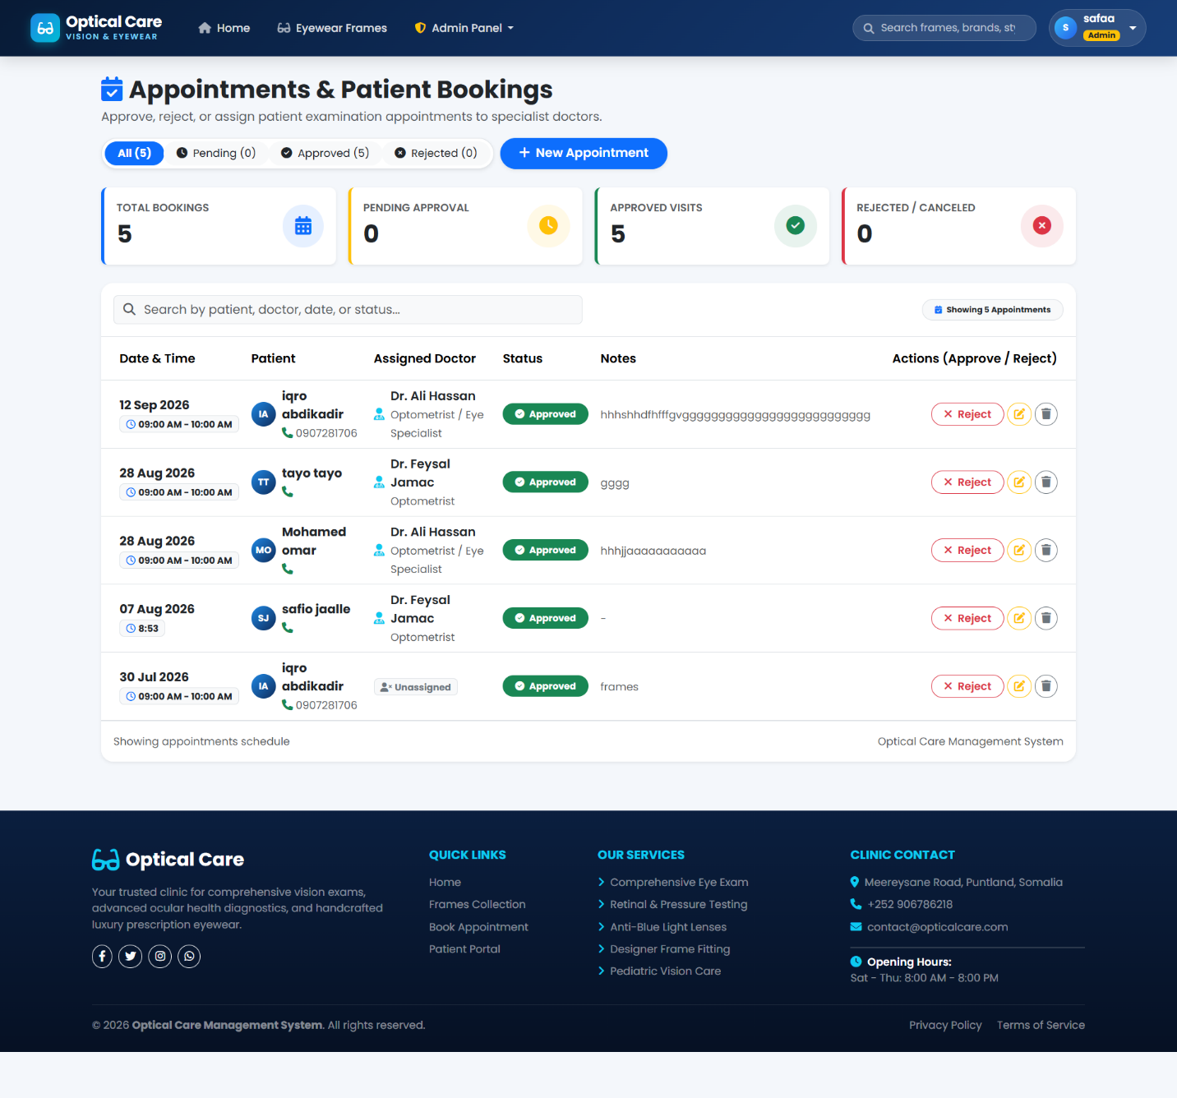
Figure 5.6: Appointments & Patient Booking Management Interface

Doctor Prescriptions & Medications
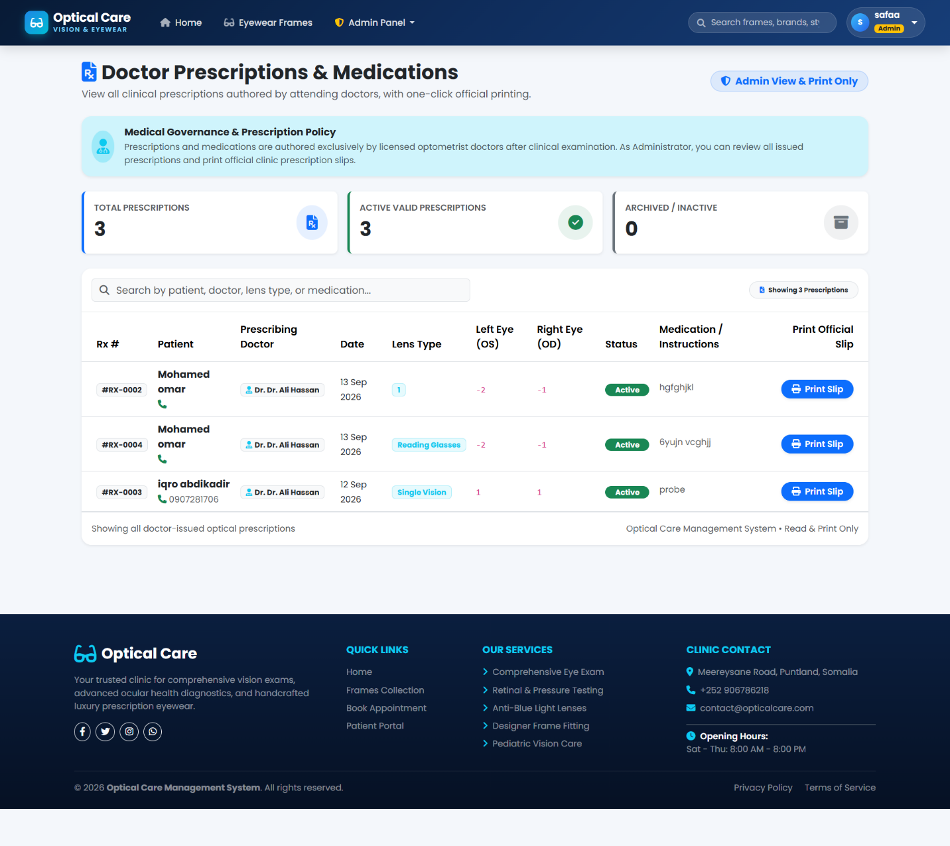
Figure 5.7: Doctor Prescriptions & Medications Management

Inventory & Stock Management
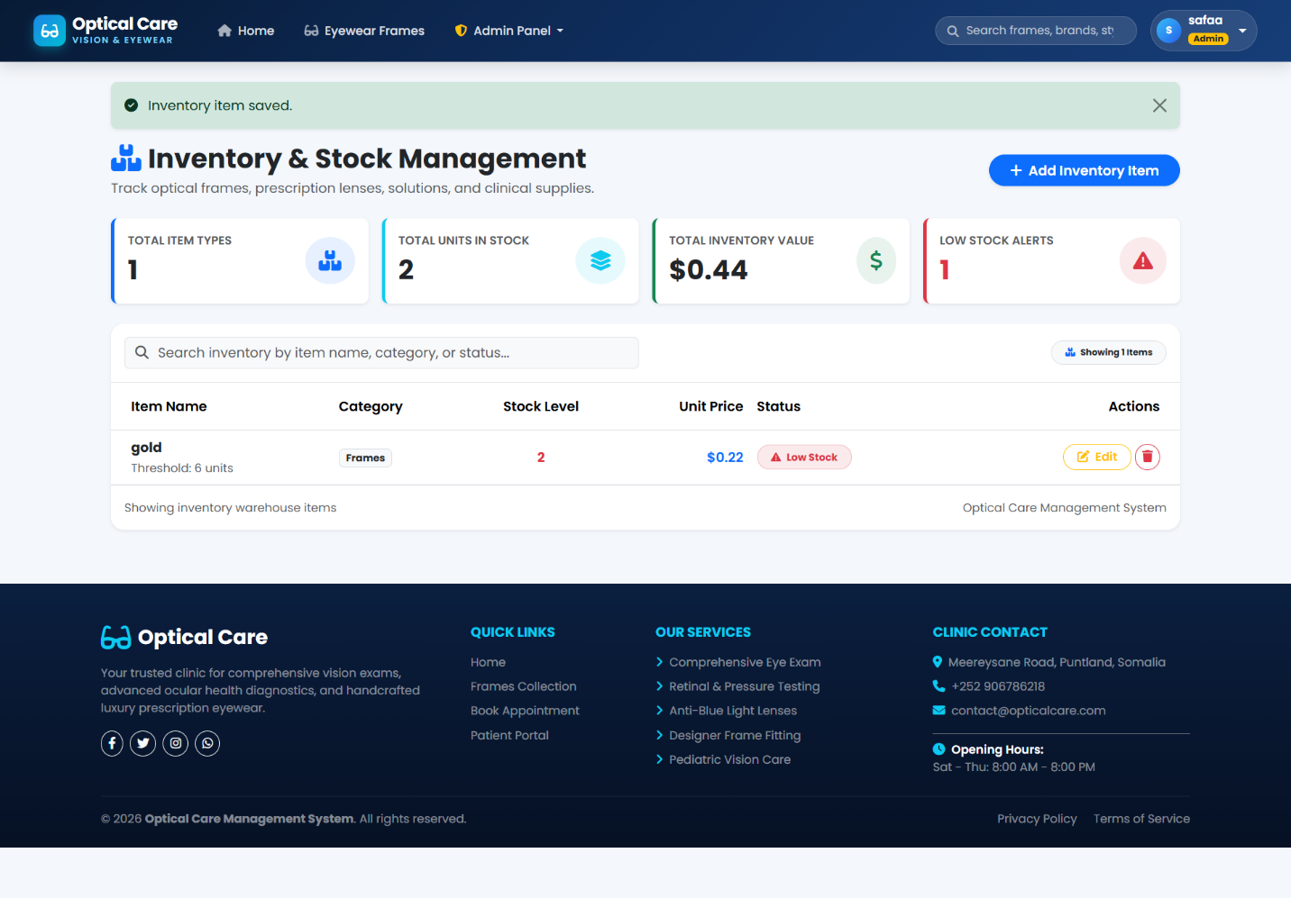
Figure 5.8: Optical Inventory & Stock Management Interface

Patient Frame Bookings
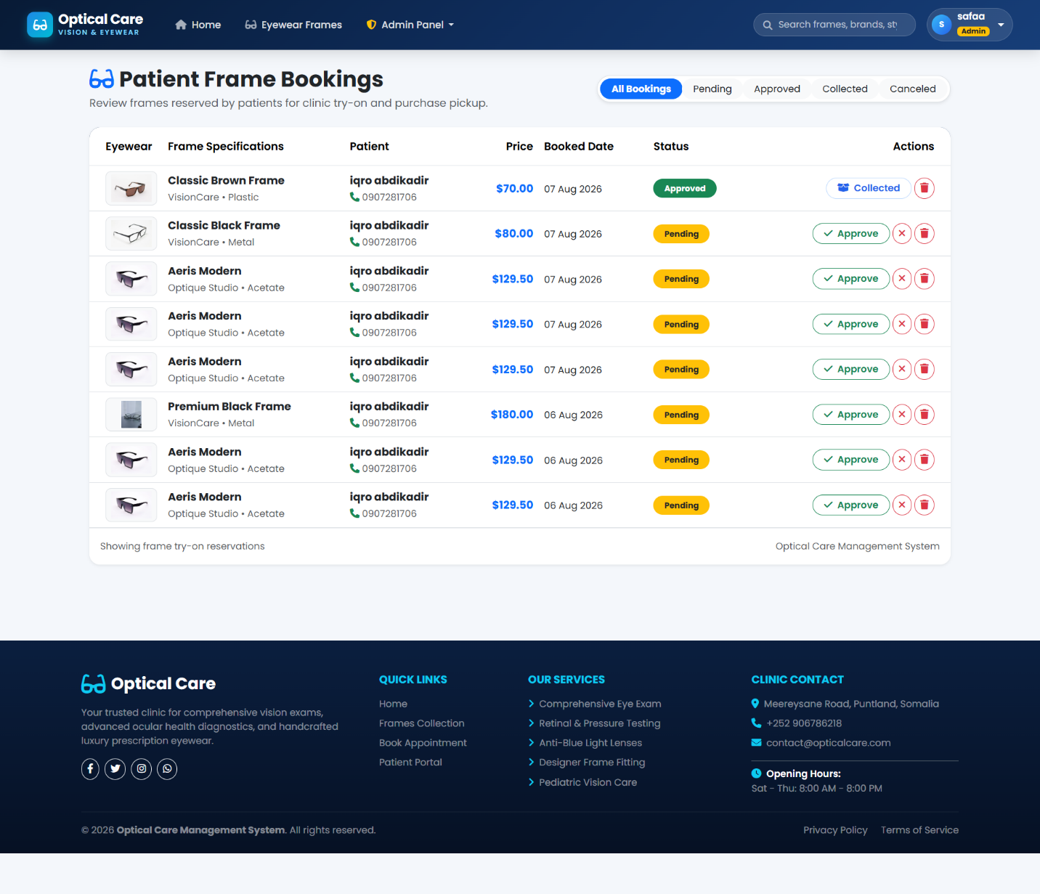
Figure 5.9: Patient Frame Bookings Tracking Screen

System Reports & Operations Analytics
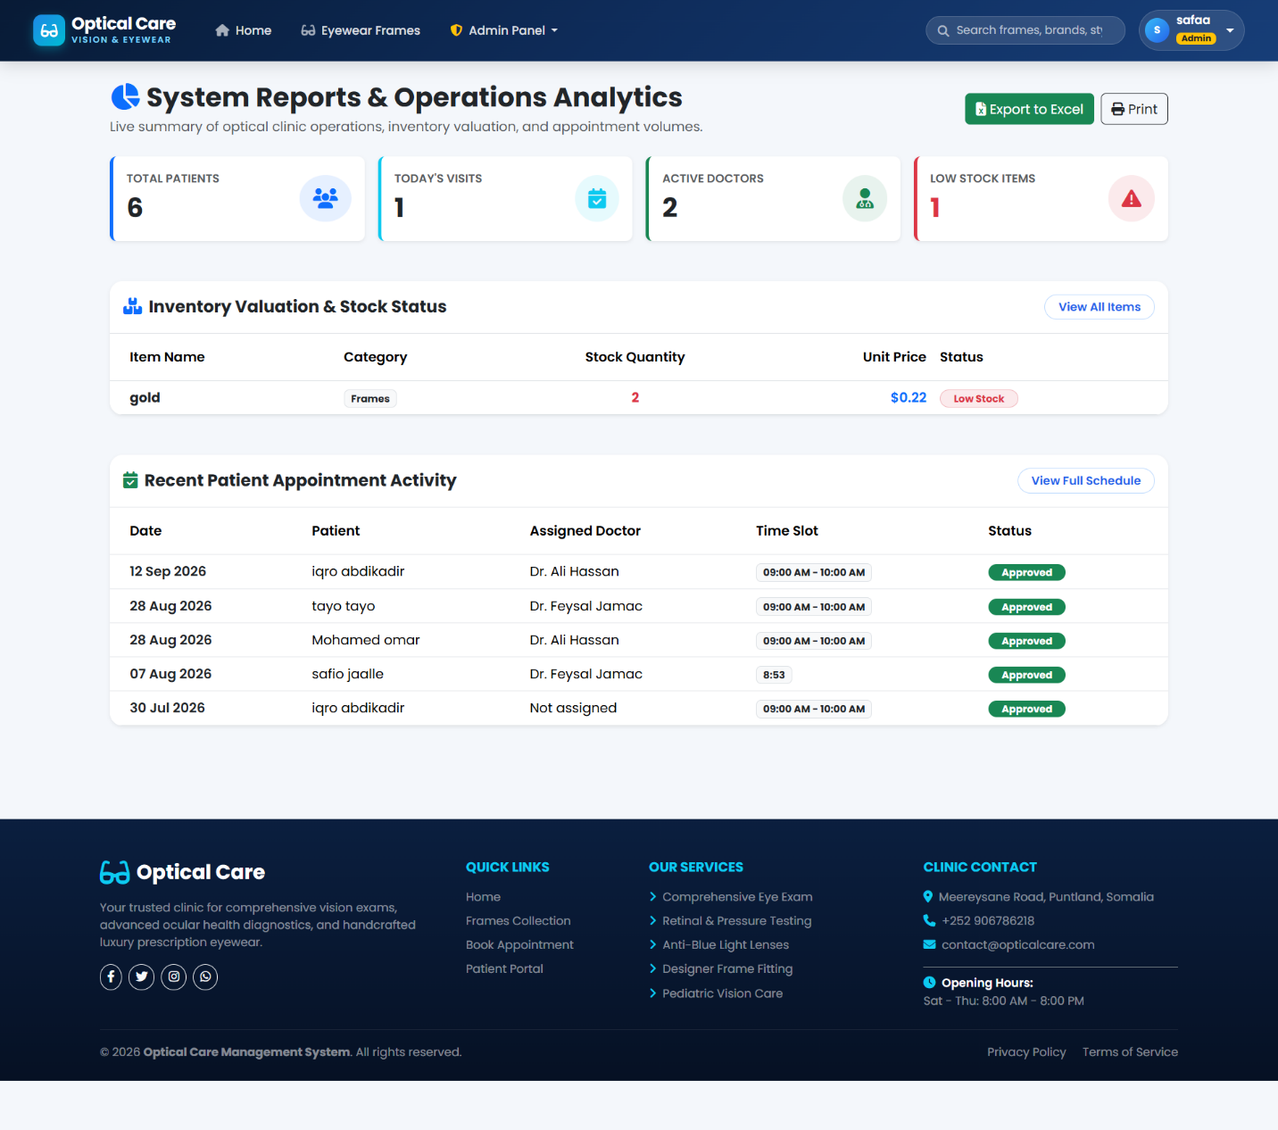
Figure 5.10: System Reports & Operations Analytics Interface
Clinical Eye Examinations
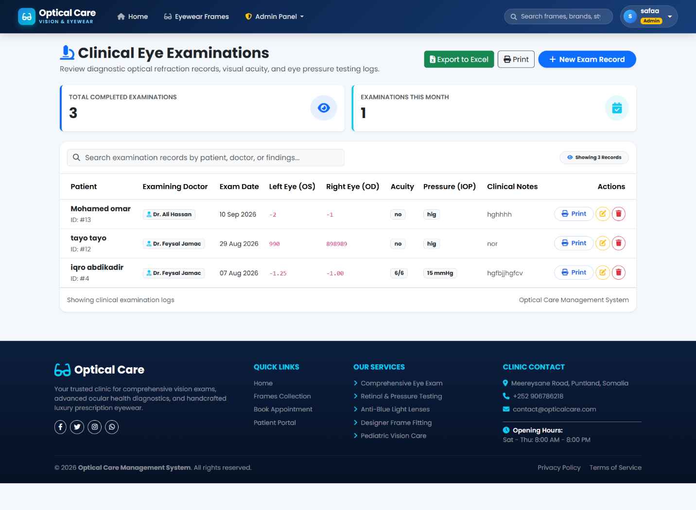
Figure 5.11: Clinical Eye Examinations Management
Patient dashboard
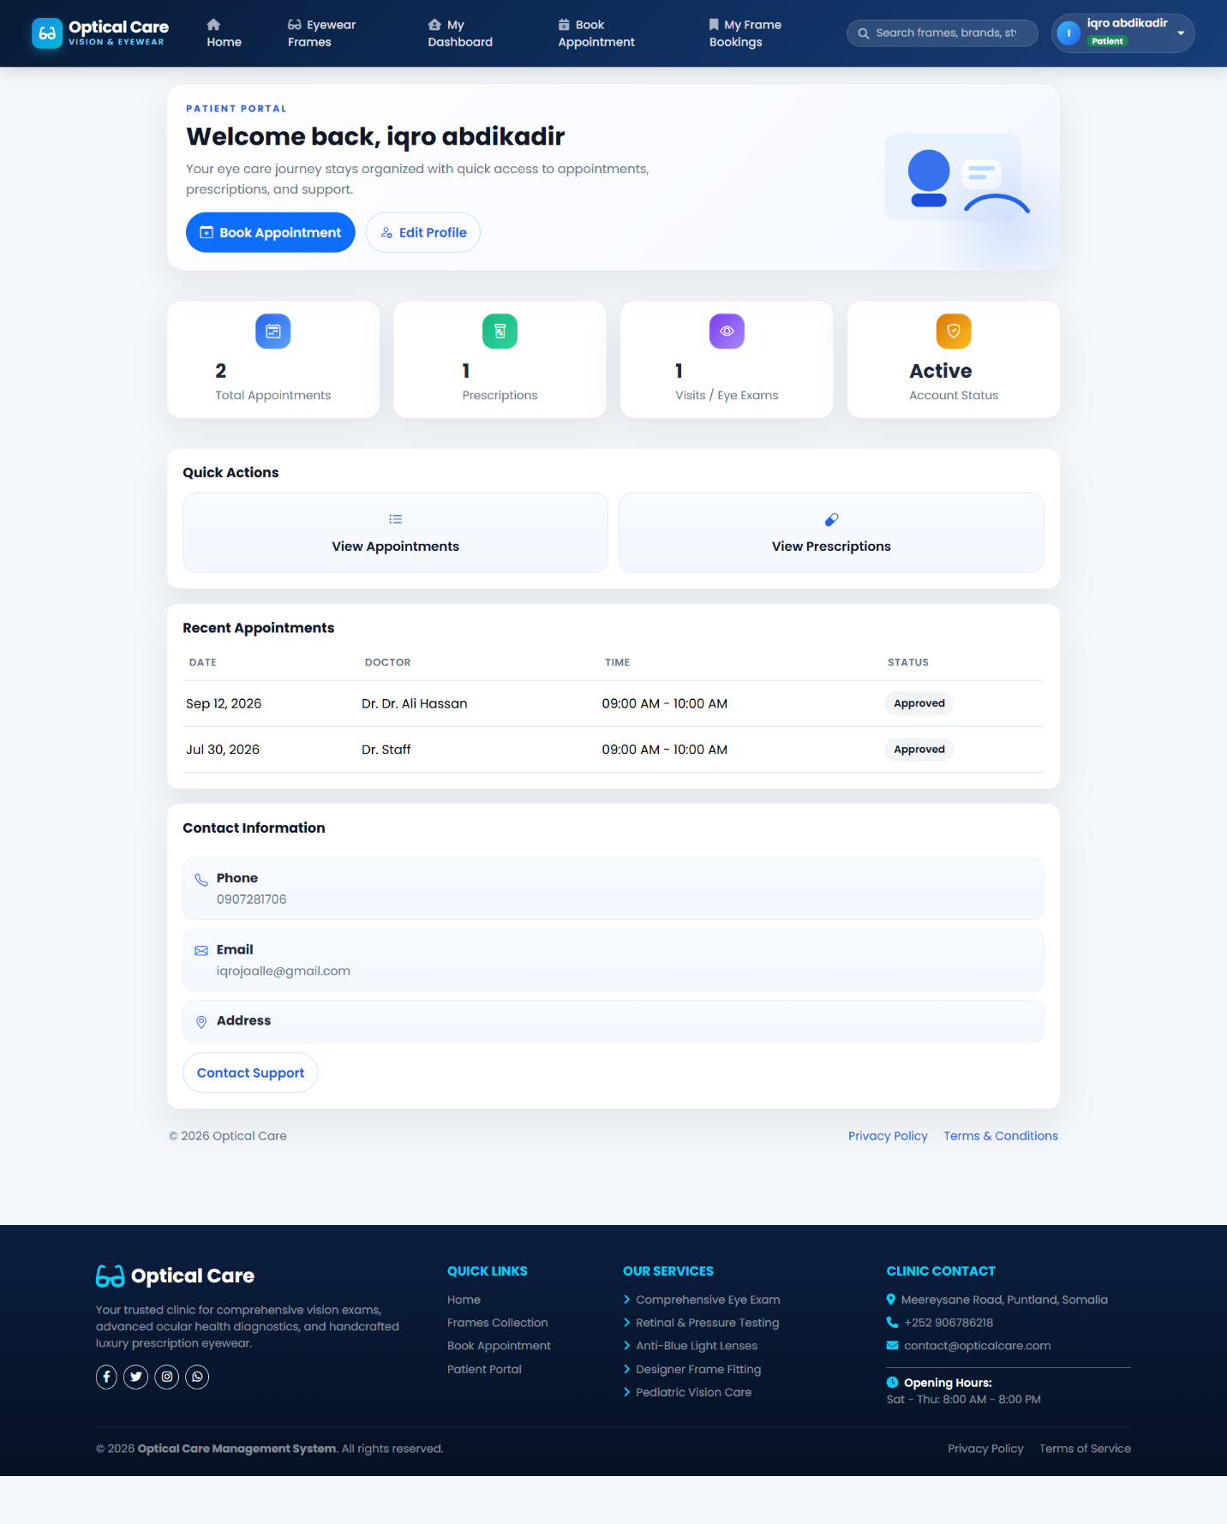
Figure 5.12: Patient Portal Dashboard
Prescriptions & Medications
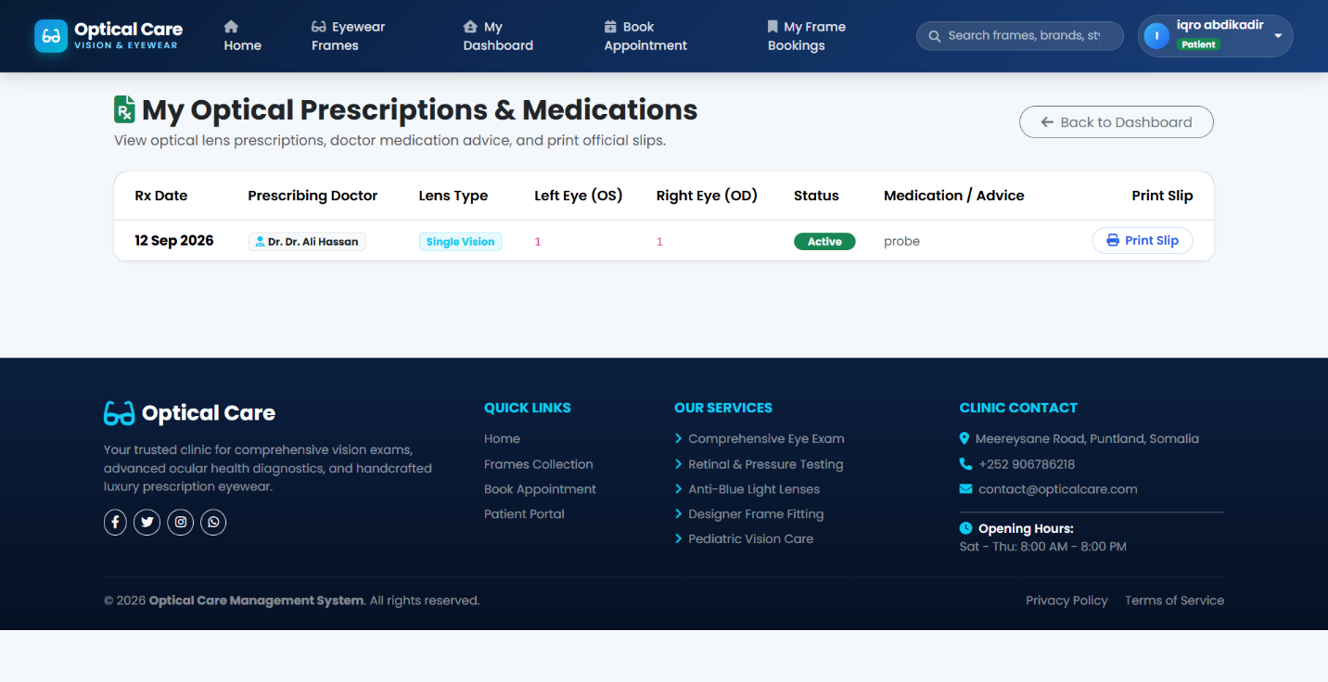
Figure 5.13: Patient Prescriptions & Medications View
Examination Results
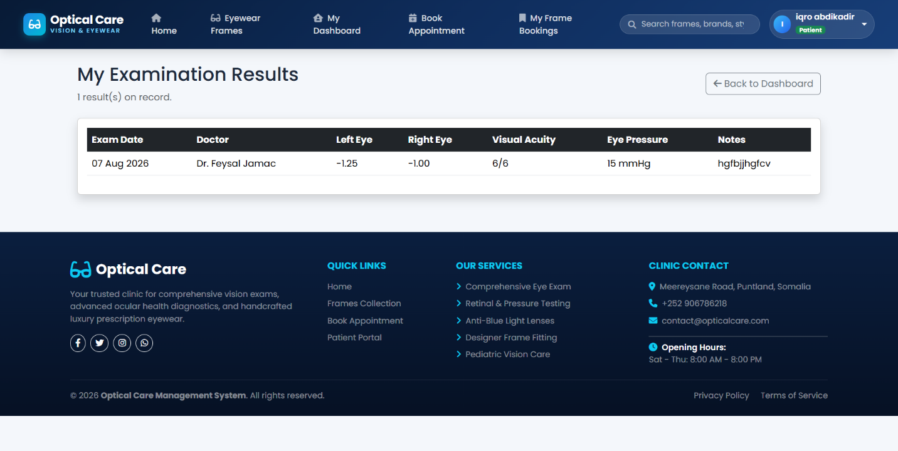
Figure 5.14: Patient Eye Examination Results View
Edit Profile
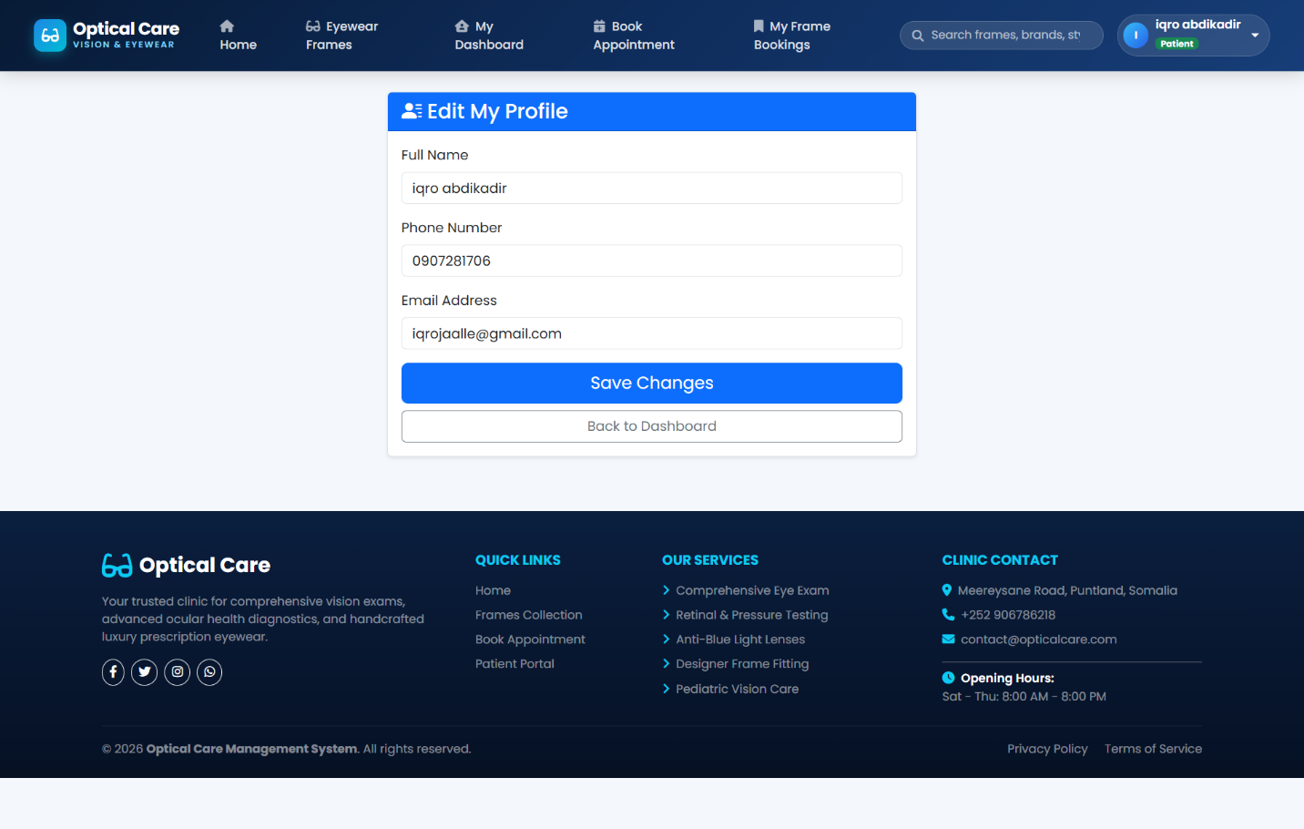
Figure 5.15: Patient Profile & Account Information Management

Eyeglass Frames

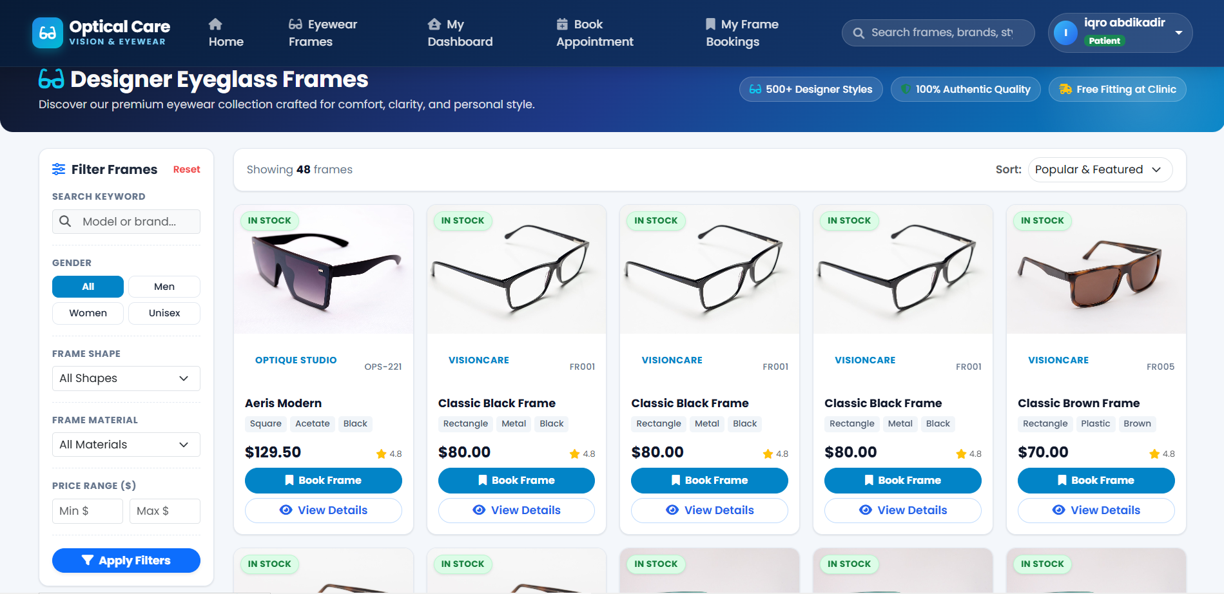
Figure 5.16: Eyeglass Frames Catalog Showcase
Frame search
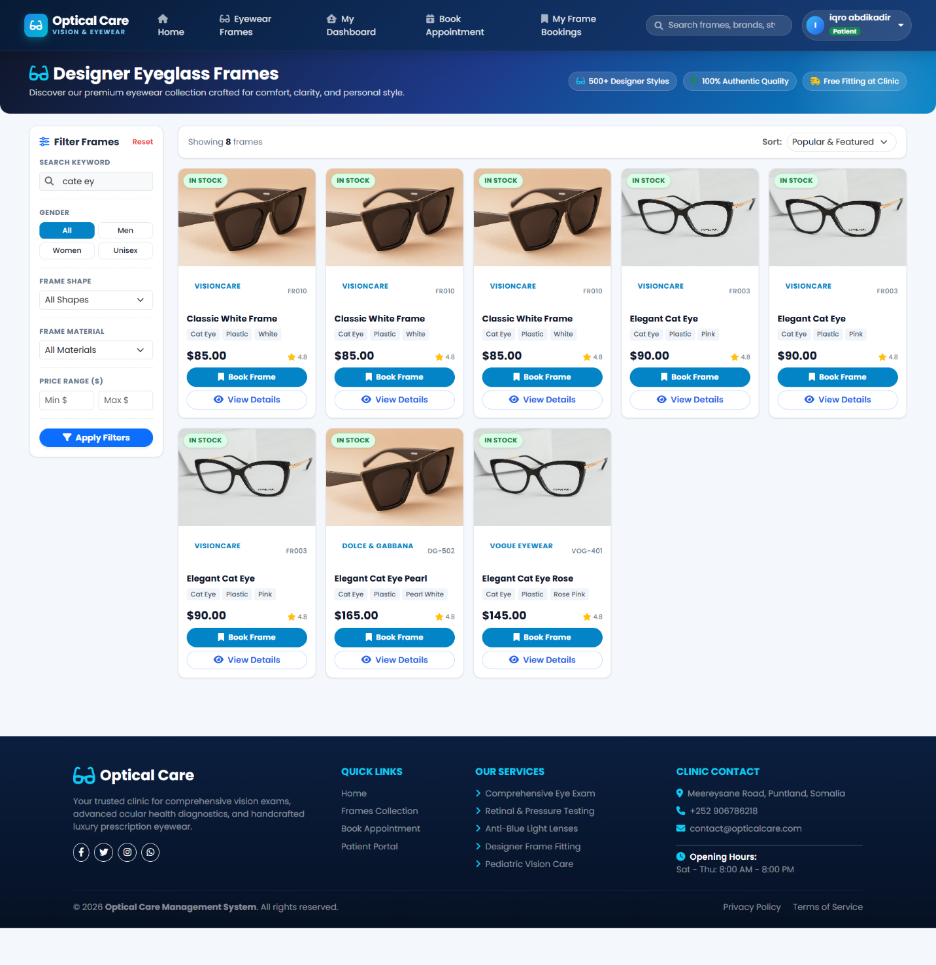
Figure 5.17: Eyeglass Frame Search & Filtering Interface

Book frame
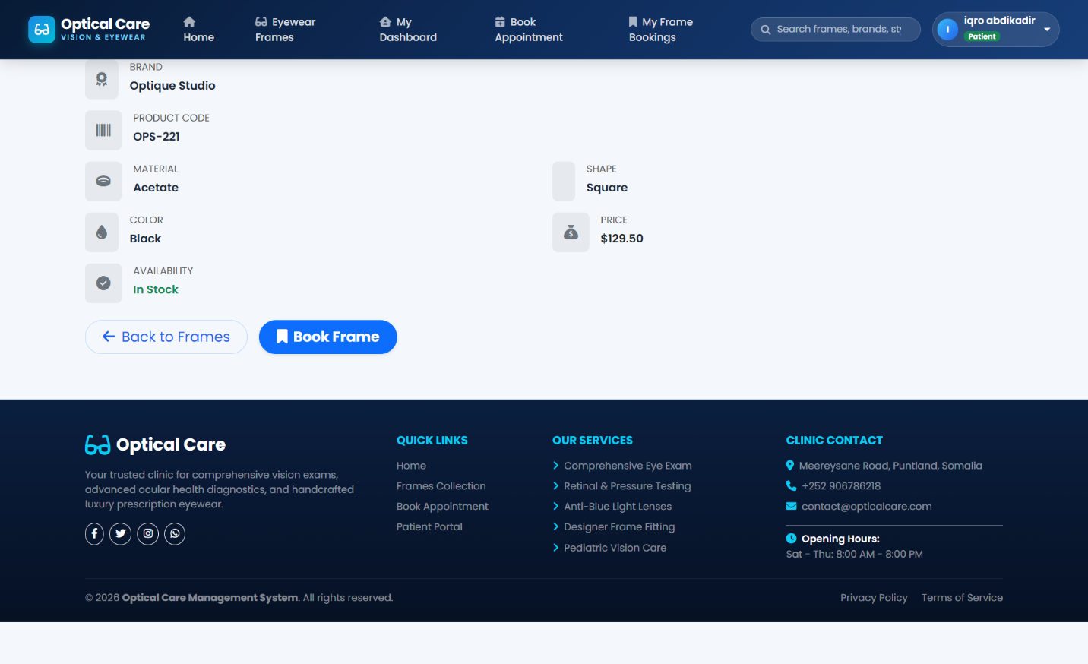
Figure 5.18: Book Eyeglass Frame Modal / Form

Frame Bookings
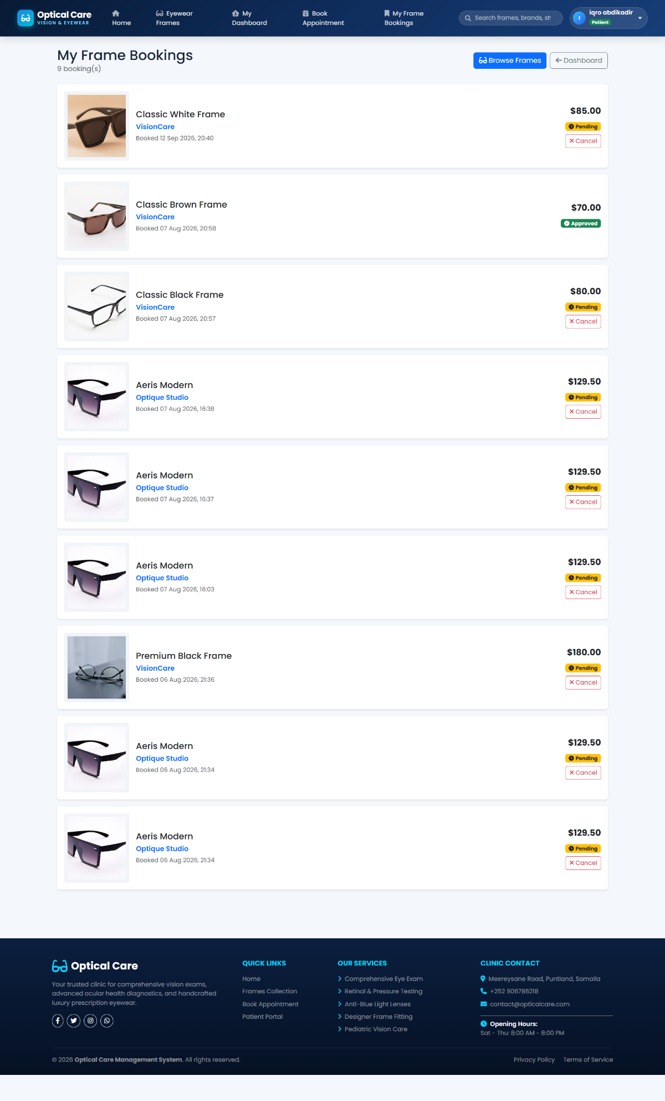
Figure 5.19: Patient Active Frame Bookings Screen

Book an Appointment
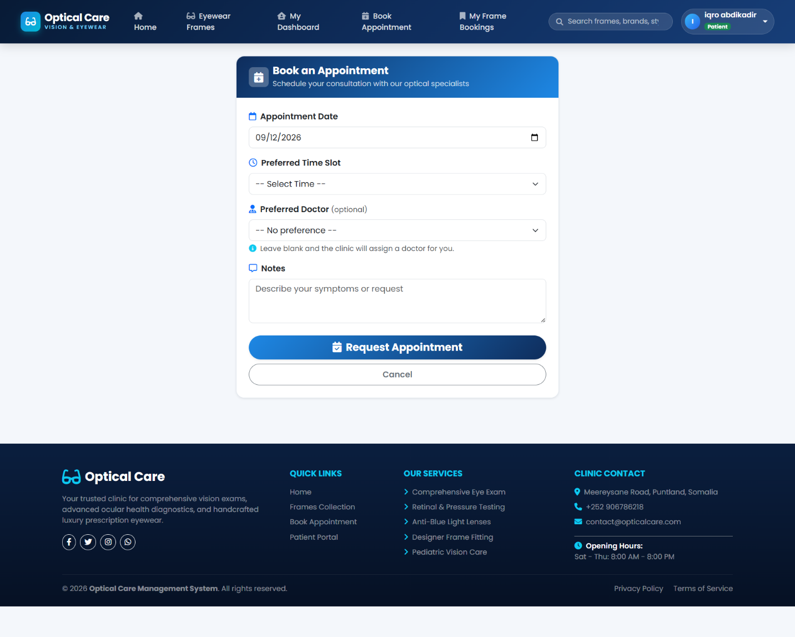
Figure 5.20: Patient Appointment Booking Interface
Doctor dashboard
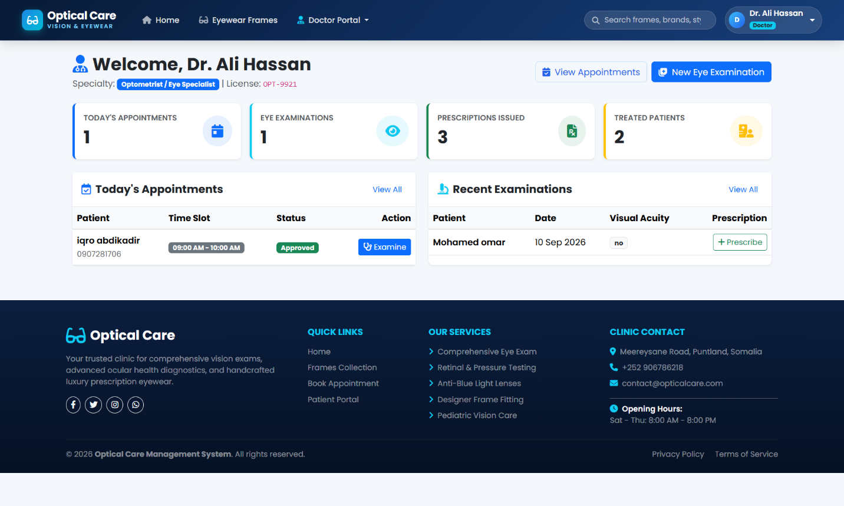
Figure 5.21: Optometrist / Doctor Personal Dashboard
Appointments
Figure 5.22: Doctor Appointments Schedule View
Eye Examination Records
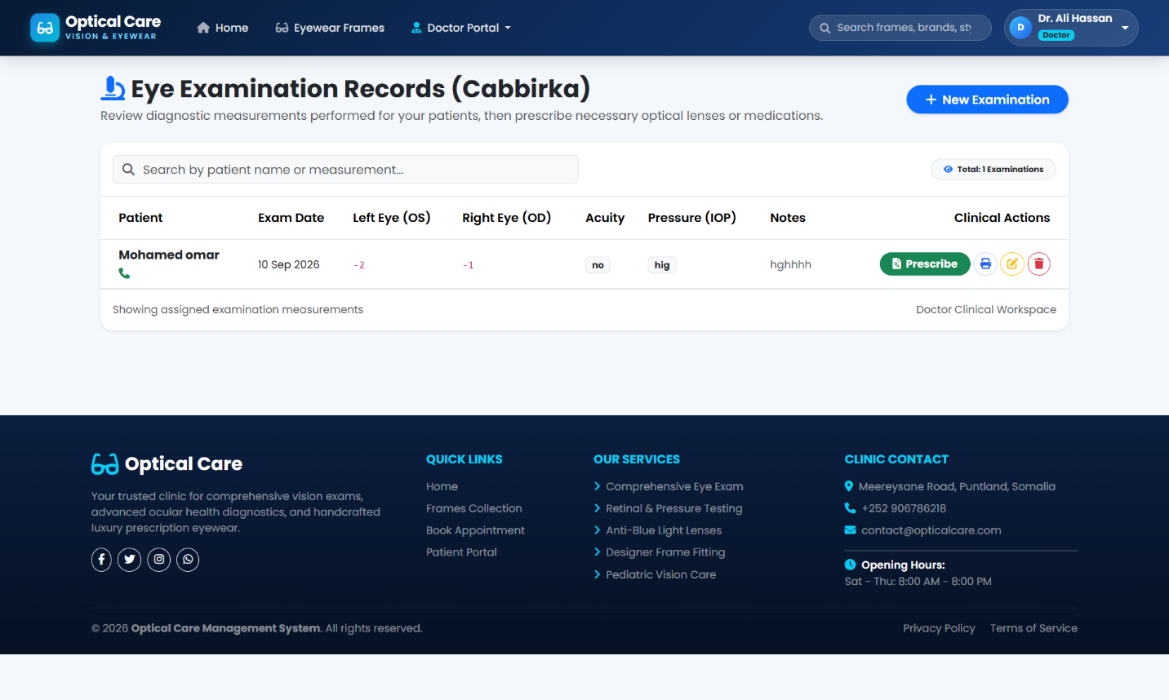
Figure 5.23: Doctor Eye Examination Records Form
Prescriptions & Medication Records
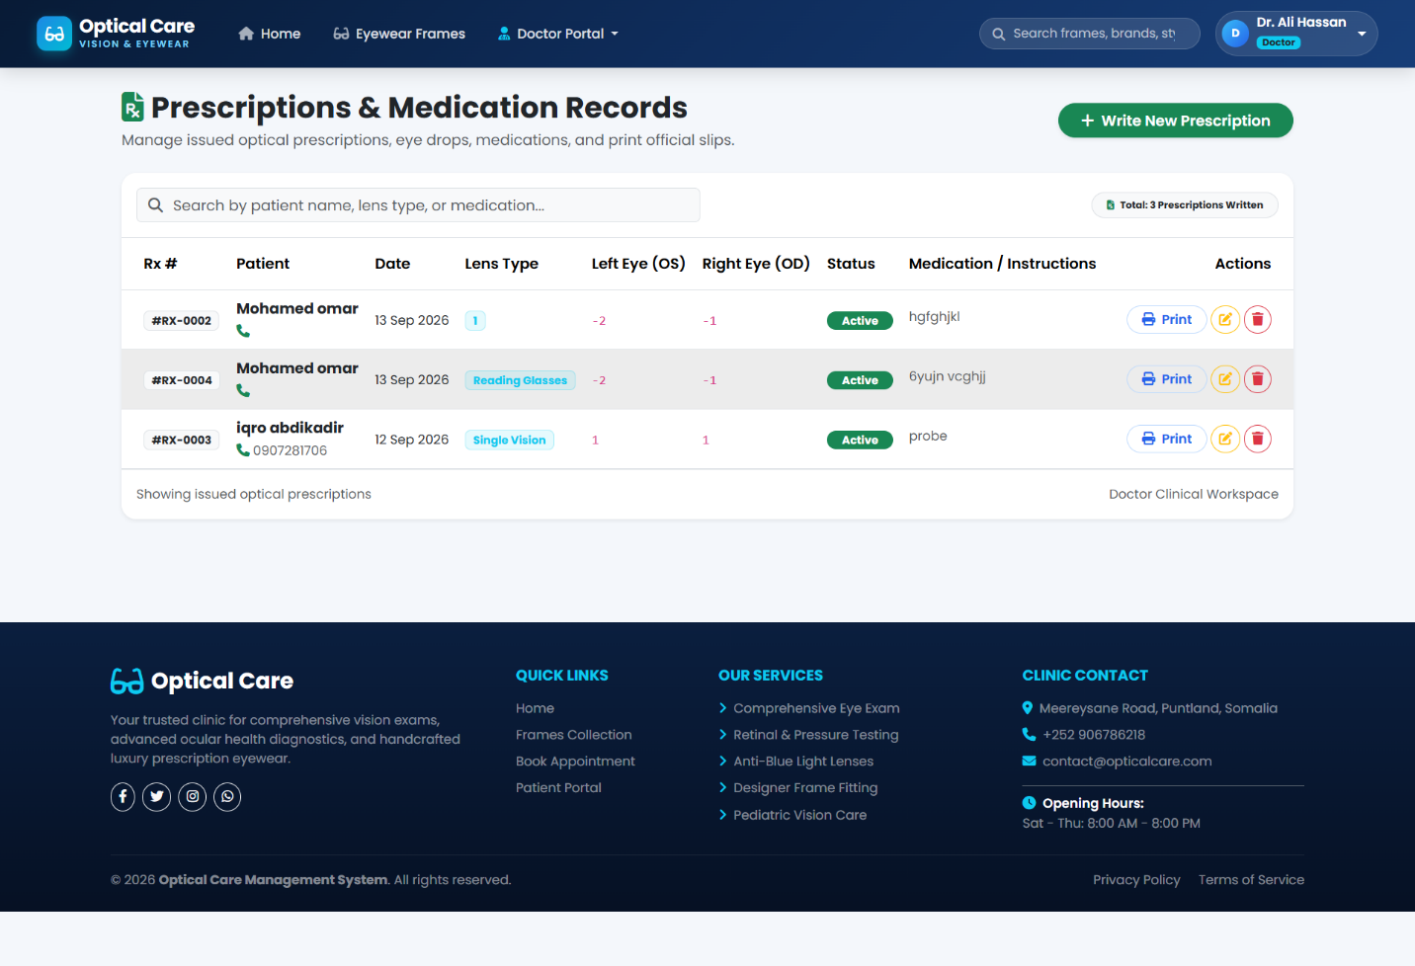
Figure 5.24: Doctor Prescription & Medication Issuance

Patients
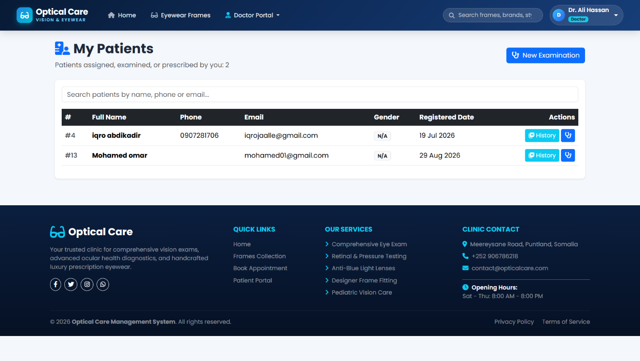
Figure 5.25: Doctor Assigned Patients Directory

Core Implementation Artifacts and Source Code
ApplicationDbContext (Entity Framework Core 9)
public class ApplicationDbContext : DbContext
{
public ApplicationDbContext(DbContextOptions<ApplicationDbContext> options)
: base(options)
{
}

public DbSet<UserAccount> UserAccounts => Set<UserAccount>();
public DbSet<Patient> Patients => Set<Patient>();
public DbSet<Doctor> Doctors => Set<Doctor>();
public DbSet<Appointment> Appointments => Set<Appointment>();
public DbSet<ExaminationRecord> ExaminationRecords => Set<ExaminationRecord>();
public DbSet<Prescription> Prescriptions => Set<Prescription>();
public DbSet<InventoryItem> InventoryItems => Set<InventoryItem>();
public DbSet<Frame> Frames => Set<Frame>();
public DbSet<FrameBooking> FrameBookings => Set<FrameBooking>();

protected override void OnModelCreating(ModelBuilder modelBuilder)
{
// Relationships...
}
}
Configuration Settings (appsettings.json)
{
"Logging": {
"LogLevel": {
"Default": "Information",
"Microsoft.AspNetCore": "Warning"
}
},
"AllowedHosts": "*",
"ConnectionStrings": {
"DefaultConnection": "Server=localhost;Database=OpticalCareDb;Trusted_Connection=True;TrustServerCertificate=True;MultipleActiveResultSets=true"
}
}
Program Configuration and Middleware (Program.cs)
using Microsoft.AspNetCore.Authentication.Cookies;
using Microsoft.EntityFrameworkCore;
using optical_care_management_system.Models;

var builder = WebApplication.CreateBuilder(args);

builder.Services.AddDbContext<ApplicationDbContext>(options =>
options.UseSqlServer(
builder.Configuration.GetConnectionString("DefaultConnection")));

builder.Services.AddAuthentication(CookieAuthenticationDefaults.AuthenticationScheme)
.AddCookie(options =>
{
options.LoginPath = "/Account/Login";
options.LogoutPath = "/Account/Logout";
options.AccessDeniedPath = "/Account/AccessDenied";

options.ExpireTimeSpan = TimeSpan.FromHours(8);
options.SlidingExpiration = true;
options.Cookie.HttpOnly = true;
});

builder.Services.AddControllersWithViews(options =>
{
options.Filters.Add(
new Microsoft.AspNetCore.Mvc.AutoValidateAntiforgeryTokenAttribute());
});

builder.Services.AddSession();

builder.Services.AddAntiforgery();

var app = builder.Build();

if (!app.Environment.IsDevelopment())
{
app.UseExceptionHandler("/Home/Error");
app.UseHsts();
}

app.UseHttpsRedirection();

app.UseStaticFiles();

app.UseSession();

app.UseRouting();

app.UseAuthentication();

app.UseAuthorization();

app.MapControllerRoute(
name: "default",
pattern: "{controller=Home}/{action=Index}/{id?}");

using (var scope = app.Services.CreateScope())
{
var dbContext = scope.ServiceProvider
.GetRequiredService<ApplicationDbContext>();

dbContext.Database.Migrate();

var passwordHasher =
new Microsoft.AspNetCore.Identity.PasswordHasher<UserAccount>();

var doctorUser = dbContext.UserAccounts
.FirstOrDefault(u => u.Username == "dr.ali");

if (doctorUser == null)
{
doctorUser = new UserAccount
{
Username = "dr.ali",
Email = "dr.ali@opticalcare.com",
FullName = "Dr. Ali Hassan",
Role = UserRole.Doctor,
CreatedAt = DateTime.UtcNow
};

doctorUser.PasswordHash =
passwordHasher.HashPassword(
doctorUser,
"Doctor@123");

dbContext.UserAccounts.Add(doctorUser);

dbContext.SaveChanges();
}
}

app.Run();
Project Completion Confirmation and Summary
The Optical Care Management System with Appointment Scheduling is now finished. We designed, built, tested and checked the Optical Care Management System with Appointment Scheduling to make optical clinic operations run better. The Optical Care Management System with Appointment Scheduling gives solutions for patient registration, appointment scheduling, medical record management, examination tracking, prescription management and report generation.

The completed Optical Care Management System with Appointment Scheduling meets the set goals. It offers a secure, reliable and easy‑to‑use platform for managing optical care services. The implementation shows that the Optical Care Management System, with Appointment Scheduling is ready to help with clinic activities and to make handling patient information and appointments faster.

CHAPTER SIX
CONCLUSION AND RECOMMENDATIONS
Introduction
This chapter shares the summary of the findings, conclusions and recommendations from the study about the Optical Care Management System with Appointment Scheduling. It looks at whether the project reached its goals and talks about ways to make the Optical Care Management System, with Appointment Scheduling better in versions. The chapter also gives advice for steps and ends with a wrap‑up of the chapter.
Summary of Findings
The main objective of this study was to design and develop an Optical Care Management System with Appointment Scheduling that improves the management of patients, appointments, eye examinations, prescriptions, eyeglass frames, and administrative activities within an optical clinic. The system was successfully developed using ASP.NET Core MVC, Entity Framework Core, and Microsoft SQL Server.
The findings of this study indicate that the developed system successfully addresses many of the problems associated with manual optical clinic management. The system provides a centralized database for storing patient information, doctor records, appointments, examination records, prescriptions, eyeglass frame information, and inventory records.
The implementation of the system also demonstrated the effectiveness of role-based access control by providing separate dashboards for Administrator, Doctor, and Patient users. Each user is able to access only the functions related to their responsibilities. The appointment scheduling feature simplifies appointment booking and management, while examination and prescription modules improve the efficiency of patient diagnosis and treatment.
System testing confirmed that all major modules function correctly and satisfy the functional requirements identified during the system analysis phase. The developed system therefore achieved its overall objective of providing a secure, reliable, and efficient solution for managing optical clinic operations.
Conclusion
This research successfully designed, developed, implemented, and evaluated the Optical Care Management System with Appointment Scheduling as a modern web-based solution for optical clinic management. The developed system replaces traditional paper-based record keeping with a centralized digital platform that improves efficiency, accuracy, accessibility, and security of patient information.
The implementation demonstrates that modern information technology can significantly improve optical clinic services by simplifying patient registration, appointment scheduling, eye examination management, prescription generation, eyeglass frame management, inventory management, and report generation.
Furthermore, the implementation of authentication and role-based authorization enhances system security by ensuring that administrators, doctors, and patients only access information appropriate to their responsibilities. The centralized database reduces data duplication, minimizes human errors, and improves decision-making within the clinic.
Overall, the developed system successfully achieved the objectives of the study and provides an effective technological solution that supports the daily operations of optical clinics while improving the quality and efficiency of healthcare services.
Recommendations for Future Work
Although the developed system successfully achieved its objectives, several improvements can be considered in future versions to further enhance its functionality:
- Develop a mobile application for Android and iOS devices to improve accessibility for patients and doctors.
- Integrate online payment services for appointment booking and optical product purchases.
- Implement SMS and email notifications for appointment reminders and prescription updates.
- Introduce telemedicine features to allow online consultation between doctors and patients.
- Integrate barcode or QR code technology for managing eyeglass frames and inventory.
- Implement Artificial Intelligence (AI) to assist doctors in analyzing eye examination results and recommending suitable lenses.
- Introduce cloud-based backup and disaster recovery mechanisms to improve data availability and reliability.
- Enhance reporting and analytics by adding interactive dashboards and graphical statistical reports.
- Support multiple languages, including English and Somali, to improve usability for different users.
- Strengthen system security by implementing Two-Factor Authentication (2FA), audit logging, and advanced cybersecurity mechanisms.
Final Remarks
This chapter presented the summary of the findings, conclusions, and recommendations of the study based on the successful development and implementation of the Optical Care Management System with Appointment Scheduling. The findings demonstrated that the system effectively improves patient management, appointment scheduling, examination recording, prescription management, inventory control, and report generation within an optical clinic. The study concludes that the developed system provides a secure, centralized, and efficient solution for modern optical clinic management. The recommended future enhancements will further improve the system's functionality, scalability, usability, and security, making it more effective in supporting healthcare service delivery.

REFERENCES
American Academy of Ophthalmology. (2024). Comprehensive adult medical eye evaluation preferred practice pattern. San Francisco, CA: American Academy of Ophthalmology.
Azameti, A. A. K., Koi-Akrofi, G., Agbodo, N., & Amegadzie, J. K. (2022). A model-driven optical clinic management systems: Systematic software engineering approach. EAI Endorsed Transactions on Pervasive Health and Technology, 8(30), 1–15.
Cayirli, T., & Veral, E. (2006). Designing appointment scheduling systems for ambulatory care services: A review. Health Care Management Science, 9(1), 47–58.
Chogo, O. J., & Musinga, J. (2012). Design and implementation of an interactive secure patient appointment booking information system: A case study of Kibuli Muslim Hospital (Unpublished bachelor's thesis). Kampala International University, Kampala, Uganda.
Dennis, A., Wixom, B. H., & Roth, R. M. (2020). Systems analysis and design (8th ed.). Hoboken, NJ: John Wiley & Sons.
Evans, L., Acton, J. H., Hiscott, C., & Gartner, D. (2023). An operations research approach to automated patient scheduling for eye care using a multi-criteria decision support tool. Scientific Reports, 13(1), 553–568.
Kuiper, A., de Mast, J., & Mandjes, M. (2021). The problem of appointment scheduling in outpatient clinics: A multiple case study of clinical practice. Omega, 102, 102122.
Kyambille, G. G., & Kalegele, K. (2016). Enhancing patient appointments scheduling that uses mobile technology. International Journal of Computer Applications, 142(6), 1–7.
Laudon, K. C., & Laudon, J. P. (2022). Management information systems: Managing the digital firm (17th ed.). Boston, MA: Pearson Education.
Microsoft Corporation. (2024a). ASP.NET Core MVC documentation. Retrieved from https://learn.microsoft.com/aspnet/core/mvc
Microsoft Corporation. (2024b). Entity Framework Core documentation. Retrieved from https://learn.microsoft.com/ef/core
Microsoft Corporation. (2024c). SQL Server documentation. Retrieved from https://learn.microsoft.com/sql
Pressman, R. S., & Maxim, B. R. (2020). Software engineering: A practitioner's approach (9th ed.). New York, NY: McGraw-Hill Education.
Sommerville, I. (2016). Software engineering (10th ed.). Boston, MA: Pearson.
World Health Organization. (2023). World report on vision. Geneva, Switzerland: World Health Organization.
APPENDIX A: SYSTEM SCREENSHOTS
Figure 1: Sign In Screen
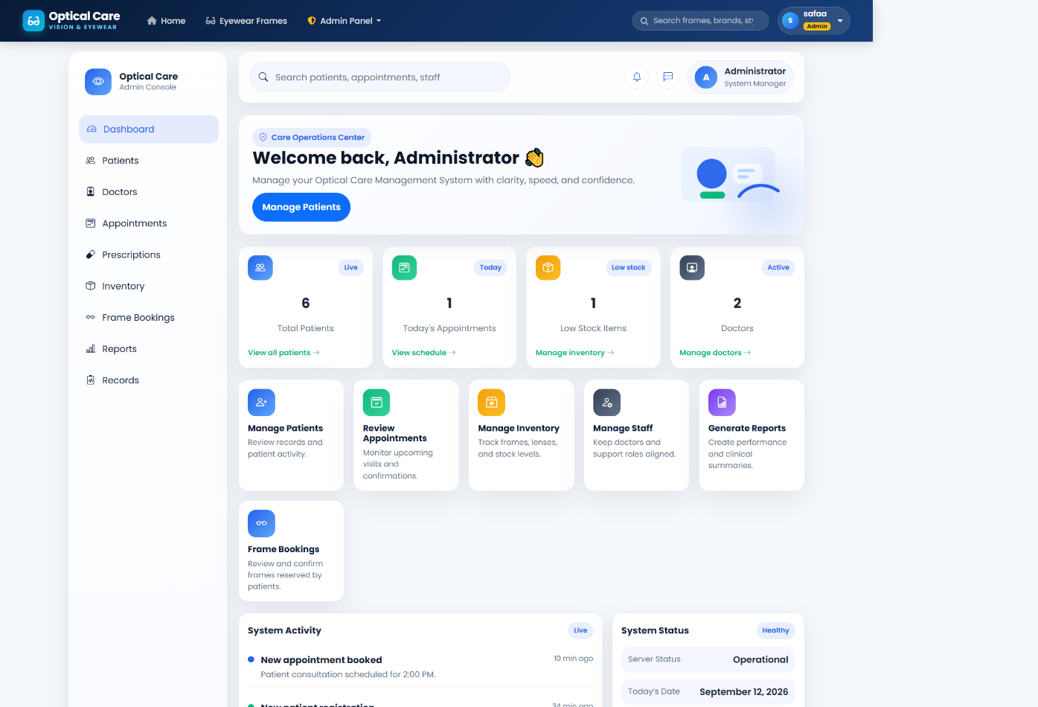
Figure 2: Dashboard Summary and Clinic Overview
APPENDIX B: SYSTEM DESIGN DIAGRAMS
Figure 1: Use Case Diagram
Figure 2: Entity Relationship Diagram (ERD)
APPENDIX C: SYSTEM ARCHITECTURE AND MODULE DIAGRAMS
Figure 1: System Architecture Diagram
Figure 2: Module Interconnection Diagram

