GROUP B – WEB DESIGN AND DEVELOPMENT PROJECT
Sustainability Goal: Number 4 - Quality Education.

Site Map:

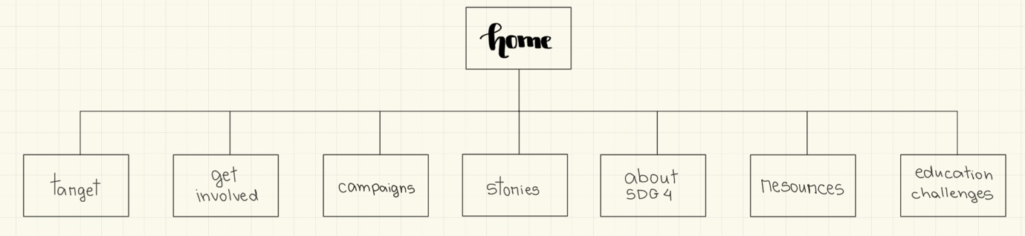

Wireframes:
Wireframes division:
- Matheus: Home and Resources;
- Thales: Campaigns and Education Challenges;
- Rubia: Target and About SDG4;
- Savio: Get Involved and Stories.

Home:
Computer | Phone
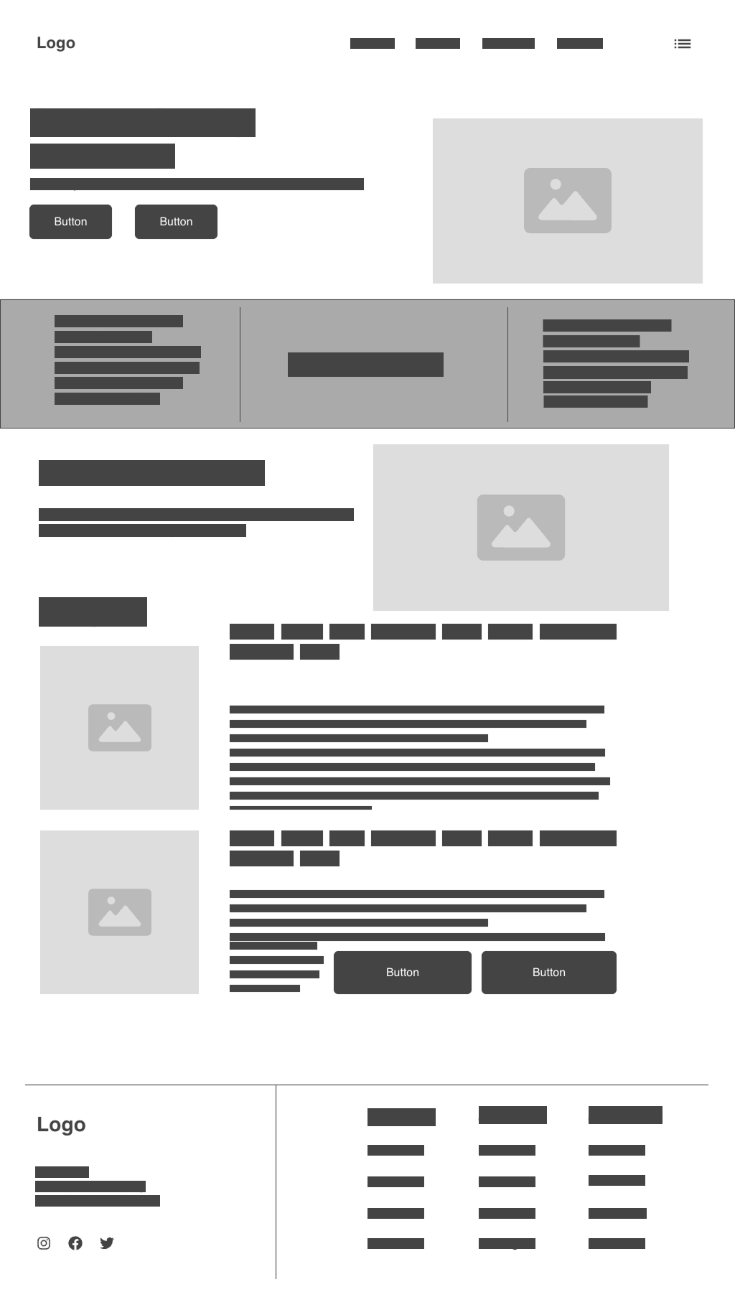 | 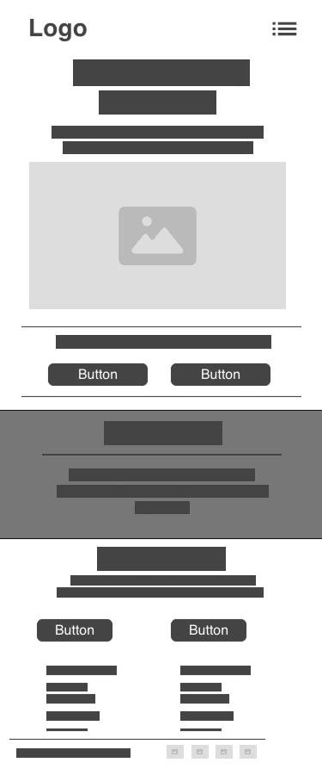

Target:
Computer | Phone
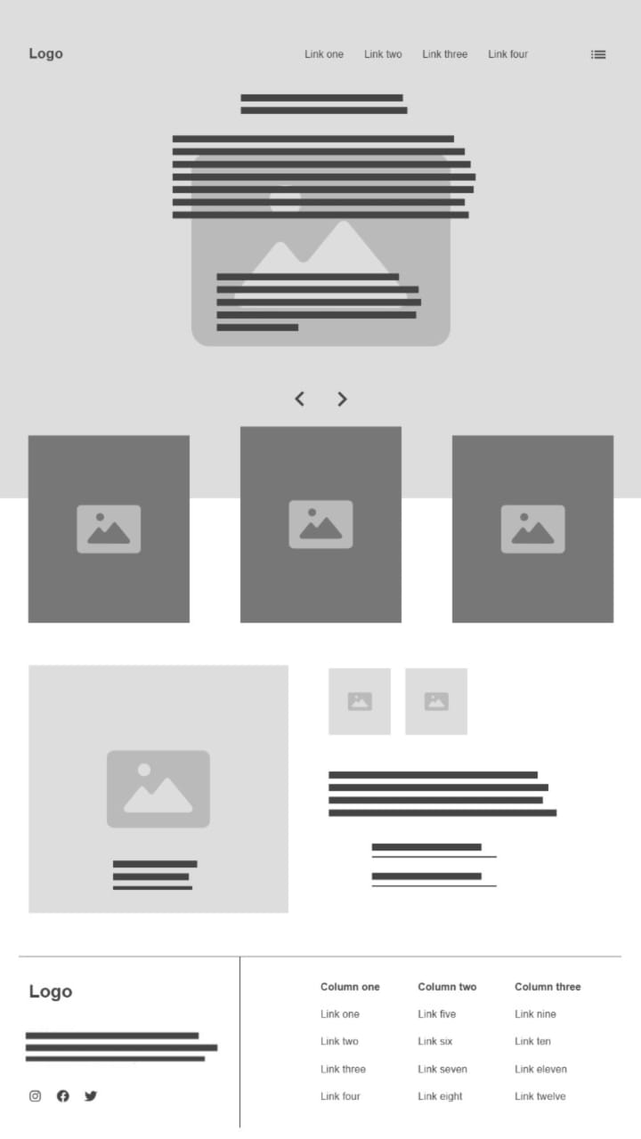 | 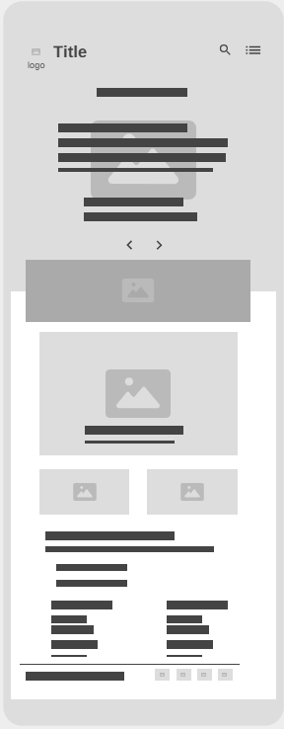

Get involved:
Computer Mobile
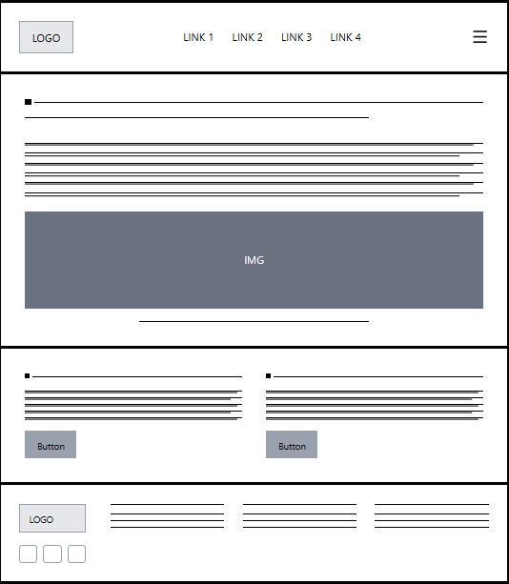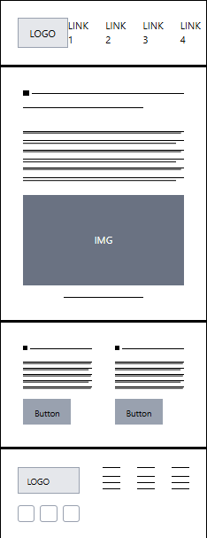

Campaigns:
Notes:
- All images will be clickable and will link to the original site where the campaign is running.

Computer | Mobile
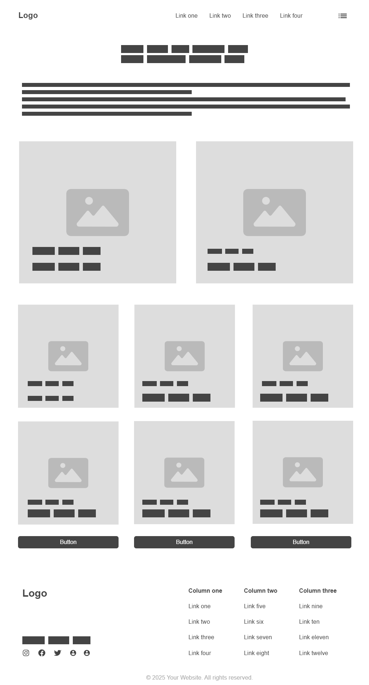 | 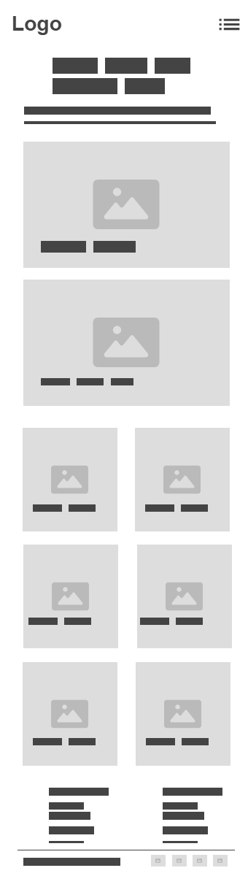

Stories:
Computer Mobile
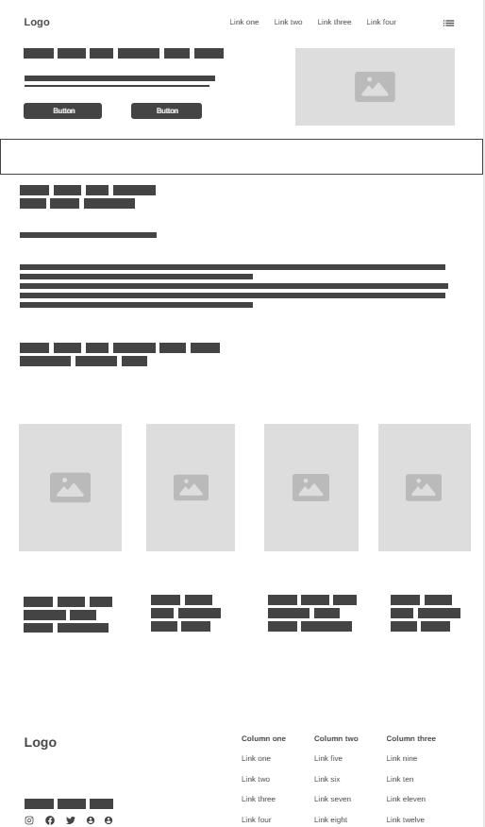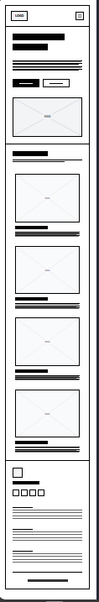

About SDG4:
Computer | Phone
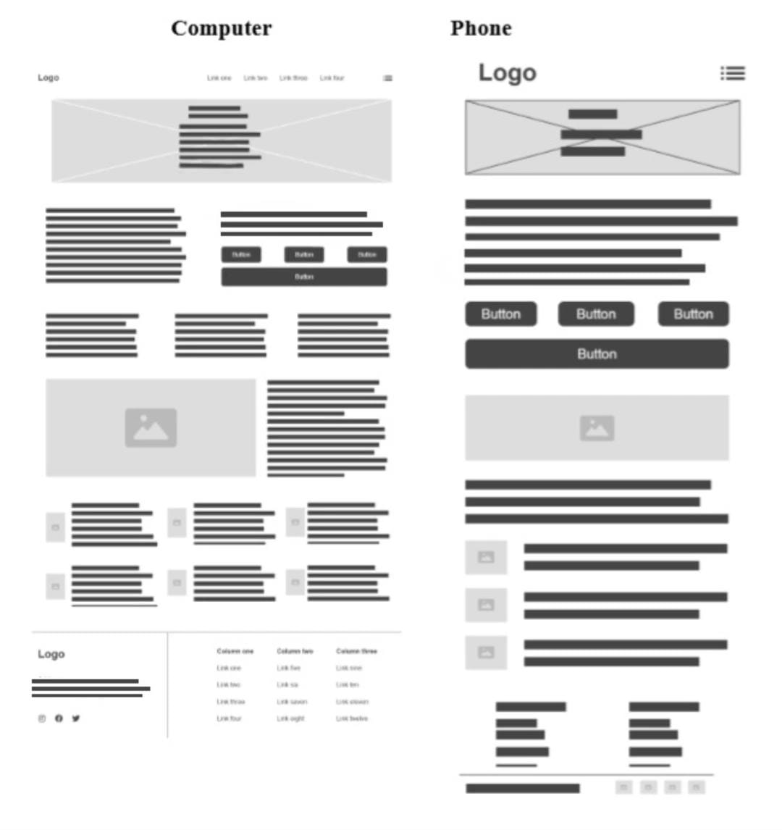

Resources:
Computer | Phone
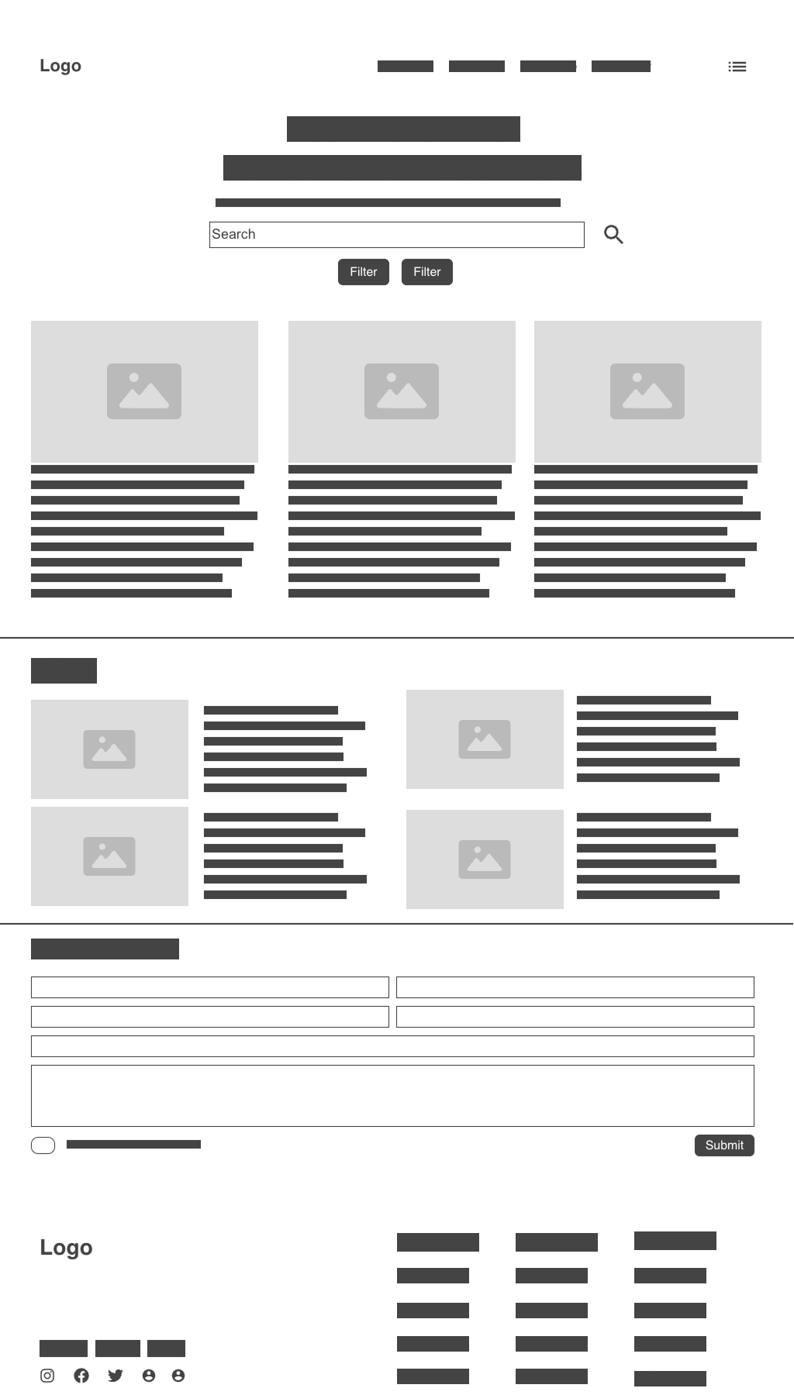 | 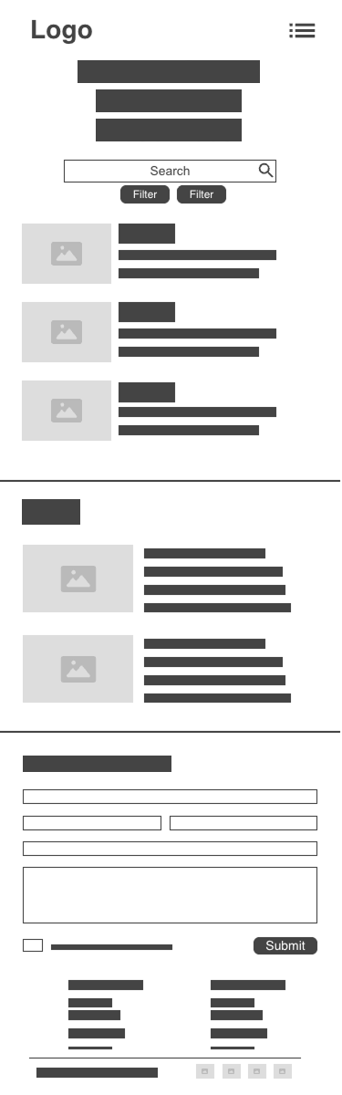

Education Challenges:
Notes:
- The first image is a background image.

Computer | Phone
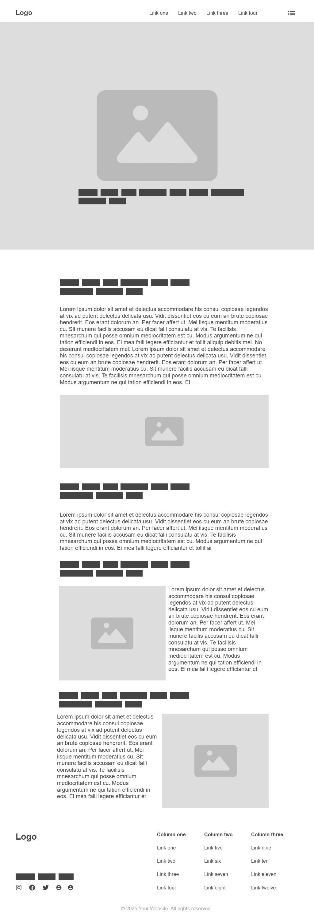 | 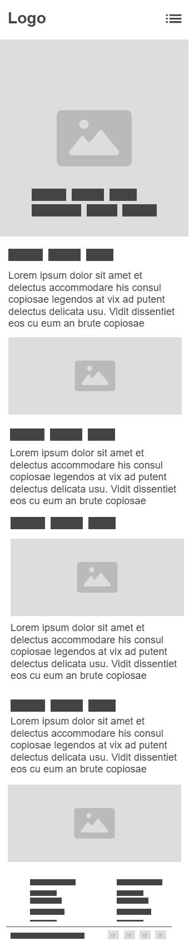
GitHub Repositories:
- Matheus: https://github.com/matreis7/sdg4-quality-education.git
- Rubia: https://github.com/rubialn/sdg4-quality-education.git
- Thales: https://github.com/thalesmf05/sdg4-quality-education.git
- Savio: https://github.com/saviomiano/sdg4-quality-education.git

Google Fonts:
Headings:
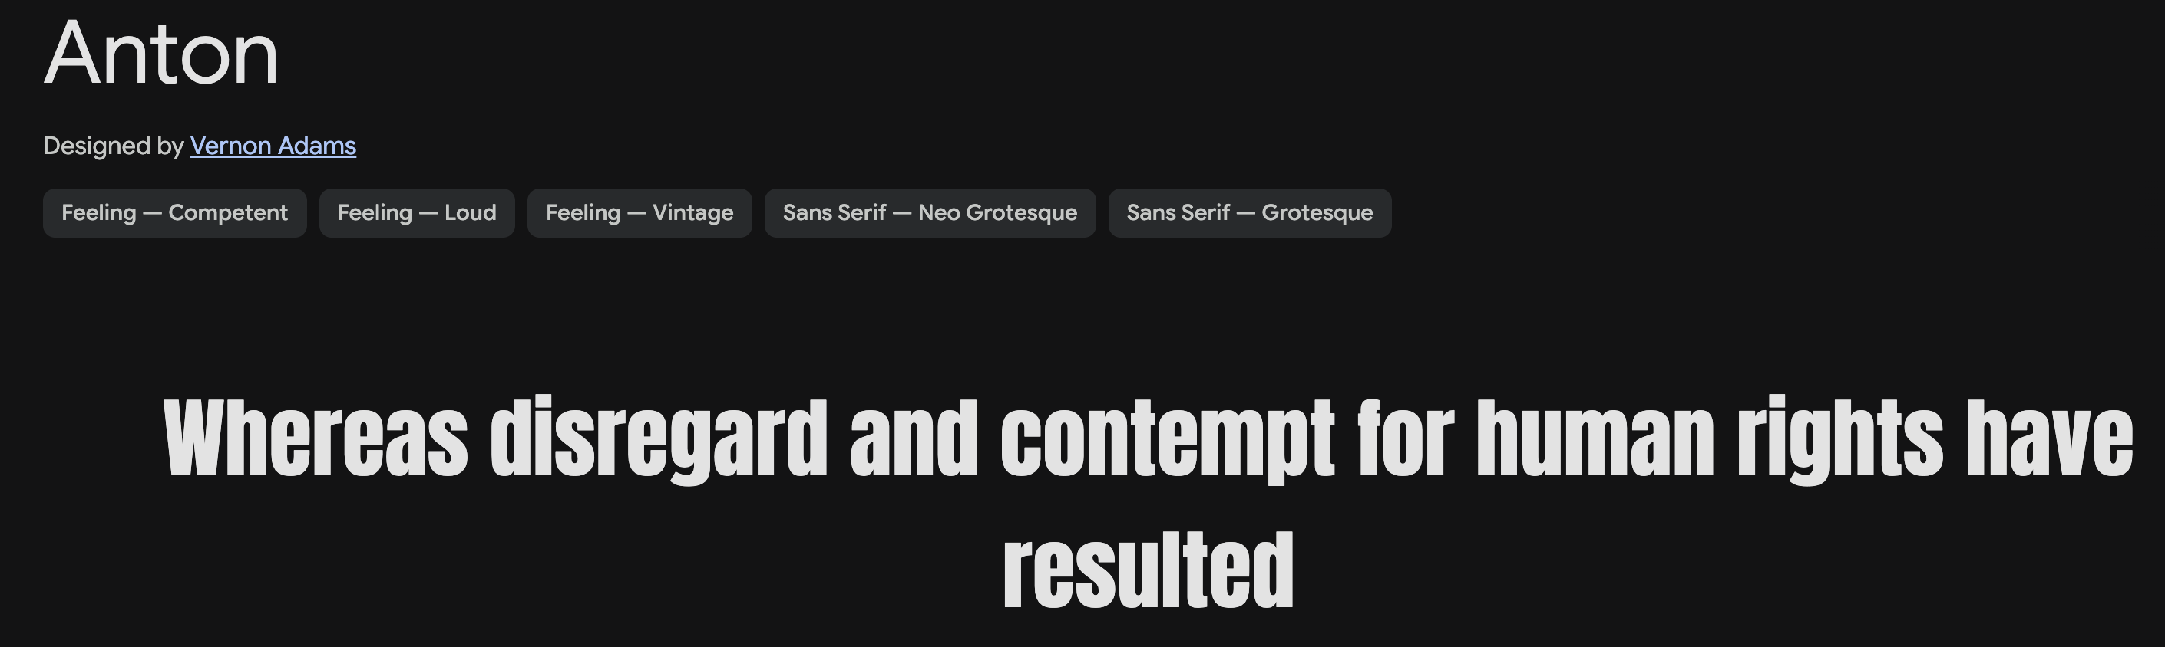https://fonts.google.com/specimen/Anton

Body:
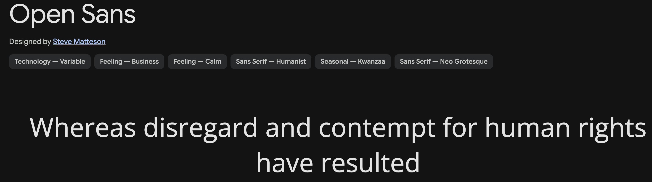https://fonts.google.com/specimen/Open+Sans

Colour Paleta:

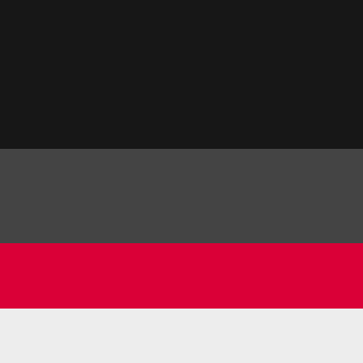
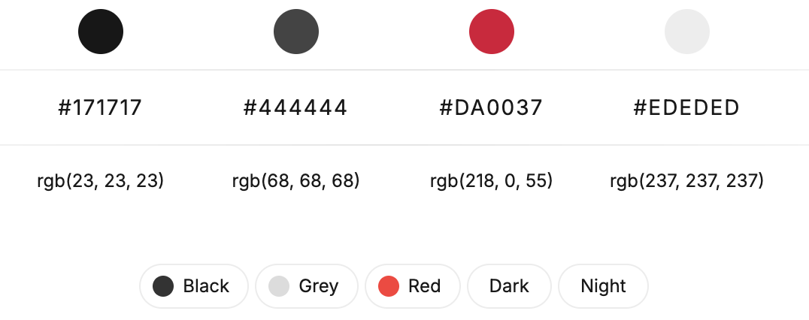
#2A140E, #FC72FF, #8F68FF, #487BFF, #8F68FF, #FC72FF, #FFF, #FF0000, #FF7300, #FFFB00, #48FF00, #00FFD5, #002BFF, #FF00C8, #FF0000, #000

Design Ideas and Useful links:
- Interactive dropdown menu: https://youtu.be/IoxHLJblUKQ?si=x3Cj7I9B6tyY6RkK
- Make images responsive: https://youtu.be/Q5m8cCGdiBo?si=BRNp0_uYozi32UDI
- Responsive navbar: https://youtu.be/yE9DLIoDwCg?si=Pg43uo5jYx9dNiNO and https://youtu.be/ZZ0gvY-4IKA?si=j6vP-N1F8Ak7Mtih
- Get icons: https://www.flaticon.com/search?word=education
- NCI Education Website: https://www.ncirl.ie/About/Faculties/Centre-for-Education-and-Lifelong-Learning
- The global goals: https://globalgoals.org/goals/4-quality-education
- Inspirations for CSS: https://webflow.com/enterprise?utm_source=google&utm_medium=search&utm_campaign=Demand-Gen-Google-Search-Brand-ContactSales&utm_source=google&utm_medium=search&utm_campaign=Demand-Gen-Google-Search-Brand-Core&utm_term=kwd-11668981_webflow_e_772662570188__&gad_source=1&gad_campaignid=19905681763&gbraid=0AAAAACZTewwBOTwSJXvKmOlQ8NjnF9u84&gclid=CjwKCAiAlMHIBhAcEiwAZhZBUs_u4TtR0N31tlKZXt6vsglstXAw0z5BHB82J-hcPfEKwuu8dZEHKBoCNVAQAvD_BwE

Excel Tasks:
