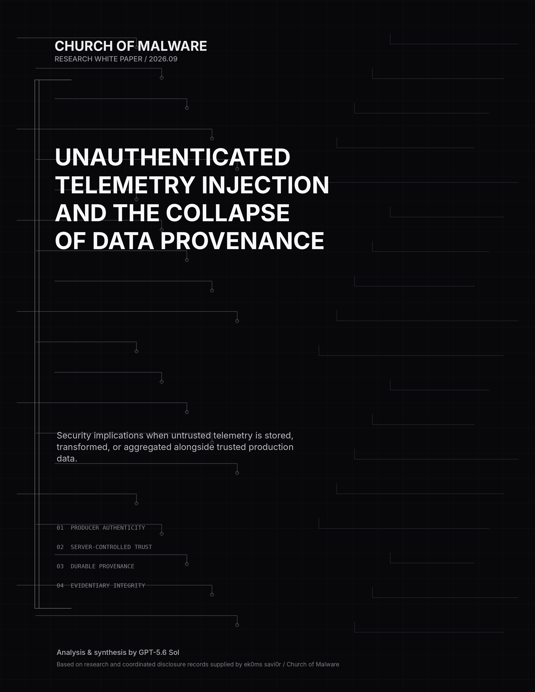

Unauthenticated Telemetry Injection
and the Collapse of Data Provenance
Security implications when untrusted telemetry is stored, transformed, or aggregated alongside trusted production data.
Prepared for | Church of Malware
Research basis | Coordinated disclosure records and proof-of-concept observations supplied by ek0ms savi0r / Church of Malware
Analysis | K3nundrum, Tjnull & ek0ms savi0r of church of malware
Version | 1.0 - September 2026

Scope note
This paper distinguishes confirmed ingestion-boundary behavior from downstream effects that cannot be independently verified from an external position. It does not claim that every unauthenticated telemetry collector is vulnerable, nor that every tested platform stores untrusted records with trusted records. The central question is architectural: if unverified records are retained, do server-controlled provenance controls remain durable and machine-actionable through every downstream stage?

Abstract
Modern telemetry is no longer passive exhaust. It feeds observability, incident response, security analytics, business intelligence, automated control loops, and increasingly machine-learning systems. Research reviewed for this paper identified multiple production telemetry collectors that accepted synthetic externally generated events without first authenticating the producer as an authoritative source. That fact alone does not establish downstream compromise. The security significance depends on what happens after acceptance. If unverified data is discarded, quarantined, or permanently tagged as untrusted by the server, risk may be limited. If unverified data is stored, transformed, aggregated, exported, or queried alongside authentic production telemetry without durable provenance, the organization can lose the ability to distinguish observation from assertion. This paper frames unauthenticated telemetry injection as a data-provenance and trust-boundary problem and proposes an assessment model centered on producer authenticity, server-controlled trust state, provenance durability, and downstream consumption.

KEY FINDING
• Public or unauthenticated ingestion is not automatically a vulnerability.
• Ingestion acceptance is not proof of retention or trusted downstream use.
• The decisive property is a server-authoritative distinction between verified and unverified producers.

CONTENTS

Contents & Research Questions
01 Telemetry Has Become Evidence
02 The Security Property: Provenance
03 What External Testing Can and Cannot Prove
04 Research Observations Across Multiple Ecosystems
05 Threat Model: The Producer Is the Adversary
06 When Fake and Real Data Share a Trust Domain
07 Security, Operations, Business, and AI Implications
08 The Aggregation and Transformation Problem
09 A Server-Controlled Provenance Architecture
10 A Four-Stage Assessment Model
11 Severity Should Follow Downstream Trust
12 Vendor Validation: Trace the Canary
13 Recommendations for Platform Operators and Customers
14 Conclusion: Protect Epistemic Integrity
A Research Notes and Claim Boundaries
R References

Research questions
— Can an external producer submit telemetry to a production collector?
— Which semantic fields can the producer control?
— Does the service assign an authoritative server-controlled trust state?
— Can the producer modify, suppress, or imitate that state?
— Does provenance survive normalization, storage, transformation, aggregation, query, alerting, and export?
— Can unverified telemetry contribute to security-sensitive or business-sensitive decisions?

01 / CONTEXT

Telemetry Has Become Evidence
Telemetry historically occupied a relatively simple role: applications emitted logs and engineers inspected them. Modern infrastructure is different. Event streams now feed observability, incident response, user and session reconstruction, fraud systems, business intelligence, reliability engineering, alerting, automated remediation, and model-development pipelines. The integrity of telemetry therefore affects more than charts. It affects what an organization believes happened.
A telemetry record is often treated as an observation. But a network-accessible collector may receive records from software that is outside the operator's trust boundary: browsers, mobile applications, newly initialized devices, embedded clients, third-party SDKs, or arbitrary external software that can reproduce the wire format. In those environments, the record may be only an assertion made by the sender.
CENTRAL QUESTION What happens when the system can no longer reliably distinguish what it observed from what someone merely claimed was true?
The answer is not "reject every unauthenticated event." Some systems have legitimate reasons to accept telemetry from untrusted client environments. The correct design objective is stronger: do not allow unverified data to silently acquire the trust characteristics of verified data.

The evidence-versus-assertion distinction
Consider a dependency event that says a payment service failed. If the event came from an authenticated backend sensor, it may be meaningful evidence. If an unknown external sender constructed the same schema and submitted it to a public ingestion interface, the record is an assertion. Both can be stored. They should not have the same evidentiary weight unless the system can prove equivalent producer authenticity.
02 / PROVENANCE

The Security Property: Provenance
The W3C PROV model defines provenance as information about the entities, activities, and agents involved in producing or influencing data, explicitly linking provenance to assessments of quality, reliability, and trustworthiness. That framing maps directly onto telemetry security: a record is not fully understood until the pipeline knows who or what produced it, under what trust conditions, and how it was transformed.

For telemetry, meaningful provenance should answer at least six questions:
• Which producer generated the record?
• Was that producer authenticated, attested, or otherwise verified?
• Which identity and resource claims came from the producer versus the receiving server?
• What transformations were applied?
• Did the record contribute to derived metrics, alerts, exports, or models?
• Can downstream consumers still determine the original trust class?
A client-controlled label is not authoritative provenance. A sender can honestly set a marker such as producer_claim=UNAUTHENTICATED_EXTERNAL_RESEARCHER to facilitate canary tracing, but an attacker could remove or falsify that field. Security-relevant trust metadata must be assigned, verified, or cryptographically bound by the receiving infrastructure.
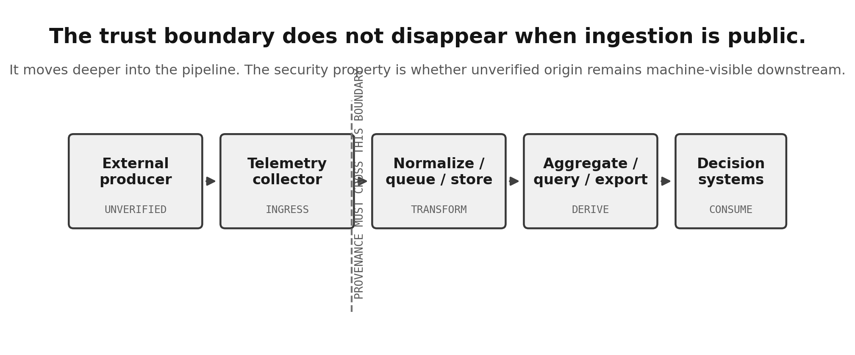
Figure 1. The telemetry trust boundary moves downstream when public ingestion is intentional.
03 / EVIDENCE

What External Testing Can and Cannot Prove
A recurring failure mode in telemetry research is collapsing ingestion acceptance and downstream impact into a single claim. They are not the same. An external researcher can usually prove the behavior of the front door. Only the platform operator can normally prove final disposition inside the backend.
Externally verifiable | Usually operator-verifiable
Authentication required or not | Final retention or deletion
Collector accepts synthetic events | Dashboard or query visibility
Caller-controlled fields are parsed | Server-side provenance classification
Production destination is recognized | Alert / automation participation
HTTP status / acceptance counters | Aggregation and export behavior
Small-sample throttling behavior | ML / model-development use
A response such as HTTP 200 with itemsAccepted=1 is meaningful: it establishes that the ingestion service received, parsed, and accepted the envelope according to its front-door semantics. It does not establish permanent storage, trusted attribution, operational use, or execution of values contained in the record. Likewise, ten accepted requests demonstrate that throttling was not observed in that small sample; they do not prove the global absence of rate limiting.
04 / RESEARCH OBSERVATIONS

Research Observations Across Multiple Ecosystems
The research corpus supplied for this paper spans multiple telemetry designs. The observations below are intentionally scoped to what the supplied evidence supports. They should not be read as a claim that every platform stores unauthenticated records in trusted downstream datasets.

Microsoft Application Insights
External tests demonstrated that synthetic Application Insights envelopes addressed to real resources could be accepted at the ingestion boundary. In a CarMax-associated deployment, caller-controlled values included event names, user/session identifiers, operation names and IDs, custom properties, and remote-dependency record text. A representative response reported itemsReceived=1, itemsAccepted=1, a non-null application identifier, and no schema errors. This proves ingestion acceptance and semantic field control; it does not independently prove retention, dashboard appearance, SSRF, alert manipulation, or trusted attribution.

Microsoft OneCollector / 1DS
Research identified multiple OneCollector/1DS collection endpoints that accepted externally supplied events. Microsoft stated that backend validation, filtering, and trust-handling controls protect downstream use and classified the reported issue as Low severity. From the external research position, the unresolved evidentiary question was whether the supplied canaries were actually traced through production handling and shown to retain a server-controlled trust classification.

Google Android Check-In
Synthetic check-in requests were accepted by the Android Check-In service, including a single uniquely tagged research canary. Google explained that unauthenticated bootstrap check-ins are expected for newly initialized devices and later stated that server-controlled mechanisms classify and segregate unauthenticated data. That architecture, if durable across downstream processing, is the kind of control this paper advocates. External testing alone could not independently verify the full trace.

TikTok analytics ingestion
A HackerOne report concerning TikTok analytics ingestion was closed as a duplicate of an earlier report, whose program disposition treated analytics/lead data as unreliable or non-mission-critical under that threat model. The remaining architectural question is whether this unreliability is only a human assumption or is encoded as server-controlled provenance that remains machine-actionable downstream.

Flock Safety / Segment
Research involving a Flock Safety deployment illustrated a multi-party pipeline in which first-party telemetry is collected through third-party analytics infrastructure. This architecture makes durability especially important: a collector may know an event is unauthenticated at ingress, but the security property fails if that trust state disappears during export, normalization, or first-party warehousing.

Cross-vendor pattern
The recurring pattern is not "all collectors are broken." It is that many telemetry systems intentionally accept data from environments where the producer cannot be assumed trustworthy. Once that design choice is made, producer trust must be represented elsewhere in the architecture. The absence of front-door authentication increases the importance of downstream provenance rather than eliminating the trust problem.
05 / THREAT MODEL

Threat Model: The Producer Is the Adversary
The relevant attacker does not necessarily need administrator access, a stolen secret, or a compromised server. In client-side telemetry systems, destination information is often intentionally shipped to the client. Microsoft documentation explicitly states that the Application Insights JavaScript connection string is visible in the browser and is not considered a security token or key. The design challenge is therefore not simply secrecy of the destination identifier.
The attacker attempts to impersonate the data-producing environment. Traditional application security asks who is allowed to access a resource. Telemetry security asks a different question: who is allowed to create evidence describing what supposedly happened inside that resource?
TRADITIONAL TRUST QUESTION
Who may perform the action?
TELEMETRY TRUST QUESTION
Who may create the record that claims the action occurred?
This distinction is crucial because identity fields inside telemetry are usually claims. A record containing user_id=Alice is not proof that Alice generated the event. Without producer authentication or durable provenance, it only proves that the sender asserted Alice as the user.
06 / FAILURE MODE

When Fake and Real Data Share a Trust Domain
Physical co-location is not necessarily the problem. A datastore may safely contain both verified and unverified events if trust state is durable and enforced. The dangerous condition is semantic co-location: unverified records participate in the same queries, aggregates, alerts, or evidentiary interpretations without an authoritative distinction.
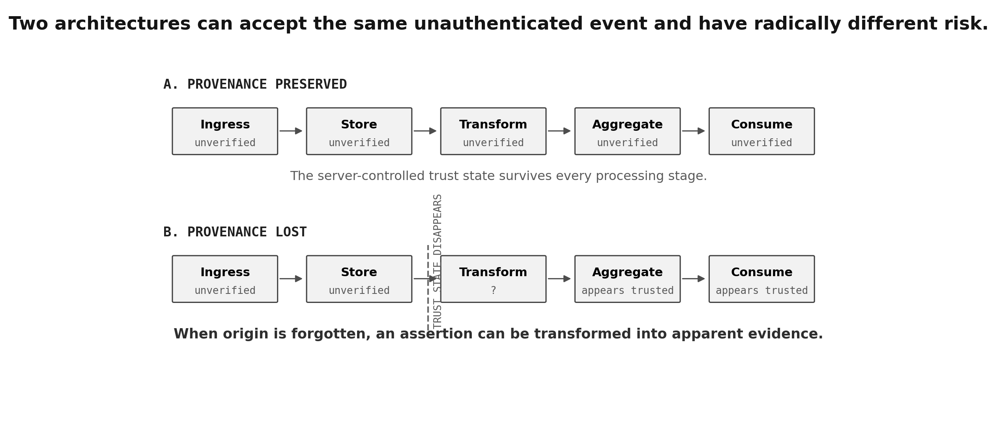
Figure 2. Provenance-preserving and provenance-losing pipelines can begin with the same accepted event.
Once provenance disappears, the information may effectively experience a privilege escalation. It entered as an untrusted assertion and emerged as trusted-looking evidence. This transformation can occur without any traditional code execution or authorization bypass.
07 / IMPLICATIONS

Security, Operations, Business, and AI Implications

7.1 Evidentiary integrity
Incident response frequently reconstructs timelines from logs and telemetry: who logged in, which operation failed, which dependency was contacted, which version emitted the event, and what happened immediately before an outage. If arbitrary producers can create indistinguishable records, affected telemetry becomes weaker evidence. The organization may still use it, but it must account for uncertainty about origin.

7.2 False operational narratives
Distributed telemetry reconstructs stories from many records. A user appears to start a session, execute an operation, encounter a dependency failure, and abandon a workflow. Synthetic events can fabricate pieces of that story. Without provenance, the resulting narrative may be internally coherent yet not grounded in observed reality.

7.3 Detection and monitoring
Security detections and reliability alerts often count events, correlate identities, or match sequences. If unverified records contribute to those calculations, they can create false positives or degrade analyst confidence. A more subtle attack is signal dilution: adding enough misleading records that analysts stop trusting the source. The target is not necessarily the alert rule; it is the signal-to-noise ratio.

7.4 Attribution failure
Fields such as user_id, session_id, device_id, operation_id, tenant_id, application version, and hostname describe apparent identities. Their evidentiary value depends on who was allowed to assert them. Systems must distinguish claimed identity from verified producer identity.

7.5 Business analytics
Product analytics, conversion metrics, reliability reports, campaign attribution, and customer-journey analysis can all be distorted if externally generated records participate without weighting or segregation. An attacker may not need to compromise the application itself; contaminating what the organization believes about the application can still produce bad decisions.

7.6 Artificial intelligence and model pipelines
Unauthenticated ingestion does not, by itself, prove machine-learning poisoning. The risk emerges only if unverified telemetry is later used in training, evaluation, feature engineering, anomaly baselines, or automated decision systems. NIST guidance on AI risk and provenance reinforces the importance of tracking the origin and history of data inputs. If telemetry-derived features lose source lineage, contamination can become difficult to detect or unwind.

7.7 Availability and cost
Public ingestion can also create resource-consumption concerns: ingestion volume, indexing, retention, export bandwidth, query cost, dashboard noise, and analyst time. These effects should be demonstrated rather than assumed. Small-sample acceptance tests cannot establish unlimited throughput or global absence of throttling.
08 / DERIVED DATA

The Aggregation and Transformation Problem
Aggregation is one of the easiest ways to accidentally destroy provenance. Imagine 99 verified failure events and one unverified event. A naive pipeline produces failure_count=100. Even if the unverified event originally carried a trustworthy server-side classification, the aggregate may no longer expose it.
NAIVE AGGREGATE
failure_count = 100
PROVENANCE-AWARE AGGREGATE
verified_failure_count = 99
unverified_failure_count = 1
This illustrates a broader rule: provenance is not only a property of raw records. It must become a property of derived information. When records are normalized, deduplicated, summarized, joined, exported, or transformed into feature vectors, downstream artifacts should retain enough lineage to prevent unverified inputs from silently acquiring stronger authority.
OpenTelemetry's data model separates the event time from the time a collection system observed an event and includes resource context describing the observed entity. That is useful structure, but a source/resource field remains a semantic claim unless the pipeline knows how that identity was established. Provenance requires both descriptive context and trust context.
09 / DESIGN

A Server-Controlled Provenance Architecture
A resilient telemetry system should treat producer authenticity as metadata that is assigned or verified by the service, protected from client control, and propagated through the full data lifecycle. Trust labels controlled by an untrusted sender are not trust labels.
Producer verification — Authenticate or attest high-trust producers where feasible. Browser and anonymous-client telemetry may remain unverified by design.
Server-controlled classification — Assign an authoritative producer class at ingress: e.g., browser_unverified, authenticated_backend, attested_device, third_party_integration.
Immutability — Prevent the external producer from setting, suppressing, or imitating authoritative trust metadata.
Propagation — Carry trust state through queues, storage, transformations, joins, exports, and derived datasets.
Policy-aware consumption — Make alerting, automation, security analytics, and business-critical queries explicitly select which producer classes may contribute.
Provenance-aware aggregation — Either segregate verified/unverified counts or attach mixed-provenance metadata to derived values.
Traceability — Support end-to-end canary tracing so operators can prove disposition during security investigations.
Abuse controls — Apply rate, anomaly, and resource-consumption defenses even when anonymous ingestion is intentional.

10 / ASSESSMENT

A Four-Stage Assessment Model
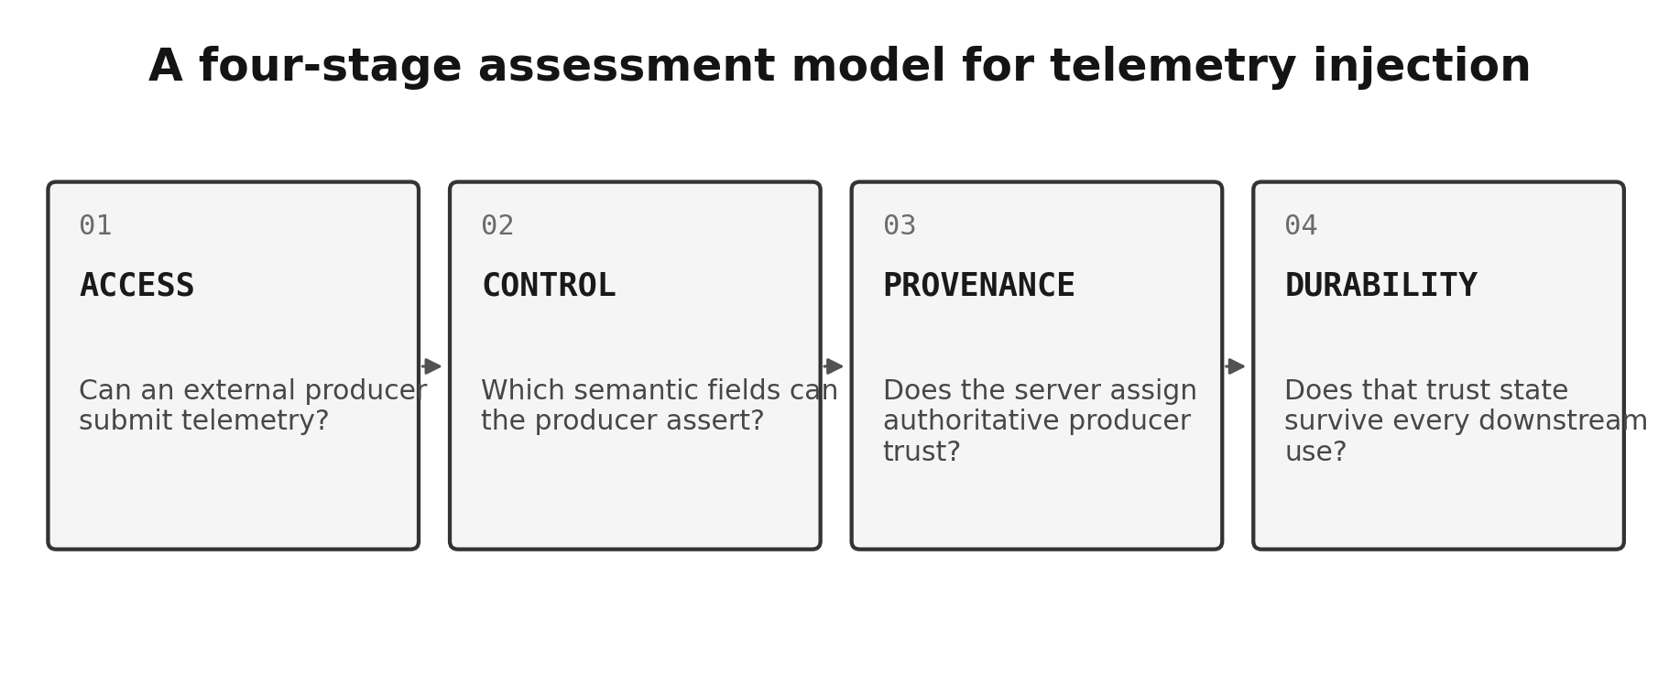
Figure 3. A telemetry-injection assessment should move from accessibility to downstream provenance durability.
This model is intentionally more demanding than the binary question "is authentication required?" A public collector can be architecturally safe if unverified provenance is preserved. An authenticated collector can still be unsafe if downstream transformations erase identity guarantees or if one authenticated producer can impersonate another. The four stages therefore separate reachability, semantic influence, authoritative classification, and downstream durability.
11 / SEVERITY

Severity Should Follow Downstream Trust
Not every instance of unauthenticated telemetry ingestion deserves the same severity. The central variable is whether unverified data can acquire the authority of verified observations or influence security-sensitive decisions.
Architecture | Primary concern | Illustrative severity posture
Unauthenticated ingress; immediate discard | No durable record | Minimal
Retained in quarantine with immutable untrusted label | Abuse / cost / operational hygiene | Low to context dependent
Stored with real data but provenance remains durable | Query misuse / accidental mixing | Context dependent
Derived aggregates mix trust classes without preserving lineage | Metric and evidentiary integrity | Moderate to significant
Indistinguishable from verified telemetry | Data-integrity / attribution failure | Significant
Drives security automation or authoritative decisions | Control-loop manipulation | Potentially high
Influences safety-critical systems | Safety and systemic risk | Potentially severe; must be demonstrated
This table is a reasoning aid rather than a universal scoring rule. Concrete severity depends on exploitability, scope, affected decisions, tenant isolation, rate controls, and evidence of actual downstream use.
12 / VALIDATION

Vendor Validation: Trace the Canary
A unique harmless canary is often the cleanest bridge between external research and internal validation. Once the collector acknowledges a uniquely tagged record, the operator can trace that exact event and answer the questions the researcher cannot safely or independently answer.

The strongest vendor response is not merely "controls exist." It is a trace-based disposition such as:
Canary X received at ingress
→ server trust class = external_unverified
→ normalization preserved class
→ retained in quarantine for N hours
→ excluded from alert query Y
→ excluded from aggregate Z
→ not exported to downstream system Q
→ deleted at T
Trace evidence turns architecture claims into verifiable findings. It also permits a clean closure when the controls work. Conversely, if the canary cannot be located or its trust state cannot be reconstructed, that may itself reveal a provenance observability gap.
13 / RECOMMENDATIONS

Recommendations for Platform Operators and Customers

For telemetry platform operators
• Define producer trust classes as first-class server-controlled metadata.
• Document which ingestion modes authenticate producers and which accept inherently untrusted clients.
• Provide safe separation patterns for browser/client telemetry and high-trust service telemetry.
• Preserve provenance through aggregation, export, and warehouse transformations.
• Expose provenance fields or policy controls to customers where downstream decisions depend on source trust.
• Implement canary-trace tooling for product security and customer investigations.
• Test whether alerts, autoscaling, security analytics, and business-critical queries accidentally consume unverified records as authoritative.
• Treat telemetry integrity as part of data governance, not only abuse prevention.

For customers and telemetry consumers
• Do not treat browser-visible instrumentation identifiers as secrets when the platform explicitly documents them as public client configuration.
• Separate high-trust service telemetry from inherently untrusted browser analytics when operational decisions require stronger assurance.
• Use authenticated ingestion or a controlled proxy where the platform supports it and the use case justifies it.
• Inventory which dashboards, alerts, exports, and ML pipelines consume client-originated telemetry.
• Make queries provenance-aware rather than relying on institutional knowledge that "this dataset is noisy."
• Avoid using unverifiable client telemetry as sole evidence for punitive, security-critical, or safety-critical decisions.
14 / CONCLUSION

Conclusion: Protect Epistemic Integrity
Cybersecurity traditionally emphasizes confidentiality, integrity, and availability. Telemetry injection exposes a closely related property that deserves explicit treatment: epistemic integrity - whether the organization can trust what its systems tell it happened.
Unauthenticated ingestion may be necessary. Untraceable provenance is not. If unverified telemetry is retained but remains durably and authoritatively marked as untrusted, the system can reason about it safely. If its origin is forgotten, the pipeline can transform an assertion into apparent evidence. That transformation is the core security concern.
A telemetry pipeline is only as trustworthy as its ability to preserve the difference between data it observed and data someone merely claimed was true.
As telemetry feeds more automation, more AI, and more security decisions, producer provenance should become a first-class property of observability architecture. The security industry has spent decades learning to distrust user input. It must also learn to distrust user-generated evidence.

Research Notes and Claim Boundaries
The following boundaries were applied throughout this paper to keep the analysis technically defensible:
Accepted is not retained: A success response or acceptance counter demonstrates ingestion semantics, not permanent storage.
Parsed text is not execution: A dependency target, HTML-like value, or other string accepted inside a telemetry schema is still data unless execution is separately demonstrated.
AI poisoning requires downstream evidence: The possibility is architecturally relevant, but a finding requires evidence that unverified telemetry enters model-development or model-input pipelines.
Vendor assertions are not automatically false: A vendor may have robust backend controls that are inaccessible to the external researcher. The correct external statement is that downstream disposition remains independently unverified unless trace evidence is provided.
Client-supplied "untrusted" flags are research markers, not controls: Only a server-controlled or cryptographically verified property can authoritatively represent producer trust.

References

Primary research materials
[R1] Church of Malware / ek0ms savi0r. Microsoft Application Insights and OneCollector/1DS research records, synthetic canary observations, and MSRC correspondence. 2026.
[R2] Church of Malware / ek0ms savi0r. Google Android Check-In research records, single-canary evidence, and Google VRP correspondence. 2026.
[R3] Church of Malware / ek0ms savi0r. TikTok analytics / HackerOne duplicate-report correspondence and provenance questions. 2026.
[R4] Church of Malware / ek0ms savi0r. Flock Safety / Segment telemetry research records and PSIRT correspondence. 2026.
[R5] Church of Malware / ek0ms savi0r. CarMax-associated Application Insights ingestion observations and preserved response logs. 2026.

Standards and platform documentation
[1] World Wide Web Consortium (W3C). PROV-DM: The PROV Data Model. W3C Recommendation, 30 April 2013. https://www.w3.org/TR/prov-dm/
[2] Scarfone, K. and Souppaya, M. Guide to Computer Security Log Management. NIST Special Publication 800-92. https://doi.org/10.6028/NIST.SP.800-92
[3] Tabassi, E. Artificial Intelligence Risk Management Framework (AI RMF 1.0). NIST AI 100-1, 2023. https://doi.org/10.6028/NIST.AI.100-1
[4] NIST. Artificial Intelligence Risk Management Framework: Generative Artificial Intelligence Profile. NIST AI 600-1, 2024. https://doi.org/10.6028/NIST.AI.600-1
[5] Microsoft Learn. Application Insights JavaScript SDK Setup in Azure Monitor. Documentation current in 2026; states the browser connection string is visible and is not considered a security token or key. https://learn.microsoft.com/en-us/azure/azure-monitor/app/javascript-sdk
[6] Microsoft Learn. Microsoft Entra authentication for Application Insights. Documentation current in 2026; authenticated ingestion and disabling local authentication. https://learn.microsoft.com/en-us/azure/azure-monitor/app/azure-ad-authentication
[7] Microsoft Learn. Application Insights FAQ. Documentation current in 2026; discusses risk isolation for browser telemetry and the possibility of spoofed, irrelevant, or high-volume telemetry polluting operational views. https://learn.microsoft.com/en-us/azure/azure-monitor/app/statsbeat
[8] OpenTelemetry. Logs Data Model. Stable specification. https://opentelemetry.io/docs/specs/otel/logs/data-model/
[9] OWASP. Logging Cheat Sheet. Guidance on log integrity, tampering, origin verification, and secure collection. https://cheatsheetseries.owasp.org/cheatsheets/Logging_Cheat_Sheet.html

