**Output:**

Compiled using online C compiler

(https://www.programiz.com/c-programming/online-compiler)

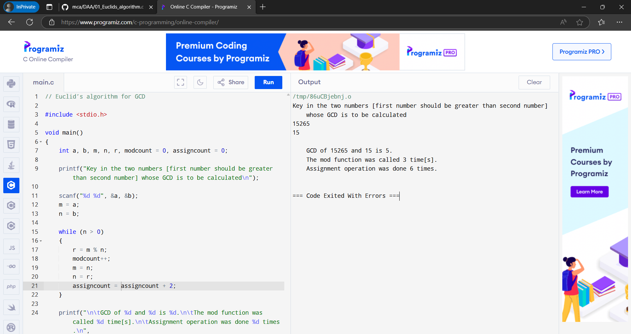

**Output:**

Compiled using online C compiler

(https://www.programiz.com/c-programming/online-compiler)

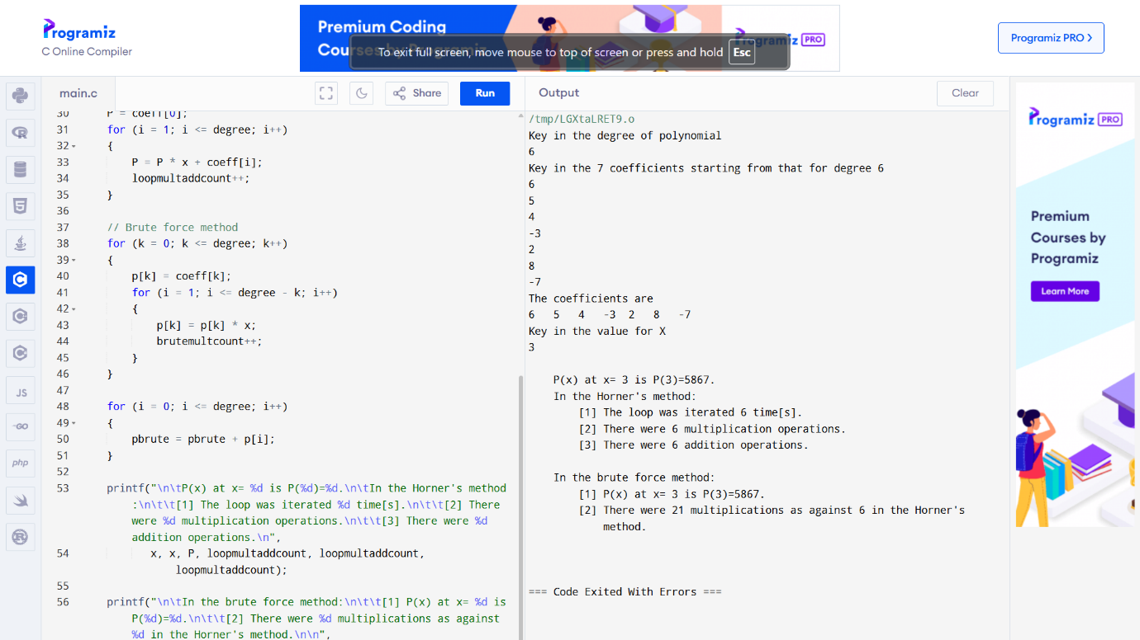

**Output:**

Compiled using online C compiler

(https://www.programiz.com/c-programming/online-compiler)

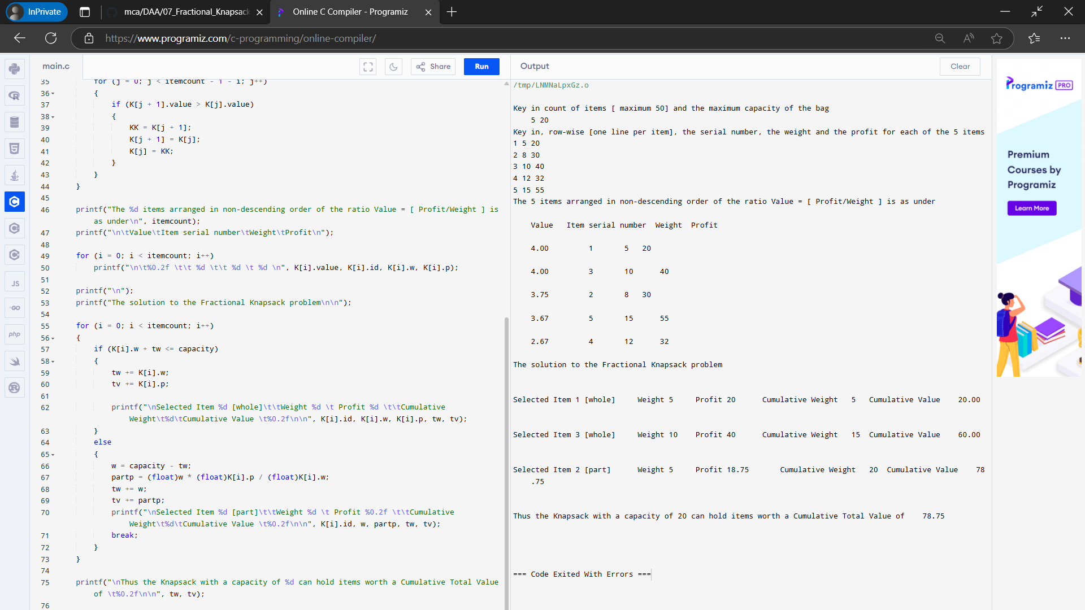

**Output:**

Compiled using online C compiler

(https://www.programiz.com/c-programming/online-compiler)

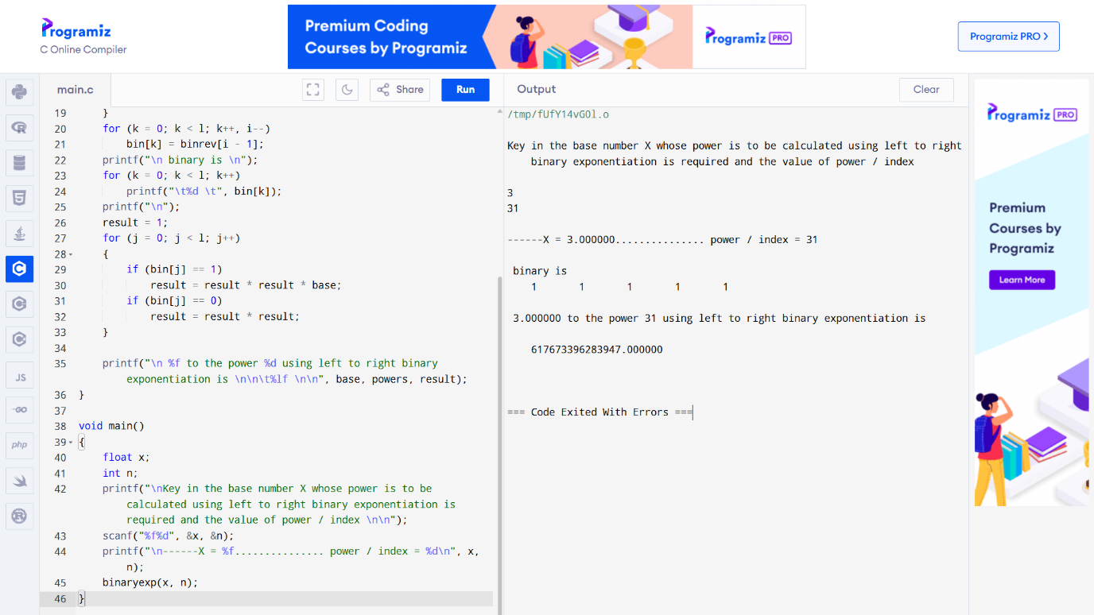

**Output:**

Compiled using online C compiler

(https://www.programiz.com/c-programming/online-compiler)

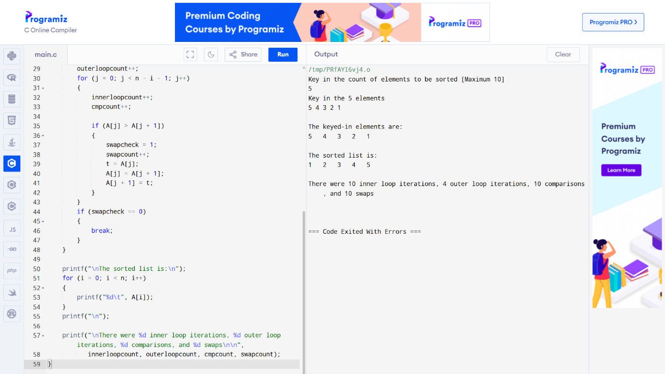

**Output:**

Compiled using online C compiler

(https://www.programiz.com/c-programming/online-compiler)

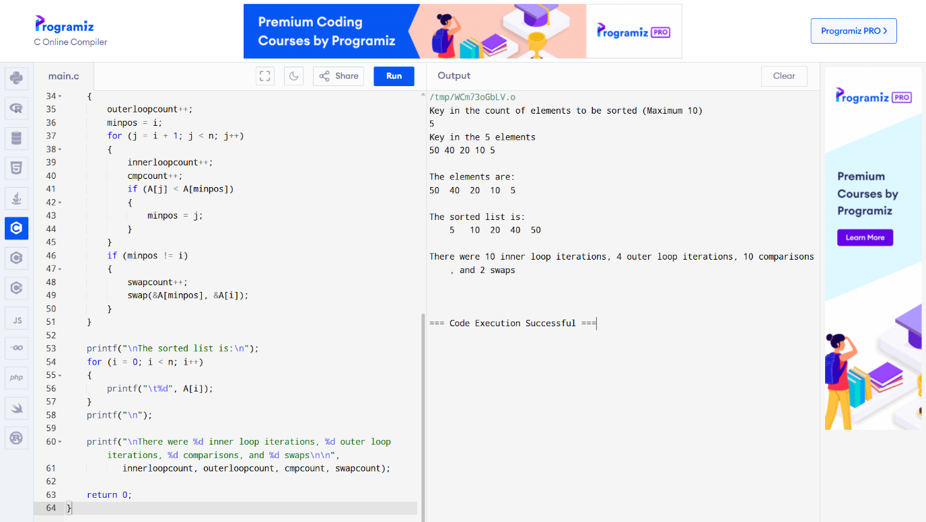

**Output:**

Compiled using online C compiler

(https://www.programiz.com/c-programming/online-compiler)

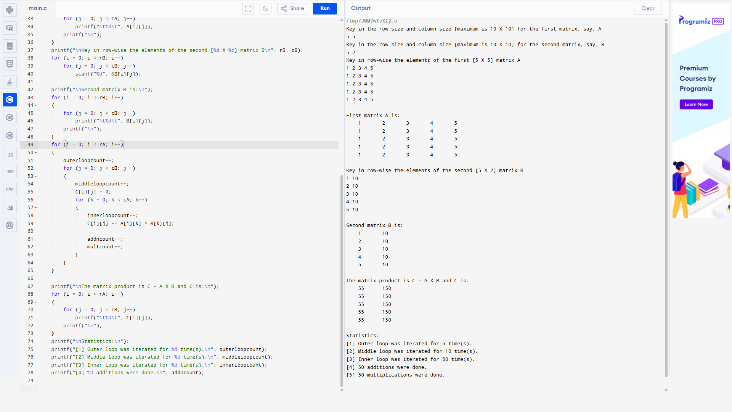

**Output:**

Compiled using GCC compiler for windows.

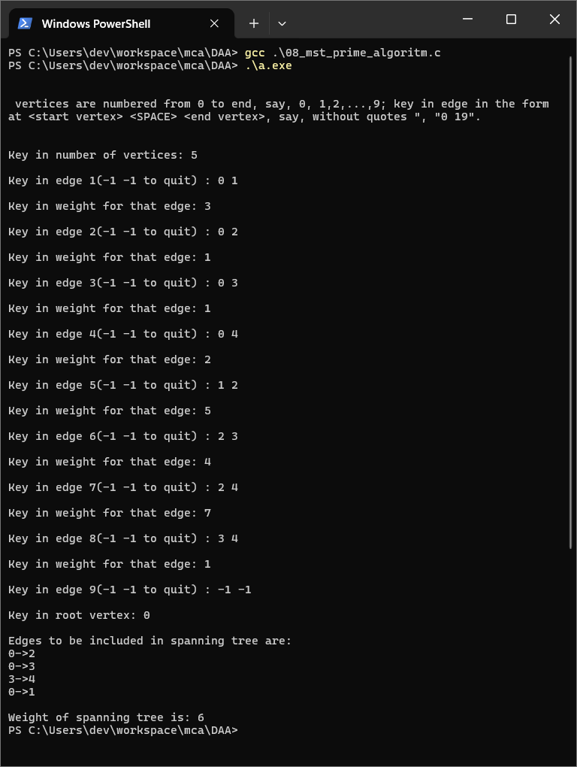

**Output:**

Compiled using GCC compiler for windows.

