Q12)

<!DOCTYPE html>
<html>
<title>Sample html code for MCA New Sem -i-2024- July</title>
<body bgcolor="blue">
<p>usage of "pre" tag</p>
<p>
I am a girl.
I am a boy. This and the previous sentence are displayed side by side in the same line in the web page.
<pre>
I am a girl
I am a boy.
That is a toy.
This is a plate
In the web page this and the above four lines are displayed in the typed format.
</pre>
</p>
<p>heading with different sizes- relative size of H1,H2,H3,H4,H5 and H6</p>
<h1>Iam H1</h1>
<p>
<h2>Iam H2</h2>
</p>
<p>
<h3>Iam H3</h3>
</p>
<p>
<h4>Iam H4</h4>
</p>
<p>
<h5>Iam H5</h5>
</p>
<p>
<h6>Iam H6</h6>
</p>
<p><b>This line is in BOLD</b></p>
<p><i>This line is in italics</i></p>
<p><u>This line is Underlined</u></p>
<p>In this sentence the word <s>Table</s> is in strikethrough format</p>
<p>Bulleted default list follows</p>
<ul>
<li>apple</li>
<li>ball</li>
</ul>
<p>bullet type is disc</p>

<ul style="list-style-type:disc">
<li>apple</li>
<li>ball</li>
</ul>
<p>bullet type is circle</p>
<ul style="list-style-type:circle">
<li>apple</li>
<li>ball</li>
</ul>
<p>without the bullet</p>
<ul style="list-style-type:none">
<li>apple</li>
<li>ball</li>
</ul>
<p>numbered list follows default case</p>
<ol>
<li>Tom</li>
<li>Jerry</li>
</ol>
<p>Type small a</p>
<ol type="a">
<li>Tom</li>
<li>Jerry</li>
</ol>
<p>Type Capital A</p>
<ol type="A">
<li>Tom</li>
<li>Jerry</li>
</ol>
<p>Type roman small i</p>
<ol type="i">
<li>Tom</li>
<li>Jerry</li>
</ol>
<p>Type roman Capital I</p>
<ol type="I">
<li>Tom</li>
<li>Jerry</li>
</ol>
<p>Type arabic numeral 1; this the default case</p>
<ol>
<li>Tom</li>
<li>Jerry</li>
</ol>
<p>numbering starts with the second number in the type specified</p>

<ol type="a" start="2">
<li>Tom</li>
<li>Jerry</li>
</ol>
<p>numbering starts with the second number in the type specified</p>
<ol type="A" start="2">
<li>Tom</li>
<li>Jerry</li>
</ol>
<p>numbering starts with the second number in the type specified</p>
<ol type="i" start="2">
<li>Tom</li>
<li>Jerry</li>
</ol>
<p>numbering starts with the second number in the type specified</p>
<ol type="I" start="2">
<li>Tom</li>
<li>Jerry</li>
</ol>
<p>numbering starts with the second number in the type specified</p>
<ol type="1" start="2">
<li>Tom</li>
<li>Jerry</li>
</ol>
<p>combined use of blockquote and pre tags</p>
<blockquote>
<pre>
Boy! Lucius! Fast asleep?
It is no matter,
Enjoy the honey-heavy dew of slumber.
Thou hast no figures nor no fantasies,
Which busy care draws in the brains of men;
Therefore thou sleep'st so sound
[by William Shakespeare in Julius Caesar]
</pre>
</blockquote>
<p>address tag displays text in italics</p>
<address>
<pre>
Name
Address line 1
Address line 2
State
Pincode
</pre>
</address>

<p>typing special character</p>
<p>&lt; is the less than symbol<br>
&gt; is the Greater than symbol<br>
&amp; is the ampersand symbol<br>
&quot; is the quotation mark symbol<br>
&agrave; is small a, grave accent symbol<br>
&Agrave; is capital a, grave accent symbol<br>
&ntilde; is small n, tilde symbol<br>
&Ntilde; is capital n, tilde symbol<br>
&uuml; is the umlaut small u symbol<br>
&Uuml; is the umlaut<br>
&#144; is the symbol Delta<br>
&#188; is the quarter symbol<br>
&#189; is the half symbol<br>
&nbsp;is the blank space<br>
</p>
<p>multiple blank lines</p>
<p>start of the ten blank line set</p>
&nbsp;<br>
&nbsp;<br>
&nbsp;<br>
&nbsp;<br>
&nbsp;<br>
&nbsp;<br>
&nbsp;<br>
&nbsp;<br>
&nbsp;<br>
&nbsp;<br>
<p>end of the ten blank line set</p>
<p>embedding image with src="FILENAME.GIF" width="value" height="value" alt="alternate text" border="value"
align="value"></p>
<p>width 100 height 100 border none</p>
<img src="zapple.jpeg" width="100" height="100" alt="Apple" border="0" align="center" />
<p>width 100 height 100 border 2</p>
<img src="zapple.jpeg" width="100" height="100" alt="Apple" border="2" align="center" />
<p>
<font face="Times New Roman, serif" size="2">I am Times New Roman size 2</font>
</p>
<p>
<font face="Times New Roman, serif" size="4">I am Times New Roman size 4</font>
</p>
<p>
<font face="Times New Roman, serif" size="7">I am Times New Roman size 7</font>
</p>
<p><!-- Page 40: [Description or notes about page 40] --></p>

<p>
<font face="Purisa" size="2">I am Purisa size 2</font>
</p>
<p>
<font face="Purisa" size="4">I am Purisa size 4</font>
</p>
<p>
<font face="Purisa" size="7">I am Purisa size 7</font>
</p>
<p>hyperlink</p>
<p>goes to hyperlink
<a href="https://www.google.com">google</a>
</p>
<p>goes to top of current page
<a href="#top">top of current page</a>
</p>
<p>yet another way to go to top of current page
<a href="#">yet another way to go to top of current page</a>
</p>
<p>body background colour, background image, text colour, colour of active/visited link, etc</p>
<p>
<body bgcolor="colour" background="image" vlink="colour" alink="colour" link="colour" text="colour">
</p>
</body>
</html>

Output:
MS Edge browser

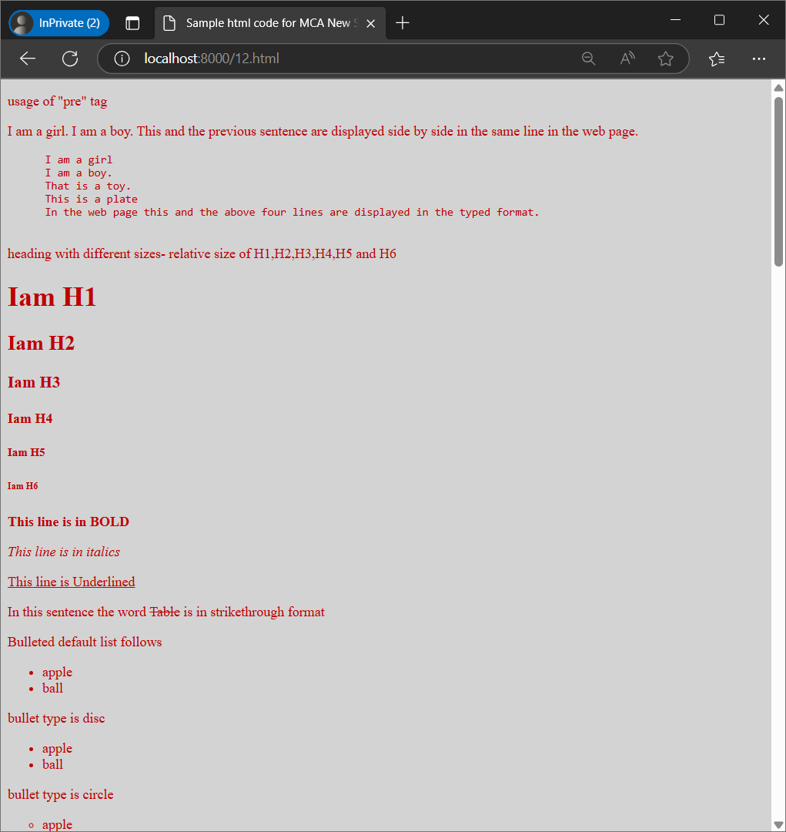

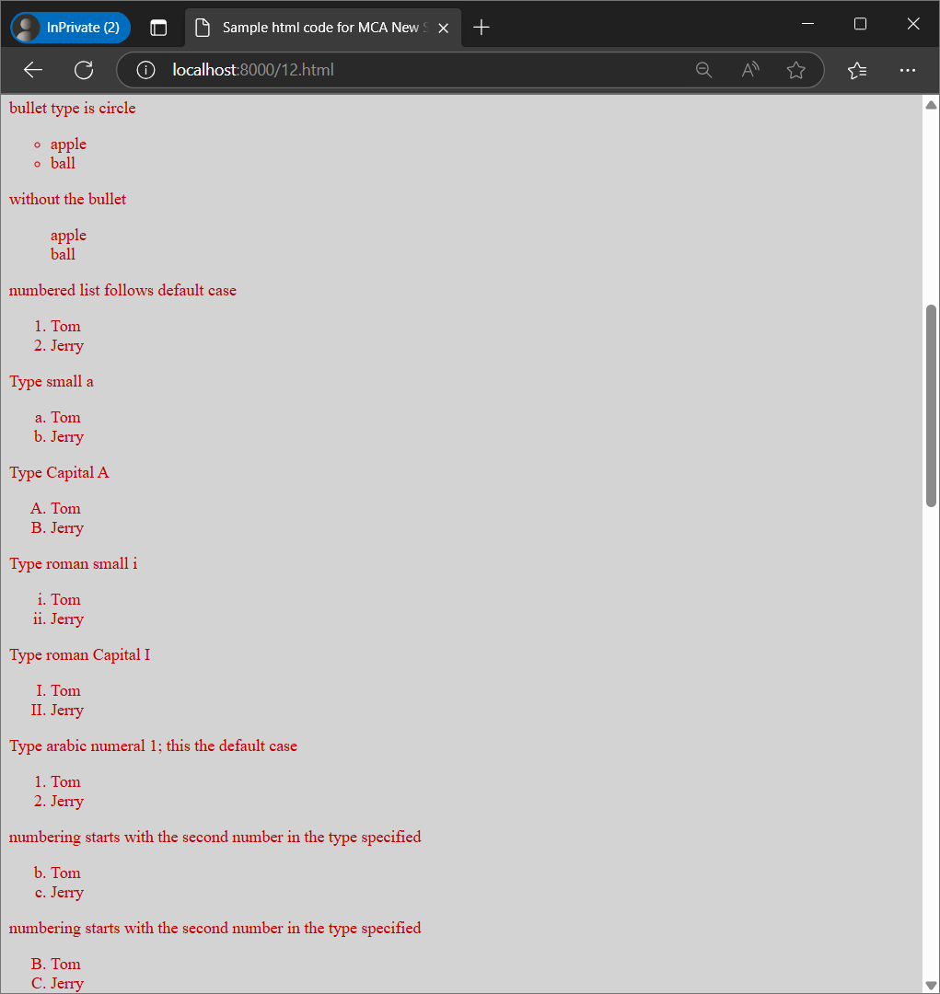

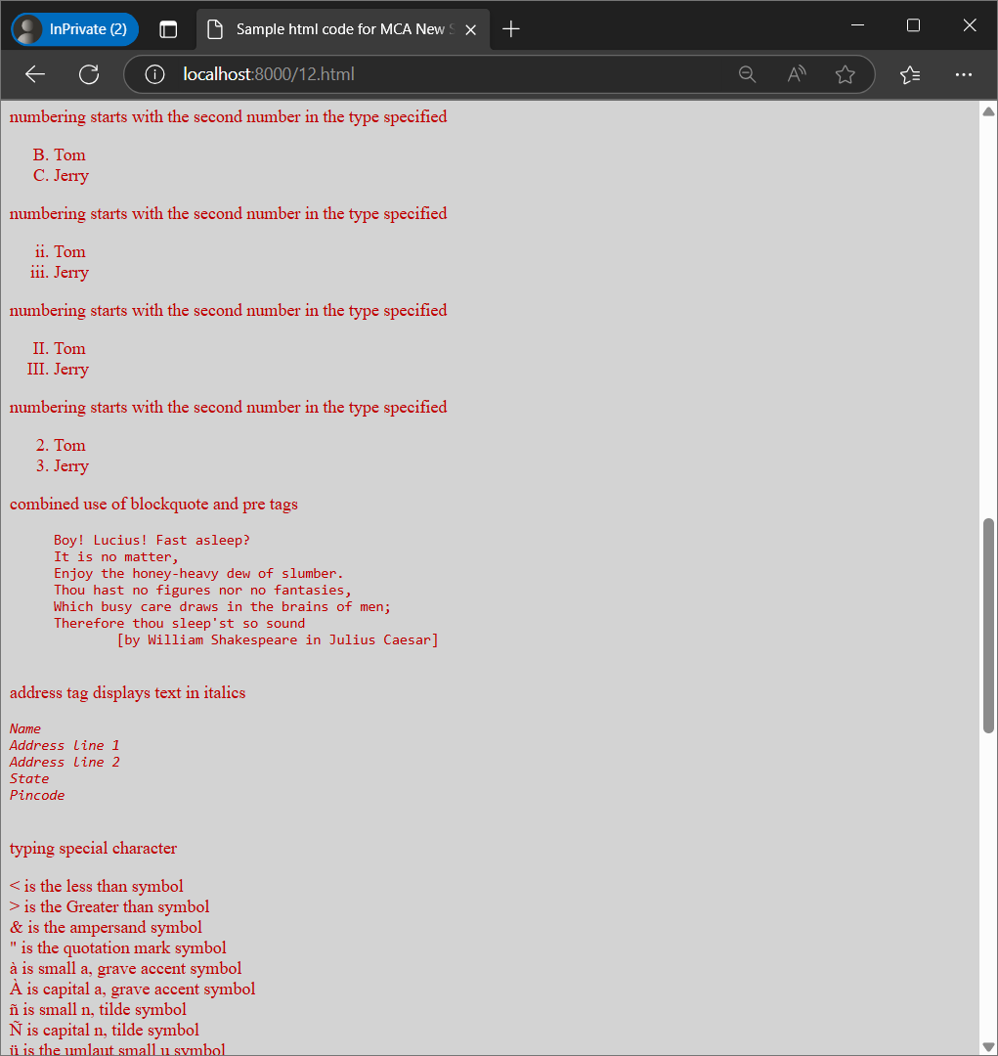

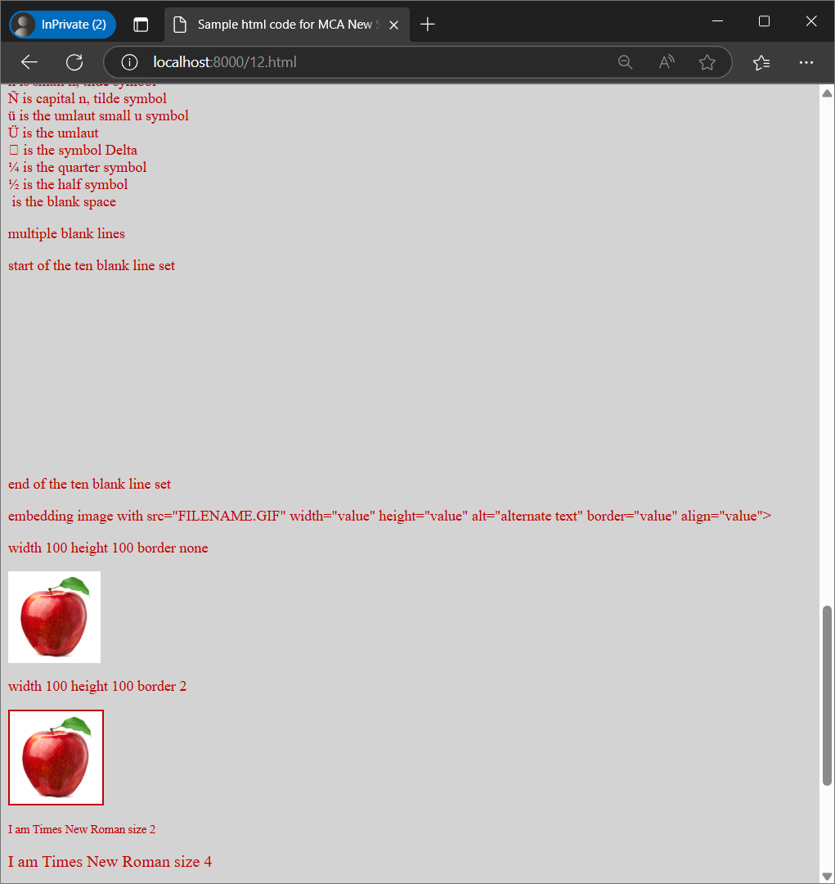

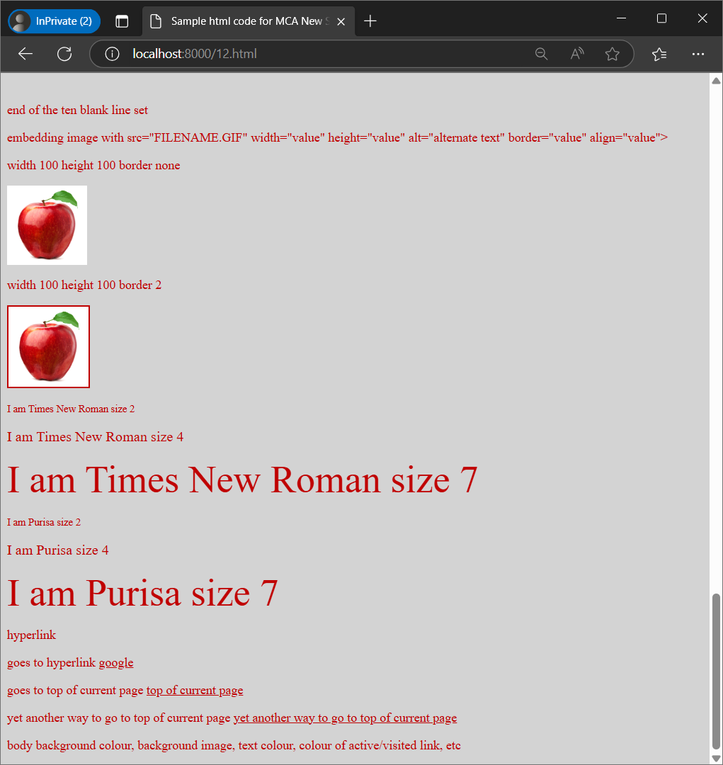
Q 13) JavaScript - Current Date and Time

<html>
<html lang="en">
<!--Java script -addition subtraction multiplication and division !-->
<head>
<meta charset="UTF-8">
<meta name="viewport" content="width=device-width, initial-scale=1.0">
<title>Simple Calculator</title>
<script>
function getDate() {
var cDate = new Date();
document.getElementById("Date").innerHTML = cDate.toString();
}

function fun() {
var numOne = parseInt(document.getElementById("one").value);
var numTwo = parseInt(document.getElementById("two").value);
var temp = document.getElementById("res");

if (!isNaN(numOne) && !isNaN(numTwo)) {
temp.style.display = "block";

var res = numOne + numTwo;
document.getElementById("add").value = res;

res = numOne - numTwo;
document.getElementById("subtract").value = res;

res = numOne * numTwo;
document.getElementById("multiply").value = res;

res = numOne / numTwo;
document.getElementById("divide").value = res;
} else {
alert("Please enter valid numbers.");
}
}
</script>
</head>

<body onload='getDate()' style="text-align: center">
<h1>Current Date and Time:</h1>
<h2 id="Date"></h2>

<p id="input">
Enter First Number: <input id="one" type="number"> <br /><br />
Enter Second Number: <input id="two" type="number">
</p>
<p>
<button onclick="fun()">Add, Subtract, Multiply, Divide</button>
</p>
<p id="res" style="display:none;">
Addition Result = <input id="add" readonly> <br /><br />
Subtraction Result = <input id="subtract" readonly> <br /><br />
Multiplication Result = <input id="multiply" readonly><br /><br />
Division Result = <input id="divide" readonly>
</p>
</body>
</html>

Output:
MS Edge browser

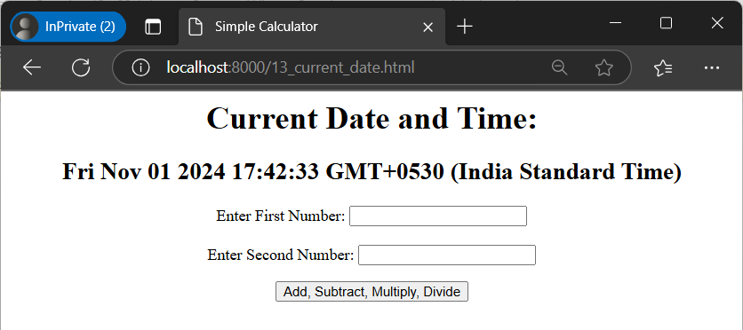
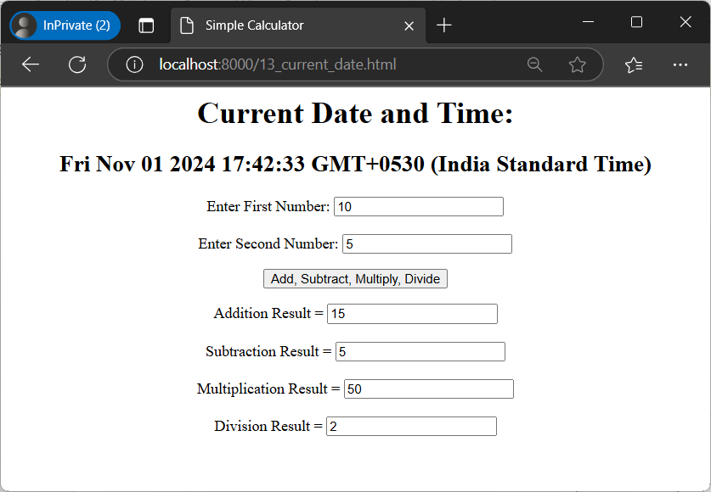

Q14) [1] radio button[2] check box [3] label [4] single e-mail [5] multiple e-mail

<html>
<title>radio-checkbox-label-single-multiple-e-mail</title>
<body>
<h1>sets radio button option</h1>
<form>
<input type="radio" id="opt1" name="opt" value="Option1">
<label for="opt1">Option1</label><br>
<input type="radio" id="opt2" name="opt" value="Option2">
<label for="opt2">Option2</label><br>
<input type="radio" id="opt3" name="opt" value="Option3">
</form>
<p>sets check box option</p>
<input type="chkbox" id="car1" name="car1" value="Benz">
<label for="car1"> I own a Benz Car</label><br>
<input type="chkbox" id="Car2" name="Car2" value="Fiat">
<label for="Car2"> I own a Fiat Car</label><br>
<p>sets label option</p>
<form action="/actions.php">
<label for="f_name">First name:</label><br>
<input type="text" id="f_name" name="f_name" value="John"><br>
<label for="l_name">Last name:</label><br>
<input type="text" id="l_name" name="l_name" value="Li"><br><br>
<input type="submit" value="Submit">
</form>
<p>sets single e-mail option</p>
<form>
<input type="email">
<input type="submit" value="Submit">
</form>
<form>
<p>sets multiple e-mail option</p>
<input type="email" multiple>
<input type="submit" value="Submit">
</form>
</body>
</html>

Output:
MS Edge browser

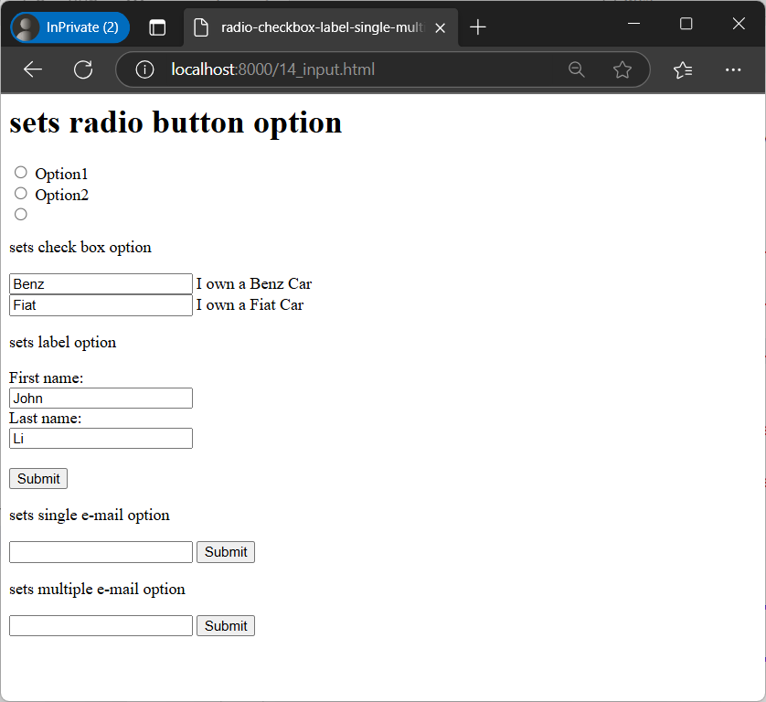

Q 15) internal CSS [ with blue background ]

<html>

<head>
<title>internal css</title>
<style>
body {
background-color: blue;
}

h1 {
margin-left: 20px;
color: red;
}
</style>
</head>

<body>
<h1>internal css - blue background</h1>
<h2>It is heading under internal CSS</h2>
<p>It is paragraph under internal CSS.</p>
</body>

</html>

Output:
MS Edge browser

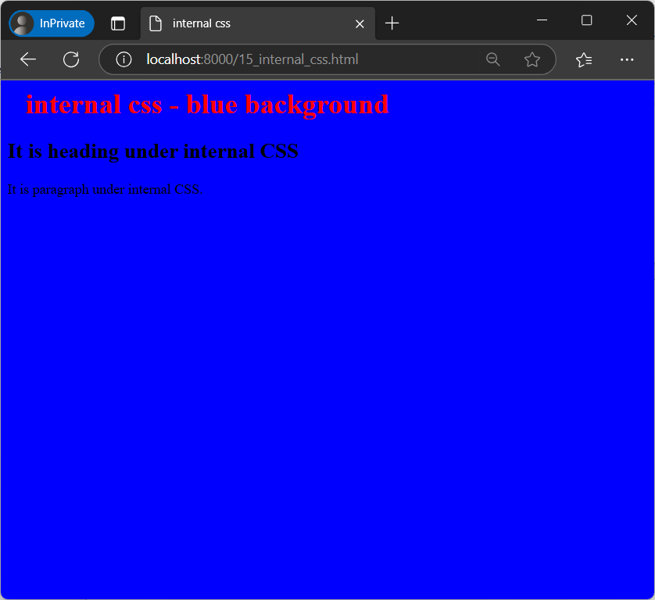

Q16) Inline CSS – caption is right aligned

<html>
<title>inline css right aligned heading </title>

<body>
<h1>
inline css
</h1>
<h2 style="text-align:right;color:red;">
right aligned heading under inline css</h2>
<p style="text-align - justify; color:green;">it is a paragraph
underline css</p>
</body>

</html>

Output:
MS Edge browser

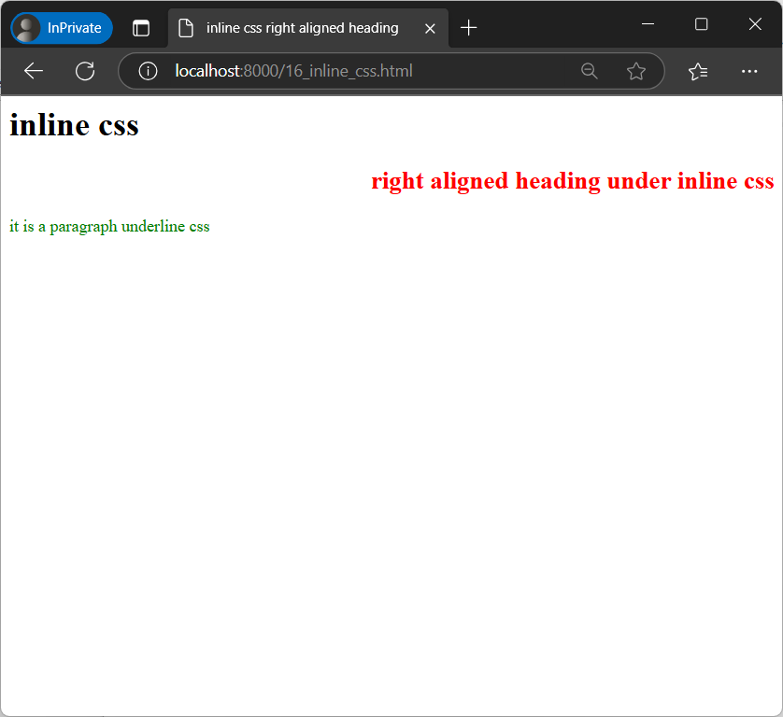

Q17) Value changes on click event

<html>

<body>
<title>click event</title>
<h1>value changes on click event</h1>
<p id="para1" onclick="Fun()">Click here to change this text.
<p>
<script>
function Fun() {
document.getElementById("para1").innerHTML = "The text is changed";
}
</script>
</body>

</html>

Output:
MS Edge browser

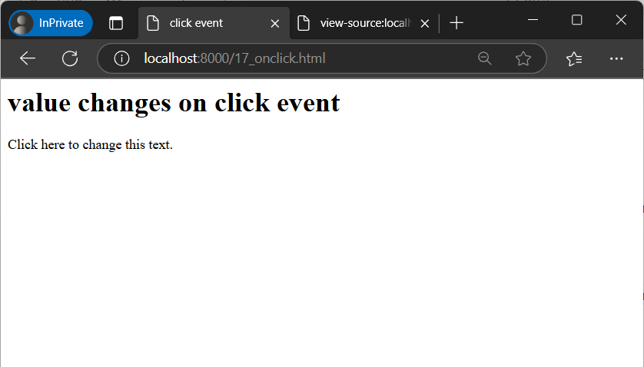
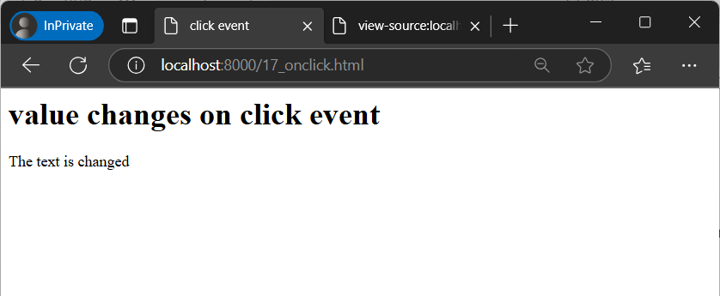

Q18) adding event listener

<html>
<title>adding event listener</title>

<body>
<h1> adding event listener</h1>
<h3>JavaScript HTML DOM addEventListener()</h3>
<p>Click on submit button below to which addEventListener() method is associated and shows an alert message on
button click.</p>
<button id="btn1">Submit</button>

<script>
document.getElementById("btn1").addEventListener("click", abc);
function abc() {
alert("Event handler!");
}
</script>
</body>

</html>
Output:
MS Edge browser

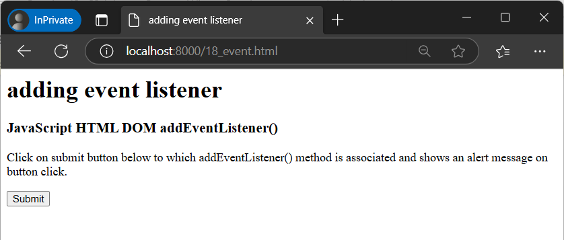
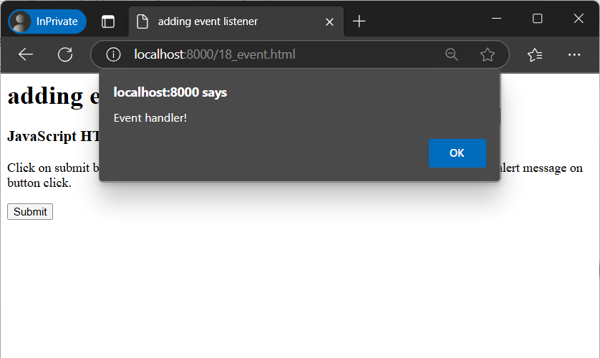
Q19) multiple event listeners

<html>
<title>multiple event listener</title>

<body>
<h1>Adding mutiple event listeners to an element</h1>
<p>Click on submit button below to which to see the effects of multiple event listeners added to an element</p>
<button id="button1">Submit</button>
<script>
document.getElementById("button1").addEventListener("click", abc1);
document.getElementById("button1").addEventListener("click", abc2);

function abc1() {
alert("This is first click");
}
function abc2() {
alert("This is second click");
}
</script>
</body>

</html>

Output:
MS Edge browser
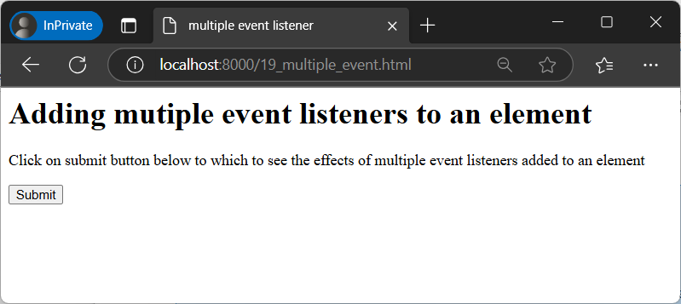
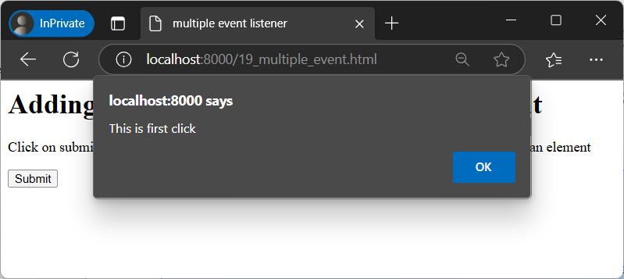
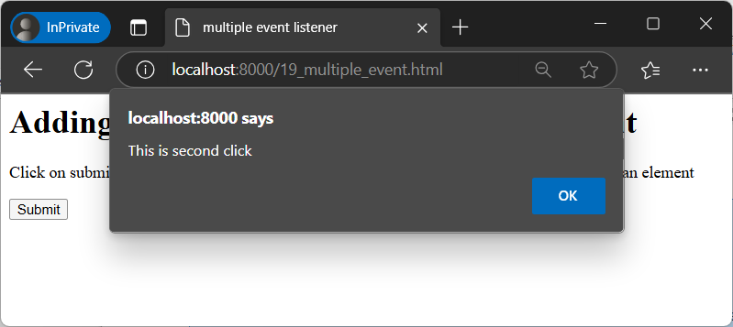
Q20) error handling in JavaScript

<html>
<title> Error handling in javascript</title>
<body>
<h1>error handling in javascript</h1>
<p id="para1"></p>
<script>
try {
eval("2=x");
}
catch(err) {
document.getElementById("para1").innerHTML = err.name;
}
</script>
</body>
</html>

Output:
MS Edge browser

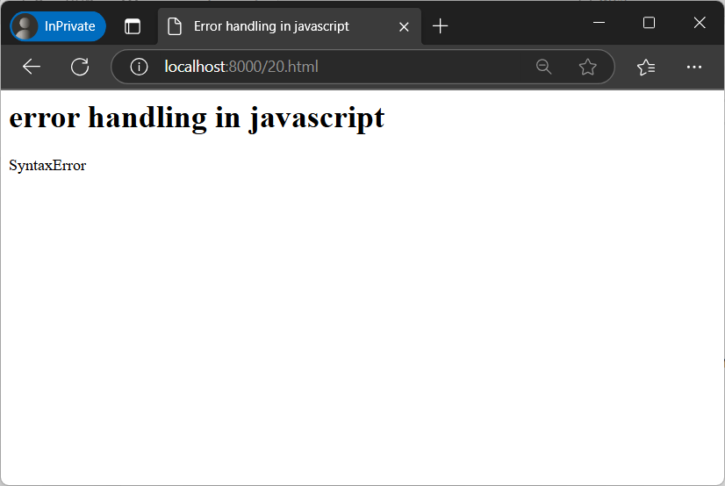
Q21) displaying object name using getter and setter in JavaScript

<html>
<title>displaying object name using getter and setter in javaScript</title>

<body>
<h1>displaying object name using getter and setter in javascript</h1>
<script>
class Bike {
constructor(make) {
this.make = make;
}
get bname() {
return this.make;
}
set bname(x) {
this.make = x;
}
}
var obj_bike = new Bike('xyz');
obj_bike.bname = 'Bullet';
document.write(obj_bike.bname);
</script>
</body>

</html>

Output:
MS Edge browser

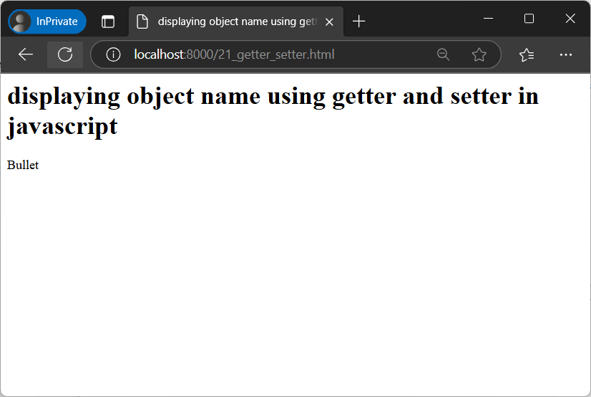

Q22) Creating class in JavaScript

<html>
<title>creating class in javascript</title>

<body>
<h1>creating class in javascript</h1>
<script>
class Bike {
constructor(make) {
this.make = make;
}
present() {
return 'My bike is of type ' + this.make;
}
}
class BikeType extends Bike {
constructor(make, bike_type) {
super(make);
this.make = make;
this.bike_type = bike_type;
}
show() {
return this.present() + ',it is a ' + this.bike_type;
}
}
var object_bike = new BikeType("Hero", "Racer");
document.write(object_bike.show());
</script>
</body>

</html>

Output:
MS Edge browser

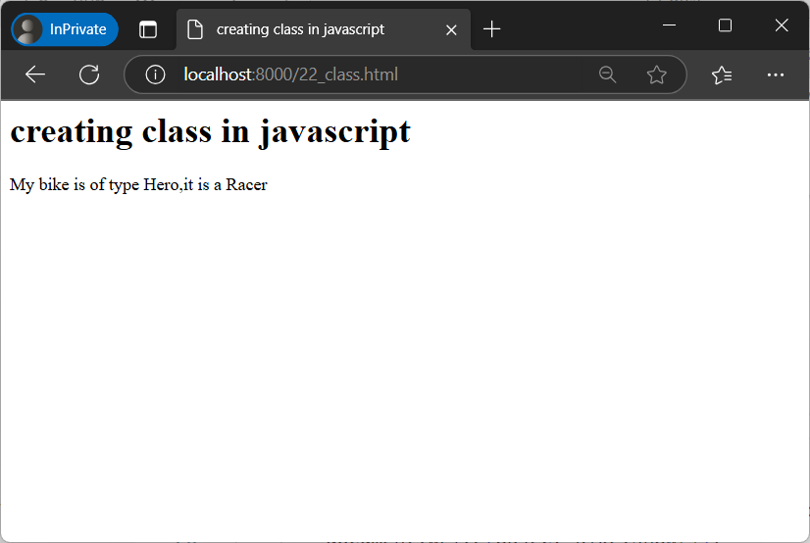
Q23) callback with timeout in JavaScript

<html>
<title>
callback with timeout in javascript
</title>

<body>
<h1>callback with timeout() in javascript </h1>
<p>please wait for 25 seconds(25000 milliseconds)</p>
<script>
setTimeout(abc, 25000);
function abc() {
document.write("This function was executed on timeout of 25 seconds");
}
</script>
</body>

</html>
Output:
MS Edge browser

