Reference website - https://engagefinancial.com.au/

**Header**

The “about,services” and other options should have separate pages not in the same sheet.

Get the headers in order (About is below Services)

Add the logo of the company next to the name & link that logo to go to the home page when clicked.  
No difference between the actual header and the home page initially.



**Footer**

Our Services - Need to be eliminated from the footer

**Page**

Get In touch – Should be in a different page.

Link FB, insta – Ideally will be done before the launch

**Client Feedback/ comments in a space – High priority – need to be shown as much as possible.**

**“Ledgerlabs”** should in single colour preferably Blue text with White Background

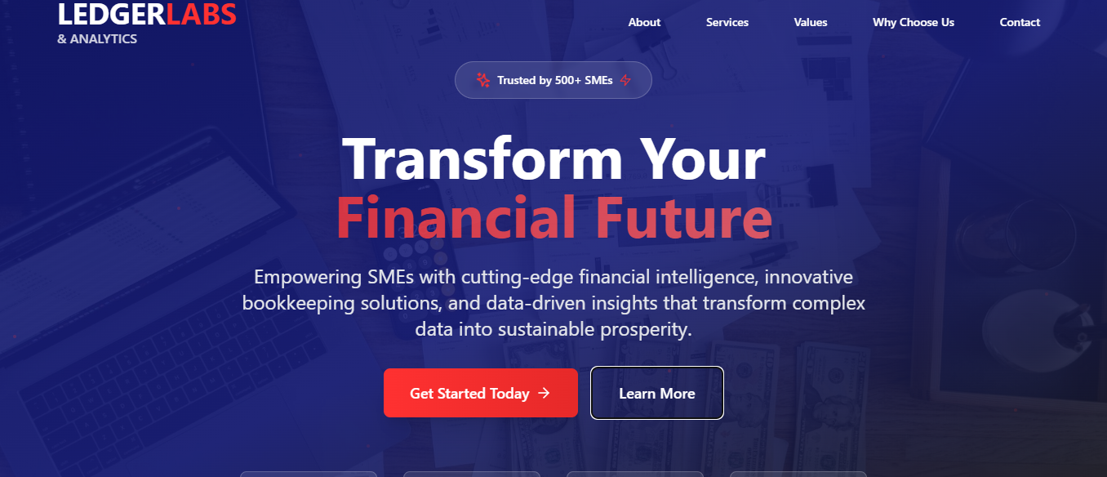

For the above section, the background should be White, Fonts to be blue and only the specific words to be highlighted to be in orange throughout the site. In this case “Transform” could be in Orange.

Make the company name in the contact form mandatory & add “individual/company name” in that form.  
  
Service – font color needs to be lighter, similar to other fonts in the form

Mandatory fields in the contact form – Asterix need to be in red color.

Notification need to be shown whether the message/contact details were shared successfully or not.

Link the “schedule consultation” button with either whatsapp or with the calendar.

Add images according to the topics (especially for “why choose us”)

Present the products similar to the Engage website

**Remove**  
Trusted by 500+ SMEs,

Get start today & learn more buttons,

Contact information (keep the contact info in the footer).

Personal contact numbers of Pranesh and Thomas – Add the company number link it to the whatsapp if possible.  
Start your journey button

Free consultation

Years of excellence,happy clients,success rate

Icons for the vision and mission

scroll down logo

