Software Design Specification
(SDS)

for
NeuroGuard Pro
Date: May 25, 2026
Prepared by:
S.P.S.N.Chandanapriya
RAT/IT/2324/F/0057

Table of Contents
1. Introduction
1.1 Purpose
1.2 Scope
1.3 Definitions and Acronyms
2. System Architecture
2.1 Component Overview
3. Data Design
3.1 Database Architecture
4. System Features & Use Cases
4.1 Core Use Cases
5. Interface Design
5.1 Web Dashboard (Fleet Manager UI)
5.2 Driver Monitor (Web Engine UI)

1. Introduction

1.1 Purpose
This Software Design Specification (SDS) document provides a comprehensive architectural overview of the NeuroGuard Pro system. It describes the design of the dual-engine driver monitoring system (DMS), outlining its structure, database schema, system behaviors, and user interfaces. This document serves as a reference for developers, system administrators, and stakeholders involved in maintaining or extending the project.

1.2 Scope
NeuroGuard Pro is a high-performance system designed to enhance road safety through real-time AI computer vision. The system detects drowsiness, yawning, and distractions (such as looking away) to alert the driver immediately and logs safety events for remote fleet management.

1.3 Definitions and Acronyms
DMS: Driver Monitoring System.
AI: Artificial Intelligence.
ER Diagram: Entity-Relationship Diagram.
SRS: Software Requirements Specification.
UI/UX: User Interface / User Experience.
Mediapipe: Google's open-source framework for building multimodal machine learning pipelines (used here for facial landmark detection).

2. System Architecture
The NeuroGuard Pro system utilizes a Dual-Engine Architecture, providing flexibility for deployment on dedicated hardware (e.g., Raspberry Pi) or seamlessly via web browsers for quick fleet deployment.

2.1 Component Overview
- Python Engine (eye_engine/): The core AI brain designed for edge devices. Utilizes Python 3.x, Mediapipe, OpenCV, and Pygame. It offers low latency, background processing, and direct hardware integration for alarms.
- Web Browser Engine (web_dashboard/): A web-based counterpart designed for remote driver monitoring. Built using JavaScript, Mediapipe Web SDK, PHP 8.x, and MySQL. It integrates directly with the admin dashboard for seamless access.
- Central Database (database/): A centralized SQL database storing administrator credentials, fleet data, and real-time safety event logs pushed by either engine.

3. Data Design

3.1 Database Architecture
The central data repository is built on MySQL/MariaDB.
- admin_users table: Stores authenticated credentials for fleet managers and system administrators accessing the dashboard.
- safety_logs table: Captures every critical event (e.g., Drowsiness, Yawning, Distraction) along with timestamps, driver ID (if applicable), severity, and event type.

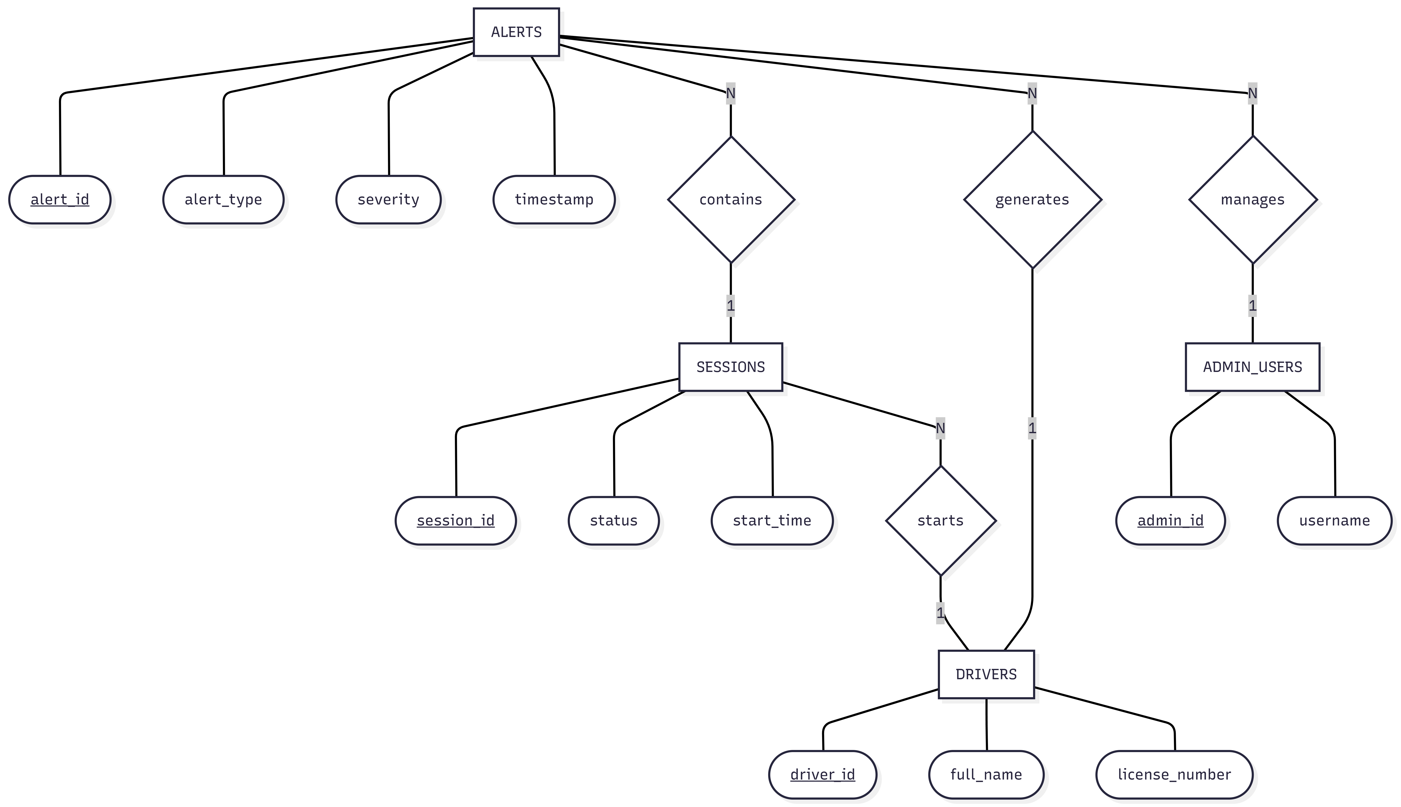

4. System Features & Use Cases

4.1 Core Use Cases
- Monitor Driver: The system continuously captures video input and maps facial landmarks.
- Detect Drowsiness: Analyzes the Eye Aspect Ratio (EAR) to detect prolonged eye closure.
- Detect Yawning: Analyzes the Mouth Aspect Ratio (MAR) to detect signs of extreme fatigue.
- Detect Distraction: Analyzes head pose and gaze to determine if the driver is not looking at the road.
- Trigger Alarm: Fires a high-frequency audio alert (alarm.wav) locally if a safety threshold is breached.
- Log Event: Sends a payload via HTTP to the remote API (log_alert.php) to record the infraction in the database.
- View Dashboard: Administrators can log in to view real-time analytics and historical logs of driving events.
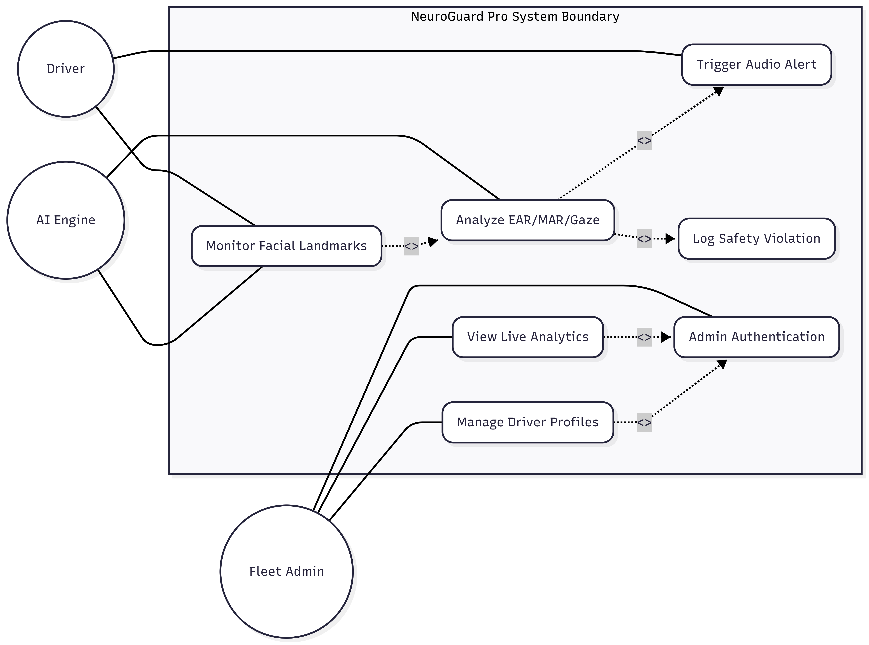

5. Interface Design

5.1 Web Dashboard (Fleet Manager UI)
- Login Portal: Secure authentication screen.
- Dashboard View: A high-level overview featuring charts, recent safety events, and a tabular log of all recorded driver infractions.
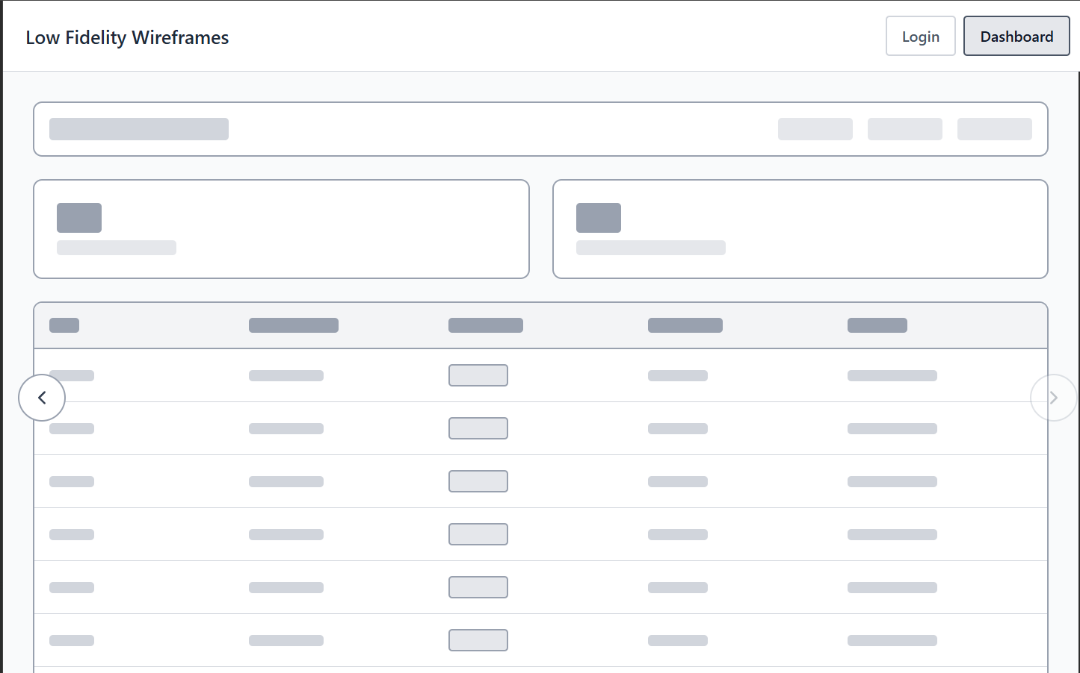

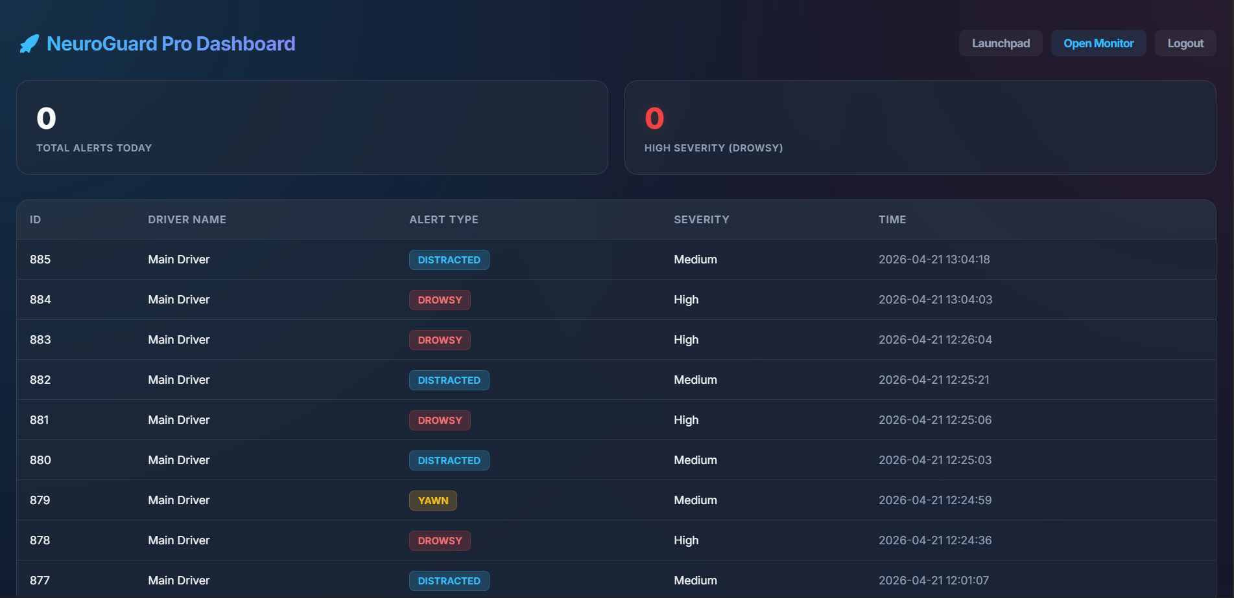

5.2 Driver Monitor (Web Engine UI)
- Live Camera Feed: Real-time display of the driver's face with overlaid Mediapipe facial landmarks.
- Status Indicators: Visual cues (e.g., "Safe", "Drowsy", "Distracted") updating in real-time.
- System Controls: Start/Stop monitoring buttons and sensitivity calibration sliders.
