Hotel Booking Cancellation Prediction
Using the K-Nearest Neighbors (KNN) Algorithm

Savita Kumari
Guide: Mr Vikas Goel
Naviotech Solution

Certificate

This is to certify that the project report titled “Hotel Booking Cancellation Prediction Using the K-Nearest Neighbors (KNN) Algorithm” has been carried out by Savita Kumari, in partial fulfillment of the requirements for internship, at Naviotech solution.

Date: 30 July 2026

Acknowledgement

I would like to express my sincere gratitude to my project guide,Mr Vikas Goel, for their valuable guidance, continuous support, and encouragement throughout the course of this project. Their suggestions and feedback at every stage helped me understand the concepts more clearly and complete this work in a structured and meaningful way.
I am also thankful to all the faculty members of Naviotech solution for providing the learning environment, and opportunity to work on this project.
Finally, I am grateful to everyone who, directly or indirectly, helped me in the successful completion of this project.

Savita Kumari

Abstract
One common issue that hoteliers face is having guests cancel their hotel bookings once they have booked into a hotel room, meaning resources are not being optimally utilized and lost revenue. The purpose of this project is to find out whether a booking to a hotel is likely to be cancelled, in advance, by utilizing machine learning. The data set (Hotel_Reservations.csv) consists of information on hotel reservations from 36275 customers, as follows: Lead Time, Hotel, Arrival Date, Departure Date, Adjusted Date, total stays, booking changes, Total of special requests, Total of special requests per booking, Prepaid Room, Age of Customer, Gender, Family Members, Family Type, Single Night Cost, Double Night Cost, total check-out cost, total system cost, adults, children and babies, and length of stay. The prediction model was constructed using the KNN (K-nearest neighbors) algorithm which is simple, intuitive and is a distance-based classification algorithm, ideal for structured tabular data such as this. The data was then preprocessed by converting categorical column to numeric column by one-hot encoding and all the numeric features were scaled (standardized) so that no single feature could have an undue influence on the distance calculations used by KNN. The data set was divided in two, 80% for training and 20% for testing. Several values of K (number of neighbors considered – a number of neighbors) were tested: K=17, distance-weighted voting, Manhattan distance were found to be best. On the test set, the final model attained an accuracy of 87.9%, a precision of 83.6%, a recall of 78.7%, an F1-score of 81.0% and a ROC-AUC score of 0.939, which is a good and reliable result. In terms of the relatively simpler features, the results indicate that booking lead time, room price and special requests are crucial variables that can be used to predict booking cancelation. This project will be an all-in-one implementation of a machine learning life cycle (data cleansing, feature encoding, feature scaling, model training etc.) to a real world business problem and extended to another prediction problem with similarly structured data (e.g., customer churn or employee attrition).

Table of Contents
Abstract
1. What Is This Project About?
2. Understanding the Dataset
3. What Is KNN? (In Simple Words)
4. The Main Formula: Measuring “Distance” Between Two Points
5. Why We Must Scale the Data First
6. Steps We Followed (The Full Process)
7. Choosing the Best Value of K
8. How We Measure If the Model Is Good (All Formulas Explained)
9. Our Results
10. Conclusion and What We Learned
11. Appendix

What Is This Project About?
What would you do if you had a hotel?
People reserve rooms on a daily basis. However, occasionally after an individual has made a booking, they think again and cancel the booking.

The hotel has a problem with:
- The room sits vacant, and the hotel has a negative impact.
- The hotel is not able to make proper plans regarding staff, food and rooms.
- There's worse and there are last minute cancellations.

So, the question the hotel has to ask: “Will this booking be cancelled or not?”.
This is what we are doing in this project. We are building a model that takes in particular details of a booking (how many days in advance it is booked, its room price, how many people are staying in that room etc.) and try to predict whether or not this booking will be cancelled.
This is a type of problem in machine learning with only two possible outcomes (Yes/No, Cancel/Not Cancel) and is referred to as a Classification problem.
In order to get rid of this, we are going to use a technique known as KNN (K-Nearest Neighbours) algorithm.

2. Understanding the Dataset
Our data file is called Hotel_Reservations.csv. It contains 36,275 rows – one row represents one booking – and 19 columns – one column represents one piece of information relating to that booking.
Here are the important columns we used:
Column Name | What It Means
no_of_adults / no_of_children | How many adults and children are staying
no_of_weekend_nights / no_of_week_nights | How many nights the guest is staying
lead_time | How many days before arrival the booking was made
avg_price_per_room | Average price paid per night for the room
no_of_special_requests | How many extra requests the guest made (like a high floor, early check-in)
repeated_guest | Whether this guest has stayed before (1 = yes, 0 = no)
market_segment_type | How the booking was made (Online, Offline, Corporate, etc.)
booking_status (TARGET) | Whether the booking was Cancelled or Not Cancelled — this is what we are predicting

Approximately 1 in every 3 bookings (32.8%) was cancelled and 2 in every 3 (67.2%) were not canceled. This is helpful to know as it means that the data is not too extreme, or too one-sided.

3. What Is KNN?
KNN stands for K-Nearest Neighbors. The idea behind it is extremely simple and is based on something we naturally do in real life:
“You are known by the company you keep.”
Say you move into a new neighbourhood and want to guess if your new neighbours are friendly or not. Simple approach . Look at the 5 houses closest to yours , and see how many of them are friendly . If most of those 5 are friendly, you assume your neighbourhood is friendly as well.
For our hotel data KNN works in the same way:
1To predict whether a NEW booking will be cancelled or not, KNN looks at all the bookings we already have answers for.
- It identifies the K most ‘similar’ (closest) reservations to this new reservation. (We just picked a number for K, like 5 or 17.)
- It checks: how many of these K similar old reservations were cancelled and not cancelled?
- The prediction is the group with the most votes. (Majority rules - like a tiny election of neighbours.)
So the crucial question is what the computer uses to decide that some bookings are 'closest' to each other or 'similar' to each other? This is answered using a distance formula which is explained next.

The Formula: Measuring “Distance” Between Two Points
To identify the 'closest' bookings to each other, KNN views each booking as a point with a set of numbers associated with it (price, lead time, number of guests, etc.) - similar to how a point on a map has an X and Y coordinate.
If two bookings have very similar numbers, they are 'close' to each other. If the numbers are very different they are 'far apart'.

Euclidean Distance

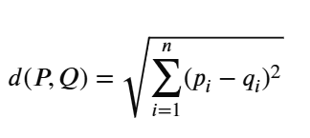

5. Why We Must Scale the Data First
Using the raw numbers without normalizing them presents a major problem when measuring how far away two records are from each other.
Consider the two attributes in question:
- One of the two numeric attributes fluctuates between approximately 0 and 540 (a large variation).
- The second numeric attribute only takes on two possible values 0 or 1 (a very small range).
Calculating the distance between the two numeric fields using their raw values will result in the price numeric field having more influence on the distance calculation because its range (0 – 540) is significantly larger than the other numeric field (0, 1).
Therefore, a model that’s based upon using raw values will be unfair and can produce a less accurate prediction.
Standardization (also referred to as Z-score Scaling) is a solution to address this issue. It is a process for converting all features onto the same scale (typically, roughly centered at zero) with values mainly falling in between -3 and +3.

Standardization Formula
z = (x - mean) / standard deviation
In plain words:
- x = the original value
- mean = the average value of that column across all bookings
- standard deviation = a measure of how spread out the values are
- z = the new, scaled value we actually use

6. Steps We Followed (The Full Process)
- Load in the data. For this project, we will load all 36,275 bookings from our downloaded CSV file into the program.
- We clean the data. The first thing we were able to do was to eliminate the Booking_ID column since it simply acts as an identifier, thus not providing any value for prediction purposes. We have verified that there are no missing values within the dataset.
- Convert booking_status from a text value to a numerical value. Since computers use numbers versus words, we converted it to 1 for Cancelled and 0 for Not Cancelled. Finally, we needed to convert categorical variables into numeric variables. Since columns such as room_type and meal_plan contain categories of text versus numerical values, we utilized a method known as One-Hot Encoding. One-Hot Encoding takes different categories of a particular column (meal_plan categories) and makes it into four categories listed as separate Yes/No columns for that particular category (for example, meal_plan would be listed as Is_Meal_Plan_1, Is_Meal_Plan_2, etc.).

Split the dataset in two parts — allocating 80% (around 29,020) of it to TRAIN the model (teach the model) and using the remaining 20% (around 7,255) to TEST the model (measure performance against new data that it has NOT seen before).

The data has been scaled using the standardization approach.

After each numeric feature had been standardised, trained KNN via 'memorising' the entire training set and all booked events.

Also experimented with different values of K to solidify which provided the best predictive power of my model .

Finally, the models evaluated accordance to how probably the outcomes of the model would be the true outcome via the various assessment methods, assessing the accuracy of the final model.

7. Choosing the Best Value of K
To determine K is a critical factor in model:
• A small value for K will look at only 1 neighbor; thus, it is very sensitive to noise and 1-time cases.

• A large value for K would look at many neighbors to provide a prediction and could include neighbors that are not very similar. This provides very general predictions that miss meaningful relationships.

To decide on the value of K, we explored a series of odd numbers of K from 1-29 and tracked the error rates of each K value. Additionally, we used a more structured approach to validate the results called Cross-Validation by splitting the data into smaller pieces and running tests over multiple iterations to ensure a correct result, rather than a lucky result.

The findings from the different trials indicated the best results would be achieved by using a K value of 17 in conjunction with using distance weighting; therefore, closer neighbors would have more vote representation than neighbors further away, thus providing a more fair representation than a simple majority.

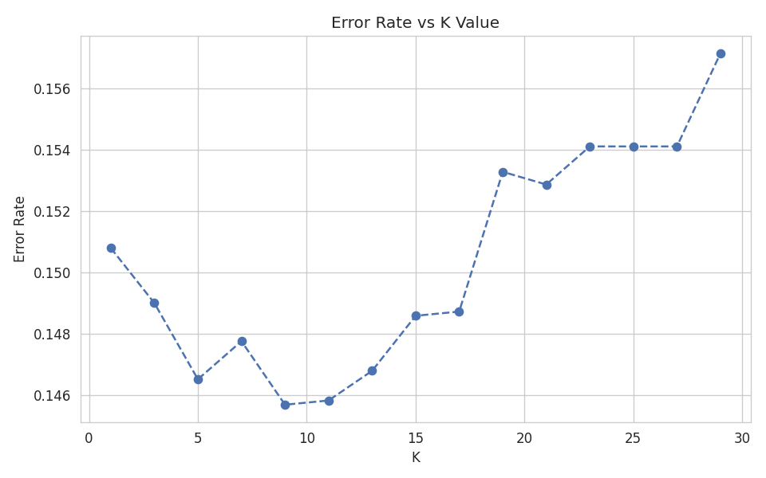

8. How We Measure If the Model Is Good
Once model makes predictions on the 7,255 test bookings (which it has never seen before), we compare its guesses to the real, actual outcomes. There are four possible results for each booking:
Term | Meaning
True Positive (TP) | Model said 'Cancelled' and it really was cancelled — correct
True Negative (TN) | Model said 'Not Cancelled' and it really wasn't — correct
False Positive (FP) | Model said 'Cancelled' but it actually was NOT — wrong
False Negative (FN) | Model said 'Not Cancelled' but it actually WAS — wrong

The confusion matrix is a simple table that displays the number of bookings in each of the four boxes listed above and allows us to calculate a number of different scores based on the four values.

Accuracy :Out of all predictions, how many were correct?
Accuracy = (TP + TN) / (TP + TN + FP + FN)
Example: if model made 7,255 predictions and got 6,381 of them right (correct TP + correct TN), then:
Accuracy = 6,381 / 7,255 = 0.879 = 87.9%
When the model gives a 87.9% accuracy score that tells you the model is right 88 out of every 100 times. This is a simple score to understand but can lead to misleading conclusions. One obvious example would be if there were many more observations for the class 'Not Cancelled' compared to 'Cancelled'. In that case, a lazy model could give an 'Not Cancelled' prediction for every observation and have the same accuracy score as a better model.

Precision When the model says 'Cancelled', how often is it right?
Precision = TP / (TP + FP)

This report only looks at the number of bookings that the model flagged as "Cancelled," and asks the question: How many of these actually were cancelled? A high precision score indicates to us that the model does not raise a false alarm too often, and that when it raises an alarm, it usually raises a correct one. The precision of the model was 83.6%, which means that approximately 5 out of every 6 predictions marked as "Cancelled" were truthful predictions.

Recall : Out of all the bookings that were actually cancelled, how many did we catch?
Recall = TP / (TP + FN)

The focus here is only on actual cancellations that were missed by our cancellation predictions model to provide insight into how well our predictive model has identified actual cancellations compared to actual cancellations that were not detected. The closer the recall percentage comes to 100%, the better the model performs at capturing real cancellations. The recall result provided for this example was 78.7%. Therefore, the model correctly identified approximately 4 out of every 5 actual cancellations.

F1-Score: A fair balance between Precision and Recall
Precision and Recall can be difficult to balance at times - a model with a very high precision may have very little recall or vice versa. The F1-Score is an overall score of accuracy that includes both scores and uses a method of calculating the score called the harmonic mean (which punishes large differences between them).
F1-Score = 2 × (Precision × Recall) / (Precision + Recall)

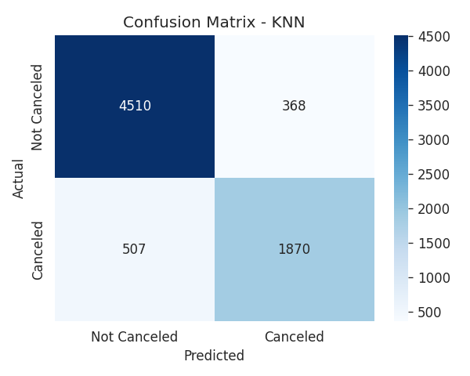

ROC-AUC — “How well does the model separate the two groups overall?”
Unlike other scores derived from a simple equation, this score uses a visual and numerical method known as the ROC Curve.

The basic concept, without complicated mathematics, is the following:
• The model generates a probability that a booking will be cancelled (for example, 73% chance).

• We can test different cut-off thresholds to see how well the model predicts the outcome of 'Cancelled' or 'Not Cancelled' based on various probabilities (e.g. predict cancelled if the probability is greater than 50 percent, greater than 30 percent, or greater than 80 percent).

• The ROC Curve shows how well the model does at distinguishing two groups based on all possible cut-off thresholds.

• AUC is just the area under the ROC Curve. The theoretical range for AUC is 0.5 to 1; if AUC==0.5, the model is no better than randomly guessing, like flipping a coin; if AUC==1, there is no error; every prediction is correct.

In our case, we were able to achieve an AUC of 0.939; therefore, our model is a very reliable predictor of cancelled versus non-cancelled bookings at any given cut-off threshold.

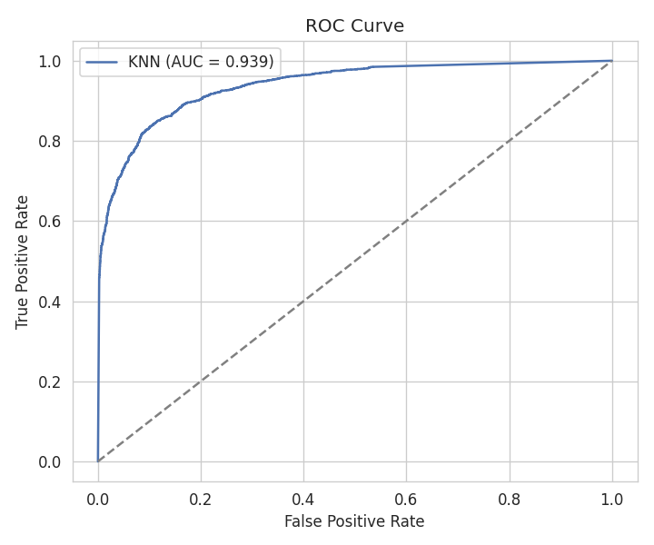

9. Results
Here is a summary of how our final KNN model (K = 17, distance-weighted, euclidean distance) performed on the 7,255 test bookings it had never seen before:
Metric | Score
Accuracy | 87.9%
Precision (for Cancelled bookings) | 83.6%
Recall (for Cancelled bookings) | 78.7%
F1-Score | 81.0%
ROC-AUC | 0.939

The booking cancellation prediction model identified that cancellations can be predicted around 90% accurately. Therefore, much like an airline booking system uses frequent flyers to identify potential problems with making reservations; a hotel could rely on its ability to identify potential issues regarding cancelled reservations and take preventative measures in advance, e.g., sending reminders to guests who reserved their room(s) with a given date, requesting deposits or providing small incentives to offset cancellations.
There were other patterns associated with cancellations that we identified by exploring the data prior to modelling:
• Long lead_times (reservations made far in the future) have an increased likelihood of cancellation because guests have more flexibility for making changes and cancelling.
• Special requests (e.g., specific floor or early check-in) by guests appear to be a sign that they will not cancel because they are showing more commitment to staying at the hotel.
• Previous guests have a lower cancellation rate than new guests.

10. Conclusion
By utilizing KNN (K-Nearest Neighbors) appropriately, we were able to generate an effective prediction with over 88% accuracy for the likelihood of cancellation on a particular booking based on the distance between its characteristics (the euclidean distance) and all the other bookings that have occurred in the past, and we also achieved a very respectable 0.939 AUC. Here are the primary lessons learned from this project:
• KNN uses similarity between examples to predict values, thus allowing us to avoid having to make complex assumptions about the observed data in order to arrive at an answer.
• KNN cannot be used correctly without normalizing/standardizing/scaling the input: data with large variances (ranges) will inappropriately influence the distance(s) used to determine "similarity."
• The value for "K" is very much a balance: if too small, the effect of excessive noise (or random values) will have a disproportionately high impact on the result; conversely, if K is too large, the model will not be able to correctly represent the data.
• Simply using the accuracy value only does not provide all of the relevant details regarding model performance (AUC, Precision, Recall and F1), and we must consider all of these together in order to understand how our model performs.

11. Appendix
import os
import pandas as pd
import numpy as np
import matplotlib.pyplot as plt
import seaborn as sns

from sklearn.model_selection import train_test_split
from sklearn.preprocessing import StandardScaler, LabelEncoder
from sklearn.neighbors import KNeighborsClassifier
from sklearn.metrics import (
accuracy_score, precision_score, recall_score, f1_score,
confusion_matrix, classification_report, roc_curve, roc_auc_score
)

# LOAD DATA

proj_path = os.getcwd()
print("Project Path = ",proj_path)

file_path = proj_path + "\\Hotel Reservations.csv"
print("File Path = ",file_path)

df = pd.read_csv(file_path)
print("Dataset shape:", df.shape)
print(df.head())
print("\nMissing values per column:\n", df.isnull().sum())

# Drop identifier column - not predictive
df = df.drop(columns=["Booking_ID"])

print("____________________________________________________________________________")
print(df.head())
print("____________________________________________________________________________")
print("The shape of the dataset:\n",df.shape)
print("____________________________________________________________________________")
print("The info of the dataset:\n",df.info)
print("____________________________________________________________________________")
print("Data type:\n",df.dtypes)
print("____________________________________________________________________________")
print("Calculating missing value:\n", df.isnull().sum().sum())
print("____________________________________________________________________________")
print("The Target Distribution:\n",df['booking_status'].value_counts())
print("____________________________________________________________________________")
print("The description of the dataset:\n",df.describe(include='all').T)
print("____________________________________________________________________________")

print("Booking Status Distribution:")
print(df["booking_status"].value_counts())

plt.figure(figsize=(6,4))

ax = sns.countplot(x="booking_status", data=df)

plt.title("Booking Status Distribution")
plt.xlabel("Booking Status")
plt.ylabel("Number of Bookings")

# Add count labels on top of each bar
for container in ax.containers:
ax.bar_label(container)
plt.grid()
plt.tight_layout()
plt.show()
# TARGET ENCODING

# booking_status: Canceled: 1, Not Canceled: 0
df["booking_status"] = df["booking_status"].map({"Canceled": 1, "Not_Canceled": 0})
print("\nTarget distribution:\n", df["booking_status"].value_counts(normalize=True))
print("____________________________________________________________________________")

# EXPLORATORY DATA ANALYSIS
fig, axes = plt.subplots(1, 2, figsize=(12, 5))

# Booking Status Distribution
df["booking_status"].value_counts().plot(kind="bar", ax=axes[0])
axes[0].set_title("Booking Status Distribution")
axes[0].set_xlabel("Booking Status")
axes[0].set_ylabel("Count")
categorical_cols = ["type_of_meal_plan", "room_type_reserved", "market_segment_type"]
df_encoded = pd.get_dummies(df, columns=categorical_cols, drop_first=True)

X = df_encoded.drop(columns=["booking_status"])
y = df_encoded["booking_status"]

print("\nFeature matrix shape after encoding:", X.shape)

print("____________________________________________________________________________")

# TRAIN/TEST SPLIT
X_train, X_test, y_train, y_test = train_test_split(
X, y, test_size=0.2, random_state=42, stratify=y
)
print(f"\nTrain size: {X_train.shape[0]}, Test size: {X_test.shape[0]}")
print("____________________________________________________________________________")

# SCALING
scaler = StandardScaler()
X_train_scaled = scaler.fit_transform(X_train)
X_test_scaled = scaler.transform(X_test)

# Lead Time vs Booking Status
sns.boxplot(data=df, x="booking_status", y="lead_time", ax=axes[1])
axes[1].set_title("Lead Time vs Booking Status")
axes[1].set_xlabel("Booking Status")
axes[1].set_ylabel("Lead Time")
plt.grid()
plt.tight_layout()
plt.show()

# Correlation Heatmap
corr_cols = [
"lead_time",
"avg_price_per_room",
"no_of_special_requests",
"no_of_previous_cancellations",
"repeated_guest",
"booking_status"
]

plt.figure(figsize=(7, 5))
sns.heatmap(
df[corr_cols].corr(),
annot=True,
fmt=".2f"
)
plt.title("Correlation with Booking Status")
plt.tight_layout()
plt.show()
#ENCODING
categorical_cols = ["type_of_meal_plan", "room_type_reserved", "market_segment_type"]
df_encoded = pd.get_dummies(df, columns=categorical_cols, drop_first=True)

X = df_encoded.drop(columns=["booking_status"])
y = df_encoded["booking_status"]

print("\nFeature matrix shape after encoding:", X.shape)

print("____________________________________________________________________________")

# TRAIN/TEST SPLIT
X_train, X_test, y_train, y_test = train_test_split(
X, y, test_size=0.2, random_state=42, stratify=y
)
print(f"\nTrain size: {X_train.shape[0]}, Test size: {X_test.shape[0]}")
print("____________________________________________________________________________")

# SCALING
scaler = StandardScaler()
X_train_scaled = scaler.fit_transform(X_train)
X_test_scaled = scaler.transform(X_test)
#FINDING K

error_rates = []
k_range = range(1, 31, 2)
for k in k_range:
knn = KNeighborsClassifier(n_neighbors=k)
knn.fit(X_train_scaled, y_train)
pred = knn.predict(X_test_scaled)
error_rates.append(np.mean(pred != y_test))

plt.figure(figsize=(8, 5))
plt.plot(list(k_range), error_rates, marker="o", linestyle="--")
plt.title("Error Rate vs K Value")
plt.xlabel("K")
plt.ylabel("Error Rate")
plt.tight_layout()
plt.grid()
plt.show()
# Best K from Error Rate Graph
best_k = list(k_range)[int(np.argmin(error_rates))]
print(f"\nBest K from Error Rate Graph: {best_k}")

# Train Final KNN Model
best_knn = KNeighborsClassifier(
n_neighbors=best_k,
weights="uniform",
metric="euclidean"
)

best_knn.fit(X_train_scaled, y_train)

print("\nFinal KNN Model:")
print(best_knn)
#MODEL EVALUATION ON TEST SET
y_pred = best_knn.predict(X_test_scaled)
y_proba = best_knn.predict_proba(X_test_scaled)[:, 1]

acc = accuracy_score(y_test, y_pred)
prec = precision_score(y_test, y_pred)
rec = recall_score(y_test, y_pred)
f1 = f1_score(y_test, y_pred)
auc = roc_auc_score(y_test, y_proba)

print("\n=== Final Model Performance (Test Set) ===")
print(f"Accuracy : {acc:.4f}")
print(f"Precision: {prec:.4f}")
print(f"Recall : {rec:.4f}")
print(f"F1 Score : {f1:.4f}")
print(f"ROC-AUC : {auc:.4f}")
print("\nClassification Report:\n", classification_report(y_test, y_pred))

# Confusion Matrix
cm = confusion_matrix(y_test, y_pred)
plt.figure(figsize=(5, 4))
sns.heatmap(
cm, annot=True, fmt="d", cmap="Blues",
xticklabels=["Not Canceled", "Canceled"],
yticklabels=["Not Canceled", "Canceled"]
)
plt.title("Confusion Matrix - KNN")
plt.ylabel("Actual")
plt.xlabel("Predicted")
plt.tight_layout()
plt.show()

# ROC Curve
fpr, tpr, _ = roc_curve(y_test, y_proba)
plt.figure(figsize=(6, 5))
plt.plot(fpr, tpr, label=f"KNN (AUC = {auc:.3f})", )
plt.plot([0, 1], [0, 1], linestyle="--")
plt.xlabel("False Positive Rate")
plt.ylabel("True Positive Rate")
plt.title("ROC Curve")
plt.legend()
plt.tight_layout()
plt.show

