1.Decentralized Voting System using Solidity in Remix

Step 1: Open Remix IDE
Open the official website:
Remix IDE

Step 2: Create a New Solidity File
VotingSystem.sol

Step 3: Write the Smart Contract Code
Paste the following code inside the file:
// SPDX-License-Identifier: MIT
pragma solidity ^0.8.0;

contract VotingSystem {

address public admin;
bool public votingStarted;
bool public votingEnded;

struct Candidate {
uint id;
string name;
uint voteCount;
}

mapping(uint => Candidate) public candidates;
mapping(address => bool) public hasVoted;

uint public candidatesCount;

constructor() {
admin = msg.sender;

addCandidate("Alice");
addCandidate("Bob");
addCandidate("Charlie");
}

modifier onlyAdmin() {
require(msg.sender == admin, "Only admin can perform this action");
_;
}

function addCandidate(string memory _name) private {
candidatesCount++;
candidates[candidatesCount] = Candidate(candidatesCount, _name, 0);
}

function startVoting() public onlyAdmin {
votingStarted = true;
votingEnded = false;
}

function endVoting() public onlyAdmin {
votingEnded = true;
}

function vote(uint _candidateId) public {

require(votingStarted == true, "Voting has not started");
require(votingEnded == false, "Voting has ended");
require(hasVoted[msg.sender] == false, "You have already voted");
require(_candidateId > 0 && _candidateId <= candidatesCount, "Invalid candidate");

hasVoted[msg.sender] = true;

candidates[_candidateId].voteCount++;
}

function getVotes(uint _candidateId) public view returns(uint) {
return candidates[_candidateId].voteCount;
}
}

Step 4: Compile the Smart Contract
Step 5: Deploy the Contract

Step 6: Start Voting
Click:
startVoting
Then click:
Transact
No parameter needed.
Voting is now ON.

Step 7: Vote for Candidate
Under vote:
You will see an input box.
Type:
1
Then click:
Transact
This means:
- Candidate 1 gets one vote
You can also vote:
- 2 for Bob
- 3 for Charlie

Step 8: Check Votes
Under:
getVotes
Type:
1
Then click:
Call
Output:
1
means candidate 1 has 1 vote.

Step 9: End Voting
Click:
endVoting
Then click:
Transact
Voting stops.
Step 10: Test One Vote Per Address To verify security:

step : Try Voting Again with SAME Account
Without changing account:
- Open vote
- Enter: 2
- Click:
Transact
Now transaction will FAIL.
You will see error like:
You have already voted
This proves:
✅ Same address cannot vote twice.

2. Crowdfunding Platform Problem Statement: Create a smart contract that allows users to create fundraising campaigns and accept donations. If the funding goal is not met by the deadline, donors should be able to withdraw their funds.
[tell me one thing when creating campaign we give goal and duration only not id and set value is 0 .but when donate it ask for campaign id in text field and value set to 4
but how i will know what campaign id is because during creating campaign we don't give id =So every new campaign gets the next number automatically. ]
Easy Smart Contract (Solidity):
// SPDX-License-Identifier: MIT
pragma solidity ^0.8.0;
contract Crowdfunding {
struct Campaign {
address payable creator;
uint goal;
uint deadline;
uint amountRaised;
bool fundsWithdrawn;
} uint public campaignCount;
mapping(uint => Campaign) public campaigns;
mapping(uint => mapping(address => uint)) public donations;
// Create Campaign
function createCampaign(uint _goal, uint _durationInMinutes) public {
campaignCount++;
campaigns[campaignCount] = Campaign({
creator: payable(msg.sender),
goal: _goal,
deadline: block.timestamp + (_durationInMinutes * 1 minutes),
amountRaised: 0,
fundsWithdrawn: false
});
}
// Donate to Campaign
function donate(uint _campaignId) public payable {
Campaign storage campaign = campaigns[_campaignId];
require(block.timestamp < campaign.deadline, "Campaign ended");
campaign.amountRaised += msg.value;
donations[_campaignId][msg.sender] += msg.value;
}
// Creator Withdraws Funds
function withdrawFunds(uint _campaignId) public {
Campaign storage campaign = campaigns[_campaignId];
require(msg.sender == campaign.creator, "Not creator");
require(block.timestamp >= campaign.deadline, "Campaign still active");
require(campaign.amountRaised >= campaign.goal, "Goal not reached");
require(!campaign.fundsWithdrawn, "Already withdrawn");

campaign.fundsWithdrawn = true;

(bool success, ) = campaign.creator.call{value: campaign.amountRaised}("");
require(success, "Transfer failed");

}
// Donor Refund
function refund(uint _campaignId) public {
Campaign storage campaign = campaigns[_campaignId];
require(block.timestamp >= campaign.deadline, "Campaign still active");
require(campaign.amountRaised < campaign.goal, "Goal was reached");
uint donatedAmount = donations[_campaignId][msg.sender];
require(donatedAmount > 0, "No donation found");
donations[_campaignId][msg.sender] = 0;
(bool success, ) = payable(msg.sender).call{value: donatedAmount}("");
require(success, "Refund failed");

}
}
Step 2: Create Solidity File
Crowdfunding.sol
Step 3: Compile Contract
Step 4: Deploy Contract
Step 5: Create Campaign
In the input box enter:
5000000000000000000,
2
Enter : Transact
Step 6: Donate to Campaign
Step 7: Test Goal Success
If donations ≥ goal:
- creator calls:
withdrawFunds(1)
- VALUE = 0
Unit:
wei
Funds transferred to creator.

Step 8: Test Refund
If donations < goal after deadline:
- donor calls:
refund(1)
Donor receives refund.
3.Decentralized To-Do List Problem Statement: Develop a smart contract that allows users to add, update, and mark tasks as completed. Each user's tasks should be stored independently and be accessible only by the user.
Step 2: Create a New Solidity File
TodoList.sol
// SPDX-License-Identifier: MIT
pragma solidity ^0.8.0;
contract TodoList {
struct Task {
uint id;
string content;
bool completed;
}
mapping(address => Task[]) private userTasks;
function addTask(string memory _content) public {
uint taskId = userTasks[msg.sender].length;
userTasks[msg.sender].push(
Task(taskId, _content, false)
);
}
function getTask(uint _id) public view returns (
uint,
string memory,
bool
) {
Task memory task = userTasks[msg.sender][_id];
return (
task.id,
task.content,
task.completed
);
}
function updateTask(uint _id, string memory _newContent) public {
userTasks[msg.sender][_id].content = _newContent;
}
function toggleCompleted(uint _id) public {
userTasks[msg.sender][_id].completed =
!userTasks[msg.sender][_id].completed;
}
function getTaskCount() public view returns (uint) {
return userTasks[msg.sender].length;
}
}

Step 4: Compile the Contract

Step 5: Deploy the Contract

Step 6: Test addTask()
Under deployed contracts:
- Find:
addTask
- Enter task:
Buy groceries
- Click transact
Task is added.

Step 7: Check Number of Tasks
- Click:
getTaskCount
Output:
1

Step 8: View Task
- In:
getTask
- Enter:
0
- Click call
Output example:
0:
uint256: 0
1:
string: Buy groceries
2:
bool: false

Step 9: Update Task
- In:
updateTask
- Enter:
0
- Enter new text:
Buy groceries and milk
- Click transact
Task updated successfully.

Step 10: Mark Task as Completed
- In:
toggleCompleted
- Enter:
0
- Click transact
Now task becomes completed.
Check again using getTask(0).
Output:
completed = true

Step 11: Verify Independent User Storage
To prove every user has separate tasks:
- Change account from the account dropdown in Remix
- Add another task
- Call:
getTaskCount
You will notice:
- New account has separate tasks
- Old account tasks are inaccessible
This happens because of:
mapping(address => Task[]) private userTasks;
Each Ethereum address has its own task list.
4.Simple Bank (Wallet System) Problem Statement: Build a smart contract that functions as a simple bank. Users should be able to deposit, withdraw, and check their balance. Only the account holder should have access to their funds.
SimpleBank.sol
// SPDX-License-Identifier: MIT
pragma solidity ^0.8.0;

contract SimpleBank {

// Store balance of each user
mapping(address => uint) private balances;
// Deposit Ether into contract
function deposit() public payable {
balances[msg.sender] += msg.value;
}
// Withdraw Ether from contract
function withdraw(uint amount) public {

// Check sufficient balance
require(balances[msg.sender] >= amount, "Insufficient balance");
// Deduct balance first
balances[msg.sender] -= amount;
// Transfer Ether
payable(msg.sender).transfer(amount);
}
// Check own balance
function checkBalance() public view returns(uint) {
return balances[msg.sender];
}
}

Step 6: Deposit Ether

To deposit money:
- In Deploy section find:
VALUE
- Enter amount:
1
- Change unit from:
wei → ether
- Click:
deposit
Now 1 Ether is stored in your wallet balance inside the contract.

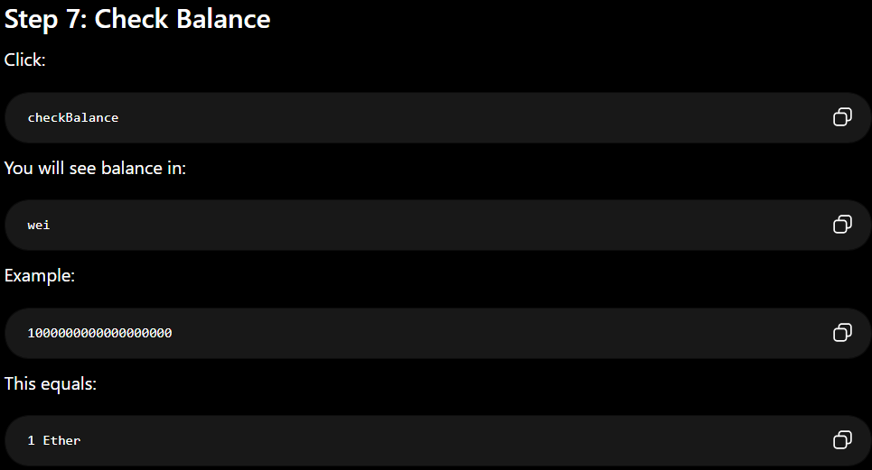

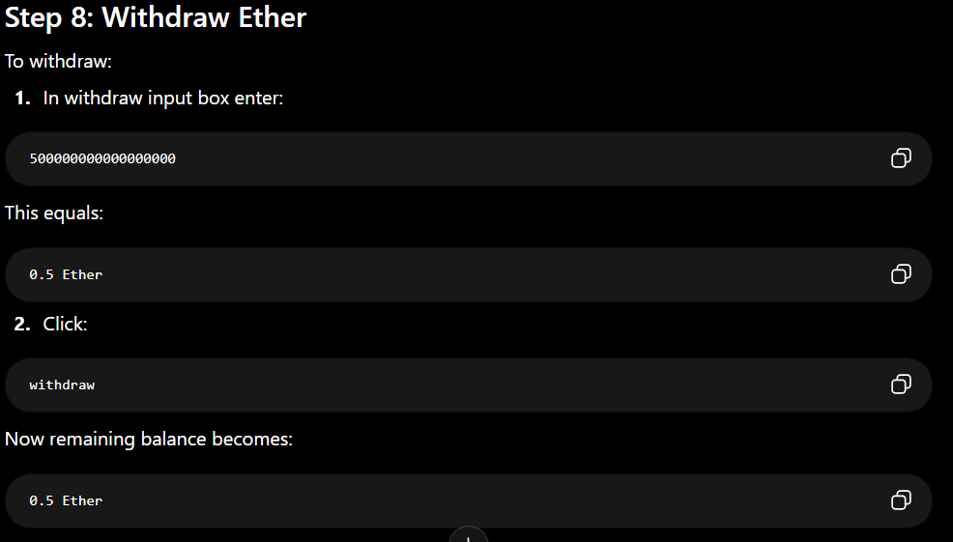
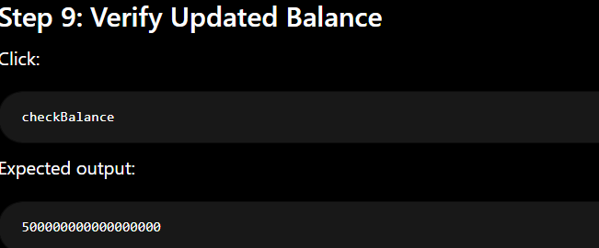
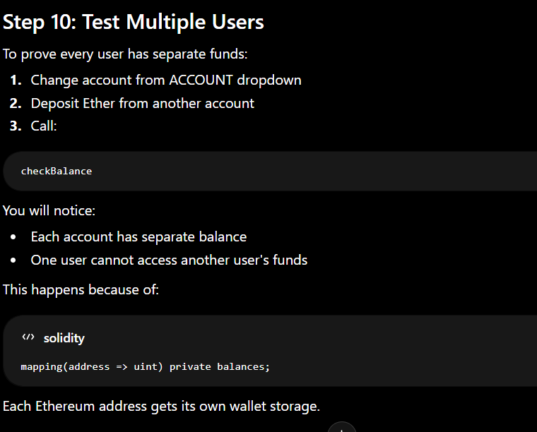

5.Supply Chain Management Problem Statement: Create a smart contract to track products from manufacturer to consumer. Each step in the supply chain should be recorded immutably with timestamps and participant addresses.

SupplyChain.sol
// SPDX-License-Identifier: MIT
pragma solidity ^0.8.0;

contract SupplyChain {

// Product structure
struct Product {
uint id;
string name;
string currentStage;
address currentHolder;
bool exists;
}

// Tracking history structure
struct Tracking {
string stage;
address participant;
uint timestamp;
}

// Store products
mapping(uint => Product) public products;

// Store tracking history
mapping(uint => Tracking[]) public productHistory;

// Add product
function addProduct(
uint _id,
string memory _name
) public {

require(!products[_id].exists, "Product already exists");

products[_id] = Product({
id: _id,
name: _name,
currentStage: "Manufactured",
currentHolder: msg.sender,
exists: true
});

productHistory[_id].push(
Tracking(
"Manufactured",
msg.sender,
block.timestamp
)
);
}

// Update supply chain stage
function updateStage(
uint _id,
string memory _newStage
) public {

require(products[_id].exists, "Product does not exist");

products[_id].currentStage = _newStage;
products[_id].currentHolder = msg.sender;

productHistory[_id].push(
Tracking(
_newStage,
msg.sender,
block.timestamp
)
);
}

// Get tracking count
function getTrackingCount(uint _id)
public
view
returns(uint)
{
return productHistory[_id].length;
}

// Get tracking details
function getTracking(
uint _id,
uint _index
)
public
view
returns(
string memory,
address,
uint
)
{
Tracking memory t = productHistory[_id][_index];

return (
t.stage,
t.participant,
t.timestamp
);
}
}

Step 4: Compile the Contract

Step 5: Deploy the Contract
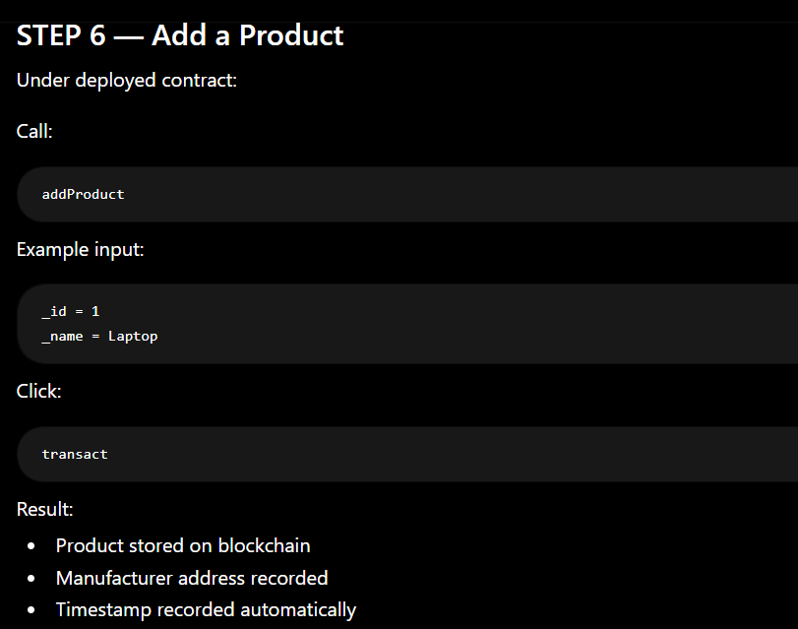

STEP 7 — Check Product Details
Call:
products(1)
You will see:
- Product ID
- Product name
- Current stage
- Current holder address
- Exists = true
Example:
1,
"Laptop",
"Manufactured",
0x123...,
True

STEP 8 — Update Supply Chain Stage
Now move product through supply chain.
Example stages:
- Packed
- Shipped
- Warehouse
- Retailer
- Delivered
Call:
updateStage
Example:
_id = 1
_newStage = Shipped
Click:
transact
Blockchain now stores:
- New stage
- Participant address
- Timestamp

STEP 9 — Simulate Different Participants
To show different participants:
In Remix:
- Change account from account dropdown
Example:
- Manufacturer account
- Distributor account
- Retailer account
Each account updates stage separately.
This records:
- Different Ethereum addresses
- Different timestamps
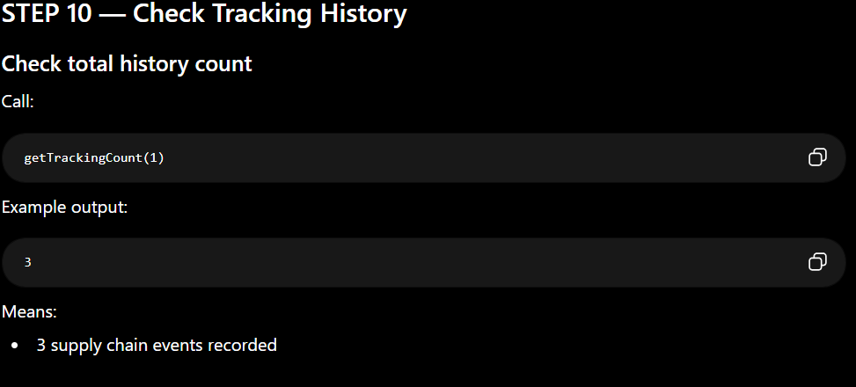
STEP 11 — View Individual Tracking Records
Call:
getTracking
Example:
_id = 1
_index = 0
Output:
"Manufactured"
0xManufacturerAddress
timestamp
Next:
_index = 1
Output:
"Shipped"
0xDistributorAddress
timestamp

STEP 12 — Important Concept Explanation

Immutable Storage
All records are stored on blockchain:
- Cannot be changed
- Cannot be deleted easily
- Fully transparent

