**Configure backup vault,backup policy and storage account**

1. **Configure Backup for production storage**

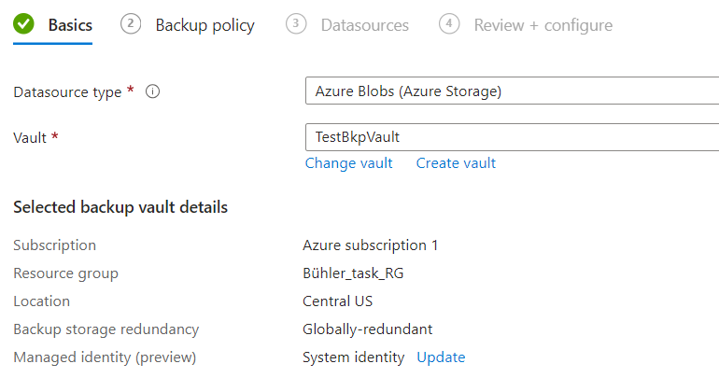

**Select Production Policy for prodstorage account**

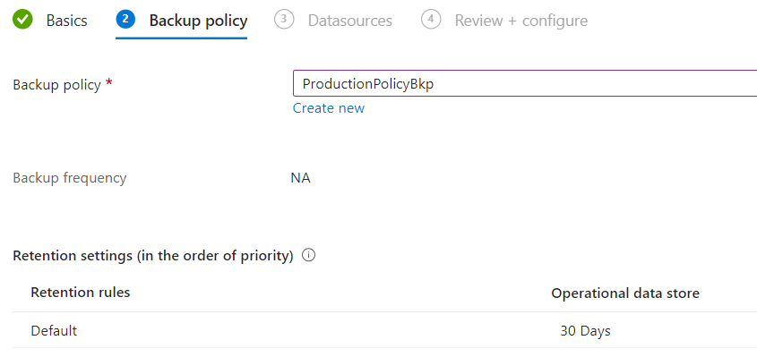

**Successfully configured production storage**

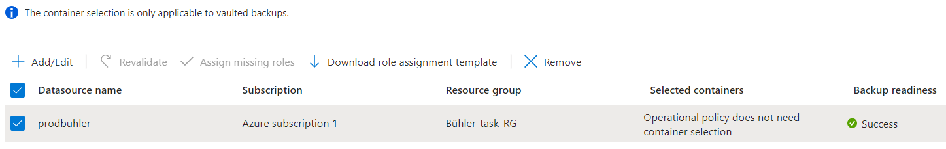

**B.Configure Backup with nonproduction policy and non production storage account.**

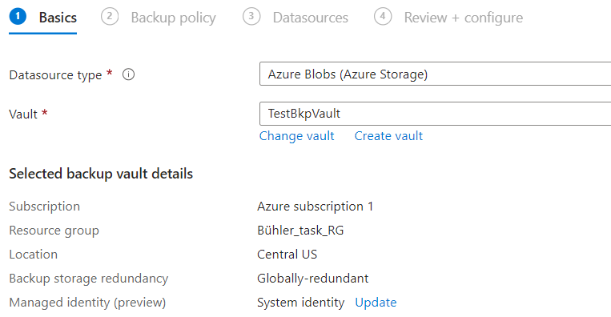

**Successfully configured nonproduction storage account.**

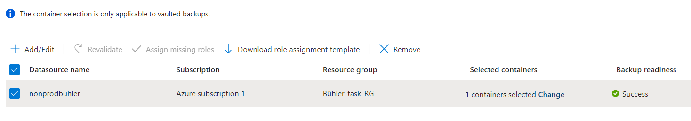

**Finally We have backup Instance**

