**Create backup Policy for both storage account (I have tried to create Backup policy by Powershell Script but Facing problem That’s why I tried with Azure Portal)**

**A.Create Policy for production storage**

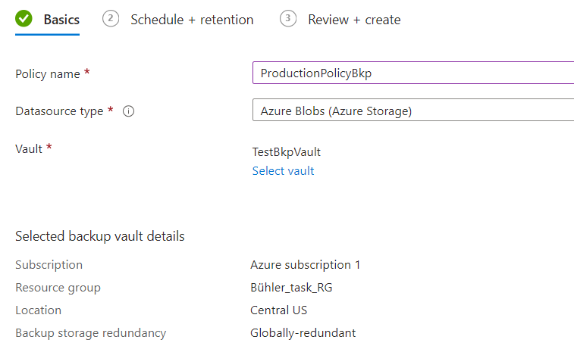

**I have choose Operation Backup to create Policy for Production Storage .**

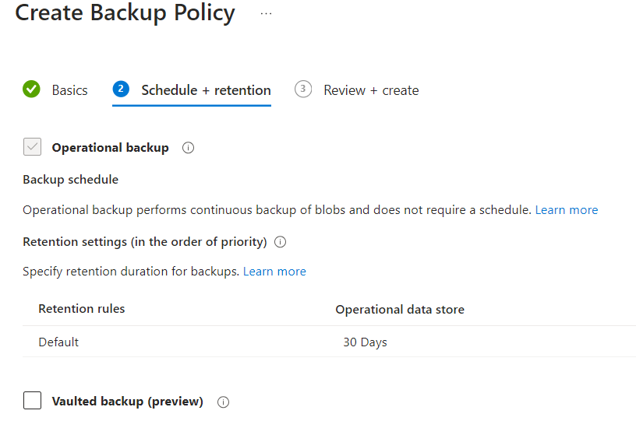

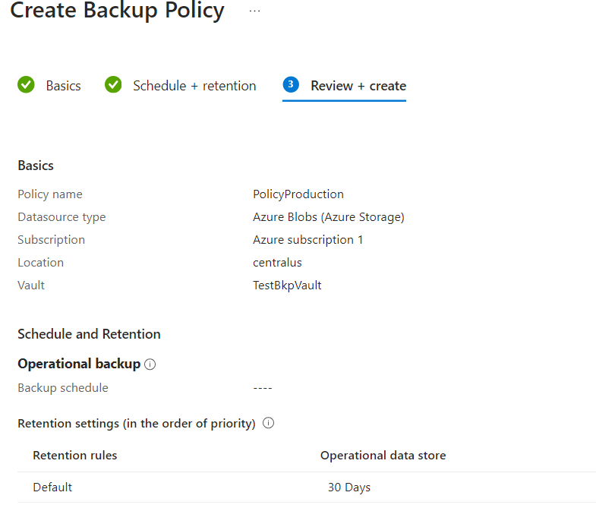

**Creating Non-production Policy with7 days retention periods.**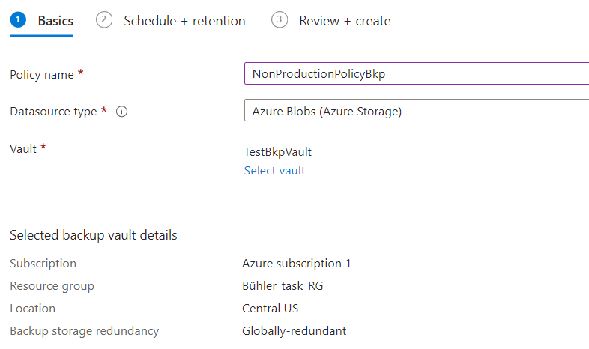

**Vault Backup to create policy for Non-production storage.**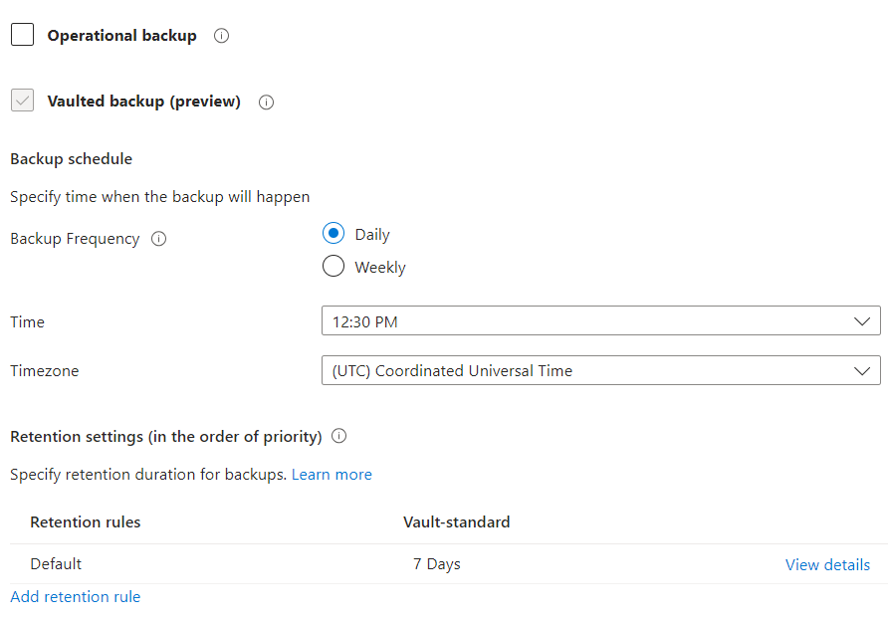

**Nonproduction policy created**