Restore backup for both account storage.

We have backup instance of both storage account.

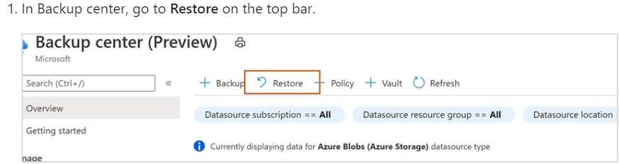

**2. Restore of backup instance**

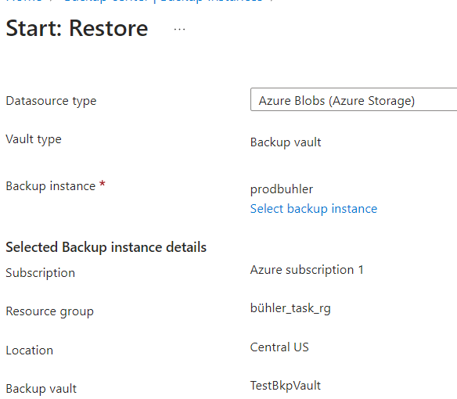

**3.Select Restore Point :Operational Backup for Production storage account.**

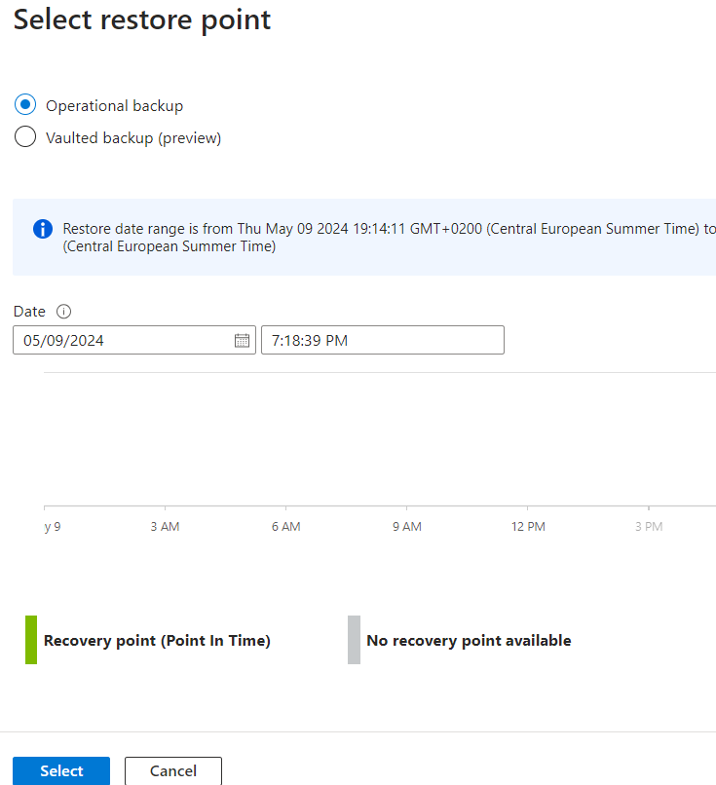

**4.Restore backup instance for nonproduction account**

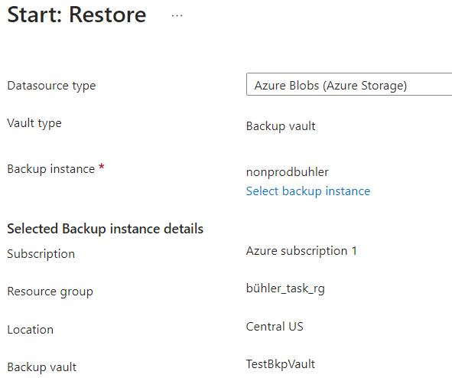

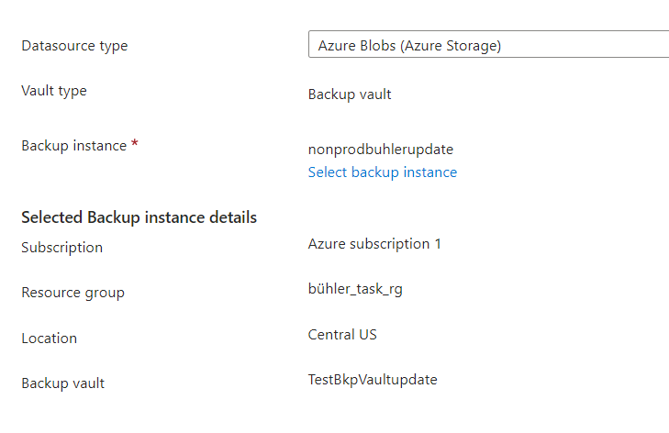

**5. Successfully we got Restore Azure blob**

