NAVODAYA VIDYALAYA SAMITI

PROSPECTUS FOR JAWAHAR NAVODAYA VIDYALAYA SELECTION TEST- 2018

1. NAVODAYA VIDYALAYA SCHEME
1.1 Introduction
In accordance with the National Policy of Education (1986) Government of India started Jawahar Navodaya Vidyalayas (JNVs). Presently the JNVs are spread in 28 States and 07 Union Territories. These are co-educational residential schools fully financed and administered by Government of India through an autonomous organization, Navodaya Vidyalaya Samiti. Admissions in JNVs are made through the JAWAHAR NAVODAYA VIDYALAYA SELECTION TEST (JNVST) at Class VI. The medium of instruction in JNVs is the mother tongue or regional language up to Class VIII and English thereafter for Maths and Science and Hindi for Social Science. Students of the JNVs appear for X and XII class examinations of the Central Board of Secondary Education. While education in the schools is free including boarding, lodging, uniforms and textbooks, a nominal fee of Rs. 600/- per month is collected from the students of Classes IX to XII only. In respect of ward of Govt. employees who are eligible for children education allowance, fee @ Rs.1500/- per month has to be paid. However, children belonging to SC/ST, Girls, Divyang and from families whose income is below poverty line (BPL) are exempted from payment of fee.

1.2 Objective of the Scheme
- To provide good quality modern education including a strong component of culture, inculcation of values, awareness of the environment, adventure activities and physical education to the talented children predominantly from rural areas.
- To ensure that students attain a reasonable level of competency in three languages.
- To promote national integration through migration of students from Hindi to non-Hindi speaking State and vice-versa.
- To serve in each district as focal point for improvement of quality of school education in general through sharing of experiences and facilities.

1.3 State-wise Distribution of Jawahar Navodaya Vidyalayas
According to the Navodaya Vidyalaya Scheme, one Jawahar Navodaya Vidyalaya is to be set up in each District in a phased manner. At present, there are 660 Vidyalayas are sanctioned in 28 States and 07 Union Territories. Out of which 626 are functioning. The State-wise distribution of JNVs sanctioned is as under:

Andhra Pradesh | 13+02 | Himachal Pradesh | 12 | Punjab | 22+01
Assam | 27+01 | Jammu & Kashmir | 22+01 | Pudducherry | 04
Arunachal Pradesh | 18 | Jharkhand | 24+02 | Rajasthan | 33+02
Andaman & Nicobar Islands | 03 | Karnataka | 30+01 | Sikkim | 04
Bihar | 38+01 | Kerala | 14 | Tripura | 08
Chandigarh | 01 | Lakshadweep | 01 | Telangana | 09
Chattisgarh | 27+01 | Madhya Pradesh | 51+02 | Uttar Pradesh | 75+01
Delhi | 09 | Maharashtra | 33+01 | Uttarakhand | 13
Daman & Diu | 02 | Manipur | 09+02 | West Bengal | 19+01
Dadra & Nagar Haveli | 01 | Meghalaya | 11+01 | Total 638+22**= 660
Goa | 02 | Mizoram | 08
Gujarat | 33+01 | Nagaland | 11
Haryana | 21 | Orissa | 30+01
** Additional JNVs sanctioned for the Districts having large concentration of SC/ST population.

A maximum of eighty students are admitted in Class VI in each Vidyalaya, through a Selection Test subject to availability of suitable candidates. The Samiti reserves the right to reduce the seats to forty or to withhold result and/or withhold admission and/or conduct of JNVST in case adequate accommodation is not available.

1.4 Jawahar Navodaya Vidyalaya Selection Test - 2018

JNV Selection Test for admission to Class-VI in JNVs for the academic session 2018-19 will be held as per following schedule. The last date for uploading online application in the office of Common Service Centre is 25th November 2017.

    - On Saturday, the_10th February, 2018 at 11.30 A.M. in the State of Andhra Pradesh, Assam, Arunachal Pradesh (except Dibang Valley & Tawang Districts), Bihar, Chhattisgarh, Goa, Gujarat, Haryana, Himachal Pradesh (except Chamba, Kinnaur, Mandi, Sirmour, Kullu, Lahaul & Spiti and Shimla Districts), Jharkhand, Kerala, Karnataka, Madhya Pradesh, Maharashtra, Manipur, Orissa, Punjab, Rajasthan, Tripura, Telangana, Uttar Pradesh, & West Bengal (except Darjeeling), Union Territories of Andaman & Nicobar Islands, Chandigarh, Dadar & Nagar Haveli, Daman & Diu, Delhi, Lakshadweep and Pudducherry.
    - On Sunday, the 8th April, 2018 at 11.30 A.M. in the States of Jammu and Kashmir (except Leh, Kargil & Doda), Meghalaya, Mizoram, Nagaland, Sikkim, Uttrakhand and in the Districts of Dibang Valley and Tawang of Arunachal Pradesh, in the Districts of Chamba, Kullu, Mandi, Sirmour of Himachal Pradesh, in the District of Darjeeling of West Bengal.
iii. On Saturday, the 9th June, 2018 at 11.30 A.M. in the Districts of Leh, Kargil & Doda of J&K State and in the District of Kinnaur, Shimla and Lahaul & Spiti of Himachal Pradesh State.

2. HOW TO APPLY FOR JNV SELECTION TEST

2.1 How to register online for JNV Selection Test 2018?

- The process for applying for JNV Selection Test has been simplified through online process. Detailed and intensive verification of proofs for residence, age, eligibility etc will be done for successful candidates through the laid down procedure.
- The eligible candidates along with his /her parent/guardians may approach Common Service Centre along with duly filled in certificate from the Head Master of School where the candidate is studying in Class V. The format of certificate may be downloaded from Samiti website www.nvshq.org The sample of format is enclosed.
- In case of candidates from NIOS, candidates should obtain `B’ certificate and residence should be in the same district where he / she is seeking admission.

The application for JNV Selection Test 2018 is being processed through Common Service Centre of Ministry of IT, Govt. of India. Common Service Centre has a wider range with 2.6 lac centres across the country virtually covering every village. As per the MOU with NVS, Common Service Centre will be charging Rs 35/-(Rupees thirty five only) to be paid by the parent/ candidate towards service charge to upload the application form per candidate
2.2 Issue of Admit Cards

The admit card can be downloaded from the office of Common Service Centre as per the following schedule:

For Exam to be Conducted on | With effect from
10th February, 2018 for Summer Bound JNVs | 15th January 2018 (Monday)
8th April 2018 for Winter Bound JNVs | 23rd March 2018 (Friday)
9th June 2018 for Extreme Winter Bound JNVs | 23rd March 2018 (Friday)
For downloading the admit card, Common Service Centre will be charging Rs.10/- Per candidate, which is to be paid by the parent/candidate.
2.3 Result of the Selection Test

The result of JNV Selection Test 2018 is expected to be announced by 1st week of April/May 2018 for Summer Bound, the last week of May 2018 for Winter Bound & 1st week of July 2018 for Extreme Winter Bound JNVs of the year of admission. The result will be displayed in the offices of the concerned (i) Jawahar Navodaya Vidyalaya (ii) District Education Officer (iii) District Magistrate (iv) Deputy Commissioner, Navodaya Vidyalaya Samiti of the Region. The Principal, Jawahar Navodaya Vidyalaya concerned, will also inform the selected candidates through registered post. The result will also be displayed on website of the Navodaya Vidyalaya Samiti at the address www.nvshq.org

- SELECTION AND ADMISSION

3.a) Selection in the test will not vest any right on the candidates to secure admission into the JNV. At the time of seeking actual admission, each selected candidate will have to produce all relevant certificates, as prescribed by the Navodaya Vidyalaya Samiti. Until admission, the selection is provisional.
3.b) In case of any dispute, the decision of Navodaya Vidyalaya Samiti shall be final and binding on the candidates.
3.c) Marks obtained by candidates (both selected and unselected) in the test are not communicated.
3.d) There is no provision for re-evaluation of the answer scripts. Since the result is processed through computer and sufficient care is taken to ensure accuracy through various checks in processing the result, no request for re-totaling of marks will be entertained.
3.e) It may also be noted by the candidates and their parents/guardians that under the scheme of JNVs, students of a JNV located in Hindi speaking State may have to be migrated to another JNV in Non-Hindi Speaking State and vice-versa for one academic year when the students are promoted to Class IX. In case of refusal from the students selected for migration, continuation of such students in JNV will not be allowed.
3.f) The candidates and their parents/guardians may note that the children selected on the basis of the Test will be admitted only in the JNV located in the district from where they are appearing at the JNVST. Under no circumstances, the selected candidate will be given admission to any other JNV. No request for shifting of students on account of medium of instruction in the JNV concerned, shifting of parents/guardians to other district(s) State(s) etc. will be entertained.
3.g) Candidates belonging to the Scheduled Castes (SCs) and Scheduled Tribes (STs) will have to produce a certificate of the Caste/Tribe at the time of seeking admission, if selected. Such certificate should be procured from the competent authority before 15th July, of the year of seeking admission so that it may be submitted to the Principal of concerned JNV at the time of admission.
3.h) Candidates belonging to the divyang category (Orthopedically Handicapped, Hearing Impaired and Visually Handicapped) if selected will have to produce a medical certificate signed by Chief Medical Officer of the District concerned at the time of admission.
3.i) Candidates belonging to the divyang category (Orthopedically Handicapped, Hearing Impaired and Visually Handicapped) can seek admission in the district in which they are studying in Class V on regular basis at the time of applying for JNVST or their native district where his/her parents are residing.

3.j) Candidates belonging to transgender category can seek admission in the district in which they are studying in Class V on regular basis at the time of applying for JNVST. They will have to submit a certificate from the competent authority prescribed by the concerned State Govt. with regard to their gender. No reservation is made for this category.

4. WHO IS ELIGIBLE

FOR ALL CANDIDATES:
4.a) Only the candidates from the district concerned where the Jawahar Navodaya Vidyalaya has been opened are eligible to apply for admission. However, the district where JNV is opened and is bifurcated at a later date, the old boundaries of the district are considered for the purpose of eligibility for admission into JNVST, in case a new Vidyalaya has not started in newly bifurcated district as yet.
4.b) A candidate seeking admission must not have been born before 01-05-2005 and after 30-04-2009. This will apply to candidates of all categories, including those who belong to the Scheduled Castes (SCs) and Scheduled Tribes (STs). In case of doubt of overage candidate seeking admission, they may be referred to the Medical Board for confirmation of the age. The decision of the Medical Board will be final.
4.c) A candidate appearing for the selection test must be studying in Class-V for the whole of the academic session 2017-18 in a Government/Government aided or other recognized schools or ‘B’ certificate competency course of National Institute of Open Schooling in the same district where he/she is seeking admission. A school will be deemed recognized if it is declared so by the Government or by any other agency authorized on behalf of Government. Schools where students have obtained ‘B’ certificate under National Institute of Open Schooling should have accreditation of NIOS. A candidate must successfully complete Class-V in the session 2017-18. Actual admission in Class-VI for the session 2018-19 will be subject to this condition.
4.d) A Candidate claiming admission under rural quota must have studied and passed classes III, IV and V from a Govt. / Govt. aided / recognized school spending one full academic session each year in a school located in rural area.
4.e) Candidates who will be passing ‘B’ certificate competency course of National Institute of Open Schooling on or before 30th September, 2017 are also eligible to write admission test provided they are in the prescribed age group. The forms of such candidates will be verified by DEO/DIOS. The rural status of a child from National Institute of Open Schooling will be decided on the basis of a certificate to be issued by Tehsildar/District Magistrate of the District indicating that the child has been residing in rural areas for the last three years. Students studying under the above scheme from urban and notified areas are not eligible for obtaining seat in rural quota.
4.f) A Candidate who has not been promoted and admitted to Class-V before 15th September, 2017 is not eligible to apply.
4.g) No candidate is eligible to appear in the selection test second time, under any circumstances.
5. The parents of the children who qualify the Selection Test will have to submit the following documents at the time of admission for verification: -
- Residence Certificate in prescribed Performa
- Proof for date of birth. However, if any doubt arises, a medical board will verify it.
- Proofs for eligibility as per the conditions of NVS.
- For candidates seeking admission under rural quota, the parents will also have to submit certificate to the effect that the child had studied in an Institution located in a notified rural area.
- Any other documents required.

FOR RURAL CANDIDATES

A) At least 75% of the seats in a district will be filled by candidates selected from rural areas and remaining seats will be filled from the urban areas of the district.
B) A candidate seeking admission under the rural quota must have studied in Classes-III, IV and V completing full academic session from the Government / Government Aided / Government recognized school(s) located in rural areas. However, the candidate should study full academic session in Class-V from the same district where admission is sought.
C) Candidates studying under the schemes of National Institute of Open Schooling should produce their rural status certificate issued by District Magistrate / Tehsildar / Block Development Officer.

FOR URBAN CANDIDATES

A Candidate who has studied in a school located in an urban area even for a single day of session in Class-III, IV and V will be considered as an urban candidate. Urban areas are those which are so defined in 2011 census or through a subsequent Government Notification. All other areas will be considered as rural.

FOR TRANSGENDER CANDIDATES

No separate reservation for transgender category candidates is provided and they will be included in Boys category for reservation purpose, under various sub-categories viz Rural, Urban, SC, ST and Divyang.

RESERVATION OF SEATS

a) | At least 75% of the seats in a district are filled by candidates selected from rural areas and remaining seats are filled from urban areas of the district.
b) | Reservation of seats in favour of children belonging to Scheduled Castes and Scheduled Tribes is provided in proportion to their population in the concerned district provided that no district, such reservation will be less than the national average (15% for SC and 7.5% for ST) but subject to maximum of 50% for both the categories (SC & ST) taken together. These reservations are interchangeable and over and above the candidates selected under open merit.
c) | One third of the total seats are filled up by girls.
d) | There is a provision for reservation of 3% seats for ** Divyang children (i.e. Orthopedically Handicapped, Hearing Impaired and Visually Handicapped).

** “Blindness” refers to a condition where a person suffers from any of the following conditions namely:-

- Total absence of sight; or
- Visual acuity not exceeding 6/60 or 20/200 (snellen) in the better eye with correcting lenses; or
- Limitation of the field of vision subtending an angle of 20 degree or worse.
** “Hearing Impairment” means loss of sixty decibels or more in the better ear in the conversational range of frequencies.
** “Locomotor disability” means disability of the bones joints or muscles leading to substantial restriction of the movement of the limbs or any form of cerebral palsy.
** “Person with disability” means a person suffering from not less than forty percent of any disability as certified by a medical authority.
ABOUT THE SELECTION TEST

1. Centre for Examination
Each candidate shall appear for the selection test at the examination centre allotted to him/her as indicated on the Admit Card. No candidate is permitted to appear from any other centre. No request for change of centre will be entertained. No candidate can appear in the selection test without the proper Admit Card. Admit card may be downloaded through the office of Common Service Centre.

2. Language of the Examination
Jawahar Navodaya Vidyalaya Selection Test is conducted in 21 languages. The test booklet is available in the following languages:

1. Assamese 2. Bengali 3. Bodo
4. English 5. Garo 6. Gujarati
7. Hindi 8. Kannada 9. Khasi
10. Malayalam 11. Manipuri 12. Marathi
13. Mizo 14. Oriya 15. Punjabi
16. Sindhi (Arabic) 17. Sindhi (Devnagri) 18. Tamil
19. Telugu 20. Urdu 21. Nepali

A candidate will be given a test booklet in the language he/she has mentioned in the application form

3. Composition of the Test

The selection test will be of two-hour duration and will have 3 sections with only objective type questions. There are 100 questions in all of 100 marks. Each question carries one mark:

Type of Test | Number of Questions | Marks | Duration
Mental ability Test | 50 | 50 | 60 Minutes
Arithmetic Test | 25 | 25 | 30 Minutes
Language Test | 25 | 25 | 30 Minutes
Total | 100 | 100 | 2 Hours
A single test booklet comprising of the 3 sections will be given to each candidate.

4. Method of Recording Answers

- A separate answer sheet will be provided. Candidates are required to indicate their answers at an appropriate place on the answer sheet itself. The Answer sheet will be of Intelligence Character Recognition (ICR)/Optical Character Recognition (OCR) Sheet. A copy of specimen Answer Sheet is enclosed.
- Only Blue/Black Ball Point Pen is to be used to write on the answer sheet. Candidates should bring their own ballpoint pens. Use of pencil is strictly prohibited.
- For each question, there are four probable answers, out of which only one is correct. The candidate is required to select correct answer and indicate correct corresponding number (1, 2, 3, 4) in the answer sheet. Any other mode such as marking ( √ ) OR (a, b, c, d) OR (A, B,C, D) etc. to indicate the answers on the answer sheet will not be accepted. For example if your answer for Question no. 37 is 3, write in the OMR Sheet as

37 3
3

- No change in the answer once written is allowed. Overwriting, cutting and erasing on the Answer Sheet is also not allowed.
- One mark will be given for every correct answer.
- No negative marking will be done.

- About Instructions and Examples

- The candidate must carefully read the instructions given on the cover page of the test booklet as well as those for each test/section before attempting the questions.
- Candidates are advised to confirm that the test booklet received by them is of the language opted for the test. In case test booklet of correct language opted for is not
provided, the candidate should get it changed before start of the examination. It is the responsibility of the candidate to obtain the test booklet of his choice as opted in the application form. No representation in this regard will be entertained after the examination is over.
- About one minute may be needed to answer each question. Therefore, the candidate should not spend too much of time on a particular question. If a question is found difficult to answer he/she may leave it and move on to the next one. This will help to save time. Once the candidate completes all the questions in a test, he/she may try those questions, which he/she had left in the first attempt.
- The total time would be two hours without any break.
- Securing qualifying marks in each of the three sections is essential. Candidates are advised not to spend more time on each section of test than suggested, although they are free to adjust the total time, as they like.
- There will be a bell after every 30 minutes.

- No candidate will be allowed to appear in the selection test without proper Admit Card.
- No candidate will be allowed to enter the examination hall/ room after 30 minutes of the commencement of the selection test.

- Nature of the test

Section-1 Mental Ability Test (MAT)

This is a non – verbal test. Questions are based on figures and diagrams only. Questions are meant to assess general mental functioning of the candidates. The section is divided into ten paras having 5 questions each. Given below are some examples:

PART-I ( ODD-MAN OUT)
Directions:
In questions 1 to 5, four figures 1, 2, 3 and 4 have been given in each question. Of these four figures, three figures are similar in some way and one figure is different. Select the figure which is different.
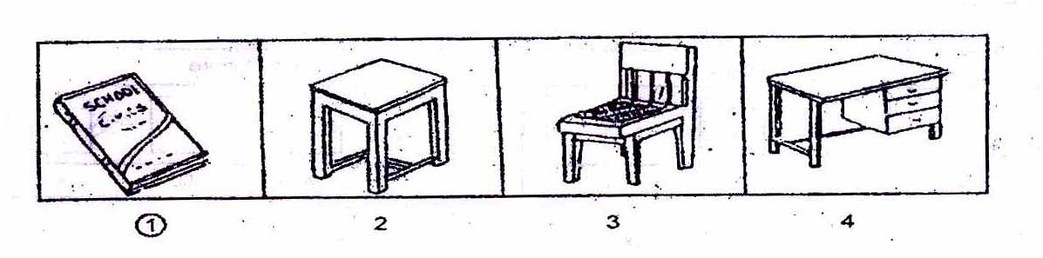

PART- II ( FIGURE MATCHING)

Directions:
In questions 6 to 10, a problem figure is given on the left side and four answer figures marked 1, 2, 3, 4 are given on the right side. Select the answer figure which is exactly the same as the problem figure.
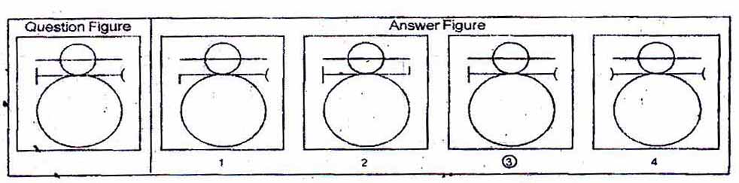
3

PART- III ( PATTERN COMPLETION)

Directions:
In questions 11 to 15 there is a problem figure on the left hand side, a part of which is missing. Observe the answer figures 1, 2, 3, 4 on the right hand side and find out the answer figure which without changing the direction, fits in the missing part of the problem figure in order to complete the pattern in the problem figure.
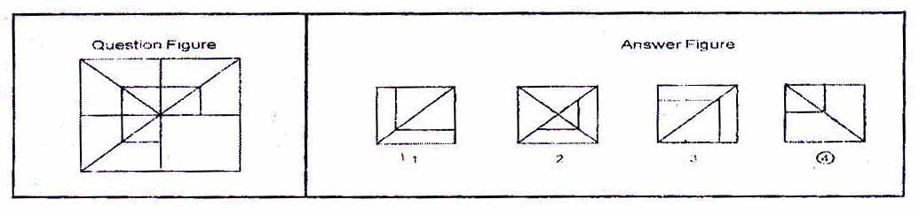
4
3
1
1
4

PART- IV ( FIGURE SERIES COMPLETION)

Directions:
In questions 16 to 20, there are three problem figures on the left hand side and the space for the fourth figure is left blank. The problem figures are in a series. Find out one figure from among the answer figures given on the right hand side, which occupies the blank space for the fourth figure on the left hand side and completes the series.
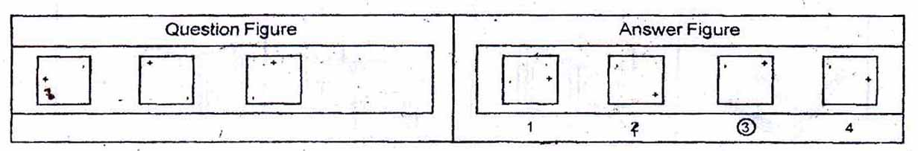
3
4

PART - V ( ANALOGY)

Directions:
In questions 21 to 25, there are two sets of two problem figures each. The second set has a mark of interrogation (?). There exists a relationship between the first two problem figures. Similar relationship should exist between the third and fourth problem figure. Select one of the answer figure which replaces the mark of interrogation.
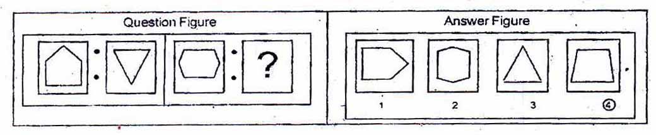

PART - VI { Geometrical Figure Completion (Triangle, Square, Circle) }

Directions:
In questions 26 to 30 one part of a square is on the left hand side as question figure and the other one is among the four answer figures 1, 2, 3, 4 given on the right hand side. Find out the figure that completes the square.
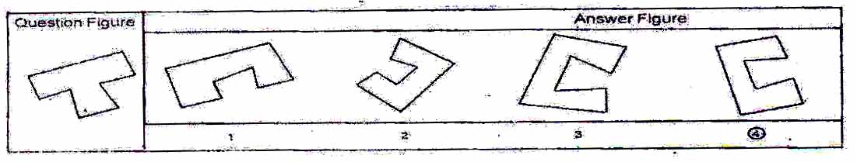
4
4
3
4
3

PART – VII (MIRROR IMAGING)
Directions:
In questions 31 to 35 there is a problem figure on the left side and four answer figures marked 1, 2, 3, 4 are given on the right side. Select the answer figure which is exactly the mirror image of the problem figure when the mirror is held at X Y.
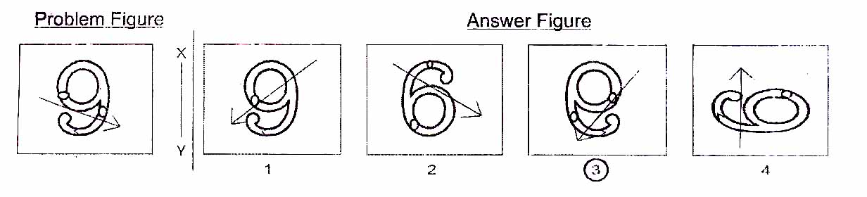
3

PART - VIII (PUNCHED HOLD PATTERN - Folding/Unfolding)
Directions:
In question 36 to 40 a piece of paper is folded and punched as shown in problem figures on the left side and four answer figures marked 1, 2, 3, 4 are given on right side. Select the answer figure which indicates how the paper will appear when opened (unfolded).
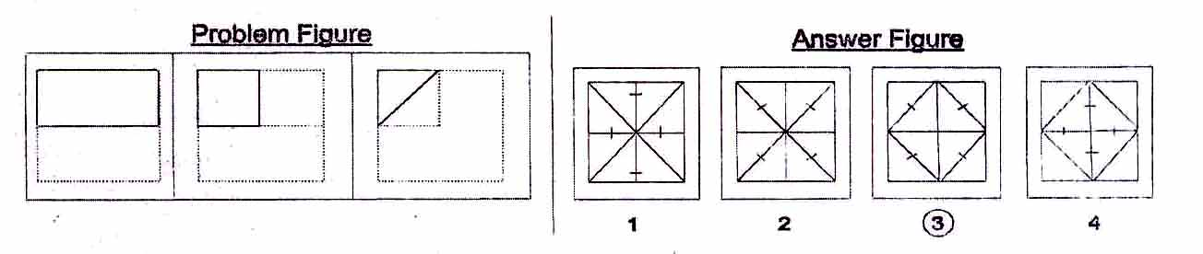
3
3
1

PART - IX (SPACE VISUALISATION)

Directions:
In questions 41 to 45 a problem figure is given on the left side and four answer figures, marked 1, 2, 3, 4 are given on the right side. Select the answer figure which can be formed from the cut-off pieces given in the problem figure.
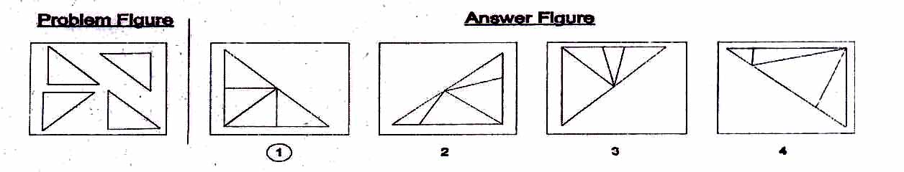
1

PART –X (EMBEDDED FIGURE)

Directions:
In questions 46 to 50 a problem figure is given on the left side and four answer figures, marked 1, 2, 3, 4 are given on the right side. Select the answer figure in which the problem figure is hidden/ embedded.

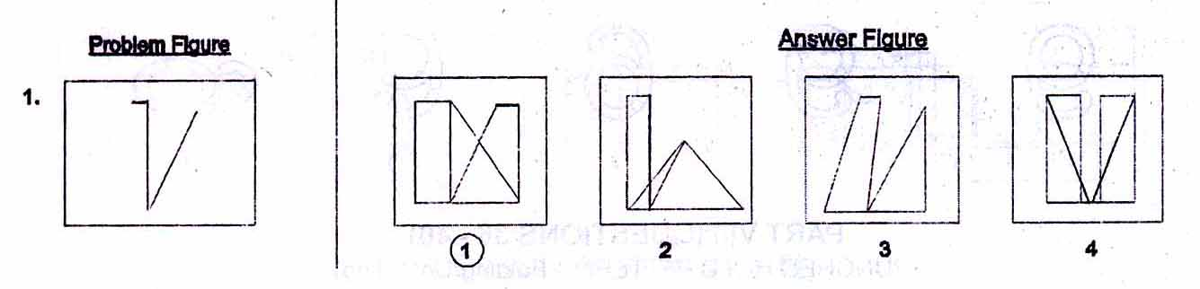
1
1

Section 2: Arithmetic Test

The main purpose of this test is to measure candidate's basic competencies in Arithmetic. All the Twenty-five questions of this test will be based on the following 15 topics

1. Number and numeric system.
2. Four fundamental operations on whole number.
3. Fractional number and four fundamental operations on them.
4. Factors and multiple including their properties.
5. LCM and HCF of numbers.
6. Decimals and fundamental operations on them.
7. Conversion of fractions to decimals and vice-versa.
8. Applications of number in measure length, mass, capacity, time, money etc
9. Distance, time and speed.
10. Approximation of expressions.
11. Simplification of Numerical Expressions,
12. Percentage and its applications.
13. Profit and loss.
14. Simple interest.
15. Perimeter, area and volume.

Note:- Emphasis will be more on testing of understanding and Application of the concepts and skills involved. In order to provide some guidance to the candidates on the types of questions that are expected in Arithmetic lest, some examples are given below-

Example - 1 (Test of Understanding):

What is the prime factorization of 1000?
1. 10x10x10
2. 2x5x5x10
3. 2 x 2 x 2 x5 x 5
4. 2 x 2x 2 x 5 x5 x 5

A factorization of a number is said to be a prime factorization if (i) the product of the factors (taking a factor as many times as it occurs) is equal to the given number, and (ii) each factor is a prime number. Here only serial number 4 satisfies both the requirements. As such, serial number 4 is the correct answer.

Example 2 (Test of Understanding):

What is the average of first four odd numbers?
  - 2.5
  - 4
  - 5
  - 16
The first four odd numbers are 1.3.5 and 7. Their average (l+3+5+7)/4. As such, serial number 2 is the correct answer.

Example 3 (Test of Application):

A 1 km. long goods train is running at speed of I km. per 3 minutes, the time taken by this train to pass through 2 kms. Long tunnel is:

1. | 1 minute
2. | 3 minute
3. | 6 minute
4. | 9 minute

The tunnel is 2 km. long and the train is I km. in length, the train will have to cover a total distance of 3 km. in order to pass through the tunnel running at a speed of 1 km, per 3 minutes, the train will take 9 minutes to pass through ibis tunnel and that is the correct answer. As such, serial number 4 is the correct answer.
Section 3: Language Test.

The main purpose of this test is to assess reading comprehension of the candidates. The test consists of three passages. Each passage is followed by 5 questions. Candidates shall read each passage carefully and answer the questions that follow. In addition, there will be 10 questions to test grammar and writing skills of candidates.

Given below is a specimen passage and the questions that follow the passage.

PASSAGE
Forests are useful to us in many ways. They provide us with timber to build houses and make furniture. Forests also provide us with wood for fuel and making paper. They provide shelter for birds, wild animals and insects. Forests bring rainfall. Existence of forests is very important for the preservation of the ecosystem. The fact that we have to care for an ecosystem is indisputably established. Wise use of the environment and its resources are essential for man's continued survival.

1. To preserve the ecosystem, existence of...............is essential.
1. forests
2. animals
3. human beings
4. resources

2. Opposite of preservation' is...............
1. conservation
2. construction
3. shelter
4. destruction

3. Which one of the following is not a synonym of 'wise'?
1. Sensible
2. Intelligent
3. Humorous
4. Judicious

4. Carpenters depend on forests because they provide...............
1. wood for fuel
2. wood for making paper
3. timber to make furniture
4. houses for animals

5. Wild animals will become homeless if...............
1. paper mills are destroyed
2. houses are built
3. forests are destroyed
4. ecosystem is taken care of

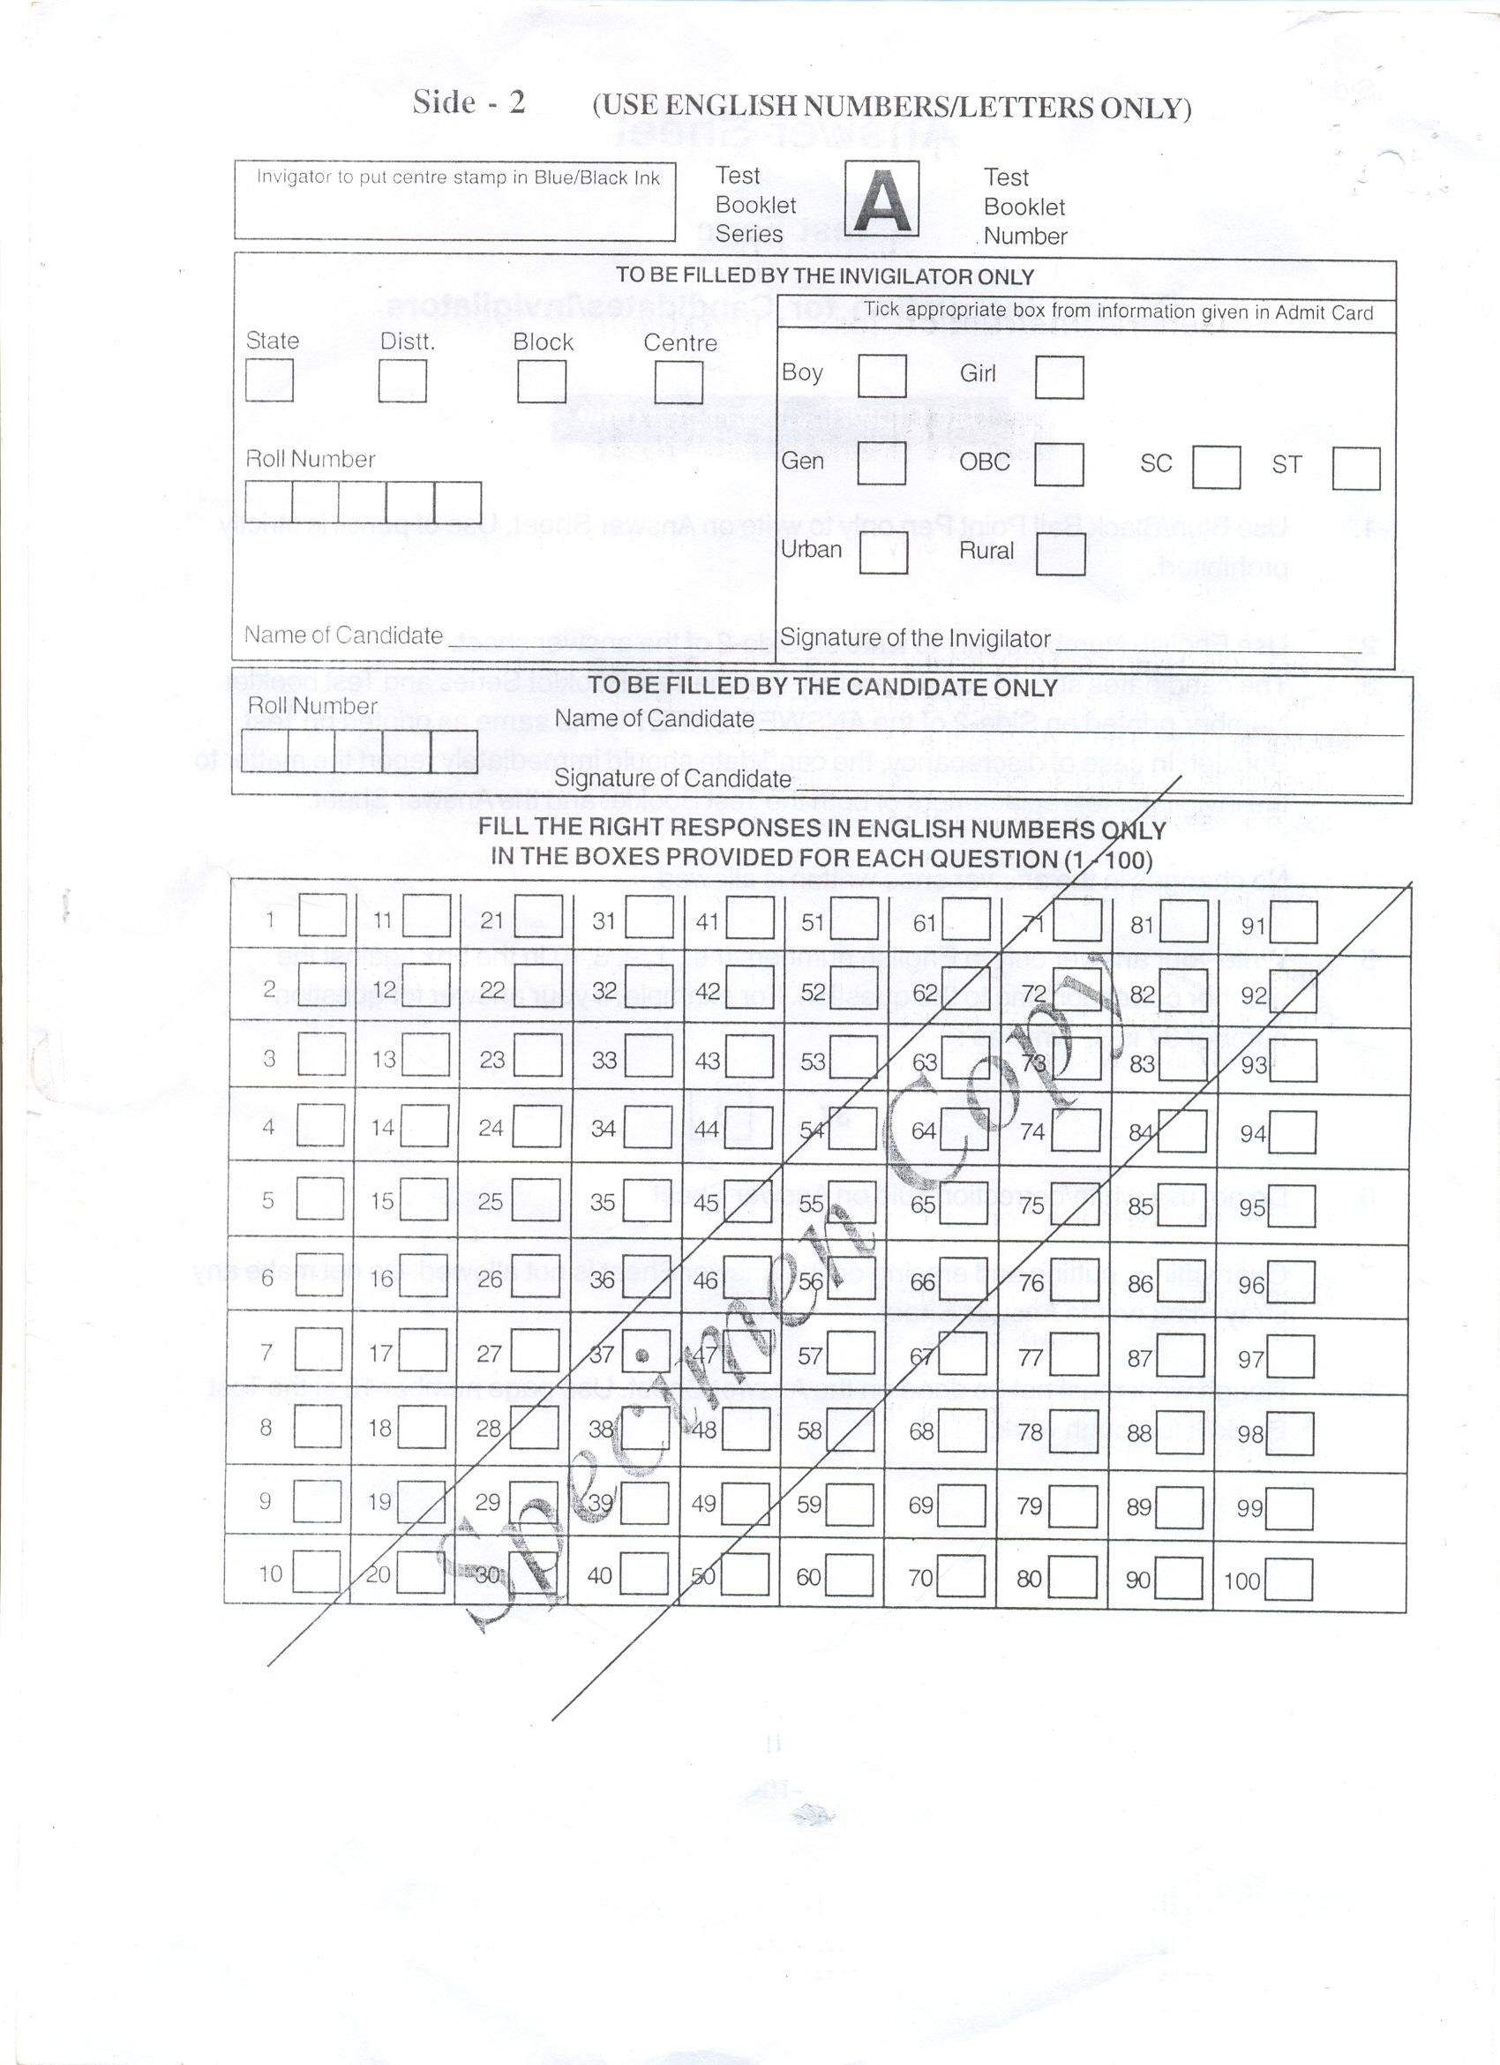
TG
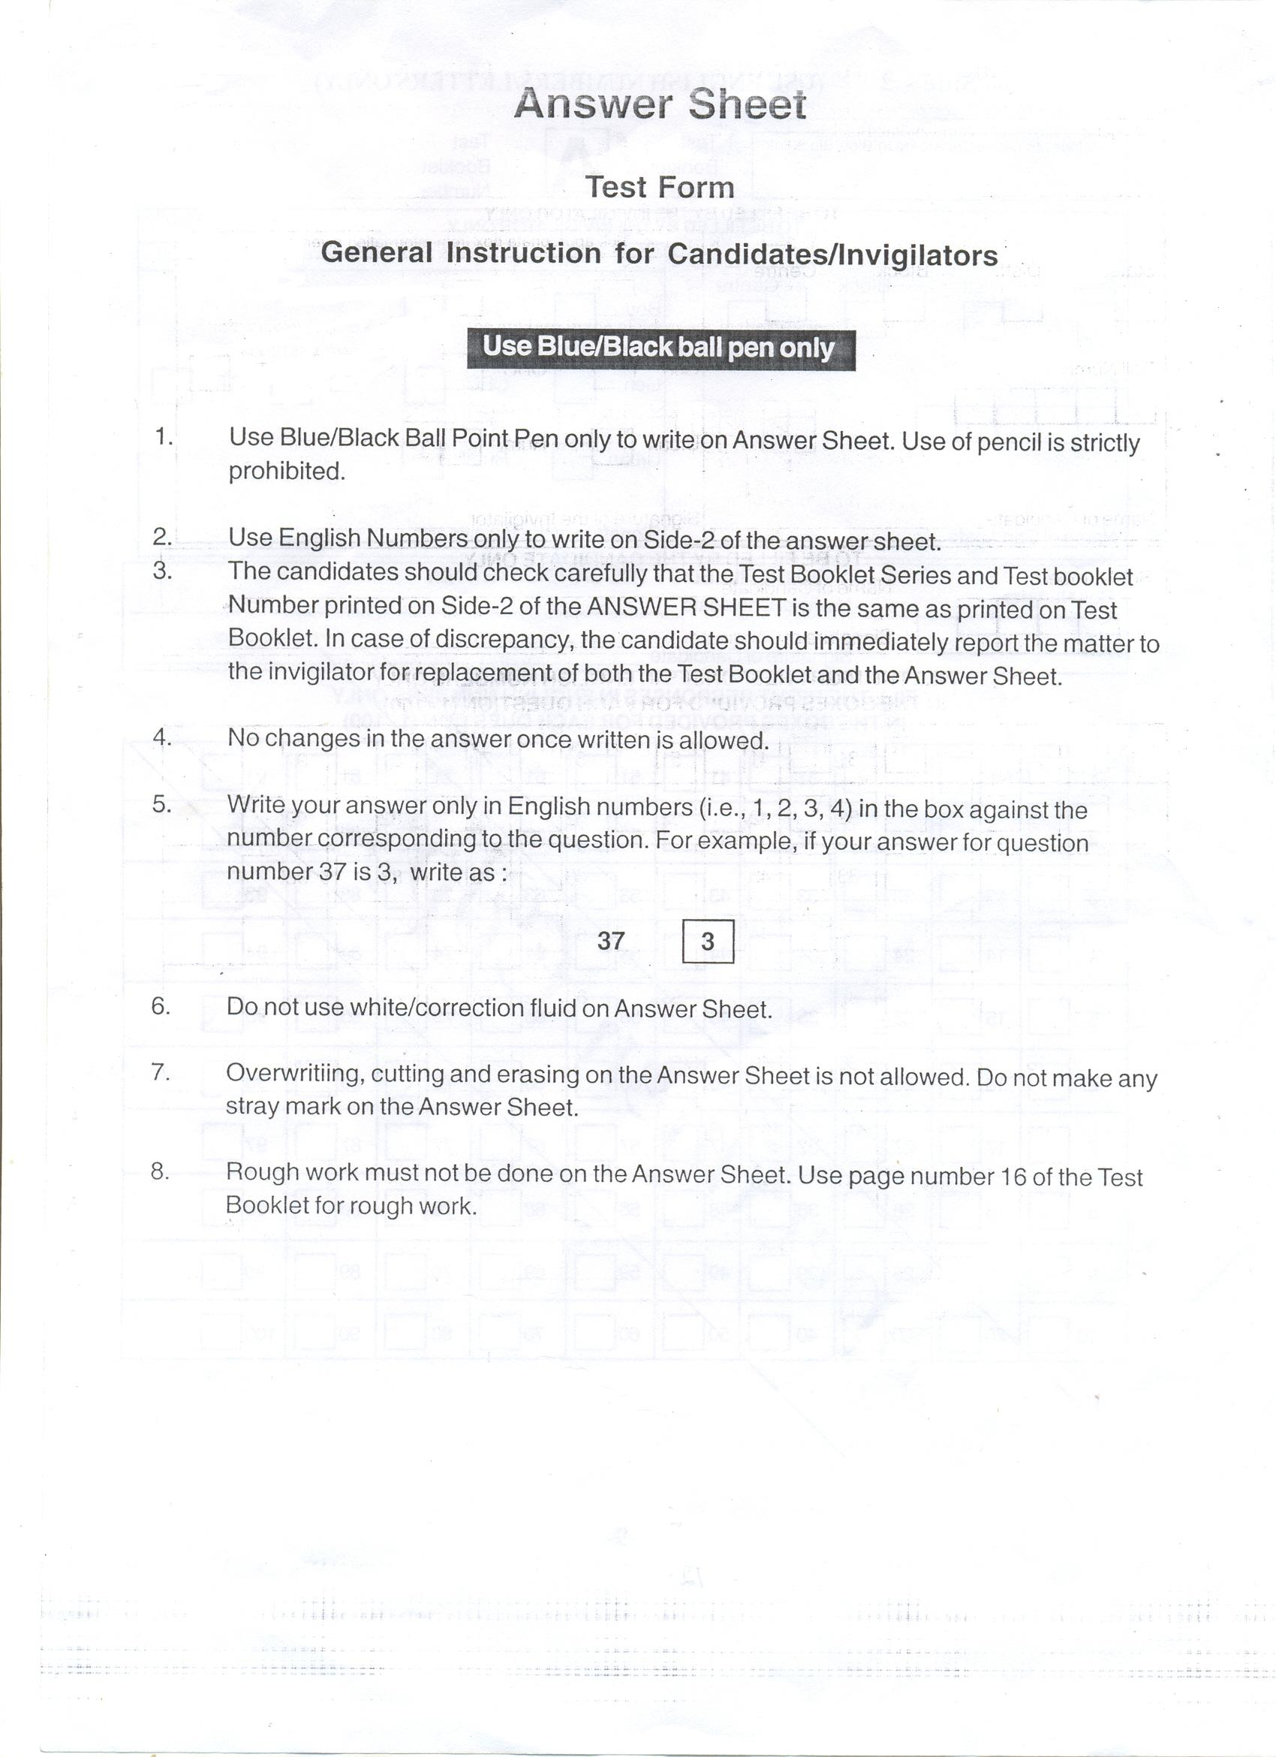

SOME IMPORTANT GUIDELINES FOR UPLOADING THE APPLICATION FORM

The Application form for admission to Class VI in Jawahar Navodaya Vidyalaya is self explanatory. However, following guidelines may be specifically kept in view by the students and their parents/guardians.

- Please read the Prospectus carefully. Fill in complete information after ensuring that the candidate fulfills all the prescribed requirements such as date of birth within prescribed range (1.5.2005 to 30.4.2009) schooling in classes III, IV & V in recognized institution(s). (Govt. / Govt. Aided / Recognized / NIOS).

- Carefully fill the self declaration certificate to be produced for uploading the application form with regard to category i.e. General, SC, ST, OBC & Divyang. In case at the time of admission, it is found that a candidate has opted SC/ST though he/she does not actually belong to SC/ST community, his/her selection is liable to be cancelled.

3(a) Mention the date of birth in figures as well as in words. Write correct Date of Birth as per school records. In case, if it is observed at a later stage that the Date of Birth of the candidate does not match with the school records the candidature is liable to be rejected.

(b) Permanent identification marks which can be identified clearly shall be mentioned in the Application Form by the candidate.

4. Signature of both, the candidate and the father / guardian should be uploaded while applying for the Jawahar Navodaya Vidyalaya Selection Test.

5. The last date of submission of online Application Form in the office of Common Service Centre is 25th November 2017 for test to be conducted on 10th February, 2018 (Summer Bound JNVs) as well as test to be conducted on 8th April 2018 (Winter Bound JNVs) & 9th June, 2018 (Extreme Winter Bound JNVs).

CAUTION : Application Form is liable to rejection if columns are left blank or the entries are incomplete. Applicants should ensure that they fulfill all the prescribed requirements of education, age and of special categories (like SC/ST/Divyang) area (Urban/Rural) wherever applicable. If any information given in the original application form is found to be false / incorrect on subsequent verification, even after the selection of the candidate, the admission is liable to be cancelled and the decision of Navodaya Vidyalaya Samiti will be final and binding. No correspondence shall be entertained in this regard. Such admissions, if any obtained by any candidate on the basis of false certificate / declaration / information shall not only be cancelled but Samiti also reserves the right to recover the expenditure incurred on a student during his/her entire stay in a Vidyalaya.

RESIDENCE CERTIFICATE

(To be furnished by the parents of the qualified children at the times of admission to JNVs)

As per Jawahar Navodaya Vidyalaya ______________________________________________________
District _________________ State _______________________ Letter no. _______________________________
Dated _____________ my ward Mast./Kum _____________________________________________ has qualified
the entrance exam for admission to Class VI at JNV ____________________ District ______________________
State / UT _______________________ during the session _____________________.

I am residing in the following address since _____________________

* The area where the residence falls under the Rural/Urban area of the District

Village ______________________________
Town _______________________________
District ______________________________
State _______________________________
Pin Code ____________________________

Certified that the information furnished by me is true and no fact has been concealed.

Signature of Parents
Full Name
Address

Place __________________
Date ___________________

* Applicable for the students who seek admission through the studies in NIOS.

CERTIFICATE

(To be filled by the District Authorities and issued under the signature of SDM/ Tehsildar to the parents of the child selected for admission to Class VI in JNVs through JNVST)

This is to certify that the above information furnished by Shri/Smt.___________________________________
Father/Mother of Master/Kumari__________________________________________a candidate selected for admission
to Class VI in JNV ____________________________ District ______________________________________ has been verified from the records and is found to be correct.

*The area where residence is located falls under (Rural/Urban) area of District ___________________.

Signature
SDM/Tehsildar

* Applicable for the students who seek admission through the studies in NIOS.

CERTIFICATE

Certified that the information given below are correct in respect of _________________________(Name of Student) who is studying in Class V in _________________________________________(Name of School) and interested to apply for Jawahar Navodaya Vidyalaya Selection Test 2018.

Name of Candidate
Father’s Name
Mother’s Name
Date of Birth
Boy/Girl/Transgender
Category(Gen/OBC/SC/ST)
Nature of Disability (PH/VH/HI) with percentage, if any

Particular | Class-III | Class-IV | Class-V
Name of the School (studied – III & IV and studying V)
Category of School (Recognized/
Not Recognized)
School Location : Rural / Urban
Month and Year of Joining

Month & year of Passing |  |  | --
Name of the Block

Name of the District

Name of the State

Signature or Thumb Impression of the Parent/ Guardian
Verified from school records.

Signature of Head Master
(with seal)
Note: The certificate is required to be uploaded along with online application for admission in Jawahar Navodaya Vidyalaya in Class VI. If any information provided is found incorrect at any stage it will result in forfeiture of candidature/admission in Jawahar Navodaya Vidyalaya

