Question 1

**Difference between HTTP 1.1 and HTTP 2**

🡪 HTTP1.1 :

\*The first usable version of HTTP was created in 1997. Because it went through several stages of development, this first version of HTTP was called HTTP/1.1. This version is still in use on the web.

\*HTTP/1.1 loads resources one after the other, so if one resource cannot be loaded, it blocks all the other resources behind it

\*In this process, a client sends a text-based request to a server by calling a method like GET or POST. In response, the server sends a resource like an HTML page back to the client.

\*For example, let’s say you are visiting a website at the domain www.example.com. When you navigate to this URL, the web browser on your computer sends an HTTP request in the form of a text-based message, similar to the one shown here:

GET /index.html HTTP/1.1

Host: www.example.com

\*This request uses the GET method, which asks for data from the host server listed after Host:. In response to this request, the example.com web server returns an HTML page to the requesting client, in addition to any images, stylesheets, or other resources called for in the HTML. Note that not all of the resources are returned to the client in the first call for data. The requests and responses will go back and forth between the server and client until the web browser has received all the resources necessary to render the contents of the HTML page on your screen.

You can think of this exchange of requests and responses as a single application layer of the internet protocol stack, sitting on top of the transfer layer (usually using the Transmission Control Protocol, or TCP) and networking layers (using the Internet Protocol, or IP):

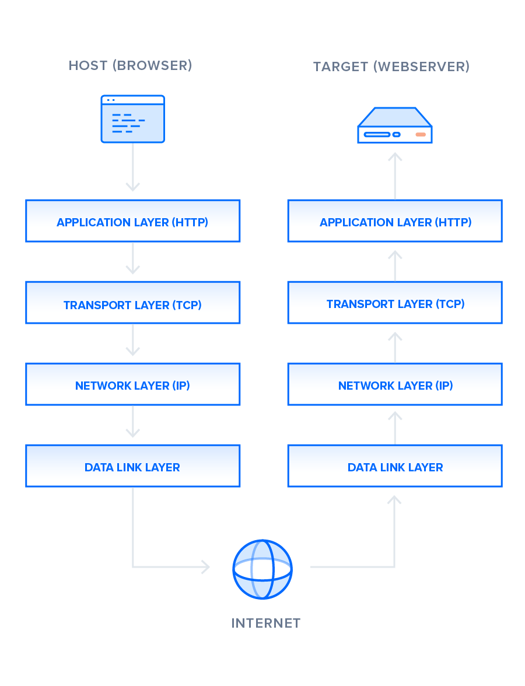

🡪HTTP 2:

\*HTTP/2 began as the SPDY protocol, developed primarily at Google with the intention of reducing web page load latency by using techniques such as compression, multiplexing, and prioritization.

\* This protocol served as a template for HTTP/2 when the Hypertext Transfer Protocol working group httpbis of the [IETF (Internet Engineering Task Force)](https://www.ietf.org/) put the standard together, culminating in the publication of HTTP/2 in May 2015. From the beginning, many browsers supported this standardization effort, including Chrome, Opera, Internet Explorer, and Safari. Due in part to this browser support, there has been a significant adoption rate of the protocol since 2015, with especially high rates among new sites.

\*From a technical point of view, one of the most significant features that distinguishes HTTP/1.1 and HTTP/2 is the binary framing layer, which can be thought of as a part of the application layer in the internet protocol stack. As opposed to HTTP/1.1, which keeps all requests and responses in plain text format, HTTP/2 uses the binary framing layer to encapsulate all messages in binary format, while still maintaining HTTP semantics, such as verbs, methods, and headers. An application level API would still create messages in the conventional HTTP formats, but the underlying layer would then convert these messages into binary. This ensures that web applications created before HTTP/2 can continue functioning as normal when interacting with the new protocol.

### \*[HTTP/2 — Stream Prioritization](https://www.digitalocean.com/community/tutorials/http-1-1-vs-http-2-what-s-the-difference#http-2-stream-prioritization)

Stream prioritization not only solves the possible issue of requests competing for the same resource, but also allows developers to customize the relative weight of requests to better optimize application performance. In this section, we will break down the process of this prioritization in order to provide better insight into how you can leverage this feature of HTTP/2.

\*As you know now, the binary framing layer organizes messages into parallel streams of data. When a client sends concurrent requests to a server, it can prioritize the responses it is requesting by assigning a weight between 1 and 256 to each stream. The higher number indicates higher priority. In addition to this, the client also states each stream’s dependency on another stream by specifying the ID of the stream on which it depends. If the parent identifier is omitted, the stream is considered to be dependent on the root stream. This is illustrated in the following figure:

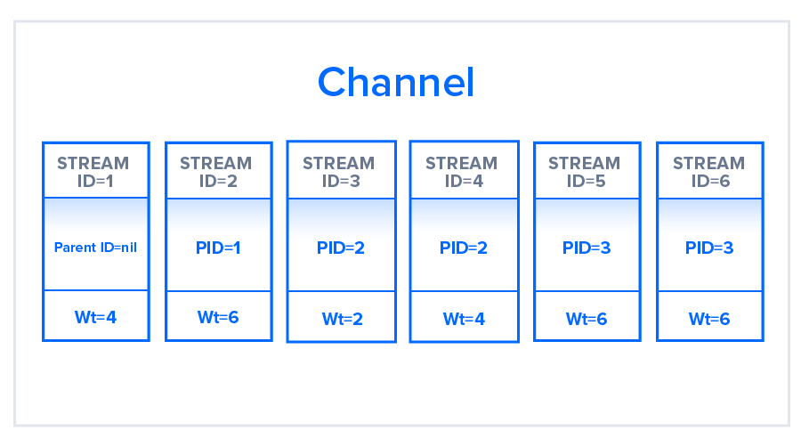

--------------------------------------------------x------------------------------------------------------

Question 2

**Objects and it’s Internal representation in JavaScript** :

\*Objects, in JavaScript, is it’s most important data-type and forms the building blocks for modern JavaScript. These objects are quite different from JavaScript’s primitive data-types(Number, String, Boolean, null, undefined and symbol) in the sense that while these primitive data-types all store a single value each (depending on their types).

\*Objects are more complex and each object may contain any combination of these primitive data-types as well as reference data-types.  
An object, is a reference data type. Variables that are assigned a reference value are given a reference or a pointer to that value. That reference or pointer points to the location in memory where the object is stored. The variables don’t actually store the value.

\*Loosely speaking, objects in JavaScript may be defined as an unordered collection of related data, of primitive or reference types, in the form of “key: value” pairs. These keys can be variables or functions and are called properties and methods, respectively, in the context of an object.

For Eg. If your object is a student, it will have properties like name, age, address, id, etc and methods like updateAddress, updateNam, etc.

# \***Objects and properties**

->A JavaScript object has properties associated with it. A property of an object can be explained as a variable that is attached to the object. Object properties are basically the same as ordinary JavaScript variables, except for the attachment to objects. The properties of an object define the characteristics of the object. You access the properties of an object with a simple dot-notation:

objectName.propertyName

->Like all JavaScript variables, both the object name (which could be a normal variable) and property name are case sensitive. You can define a property by assigning it a value. For example, let’s create an object named myCar and give it properties named make, model, and year as follows:

var myCar = new Object();  
myCar.make = 'Ford';  
myCar.model = 'Mustang';  
myCar.year = 1969;

Unassigned properties of an object are [undefined](https://developer.mozilla.org/en-US/docs/Web/JavaScript/Reference/Global_Objects/undefined) (and not [null](https://developer.mozilla.org/en-US/docs/Web/JavaScript/Reference/Global_Objects/null)).

myCar.color; // undefined

->Properties of JavaScript objects can also be accessed or set using a bracket notation (for more details see [property accessors](https://developer.mozilla.org/en-US/docs/Web/JavaScript/Reference/Operators/Property_Accessors)). Objects are sometimes called associative arrays, since each property is associated with a string value that can be used to access it. So, for example, you could access the properties of the myCar object as follows:

myCar['make'] = 'Ford';  
myCar['model'] = 'Mustang';  
myCar['year'] = 1969;

->An object property name can be any valid JavaScript string, or anything that can be converted to a string, including the empty string. However, any property name that is not a valid JavaScript identifier (for example, a property name that has a space or a hyphen, or that starts with a number) can only be accessed using the square bracket notation. This notation is also very useful when property names are to be dynamically determined (when the property name is not determined until runtime). Examples are as follows:

// four variables are created and assigned in a single go,   
// separated by commas  
var myObj = new Object(),  
 str = 'myString',  
 rand = Math.random(),  
 obj = new Object();  
myObj.type = 'Dot syntax';  
myObj['date created'] = 'String with space';  
myObj[str] = 'String value';  
myObj[rand] = 'Random Number';  
myObj[obj] = 'Object';  
myObj[''] = 'Even an empty string';console.log(myObj);

You can also access properties by using a string value that is stored in a variable:

var propertyName = 'make';  
myCar[propertyName] = 'Ford';propertyName = 'model';  
myCar[propertyName] = 'Mustang';

->You can use the bracket notation with [for...in](https://developer.mozilla.org/en-US/docs/Web/JavaScript/Reference/Statements/for...in) to iterate over all the enumerable properties of an object. To illustrate how this works, the following function displays the properties of the object when you pass the object and the object's name as arguments to the function:

function showProps(obj, objName) {  
 var result = ``;  
 for (var i in obj) {  
 // obj.hasOwnProperty() is used to filter out properties from the object's prototype chain  
 if (obj.hasOwnProperty(i)) {  
 result += `${objName}.${i} = ${obj[i]}\n`;  
 }  
 }  
 return result;  
}

So, the function call showProps(myCar, "myCar") would return the following:

myCar.make = Ford  
myCar.model = Mustang  
myCar.year = 1969

# **Creating Objects In JavaScript :**

# Create JavaScript Object with Object Literal

One of easiest way to create a javascript object is object literal, simply define the property and values inside curly braces as shown below

let bike = {name: 'SuperSport', maker:'Ducati', engine:'937cc'};

# Create JavaScript Object with Constructor

Constructor is nothing but a function and with help of new keyword, constructor function allows to create multiple objects of same flavor as shown below

function Vehicle(name, maker) {  
 this.name = name;  
 this.maker = maker;  
}  
let car1 = new Vehicle(’Fiesta’, 'Ford’);  
let car2 = new Vehicle(’Santa Fe’, 'Hyundai’)  
console.log(car1.name); //Output: Fiesta  
console.log(car2.name); //Output: Santa Fe

# Using the JavaScript Keyword new

The following example also creates a new JavaScript object with four properties:

Example

var person = new Object();  
person.firstName = “John”;  
person.lastName = “Doe”;  
person.age = 50;  
person.eyeColor = “blue”;

# Using the **Object.create** method

Objects can also be created using the [Object.create()](https://developer.mozilla.org/en-US/docs/Web/JavaScript/Reference/Global_Objects/Object/create" \t "_blank) method. This method can be very useful, because it allows you to choose the prototype object for the object you want to create, without having to define a constructor function.

// Animal properties and method encapsulation  
var Animal = {  
 type: 'Invertebrates', // Default value of properties  
 displayType: function() { // Method which will display type of Animal  
 console.log(this.type);  
 }  
};  
// Create new animal type called animal1   
var animal1 = Object.create(Animal);  
animal1.displayType(); // Output:Invertebrates  
// Create new animal type called Fishes  
var fish = Object.create(Animal);  
fish.type = 'Fishes';  
fish.displayType(); // Output:Fishes

-----------------------------------x--------------------------------------------