EVENTFORCE MANAGEMENT SYSTEM
SALESFORCE IMPLEMENTATION

COLLEGE NAME: ALPHA COLLEGE OF ENGINEERING
COLLEGE CODE: 2101
UNIVERSITY NAME: ANNA UNIVERSITY

TEAM ID: SWTID-2026-3951

TEAM LEADER: SAVITHA K.M

Registered mail id: savithachitra1809@gmail.com

TEAM MEMBER: VIGNESH M

Registered mail id: mkvignesh2005@gmail.com

TEAM MEMBER: VISHWA K

Registered mail id: kdvishwa000@gmail.com

Table of Contents

- Project Overview
- Objectives
- Phase 1 – Requirement Analysis & Planning
- Phase 2 – Backend Development & Configuration
- Phase 3 – UI/UX Development & Customization
- Phase 4 – Data Migration, Testing & Security
- Phase 5 – Deployment, Documentation & Maintenance
- Conclusion
- Project Learnings & Outcomes

Project Overview
The EventForce Management System is a Salesforce-based Customer Relationship Management (CRM) solution designed to digitize and coordinate event management operations. The system brings client bookings, venue reservations, vendor coordination, event scheduling, feedback collection, automation, reporting, and controlled access into a single CRM environment.
The source project defines EventForce as a platform for Event Planner Solutions. It is designed to replace fragmented manual activities with centralized records, automated workflows, approval processes, real-time visibility, and analytics. The implementation uses Salesforce custom objects, relationships, validation rules, Flow automation, Apex classes and triggers, Lightning App components, reports, dashboards, and security controls.
The implemented data model includes Event, Client, Vendor, Venue, Feedback, and Event Vendor junction objects. Relationships support client and venue associations, feedback tracking, and the many-to-many relationship between events and vendors.

Objectives
The primary objective is to create a comprehensive CRM platform that digitizes and automates event management operations. The system is intended to streamline client bookings, venue reservations, vendor coordination, and feedback collection while providing real-time operational visibility.
The project source identifies the following business goals:
  - Centralize event, client, vendor, venue, and feedback information in Salesforce.
  - Automate event scheduling, client reminders, cancellation approvals, and notification workflows.
  - Improve data accuracy through validation rules, formula fields, lookup filters, and controlled relationships.
  - Prevent operational conflicts such as double-booking a venue on the same date.
  - Provide role-based access and controlled record visibility for administrators, coordinators, vendor managers, and clients.
  - Provide reports and dashboards for upcoming events, budgets, vendor activity, and operational insights.
  - Reduce manual processes, improve booking efficiency, and support data-driven business decisions.

Phase 1 – Requirement Analysis & Planning
Phase 1 establishes the business and technical requirements for the EventForce CRM. The system is planned as a single Salesforce platform for managing event planners, clients, vendors, venues, and feedback.

Functional scope
  - Custom objects: Event, Client, Vendor, Venue, Feedback, and Event Vendor junction object.
  - Lookup, Master-Detail, and many-to-many relationship modelling.
  - Flows for reminders, feedback notifications, and approval updates.
  - Validation rules and formula fields for data accuracy and event budget calculation.
  - Approval processes for event cancellation requests with email notifications.
  - Profiles, Roles, Permission Sets, and Sharing Rules for user-level access and record visibility.
  - Reports and Dashboards for event summaries, vendor performance, and upcoming-event insights.

Stakeholders
  - Clients – request event services, provide feedback, and view event updates.
  - Event Coordinators – manage scheduling, communication, and approval workflows.
  - Vendors – handle assigned services such as catering, décor, and logistics.
  - Venue Managers – manage venue availability and reservations.
  - Event Administrators – oversee system operations, security, and data monitoring.

Execution roadmap
Create objects and fields
↓
Build automation flows
↓
Implement validation rules and formula fields
↓
Configure profiles, roles, permission sets, and visibility
↓
Configure event-cancellation approval processing
↓
Implement Apex logic for venue availability and double-booking
Prevention
↓
Build reports and dashboards

Phase 2 – Backend Development & Configuration
Phase 2 builds the functional backend of EventForce. Salesforce declarative automation and Apex are combined to create a dynamic, automated, and secure CRM solution.

Core data architecture
  - Event c – Event Name, Event Date, Event Type, Event Status, Event Budget.
  - Client c – Client Name, Email, Phone, Address, Country, City.
  - Vendor c – Vendor Name, Email, Phone, Service Type, Status.
  - Venue c – Venue Name, Address, Location, Capacity, Availability Status.
  - Feedback c – Feedback ID, Rating, Comments.
  - EventVendor c – junction object linking Event and Vendor.

Relationships and data integrity
  - Event to Client – Lookup.
  - Event to Venue – Lookup.
  - Feedback to Event – Lookup.
  - Feedback to Client – Lookup.
  - Event Vendor to Event – Master-Detail.
  - Event Vendor to Vendor – Master-Detail.

Milestone 1: Object

Activity 1: Create Custom Object

Create ‘Event’ custom object

Go to setup, Click on object manager

Click on create and select custom object

Label: Event

Plural label: Events

Record name: Event name

Data type: Text

In Optional Features section: Allow Reports, Allow Activities and Track Field History

In Deployment Status section: select Deployed

In Search Status section: select Allow Search

In Object Creation Options section: select Add Notes and Attachments related list to default page layout

Click Save.

Repeat the same steps for Client, Vendor and Venue custom object as well

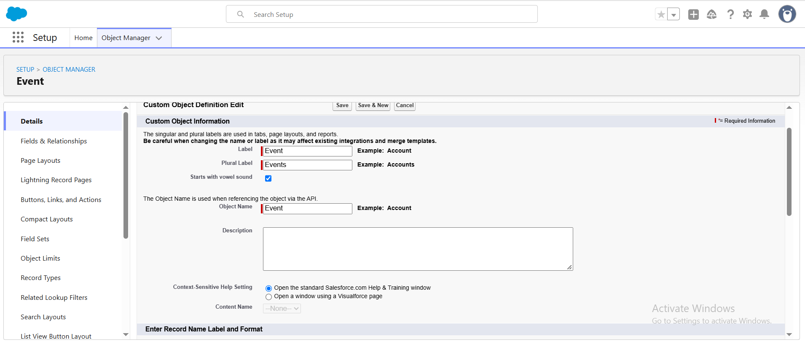

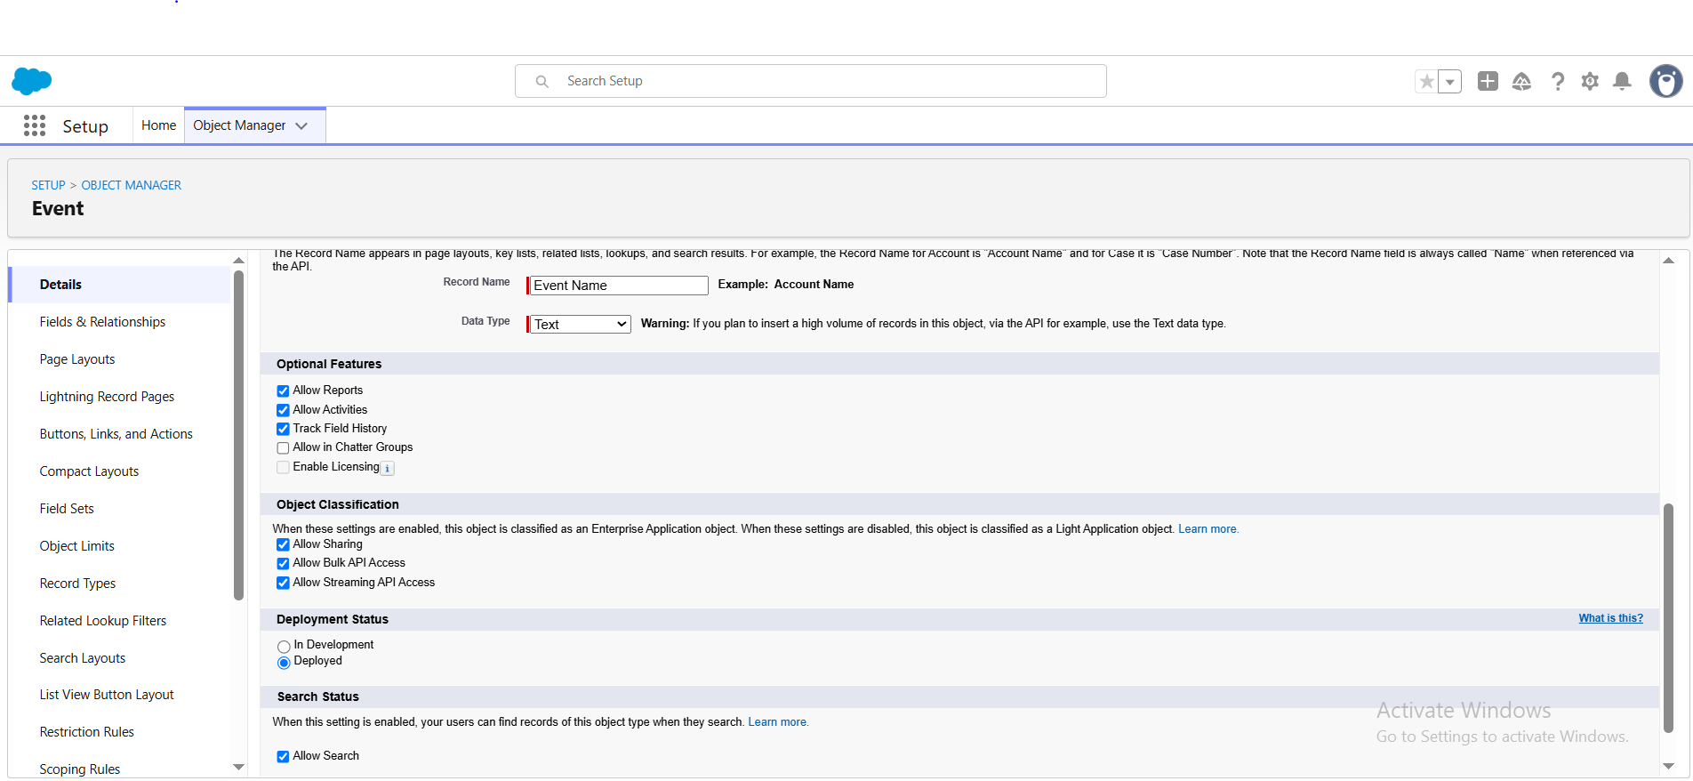

Create ‘Feedback’ custom object

Go to setup, Click on object manager

Click on create and select custom object

Label: Feedback

Plural label: Feedbacks

Record name: Feedback

Data type: Auto Number

Display format: F-{0000}

Starting number: 1

In Optional Features section: Allow Reports, Allow Activities and Track Field History

In Deployment Status section: select Deployed

In Search Status section: select Allow Search

In Object Creation Options section: select Add Notes and Attachments related list to default page layout

Click Save.

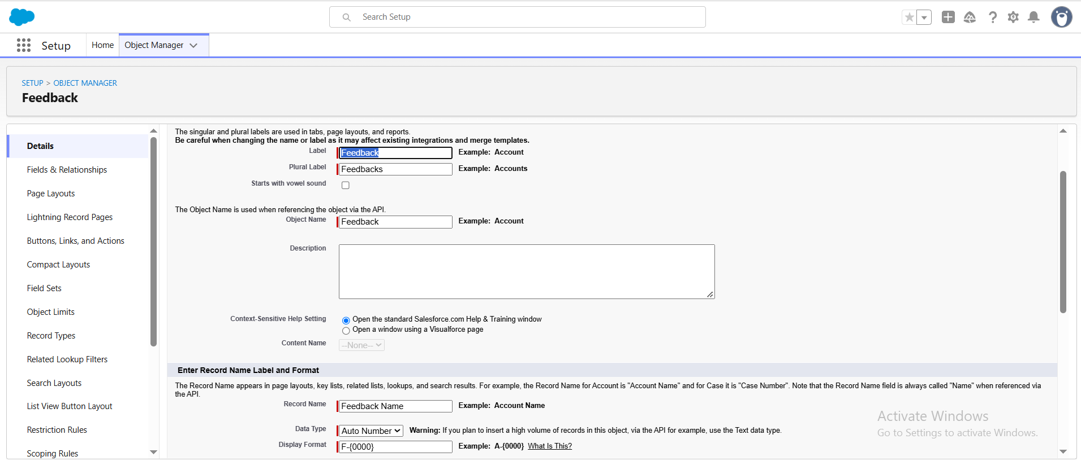

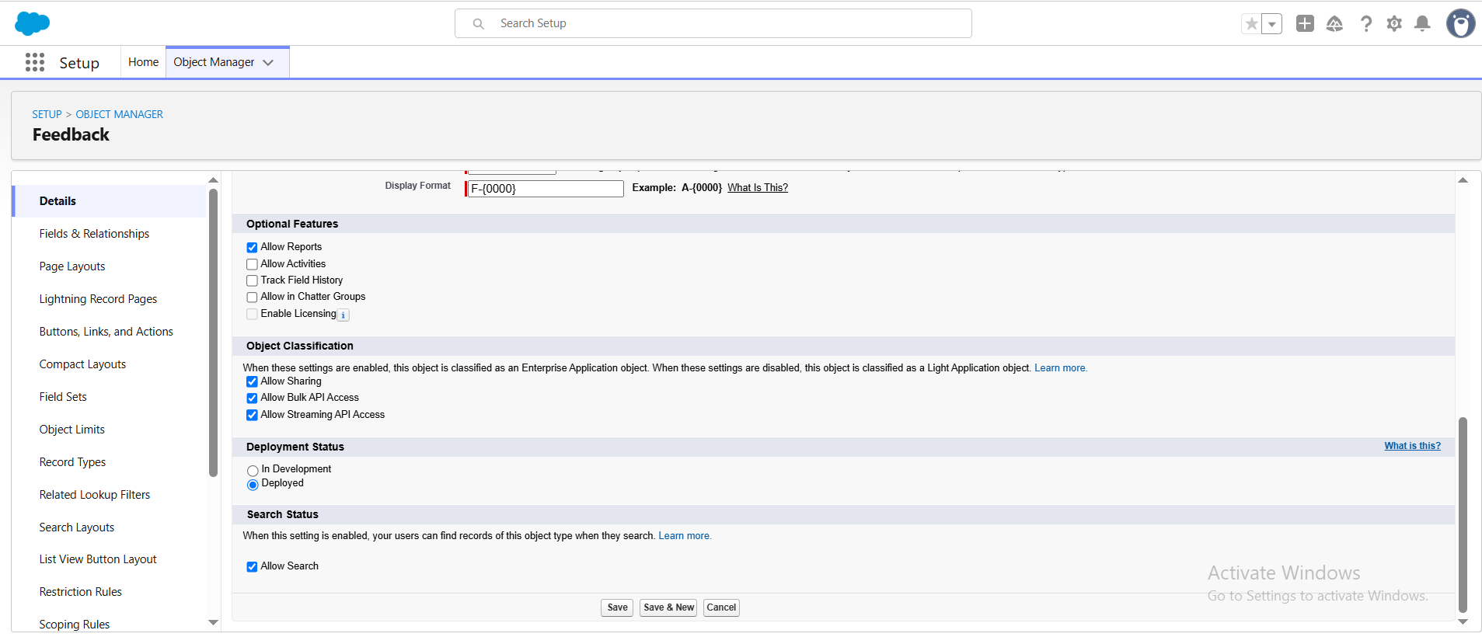

- Milestone 2: Tabs
Activity 1: Creating a Custom Tab

- Event

- Click on home tab, Enter tab and select it
- Under Custom Object, Click New
- Object: Event
- Tab Style: Any icon
- Click next, next and save.

Repeat the same steps for Client, Vendor, Venue and Feedback tabs as well

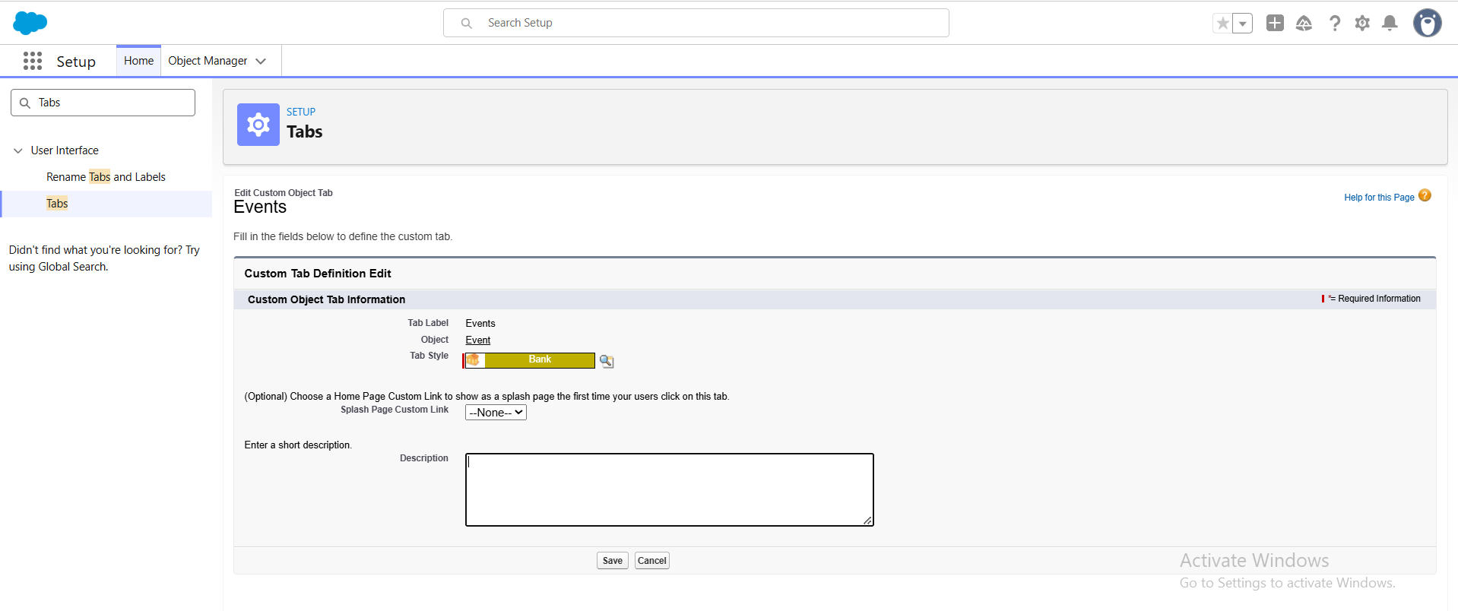

Milestone 3: Fields and Relationship
Activity 1: Creation of fields for objects:

- Event

- Go to setup, Click on object manager
- Select Event and then select fields and relationship
- Click on New

Data type | Field label
Picklist | Event type  Values: Wedding, Corporate, Birthday, Anniversary, Festival, Concert and Other
Date | Event date
Picklist | Event status  Values: Planned, Confirmed, Completed, Pending Cancellation, Canceled, Rejected
Formula | Event Budget  Formula return type: Currency  Formula: CASE(TEXT(Event_Type__c), "Wedding", 50000,"Corporate", 30000,"Birthday", 10000, "Anniversary", 20000,"Festival", 60000,"Concert", 40000,"Other", 15000,0)

- Click next, next and save
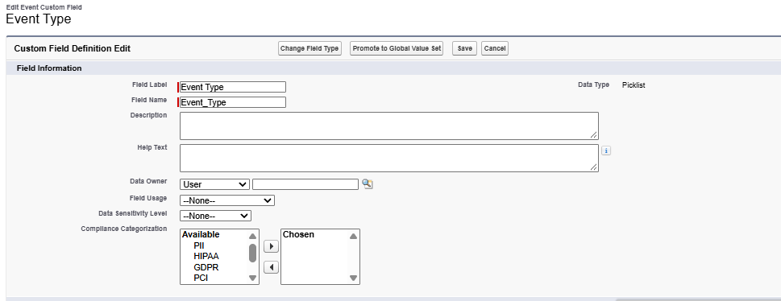
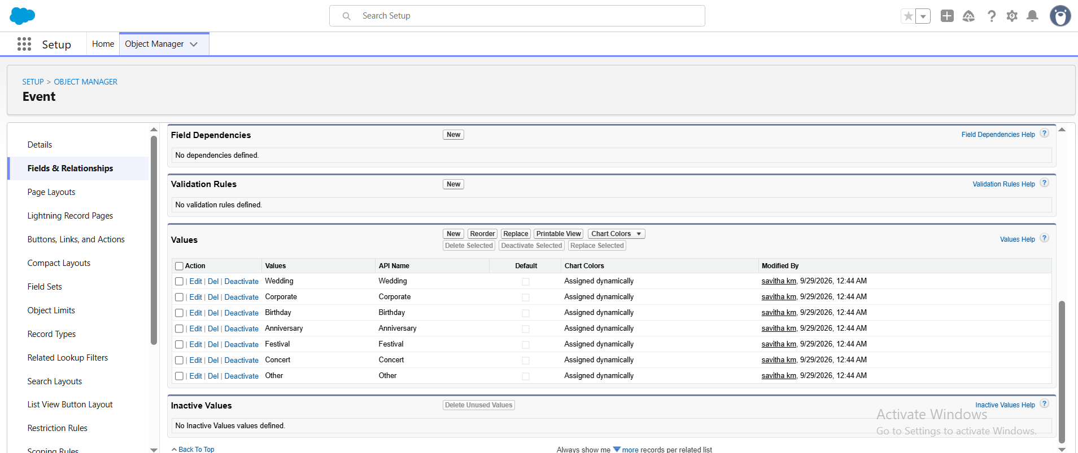

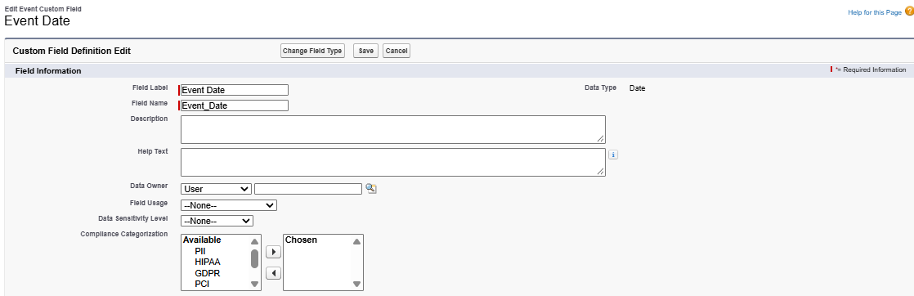
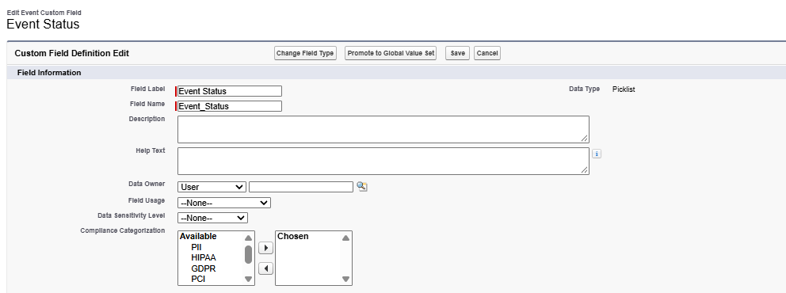
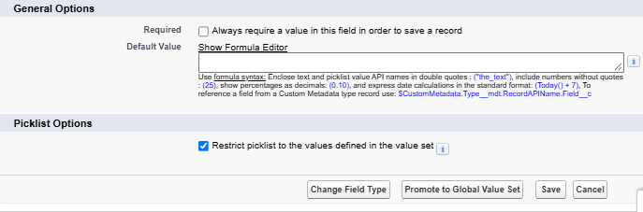
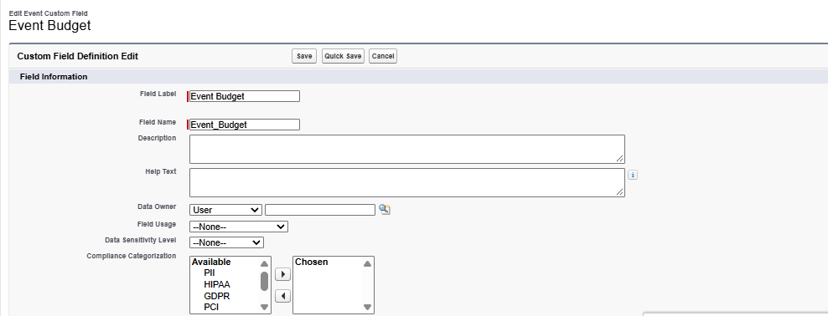

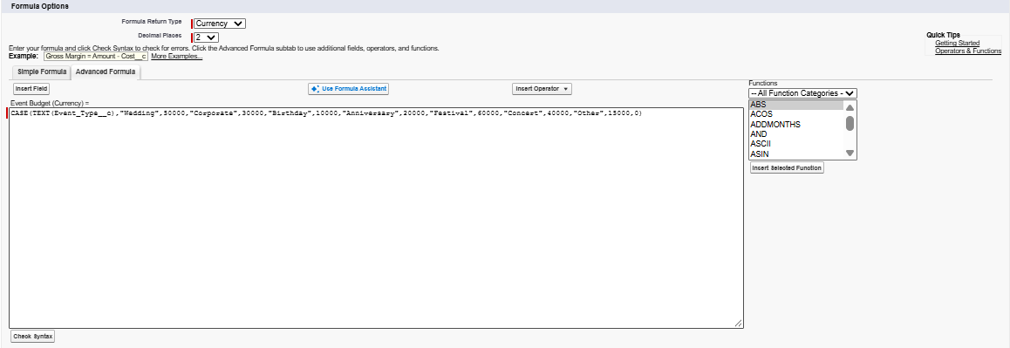
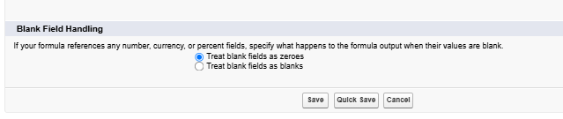
- Client
- Go to setup, Click on object manager
- Select Client and then select fields and relationship
- Click on New

Data type | Field label
Email | Email
Phone | Phone
Text area | Address
Picklist | Country  Values: India, Philippines, Saudi Arabia, USA, Switzerland, Thailand, Maldives, Dubai, Sri Lanka, Bangkok, Singapore Myanmar, France, Nepal
Picklist | City  Values: Hyderabad, Mumbai, Delhi, Bangalore, Chennai, Alaminos, Angeles City, Palayan, Quezon City, San Juan, Riyadh, Jeddah, Tayma, Dammam, Medina, New York, Los Angeles, Chicago, Houston, Columbus, Geneva, Basel, Lausanne, Bern, Lucerne

- Click next, next and save
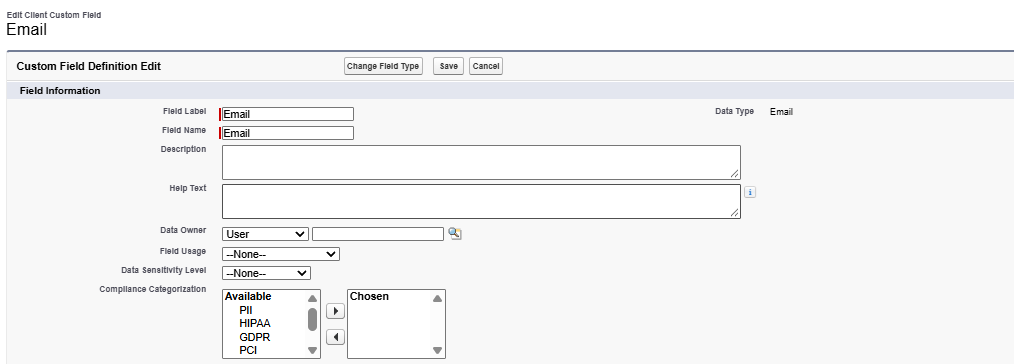

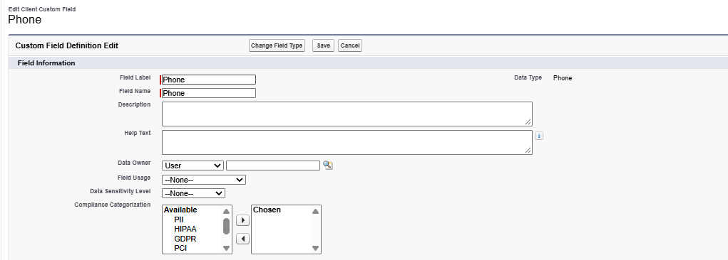

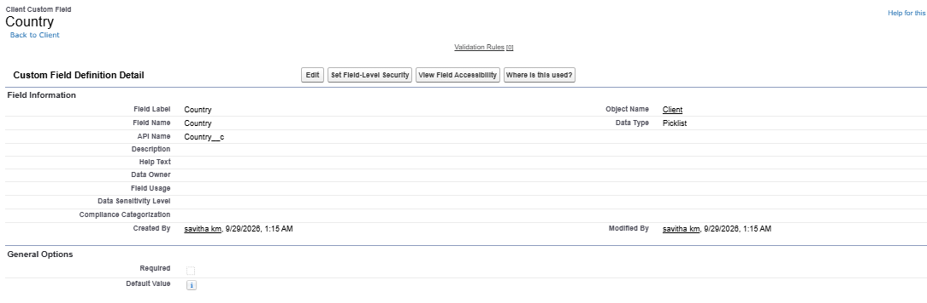
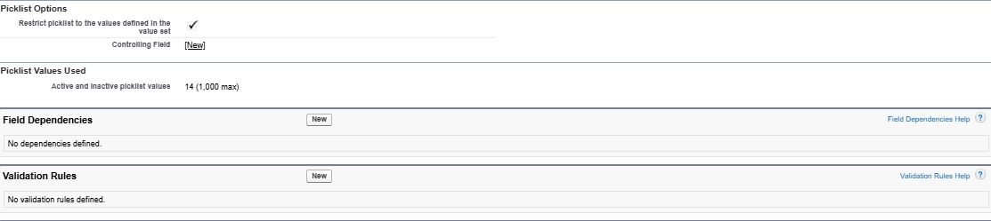
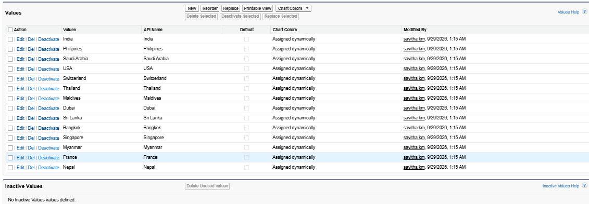
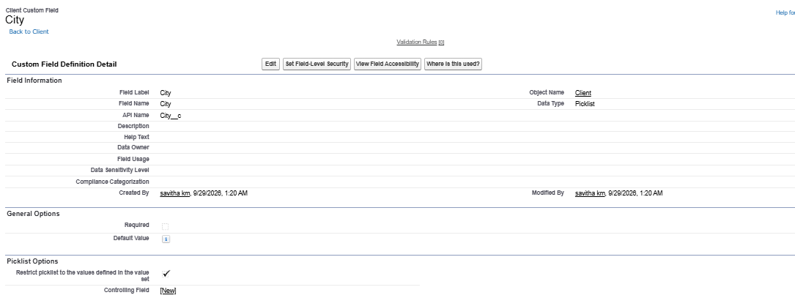
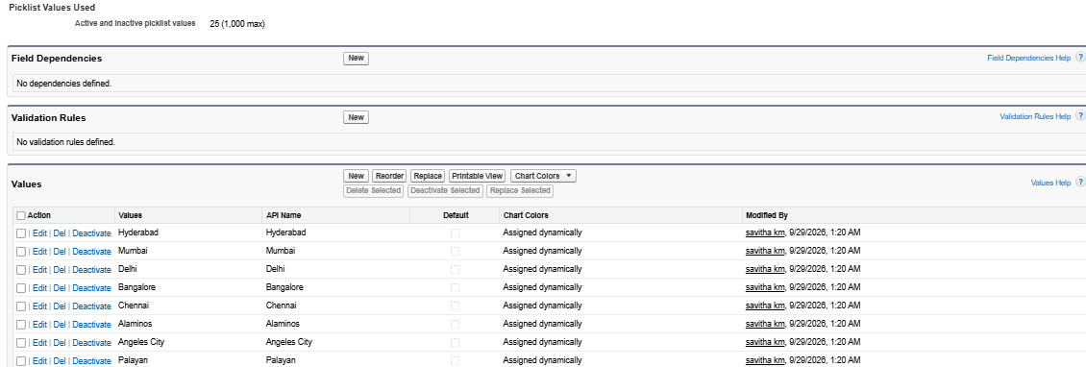
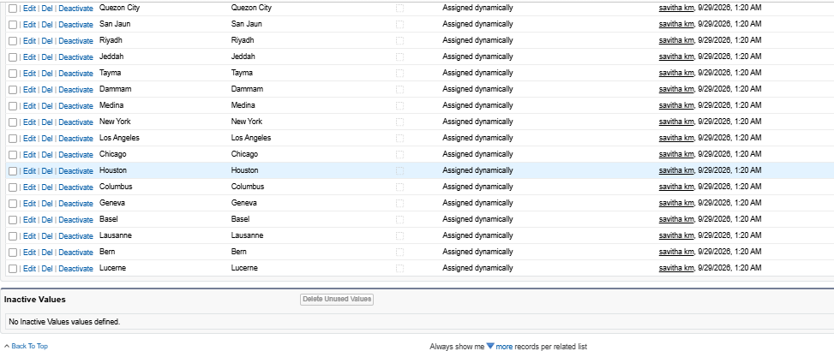
- Vendor
- Go to setup, Click on object manager
- Select Vendor and then select fields and relationship
- Click on New

Data type | Field label
Multi Select Picklist | Service type  Values: Catering, Décor, Photography, Videography, Lighting, Stage Setup, Makeup Artist, DJ/Music, Transportation, Hosting/Anchor
Email | Email
Phone | Phone
Picklist | Status  Values: Available, Booked, Cancelled

- Click next, next and save
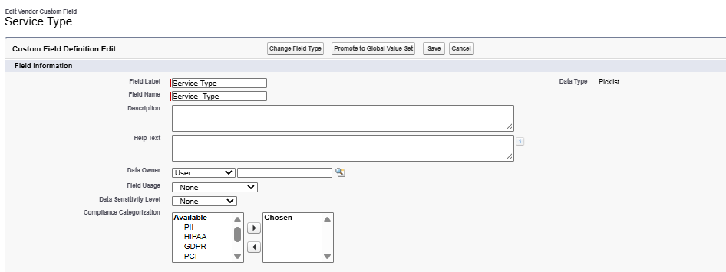
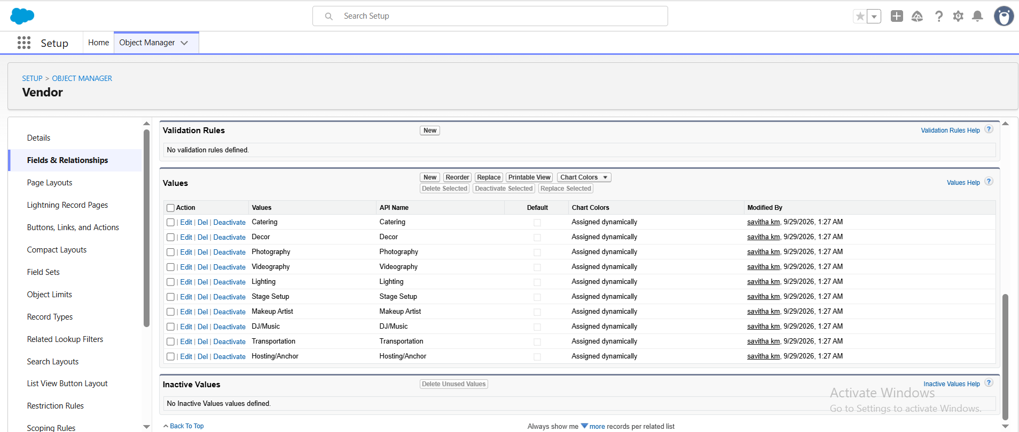
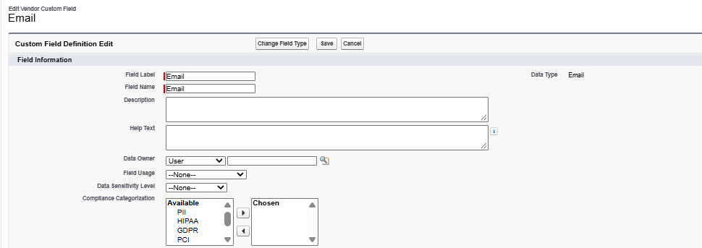

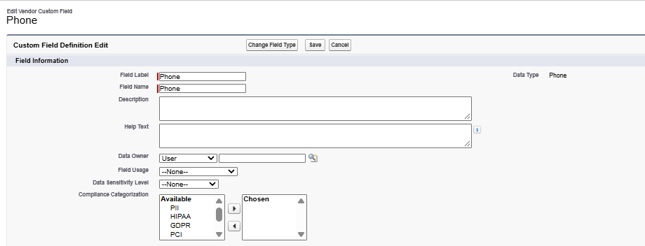

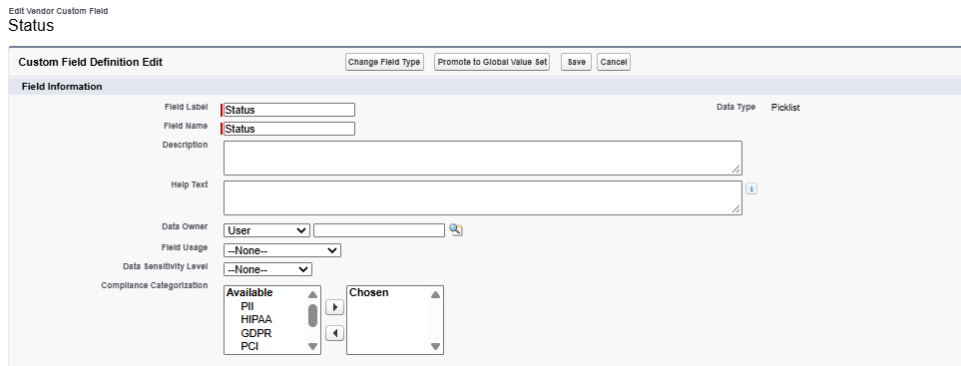
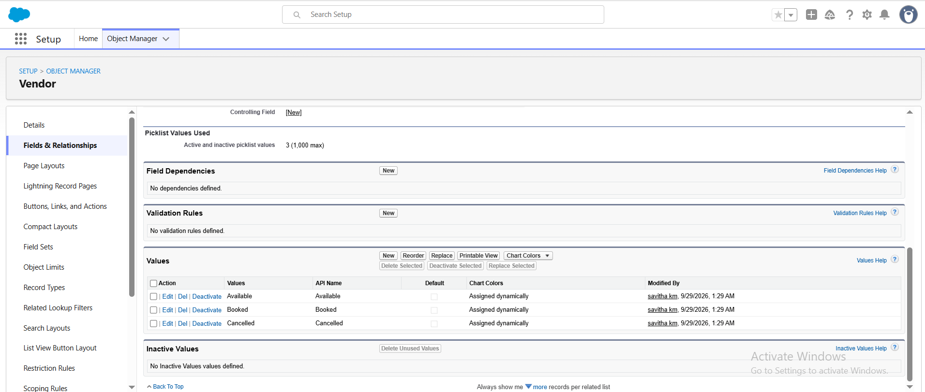

- Venue

- Go to setup, Click on object manager
- Select Venue and then select fields and relationship
- Click on New

Data type | Field label
Text area | Address
URL | Location
Number | Capacity
Picklist | Availability Status  Values: Available, Reserved, Not Available

- Click next, next and save
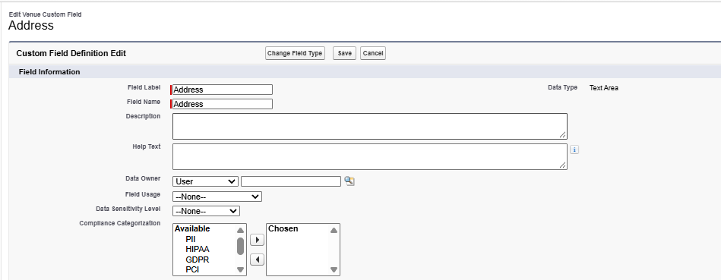
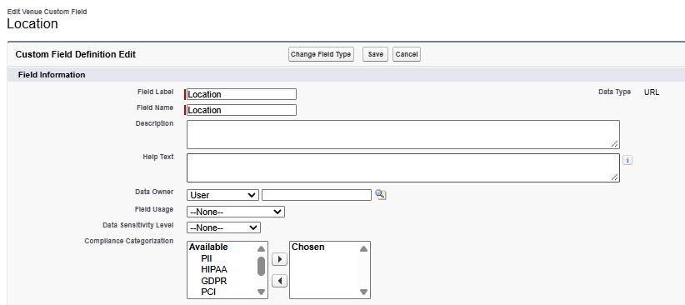
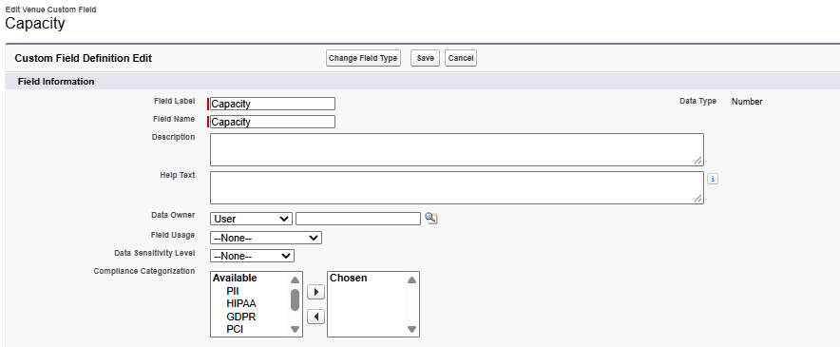
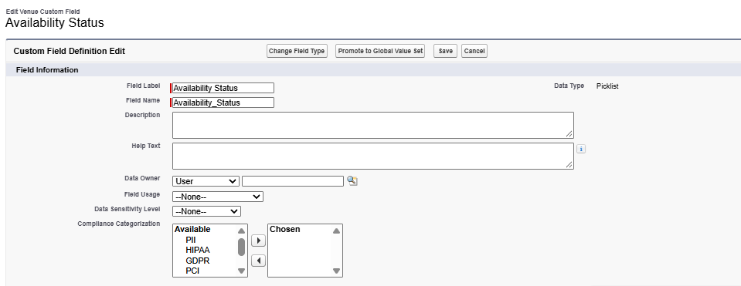
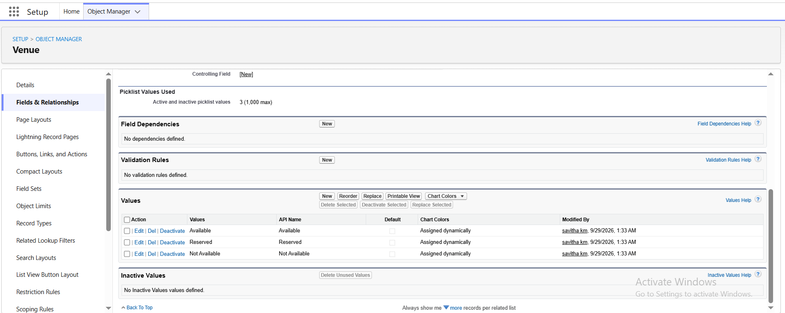

- Feedback

- Go to setup, Click on object manager
- Select Feedback and then select fields and relationship
- Click on New

Data type | Field label
Picklist | Rating  Values: 1, 2, 3, 4, 5
Long text | Comments

- Click next, next and save
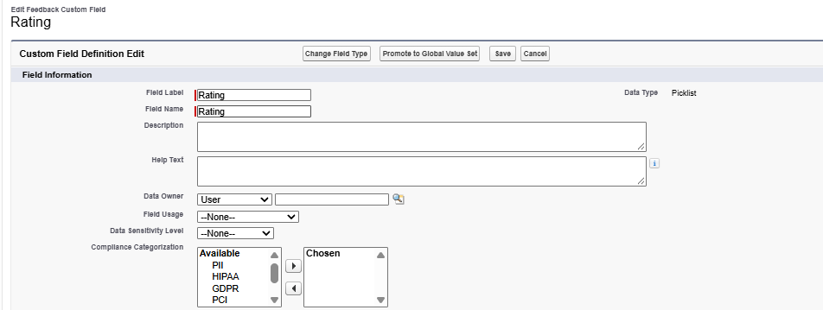
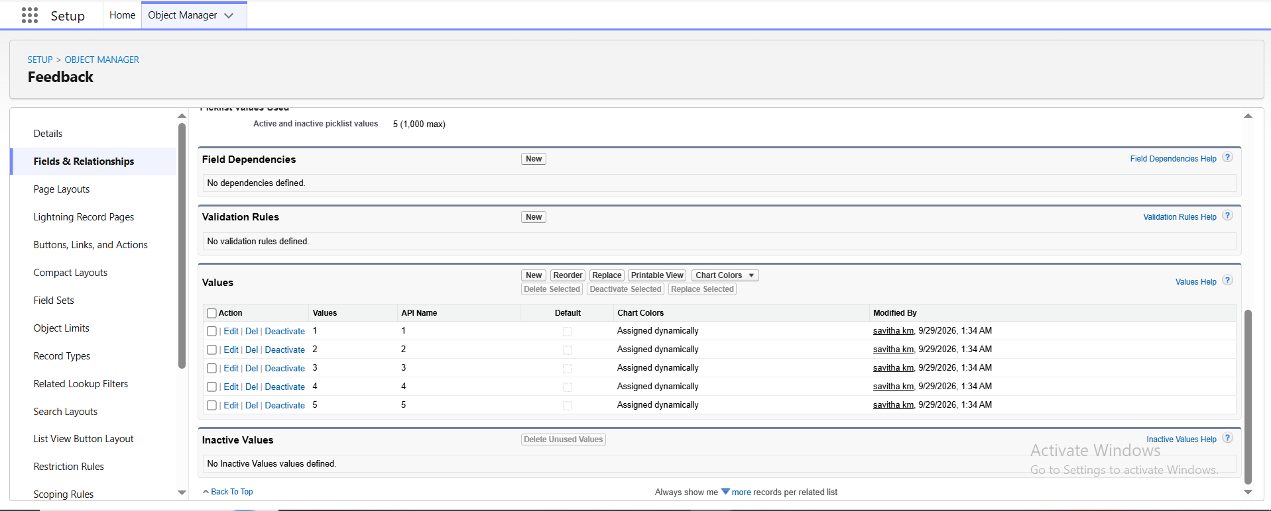
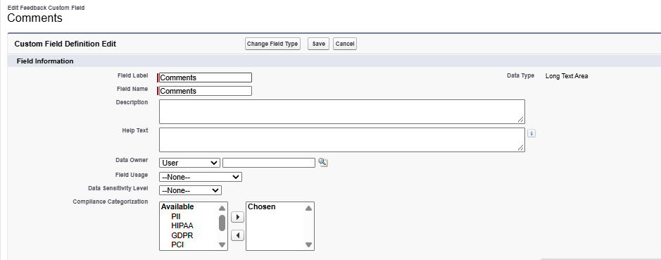

Relationships:
Activity 1: Creation lookup relationship
- Event
- Go to setup, Click on object manager
- Select Event object, click Fields & Relationship
Data type | Related to | Field label
Lookup relationship | Venue | Venue

- Click next, next and save
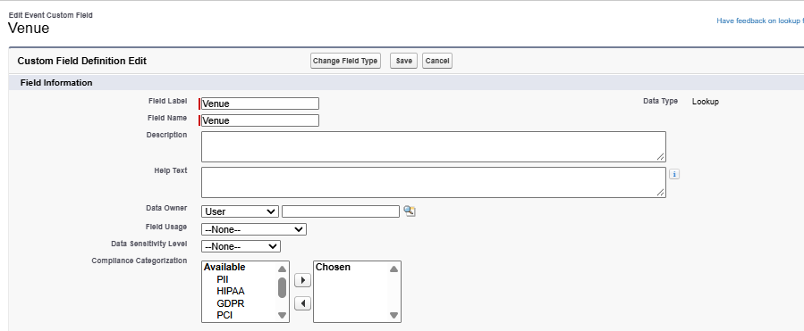
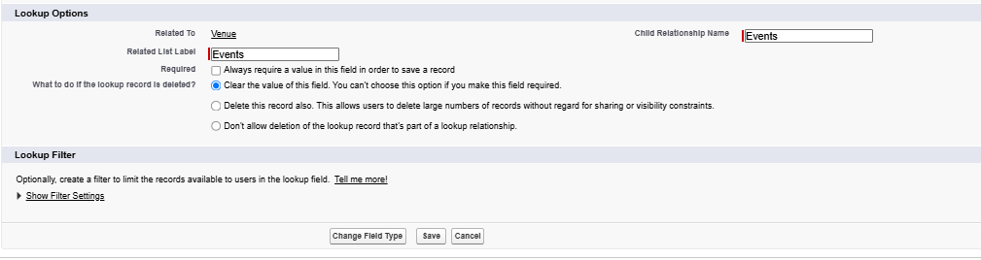
Create Many-to-Many Relationship (Event ↔ Vendor)
- Go to object manager, Click on custom object
- Label: Event Vendor
- Object Name: EventVendor__c
- Go to Setup, Click on object manager
- Select Event Vendor, click Fields & Relationship
Data type | Related to | Field label
Master Detail relationship | Event | Event
Master Detail relationship | Vendor | Vendor

- Click next, next and save
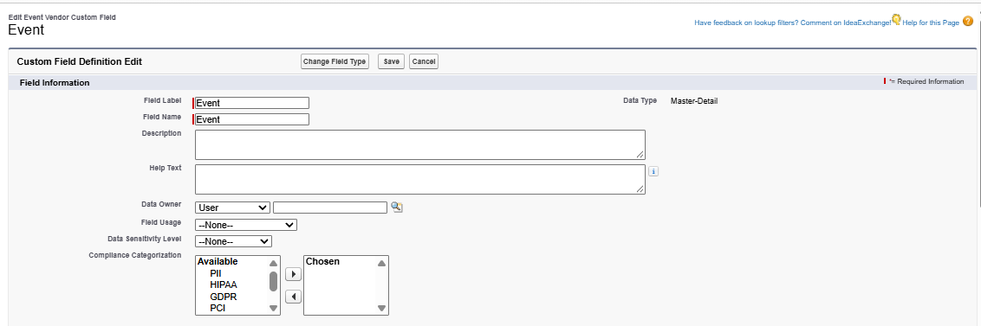
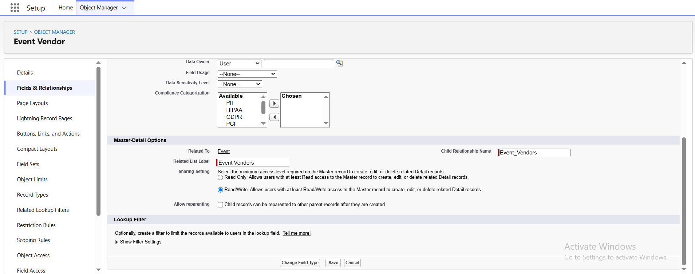
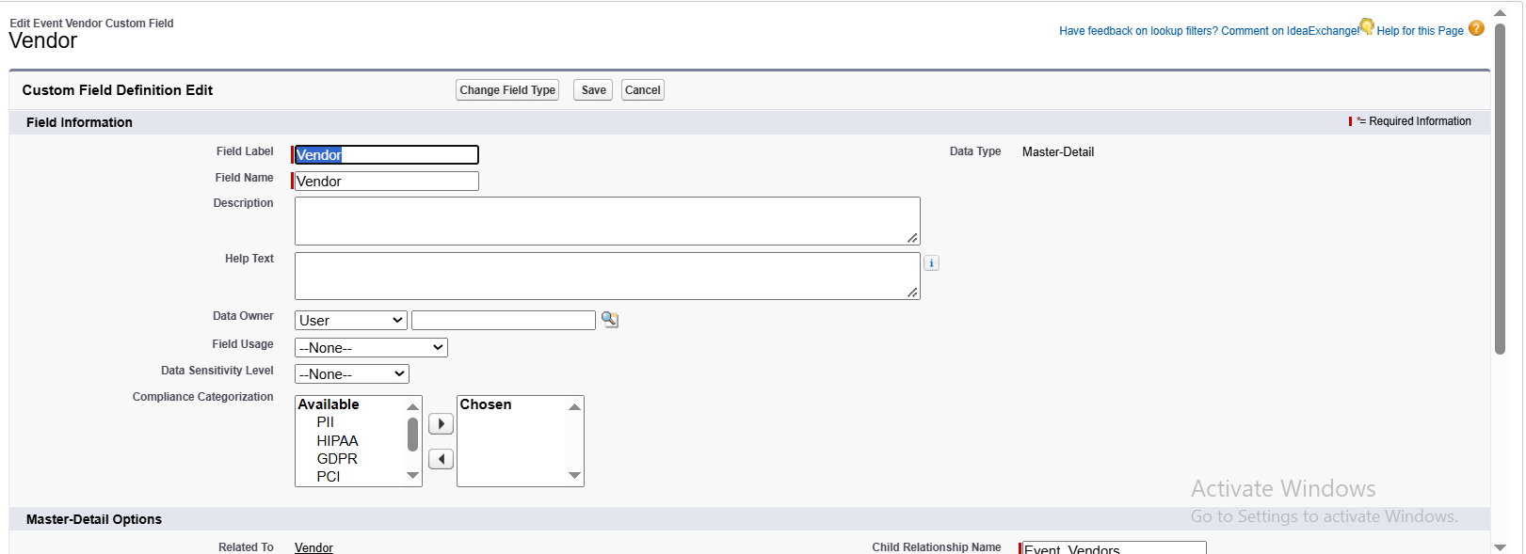
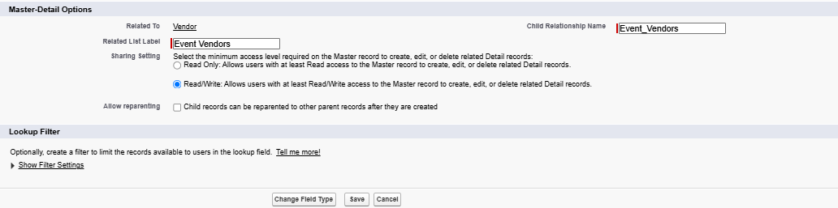

Add Lookup Relationship (Event → Client) :

- Go to setup, Click on object manager
- Select Event object, click Fields & Relationship
Data type | Related to | Field label
Lookup relationship | Client | Client

- Click next, next and save
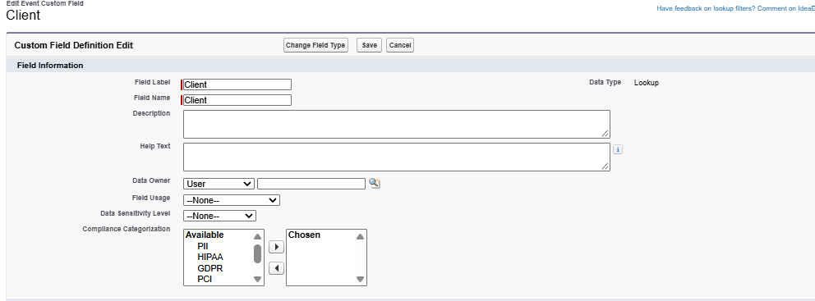
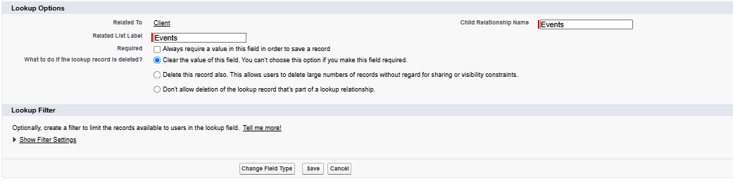

- Feedback
- Go to setup, Click on object manager
- Select Feedback object, click Fields & Relationship
Data type | Related to | Field label
Lookup relationship | Event | Event
Lookup relationship | Client | Client

- Click next, next and save
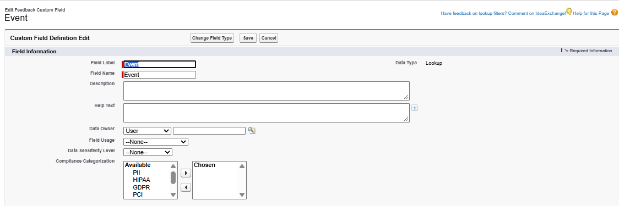
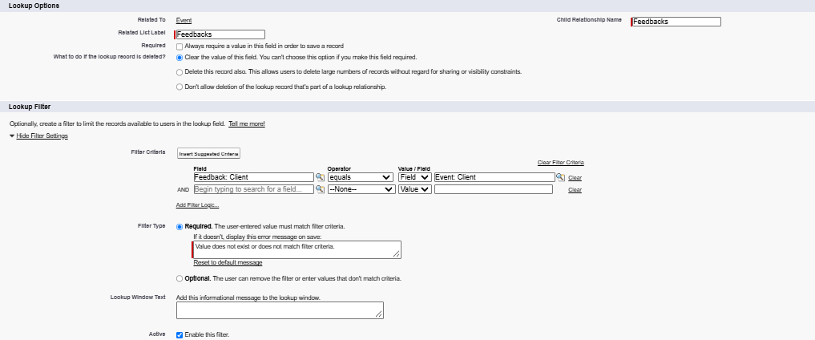
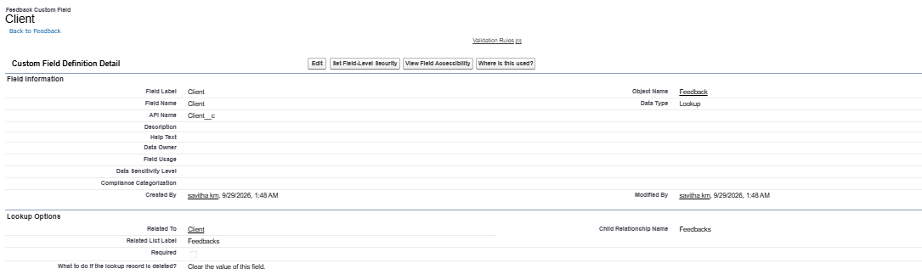

Activity 3: Lookup Filters

- Go to Setup, Click on home and type Object manager
- Open it, find and open Feedback object
- Click Fields & Relationships, find Event lookup field and click it
- Click On Edit, Scroll to the Lookup Filter section and click Show filter Settings
- Build the filter criteria
- Field: Event: Client__c
- Operator: equals.
- Value: Feedback: Client__c
- Check Enable this Filter box
- Click on Save.

- Milestone 4 - Validation Rules
Activity 1: Create Validation Rules

- Client
- Go to Setup, Click on Object manager
- Click on Client object, click on validation rule
- Click New
- Rule name: Email_Valid_Address
- Select Active, Insert error formula: NOT(REGEX(Email__c, "^[a-zA-Z0-9._]+@[a-zA-Z0-9.]+\\.[a-zA-Z]{2,}$" ))
- Error Message: Please Enter Valid Email Address
- Error location: Field
- Field: Email, Click save.
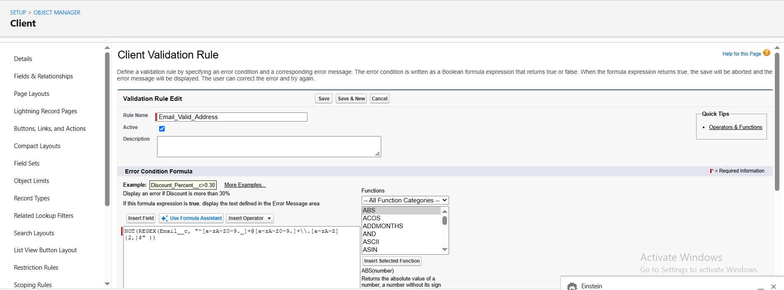

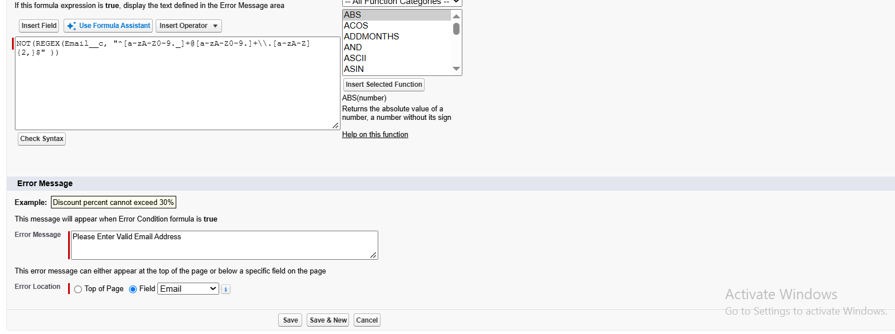

- Milestone 5 : APPROVAL PROCESS
Activity 1: Create an Approval Process for Event Cancellation Approval

- Create Classic Email Template
- Go to Setup, Click on Home
- Type Email Template, Click on Classic email template
- Click New template, Choose type
- Text: Plain text
- Email Template Information:

Folder | Public or private folder (use "Unfiled Public Email Templates" for now)
Email Template Name | Event Cancellation Request Notification
Template Unique Name | Auto-filled, or change it (no spaces)
Encoding | Leave default (UTF-8)
Subject | Approval Request: Cancel Event {!Event__c.Name}
Email Body | Hello!  An approval request has been submitted to cancel the event:  - Event Name: {!Event__c.Name}  - Event Date: {!Event__c.Event_Date__c}  Thank you,  EventForce Management System

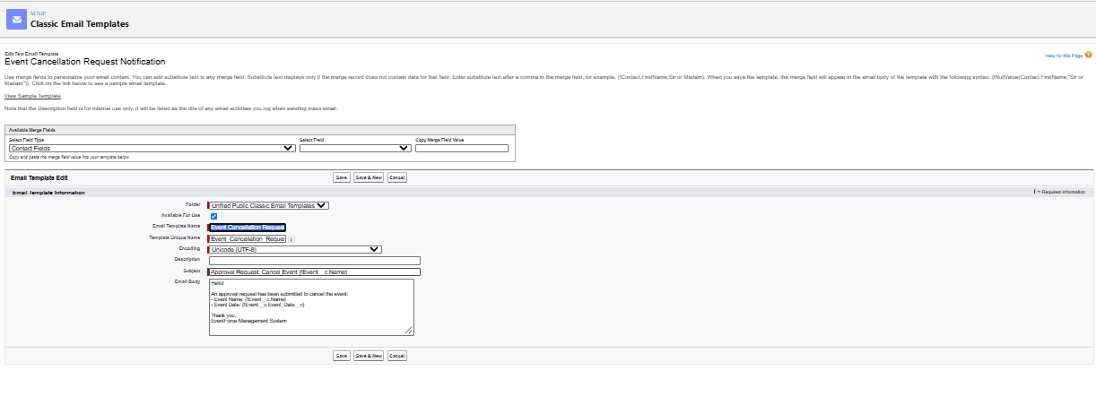
Activity 2.Create Another Email Template to Send Customer Email. If Cancellation Approved
- Template Name : Email to Client After Cancellation
- Subject : Event Cancellation Notice – {!Event__c.Name}
- Body: Hello!
We would like to inform you that the event has been canceled.
Event Name: {!Event__c.Name}
Date: {!Event__c.Event_Date__c}
If you have any questions or need assistance, please contact us.
Thank you for your understanding,
Event Management Team
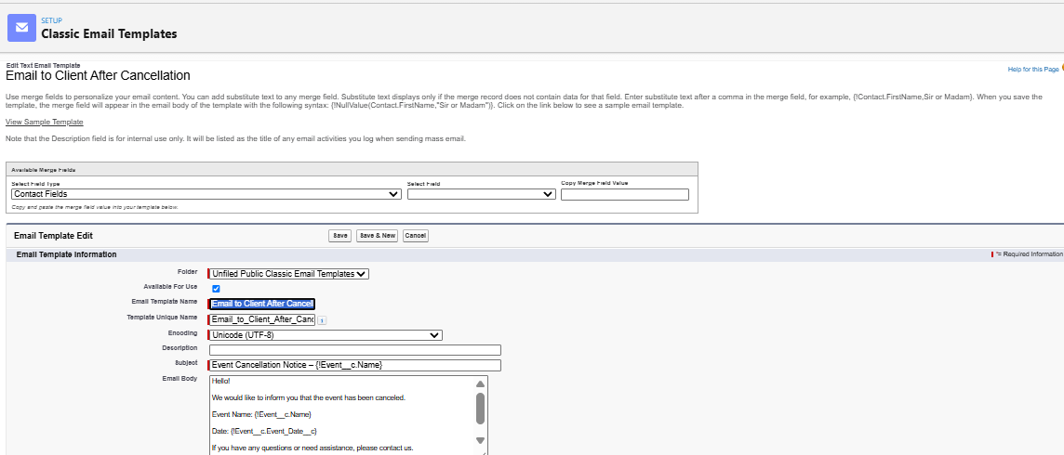

Activity 3. Create Another Email Template to Send Owner Email. If Cancellation Approved
- Template Name: Approval Notification to Event Owner
- Subject: Event Cancellation Approved: {!Event__c.Name}
- Body: Hello {!Event__c.OwnerFullName}
Your cancellation request for the event {!Event__c.Name} has been approved.
Event Date: {!Event__c.Event_Date__c}
The event status has been updated to Canceled.
Thank you,
EventForce Management System
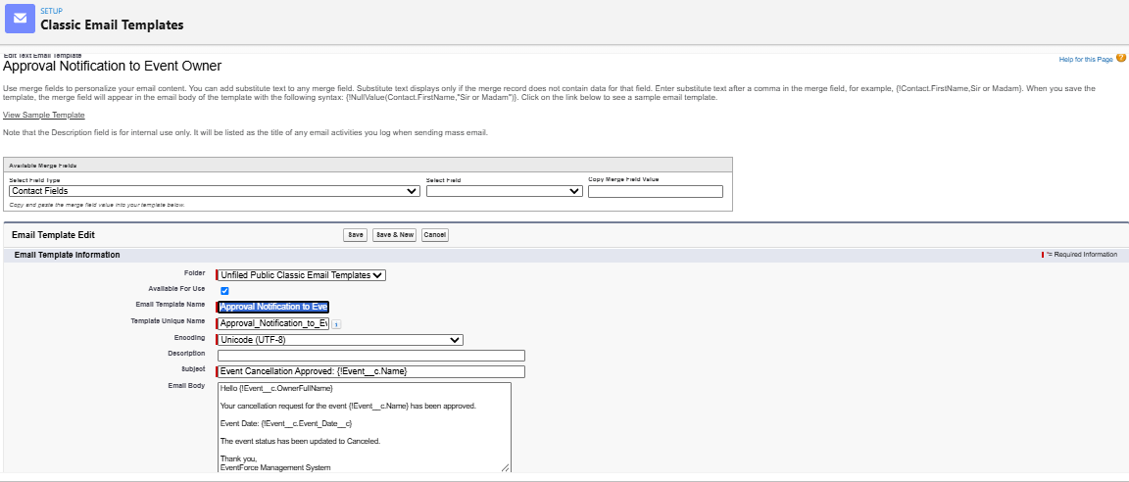

Activity 4. Create Another Email Template to Send Owner Email. If Cancellation Rejected
- Template Name : Rejection Notification to Event Owner
- Subject : Event Cancellation Rejected: {!Event__c.Name}
- Body : Hello {!Event__c.OwnerFullName},
Your cancellation request for the event {!Event__c.Name} has been rejected.
Event Date: {!Event__c.Event_Date__c}
The event status has been reverted to Confirmed.
Thank you,
EventForce Management System
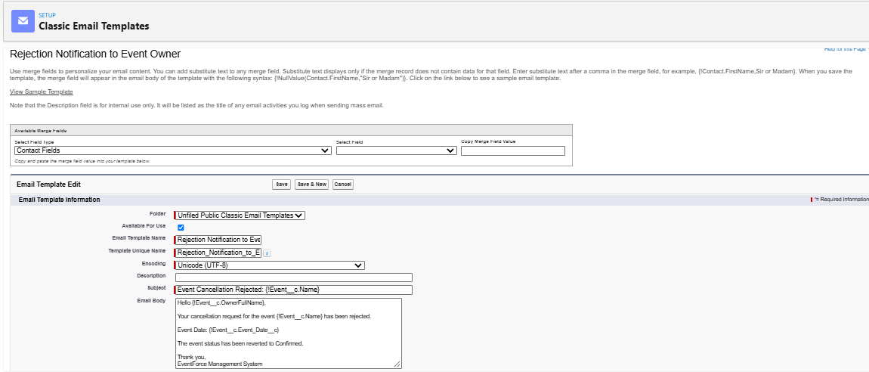

Activity 5. Create the Approval Process
- In the Quick Find box, type: Approval Processes
- Click on "Approval Processes" under Process Automation
- Object name: Event
- Click Create New Approval Process → Use Standard Setup Wizard
Step 1: Basic Settings
- Name: Event_Cancellation_Process
- Unique Name: Auto-fills (you can keep it as is) and Click Next
- Specify Entry Criteria:
- This defines when the process will be triggered.
- Choose "Criteria are met" Set:
- Field: Event→ Event Status
- Operator: Equals
- Value: Pending Cancellation and Click Next.
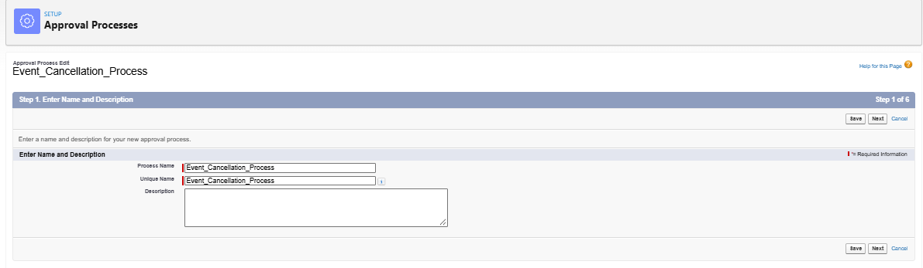
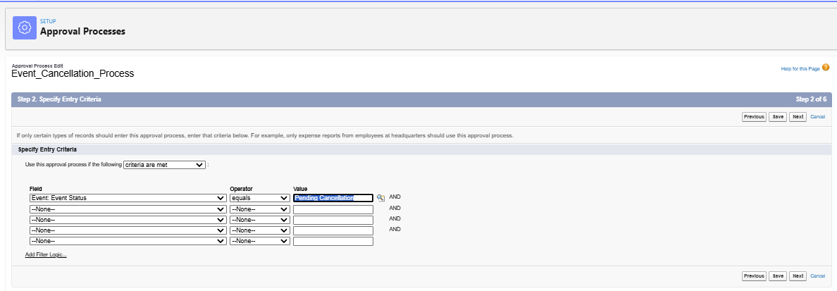

Step 2: Select Approver
- Use a specific user
- Select: Automatically assign using user or queue
- Choose: A specific user (Manager)
- Use Manager of the user
- Select: Automatically assign to the manager of the user who submitted the record
- Make sure users have a manager assigned in their User record and click next
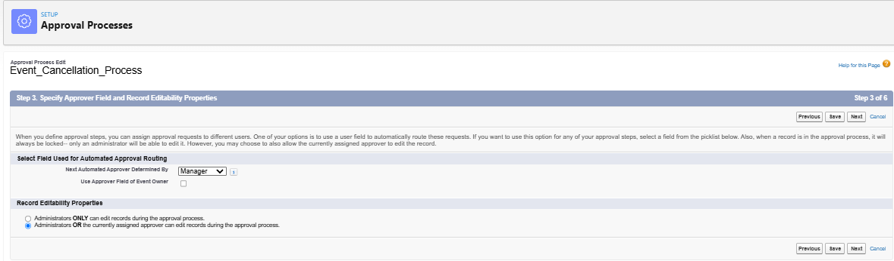

Step 3: Email Template
- Approval Assignment Email Template:
- Select Email Template : Event Cancellation Request Notification
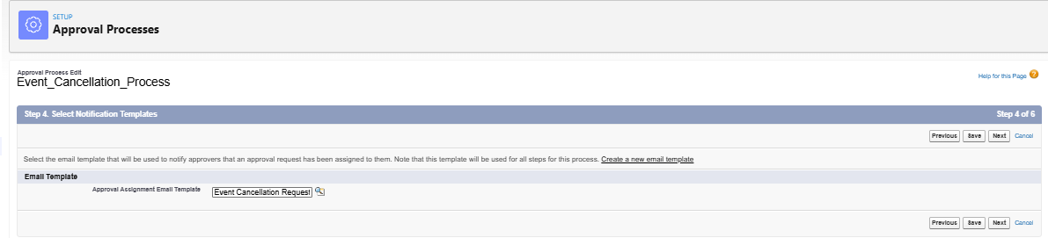

Step 4: Select Fields to Display on Approval Page Layout
- You’ll see a dual list:
- Available Fields on the left
- Selected Fields on the right
- Choose the fields you want approvers to see (typically key business info). Example for Event:
Suggested Fields:
- Event Name
- Owner
- Client
- Last Modified By
- Created By
- Event Budget
- Event Date
- Event Status
- Event Type
- Venue
- Use the Add button to move fields from left to right
- Use the Up/Down arrows to reorder and Click next
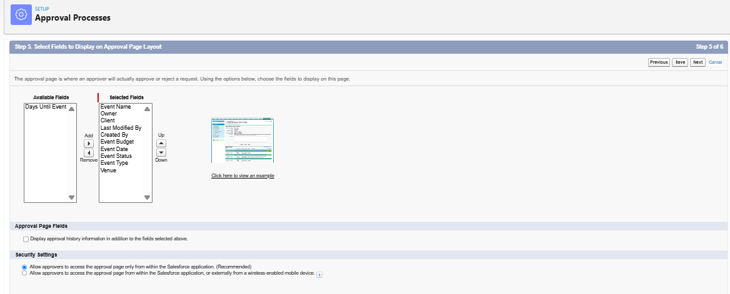

Step 5: Specify Initial Submitters
- Select Event Owner As Initial Submitters.
- Click Save.
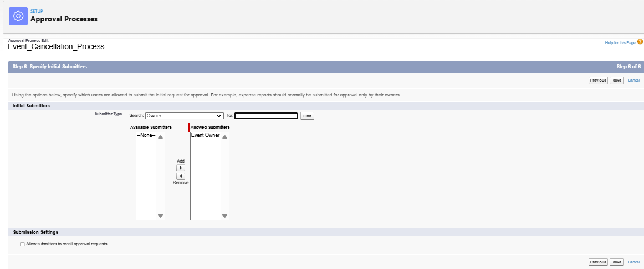
Step 6: Initial Submission Actions
- Click Add New → Email Alert
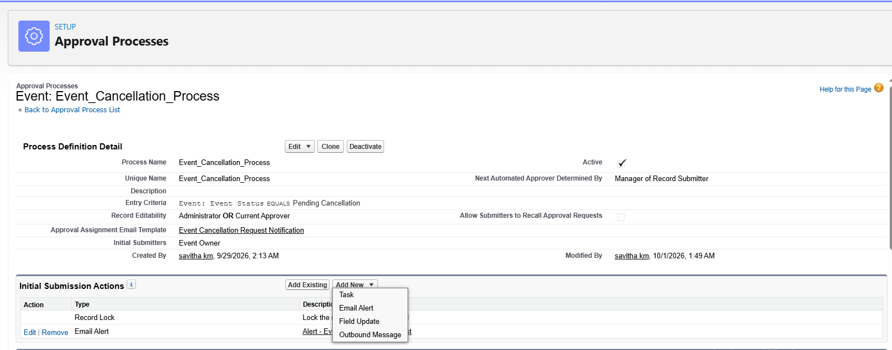
Fill in the details:
- Description: Alert - Event Cancellation Request
- Unique Name: Auto-filled.
- Object: Event__c
- Email Template: Event Cancellation Request Notification
- Recipients: Role - Event Coordinator.
- From Email Address: Current User’s Email Address
- Click Save.
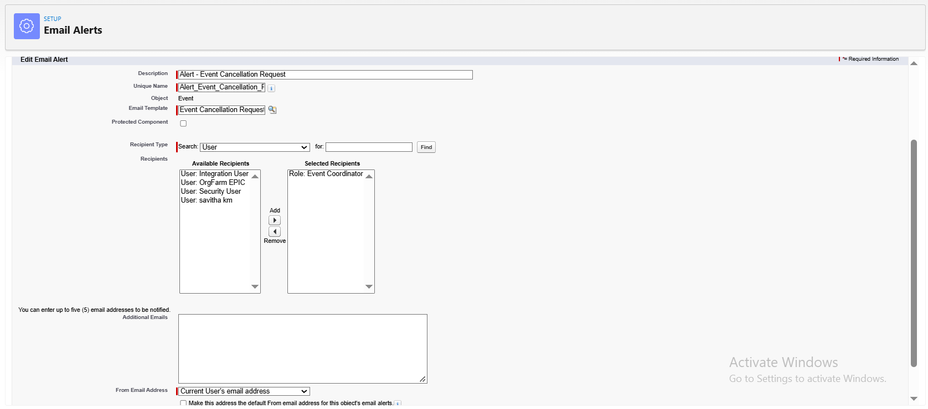

Step 7: Final Approval Actions
- Click Add New → Field Update
- Field: Event status.
- Name: Event Status Update
- Field: Event Status
- New Value: Canceled and Save
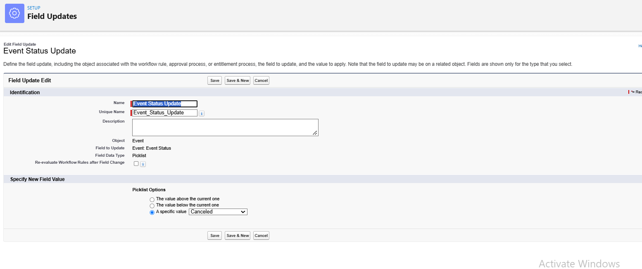
- Click Add New → Email Alert
- Description: Alert - Cancellation Approved
- Email Template : Approval Notification to Event Owner
- Recipient Type : Select Event Owner
- From Email Address: Current User’s Email and Save.
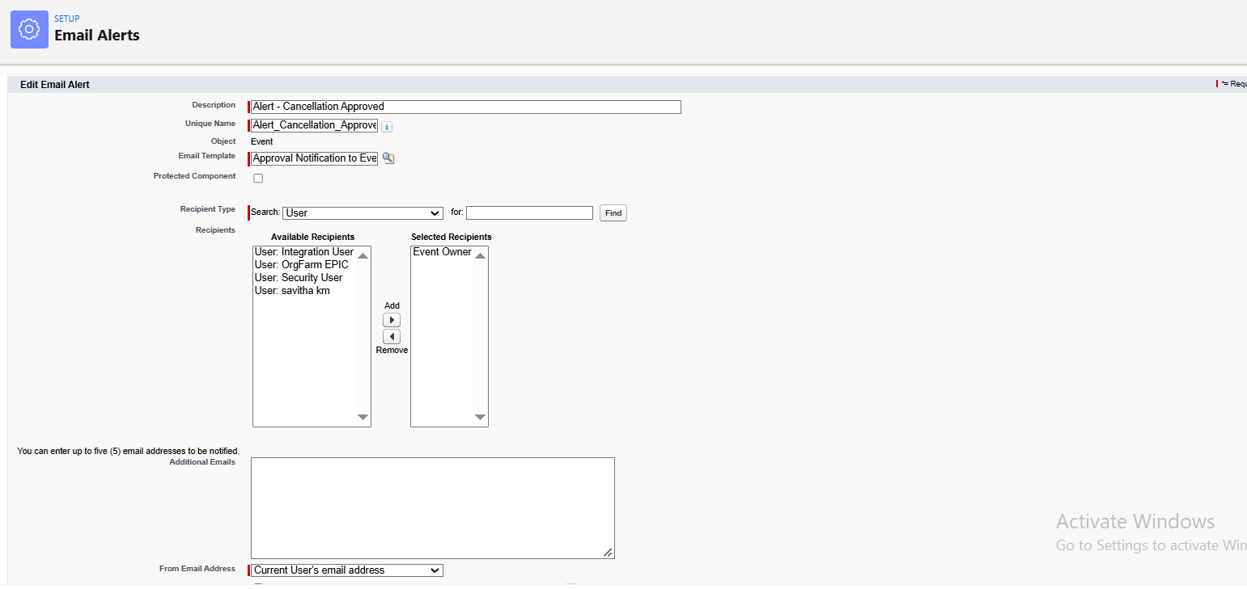

Step 8: Final Rejection Actions
- Click Add New → Email Alert
- Description: Alert - Cancellation Rejected
- Email Template : Rejection Notification to Event Owner
- Recipient Type : Select Event Owner
- From Email Address: Current User’s Email and Save.
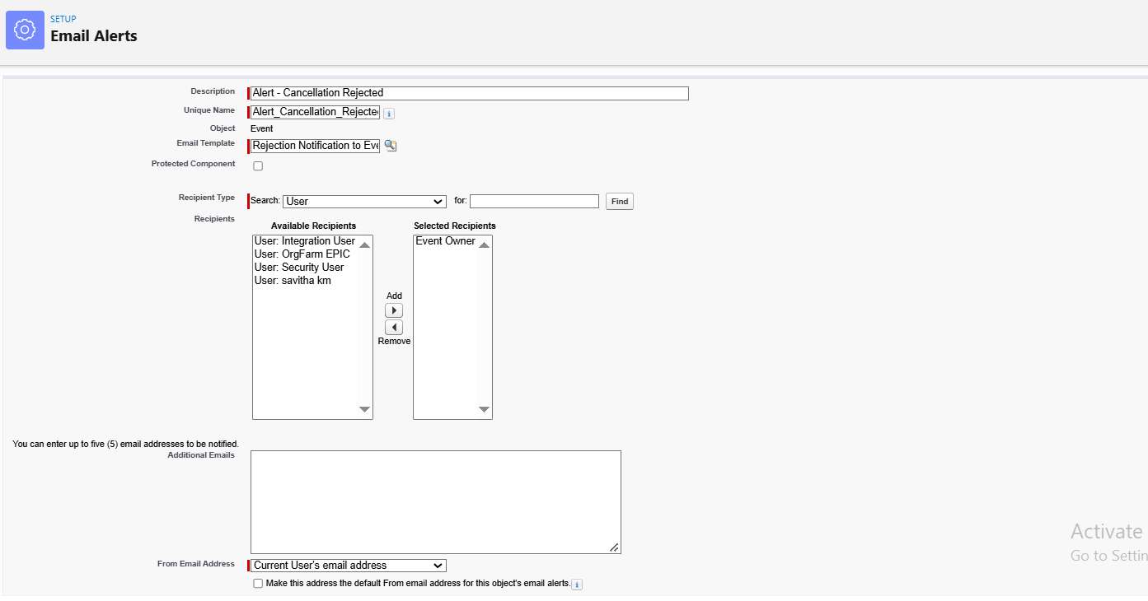
- Click Add New → Field Update
- Field: Event status.
- Name: Event Status To Rejected
- Field: Event Status
- New Value: Rejected and Save.
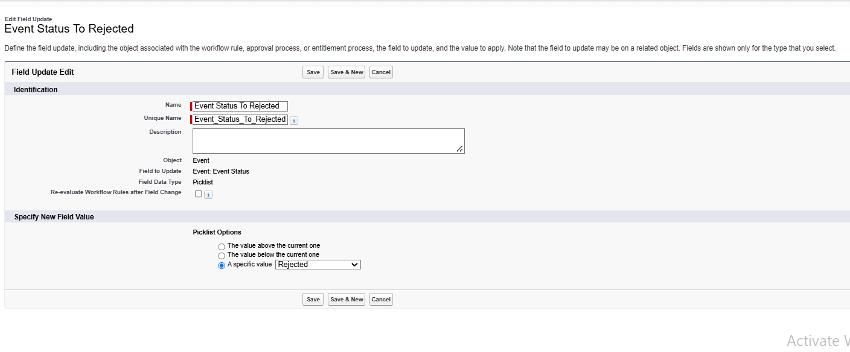
Step 9: Approval Steps
- Click Add New Step
- Enter: Manager Review
- Unique Name (auto-filled)
- Step Number (optional – controls order) and Click Next
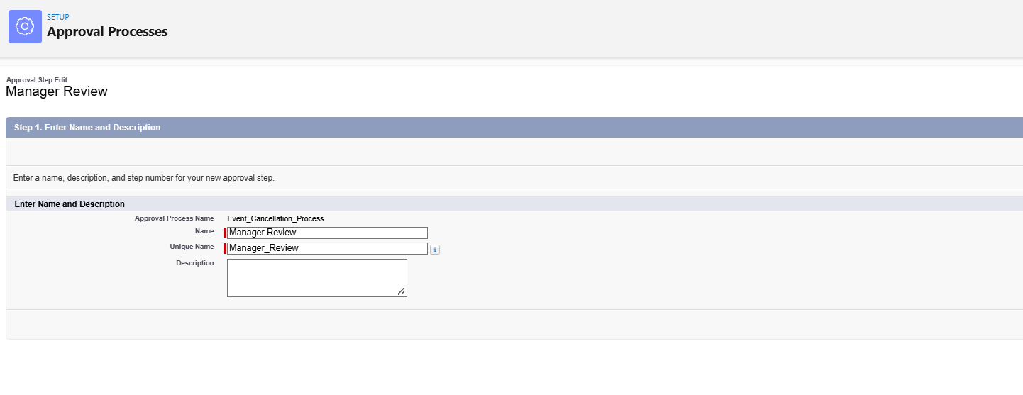
- Specify Step Criteria
- Choose All records should enter this step
- Click Next.
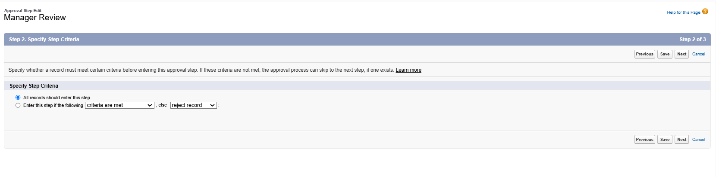
- Select Assigned Approver
- Choose: user field
- Automatically assign to approver(s) and click specific user
- Related user: Savitha km and Click Save.
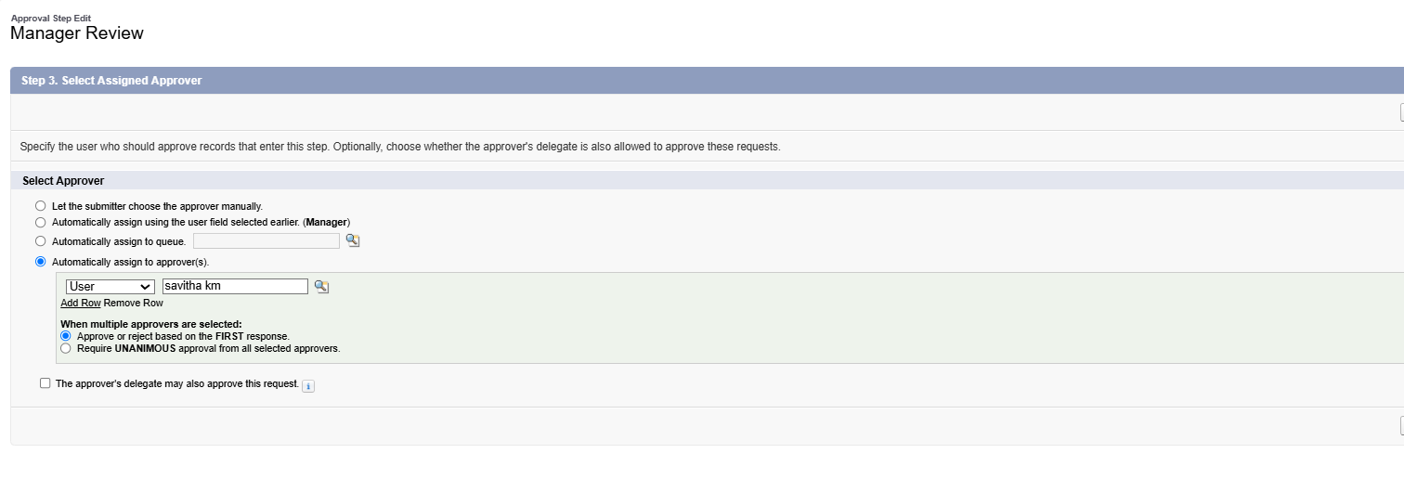
Step 10: Activate the Approval Process
- Click View Approval Process Detail Page
- Click Activate
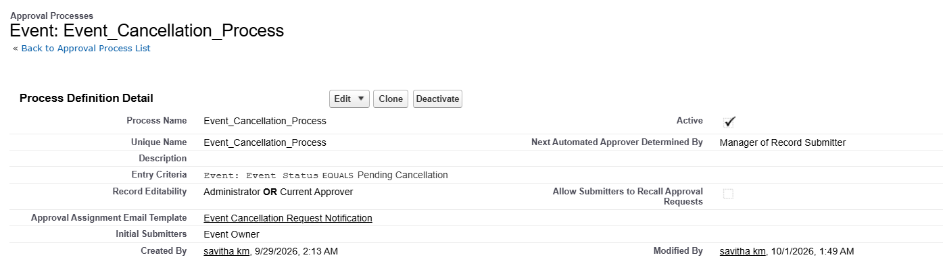

- Milestone 6 – Flows
Activity 1 : Create Flow to Send 3-Day Reminder Email to Client
- Go to setup and type Flow
- Click on Flow and Select New Flow
- Select the Record Triggered flow and Click on create
- Under Object select Event
- Select: A record is Created or Updated
- Enter Condition as
Field: Event Status
Operator: Equals
Value: Confirmed
- Optimize the flow: Actions and Related Records and Click on Done
- Click On Start Button and Click on Add Schedule Path
- Path name: 3_Days_Before and API name: Automatically Populates
- Time Source: Event__c: Event Date
- Offset Number : 3
- Offset Options : Days Before and Click on ‘x’ icon
- Click Toolbox from Top left corner and Click on New Resource
- Select Text Template
- Enter API Name : Subject
- Body: Reminder: Your Event {!$Record.Name} is in 3 days
- View: Plain Text and Click Done
Create another Resources
- Select Text Template
- API Name : Body
- Body: Hello {!$Record.Client__r.Name},
This is a reminder that your event "{{!$Record.Name}" will take place on {!$Record.Event_Date__c}.
Venue: {!$Record.Venue__r.Name}
Type: {!$Record.Event_Type__c}
We look forward to seeing you!
- EventForce Team
- View: Plain Text and Click Done
- Under the 3 Days Before, Click on “+” Symbol
- Click on Action and Select Email Action
- Search: Send Email and Click On Send Email
- Label Name: Alert_Client_3Day_Reminder
- Recipient Address List: Client Email
- CC Recipient Address List : Event Owner
- Configure Email Content: Select Compose Email Content
- Subject: Subject Resource
- Body: Body Resource and Click Save
- Flow Label: Client Reminder - 3 Days Before and Click Save & Activate
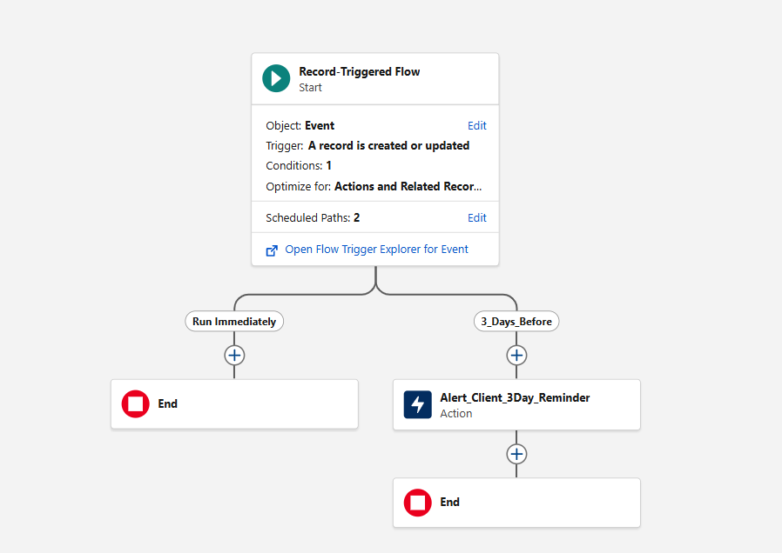
- Milestone 7 – Apex Classes

Activity1: Create Apex Class

- Click Gear Icon and Select Developer Console
- Click on File and Click New and Click on Apex class
- Name: VenueStatusHelper and Click Ok
- Apex Class Code:
public with sharing class VenueStatusHelper {
public static void updateVenueStatus(List<Event__c> events){
List<Venue__c> venues = new List<Venue__c>();
for(Event__c ev : events){
if(ev.Venue__c != null){
if(ev.Event_Status__c == 'Confirmed'){
venues.add(new Venue__c(Id=ev.Venue__c, Availability_Status__c='Reserved'));
} else if(ev.Event_Status__c == 'Canceled'){
venues.add(new Venue__c(Id=ev.Venue__c, Availability_Status__c='Available'));
}
}
}
if(!venues.isEmpty()) update venues;
}
}

- Save the class using CTRL+S
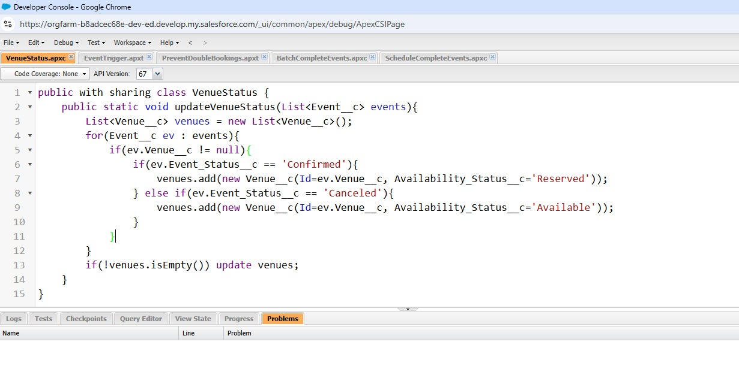
Create Trigger Class :

- Click on File and Click New and Click on Apex Trigger
- Name: EventTrigger13 and Object: Event__c and Click Submit
- Apex Code
trigger EventTrigger13 on Event__c (after insert, after update) {
VenueStatusHelper.updateVenueStatus(Trigger.new);
}

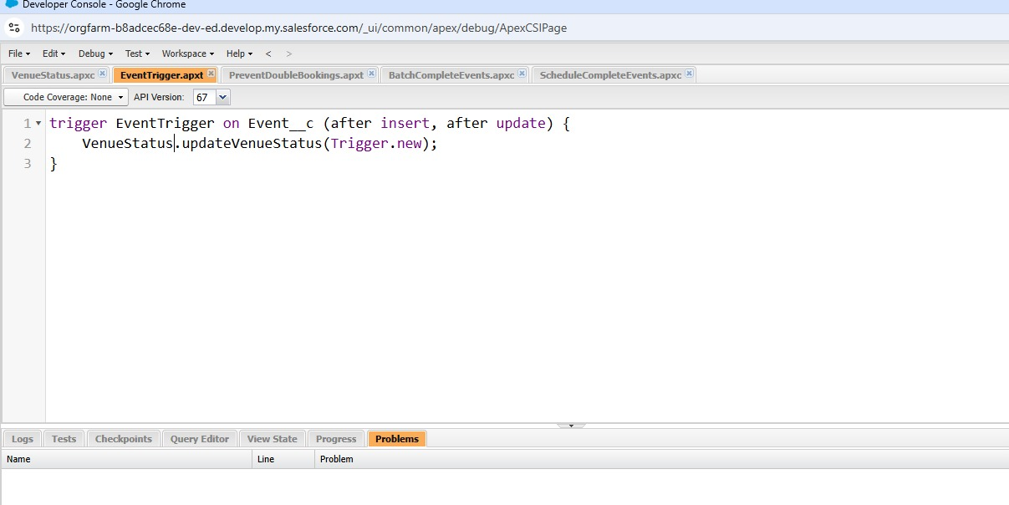

Milestone 8: Apex Trigger

Activity1: Create an Apex Trigger
- Click on File and Click New and Click on Apex Trigger
- Name: PreventDoubleBooking and Object: Event__c and Click Submit.
- Apex trigger Code
trigger PreventDoubleBooking on Event__c (before insert, before update) {
Set<Id> venueIds = new Set<Id>();
for(Event__c ev : Trigger.new){
if(ev.Venue__c != null) venueIds.add(ev.Venue__c);
}
Map<Id, List<Event__c>> venueEventMap = new Map<Id, List<Event__c>>();
for(Event__c e : [SELECT Id, Venue__c, Event_Date__c
FROM Event__c WHERE Venue__c IN :venueIds]){
if(!venueEventMap.containsKey(e.Venue__c)){
venueEventMap.put(e.Venue__c, new List<Event__c>());
}
venueEventMap.get(e.Venue__c).add(e);
}
for(Event__c ev : Trigger.new){
if(ev.Venue__c != null && venueEventMap.containsKey(ev.Venue__c)){
for(Event__c existing : venueEventMap.get(ev.Venue__c)){
if(existing.Event_Date__c == ev.Event_Date__c && existing.Id != ev.Id){
ev.addError('This Venue is already booked on this date.');
}
}
}
}
}
- Save the trigger using CTRL+S
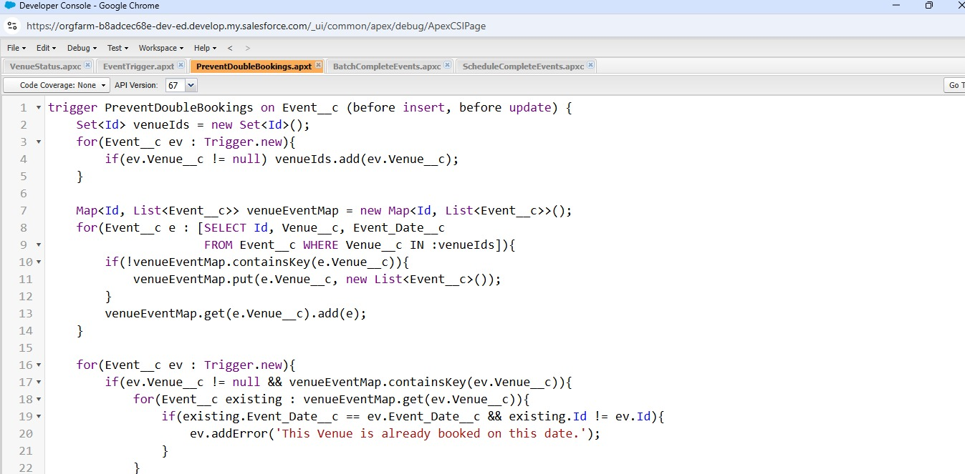

- Milestone 9: Batchable and Schedulable Asynchronous Apex
Step 1: Create Batch Apex Class:
- Click Gear Icon and Select Developer Console
- Click on File and Click New and Click on Apex class
- Name: BatchCompleteEvents and Click Ok
- Apex Class Code

global class BatchCompleteEvents implements Database.Batchable<sObject> {
global Database.QueryLocator start(Database.BatchableContext bc){
return Database.getQueryLocator(
'SELECT Id, Event_Date__c, Event_Status__c FROM Event__c WHERE Event_Date__c < TODAY AND Event_Status__c != \'Completed\''
);
}
global void execute(Database.BatchableContext bc, List<Event__c> scope){
for(Event__c ev : scope){
ev.Event_Status__c = 'Completed';
}
update scope;
}
global void finish(Database.BatchableContext bc){
System.debug('Past events marked as Completed');
}
}
- Save the class using CTRL+S
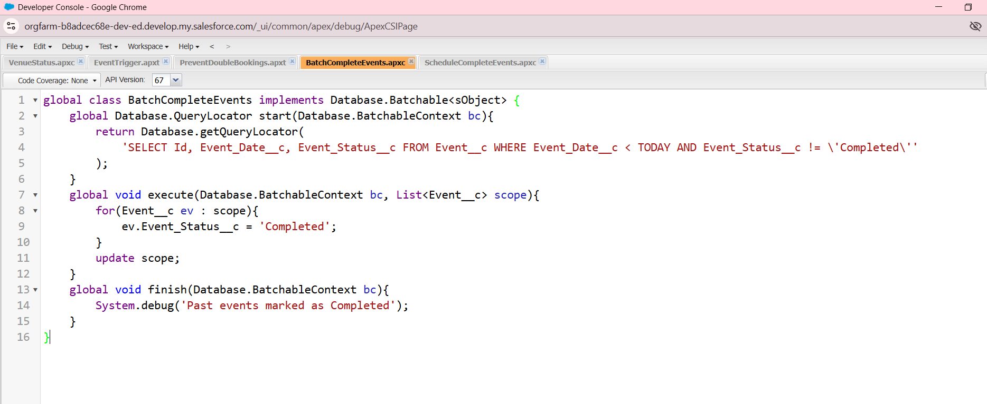

Step 2: Schedulable class Implementation:
- Click Gear Icon and Select Developer Console
- Click on File and Click New and Click on Apex class
- Name: ScheduleCompleteEvents and Click Ok
- Apex Class Code

global class ScheduleCompleteEvents implements Schedulable {
global void execute(SchedulableContext sc){
Database.executeBatch(new BatchCompleteEvents(), 200);
}
}
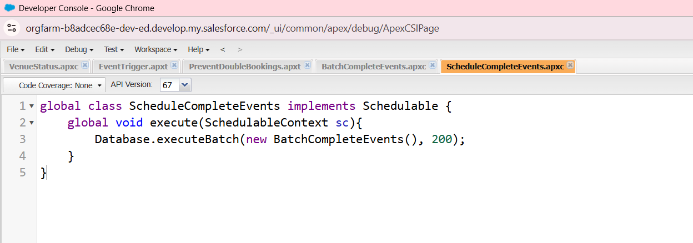

Step 3: Schedule Batch Apex from Salesforce Setup
- Go to Setup and Click on home
- Search for Apex Classes and Click Apex Classes
- Click the Schedule Apex
- Job Name: Daily Event Completion
- Apex Class: ScheduleCompleteEvents
- Schedule Time
- Frequency: Weekly or Monthly → Choose Weekly
- Days: Select All Days
- Preferred Start Time: Select 08:00 PM
- Click Save
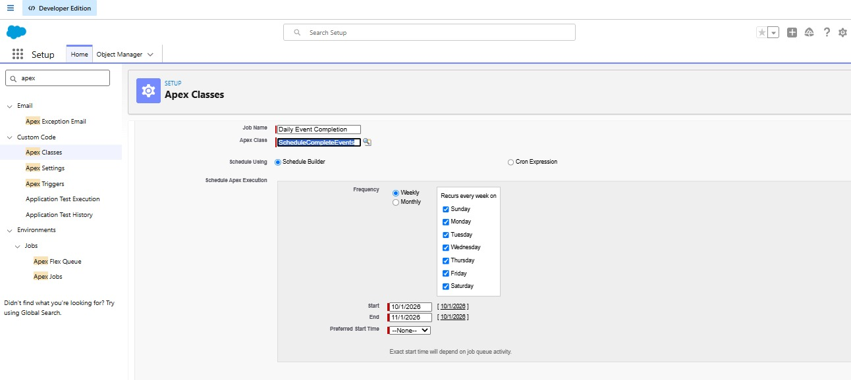

Phase 3 – UI/UX Development & Customization
Phase 3 focuses on making the Salesforce solution accessible and practical for end users. A custom Lightning application brings the major EventForce modules into one workspace.

Milestone 10: The Lightning App

Activity 1: Create a Lightning App

Create the Event Planner Management System app
- Go to Setup and select App Manager
- Click New Lightning App, App Name: Event Planner
- Upload Image and click next.
- Under App Options, leave the default selections and click Next
- Under Utility Items, leave as it is and click Next.
- From Available Items, select Event, Client, Vendor, Venue, Feedback, Reports and Dashboards and move them to Selected Items, Click Next.
- From Available Profiles, select System Administrator and move it to
- Selected Profiles and Click Save & Finish.
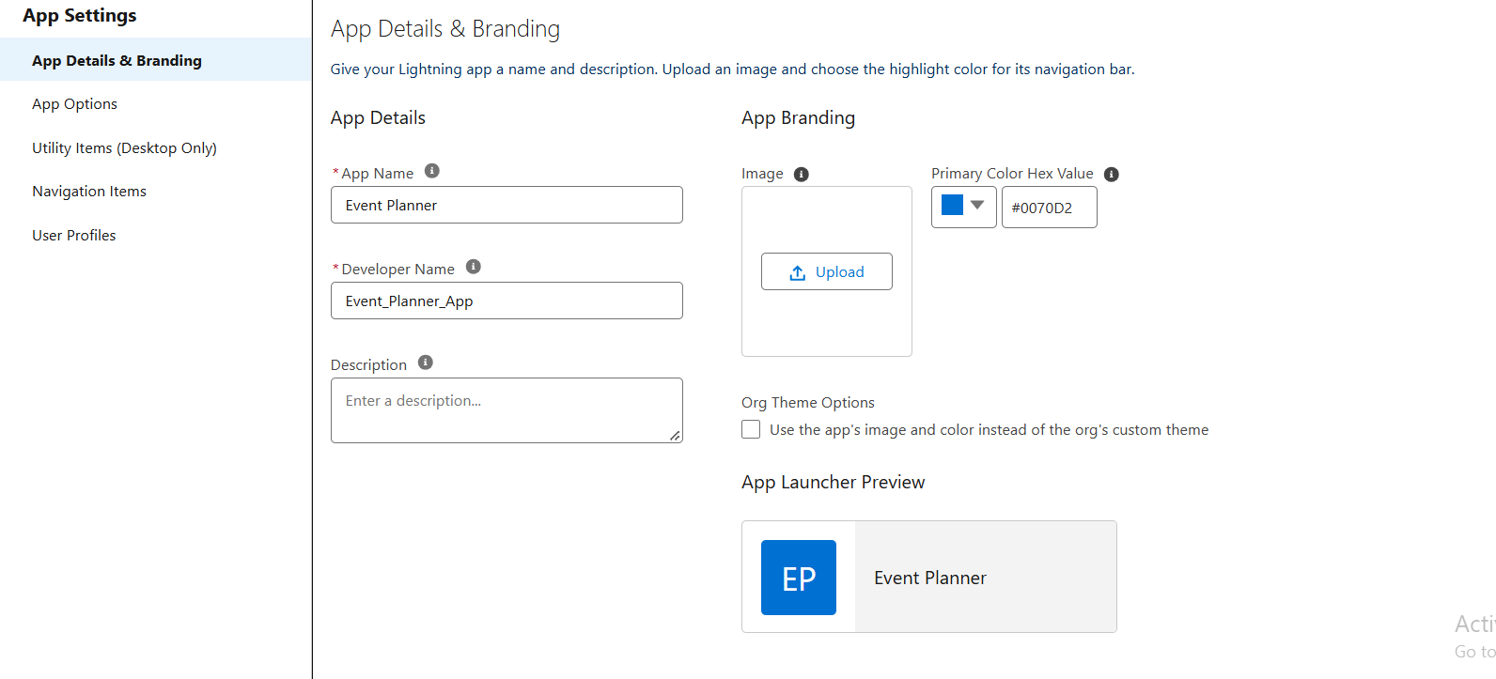

Milestone 11: Reports

Activity 1: Create a Report folder
- Click on app launcher and search reports
- Click on report tab, click new folder
- Folder label: EventForce Report
- Folder unique name: Auto populated and Click save.

Activity 2: Sharing a Report folder
- Go to the app and click reports tab
- Click on All folder , search EventForce Report Folder and Click on share
- Share with: Roles, Name field: Event Coordinator, Vendor Manager and View: Role.
- Click share and click Done.

Activity 3: Create Report

Report 1: Upcoming Events — Summary by Month
- Go to the App Launcher and click Reports tab
- Click New Report and Select Category: All
- Search: Events or Events with Client & Venue and click Start Report
- In the outline pane, select the fields in Columns section
  - Event Name
  - Event Date
  - Event Type
  - Client__r.Name
  - Venue__r.Name
  - Event_Budget__c
- Toggle Update Preview Automatically

- Go to Filters and apply the filters
  - Show Me = All Events
  - Event Date ≥ TODAY (or Next 30 Days)
  - Event Status ≠ Canceled
- In the group rows section, select the fields
  - Event Date and click the drop-down, Group by Calendar Month
- Click on Add Summary, summarize
  - Row Count (auto)

  - Event_Budget__c → SUM (to see total budget per month)
- Click on Add Chart, select:
  - Chart Type: Column or Line
  - X-axis = Event Date (Calendar Month)
  - Y-axis = Row Count or SUM(Event_Budget__c)
- Click Save and report name: Upcoming Events by Month

- Report Unique Name: Auto-populated

- Select folder: EventForce Reports and click Save, Run

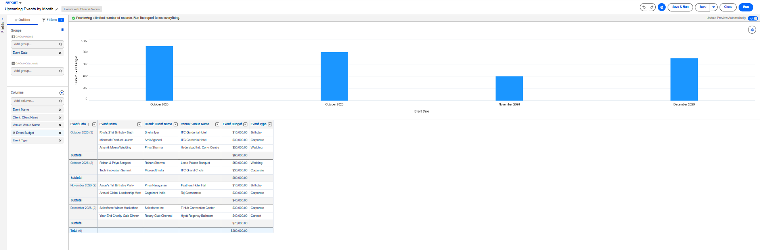

Milestone 12: Dashboards

Activity 1: - Create Dashboard

Create EventForce Dashboard
- Click Dashboards tab from EventForce Management System application
- Click on New Dashboard and Name: EventForce Operations Dashboard
- Click Create and Click on +Widget
- Select the Upcoming Events by Month Report
- Chart: Donut Chat and Max Values Displayed: 6
- Subtitle: Upcoming Events Overview and Widget Theme: Light
- Click save.
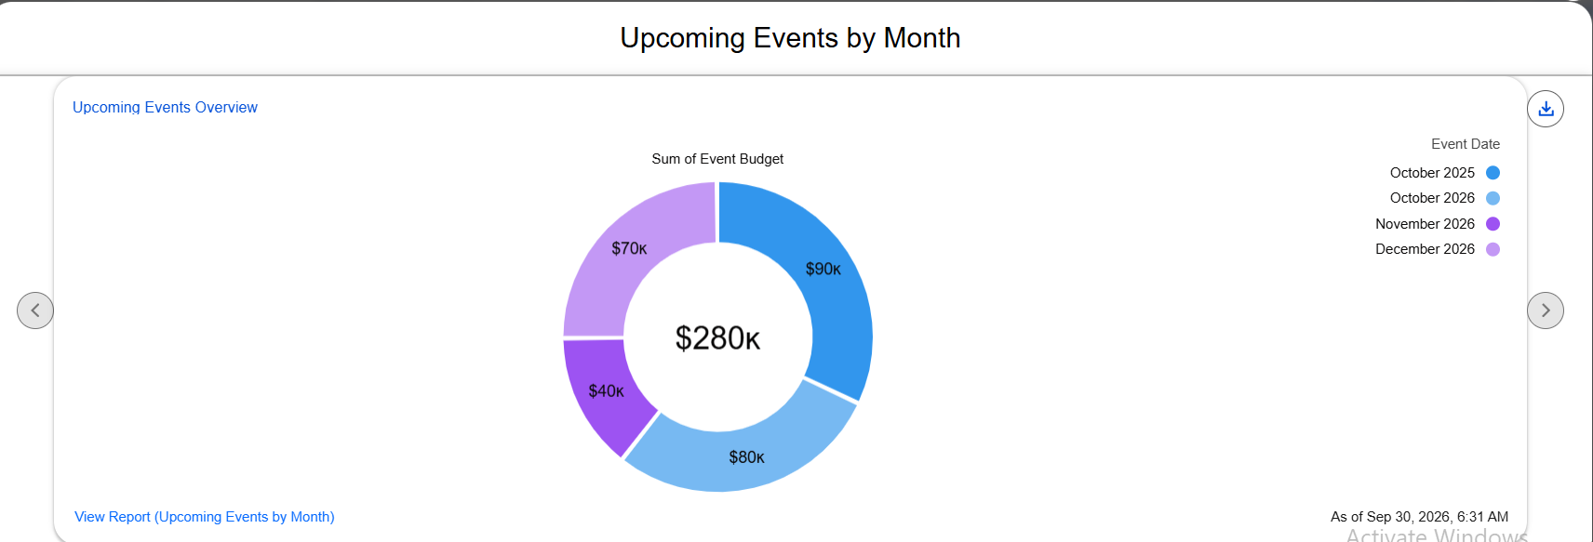

Phase 4 – Data Migration, Testing & Security
Phase 4 prepares the solution for reliable operation by validating data, configuring users, controlling access, and testing automation and permissions.
- Milestone 13: Profile
Activity 1: Create a custom profile
- Go to setup , search profiles
- Click On New Profile
- Existing Profile: System Administration
- Profile Name: Event Admin and Click save.
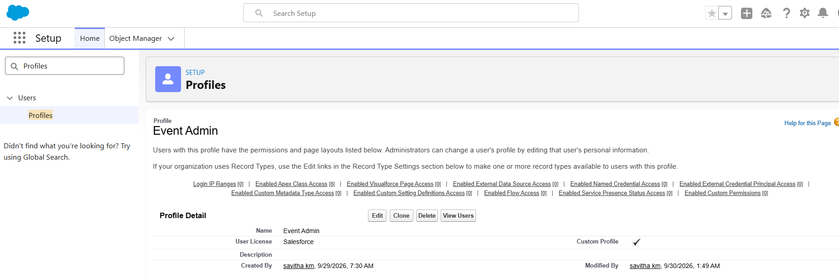

Activity 2: Create a Custom profile
- Go to setup , search profiles
- Click On New Profile
- Existing Profile: Standard Platform User
- Profile Name: Event Coordinator
- Click On save and Click On Edit
- Select the Custom App settings as default for the Event Planner.
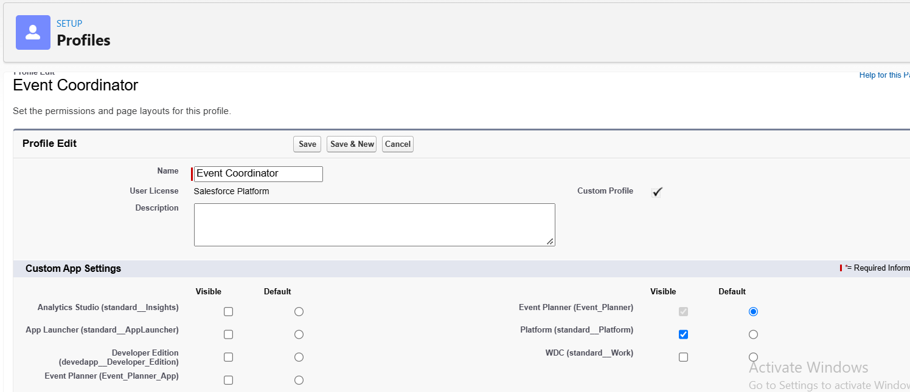
- Custom Object Permissions Give Access:
Event: CRED (Create, Read, Edit, Delete)
Client: Read / Edit
Vendor: Read
Venue: Read
Feedback: Create / Read
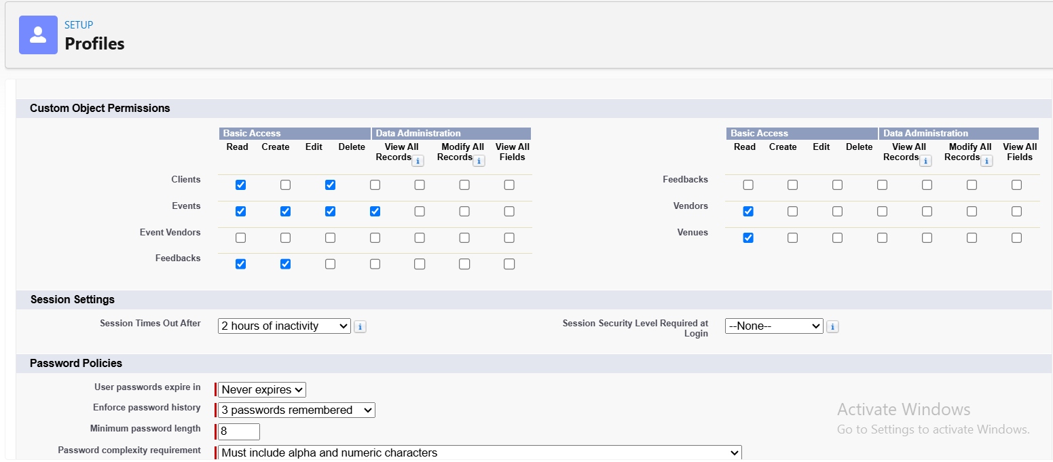
- Session times out after: 2 hours of inactivity
- Change the password policies:
User passwords expire: never expires
Minimum password length: 8
- Click save.
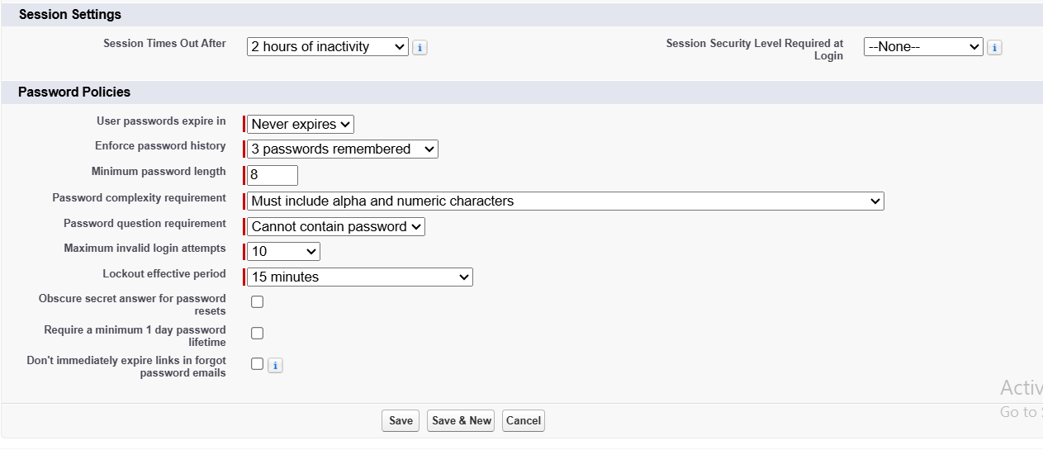

Activity 3: Create a Custom profile
- Go to setup, search profiles
- Click On New Profile
- Existing Profile: Standard Platform User
- Profile Name: Vendor Manager
- Click On save and Click On Edit
- Select the Custom App settings as default for the Event Planner.
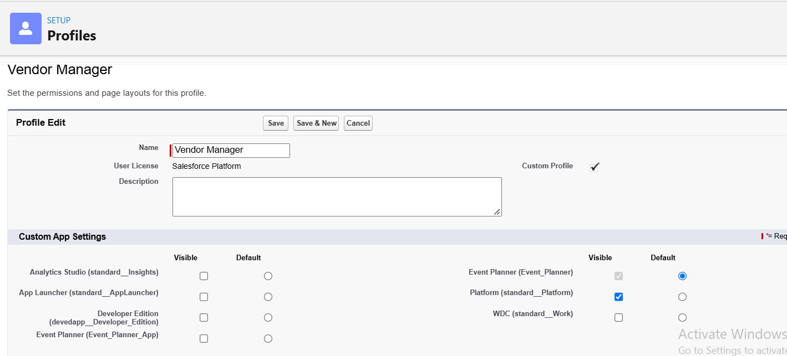
- Custom Object Permissions Give Access:
Vendor: CRED
Event: Read Only
Venue: Read Only
Client: Read Only
Feedback: Read Only
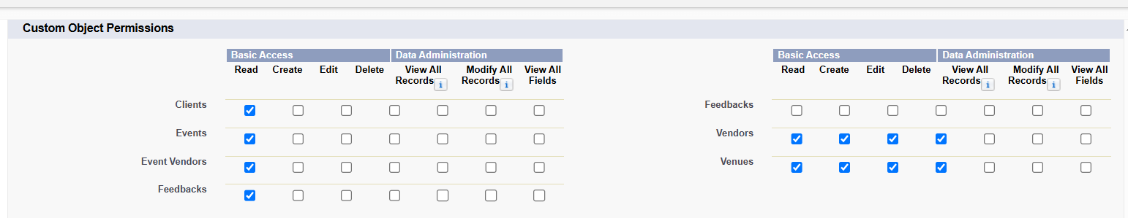
- Session times out after: 2 hours of inactivity
- Password policies :
User passwords expire: never expires
Minimum password length: 8 and click save.
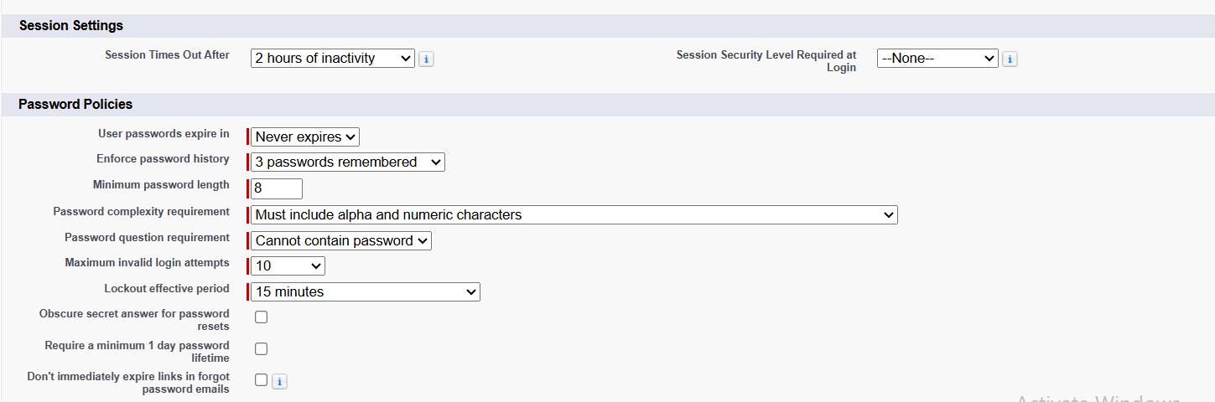

Activity 4: Create a Custom profile
- Go to setup, search profiles
- Click On New Profile
- Existing Profile: Standard Platform User
- Profile Name: Client Profile
- Click On save and Click On Edit
- Select the Custom App settings as default for the Event Planner.
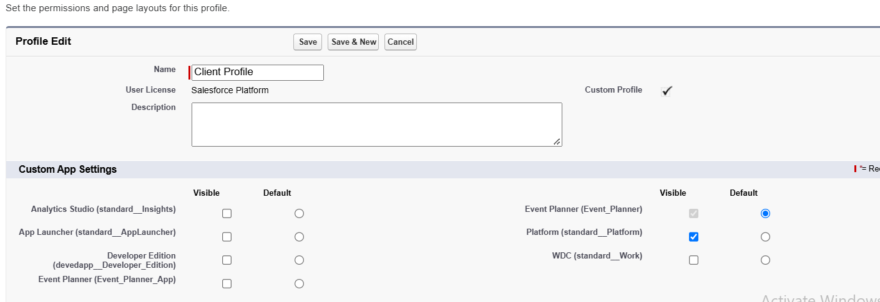
- Custom Object Permissions Give Access:
Event: Read Only (for their own events)
Feedback: Create / Read (give feedback)
Vendor/Venue: No Access
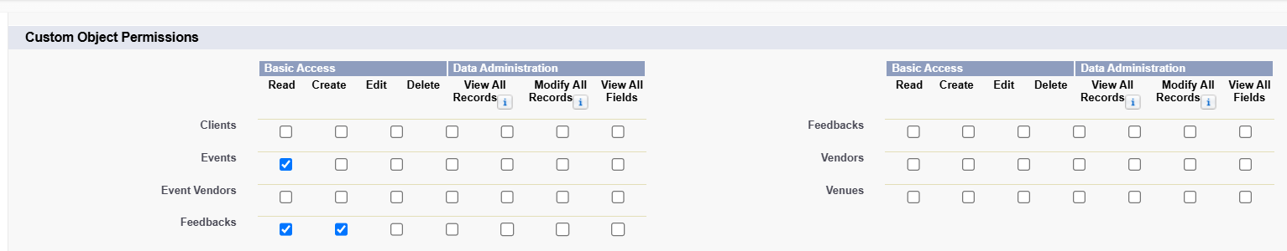
- Session times out after: 2 hours of inactivity
- Password policies:
User passwords expire: never expires
Minimum password length: 8 and click save
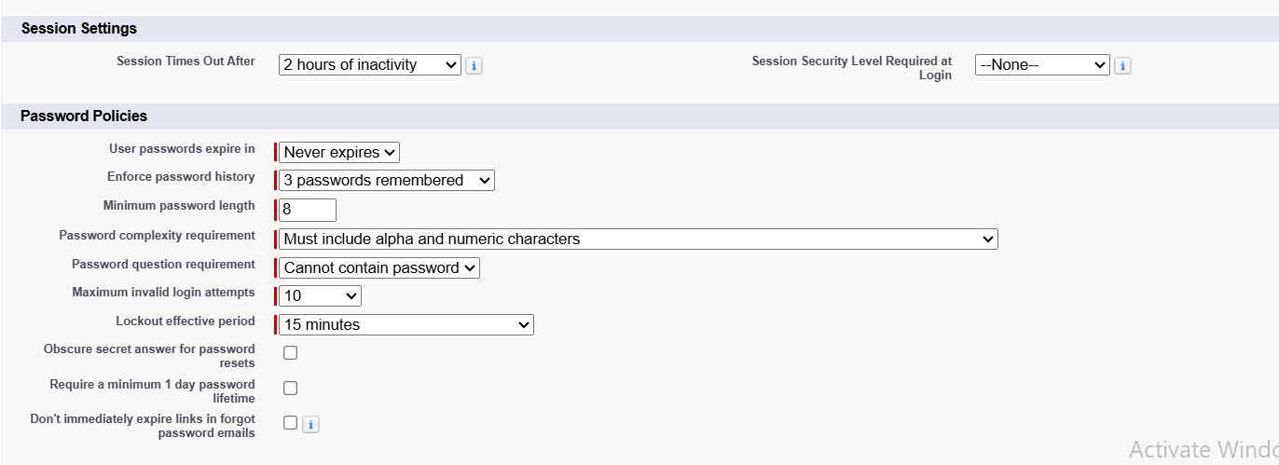

- Milestone 14: Role
Activity 1: Creation of Event Admin Role
- From the Quick find box, search role and click on roles option
- Select set up roles option
- Click on Expand All and click on add role under CEO
- Label: Event Admin and Role name: Auto populated
- click on Save.
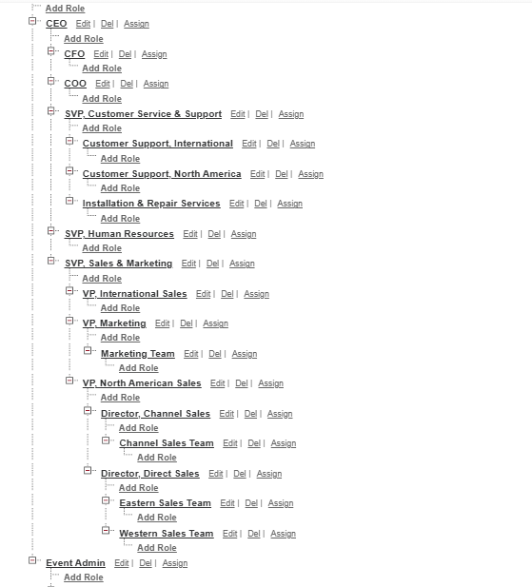

Activity 2: Creating other Role Under Event Admin Role

- Create Another Role.
- Create a Role with Name: Event Coordinator
- Below Event Admin, click on add role and label name: Event Coordinator
- Role name: Automatically populated and click save.
- Follow the steps from above Activity
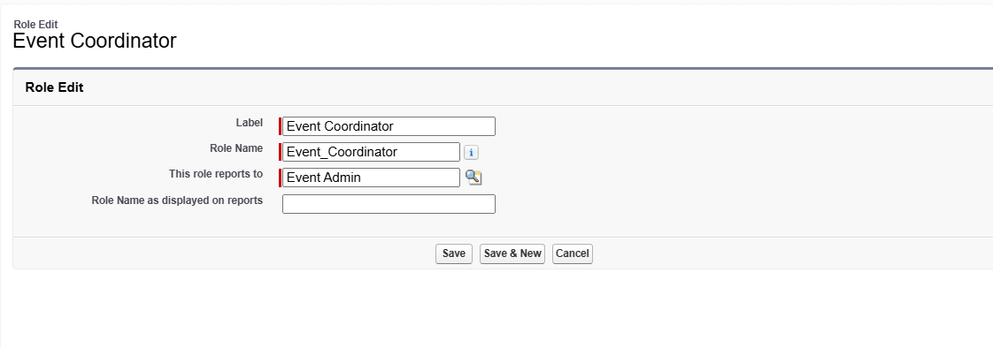

Activity 3: Creating other Role Under Event Admin Role

- Create Another Role.
- Create a Role with Name: Vendor Manager
- Below Event Admin, click on add role and label name: Vendor Manager
- Role name: Automatically populated and click save
- Follow the steps from above Activity.
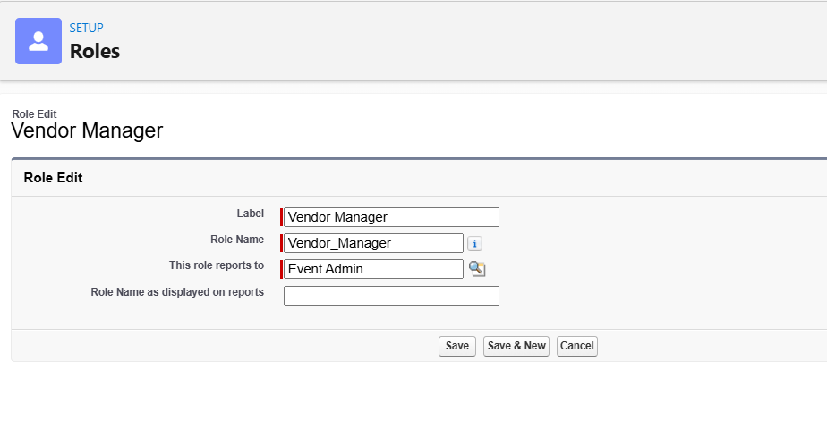

Activity 4: Creating other Role Under Event Admin Role

- Create Another Role.
- Create a Role with Name: Client
- Below Event Admin, click on add role and label name: Client
- Role name: Automatically populated and click save
- Follow the steps from above Activity.
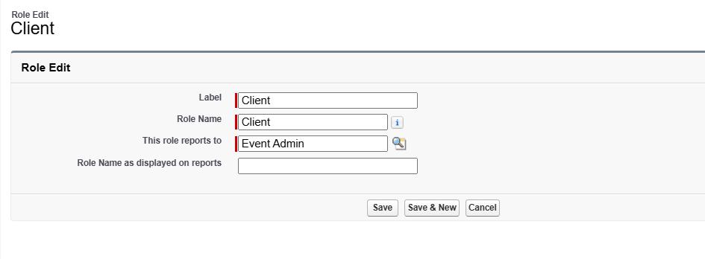
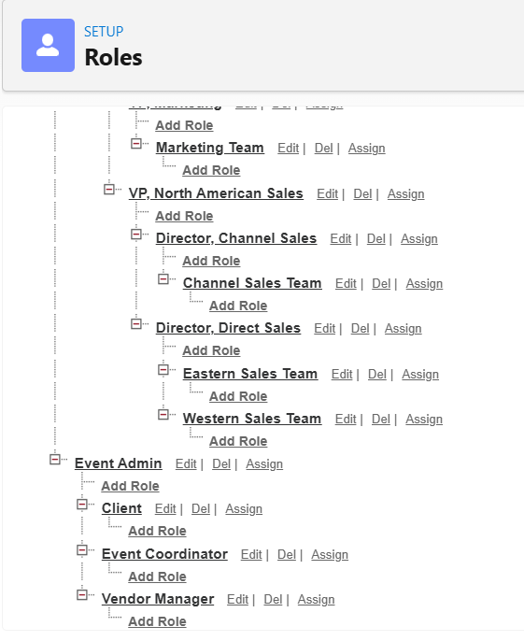

- Milestone 15: User
Activity 1: To Create a User
- Go to Setup, Search Users and select it
- Click New User
- Fill in the fields :
First Name : Sizzler
Last Name : Jaligam
Alias : Give an Alias Name
Email id : Give your Personal Email id
Username : text@text.text must be Unique.
Nick Name : Give a Nickname
Role : Event Admin
User licence : Salesforce
Profiles : Event Admin
- Click On Save.
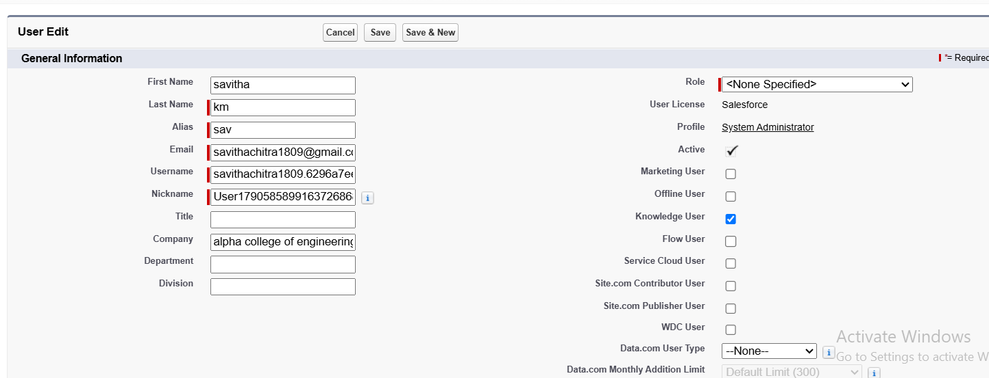

Activity 2: Creating Other Users
- Repeat the steps and create
Role : Event Coordinator,Vendor Manager,Client
User licence : Salesforce Platform
Profile : Event Coordinator,Vendor Manager,Client

- Milestone 16: Permission Set

Activity 1: Creating New Permission Set
- Go to setup and type Permission Set
- Select Permission Set and click New
- Label: Feedback Manager and Click Save
- Extra Permission For Feedback Manager Permission Set
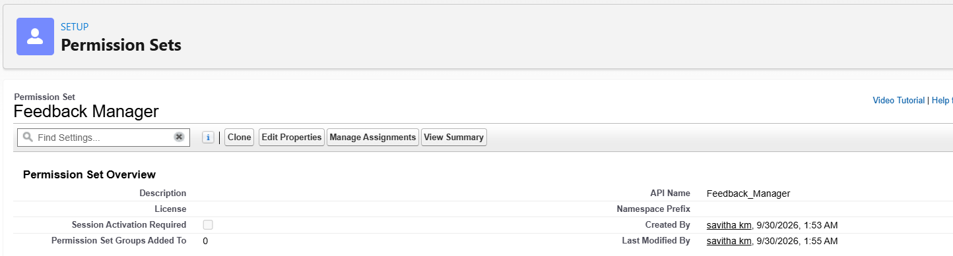

- Go To the Object Settings and Search Feedback Object
- Click On Edit and Go to the Object Permission
- Enable The R/E/C/D Permissions and Click Save
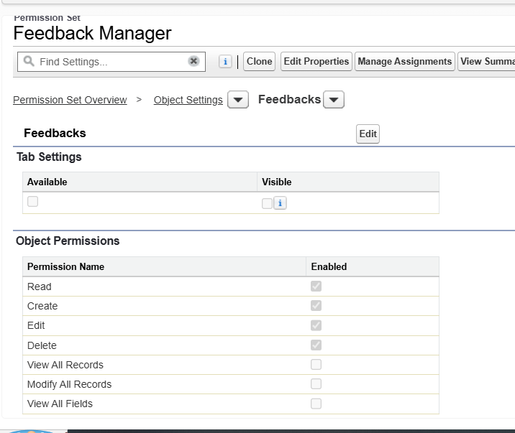

- Click On Manage Assign and Click On Add Assignment
- Select Event Coordinator Role User and Click Next & Assign.

Milestone 17: Sharing Settings

Activity 1: Configure OWD
- Go to Setup and Sharing Settings
- Click On Edit
- Open Sharing Setting, In Organization Wide Defaults
- Select Event Object and Click On Edit Button
- Default Internal Access: Private and Default External Access: Private in Event Object
- Click Save.
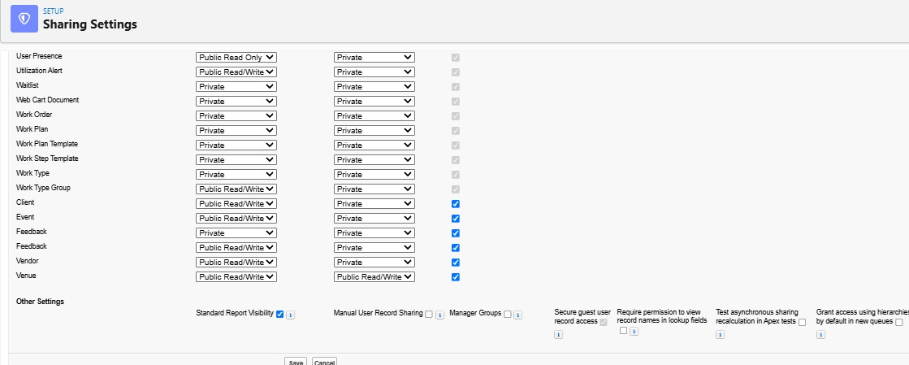

Sharing Rules:
Activity 1: Create a sharing rule
- Go to Sharing Settings and Scroll down to find Event object and click on New to create a new sharing rule
- Label name: Event_Sharing_For_Vendors
- Rule name: Auto populated.
- Select records to shared, members of Roles and Event Coordinator
- Share with Roles and Vendor Manager
- Access level: Read Only and Click Save.
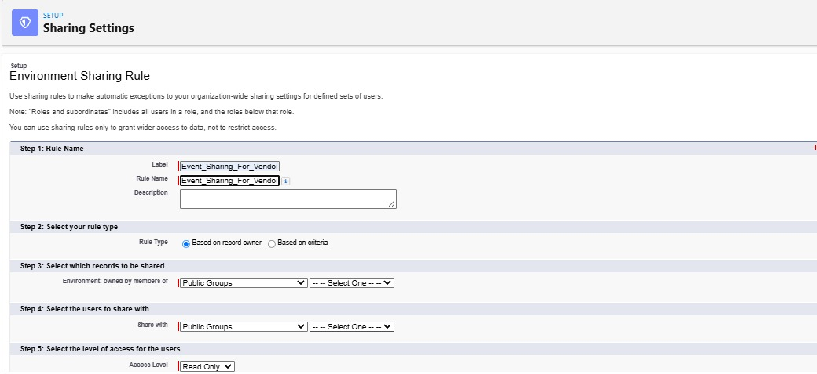

Phase 5 – Deployment, Documentation & Maintenance

Deployment strategy
The EventForce implementation was developed and tested within a Salesforce Developer Edition Org. The source documentation states that production deployment was not performed because a Developer Edition org is a standalone environment. A real production implementation would require an appropriate deployment path such as sandbox-based validation, change sets, Salesforce DX, or an enterprise DevOps pipeline.
The deployment preparation therefore focuses on ensuring that metadata—including objects, fields, flows, Apex components, reports, dashboards, and security configurations—is structured and ready for migration.

Maintenance and monitoring
  - Keep event, client, vendor, venue, and feedback records accurate and current.
  - Monitor Flows, Apex jobs, and approval processes for failures.
  - Resolve access errors and permission conflicts.
  - Debug Apex triggers and Flow logic when automation fails.
  - Update validation rules and sharing settings when business requirements change.

Documentation summary
  - Business overview and objectives.
  - Phase-wise implementation from requirements through security.
  - Data model and relationship design.
  - Automation components including Flows, Approval Processes, Validation Rules, and Apex.
  - Security model including Profiles, Roles, Permission Sets, and Sharing Rules.
  - Testing results and supporting Salesforce screenshots.
The source describes documentation as a complete record of the project's purpose, data model, configuration, automation, and testing processes, supporting future scalability, training, maintenance, and knowledge transfer.

Conclusion
The EventForce Management System demonstrates how Salesforce can be configured as an integrated CRM platform for event-management operations. The project covers the complete implementation lifecycle from requirements and data modelling through automation,user-interface customization, data preparation, testing, security, and deployment planning.
The major learning outcomes include practical experience with Salesforce custom objects, relationships, custom fields, validation rules, approval processes, Flows, Apex classes and triggers, asynchronous Apex, Lightning Apps, reports, dashboards, Profiles, Roles, Permission Sets, Organization-Wide Defaults, and Sharing Rules.
The completed design provides a structured foundation for managing events, clients, vendors, venues, and feedback within one CRM environment. The project also demonstrates the importance of combining declarative Salesforce features with programmatic Apex logic where advanced business rules are required.
For an academic implementation, the project provides a clear end-to-end Salesforce CRM case study. For future enhancement, the documented deployment, monitoring, testing, and maintenance practices provide a foundation for moving the solution toward a controlled production environment.

Project Learnings and Outcomes

Area | Implemented Components
CRM Data Model | Event, Client, Vendor, Venue, Feedback, Event Vendor
Relationships | Lookup, Master-Detail, Many-to-Many via junction object
Automation | Flows, Approval Process, Email Alerts, Scheduled Apex
Business Rules | Validation Rules, Formula Fields, Lookup Filters, Apex triggers
User Experience | Lightning App, Tabs, Reports, Dashboard
Analytics | Upcoming Events by Month, EventForce Operations Dashboard
Security | Profiles, Roles, Permission Sets, OWD, Sharing Rules
Data Operations | Data Import Wizard, validation and testing
Deployment | Developer Edition implementation with deployment preparation
Maintenance | Monitoring, troubleshooting, permission and automation review

