Analyzing Traffic Accident Contributing Factors for Enhanced Road Safety
By A D Savith Rangana
Programme title | Master of IT
Course code and title | PGDAV8.100 Data Analytics and Visualisation T2 2025
Lecturer name | Dr. Farhad Mehdipour
Assessment title | Assessment 1 – Topic 1
Due date | 9th May 2025
PLAGIARISM DECLARATION

Plagiarism is a breach of EIT academic regulations. Penalties range from a warning to suspension or expulsion, as identified in the Student Handbook.

In signing this declaration, you acknowledge that you understand:
- what constitutes plagiarism
- that all work submitted for assessment may be screened for plagiarism
- that this assessment will not be graded if it is found to contain any AI generated content that is not explicitly permitted by the assessment instructions, including output from generative tools such as ChatGPT, paraphrasing tools such as Grammarly, translation tools such as Google Translate, or grammar checking tools such as the MS Word grammar checking function
- that any allegations of plagiarism will be handled according to the EIT Academic Integrity Procedure
I declare that the work submitted is my own work.

Name |  | ID |  | Signature | Date
A D Savith Rangana |  | 2024003716 |  | ADSavith | 08/05/2025

Table of Contents

1. Overview 2
2. Dataset Rationale 2
3. Discussion 3
3.1 Business Problem Evaluation 3
3.2 Potential Research Questions 3
3.3 Potential Data Product and Applications 3
4. References 4

Overview

Traffic accidents are a big problem for public safety. They cause many injuries, deaths and economic losses all over the world. According to WHO (2023), about 1.19 million people die every year in road traffic accidents and many more get injured. These accidents happen for many reasons such as bad weather, poor road design, traffic signals and the time of day (Yakupova et al., 2020).
By analyzing the traffic accident data city authorities can understand the main causes and they can take actions to improve road safety. This study will look at the traffic accident dataset with more than 200,000 records. The data include information like the type of crash, weather conditions, lighting and road conditions. The results from this study can help to improve city planning, traffic control and public safety as well as reduce accidents and make roads safer.

Dataset Rationale

The traffic accidents dataset used in this analysis is taken from Kaggle (Ördekçi, 2025). This dataset has 24 variables and 209,307 traffic accident records and is created in CSV fomat. The explanation of all the variables are listed in below figure 1.
Figure 1
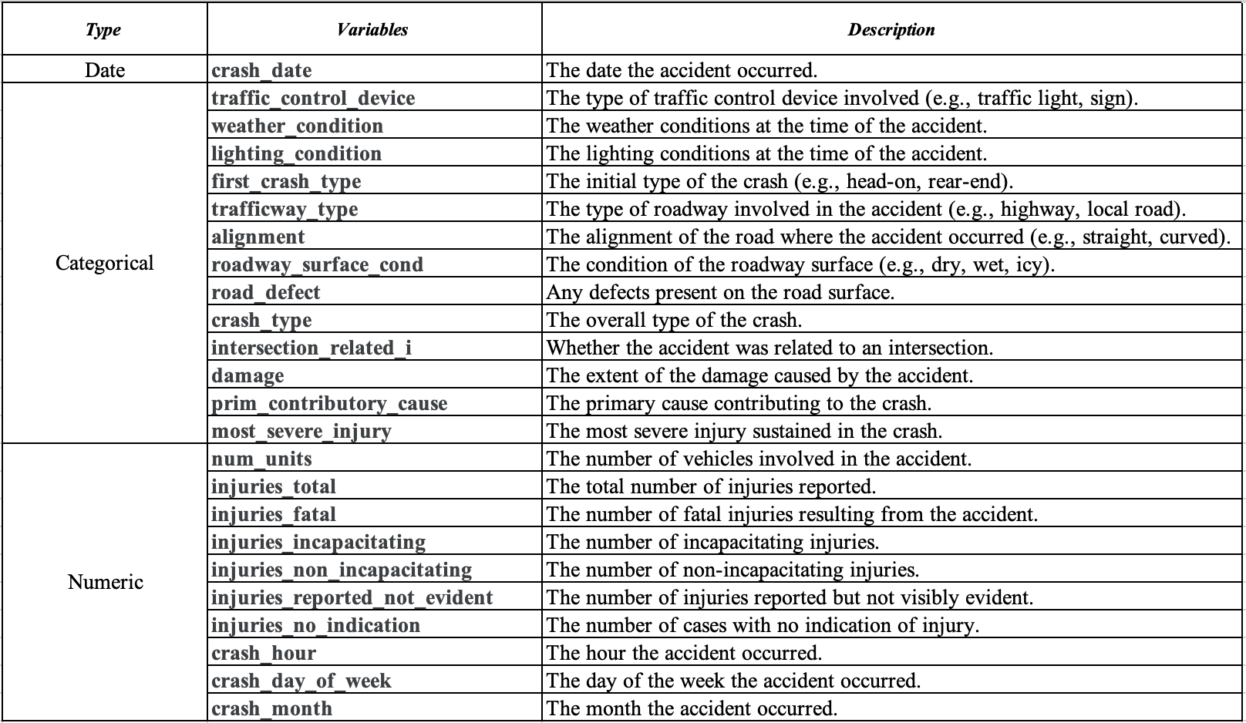
Explanation of the variables
URL for dataset: - https://www.kaggle.com/datasets/oktayrdeki/traffic-accidents?resource=download
This dataset is compatible with tools like R Studio and Microsoft Excel for effective data cleaning, transformations and visualizations. The dataset is very useful for analysing the causes of traffic accidents because it has lot of information and many records.

Discussion

Business Problem Evaluation

Traffic accidents cause many problems for city authorities and businesses especially in areas like transport and insurance. Accidents can lead to delays, higher insurance costs and lower work efficiency. By studying past accident data, we can find patterns and reasons why accidents happen. This helps create plans to reduce accidents, make roads safer and avoid problems in daily operations (Chand et al., 2021). It is important to understand things like weather, time of day and road conditions to predict when and where accidents might happen. For example if we know that more accidents happen during rain or at night, we can make changes like adding better signs, improving street lighting or giving weather warnings to drivers.

Potential Research Questions

- What are the main factors influencing the occurrence of high severity traffic accidents?
- How does the time of day impact the frequency and severity of accidents?
- What is the relationship between weather conditions and the severity of traffic accidents?
- How do road conditions like wet or icy surfaces affect the accident rates?
- Are there correlations between traffic control devices like traffic lights, stop signs and accident frequency?

Potential Data Product and Applications

Through the insights derived from the analysis, we can create useful tools such as predictive models and interactive dashboards.
- Predictive models can guess the chance of an accident happening using information like time of day, weather and road conditions. These models will be valuable to Transportation Businesses by giving them optimized routes and avoiding high risk areas so that it will reduce delays and city planners can use it to fix dangerous areas.
- Interactive Dashboards will help authorities such as traffic management centers to make better safety decisions because these are charts and graphs that show accident trends.

References

Chand, A., Jayesh, S., & Bhasi, A. (2021). Road traffic accidents: An overview of data sources, analysis techniques and contributing factors. Materials Today: Proceedings, 47, 5135-5141.
Ördekçi, O. (2025). Traffic Accidents. https://www.kaggle.com/datasets/oktayrdeki/traffic-accidents
WHO. (2023). Global status report on road safety 2023. https://www.who.int/publications/i/item/9789240086517
Yakupova, G., Buyvol, P., & Shepelev, V. (2020). Identification of factors affecting the road traffic injury rate. Transportation Research Procedia, 50, 735-742. https://doi.org/https://doi.org/10.1016/j.trpro.2020.10.086

